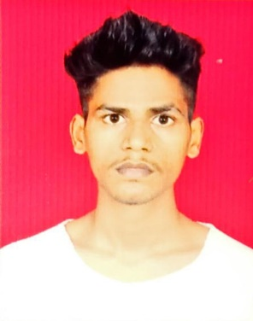

Deepak patel

Deepakpatl1029@gmail.com

**+91-8355911369**

**CAREER OBJECTIVE**

Strong in design and integration with intuitive problem-solving skills. intermediate in JAVA, Web programming, C/C++, PYTHON, Networking and SQL. Passionate about implementing and launching new projects. Ability to translate business requirements into technical solutions. Looking to start the career as an entry-level software engineer with a reputed firm driven by technology.

In terms of my goals, my immediate aim is to secure a position in a reputable company that values creativity and innovation. Looking ahead, I envision myself climbing the corporate ladder and taking on leadership roles within an organization. My ultimate ambition is to build a rewarding and fulfilling career that aligns with my passion and talents.

**PROJECTS**

**Disease detector**

I have made a disease detector system using python as my final semester project.

**Video and voice recorder**

I have built a video recorder that records video along with voice. I have used python to build this project.

**SKILLS**

Java  Python

Oracle  Critical thinking

Digital marketing  Data Structures

**EDUCATIONS**

|  |  |  |  |  |
| --- | --- | --- | --- | --- |
| **College/school** | **University/Board** | **Degree/Standard** | **Passing Date** | **Percentage/Pointer** |
| Anna leela Shobha jayram Shetty college Kurla | MU | B.Sc. | Present |  |

|  |  |  |  |  |
| --- | --- | --- | --- | --- |
| **College/school** | **University/Board** | **Degree/Standard** | **Passing Date** | **Percentage/Pointer** |
| National sarvodhya junior college | Maharashtra State Board of Secondary and Higher Secondary Education | 12th | 2021 | 76% |
| Shree sanatan dharm vidayalay | MSBSHSE | 10th | 2019 | 69% |

**PERSONAL INFORMATION**

|  |  |
| --- | --- |
| **Date Of Birth** | 02-01-2004 |
| **Country** | India |
| **Father's Name** | Dalsingar patel |
| **Marital Status** | Single |
| **Gender** | Male |
| **Languages Known** | Hindi, English |
| **Strengths** | I contribute to my effectiveness and success, i am known for my disciplined approach, punctuality and perpetually positive attitude. |
| **Address** | Shankar mandir , vashi naka , Chembur , Mumbai 400074 |

I hereby declare that all above information is in correct with fact or truth up to my knowledge and I bear the responsibilities for the correctness of the above-mentioned particulars.

Date: 15/06/2023 Deepak Patel