Issues Faced During Execution:
Issue-1 – New Item:
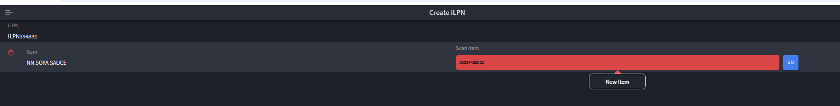
Steps to be followed for Debugging:
1.For this issue we need to navigate to Item Facilities UI.
2. Select the item and click on edit.
3.Uncheck the New item flag box and click on Save button.
4. New Item flag should update as ‘No’
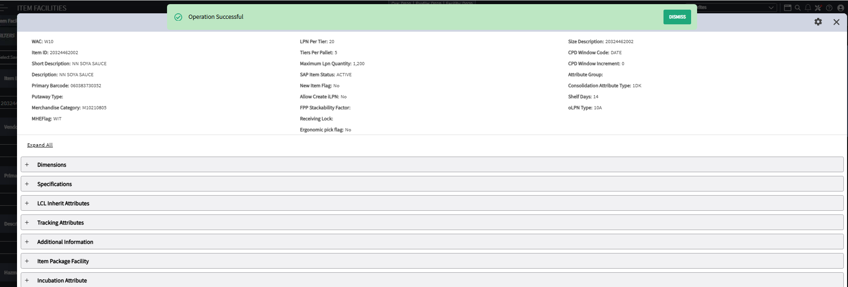
Issue-2-Releasing ORH without OCL.
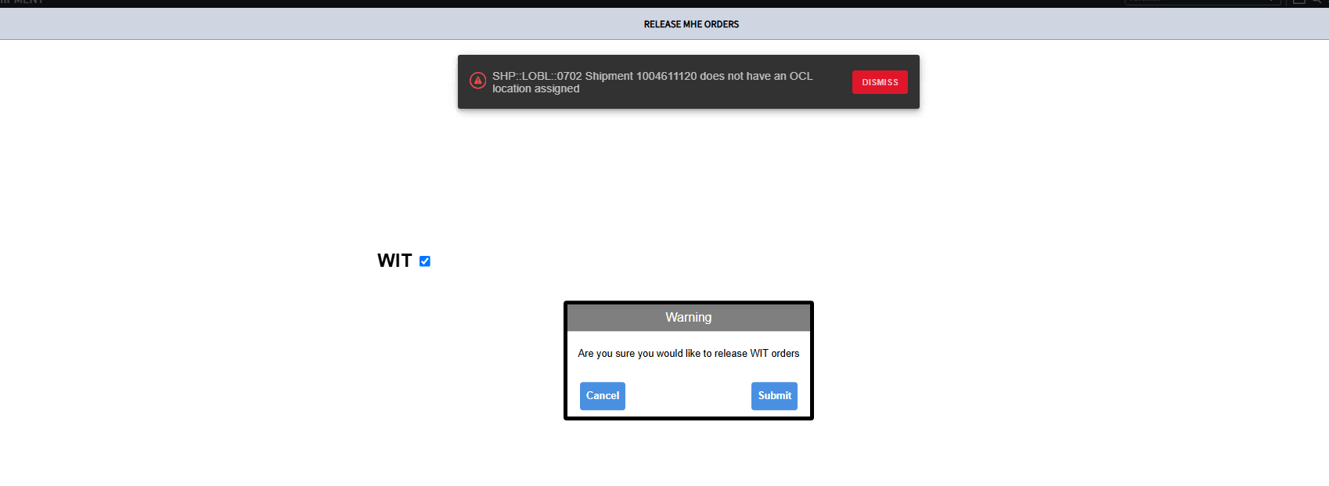
Steps to be followed for Debugging:
1.Navigate Consolidation Locations UI and check for the Consolidation Zone.
2.Assign the OCL and release the ORH.
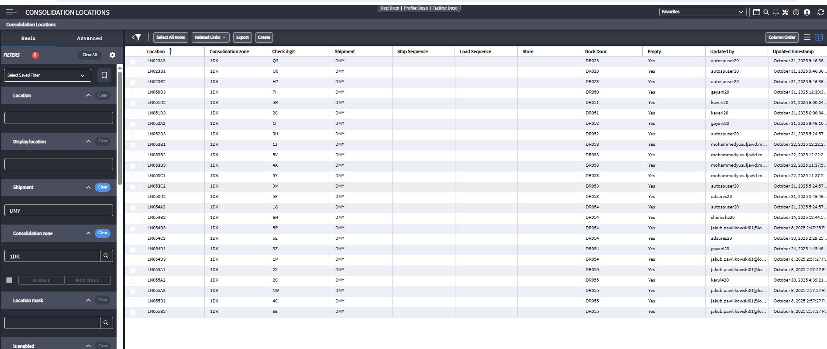
ISSUE-3- Qty received more than Ti*HI for IB
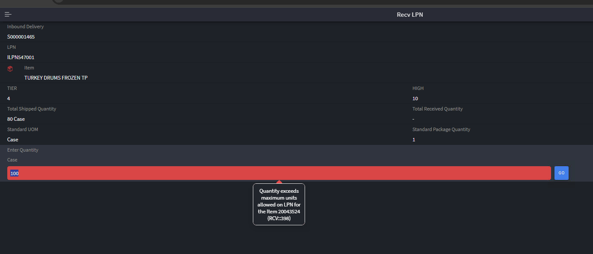
Steps to be followed for Debugging:
1.Navigate to item facilities UI and check the Ti*Hi of the Item.
2.In Recv ILPN transaction give the qty less than or equal to Ti*HI
