***VEHICLE INSURANCE DATABASE***

***DBMS (CS310)***

**PREPARED BY:**

* B. Deepak (20BCS027)
* Chippagiri Karthik (20BCS036)
* Bhukya Jagadeesh (20BCS032)
* Ankati Vivek (20BCS016)
* Kasse Lokesh Babu (20BCS067)
* K. Nirmal Swaroop(20BCS068)
* K. Balaji (20BCS073)
* P. Vivek Yadav (20BCS105)
* Ravula Veekshith Reddy(20BCS111)
* Rangam Sai Charan(20bcs108)

# Under the Guidance of-

**Dr. Uma Seshadri,**

Professor, HOD, Department of Computer Science

Indian Institute of Information Technology Dharwad.

**Dr. Pramod Yelmewad**

Assistant Professor, Department of Computer Science

Indian Institute of Information Technology Dharwad.

**Dr. Supriya Nadiger**

Assistant Professor, Department of Computer Science

Indian Institute of Information Technology Dharwad.



## 

## TABLE OF CONTENTS

## ACKNOWLEDGEMENT

## AIM

## OBJECTIVE

## ROLES AND RESPONSIBILITIES

## TIMELINE

## PROJECT IMPLEMENTATION

→ Tables Creation

→ Conceptual data model (CDM)

→ Physical data model (PDM)

→ Understanding Database

→ Insertion of valid data

→ Creating functions and stored procedures

→ Writing the queries

→ Execution of queries

→ Working on the errors

🡪CONCLUSION

## ACKNOWLEDGEMENT

We would like to sincerely and profusely thank **Dr Uma Seshadri,** for her able guidance and for giving us the opportunity to take up this project. We would also like to thank **Dr. Pramod Yelmewad** and **Dr. Supriya Nadiger** for their guidance and also for giving us the opportunity to take up this project.

**AIM:**

Project is meant for helping our learning skills improve in understanding relational database management system (DBMS). We will learn some theoretical and practical concepts of DBMS and how they are implemented in real life.

**OBJECTIVE:**

The main objective is to gain practical knowledge on working with a database, encountering and overcoming the problems and challenges faced during its implementation. We need to create a database for a vehicle insurance company. To understand all the relationships, functions, constraints, operators etc. which are used while using MySQL. Lastly, an important objective of this project is to be able to collaborate and work as team and bring out value for everybody.

**ROLES AND RESPONSIBILITES:**

|  |  |  |  |  |
| --- | --- | --- | --- | --- |
| STUDENT NAME | ROLE | | ROLLNO | Email |
| B. Deepak | Data insertion, Conceptual DM, | 20BCS027 | | 20bcs027@iiitdwd.ac.in |
| C. Karthik | Data Insertion,  Conceptual DM | 20BCS036 | | 20bcs036@iiitdwd.ac.in |
| Jagadeesh | Data Insertion, Physical Model | 20BCS032 | | 20bcs032@iiitdwd.ac.in |
| A. Vivek | Data Insertion,  Queries | 20BCS016 | | 20bcs016@iiitdwd.ac.in |
| K. Lokesh | Data Insertion,  Physical Model | 20BCS067 | | 20bcs067@iiitdwd.ac.in |
| K. Nirmal Swaroop | Data Insertion,  Queries | 20BCS068 | | 20bcs068@iiitdwd.ac.in |
| K. Balaji | Data Insertion,  Physical model | 20BCS073 | | 20bcs073@iiitdwd.ac.in |
| P. Vivek | Data Insertion,  Queries | 20BCS105 | | 20bcs105@iiitdwd.ac.in |
| Sai Charan | Data Insertion,  Queries | 20BCS108 | | 20bcs027@iiitdwd.ac.in |
| Veekshith | Data Insertion,  Queries | 20BCS111 | | 20bcs027@iiitdwd.ac.in |

**TIMELINE:**

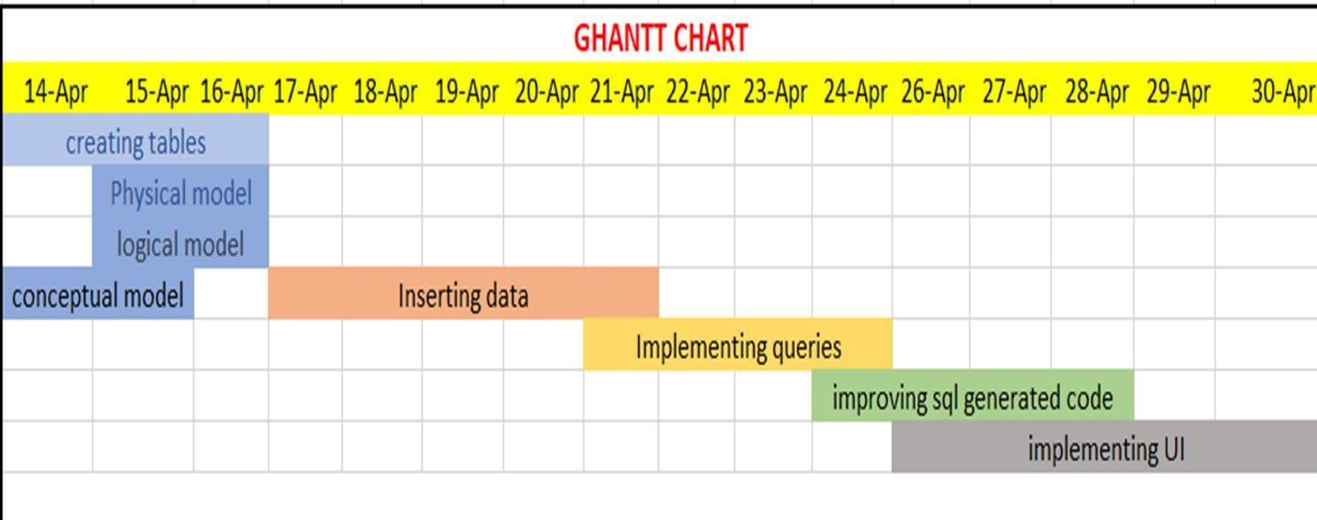

**PROJECT IMPLEMENTATION:**

→ Tables Creation

→ Conceptual data model (CDM)

→ Physical data model (PDM)

→ Understanding Database

→ Insertion of valid data

→ Creating functions and stored procedures

→ Writing the queries

→ Execution of queries

→ Working on the errors, if they occur while improving the data base.

**TABLES CREATION:**

According to database the tables which are required are created without inserting any data initially. Table with the column names and rows are created.

Here are the following tables and the names of the tables,

* t14_customer;
* t14_application;
* t14_quote;
* t14_insurance_policy;
* t14_premium_payment;
* t14_vehicle;
* t14_claim;
* t14_claim_settlement;
* t14_staff;
* t14_department;
* t14_office;
* t14_membership;
* t14_vehicle_service;
* t14_nok;
* t14_insurance_companies;
* t14_policy_renewable;
* t14_incident;
* t14_incident_report;
* t14_coverage;
* t14_product;
* t14_receipt;
* t14_insurance_Policy_coverage;

**CONCEPTUAL DATA MODEL(CDM):**

The other name for the conceptual data model is a business model. This model focuses on identifying the data used in the business but not its processing flow or physical characteristics. As the conceptual data model is of high level it usually not contains attributes in its structure. This model is used to define the relationship among the data entities but not provide information about cardinality properties.

Below is the **CDM** of vehicle insurance database.

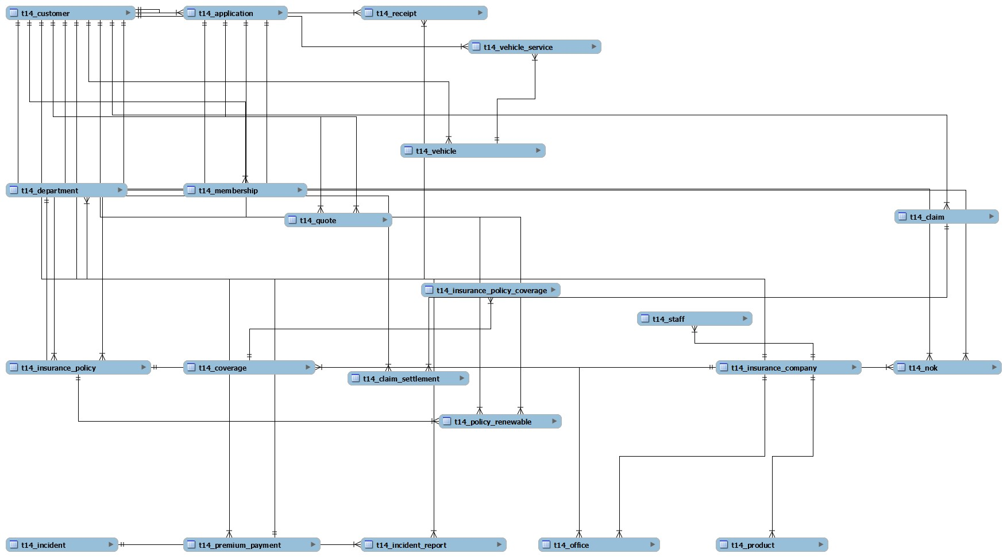

**PHYSICAL DATA MODEL (PDM):**

Physical data model represents how the model will be built in the database. A physical database model shows all table structures, including column name, column data type, column constraints, primary key, foreign key, and relationships between tables. Features of a physical data model include:

→ Specification all tables and columns.

→ Foreign keys are used to identify relationships between tables.

→ Denormalization may occur based on user requirements.

→ Physical considerations may cause the physical data model to be quite different from the logical data model.

→ Physical data model will be different for different RDBMS. For example, data type for a column may be different between MySQL and SQL Server.

Below is the PDM of Vehicle database management system.

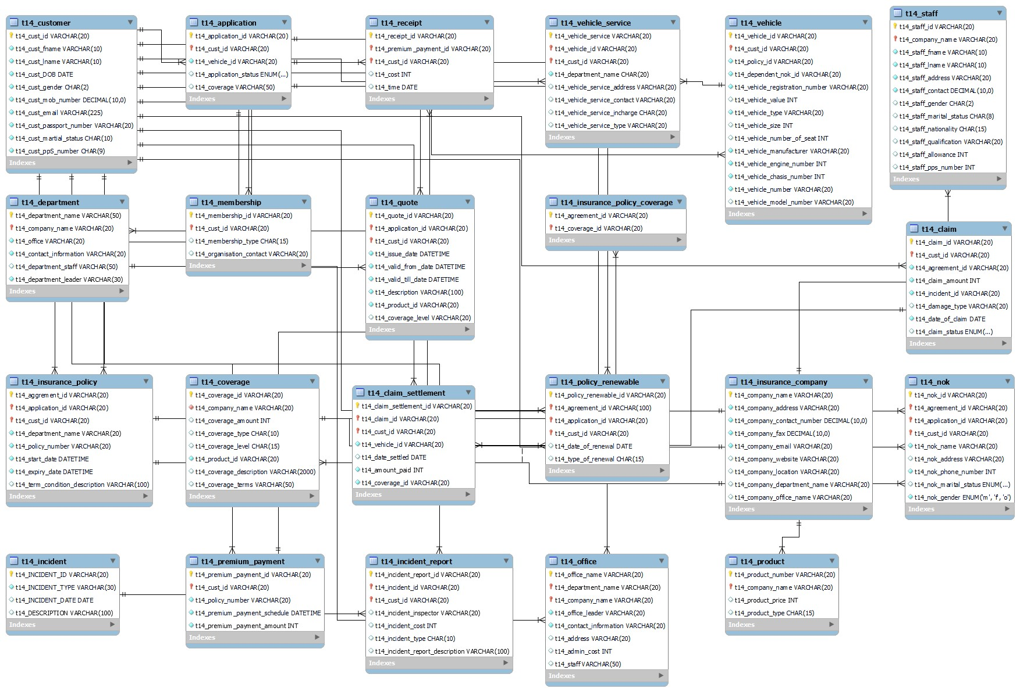

**Understanding Relations between Entities:**

The main purpose of the Physical data model and Logical Data Model is to understand the cardinality, type of relation and relational constraints on relationship and many more. From the physical and logical data models following are the inference made

Relationship types:

One to one relation: only one mapping can be done from parent entity to child entity i.e. the foreign key in the chid table must be unique. To implement one to one relation in sql we use unique constraint on foreign key in child table.

Following are the one-to-one relationships in the database 🡪 Application to Quote

🡪 Customer to membership

🡪 Premium payment to Receipt

🡪 Claim to Claim settlement

Many to Many relation: many mappings can be done from parent entity to child entity and vice versa. To implement many to many relation in sql we use a bridged table with foreign keys from both the table and created a composite primary key to prevent the repetition of same combined attribute. Following are the Many to Many relationships in the database

🡪Insurance policy to coverage,

Bridged_table:t14_insurance_Policy_coverage;

One to Many relation: many mapping can be done from parent entity to child entity. To implement one to many relation in sql we just reference the foreign key in child table. Following are the Many to Many relationships in the database

🡪 all Remaining relations except the above relations

**Creating Functions and Stored Procedures**

A function is compiled and executed every time whenever it is called. A function must return a value and cannot modify the data received as parameters. In MySQL the creation of function is as followed

CREATE FUNCTION function_name [ (parameter datatype [, parameter datatype])]

RETURNS return_datatype

BEGIN

declaration_section

executable_section

END;

Stored Procedures are pre-compiled objects which are compiled for the first time and its compiled format is saved, which executes (compiled code) whenever it is called.

DELIMITER &&

CREATE PROCEDURE procedure_name [[IN | OUT | INOUT] parameter_name datatype [, parameter datatype])]

BEGIN

Declaration_section

Executable_section

END &&

DELIMITER ;

The following are the functions used in the vehicle insurance database:

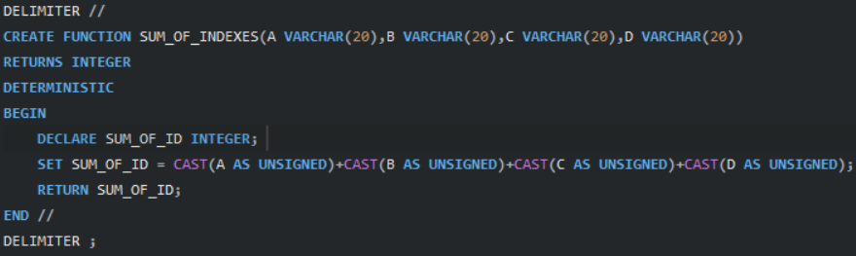SUM_OF_INDEXES() – To sum up all the indexes and designed for query 6

GET_VEHICLE_NUMBER () – To get vehicle number and designed for query 4

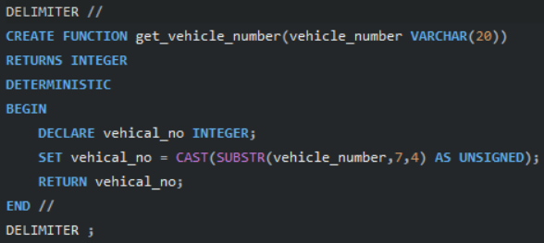

To get data stored procedure Get data is used and to delete data stored procedure

Delete data is used.

**QUERIES:**

Query 1:

Retrieve Customer and Vehicle details who has been involved in an incident and claim status is pending – Customer, vehicle, claim status, incident

SELECT c.T14_cust_id, CONCAT (T14_cust_fname, ' ', T14_cust_lname) AS cust_name, v.T14_vehicle_id, T14_CLAIM_STATUS, T14_incident_id FROM T14_claim cl JOIN T14_vehicle v ON v.T14_policy_id = cl. T14_agreement_id JOIN T14_customer c ON c.T14_cust_id = v.T14_cust_id WHERE T14_incident_id IS NOT NULL AND T14_claim_status LIKE 'pending';

RESULT OF THE QUERY:

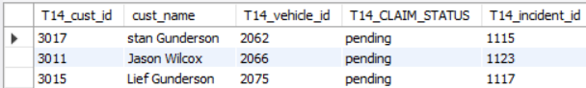

Query 2:

Retrieve customer details who has premium payment amount greater than the sum of all the customer Ids in the database – premium payment, customer

CREATE VIEW cust_sum AS SELECT SUM(T14_cust_id) FROM T14_customer; SELECT * FROM T14_CUSTOMER WHERE T14_CUST_ID IN (SELECT T14_CUST_ID FROM T14_PREMIUM_PAYMENT WHERE T14_premium_payment_amount > (SELECT * FROM cust_sum));

**(OR)**

SELECT * FROM T14_CUSTOMER WHERE T14_CUST_ID IN (SELECT T14_CUST_ID FROM T14_PREMIUM_PAYMENT WHERE T14_premium_payment_amount > (SELECT SUM(T14_cust_id) FROM T14_customer));

RESULT OF THE QUERY:

Query 3:

Retrieve Company details whose number of products is greater than departments, where the departments are located in more than one location— company, product, departments, office Query 3:

SELECT * FROM t14_insurance_companies WHERE t14_company_name in(select o.t14_company_name from t14_PRODUCT p inner join t14_OFFICE o on o.t14_Company_Name = p.t14_Company_Name group by o.t14_Company_Name having Count(distinct(t14_Product_Number)) <count(distinct(t14_Department_Name) ) and count(t14_address)>1);

RESULT OF THE QUERY:

Query 4:

Select Customers who have more than one Vehicle, where the premium for one of the Vehicles is not paid and it is involved in accident

select T14_customer.* from T14_Customer where T14_customer.T14_cust_id IN( SELECT c.T14_cust_id from T14_customer c join t14_incident_report IR on c.T14_cust_id = IR.T14_cust_id left join t14_receipt R on c.T14_cust_id = r.T14_cust_id where c.T14_cust_id in ( select v.T14_cust_id from T14_vehicle V group by T14_cust_id having count(V.T14_cust_id)>1) and R.t14_receipt_id is null and T14_incident_type like "%accident%");

RESULT OF THE QUERY:

Query 5:

Select all vehicles which have premium more than its vehicle number.

SELECT t14_vehicle. * FROM t14_vehicle JOIN t14_premium_payment ON t14_vehicle. T14_cust_id = t14_premium_payment. T14_cust_id WHERE t14_premium_payment_amount > GET_VEHICLE_NUMBER(t14_vehicle_number);

RESULT OF THE QUERY:

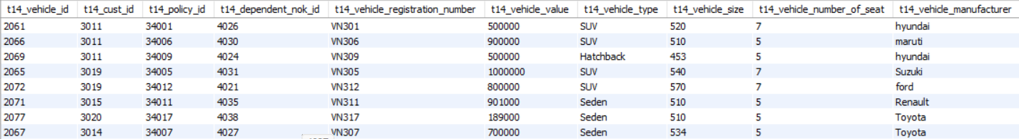

Query 6:

Retrieve Customer details whose Claim Amount is less than Coverage

Amount and Claim Amount is greater than Sum of (CLAIM_SETTLEMENT_ID,

VEHICLE_ID, CLAIM_ID, CUST_ID)

SELECT * FROM T14_CUSTOMER WHERE T14_CUST_ID IN (SELECT CL.T14_CUST_ID FROM T14_COVERAGE CV JOIN T14_INSURANCE_POLICY_COVERAGE `IPC` ON `IPC`.T14_COVERAGE_ID=CV.T14_COVERAGE_ID JOIN T14_INSURANCE_POLICY IP ON `IPC`.T14_AGREEMENT_ID=IP.T14_AGGREMENT_ID JOIN T14_CUSTOMER C ON IP.T14_CUST_ID = C.T14_CUST_ID JOIN T14_CLAIM CL ON CL.T14_CUST_ID = C.T14_CUST_ID JOIN T14_CLAIM_SETTLEMENT CLS ON CL.T14_CLAIM_ID = CLS.T14_CLAIM_ID JOIN T14_VEHICLE V ON V.T14_CUST_ID = C.T14_CUST_ID WHERE T14_COVERAGE_AMOUNT>T14_CLAIM_AMOUNT AND T14_CLAIM_AMOUNT>(SUM_OF_INDEXES(CL.T14_CUST_ID,CLS.T14_CLAIM_ID,CLS.T14_CLAIM_SETTLEMENT_ID,V.T14_VEHICLE_ID)));

RESULT OF THE QUERY:



**CONCLUSION:**

A complete Car Vehicle Insurance company database is completely implemented and all the given project queries are executed and are completely working fine giving at least one line of output. Each table consists of at least 10 tuples of data. Further developments for this project can be making a user interface for this database to perform INSERT, UPDATE, DELETE operations, and Normalisation of a few tables till 4th NF. To adjust the data according to queries functions are used ad stored procedures are used to remove and select the data. Views also assist in the implementation of queries.