**Exp 3 Design a switch controlled led**

**Circuit Diagram**

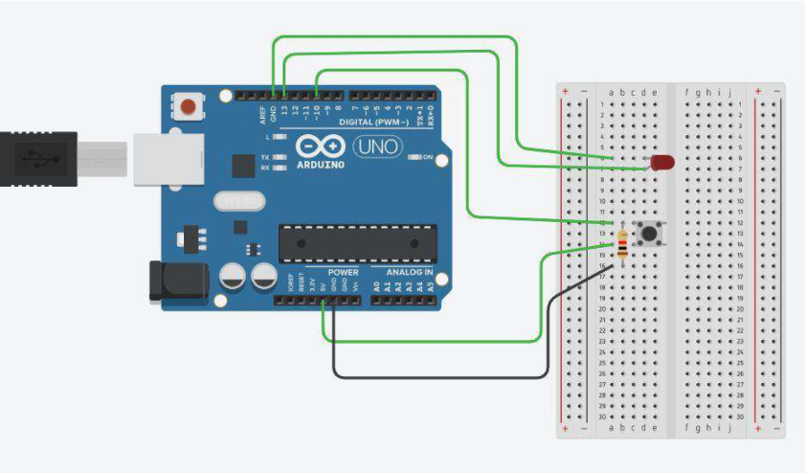

**Theory**

**Concepts Used**

1. **Led** emits lights when current is in forward biased.
2. **Push Button** is a device which controls the flow of the current in the circuit.
3. **Ground** is required to provide the return pathway for low value of output voltage while the switch is open.
4. **Blinking** of led concept is used.
5. Concept of **condition statement** used.
6. Concept of parallel and series connection used.

**Learnings and Observations**

In this experiment we learn the following :

1. Basic circuit building with Arduino uno.
2. Interfacing an LED with Arduino uno.
3. Interfacing a switch with led and Arduino.

We observe the following things:

1. When we press the switch the led will start blinking.
2. After changing in the code we observe that when we press the switch first time the led blink for one time again press the switch twice the led will also blink twice this will continue till four times after that it will again blink one times and this will continue.

**Precautions**

1. Don’t make the connection loose.
2. Before uploading the code into the Arduino make sure that the circuit is correct to avoid the damage of the circuit
3. Check the leds are working or not with the help of the multimeter.
4. The LED should not be connected in reversed direction because it doesn’t allow passing the current and circuit does not completed and LED will not glow.

**Learning Outcomes**

1. We learn the interface between the switch and led.
2. Working of switch.