**Exp**

**Circuit Diagram**

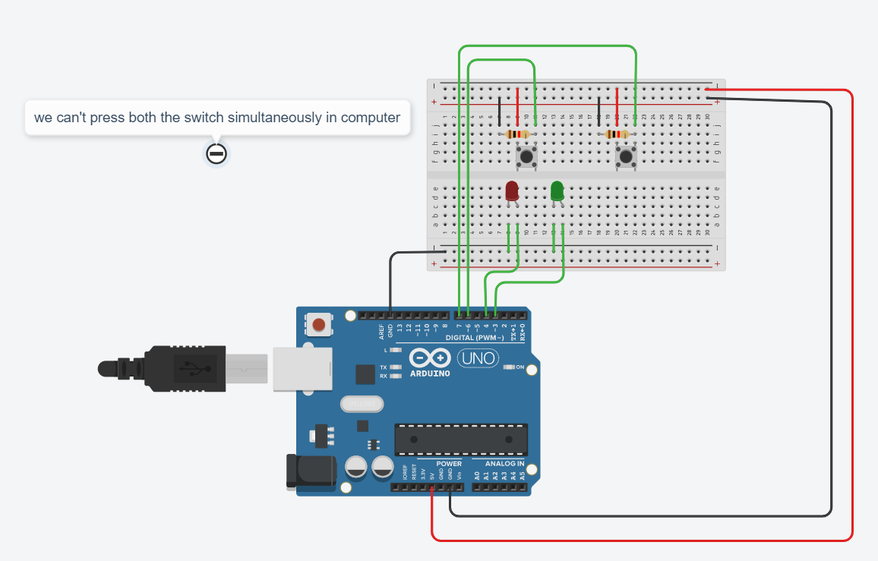

**Theory**

**Concepts Used**

1. Interfacing The push button with the Arduino and leds.
2. Blinking Of Leds concept used.
3. Concept of Condition Statement used.
4. Concept of digitalread used.

**Learnings and Observations**

In this experiment we learnt the following:

1. Basic circuit building with Arduino uno.
2. Interfacing an LED with Arduino uno.
3. Interfacing a switch with led and Arduino.

We observe the following things:

1. When we press the one switch the red led will blink for 60 times in a second.
2. When we press both the switch simultaneously the green led will blink for 120 times in a minute.

**Precautions**

1. Don’t make the connection loose.
2. Before uploading the code into the Arduino make sure that the circuit is correct to avoid the damage of the circuit
3. Check the leds are working or not with the help of the multimeter.
4. The LED should not be connected in reversed direction because it doesn’t allow passing the current and circuit does not completed and LED will not glow.

**Learning Outcomes**

1. **We learn that how by touching the one side of the heart how led blinks.**
2. **We also learn that how to use more than one switch in a circuit.**
3. **We also get to know the function of the “digitalRead”.**