Concrete model based pure identity furnisher with resources
Deepak Kumar
(MCA Department, Vishveshwarya University, Bangalore
Email: sid34000@gmail.com)
Asst. Professor- Prof. Siddegowda C J
(MCA Department, Vishveshwarya University, Bangalore)

ABSTRACT

The provision provided for convenient Central integrity-based service provider is the main conceptual understanding for the development of our application.

The application platform is intended to provide service based platform for the business houses where are secured label factor will be implemented for the identity based application access through multiple customized
options.

The application will help to interconnect all the related functional Association that is required for optimizing and maintaining advance involvement. The application is very convenient with the requested individual sign on features that will help to provide secure integration for the provisional access of the business identity.

- INTRODUCTION

During the economic meltdown, many organizations found themselves downsizing staff. Those efforts were complicated by the fact that IT had numerous capital investments to support those employees. Even when those investments were no longer needed, they still had to be paid for.

If you're laying off 5,000 people, you don't need the same amount of Exchange servers, file servers and other systems. If you bought them, though, you're still paying for them. So if your goal was to reduce costs, you end up having to lay off more employees to hit that number. Your only avenue for savings is their salaries and hard benefits.

Renting software fixes that. If you do end up laying people off, you also cancel that portion of the subscription they were using. This saves you incrementally more per person. Renting software also
helps the company make better decisions.

Today, few organizations can point to the overall cost of a single employee. Overhead like office space rental and utility expenses aside, IT is typically a giant bucket of overhead that's tough to quantify.

Moving some of that IT investment to rental makes it easy to get a better idea of how much each employee costs. In many ways, renting helps accomplish something IT should have been doing all along for cost allocation. If we rented everything, IT wouldn't be overhead anymore. It would be a break-even proposition, with costs easily allocated to actual production expenses.

- LITERATURE REVIEW

There's also the matter of depreciation. That's something financial folks live with as a necessary evil. Buy a piece of software and in most cases you can't write off the expense as a capital investment right away.

You have to depreciate it over five years. With rentals, you write off the entire amount in the same year you make the payment. Your bookkeeping becomes slightly easier. You're no longer sitting on capital investments that have yet to be depreciated. There's less financial resistance to upgrading software when the time comes.

- OBJECTIVE

Renting is better for the vendor, too. Instead of having to build up to a massive new release every few months hoping customers will get on board, vendors can ship features in a more agile, customer-responsive fashion.

They don't need to worry about customers perceiving value and deciding to upgrade. They're already paying for it.

- PROCESS OF WORK

The process of the whole work is generated in a figured which helps us to understand the whole system process which includes the every bit of step followed in the commodity shop.

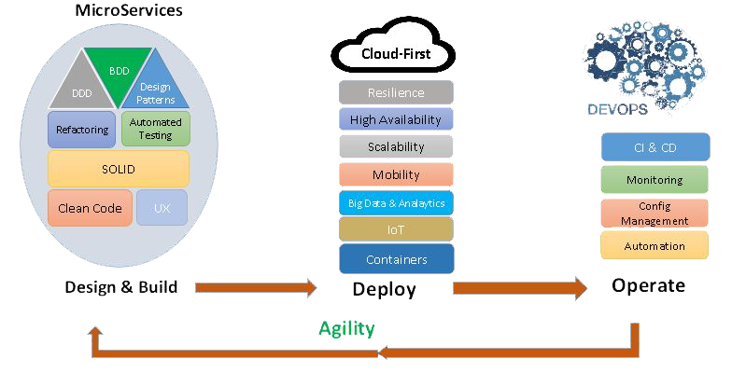

Fig 1.1

The above figure 1.1 shows the process being followed from the scheduler/programmer to the whole system process. Admin environment for the multi-job scheduling system.

- CONCLUSION

Application will have sorted segment for the business application determination where the clients can choose different alternatives to look the required application that must be incorporated for the utilization.
Application will give that in field data one after another in order on the interface supplier Where are characterized insight about the application can be checked.
The application can be chosen and added from the interface gave to take a shot at the individual record framework.
Application chose can be effectively relegated to the gathering for the individual clients required to deal with that specific usefulness.
Affectability construct settings will be bolstered in light of the cloud with the assistance of the cloud interface to actualize and strategize the work.

.

