**MICROSERVICES ASSIGNMENT SUBMISSION**

* **Pull Docker Images of All Microservices from Docker Hub**

docker pull dpcode72/orderapi:1.0

docker pull dpcode72/cartapi:4.0

docker pull dpcode72/productapi:2.0

docker pull dpcode72/authapi:3.0

docker pull dpcode72/apigateway:5.0

* **After Pulling Docker images of All Microservices then Please Create a custom Network using command because I used custom network that is (172.20.0.1)**

sudo docker network create --driver bridge nagarroAss

* **After this Please you wish to run any of above images of Microservices then Please use below command to run**

sudo docker run -p 7000:80 --network nagarroAss

dpcode72/apigateway:5.0

* **As you can see above command that is used to run apigateway(Ocelot) Service & So you will wish to run further images then please use below Command**
* **Rest of all command to run the Docker Images like ProductAPI, CartAPI, AuthAPI & OrderAPI**

sudo docker run -p 8082:80 --network nagarroAss dpcode72/productapi:2.0

sudo docker run -p 8081:80 --network nagarroAss dpcode72/authapi:3.0

sudo docker run -p 8083:80 --network nagarroAss dpcode72/cartapi:4.0

sudo docker run -p 8084:80 --network nagarroAss dpcode72/orderapi:1.0

* **Please, Also Run two Commands to let Microservice be registered on EUREKA As well as TO communicate Microservice to each other with help of Message Broken Service (RabitMQ).**

**Commands are Below:-**

*//RabbitMQ*

docker run -d --hostname rmq --name rabbit-server -p 9000:15672 -p 5672:5672 rabbitmq:3-management

*//EUREKA*

docker run --publish 8761:8761 steeltoeoss/eureka-server

* **After Running all above Commands you can see such interface on Eureka Server Where all Services are register On Eureka As well as you can also see Message Broken Service on Web Browser Queue are generated on name of Consumermessage**

**EUREKA UI Where you can all Services are registered.  
**

**As you can also see the Message Broken Service(Rabbitmq)**

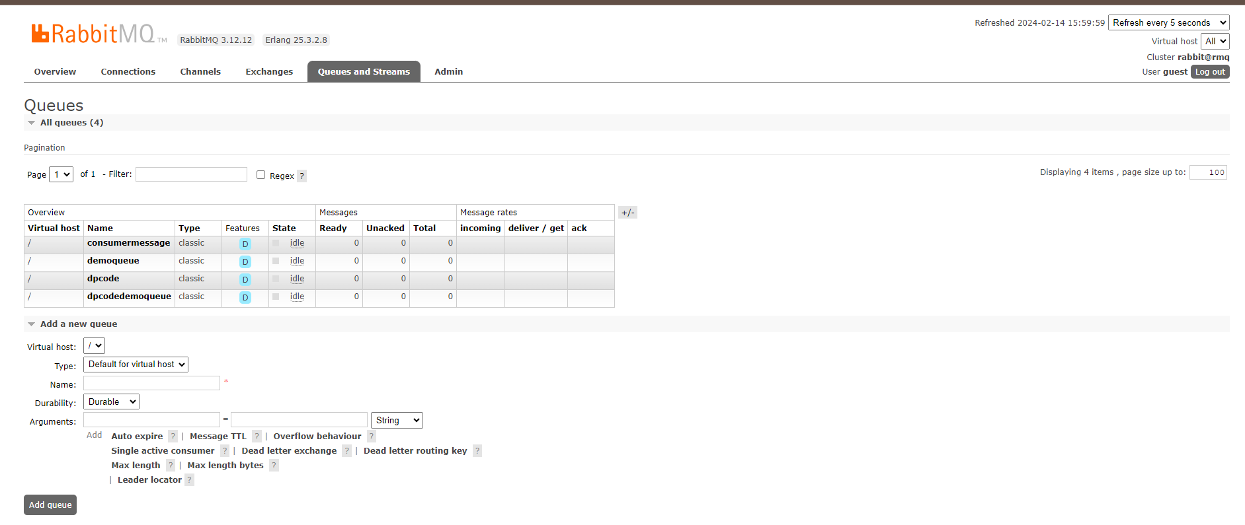

**For shake of understanding of Rabbitmq I tried to make Service Communicate to each other like ProductAPI Service is communicating with OrderAPI Service  
  
As you can see in below Images  
  
**

**Import the postman collection named“MicroservicesAllApiTesting”**

**in the postman application.**

Now, after giving right credentials for login as you can see that user will get jwt token to access the Microservices Service such Proudct Service, Cart Service & Order Service, but passing Jwt token with every request to get authorized to use service like add item to cart & place order & so on….  
  
As you can see in below images of POSTMAN like how things are working  
  
Here you can see that user trying to add item to cart

Later user can place order which he/she added to the cart as you can see in below images of POSTMAN like how things are working

For more information such you will like to know like EUREKA, Message Broken Service & My Docker Hub Repository  
  
I am giving reference of all those below please check in case you found something messing or anything

EUREKA DASHBOARD URL  
http://localhost:8761/  
MESSAGE BROKEN SERVICE URL  
<http://localhost:9000/#/connections>  
MY DOCKER HUB REPOSITORY URL  
https://hub.docker.com/u/dpcode72