DEPARTMENT OF COMPUTER SCIENCE AND ENGINEERING
CSA16 – DATA WAREHOUSING AND DATA MINING
ASSIGNMENT 1 – CO1
Design, Build and Validate a Data Warehouse and OLAP Reporting Solution for a Retail Chain (FreshCart)
Student Name: SHAILAJA S Register Number: 192511026

TASK 1 – Analyse the Decision-Support Requirement (4 Marks)
FreshCart’s operational database is an OLTP system built to record each sale, return, loyalty swipe and promotion quickly and correctly across 120 stores. Its normalised tables (Orders, OrderLines, Customers, Products, Stores, Returns and others) avoid duplication and favour short inserts and updates. Management analysis behaves differently: it reads millions of historical order lines, joins many tables and groups them by time, product, store and customer segment. Running such queries on the billing database competes with checkout transactions, which is why counters slow down at peak hours. Because every department applies its own rule, “net sales” is also reported with different values.
A separate decision-support data warehouse is therefore needed. It must (i) keep analytical load off the billing system, (ii) integrate store and online data under one approved definition, Net Sales = gross line amount − discount − recognised return amount, (iii) keep history so that year-on-year questions can be answered, (iv) refresh dashboards hourly, (v) stay practical beyond 1,000,000 sales lines and (vi) reconcile to source totals.
Table 1.1 Business questions, classification, measures, dimensions and OLTP suitability
No. | Business question | Type | Measures | Dimensions | Efficient on OLTP?
1 | Which product categories show declining net sales quarter over quarter in each region? | Strategic | Net sales; QoQ change % | Date (quarter), Product (category), Store (region) | No – scans all history, joins 8 tables to reach category and region
2 | Which promotions increased average basket value, and in which stores? | Tactical | Basket value; average basket; uplift | Promotion, Store, Date, Order | No – must regroup lines into baskets while billing is running
3 | How does weekend sales performance differ from weekday performance for each department? | Tactical | Gross sales; discount; net sales | Date (day type), Product (department), Store | No – day type is not stored; derived per row on millions of lines
4 | Which customer segments return the most items, and which products? | Strategic | Returned qty; return value; return rate | Customer segment, Product, Store, Date | No – joins Returns to sales lines, customers and products
5 | What is year-to-date sales of every store compared with the same period last year? | Strategic | YTD net sales; prior-year YTD; variance | Date, Store | No – needs two full date ranges; OLTP may purge or overwrite history
6 | Which stores have high daily sales yet are below target? | Tactical | Daily net sales; target; variance | Date, Store, Region | Partly – needs targets that OLTP does not hold
7 | Which suppliers provide products with the highest sales and return rates? | Strategic | Sales qty; net sales; return rate | Supplier, Product, Date, Store | No – crosses sales, product, supplier and returns data
8 | What is the hourly order volume and average basket value by sales channel? | Tactical | Order count; line count; basket value | Time, Channel, Store, Promotion | Poor – repeated scans of live Orders at the busiest hour

Table 1.2 OLTP versus decision support, related to FreshCart
Aspect | FreshCart OLTP | FreshCart decision-support warehouse
Purpose | Record current orders, payments, customer updates and returns at the billing counter. | Explain performance: trends, segments, promotion effects, year-on-year comparison.
Data currency | Current state; rows are updated and overwritten continuously. | Historical, integrated snapshots; refreshed hourly for dashboards; history is preserved.
Structure | Normalised (Orders, OrderLines, Customers …) to avoid update anomalies. | Dimensional star schema: one fact table with conformed dimensions for simple, fast grouping.
Query pattern | Short transactions touching a few rows, e.g. insert one order line. | Long scans, multi-table joins and aggregation over millions of rows.
Users | Cashiers, order-processing services, store staff. | Category managers, regional heads, executives, analysts.
Volume | Many small reads and writes with strict response times (hundreds per second at peak). | Years of history (1,000,000+ lines, growing by about 60,000 lines per day once online sales start).

Questions 1, 3, 4, 5, 7 and 8 cannot be answered efficiently from OLTP because each needs aggregation over very many order lines and several dimensions at once, and each would compete with checkout transactions. Question 5 additionally needs a consistent same-period-last-year view, which operational tables do not guarantee. Question 2 needs baskets rebuilt from lines. The experiment in Task 8 supports this: even with indexed foreign keys, the normalised schema needed 8 joins and for the quarterly category/region query on 1,000,000 lines, against on the star schema and under 1 ms on a summary table.

TASK 2 – Propose the Warehouse Architecture (3 Marks)
Choice: enterprise data warehouse with dependent data marts. All stores and the online channel load into one central, integrated warehouse; the Sales, Marketing and Inventory marts, and the OLAP server, are fed from it.
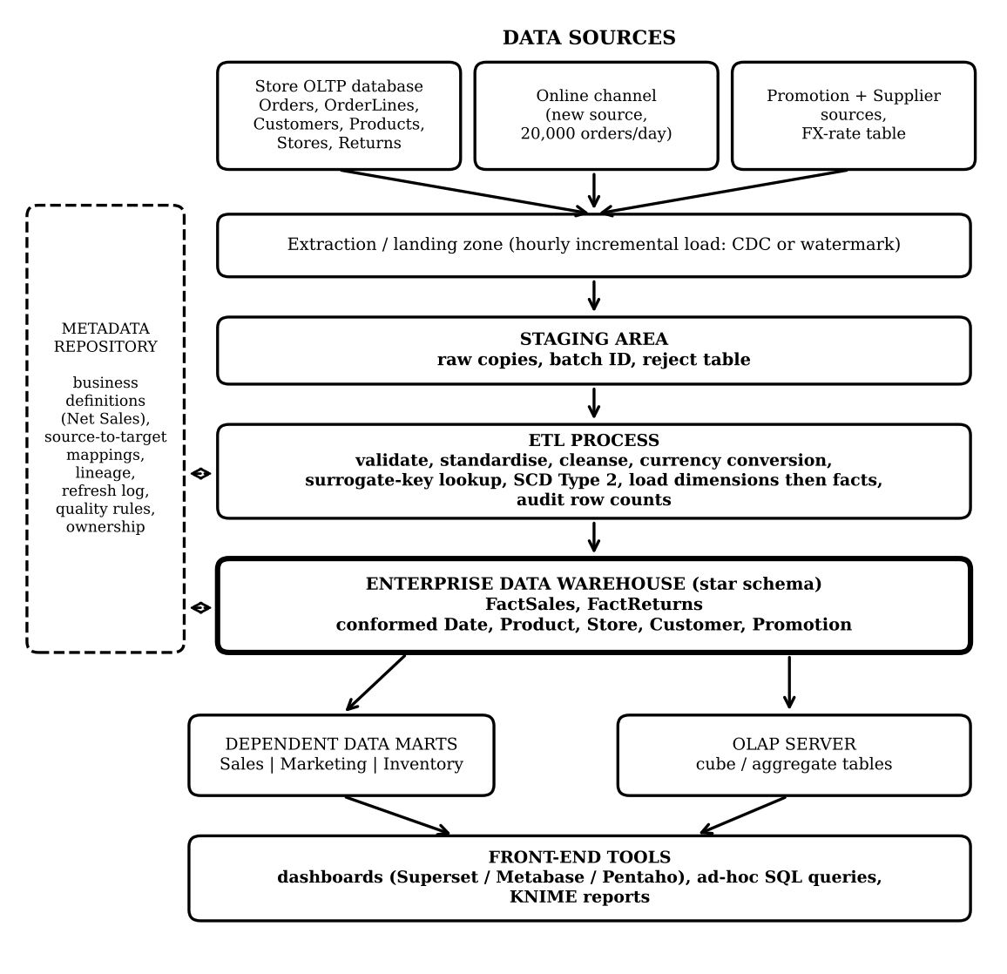
Figure 2.1 Proposed architecture for FreshCart
Table 2.1 Components and their role
Component | Role at FreshCart
Data sources | Store OLTP (Orders, OrderLines, Customers, Products, Stores, Returns), promotion and supplier files, FX-rate table; online channel added later.
Staging area | Raw, unmodified extracts with batch ID and load time; allows audit, replay and a reject table.
ETL process | Validate, standardise, cleanse, convert currency, look up surrogate keys, apply SCD Type 2, load dimensions before facts, record audit counts.
Warehouse storage | Star schema (FactSales, FactReturns, conformed dimensions) holding the single approved definition of Net Sales.
Metadata repository | Source-to-target mappings, measure definitions, lineage, refresh history, data-quality rules, ownership.
Data marts / OLAP server | Dependent marts for department views; OLAP server holds aggregates so dashboards read small tables.
Front end | Superset / Metabase / Pentaho dashboards, ad-hoc SQL and KNIME reports.

Why this choice. Independent marts would let each department keep its own net-sales rule, which is the problem FreshCart has today. A virtual warehouse would leave analytical queries running on the operational systems, so the billing slowdown and the history problem would remain. An enterprise warehouse with dependent marts gives one set of definitions, protects the counters, preserves history and still gives each department a tailored view.

TASK 3 – Design the Star Schema (6 Marks)

3.1 Business process and declared grain
Business process: retail sales. Grain: one row in FactSales is one product line on one customer order, at one store, on one order date, for one customer and under one promotion (or the “no promotion” member). The grain is declared before the measures, so each measure below describes exactly one order line, and each dimension has exactly one value for that line. Basket-level values such as order count and basket value are therefore not stored on lines; they are derived by grouping on OrderNumber (a degenerate dimension kept in the fact table).

3.2 Fact table and measures
Table 3.1 FactSales measures and additivity
Measure | Definition at line grain | Additivity
Quantity | Units sold on the line. | Additive across all dimensions
GrossAmount | Quantity × unit selling price, before discount. | Additive
DiscountAmount | Discount applied to the line. | Additive
NetSalesAmount | GrossAmount − DiscountAmount (returns are held in FactReturns and netted in reports). | Additive
MarginAmount | NetSalesAmount − cost of goods sold. | Additive
UnitPrice | Selling price per unit. | Non-additive: use SUM(Gross)/SUM(Qty), never SUM(UnitPrice)
MarginPct (derived) | MarginAmount / NetSalesAmount. | Non-additive ratio: recompute from additive parts

A transaction-grain sales fact has no naturally semi-additive measure. Semi-additive measures such as stock on hand or loyalty-point balance belong to periodic-snapshot facts: they can be summed across stores but not across time. Returns use a second fact table, FactReturns, at the grain “one returned product line”, because a return is a separate event and can occur on a later date than the sale. Its measures ReturnedQuantity and ReturnAmount are additive.

3.3 Dimensions, keys and concept hierarchies
Table 3.2 Dimension tables
Dimension | Keys | Main attributes | Concept hierarchy
DimDate | PK DateKey (YYYYMMDD) | FullDate, DayName, IsWeekend, MonthNo, QuarterNo, YearNo | Day → Month → Quarter → Year
DimProduct | PK ProductKey (surrogate); business key ProductCode | ProductName, Brand, Category, Department, PackSize, Supplier | Product → Brand → Category → Department
DimStore | PK StoreKey; business key StoreCode | StoreName, City, StateName, Region | Store → City → State → Region
DimCustomer | PK CustomerKey; business key CustomerID | Name, Segment, LoyaltyTier, Address, EffectiveFrom, EffectiveTo, IsCurrent | Customer → Segment; tier and address versioned (SCD Type 2)
DimPromotion | PK PromotionKey; business key PromotionCode | Name, PromotionType, StartDate, EndDate (key 0 = no promotion) | Promotion → Promotion type

Every dimension has a warehouse-generated surrogate primary key, and the source system’s business key is kept as an ordinary attribute for matching. FactSales holds one foreign key per dimension, so the fact primary key is its own surrogate SalesLineKey. Reserved member 0 (“Unknown / Not applicable”) in each dimension avoids NULL foreign keys. Consistency with the grain: each line has one date, product, store, customer version and promotion, so all five foreign keys are single-valued at the declared grain; every measure is defined per line.

3.4 Conformed dimensions shared with FactReturns
FactReturns uses the same DimDate, DimProduct, DimStore and DimCustomer tables, with identical keys and attribute meanings. Date is a role-playing dimension in FactReturns (ReturnDateKey and OriginalSaleDateKey point to the same DimDate). Because the dimensions are conformed, the return rate of Question 4 is calculated by grouping FactSales and FactReturns on the same Segment and Category values and dividing the results (a drill-across query).

3.5 Schema diagram
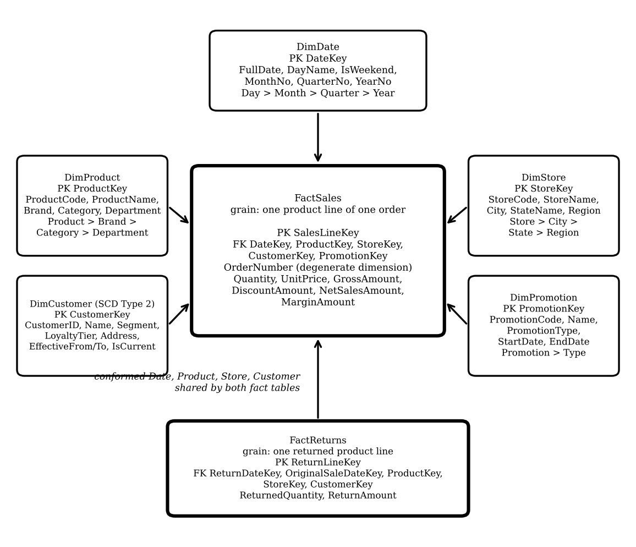
Figure 3.1 Star schema with a second fact table sharing conformed dimensions

3.6 Table-creation (DDL) statements
CREATE TABLE DimDate (
DateKey INT PRIMARY KEY, FullDate DATE NOT NULL, DayName VARCHAR(12), IsWeekend BOOLEAN,
MonthNo INT, QuarterNo INT, YearNo INT);
CREATE TABLE DimProduct (
ProductKey INT GENERATED ALWAYS AS IDENTITY PRIMARY KEY,
ProductCode VARCHAR(40) NOT NULL, ProductName VARCHAR(120), Brand VARCHAR(60),
Category VARCHAR(60), Department VARCHAR(60), PackSize VARCHAR(30));
CREATE TABLE DimStore (
StoreKey INT GENERATED ALWAYS AS IDENTITY PRIMARY KEY,
StoreCode VARCHAR(30) NOT NULL, StoreName VARCHAR(100), City VARCHAR(60),
StateName VARCHAR(60), Region VARCHAR(40));
CREATE TABLE DimCustomer (
CustomerKey INT GENERATED ALWAYS AS IDENTITY PRIMARY KEY,
CustomerID VARCHAR(40) NOT NULL, CustomerName VARCHAR(100), Segment VARCHAR(40),
LoyaltyTier VARCHAR(30), AddressText VARCHAR(250),
EffectiveFrom TIMESTAMP, EffectiveTo TIMESTAMP, IsCurrent BOOLEAN);
CREATE TABLE DimPromotion (
PromotionKey INT GENERATED ALWAYS AS IDENTITY PRIMARY KEY,
PromotionCode VARCHAR(40), PromotionName VARCHAR(100), PromotionType VARCHAR(40),
StartDate DATE, EndDate DATE);
CREATE TABLE FactSales (
SalesLineKey BIGINT GENERATED ALWAYS AS IDENTITY PRIMARY KEY,
OrderNumber VARCHAR(40) NOT NULL, -- degenerate dimension
DateKey INT NOT NULL REFERENCES DimDate(DateKey),
ProductKey INT NOT NULL REFERENCES DimProduct(ProductKey),
StoreKey INT NOT NULL REFERENCES DimStore(StoreKey),
CustomerKey INT NOT NULL REFERENCES DimCustomer(CustomerKey),
PromotionKey INT NOT NULL REFERENCES DimPromotion(PromotionKey),
Quantity INT, UnitPrice DECIMAL(12,2), GrossAmount DECIMAL(14,2),
DiscountAmount DECIMAL(14,2), NetSalesAmount DECIMAL(14,2), MarginAmount DECIMAL(14,2));
CREATE TABLE FactReturns (
ReturnLineKey BIGINT GENERATED ALWAYS AS IDENTITY PRIMARY KEY, ReturnNumber VARCHAR(40),
ReturnDateKey INT NOT NULL REFERENCES DimDate(DateKey),
OriginalSaleDateKey INT REFERENCES DimDate(DateKey),
ProductKey INT NOT NULL REFERENCES DimProduct(ProductKey),
StoreKey INT NOT NULL REFERENCES DimStore(StoreKey),
CustomerKey INT NOT NULL REFERENCES DimCustomer(CustomerKey),
ReturnedQuantity INT, ReturnAmount DECIMAL(14,2));
-- Unknown members (key 0) are inserted into each dimension before the first load.
-- Identity syntax varies by DBMS; adapt it to the DBMS actually used.

TASK 4 – Compare with a Snowflake Schema (4 Marks)

4.1 Snowflaked design: additional tables, keys and joins
Table | Columns (PK, FK) | Join added from the level below
DimDepartment | DepartmentKey PK, DepartmentName | DimCategory → DimDepartment
DimCategory | CategoryKey PK, CategoryName, DepartmentKey FK | DimBrand → DimCategory
DimBrand | BrandKey PK, BrandName, CategoryKey FK | DimProduct → DimBrand
DimProduct | ProductKey PK, ProductCode, ProductName, BrandKey FK | FactSales → DimProduct
DimRegion | RegionKey PK, RegionName | DimState → DimRegion
DimState | StateKey PK, StateName, RegionKey FK | DimCity → DimState
DimCity | CityKey PK, CityName, StateKey FK | DimStore → DimCity
DimStore | StoreKey PK, StoreCode, StoreName, CityKey FK | FactSales → DimStore

Product moves from 1 table to 4 (product → brand → category → department) and Store from 1 table to 4 (store → city → state → region), so 6 new tables and 6 new foreign keys are introduced. The fact table is unchanged: it still points to the lowest level.

4.2 Dimension storage estimate
Assumptions: each text label takes 20 bytes, each integer key 4 bytes, and row headers, indexes and compression are ignored. With 50,000 products, 800 brands, 60 categories, 12 departments, 120 stores, 70 cities, 6 states and 3 regions:
Table 4.1 Storage calculation (bytes)
Dimension | Star (hierarchy labels repeated per row) | Snowflake (labels once per member, plus keys)
Product | 50,000 × 3 labels × 20 = 3,000,000 | DimProduct BrandKey 50,000 × 4 = 200,000  Brand 800 × (20+4+4) = 22,400  Category 60 × (20+4+4) = 1,680  Department 12 × (20+4) = 288  Total = 224,368
Store | 120 × 3 labels × 20 = 7,200 | DimStore CityKey 120 × 4 = 480  City 70 × 28 = 1,960  State 6 × 28 = 168  Region 3 × 24 = 72  Total = 2,680
Change | — | Product: 3,000,000 − 224,368 = 2,775,632 saved (92.5%, about 2.65 MiB)  Store: 7,200 − 2,680 = 4,520 saved (63%)

Context: in the 1,000,000-row experiment of Task 8 the FactSales table alone occupied about . The snowflake therefore saves roughly 2.65 MiB of about 45 MB, i.e. about 6.2% of the fact table, and the saving does not grow with the number of fact rows.

4.3 Join count for three representative queries
Query | Star (joins from fact) | Snowflake (joins from fact)
A Net sales by department and region | 2 (Product, Store) | 8 (Product, Brand, Category, Department, Store, City, State, Region)
B Net sales by category | 1 (Product) | 3 (Product, Brand, Category)
C Net sales by state | 1 (Store) | 3 (Store, City, State)

Evidence from Task 8: the normalised OLTP-style schema, which has the same chain of hierarchy tables, needed 8 joins for the department/region query and took as long as the 3-join star query at 1,000,000 rows (16,139 ms against 1,651 ms). A snowflake schema would fall between the two, because the fact-to-dimension joins remain but the hierarchy joins return.

4.4 Effect on performance, ETL and usability
- Performance: every extra join adds lookups and plan complexity; Query A grows from 2 to 8 joins.
- ETL maintenance: parents must be loaded before children (Region → State → City → Store; Department → Category → Brand → Product), and a hierarchy change touches several tables. In the star, one dimension row is rewritten.
- Ease of understanding: business users see 1 Product table instead of 4 and 1 Store table instead of 4, so ad-hoc queries are simpler and less error-prone.

4.5 Decision
FreshCart should use the star schema: the dimensions are small (50,000 products, 120 stores), the snowflake would save only about 2% of fact-table size, and dashboard speed and usability matter more than 2.65 MiB. I would switch selectively to a snowflake only if (a) the Product dimension grows to tens of millions of rows so that repeated labels become a measurable share of total storage (for example more than 10%), or (b) hierarchy names are governed centrally by a different team so that single-table maintenance becomes valuable, and measured query times with the extra joins still meet the dashboard target.

TASK 5 – Design the ETL Process (5 Marks)
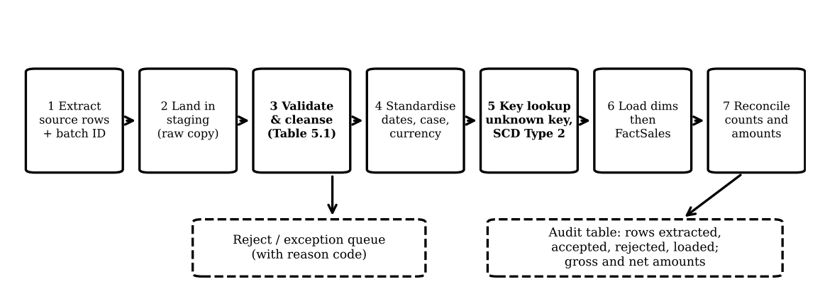
Figure 5.1 ETL flow

5.1 Data-quality problems and transformation rules
Defect in the extract | Transformation rule
Dates in several formats: 03/11/2026, 2026-11-03, 04-Nov-26, 04/11/2026 | Parse each with its own format and the source convention DD/MM/YYYY; store as DATE and DateKey YYYYMMDD. Orders 1001 and 1002 are both 3 Nov 2026.
Customer name variants: Rajesh Kumar / R. Kumar | Match on customer or loyalty ID, never on name alone. If no ID exists, load under provisional keys and send the pair to a data steward; do not merge automatically.
Store code case and abbreviation: Chennai-04 / chennai-04, Hyd-02 | TRIM and UPPER-CASE, then map aliases through the store master to the canonical code (CHENNAI-04, HYD-02).
Product name variants: Basmati Rice 5kg / Basmati rice 5 kg | Normalise case and the space before the unit, then look up the product alias table so both rows get the same ProductKey.
Negative quantity (order 1003, −3) | Invalid for a sale. Reject to the exception queue (reason NEG_QTY). Only if the source transaction type says “return” is it routed to FactReturns as +3; the sign is never flipped silently.
NULL store (order 1004) | Assign Unknown Store key 0, flag for correction; reject instead if the store is mandatory for that transaction type.
Mixed currency: 9.40 (USD) beside INR prices | Parse amount and currency code; convert with the approved FX rate for the order date; keep original amount and currency columns for audit. Illustration: at 1 USD = 83 INR, 9.40 USD ≈ 780.20 INR, consistent with the 780.00 INR price of the same product; the real rate must come from the FX table.
NULL product (order 1006) | Use Unknown Product key 0 and place the row in the late-arriving queue; reject if unresolved within the agreed time.
Thousands separator: 1,250 | Strip the comma and load 1250.00; confirm currency from source metadata (assumed INR, flagged).

5.2 Before and after versions of the extract
Table 5.2 Before (as received)
Order ID | Customer | Store | Product | Qty | Unit Price | Order Date
1001 | Rajesh Kumar | Chennai-04 | Basmati Rice 5kg | 2 | 620.00 | 03/11/2026
1002 | R. Kumar | chennai-04 | Basmati rice 5 kg | 1 | 620.00 | 2026-11-03
1003 | Anita Joseph | Pune-11 | Olive Oil 1L | -3 | 780.00 | 04-Nov-26
1004 | Meena S | (null) | Tea 250g | 4 | 95.50 | 04/11/2026
1005 | Anita Joseph | Pune-11 | Olive Oil 1L | 3 | 9.40 (USD) | 04/11/2026
1006 | Vikram Rao | Hyd-02 | (null) | 1 | 1,250 | 05/11/2026

Table 5.3 After (cleaned staging, ready for key lookup)
Order | Customer | Store | Product | Qty | Unit price (INR) | Date | Disposition
1001 | Rajesh Kumar † | CHENNAI-04 | Basmati Rice 5kg | 2 | 620.00 | 2026-11-03 | Load
1002 | R. Kumar † | CHENNAI-04 | Basmati Rice 5kg | 1 | 620.00 | 2026-11-03 | Load
1003 | Anita Joseph | PUNE-11 | Olive Oil 1L | -3 | 780.00 | 2026-11-04 | Reject (NEG_QTY)
1004 | Meena S | UNKNOWN (0) | Tea 250g | 4 | 95.50 | 2026-11-04 | Load, flag store
1005 | Anita Joseph | PUNE-11 | Olive Oil 1L | 3 | 780.20 ‡ | 2026-11-04 | Load after FX convert
1006 | Vikram Rao | HYD-02 | UNKNOWN (0) | 1 | 1,250.00 | 2026-11-05 | Load, late-arriving product

† Identity of the two Kumar rows is resolved from a stable customer ID, not from the name. ‡ Illustrative rate of 83 INR per USD; the approved FX table decides the real value.

5.3 Surrogate-key lookup, unknown and late-arriving members
The lookup joins staging to each dimension on source business key plus source-system code; for DimCustomer the order date must also fall between EffectiveFrom and EffectiveTo. If the business key is missing (order 1006), the fact takes the reserved Unknown key 0 and is queued. If the key is present but the master row has not arrived yet, an inferred member is inserted with that business key and an “inferred” flag so the fact loads with a valid key; when the real attributes arrive the row is updated in place and no fact changes. Facts that used key 0 are corrected later by matching on the source transaction key, and each correction is written to the audit table.

5.4 Slowly changing dimension for customer address and loyalty tier
FreshCart must report sales by the address and tier that applied at the time of the order, so Type 2 is chosen. Type 1 would overwrite the old values and rewrite history; Type 3 keeps only one previous value and fails when a customer changes twice. On a change, the current row is closed and a new row is inserted:
Customer Key | Customer ID | Address | Tier | Effective From | Effective To | Is Current
101 | C-1001 | 12 Gandhi Rd, Pune | Silver | 2025-03-01 | 2026-11-05 | No
245 | C-1001 | 7 MG Road, Mumbai | Gold | 2026-11-06 | 9999-12-31 | Yes

(Illustrative customer.) An order placed on 2026-11-04 keeps CustomerKey 101; an order on 2026-11-07 uses 245. Both versions remain available for reporting.

5.5 Initial load, incremental load, rejects and audit
- Initial load: extract the agreed history, clean and de-duplicate master data, load dimensions in the order Date, Product, Store, Customer, Promotion, then FactSales and FactReturns, then reconcile. Dimensions go first so that every fact finds its surrogate keys.
- Incremental load: pick up new or changed rows by timestamp or change-data-capture position; apply dimension changes (including new SCD versions) first; then load new facts idempotently using batch ID and source transaction key so a re-run cannot duplicate rows.
- Rejected records: kept in a reject table with source, batch ID, load time and reason code, and reviewed by the data steward.
- Row-count audit for the sample: extracted 6 = loaded 5 + rejected 1; of the loaded rows, 2 (orders 1004 and 1006) are flagged. Loaded gross amount = 1,240.00 + 620.00 + 382.00 + 2,340.60 + 1,250.00 = 5,832.60 INR, which equals the cleaned staging total excluding the rejected line (using the illustrative rate).

TASK 6 – Model the Data Cube and Apply OLAP Operations (5 Marks)

6.1 Number of cuboids
With hierarchies, each dimension can be aggregated to any of its levels or to ALL, so the lattice has ∏(Lᵢ + 1) cuboids, where Lᵢ is the number of hierarchy levels. Time has 4 levels (day, month, quarter, year), Product 3 (product, category, department), Store 3 (store, city, state) and Customer segment 1:
(4+1) × (3+1) × (3+1) × (1+1) = 5 × 4 × 4 × 2 = 160 cuboids.
Without hierarchies each dimension has only its detailed level or ALL, so the lattice has 2⁴ = 16 cuboids.

6.2 Base and apex cuboids
The base cuboid is (day, product, store, customer segment): the most detailed level, holding the sales measures for every combination that occurs (at most one cell per fact combination; in practice no larger than the fact table). The apex cuboid is (ALL, ALL, ALL, ALL): a single cell holding the grand total of net sales, quantity and so on.

6.3 OLAP operations on FreshCart questions
Roll-up. “Management wants quarterly net sales by department and state instead of the monthly category report.” Cuboid: (quarter, department, state, ALL), obtained by rolling up (month, category, state, ALL).
SELECT d.YearNo, d.QuarterNo, p.Department, s.StateName, SUM(f.NetSalesAmount) AS net_sales
FROM FactSales f JOIN DimDate d ON f.DateKey = d.DateKey
JOIN DimProduct p ON f.ProductKey = p.ProductKey
JOIN DimStore s ON f.StoreKey = s.StoreKey
GROUP BY d.YearNo, d.QuarterNo, p.Department, s.StateName;

Drill-down. “Grocery in Tamil Nadu fell in Q4 2026; which month caused it?” Cuboid: (month, department, state, ALL), moving down from quarter to month.
SELECT d.MonthNo, SUM(f.NetSalesAmount) AS net_sales
FROM FactSales f JOIN DimDate d ON f.DateKey = d.DateKey
JOIN DimProduct p ON f.ProductKey = p.ProductKey
JOIN DimStore s ON f.StoreKey = s.StoreKey
WHERE d.YearNo = 2026 AND d.QuarterNo = 4 AND p.Department = 'Grocery' AND s.StateName = 'Tamil Nadu'
GROUP BY d.MonthNo ORDER BY d.MonthNo;

Slice. “Show 2026 only, by category and state.” Cuboid: (year, category, state, ALL) with Time fixed to Year = 2026, leaving a 2-dimensional sub-cube.
SELECT p.Category, s.StateName, SUM(f.NetSalesAmount) AS net_sales
FROM FactSales f JOIN DimDate d ON f.DateKey = d.DateKey
JOIN DimProduct p ON f.ProductKey = p.ProductKey
JOIN DimStore s ON f.StoreKey = s.StoreKey
WHERE d.YearNo = 2026
GROUP BY p.Category, s.StateName;

Dice. “Compare Grocery and Dairy in Tamil Nadu and Maharashtra for the first two quarters of 2026.” Cuboid: (quarter, department, state, ALL) restricted on three dimensions at once.
SELECT d.QuarterNo, p.Department, s.StateName, SUM(f.NetSalesAmount) AS net_sales
FROM FactSales f JOIN DimDate d ON f.DateKey = d.DateKey
JOIN DimProduct p ON f.ProductKey = p.ProductKey
JOIN DimStore s ON f.StoreKey = s.StoreKey
WHERE d.YearNo = 2026 AND d.QuarterNo IN (1, 2)
AND p.Department IN ('Grocery', 'Dairy') AND s.StateName IN ('Tamil Nadu', 'Maharashtra')
GROUP BY d.QuarterNo, p.Department, s.StateName;

Pivot. “Give the regional manager a cross-tab with departments as rows and states as columns.” Cuboid: (ALL, department, state, ALL) with the axes rotated; conditional aggregation produces the columns.
SELECT p.Department,
SUM(CASE WHEN s.StateName = 'Tamil Nadu' THEN f.NetSalesAmount ELSE 0 END) AS tamil_nadu,
SUM(CASE WHEN s.StateName = 'Maharashtra' THEN f.NetSalesAmount ELSE 0 END) AS maharashtra,
SUM(CASE WHEN s.StateName = 'Delhi' THEN f.NetSalesAmount ELSE 0 END) AS delhi
FROM FactSales f JOIN DimProduct p ON f.ProductKey = p.ProductKey
JOIN DimStore s ON f.StoreKey = s.StoreKey
GROUP BY p.Department;

6.4 Cuboids to materialise
If storage allows only a small fraction of the 160 cuboids, the choice should weigh how many queries a cuboid can answer against its size. Assuming 3 years of data, 6 states, 12 departments, 60 categories and 4 segments, approximate cell counts are:
Cuboid | Cells | Decision
Base: (day, product, store, segment) | up to fact rows (1,000,000+) | Always kept (the fact table itself)
(month, category, state, segment) | 36 × 60 × 6 × 4 = 51,840 | Materialise: answers every roll-up of time, product and store up to these levels, with any segment filter, from about 5% of the base rows
(quarter, department, state, ALL) | 12 × 12 × 6 = 864 | Materialise: the most frequent dashboard view; tiny and instant
(year, ALL, state, ALL) | 3 × 6 = 18 | Materialise: store comparison and year-to-date questions
Apex (ALL, ALL, ALL, ALL) | 1 | Materialise: costs one cell, serves every total
Cuboids at day, product or store level | very large | Do not materialise: rarely requested and almost as big as the base; answered from the fact table with filters

Reasoning: a cuboid is worth storing when it is much smaller than the base yet can answer many queries (greedy benefit selection). The evidence in Task 8 agrees: summary tables of 120 to 2,880 rows answered the test queries in under 1 ms against for the same query on the 1,000,000-row fact table. Materialised cuboids must be refreshed after every hourly load and checked against base totals.

TASK 7 – Develop an OLAP Application (5 Marks)

7.1 Design
The application is written in Python 3 with SQLite and pandas (file freshcart_olap_app.py). It reads the star schema of Task 3 and lets the user choose the operation, dimension, level, filter values and measure through input. The query is assembled from an allow-list of dimensions and levels, and filter values are passed as bound parameters; the user cannot type raw SQL, which prevents SQL injection and invalid hierarchy levels.
Table 7.1 Operations and user inputs
Operation | User chooses | Implementation
Roll-up | Dimension, coarser level | GROUP BY the chosen level (e.g. month → quarter → year)
Drill-down | Dimension, parent level, parent value | Looks up the next finer level in the hierarchy and filters on the parent value
Slice | Dimension, level, one value, result grouping | Adds one equality filter on the chosen level
Dice | Dimension, level, list of values | Adds IN (…) filters on one or more dimensions
Pivot | Row dimension/level, column dimension/level | Aggregates, then rotates with a pandas pivot table including totals
Reconcile | none | Compares source, fact-table and cube totals

7.2 Core of the source code
LEVELS = {'time': {'year': ('DimDate','YearNo'), 'quarter': ('DimDate','QuarterNo'), 'month': ('DimDate','MonthNo')},
'product': {'category': ('DimProduct','Category'), 'department': ('DimProduct','Department'), ...},
'store': {'city': ('DimStore','City'), 'state': ('DimStore','StateName'), 'region': ('DimStore','Region')},
'customer': {'segment': ('DimCustomer','Segment')}} # allow-list

def query(conn, group_by, filters=None, measure='net_sales'):
sel, grp, tables, where, params = [], [], set(), [], []
for dim, level in group_by: # validated against LEVELS
t, c = LEVELS[dim][level]; tables.add(t); sel.append(f'{t}.{c} AS {level}'); grp.append(f'{t}.{c}')
for dim, level, values in (filters or []):
t, c = LEVELS[dim][level]; tables.add(t)
where.append(f"{t}.{c} IN ({','.join('?'*len(values))})"); params += list(values) # bound parameters
sql = f'SELECT {", ".join(sel + [MEASURES[measure]])} FROM FactSales f ' + ' '.join(JOIN[t] for t in sorted(tables))
if where: sql += ' WHERE ' + ' AND '.join(where)
return pd.read_sql_query(sql + ' GROUP BY ' + ', '.join(grp), conn, params=params)

def rollup(conn, dim, level, extra=None): return query(conn, [(dim, level)] + (extra or []))
def drilldown(conn, dim, parent, value): return query(conn, [(dim, finer(dim, parent))], [(dim, parent, [value])])
def slice_(conn, dim, level, value, group_by): return query(conn, group_by, [(dim, level, [value])])
def dice(conn, filters, group_by): return query(conn, group_by, filters)
def pivot(conn, row, col, filters=None): return query(conn, [row, col], filters).pivot_table(index=row[1], columns=col[1], values='net_sales', aggfunc='sum', margins=True)

The complete source files freshcart_olap_app.py (application) and freshcart_benchmark.py (data generation, ETL into the star schema, indexes, summary tables and timing) accompany this report.

7.3 Data-generation method
Synthetic data are generated by freshcart_benchmark.py with a fixed random seed (42), so every run reproduces the same rows. The generator first fills the normalised OLTP-style tables and then loads the star schema with INSERT … SELECT statements, which is the ETL of Task 5 in miniature.
- Stores: 120 stores in 18 cities, 6 states (Delhi, Punjab, Tamil Nadu, Karnataka, Maharashtra, Gujarat) and 3 regions.
- Products: 2,000 products, 80 brands, 30 categories and 6 departments; customers: 5,000 in 4 segments.
- Orders: one third of the line count; order dates uniform over 730 days (1 Jan 2025 to 30 Dec 2026); each order line has quantity 1–5, unit price 20–900 and a discount of 0%, 5% or 10% (60% with no discount).
- Returns: 4% of order lines, each line returned at most once.
Table 7.2 Data volumes generated
Fact rows | Orders | Returns | Star-load time (s) | Database size (MB)
1,000 | 333 | 40 | 0.014 | 0.8
10,000 | 3,333 | 400 | 0.021 | 2.2
100,000 | 33,333 | 4,000 | 0.16 | 16.3
1,000,000 | 333,333 | 40,000 | 2.65 | 161.6

7.4 Sample output (100,000-row warehouse, demonstration mode)
1) ROLL-UP quarterly net sales by department (time: month->quarter, product: category->department)
quarter year department net_sales
0 1 2025 Bakery 2630453.23
1 1 2025 Beverages 2619436.01
2 1 2025 Dairy 3020823.37
3 1 2025 Grocery 2820522.73
4 1 2025 Household 2923766.83
5 1 2025 Personal Care 2818671.64
6 1 2026 Bakery 2785937.90
7 1 2026 Beverages 2613188.47

2) DRILL-DOWN quarter 4 of 2026 -> months
month net_sales
0 10 5833314.60
1 11 5606710.81
2 12 6008873.98

3) SLICE year = 2026, net sales by region
region net_sales
0 North 25344097.42
1 South 23002053.56
2 West 19285911.60

4) DICE Q1-Q2, regions North/South, departments Grocery/Dairy
quarter region department net_sales
0 1 North Dairy 2138158.04
1 1 North Grocery 1987436.49
2 1 South Dairy 2108791.39
3 1 South Grocery 2018027.17
4 2 North Dairy 2261998.80
5 2 North Grocery 1970249.42
6 2 South Dairy 2037335.65
7 2 South Grocery 1894031.27

5) PIVOT department (rows) x region (columns)
region North South West All
department
Bakery 8273788.0 7539459.0 6254529.0 22067777.0
Beverages 7841684.0 7416774.0 6121549.0 21380006.0
Dairy 9043900.0 8219260.0 6553128.0 23816288.0
Grocery 8052435.0 7785943.0 6199801.0 22038179.0
Household 8519769.0 7632846.0 6365209.0 22517823.0
Personal Care 8360504.0 7756001.0 6380530.0 22497036.0
All 50092080.0 46350283.0 37874747.0 134317109.0

RECONCILIATION
Source OLTP total: 134,317,108.99 (100000 lines) | FactSales total: 134,317,108.99 | cube roll-up total: 134,317,108.99 | difference: 0.00

7.5 Reconciliation against an independent calculation
The source total is computed directly from the OLTP order lines (Qty × UnitPrice − Discount), independently of the star schema. The fact-table total and the total of the department summary table (the roll-up of the cube) must equal it.
Rows | Source net total (INR) | FactSales net total | Summary table total | Difference
1,000 | 1,369,567.42 | 1,369,567.42 | 1,369,567.42 | 0.00
10,000 | 13,406,196.85 | 13,406,196.85 | 13,406,196.85 | 0.00
100,000 | 134,317,108.99 | 134,317,108.99 | 134,317,108.99 | 0.00
1,000,000 | 1,339,618,590.35 | 1,339,618,590.35 | 1,339,618,590.35 | 0.00

Row counts also match (source order lines = FactSales rows at every size) and gross amounts agree: for example 1,380,985,636.84 in both source and FactSales at 1,000,000 rows. The same comparison is available inside the application through the “reconcile” operation.

TASK 8 – Evaluate Query Processing Performance (4 Marks)

8.1 Set-up
Three representative queries were run on three designs at 1,000, 10,000, 100,000 and 1,000,000 fact rows, using the same data, DBMS (SQLite 3.45), cache conditions and hardware (a single-core virtual machine with 4 GB RAM). Each time is the median of 7 runs (3 runs at 1,000,000 rows). Designs: (i) normalised OLTP-style schema with primary keys and indexed foreign keys; (ii) star schema with no extra indexes; (iii) star schema with indexes on the foreign-key columns of both fact tables (iii-a) and with summary (aggregate) tables (iii-b).
- Q1: quarterly net sales by department and region.
- Q2: year-to-date (January to October) net sales by store, 2026 against 2025.
- Q3: returned quantity and return rate by customer segment and product category.
The result sets of the three designs were compared automatically for all 12 test cases (every query, every size) and were identical, so the times compare equal answers.

8.2 Execution time
Table 8.1 Median execution time in milliseconds
Rows | Query | (i) OLTP-style | (ii) Star | (iii-a) Star + indexes | (iii-b) Star + summary
1,000 | Q1 | 2.12 | 1.37 | 1.71 | 0.16
10,000 | Q1 | 26.6 | 9.58 | 12.7 | 0.10
100,000 | Q1 | 252 | 139 | 218 | 0.10
1,000,000 | Q1 | 16,139 | 1,651 | 2,850 | 0.10
1,000 | Q2 | 0.77 | 0.70 | 0.50 | 0.13
10,000 | Q2 | 5.53 | 3.84 | 5.66 | 0.63
100,000 | Q2 | 130 | 59.0 | 104 | 0.70
1,000,000 | Q2 | 1,902 | 643 | 1,297 | 0.74
1,000 | Q3 | 1.22 | 1.04 | 1.01 | 0.11
10,000 | Q3 | 12.9 | 10.4 | 9.97 | 0.15
100,000 | Q3 | 239 | 109 | 164 | 0.16
1,000,000 | Q3 | 3,852 | 1,252 | 2,272 | 0.16

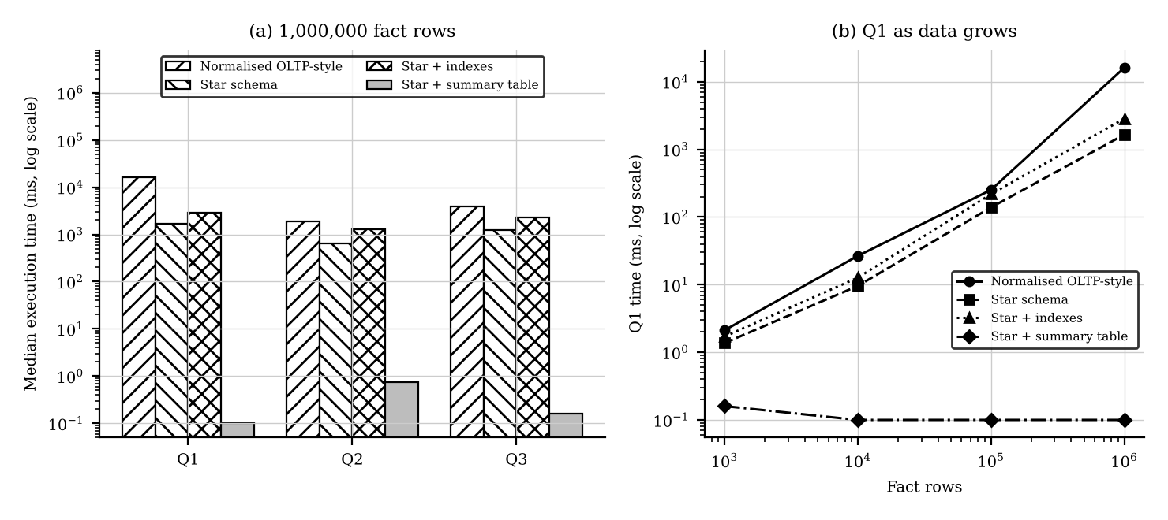
Figure 8.1 (a) Query times at 1,000,000 rows and (b) growth of Q1 time with data size (log scales)

8.3 Rows read, joins and query plan (1,000,000 rows)
Query | Design | Joins | Rows read | Query plan (abridged EXPLAIN QUERY PLAN)
Q1 | (i) OLTP-style | 8 | 1,000,000 | Scan of region table, then index look-ups through states, cities, stores, orders, order lines, products, categories, departments; temporary B-tree for GROUP BY
Q1 | (ii) Star | 3 | 1,000,000 | One full scan of FactSales; primary-key look-ups in DimDate, DimProduct, DimStore; temporary B-tree for GROUP BY
Q1 | (iii-a) Star + indexes | 3 | 1,000,000 (via index) | Planner scans DimProduct and probes FactSales through index ix_fs_prod (one probe per product)
Q1 | (iii-b) Star + summary | 0 | 144 | Scan of AggQtrDeptRegion (144 rows)
Q2 | (i) OLTP-style | 2 | 1,000,000 | Scan of stores; index on Orders.StoreID; index on OrderLines.OrderID
Q2 | (ii) Star | 1 | 1,000,000 | One full scan of FactSales; look-up in DimDate; temporary B-tree for GROUP BY
Q2 | (iii-a) Star + indexes | 1 | 1,000,000 (via index) | Full scan of index ix_fs_store with row look-ups in FactSales, then DimDate look-up
Q2 | (iii-b) Star + summary | 0 | 2,880 | Scan of AggStoreMonth (2,880 rows)
Q3 | (i) OLTP-style | 5 | 1,000,000 + 40,000 | Scan of categories; index look-ups to products, order lines, orders, customers; LEFT JOIN Returns by index
Q3 | (ii) Star | 5 | 1,000,000 + 40,000 | Two grouped sub-queries (full scan of FactSales and of FactReturns) joined on segment and category
Q3 | (iii-a) Star + indexes | 5 | 1,000,000 + 40,000 (via index) | Customer-driven index probes on ix_fs_cust and ix_fr_prod instead of sequential scans
Q3 | (iii-b) Star + summary | 1 | 240 | Scan of two summary tables (120 + 120 rows) joined on segment and category

Rows read are taken from the plans: a full scan of the fact table reads every fact row, whereas a summary table reads only its own rows. Plans for the smaller sizes are the same apart from table statistics.

8.4 Cost of the additional structures
Table 8.2 Storage and build time
Rows | Star load (s) | Index build (s) | Index size (MB) | Summary build (s) | Summary size (KB)
1,000 | 0.014 | 0.006 | 0.07 | 0.007 | 33
10,000 | 0.021 | 0.021 | 0.44 | 0.039 | 70
100,000 | 0.158 | 0.151 | 4.49 | 0.397 | 90
1,000,000 | 2.650 | 2.140 | 45.82 | 4.676 | 90

8.5 Interpretation
- Star against normalised: at 1,000,000 rows the star schema is 9.8 times faster for Q1 (8 joins reduced to 3), 3.0 times for Q2 and 3.1 times for Q3. The gain comes from fewer joins and from denormalised hierarchy attributes that need no lookups through brand, city or state tables. At 1,000 rows the difference is within about 1 ms, so the design matters only as data grows.
- Indexes did not help these queries: Q1 took 2,850 ms with indexes against 1,651 ms without. These queries aggregate every fact row, so a sequential scan is cheapest; once indexes exist the planner switches to one index probe per row, which costs more. The indexes also occupy 45.8 MB (about the size of the fact table itself, 45.0 MB), take 2.1 s to build and must be updated on every insert. Indexes pay off for selective filters, which these dashboard queries do not use.
- Summary tables: answers came back in 0.10 to 0.74 ms, about 16,511 times faster than the star query for Q1, and their time stays flat as rows grow because they read 144 to 2,880 rows regardless of fact size. Their cost is a 4.7 s full rebuild, extra ETL work and the risk of showing stale numbers until refreshed (handled in Task 11 with incremental refresh).
- Limits of the evidence: SQLite on a single core; absolute times will differ on PostgreSQL or a larger server, but the ratios and the shape of the curves are what support the design decision.

TASK 9 – Build a KNIME Reporting Workflow (3 Marks)
The workflow reads warehouse data (CSV export or database), cleans it, aggregates it and writes a management report. Nodes and their purpose are shown below, with the ETL or OLAP concept each one implements.
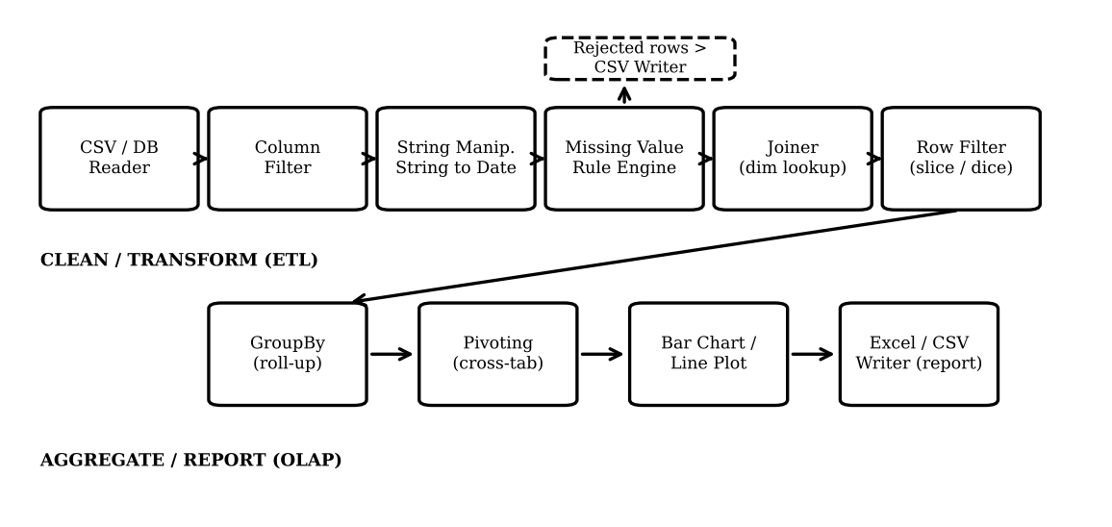
Figure 9.1 KNIME workflow (schematic of the node chain)
KNIME node | Purpose in the workflow | ETL / OLAP concept (Tasks 5 and 6)
CSV Reader / DB Reader | Reads FactSales and dimension data | Extract
Column Filter | Keeps only needed columns | Transform: projection
String Manipulation, String to Date&Time | Standardises text, case and dates | Cleanse and standardise (Task 5 rules)
Missing Value, Rule Engine | Handles permitted NULLs; flags invalid quantity or missing keys | Validation; unknown member handling
Row Filter (rejects) | Routes invalid rows to a reject CSV | Reject table and audit
Joiner | Joins facts to dimensions | Surrogate-key / dimension lookup
Row Filter (selection) | Selects year, state or category | Slice and dice
GroupBy | Sums net sales by month, category, state | Roll-up to a chosen cuboid
Pivoting | Department-by-state cross-tab | Pivot
Bar Chart, Line Plot | Management visuals | Reporting
Excel Writer / CSV Writer | Exports the report | Publish

Limitation at 1,000,000+ rows: a desktop KNIME workflow holds each node’s table in memory (spilling to disk when memory is short), so joins and GroupBy on the full fact table become slow and RAM-hungry, and every refresh repeats the whole chain. The remedy is to push joins and aggregation into the database with database nodes, filter early, drop unused columns, and read summary tables for reports, as Task 8 shows. The annotated screenshot and the exported report from the actual KNIME run are attached as evidence.

TASK 10 – Recommend and Defend the Final Design (3 Marks)
Recommendation: an enterprise data warehouse with dependent marts, a sales star schema with a separate FactReturns table and conformed Date, Product, Store, Customer and Promotion dimensions, SCD Type 2 for customer address and tier, a staged ETL with audit logging and hourly incremental loads, and a small set of summary tables behind the dashboards.
Table 10.1 Evidence supporting the choice
Decision | Evidence from my own design and experiments
Star rather than snowflake (Task 4) | Snowflake saves 2.65 MiB (about 2% of the 45 MB fact table) but raises joins from 2 to 8 for the department/region query; the 8-join normalised form was 9.8 times slower than the 3-join star at 1,000,000 rows.
Star rather than normalised (Task 8) | Star was 3.0 to 9.8 times faster across Q1–Q3 with identical results.
Summary tables, not blanket indexes (Task 8) | Summaries answered in 0.10–0.74 ms; indexes slowed the aggregate queries and cost 45.8 MB.
Enterprise warehouse with dependent marts (Task 2) | One definition of Net Sales; Task 7 reconciliation shows zero difference between source, fact table and cube totals.

Trade-offs and limitations: extra storage for the warehouse and summaries; ETL complexity (SCD Type 2, key lookup, audit); data latency of up to one hour; summary tables must be rebuilt or incrementally refreshed (4.7 s for a full rebuild at 1,000,000 rows). The experiments are single-node SQLite results.
Practical beyond 1,000,000 rows: yes, if dashboards read summary tables and loads are incremental. Star query time grew almost linearly with data (Q1: 1.37 ms at 1,000 rows to 1,651 ms at 1,000,000), while the summary time stayed flat. Beyond about 100 million lines, partition FactSales by month, apply a retention policy and consider a columnar or distributed DBMS.

TASK 11 – Day-4 Design Challenge: Re-evaluate and Adapt the Design (8 Marks)
Decision in one line: retain the star-schema core and the enterprise architecture, modify the dimensions, ETL and aggregates. This is controlled evolution, not a redesign.

A. Impact analysis (2 Marks)
Assumption: an online order has about 3 lines, as in the synthetic data, so 20,000 orders per day are about 60,000 lines per day, 21.9 million lines per year (20,000 × 365 × 3), and on average 833 orders (about 2,500 lines) per hour. A peak hour is assumed to be three times the average (about 7,500 lines).
Component | Change type | Affected? | What changes
FactSales grain and measures | Structure | No | Still one product line of one order; measures unchanged.
FactSales keys | Structure | Yes | Add ChannelKey and DeliveryPartnerKey (key 0 for store sales).
DimChannel, DimDeliveryPartner | Structure | New | Two new small dimensions; delivery partner is descriptive and may be analysed over time.
DimCustomer | Structure / load | Modified | Type 2 columns already exist; EffectiveFrom/To become timestamps because a customer may change twice in a day; lookup uses the order timestamp.
DimProduct / product codes | Structure / load | Modified | New ProductCodeCrosswalk (SourceSystem, SourceProductCode → ProductKey); ETL lookup changes.
DimDate, DimStore, DimPromotion | — | No | Online orders use an ‘Online’ store member; the rest is unchanged.
ETL | Load process | Yes | Second source adapter, hourly micro-batch instead of a daily batch, idempotent incremental load.
Cube and aggregates | Structure / performance | Yes | Two new no-hierarchy dimensions double the lattice twice: 160 → 320 → 640 cuboids, so materialisation must stay selective; summaries refresh each hour.
Architecture | — | Mostly no | Enterprise warehouse with dependent marts is kept; staging gains a source; OLAP refresh becomes hourly.

B. Evaluation of the original design (2 Marks)
I simulated the new load on the 1,000,000-row warehouse of Task 8 (with its four fact-table indexes in place): an average hour (2,500 lines) and a peak hour (7,500 lines) were inserted into FactSales, then the quarter × department × region summary was refreshed in two ways, by full rebuild and by applying only the new batch.
Table 11.1 Simulated hourly batch on 1,000,000 existing rows (median of 3 runs)
Batch | Lines | Fact insert (ms) | Full summary rebuild (ms) | Incremental refresh (ms)
Average hour (833 orders) | 2,500 | 118.4 | 2,623 | 4.0
Peak hour (3× average) | 7,500 | 192.5 | 2,857 | 10.4

Table 11.2 Where the original design is adequate and where it fails
Requirement | Test or calculation | Verdict
Volume of fact rows | Inserting a peak hour takes 193 ms into a 1,000,000-row fact table; the star grain absorbs 21.9 million extra lines per year. | Adequate
Hourly dashboards from a daily batch | A daily batch leaves data up to 24 hours old against a 1-hour requirement. | Fails
Summary refresh by full rebuild | Takes 2.6 s at 1,000,000 rows and grows linearly: about 57 s per summary after one year of online data, repeated for each summary every hour. | Adequate now, fails to scale
Dashboard queries on the base star | Q1 takes 1.65 s at 1,000,000 rows; at 21.9 million lines about 36 s (linear estimate). | Fails unless aggregates are used
Dashboard queries on summaries | Under 1 ms at every size (Task 8). | Adequate
Product codes | A new code format would not match DimProduct codes, so every online line would fall to Unknown Product key 0. | Fails without a crosswalk
Customer history | Type 2 design already preserves address and tier at order time; lookup by date only is ambiguous for two changes in one day. | Adequate, with a timestamp change

C. Adaptation / revised design (2 Marks)
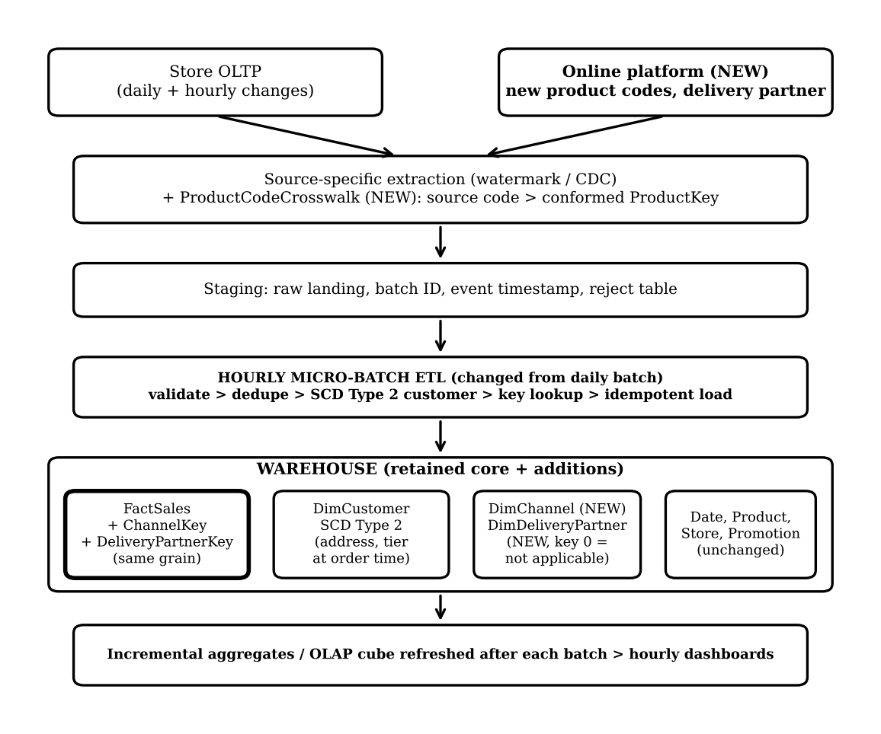
Figure 11.1 Revised design
CREATE TABLE DimChannel (ChannelKey INT PRIMARY KEY, ChannelName VARCHAR(30)); -- 0 = unknown
CREATE TABLE DimDeliveryPartner (DeliveryPartnerKey INT PRIMARY KEY, PartnerCode VARCHAR(30),
PartnerName VARCHAR(80)); -- 0 = not applicable
CREATE TABLE ProductCodeCrosswalk (SourceSystem VARCHAR(20), SourceProductCode VARCHAR(40),
ProductKey INT NOT NULL REFERENCES DimProduct(ProductKey), EffectiveFrom DATE, EffectiveTo DATE,
PRIMARY KEY (SourceSystem, SourceProductCode, EffectiveFrom));
ALTER TABLE FactSales ADD COLUMN ChannelKey INT NOT NULL DEFAULT 0 REFERENCES DimChannel(ChannelKey);
ALTER TABLE FactSales ADD COLUMN DeliveryPartnerKey INT NOT NULL DEFAULT 0 REFERENCES DimDeliveryPartner(DeliveryPartnerKey);

-- customer version valid at the order timestamp (Type 2 as-of lookup)
SELECT c.CustomerKey FROM DimCustomer c
WHERE c.CustomerID = :cust AND :order_ts >= c.EffectiveFrom AND :order_ts < c.EffectiveTo;

-- incremental aggregate refresh: apply only the new batch
UPDATE AggQtrDeptRegion a SET NetSales = a.NetSales + d.n
FROM (SELECT YearNo y, QuarterNo q, Department dep, Region r, SUM(NetSalesAmount) n
FROM NewBatchJoinedToDims GROUP BY 1,2,3,4) d
WHERE a.YearNo=d.y AND a.QuarterNo=d.q AND a.Department=d.dep AND a.Region=d.r;

- Micro-batch ETL: every hour extract rows after the stored watermark (or CDC position), land them in staging with a batch ID, de-duplicate on (SourceSystem, SourceOrderLineID), apply customer SCD Type 2, resolve keys through the product crosswalk, insert facts idempotently (a failed batch can be re-run safely), and refresh only the affected aggregate cells.
- Delivery partner: kept as its own dimension because the business wants to compare partners; store sales carry key 0.
- Cube: Channel and Delivery Partner added as dimensions, with only the small, high-use cuboids materialised (the same selection rule as Task 6).

D. Evidence-based defence and monitoring (2 Marks)
Table 11.3 Measured evidence for the revised design
Measurement | Result
Load of an average / peak hourly batch into the fact table | 118 ms / 193 ms, against a 3,600,000 ms hourly window.
Summary refresh: incremental against full rebuild | 4.0 ms against 2,623 ms (about 656 times faster) for an average hour; 10.4 ms against 2,857 ms at peak.
Dashboard query on summary tables | Under 1 ms at 1,000,000 rows (Task 8), independent of fact size.
Storage growth | FactSales used 45.0 MB and its four indexes 45.8 MB per 1,000,000 rows; one year of online data (21.9 million lines) adds about 2.0 GB.
Correctness | Summary totals reconcile with the fact table to 0.00 difference at every size (Task 7).

The measured pipeline steps (batch insert plus incremental refresh) take well under one second against a one-hour window, so the hourly requirement is met with wide margin. Extraction and transformation time from the real online platform were not measured here and must be added during the pilot load test.
Table 11.4 What to monitor after deployment
Metric | Reason and alert threshold
Source-to-dashboard latency | Alert if the newest loaded order is older than 60 minutes.
Rows extracted, loaded and rejected | Alert on any gap (extracted ≠ loaded + rejected) or on a reject rate far above its normal level.
Share of facts on Unknown keys (product, customer, store) | Alert above 1% or on a rising trend: indicates crosswalk or late-arriving-dimension problems.
Customer SCD Type 2 versions created per day | A sudden jump signals faulty source updates; check against the usual rate.
Batch duration and aggregate refresh time | Alert if the pipeline uses more than half of the hourly window (30 minutes).
Dashboard query latency and database load | Add or tune summaries, partitions or indexes when the response target (for example 3 seconds) is missed.
Reconciliation difference | Any unexplained difference between source and warehouse totals is investigated the same day.
Fact table growth | Track against the 2 GB per year estimate to plan partitioning and retention.

Conclusion: keep the enterprise warehouse and star-schema core; add the channel and delivery-partner dimensions and the product crosswalk, keep Type 2 customer history with timestamps, move to hourly micro-batch loading and refresh aggregates incrementally. The measurements show the original grain scales to the new volume, while the daily batch, the full-rebuild aggregates and the product-code mapping are the parts that had to change.

References / Implementation Notes
The assignment brief defines the FreshCart scenario and tasks. All measured figures in Tasks 7, 8, 10 and 11 come from the supplied scripts (Python 3, SQLite 3.45, pandas, fixed seed 42) run on a single-core virtual machine; rerun them on the lab machine to reproduce or compare, and note that absolute times depend on the hardware and DBMS. SQL is written in a generally portable style; identity columns, BOOLEAN and execution-plan commands differ by DBMS. Suggested open-source tools: PostgreSQL or SQLite for the database, Python with pandas for the OLAP application, KNIME Analytics Platform for the workflow, and Metabase, Apache Superset or Pentaho for dashboards.

