**Adult Census Income Prediction**

Wireframe Documentation

**This is the home page of the project 🡪 url for this page:-“localhost:5000”**



Here we need to give some numerical and categorical inputs:- url for this page:- “localhost:5000/predict”

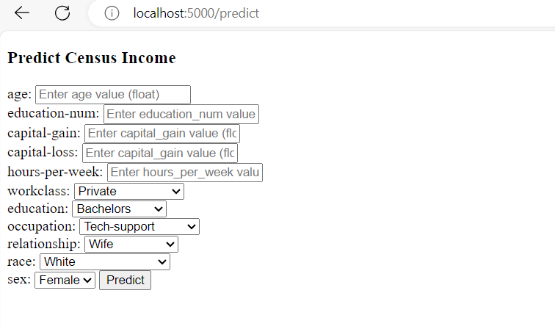

This page show the Result of the prediction:- “tab to predict button”

