ASSIGNMENT NO:- 01

**PROGRAM:**

**#include<stdio.h>**

**int sum(int a,int b){ return a+b;**

**}**

**int main(){ int a,b;**

**printf("Enter the value of num 1: "); scanf("%d",&a);**

**printf("Enter the value of num 2: "); scanf("%d",&b);**

**printf("The sum of the given 2 numbers is : %d",sum(a,b));**

**}**

**Output:**

**i)**

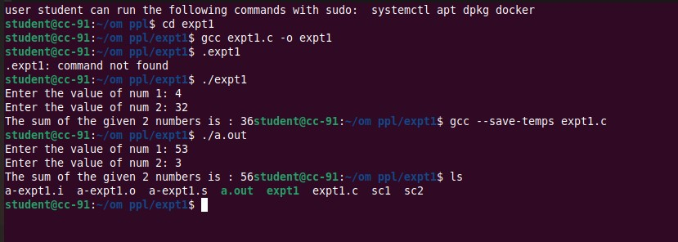

**ii)ppl2.s**

.file "ppl2.c"

.text

.globl function

.type function, @function

function:

.LFB0:

.cfi_startproc

endbr64

pushq %rbp

.cfi_def_cfa_offset 16

.cfi_offset 6, -16

movq %rsp, %rbp

.cfi_def_cfa_register 6

subq $32, %rsp

movq %fs:40, %rax

movq %rax, -8(%rbp)

xorl %eax, %eax

nop

movq -8(%rbp), %rax

subq %fs:40, %rax

je .L2

call __stack_chk_fail@PLT

.L2:

leave

.cfi_def_cfa 7, 8

ret

.cfi_endproc

.LFE0:

.size function, .-function

.globl main

.type main, @function

main:

.LFB1:

.cfi_startproc

endbr64

pushq %rbp

.cfi_def_cfa_offset 16

.cfi_offset 6, -16

movq %rsp, %rbp

.cfi_def_cfa_register 6

subq $16, %rsp

movl $1, -12(%rbp)

movl $5, -8(%rbp)

movl $6, -4(%rbp)

movl $0, %eax

call function

movl $0, %eax

leave

.cfi_def_cfa 7, 8

ret

.cfi_endproc

.LFE1:

.size main, .-main

.ident "GCC: (Ubuntu 11.4.0-1ubuntu1~22.04) 11.4.0"

.section .note.GNU-stack,"",@progbits

.section .note.gnu.property,"a"

.align 8

.long 1f - 0f

.long 4f - 1f

.long 5

0:

.string "GNU"

1:

.align 8

.long 0xc0000002

.long 3f - 2f

2:

.long 0x3

3:

.align 8

4:

**iv) ppl2.i:**

# 0 "ppl2.c"

# 0 "<built-in>"

# 0 "<command-line>"

# 1 "/usr/include/stdc-predef.h" 1 3 4

# 0 "<command-line>" 2

# 1 "ppl2.c"

void function()

{

char buff[5];

char buff1[16];

}

int main()

{

int a=1,b=5,c=6;

function();

return 0;

}

**iv) ppl2.o:**

GCC: (Ubuntu 11.4.0-1ubuntu1~22.04) 11.4.0 ppl2.c function __stack_chk_fail main .symtab .strtab .shstrtab .rela.text .data .bss .comment .note.GNU-stack .note.gnu.property .rela.eh_frame