Name – Deepak Shitole

Mis id – 642303019

Div - 2

Assignment 3

1.Each offering of a course (i.e. a section) can have many Teaching assistants; each teaching assistant is a student. Extend the existing schema(Add/Alter tables) to accommodate this requirement.

ANS-> ALTER TABLE TEACHING_ASSISTANT change COLUMN ID STUDENT_ID VARCHAR(20);

INSERT INTO TEACHING_ASSISTANT (student_id, course_id, sec_id, semester, year)

VALUES

('12345', 'CS-101', '1', 'Fall', 2009), -- Shankar as a TA for CS-101

('54321', 'CS-101', '1', 'Fall', 2009), -- Williams as a TA for CS-101

('76543', 'CS-347', '1', 'Fall', 2009), -- Brown as a TA for CS-347

('00128', 'CS-315', '1', 'Spring', 2010), -- Zhang as a TA for CS-315

('45678', 'CS-319', '1', 'Spring', 2010), -- Levy as a TA for CS-319

('19991', 'HIS-351', '1', 'Spring', 2010), -- Brandt as a TA for HIS-351

('44553', 'PHY-101', '1', 'Fall', 2009), -- Peltier as a TA for PHY-101

('54321', 'CS-319', '2', 'Spring', 2010), -- Williams as a TA for CS-319

('55739', 'MU-199', '1', 'Spring', 2010), -- Sanchez as a TA for MU-199

('23121', 'FIN-201', '1', 'Spring', 2010); -- Chavez as a TA for FIN-201

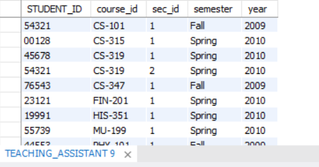

2. Alter the schema to allow a student to have multiple advisors and make sure that you are able to insert multiple advisors for a student

ANS-> FOLLOWING IS THE QUERY TO FIND THE CONSTRAINT NAME AND AND DROP THAT CONSTAIRNT FROM THE TABLE -

SELECT CONSTRAINT_NAME

FROM INFORMATION_SCHEMA.KEY_COLUMN_USAGE

WHERE TABLE_NAME = 'advisor' AND COLUMN_NAME = 's_ID';

->CONSTRAINT NAME=ADVISOR_IBFK_2

ALTER TABLE advisor DROP FOREIGN KEY ADVISOR_IBFK_2;

SELECT CONSTRAINT_NAME

FROM INFORMATION_SCHEMA.KEY_COLUMN_USAGE

WHERE TABLE_NAME = 'advisor' AND COLUMN_NAME = 'I_ID';

CONSTRAINT NAME-ADVISOR_IBFK_1

ALTER TABLE advisor DROP FOREIGN KEY ADVISOR_IBFK_1;

ALTER TABLE ADVISOR DROP PRIMARY KEY;

ALTER TABLE advisor

ADD CONSTRAINT pk_advisor PRIMARY KEY (s_ID, i_ID);

SELECT*FROM ADVISOR;

INSERT INTO ADVISOR value('44553','98345');

SELECT*FROM ADVISOR;

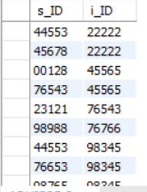

3.Find all students who have more than 3 advisors

-> SELECT S_ID,COUNT(I_ID) FROM ADVISOR GROUP BY S_ID HAVING(COUNT(I_ID)>3);

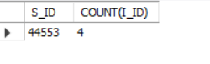

4.Find all students who are co-advised by Prof. Srinivas and Prof. Ashok.

-> SELECT*FROM ADVISOR WHERE I_ID='10101';

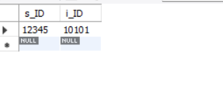

5.Find students advised by instructors from different departments. etc.

-> SELECT s.ID AS student_id

FROM advisor a

JOIN student s ON a.s_ID = s.ID

JOIN instructor i ON a.i_ID = i.ID

GROUP BY s.ID

HAVING COUNT(DISTINCT i.dept_name) = COUNT(i.ID);

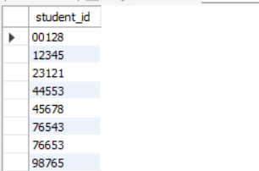

6. Delete all information in the database which is more than 10 years old. Add data as necessary to verify your query.

-> DELETE FROM SECTION WHERE YEAR<YEAR(curdate())-10;

DELETE FROM TEACHES WHERE YEAR<YEAR(curdate())-10;