**DBMS Assignment – 1**

**MIS – 642303019 DIV – 2 ; Batch – T5**

**Name – Deepak Zumbar Shitole**

1. **Write the following simple SQL Queries on the University Schema.**

Q) **Find the names of all the students whose total credits are greater than 100**

Ans) SELECT name FROM student WHERE tot_cred > 100;

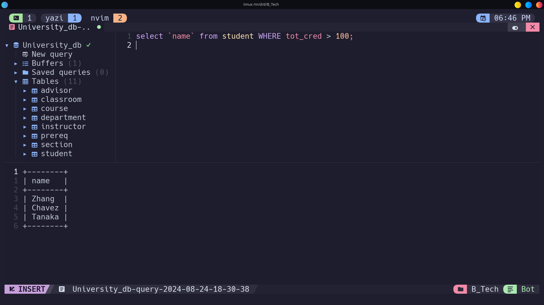

**Q) Find the course id and grades of all courses taken by any student named 'Tanaka'.**

Ans) SELECT t.course_id, t.grade FROM takes t JOIN student s ON t.ID = s.ID WHERE s.name = 'Tanaka';

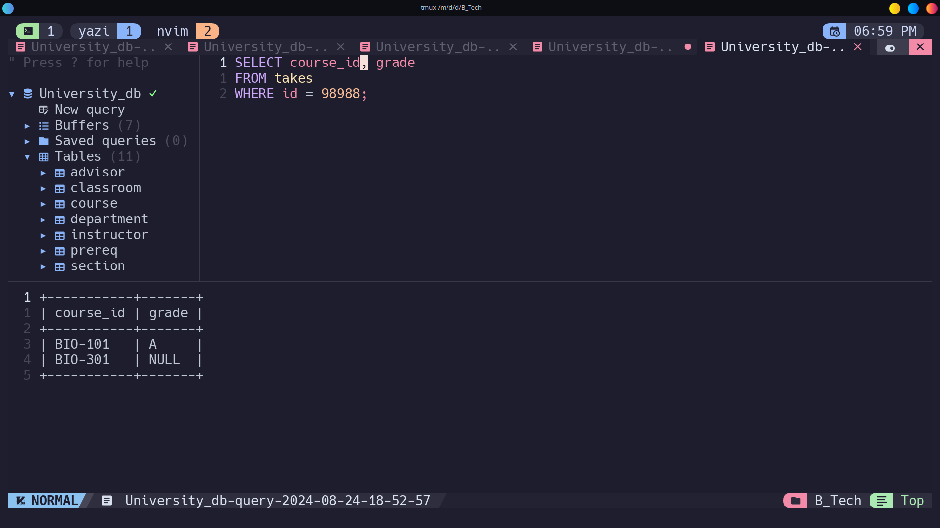

Q**) Find the courses which are offered in both 'Fall' and 'Spring' semester (not necessarily in the same year).**

Ans) SELECT DISTINCT s1.course_id FROM section s1

JOIN section s2 ON s1.course_id = s2.course_id

WHERE s1.semester = 'Fall'

AND s2.semester = 'Spring';

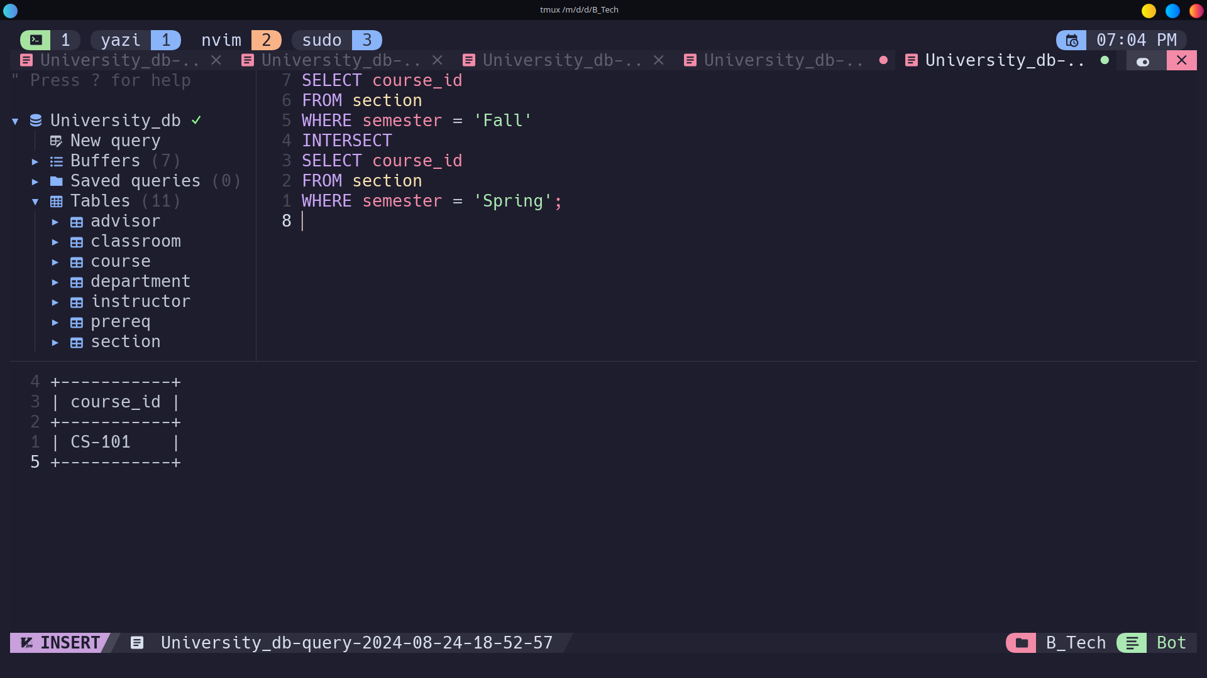

Q) **Find the names of all the instructors from Comp. Sci. department**.

Ans) SELECT name FROM instructor WHERE dept_name = 'Comp. Sci.';

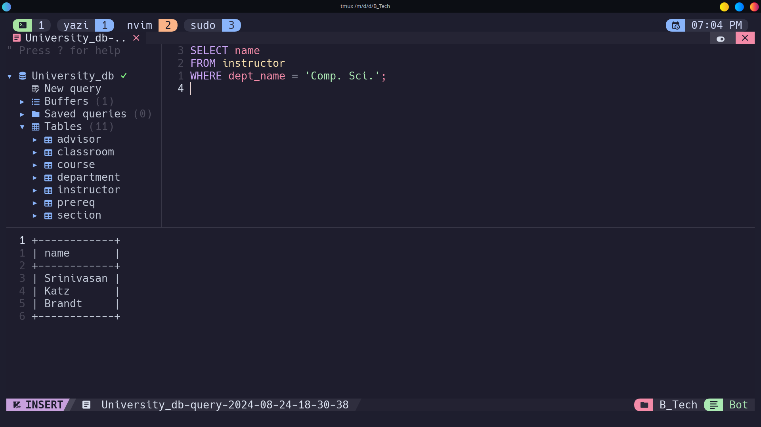

Q) **Find the course id and titles of all courses taught by an instructor named 'Srinivasan'**

Ans) SELECT c.course_id, c.title FROM course c

JOIN teaches t ON c.course_id = t.course_id

JOIN instructor i ON t.ID = i.ID

WHERE i.name = 'Srinivasan';

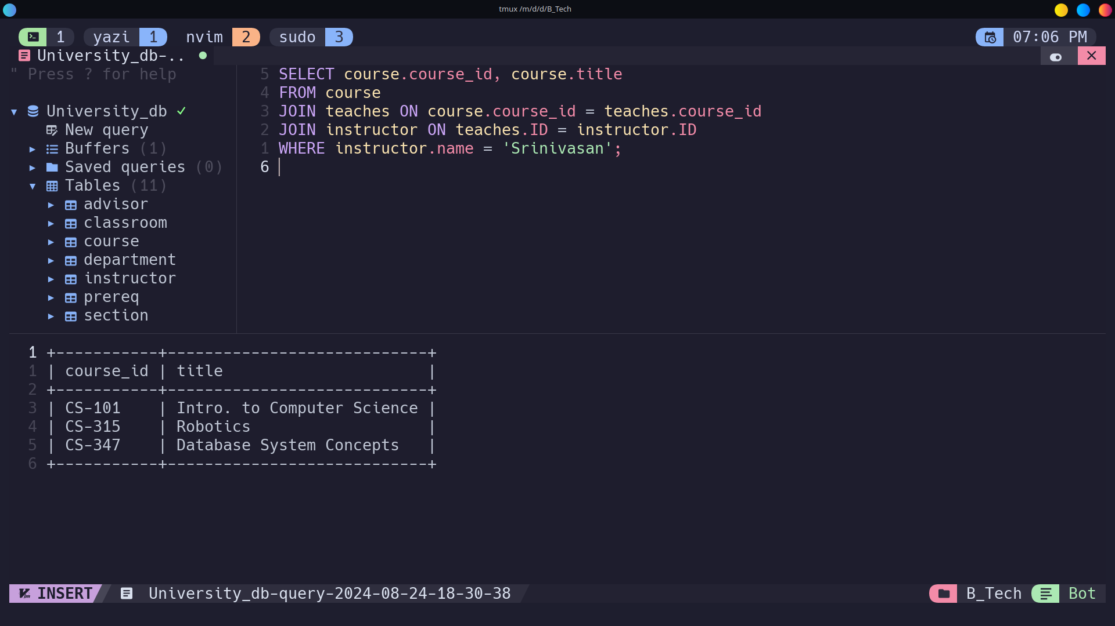

Q) **Find the names of instructors who have taught at least one course in Spring 2009.**

**Ans)** SELECT DISTINCT i.name FROM instructor i

JOIN teaches t ON i.ID = t.ID

WHERE t.semester = 'Spring' AND t.year = 2009;

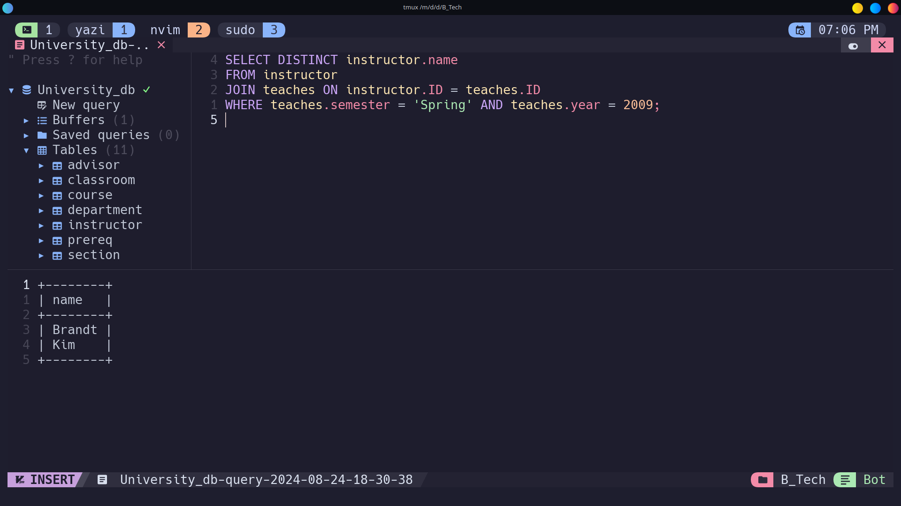

**RAILWAY SCHEMA**

**Q) Find pairs of stations (station codes) that have a track (direct connection) with distance less than 20Kms between them**

**Ans)** SELECT stcode1, stcode2 FROM track WHERE distance < 20**;**

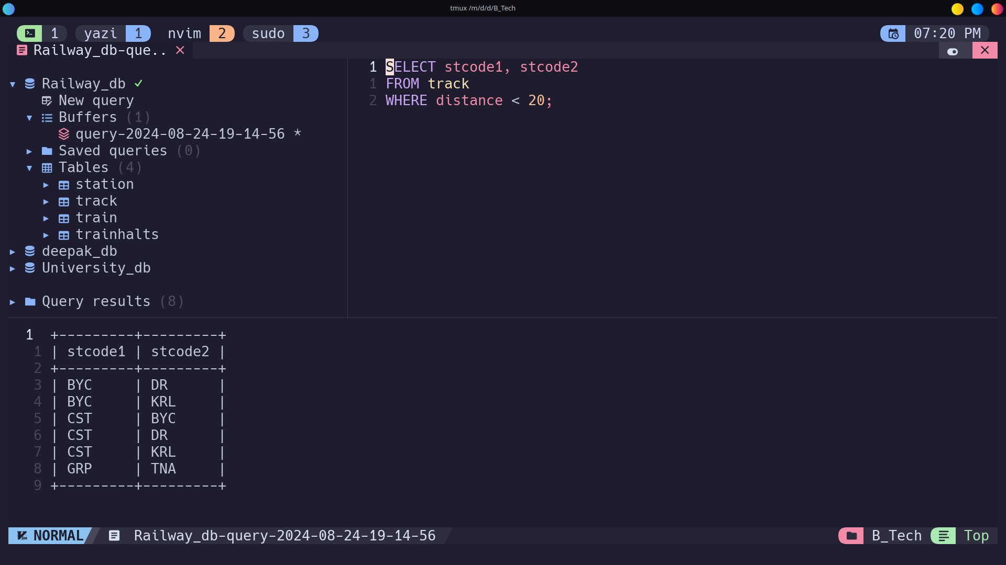

**Q) Find the IDs of all the trains which have a stop at THANE**

Ans) SELECT DISTINCT t.id FROM trainhalts t

JOIN station s ON t.stcode = s.stcode

WHERE s.name = 'THANE';

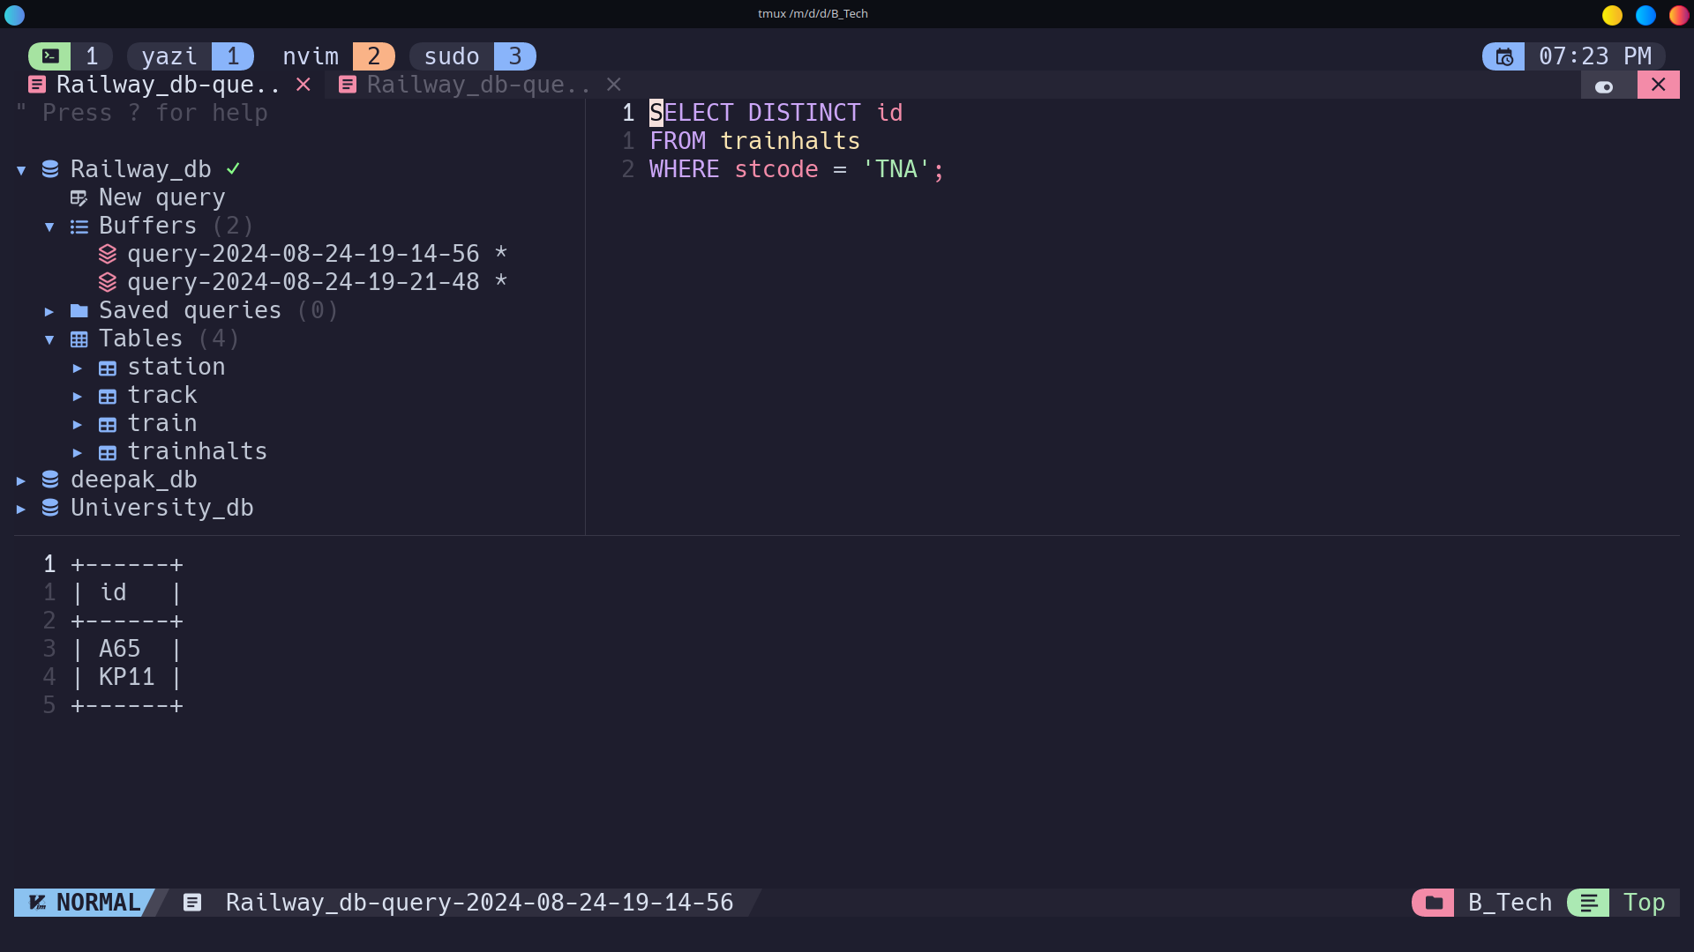

**Q) Find the names of all trains that start at MUMBAI.**

Ans) SELECT tr.name FROM trainhalts th

JOIN train tr ON th.id = tr.id

JOIN station st ON th.stcode = st.stcode

WHERE th.seqno = 0 AND st.name = 'MUMBAI';

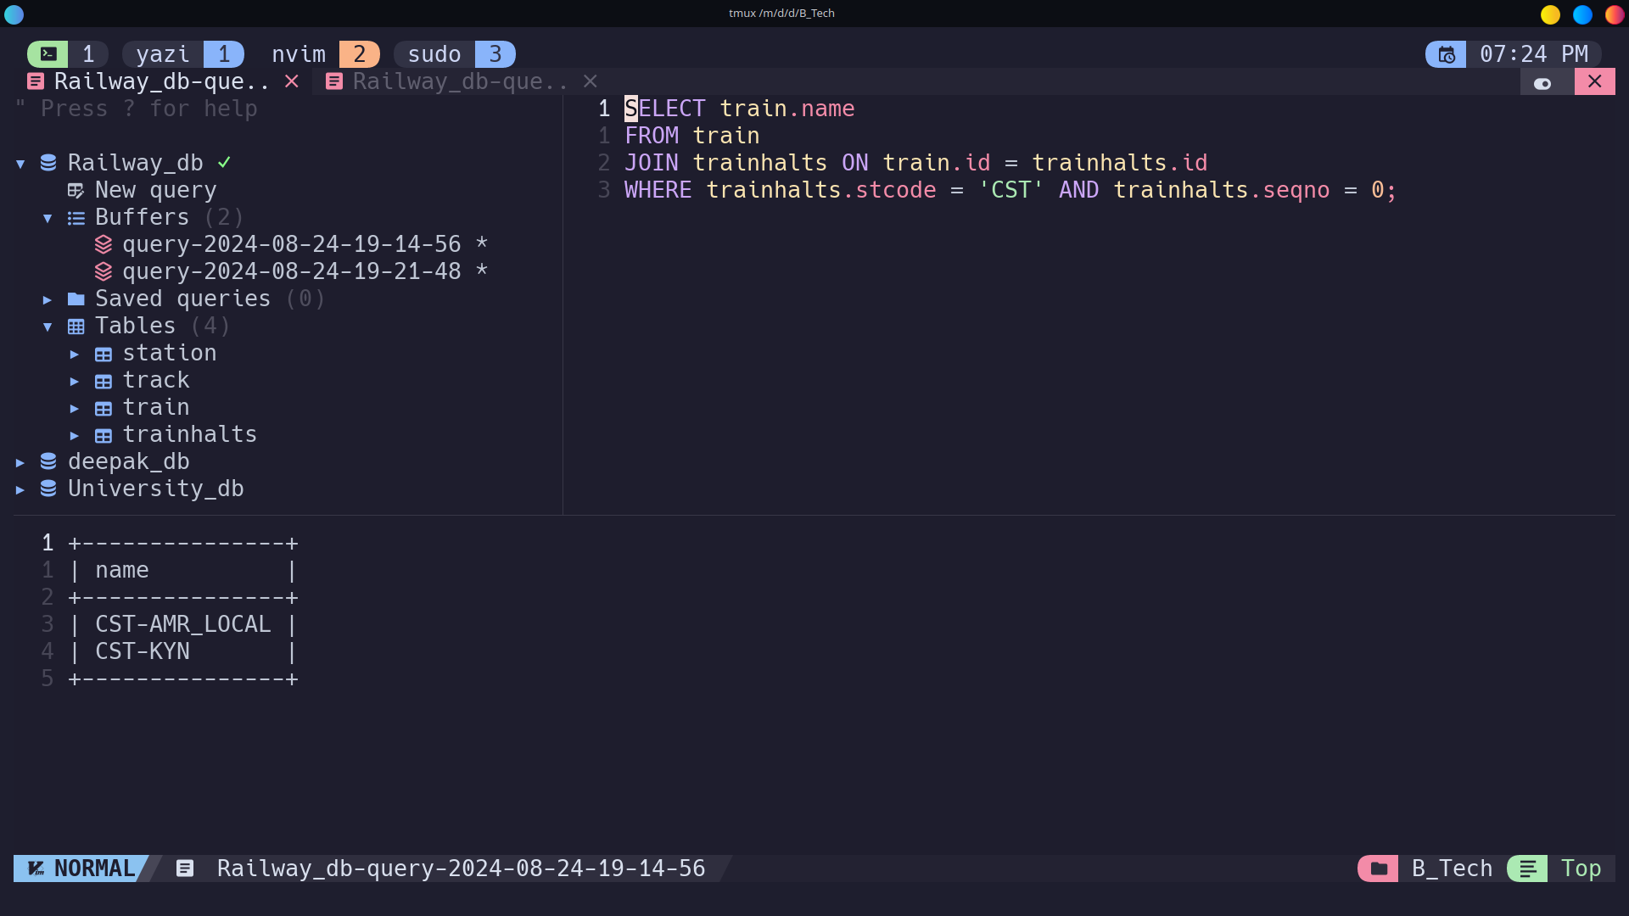

Q) **List all the stations in order of visit by the train 'CST-AMR_LOCAL'.**

Ans) SELECT st.name FROM trainhalts th

JOIN station st ON th.stcode = st.stcode

JOIN train tr ON th.id = tr.id

WHERE tr.name = 'CST-AMR_LOCAL' ORDER BY th.seqno;

