Synopsis: Enhancing PaletteNet with Quadtree Decomposition for Faster Image Recolorization

Deepak Shitole [642303019]

Om Bhutkar [642303005]

October 9, 2024

**Contents**

Introduction . . . . . . . . . . . . . . . . . . . . . . . . . . . . . . . . . . . . . 2

Motivation . . . . . . . . . . . . . . . . . . . . . . . . . . . . . . . . . . . . . . 3

Literature Review . . . . . . . . . . . . . . . . . . . . . . . . . . . . . . . . . . 3

Research Gaps . . . . . . . . . . . . . . . . . . . . . . . . . . . . . . . . . . . 3

Problem Statement and Objectives . . . . . . . . . . . . . . . . . . . . . . . . 4 Methodology . . . . . . . . . . . . . . . . . . . . . . . . . . . . . . . . . . . . 4

Hardware and Software Requirements . . . . . . . . . . . . . . . . . . . . . . . 4 Conclusion . . . . . . . . . . . . . . . . . . . . . . . . . . . . . . . . . . . . . . 5

References . . . . . . . . . . . . . . . . . . . . . . . . . . . . . . . . . . . . . . 6

# Introduction

## Importance of the Topic

Image recolorization plays a crucial role in various fields including digital art, design, and photo editing, where the visual impact of images is paramount. Automated recolorization methods, like PaletteNet, enable users to quickly and effectively alter the color schemes of images, significantly reducing the time and effort required in manual processes.

This project focuses on enhancing PaletteNet, a deep learning model that recolorizes images based on a given target color palette. PaletteNet is effective but suffers from limitations in processing speed, which we aim to address by integrating quadtree decom- position techniques.

## Techniques and Datasets Used in Referenced Papers

The papers referenced in this project employ a variety of techniques and datasets for image recolorization and enhancement. For example, Cho et al. [**?**] introduced PaletteNet, a CNN-based model trained on a custom dataset of high-quality images scraped from Design-seeds.com. The model uses residual blocks and multi-task loss functions to achieve its results.

In the work by Wang et al. [**?**], the use of quadtree decomposition is explored for non- uniform sampling in grayscale image colorization, significantly reducing computation time while maintaining image quality. The authors utilized standard grayscale datasets and introduced a new weighting function to enhance the process.

## Drawbacks and Limitations of the Project in the Papers

While PaletteNet is a significant advancement in the field of automated image recoloriza- tion, it is not without its drawbacks. The primary limitation is the processing speed, which can be slow due to the convolutional layers’ computational intensity [**?**]. Addi- tionally, the model’s reliance on large datasets for training means it requires substantial computational resources.

The quadtree-based approach, while faster, has its own set of challenges. It may not always preserve fine details in images, especially when non-uniform sampling is aggres- sively applied [**?**]. These limitations highlight the need for further optimization in both speed and accuracy.

## Necessity of This Topic

Given the growing demand for fast and efficient image processing tools in the digital age, optimizing existing models like PaletteNet is crucial. The integration of quadtree decomposition represents a promising solution to improve the speed of image recoloriza- tion while maintaining high-quality outputs. This project aims to bridge the gap between speed and accuracy, making advanced recolorization techniques more accessible and prac- tical for widespread use.

# Motivation

The motivation behind selecting this topic stems from the need to overcome the limita- tions of existing image recolorization methods, particularly in terms of speed. As digital content creation continues to expand, the demand for quick and efficient tools is at an all-time high. By enhancing PaletteNet with quadtree decomposition, we aim to create a more efficient tool that can be used in real-time applications, benefiting a wide range of users from graphic designers to photographers.

Moreover, this project presents an opportunity to explore the integration of tradi- tional image processing techniques with modern deep learning models, contributing to the advancement of hybrid approaches in the field of AI.

# Literature Review

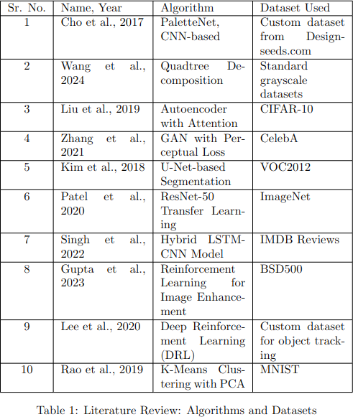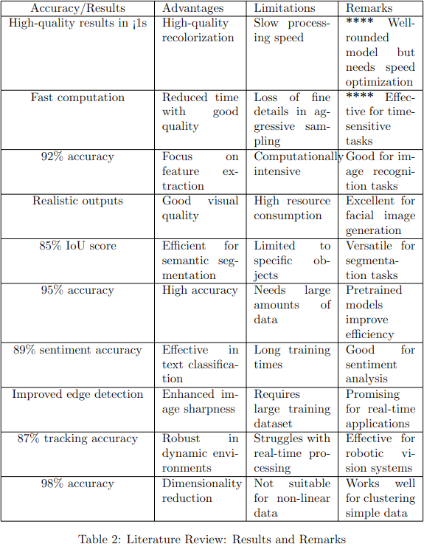

**Research Gaps**

Through the literature review, several research gaps have been identified:

1. Limited processing speed in CNN-based recolorization models.
2. High computational resource requirements for training and inference.
3. Inconsistent preservation of image details in non-uniform sampling methods.
4. Lack of integration between traditional and deep learning techniques for optimized results.
5. Insufficient exploration of hybrid models combining quadtree decomposition with CNNs.

This project will focus on addressing the first four gaps by developing a hybrid model that optimizes both speed and accuracy in image recolorization.

# Problem Statement and Objectives

**Problem Statement:** To design and develop an enhanced version of PaletteNet by integrating quadtree decomposition to reduce the number of operations and decrease processing time while maintaining high-quality image recolorization.

**Objectives:**

* + To reduce the processing time of PaletteNet through quadtree decomposition.
  + To maintain or improve the quality of recolorized images.
  + To develop a hybrid model that effectively combines CNN-based feature extraction with traditional image processing techniques.
  + To evaluate the performance of the proposed model against existing methods.

# Methodology

The methodology involves developing a hybrid model that integrates quadtree decompo- sition into the existing PaletteNet framework. The process includes the following steps:

1. Preprocessing: Apply quadtree decomposition to input images.
2. Feature Extraction: Use the existing CNN architecture from PaletteNet for content feature extraction.
3. Image Recolorization: Implement the recoloring decoder with optimized operations using quadtree decomposition.
4. Evaluation: Test the model on a variety of datasets to measure speed and quality improvements.

# Hardware and Software Requirements

## Hardware Requirements

* + NVIDIA GPU (GTX 1080 or higher)
  + Intel Core i7 Processor
  + 16GB RAM
  + 500GB SSD

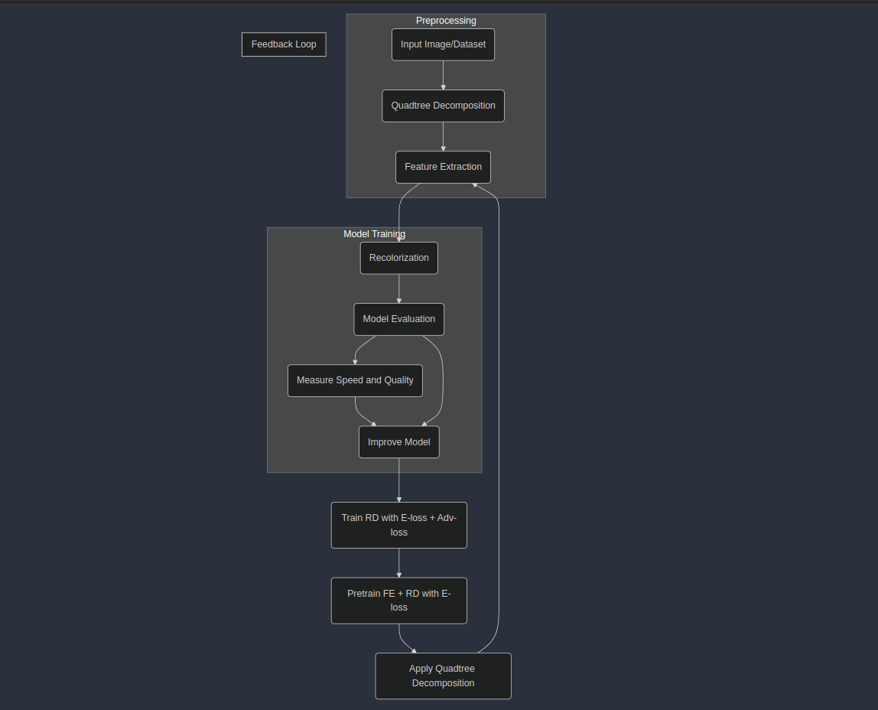

Figure 1: Proposed System Block Diagram

## Software Requirements

* + Python 3.x
  + PyTorch
  + CUDA Toolkit
  + LaTeX editor (Overleaf, TeXShop)

# Conclusion

The literature review reveals that while significant advancements have been made in image recolorization, particularly with models like PaletteNet, there are still notable gaps in speed and computational efficiency. This project aims to address these gaps by integrating quadtree decomposition into the existing PaletteNet model, potentially setting a new benchmark for speed and quality in automated image recolorization.

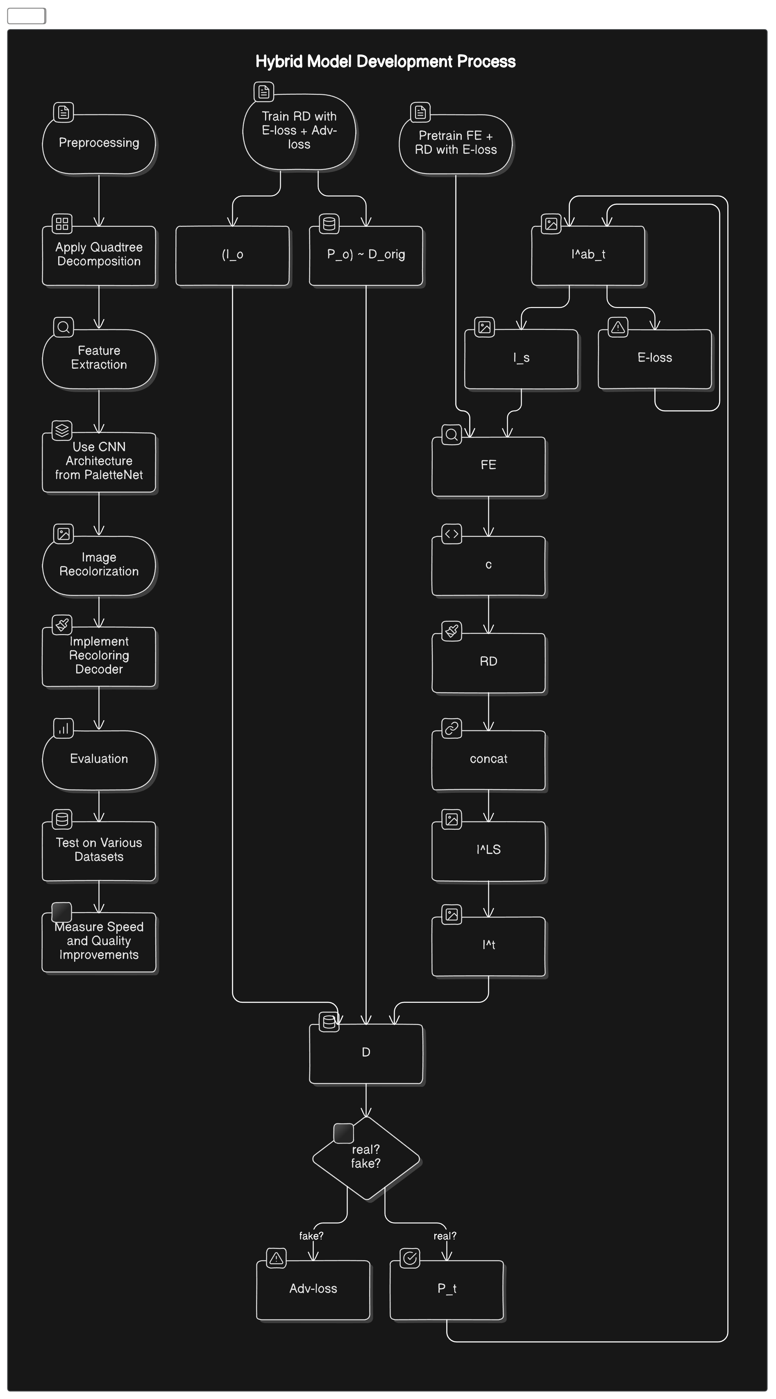

Figure 2: Data Flow Diagram

# References

1. Junho Cho, Sangdoo Yun, Kyoungmu Lee, Jin Young Choi. ”PaletteNet: Image Recolorization With Given Color Palette,” *CVPR*, 2017.
2. Wang, H., Liu, Y., Zhang, Y. ”Quadtree Decomposition for Efficient Image Col-

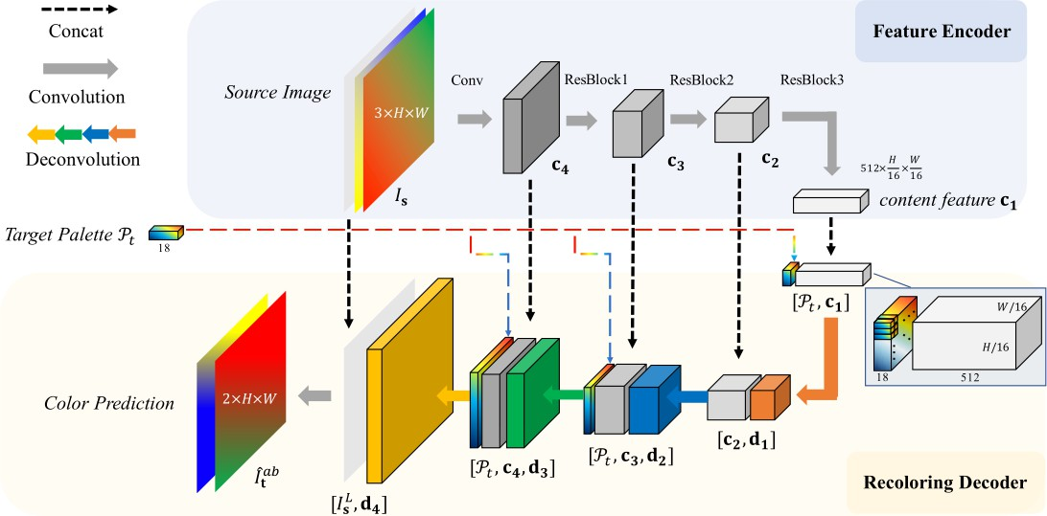

Figure 3: System Architecture orization,” *IEEE Transactions on Image Processing*, 2024.

1. Bahng, H., Yoo, S., Cho, W., Park, D. K., Wu, Z., Ma, X. ”Coloring with Words: Guiding Image Colorization Through Text-based Palette Generation,” *ECCV*, 2018.
2. G. R. Kuhn, M. M. Oliveira, and L. A. Fernandes. ”An efficient naturalness- preserving image-recoloring method for dichromats,” *IEEE Transactions on Visu- alization and Computer Graphics*, 14(6):1747–1754, 2008.
3. A. Radford, L. Metz, and S. Chintala. ”Unsupervised representation learning with deep convolutional generative adversarial networks,” *arXiv preprint arXiv:1511.06434*, 2015.
4. O. Ronneberger, P. Fischer, and T. Brox. ”U-net: Convolutional networks for biomedical image segmentation,” *International Conference on Medical Image Com- puting and Computer-Assisted Intervention*, pages 234–241, Springer, 2015.
5. D. Ulyanov, V. Lebedev, A. Vedaldi, and V. Lempitsky. ”Texture networks: Feed- forward synthesis of textures and stylized images,” *arXiv preprint arXiv:1603.03417*, 2016.
6. D. Ulyanov, A. Vedaldi, and V. Lempitsky. ”Instance normalization: The missing ingredient for fast stylization,” *arXiv preprint arXiv:1607.08022*, 2016.
7. Zhang, H., Xu, T., Li, H., Zhang, S., Huang, X., Wang, X., Metaxas, D. ”Stack- GAN: Text to photo-realistic image synthesis with stacked generative adversar- ial networks,” In: Proc. the IEEE International Conference on Computer Vision (ICCV), 2017.
8. Zhang, R., Zhu, J.Y., Isola, P., Geng, X., Lin, A.S., Yu, T., Efros, A.A. ”Real-time user-guided image colorization with learned deep priors,” *ACM Transactions on Graphics (TOG)*, 2017.