ASSIGNMENT 01

Q1). A) Use the stack abstract data type to solve the Parenthesis Matching Problem, where the input is the string containing parentheses ((, ), {, }, [, ]), and the goal is to determine if the parentheses are balanced.

CODE:

#include <iostream>

using namespace std;

class Stack {

private:

int top;

char arr[100];

public:

Stack() { top = -1; }

void push(char ch) {

if (top >= 99) {

cout << "Stack Overflow" << endl;

return;

}

arr[++top] = ch;

return;

}

void pop() {

if (top < 0) {

cout << "No Elements to pop" << endl;

return;

}

top--;

return;

}

char topelem() { return arr[top]; }

bool empty() {

if (top < 0) {

return true;

}

return false;

}

};

int main() {

string ins = "";

cin >> ins;

Stack s;

for (int i = 0; i < ins.length(); i++) {

if (ins[i] == '(' || ins[i] == '{' || ins[i] == '[') {

s.push(ins[i]);

} else if (ins[i] == ')' && !s.empty() && s.topelem() == '(') {

s.pop();

} else if (ins[i] == '}' && !s.empty() && s.topelem() == '{') {

s.pop();

} else if (ins[i] == ']' && !s.empty() && s.topelem() == '[') {

s.pop();

} else {

cout << "Not matching!" << endl;

return 0;

}

}

if (s.empty()) {

cout << "Matching!" << endl;

} else {

cout << "Not matching!" << endl;

}

return 0;

}

OUTPUT:

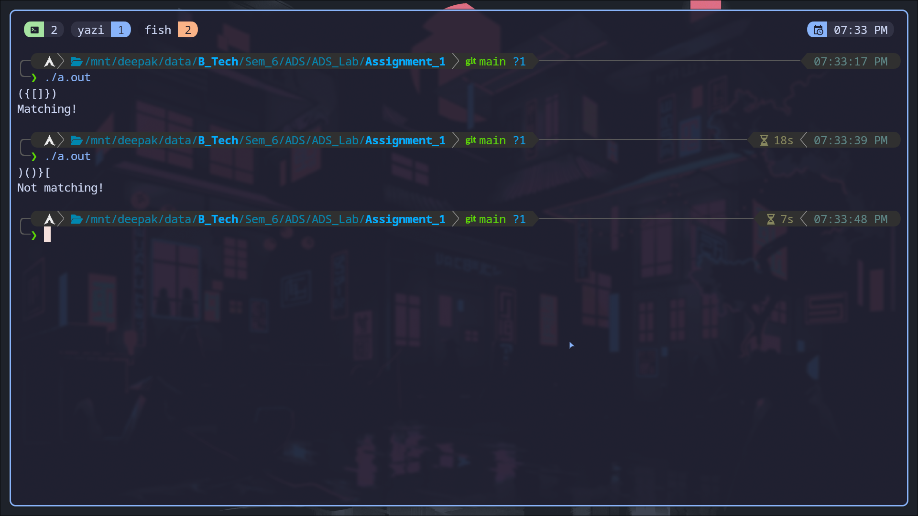

B) Name the data structure used to solve the Parenthesis Matching Problem.

Ans→ Stack Data Structure.

Q2). A) Design a ticket booking system where customers arrive to book tickets and join a queue. The system should process customers in a first-come, first-served (FIFO) manner. The queue must provide the following operations (options) to the user:

1. Add Customer -> Add a new customer to the booking queue.

2. Process Booking -> Process the ticket booking for the current customer in line and remove them from the queue after processing.

3. View Queue -> Display the current list of customers waiting in the queue.

The system should simulate real-life ticket booking, where customers are served in the order of arrival.

CODE:

#include <iostream>

#include <string>

#include <vector>

using namespace std;

class Queue {

private:

int front, rear;

vector<string> namearr;

public:

Queue() : front(-1), rear(-1) {}

void push(const string &name) {

if (front == -1) {

front = 0;

}

rear++;

if (rear < namearr.size()) {

namearr[rear] = name;

} else {

namearr.push_back(name);

}

cout << name << " added to the queue.\n";

}

void pop() {

if (empty()) {

cout << "Queue Underflow\n";

return;

}

front++;

if (front > rear) {

front = rear = -1;

}

}

string top() const {

if (empty()) {

return "Queue is empty!";

}

return namearr[front];

}

bool empty() const { return front == -1 || front > rear; }

void remove(const string &name) {

bool found = false;

vector<string> newQueue;

for (int i = front; i <= rear; ++i) {

if (namearr[i] == name && !found) {

found = true;

} else {

newQueue.push_back(namearr[i]);

}

}

if (found) {

cout << "Processed booking for: " << name << "\n";

} else {

cout << "Booking for " << name << " not found.\n";

}

namearr = newQueue;

front = newQueue.empty() ? -1 : 0;

rear = newQueue.size() - 1;

}

void display() const {

if (empty()) {

cout << "Queue is empty!\n";

return;

}

cout << "Current Queue: ";

for (int i = front; i <= rear; ++i) {

cout << namearr[i] << " ";

}

cout << "\n";

}

};

int main() {

Queue q;

int choice;

cout << "Welcome to Bus Booking!\n\n";

while (true) {

cout << "\n1. Add Customer\n2. Process Booking\n3. View Queue\nEnter your "

"Choice> ";

cin >> choice;

if (choice == 1) {

cout << "Enter Name: ";

string name;

cin >> name;

q.push(name);

} else if (choice == 2) {

cout << "Enter the name to remove: ";

string name;

cin >> name;

q.remove(name);

} else if (choice == 3) {

q.display();

} else {

cout << "Invalid choice! Try again.\n";

}

}

return 0;

}

OUTPUT:

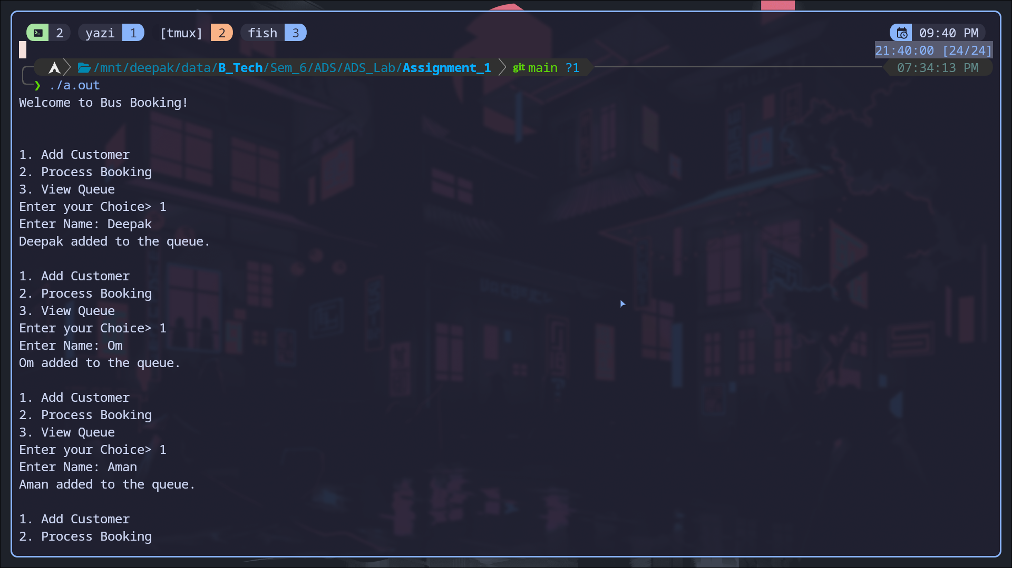

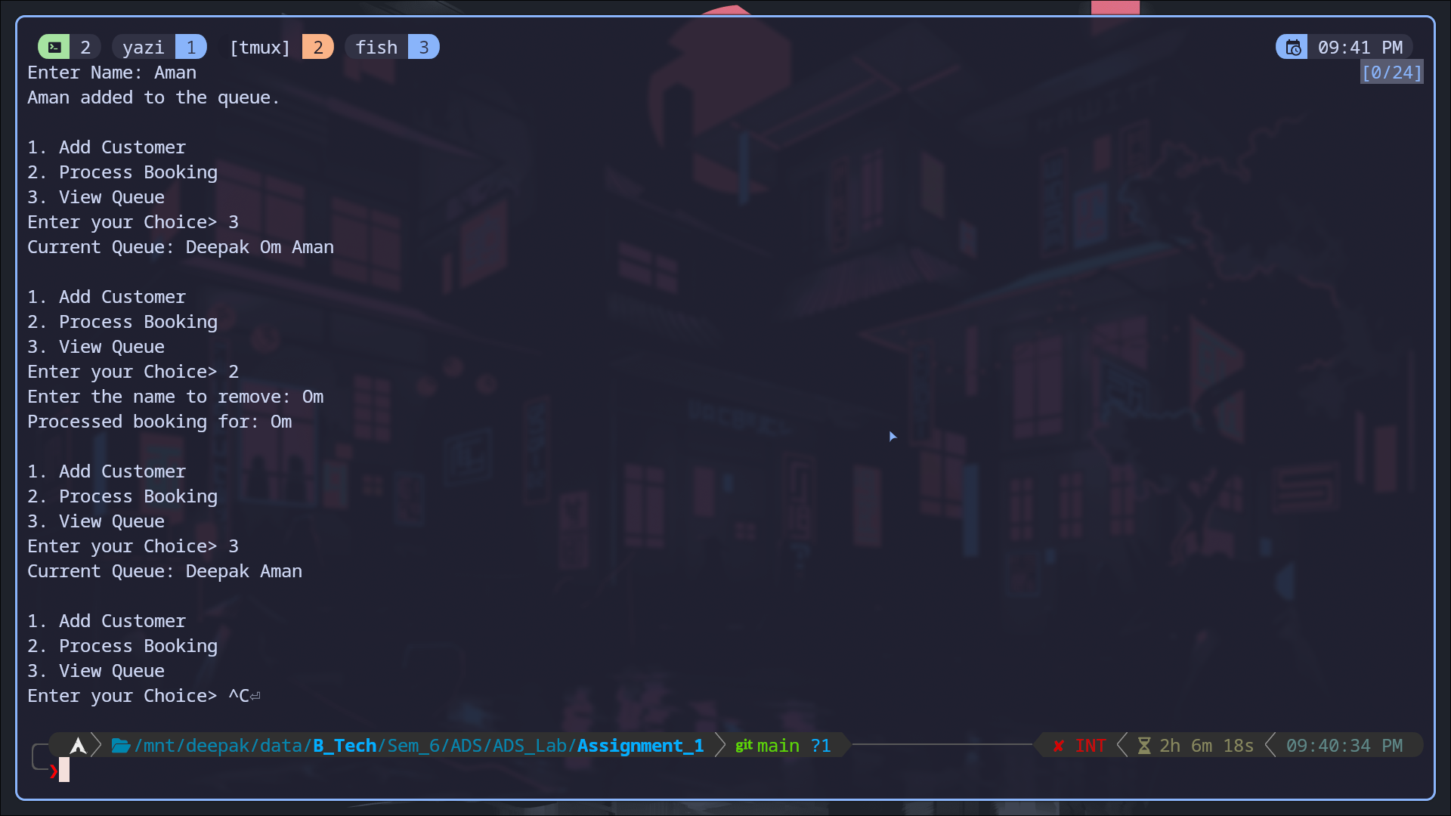

B) Name the data structure used for the ticket booking system.

Ans → Queue Data Structure.