•

•

•

•

DEEPAK KUMAR GUPTA

Software Associate/Capgemini

Hi, I’m Deepak.

Looking forward to an opportunity for working in a dynamic, challenging environment, where I can utilize my skills for developing my career and for the growth of the organization.

# PERSONAL INFORMATION

 +91 8529467751

 [deepakgupta50000@gmail.com](mailto:yourname@mail.com)

 https://[www.linkedin.com/in/deepak-](http://www.linkedin.com/in/deepak-) gupta-90b3681b8/

 Noida, UP

# EXPERTISE

Java

Business for client

C and C++ HTML, CSS, JS

# EDUCATION

High School ICSE

HOLY CROSS SCHOOL BALLIA

Class XII - CBSE

ST MICHAEL SCHOOL BALLIA

Graduation {BSc Physics, Math, Computer Science}

ALLAHABAD AGRICULTURE UNIVERSITY

# INTERNSHIPS/PROJECTS

## Capstone Project

HTML CSS JS Project Registration Page

Duration - 2 months

## Highlights -

1. Banking account openings
2. Increased sales and customer acquisition

# McDonalds US RFM

Duration – 6 months

## Highlights -

2017 pa

July 2017- May 2019

2022 June

April 2022

Jan 2022 - April 2022

Problem Solving

# LANGUAGES

Fluent in **English** + **Hindi**

Conversation in ***English***

# Hobbies

Reading Books Mathematics and Research

1. Provide service to clients, making the kiosks and devices of restaurants fine.
2. To determine the market financial condition and show the products on digital channels

**Learnt** – team work, self confidence

# AWARDS AND ACHIEVEMENTS

* + Secured silver medal at debate (National Science Day 28 Feb)
  + Academic Record Holder
  + Appeared NDA Air force Selection Board Gandhinagar
  + Fastest probation complete in Capgemini

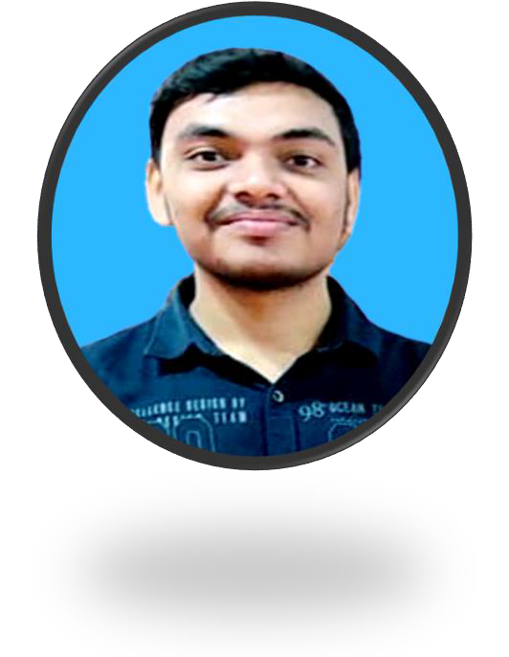

I hereby declare that the above information provided by me is true and have all the relevant documents to authenticate the same. **SIGNATURE: Deepak**