1.Version:

<!DOCTYPE html>

<html>

<head>

<title>Browser</title>

</head>

<body>

<script language="javascript" type="text/javascript">

document.write(navigator.userAgent);

</script>

</body>

</html>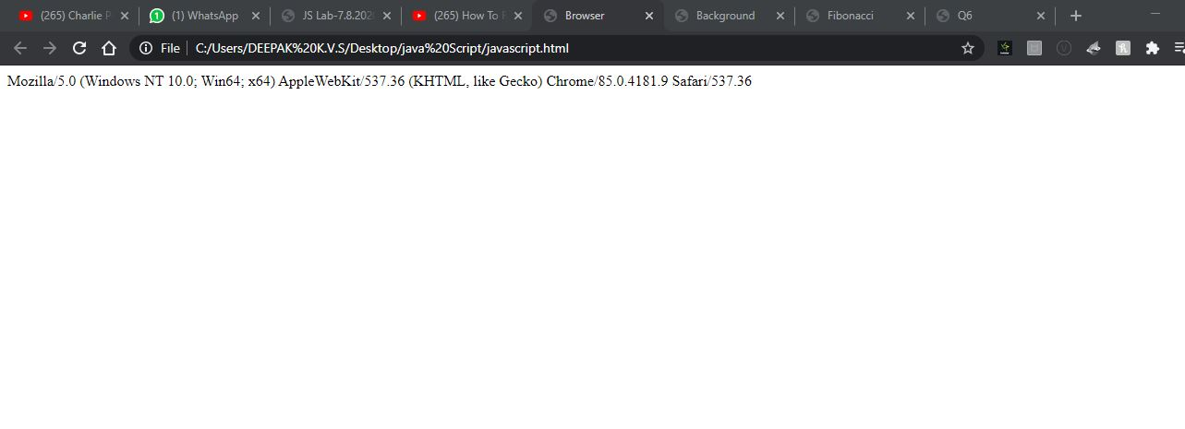

2. Background change:

<!DOCTYPE html>

<html>

<head>

<title>Background</title>

</head>

<body>

<script language="javascript" type="text/javascript">

function changecolour()

{

document.body.style.background="gray"

}

function oldcolour()

{

document.body.style.background="blue"

}

</script>

<a href="https://www.google.com/">

<img id="img1" onmouseover="changecolour()" onmouseout="oldcolour()" src="7.JPEG" width="300px">

</a>

</body>

</html>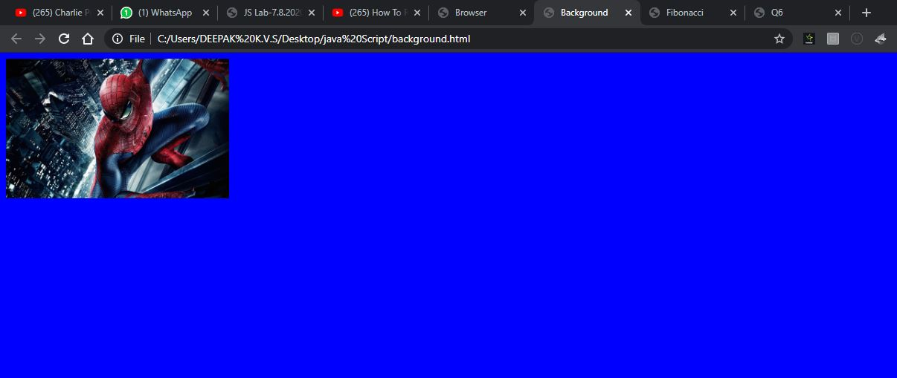

4.Fibanocii number:

<!DOCTYPE HTML>

<?xml version="1.0" encoding="UTF-8"?>

<html>

<head>

<title> Fibonacci</title>

</head>

<body >

<h3 style="text-align:center; black"> Program to generate the Fibonacci Series </h3>

<script type="text/javascript">

function fibonacci(num)

{

var num1=0;

var num2=1;

document.write("",num1," ");

document.write("",num2," ");

var sum;

var i=0;

for (i = 2; i < num; i++)

{

sum=num1+num2;

document.write("",sum," ");

num1=num2;

num2=sum;

}

return num2;

}

var num = prompt("Enter a number to generate the fibonacci series:", " ");

document.write("The number entered to generate the fibonacci series is: ",num, "<br/>");

document.write("The fibonacci series : ");

document.write("fibonacci(num): "+fibonacci(num)+"<br>");

</script>

</body>

</html>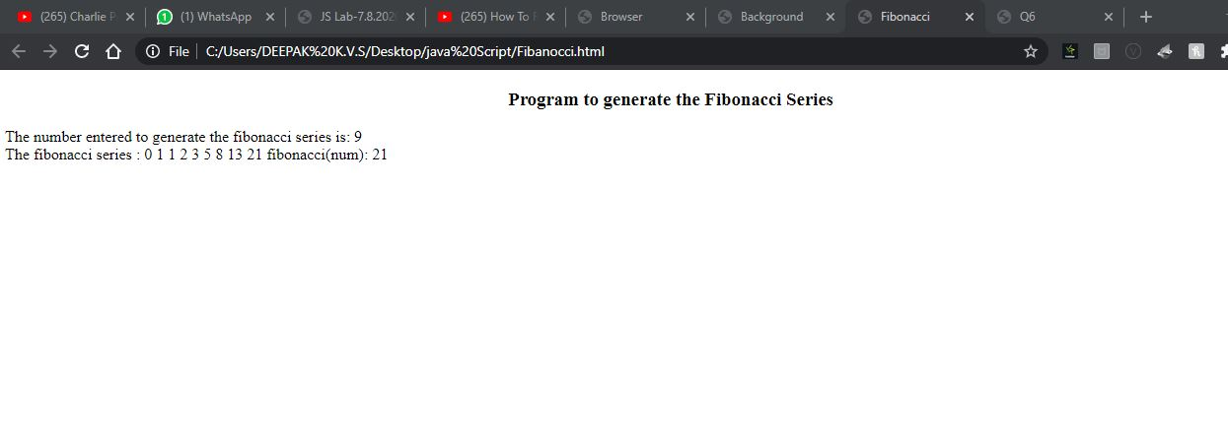

5.Sort:

<!DOCTYPE HTML>

<?xml version="1.0" encoding="UTF-8"?>

<html>

<head>

<title> Q5 </title>

</head>

<body style="background-color:white">

<script type="text/javascript">

function sort(names)

{

return names.sort();;

}

var names = prompt("Enter names").split(",")

document.write("sorted names are: "+sort(names)+"<br>");

</script>

</body>

</html>

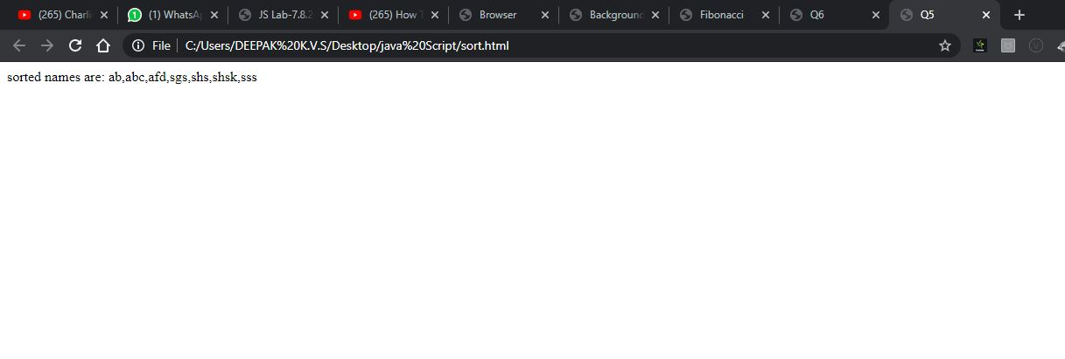6. Simple Intrest:

<html>

<head>

<title>Q6</title>

<script>

function calculate()

{

p = document.getElementById("p").value;

n = document.getElementById("n").value;

r = document.getElementById("r").value;

result = document.getElementById("result");

result.innerHTML = "The interest is " + (p\*n\*r/100);

}

</script>

</head>

<body>

<h3>Simple Interest Calculation</h3>

Amount: <input id="p"><br/>

Rate: <input id="r"><br/>

No. of Years: <input id="n"><br/>

<button onclick="calculate()">Calculate</button>

<p id="result"></p>

</body>

</html>

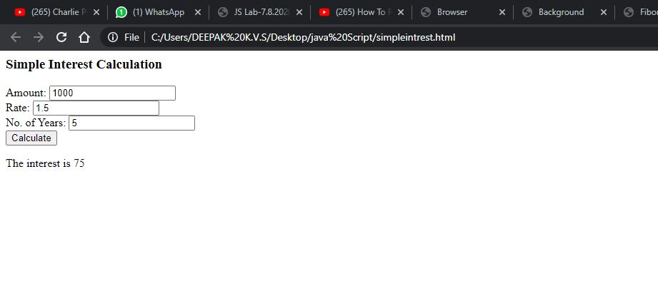

3. <!DOCTYPE html>

<html lang="en">

<head>

<meta charset="UTF-8">

<title>Image map</title>

</head>

<body>

<img src="spiderman.jpg" usemap="#map" >

<map name="#map">

<area shape="rect" coords="0,0,270,400" onmouseover="left()" onmouseout="out()" onclick="imageClick()">

<area shape="rect" coords="270,0,550,406" onmouseover="right()" onmouseout="out()" onclick="imageClick()">

</map>

<p id="popup">place cursor on image</p>

</body>

<script>

function left()

{

document.getElementById("popup").innerText="Left Side of Image"

}

function right() {

document.getElementById("popup").innerText = "Right side of Image"

}

out()

{

document.getElementById("popup").innerText= "place cursor on image"

}

function imageClick()

{

window.open("large.html")

}

</script>

</html>

Large.html:

<!DOCTYPE html>

<html>

<head>

<title>Larged Image</title>

</head>

<body>

<img src="7.JPEG" width="1000px">

</body>

</html>

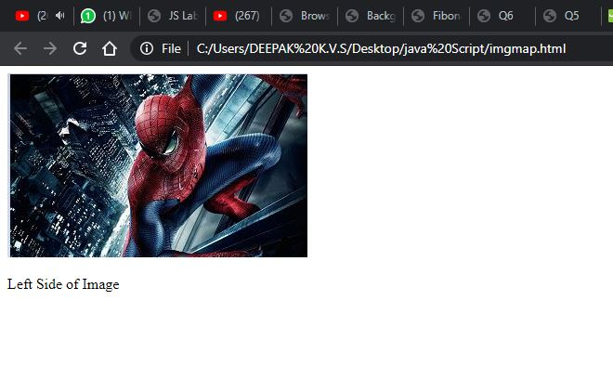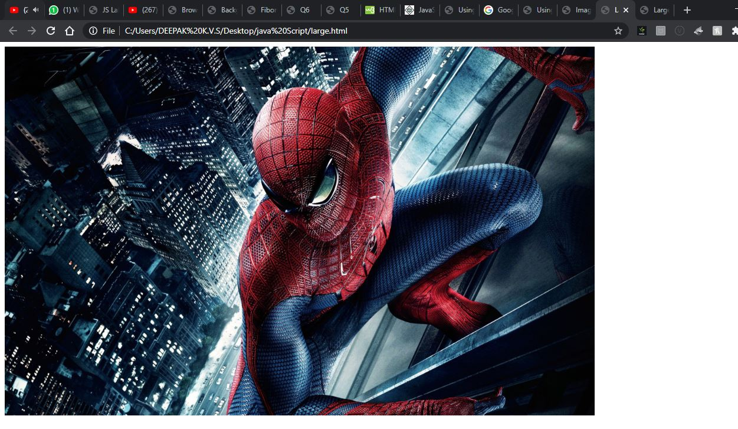s