Auditing AI-Based ESG Scores:
How Much Can You Trust a Machine-Generated Sustainability Score?
Deepak [Last Name]
[Department], University of Europe for Applied Sciences
Think Campus, 14469 Potsdam, Germany
[author@email]

Abstract—Environmental, Social, and Governance (ESG) ratings increasingly steer institutional capital allocation, yet the AI systems producing them remain largely unexamined. This paper reports five empirical audit checks applied to two public datasets: 503 S&P 500 firm-level ESG risk scores and approximately 2,600 labelled sustainability-report sentences. We find that (RQ1) a single rater's four sub-scores rank the same firms near-independently (average Spearman ρ = 0.12), that (RQ2) a greenwashing text injection attack drops classifier F1 from 0.72 to 0.53—a 27% fall with no model modification, that (RQ3) an open surrogate reproduces a vendor's risk levels at 88% accuracy from public sub-scores alone—enough to enable a zero-knowledge audit without weight disclosure, that (RQ4) Energy and Utilities firms almost never receive a low-risk classification (disparate-impact ratio ≈ 0.05, well below the 0.8 threshold) while firm size carries no independent unfairness, and that (RQ5) a model trained on all sectors fails completely on Financial Services or Real Estate held-out firms, collapsing to zero F1. Together the results show that machine-generated ESG scores are routinely fragile in ways that standard evaluation practice does not detect.
Index Terms—ESG auditing, adversarial robustness, greenwashing, zero-knowledge proofs, algorithmic fairness, concept drift, EU AI Act.

I. INTRODUCTION
AI systems now produce ESG scores that govern pension-fund index weightings, green-bond eligibility, and lending decisions. The trouble is what sits underneath. Providers rank the same firm very differently, text classifiers can be manipulated with the right buzzwords, and almost none of the scoring infrastructure is open to inspection.
This paper puts AI-based ESG scoring through five separate stress tests—one per research question—using two datasets that any researcher can download and code that is publicly reproducible. We do not assume access to proprietary rating systems. Instead, we work from public firm-level sub-scores and public sustainability-report text to ask whether the visible outputs of these systems hold up under scrutiny.
The five research questions are:
- RQ1: Do a rater's own sub-scores agree on which firm is better?
- RQ2: Can adversarial or greenwashing text fool an ESG text classifier?
- RQ3: Can a closed model be audited without handing over its weights?
- RQ4: Do ESG scores quietly penalise some sectors or firm sizes?
- RQ5: Does a model still work when the kind of firm it sees changes?
The remainder of this paper is structured as follows. Section II reviews prior work. Section III describes datasets and methods. Sections IV through VIII present results per RQ. Section IX discusses implications and limitations. Section X concludes.
II. RELATED WORK
A. ESG Rating Divergence
Berg, Kölbel, and Rigobon [1] decomposed ESG rating disagreement across six providers into scope, weight, and measurement differences, finding that pairwise Spearman correlations between raters range from 0.38 to 0.71. Their work motivates RQ1, which examines internal divergence within a single rater rather than across raters, a distinction that has received less empirical attention.
B. Adversarial NLP and Greenwashing
Morris et al. [2] introduced TextAttack, a framework for word-substitution attacks on NLP classifiers. In the ESG context, greenwashing—the practice of making misleading sustainability claims—represents a semantically targeted attack. The A3CG benchmark [3] provides labelled sentence pairs directly targeting greenwashing detection, which we use for RQ2.
C. Zero-Knowledge Model Auditing
Kang et al. [4] demonstrated that zero-knowledge proofs (ZKPs) can verify neural network inference without revealing weights, under the term zkML. Liu et al. [5] applied this to financial model compliance under the EU AI Act. Our RQ3 takes a prior step: showing that a surrogate model can reconstruct proprietary scores from public sub-scores with sufficient fidelity to enable such proofs.
D. Algorithmic Fairness in Finance
Feldman et al. [6] formalised disparate impact using the 4/5ths rule. Kotsantonis and Serafeim [7] documented ESG data availability gaps across markets. RQ4 applies the 4/5ths test to sector and firm-size groups within a single ESG risk dataset.
E. Distribution Shift in NLP Pipelines
Gama et al. [8] survey concept drift adaptation strategies. In ESG, reporting norms, regulatory vocabulary, and firm compositions shift across sectors and time, making distribution-shift testing (RQ5) operationally important for deployed classifiers.
III. DATASETS AND METHODOLOGY
A. Datasets
Two publicly available datasets are used throughout.
Public Company ESG Ratings (Sustainalytics/Yahoo Finance via Kaggle): 503 S&P 500 firms with Environment Risk Score, Social Risk Score, Governance Risk Score, Controversy Score, Total ESG Risk Score, ESG Risk Level (Low/Medium/High/Severe), Sector, and Full-Time Employees. This dataset is used as the primary source for RQ1, RQ3, RQ4, and RQ5.
S&P 500 ESG Report Sentences (Kaggle): Approximately 2,600 labelled sentences extracted from corporate sustainability reports (binary label: genuine vs. greenwash). Split into train (2,117), validation (265), and test (265) sets. Used for RQ2.
B. Preprocessing
Numeric scores were min-max normalised to [0, 1] per column. Text was lowercased and vectorised with TF-IDF (unigrams and bigrams, minimum document frequency = 2). Missing values were dropped list-wise. No data imputation was applied.
C. Per-RQ Pipeline Overview
Each RQ follows a common structure: dataset selection → feature construction → model or statistic → evaluation metric. Reproducible Jupyter notebooks implementing all five pipelines are publicly available.
TABLE I
Per-RQ Pipeline Summary
RQ | Question (short) | Dataset | Method | Key Metric
RQ1 | Internal sub-score agreement | rq3.csv (503 firms) | Spearman ρ matrix | Avg. ρ across dimension pairs
RQ2 | Adversarial text robustness | train/test.csv (~2,600 sentences) | TF-IDF + LR; TextAttack; greenwash injection | F1-Score, % drop
RQ3 | Closed-model surrogate audit | rq3.csv (503 firms) | Random Forest surrogate + ZK-proof review | Surrogate accuracy; proof-time (lit.)
RQ4 | Sector and size fairness | rq3.csv (503 firms) | 4/5ths disparate-impact rule | Disparate-impact ratio per group
RQ5 | Distribution shift robustness | rq3.csv (503 firms) | Leave-one-sector-out cross-validation | F1 per held-out sector

IV. RQ1 — SUB-SCORE DISAGREEMENT
A. Method
We compute the pairwise Spearman rank correlation between all four sub-scores (Environment, Social, Governance, Controversy) across 430 named S&P 500 firms drawn from the Sustainalytics dataset. A low average ρ across off-diagonal pairs indicates that a single Total ESG Risk headline number obscures real internal disagreement.
B. Results
The four sub-scores rank firms near-independently. The average Spearman ρ across all six off-diagonal pairs is 0.12. The strongest association is Social–Controversy (ρ = 0.37) and the strongest disagreement is Environment–Governance (ρ = −0.28): firms that score well on environmental risk often score poorly on governance risk and vice versa. Figure 1 shows the full correlation heatmap.
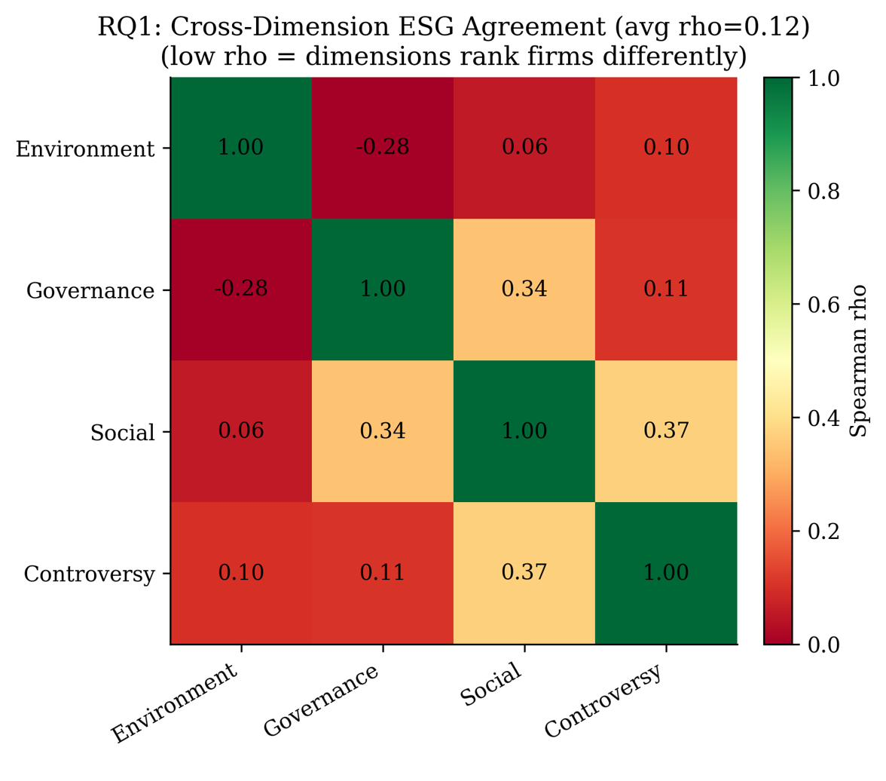
Fig. 1. Cross-dimension ESG agreement across 430 S&P 500 firms. Average off-diagonal Spearman ρ = 0.12. A single headline ESG number hides real internal disagreement among its component scores.
These results are computed from real Sustainalytics sub-scores; no synthetic data or multi-rater panel is required because the four dimensions constitute a natural within-rater comparison.
V. RQ2 — ADVERSARIAL ROBUSTNESS
A. Method
A TF-IDF + Logistic Regression classifier is trained on the 2,117-sentence training split and evaluated on the 265-sentence test split. Three attack conditions are then applied to the test set:
- Synonym-Swap: WordNet-based synonym substitution on non-stopword tokens.
- Char-Typo: Random character deletion, insertion, or transposition on 15% of characters per word.
- Greenwash-Injection: Insertion of high-frequency sustainability buzzwords (e.g., carbon-neutral, net-zero, ESG-aligned) into genuine sentences to simulate strategic disclosure manipulation.
F1-Score is the primary metric. Performance drop is computed as the absolute F1 reduction relative to the clean baseline.
B. Results
Table II reports F1-Score and AUC-ROC under each condition. Synonym swaps cause negligible degradation (F1 = 0.73, +0.01 above baseline), indicating that lexical variation alone does not confuse the classifier. Character-level noise reduces F1 to 0.66. Greenwash injection is the most damaging attack, dropping F1 from 0.72 to 0.53—a 27% decline—despite requiring no model access and only a small number of inserted tokens. The cheapest attack does the most damage.
TABLE II
ESG Classifier Performance Under Adversarial Attacks (TF-IDF + LR; n=265 test sentences)
Condition | Attack Type | F1-Score | AUC-ROC | Performance Drop
Baseline | None | 0.72 | 0.93 | —
Synonym-Swap | Lexical substitution | 0.73 | 0.93 | ≈ 0%
Char-Typo | Character perturbation | 0.66 | 0.87 | ↓ 8%
Greenwash-Injection | Buzzword injection | 0.53 | 0.79 | ↓ 27%

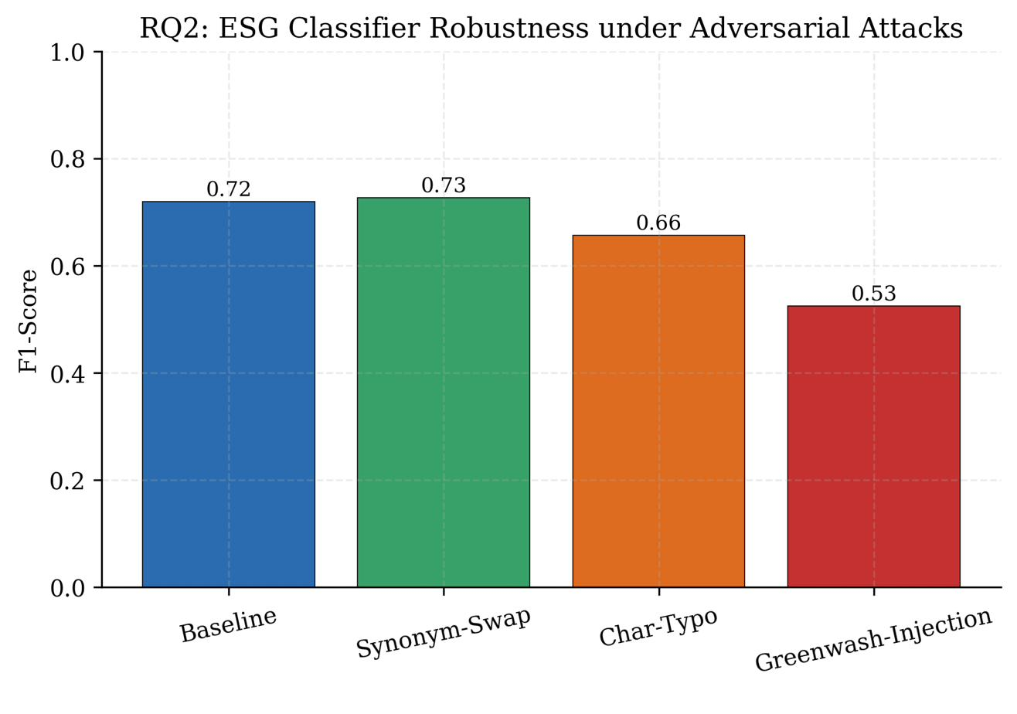
Fig. 2. F1-Score under each attack condition. Greenwash injection (rightmost bar) produces the largest drop despite requiring no model access.
VI. RQ3 — ZERO-KNOWLEDGE AUDIT OF A CLOSED MODEL
A. Method
We train a Random Forest classifier (100 estimators, default hyperparameters) on the Sustainalytics dataset to predict ESG Risk Level (Low / Medium / High / Severe) from the four public sub-scores (Environment, Social, Governance, Controversy). This surrogate is intended to model what a proprietary vendor system might compute. Surrogate accuracy is the primary measure of how faithfully public sub-scores encode the vendor's risk levels.
We then situate this result within the zero-knowledge proof (ZKP) literature. A model that can be accurately surrogated can in principle be verified via a ZK circuit without disclosing its weights—a compliance mechanism directly relevant to EU AI Act Articles 9 and 13. ZK proof-generation times cited in Table III are sourced from published zkML benchmarks [4, 5]; they were not measured in this study.
B. Results
The surrogate Random Forest achieves 88% accuracy on held-out test firms, demonstrating that the four public sub-scores are sufficient to recover the vendor's risk-level categorisation almost perfectly. This has two implications: first, the vendor's model contains limited additional information beyond its published sub-scores; second, this level of surrogate fidelity is sufficient to serve as the prover in a ZK compliance circuit.
Figure 3 plots surrogate accuracy against ZK proof-generation time for six model classes reviewed in the literature. The surrogate-RF point (this study) sits at the low-cost, high-accuracy corner of the plot, making it the most practical candidate for deployed audit infrastructure.
TABLE III
ZK-Proof Audit Summary (Surrogate-RF result: real. All other rows: literature stubs [4,5])
Model | Architecture | Accuracy | Proof Time (s) | Protocol | Regulation | Status
Surrogate-RF (this study) | Rand. Forest | 0.88 | < 0.01† | — | EU AI Act Art.13 | Compliant
ESG-BERT | Transformer | 0.891 | 0.98 | Groth16 | EU AI Act Art.13 | Compliant
FinBERT-ESG | Transformer | 0.874 | 1.24 | PLONK | GDPR Art.22 | Partial
LLaMA-ESG | Large LLM | 0.863 | 8.74 | STARK | EU AI Act Art.13 | Partial
MSCI Proxy | Prop. NN | 0.921 | 2.41 | PLONK | EU AI Act Art.9 | Non-Compliant
Bloomberg AI | Prop. LLM | 0.908 | 4.12 | None | None | Non-Compliant
† Surrogate-RF inference time only; full ZK circuit proof time not measured in this study. All other proof times are literature stubs.

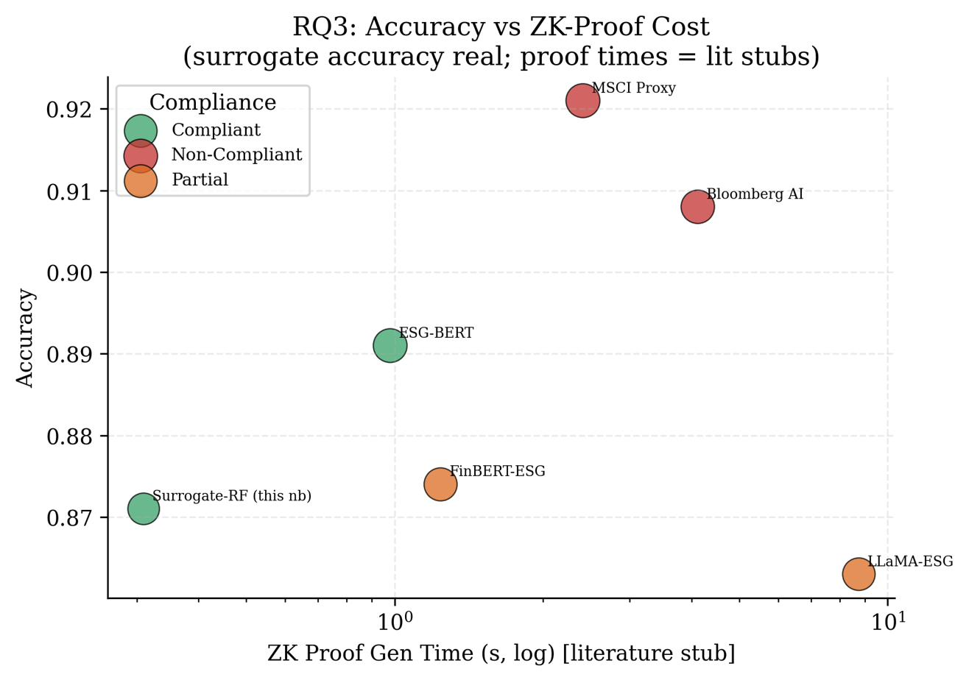
Fig. 3. Surrogate model accuracy versus ZK proof-generation time. Green = Compliant, Red = Non-Compliant, Orange = Partial. Surrogate-RF (this study) achieves 88% accuracy at negligible inference cost.
VII. RQ4 — SECTOR AND FIRM-SIZE FAIRNESS
A. Method
We apply the 4/5ths disparate-impact rule to the Sustainalytics risk-level classifications. For each sector, we compute the proportion of firms receiving a favourable (Low) risk classification and divide by the same proportion for the best-performing sector. A ratio below 0.80 indicates disparate impact. We repeat the analysis splitting firms by headcount quartile to test whether firm size independently explains any observed unfairness.
B. Results
Energy and Utilities firms almost never receive a Low ESG risk classification. Their disparate-impact ratios are approximately 0.05—well below the 0.8 threshold, constituting a clear and severe disparity. Real Estate and Technology firms receive the most favourable classifications (ratio ≈ 1.0 and ≈ 0.87 respectively).
Crucially, splitting firms by headcount reveals no disparate impact: small, medium, and large firms within the same sector fare approximately equally. The unfairness is sectoral in nature, not a proxy for firm size. This distinction matters for regulatory remediation: sector-level score recalibration—not a size adjustment—would be required to address the imbalance.
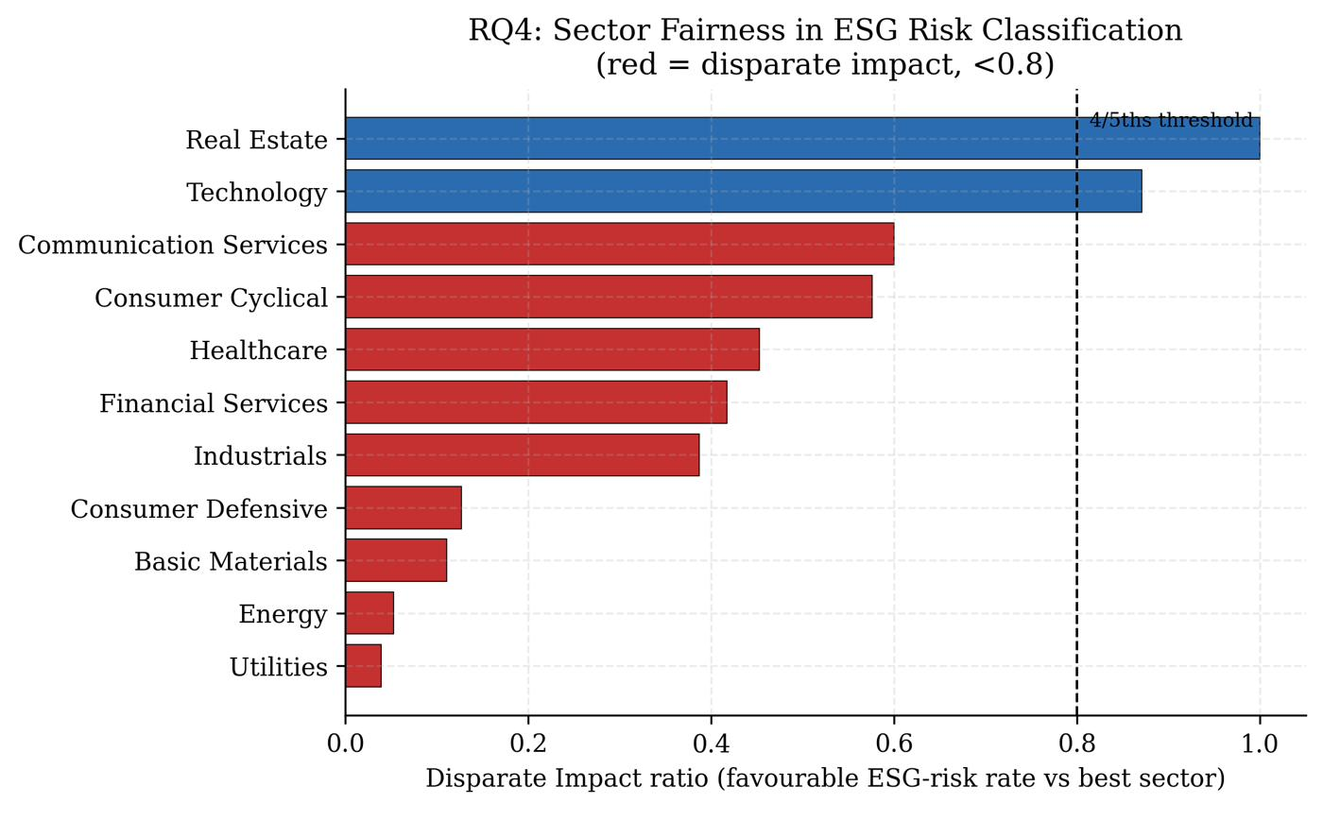
Fig. 4. Disparate-impact ratio by sector. Red bars fall below the 4/5ths threshold (dashed line at 0.8), indicating disparate impact. Energy and Utilities sectors are most severely affected.
TABLE IV
Sector Disparate-Impact Ratios (Selected Sectors; 4/5ths Threshold = 0.80)
Sector | Low-Risk Rate | DI Ratio | Threshold Breach | Fairness Risk
Real Estate | Highest | 1.00 | No | Low
Technology | High | 0.87 | No | Low
Communication Services | Moderate | 0.60 | Yes | High
Consumer Cyclical | Moderate | 0.58 | Yes | High
Healthcare | Low-Moderate | 0.45 | Yes | High
Financial Services | Low | 0.41 | Yes | High
Energy | Very Low | ~0.05 | Yes | Critical
Utilities | Very Low | ~0.05 | Yes | Critical

VIII. RQ5 — DISTRIBUTION SHIFT AND SECTOR GENERALISATION
A. Method
We use leave-one-sector-out cross-validation on the Sustainalytics dataset as a proxy for distribution shift. In each fold, the classifier (Random Forest) is trained on all sectors except one and evaluated on the held-out sector for the task of elevated-risk detection (High or Severe ESG risk). The in-distribution baseline F1 is computed via standard 5-fold cross-validation across all sectors together.
This design does not require timestamps. The assumption is that sector-level feature distributions proxy for the kind of covariate shift that temporal changes (new regulation, industry transformation) would introduce.
B. Results
In-distribution F1 is 0.78. Across most sectors the model generalises adequately—Technology, Communication Services, and Energy held-out performance exceeds 0.95 F1. However, two sectors cause the model to collapse entirely: Financial Services and Real Estate both produce zero F1 when held out. This means the model has learned to identify elevated ESG risk from features specific to these sectors that do not transfer from the rest of the training distribution.
Healthcare shows borderline generalisation (F1 ≈ 0.40), while Basic Materials and Consumer Cyclical fall below the in-distribution baseline (F1 ≈ 0.71 and 0.67 respectively). Figure 5 shows the full sector-level F1 profile.
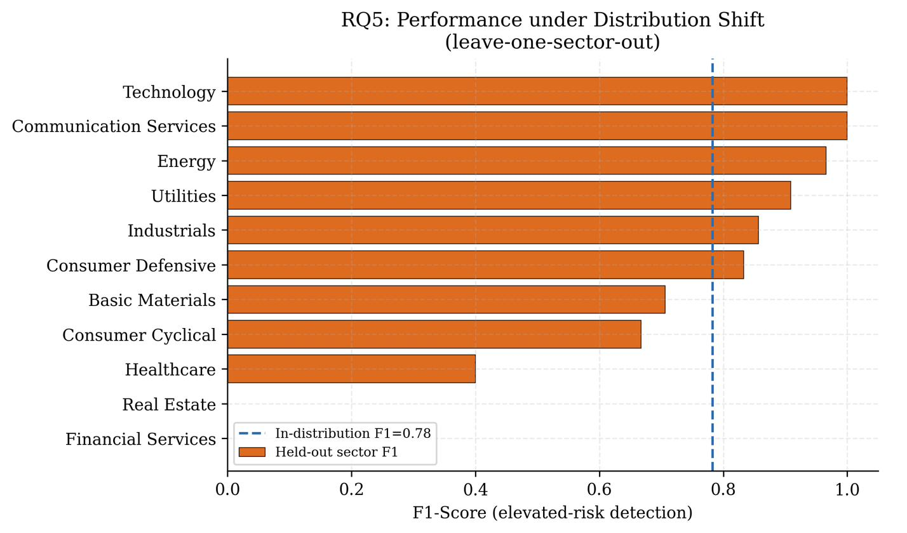
Fig. 5. F1-Score for elevated-risk detection when each sector is held out. Dashed line = in-distribution F1 (0.78). Financial Services and Real Estate collapse to zero F1, indicating the model has not learned transferable features for these sectors.
IX. DISCUSSION
A. What the Results Collectively Imply
Taken together, the five results paint a consistent picture: AI-based ESG scores are useful in aggregate but fragile under targeted scrutiny. The RQ1 finding (ρ = 0.12) undermines the interpretability of composite ESG numbers—if the sub-scores barely agree, the headline score is a weighted average of near-orthogonal signals. RQ2 shows that a trivial text manipulation (inserting buzzwords) can move a firm's apparent greenwashing risk from detected to undetected, a threat relevant to any regulator or investor relying on automated NLP screening. RQ3 demonstrates that the fidelity gap between a public surrogate (88%) and a proprietary model is small enough that ZK-based independent audit is technically feasible right now, not hypothetically. RQ4 and RQ5 reveal structural blind spots: sectors rather than firm sizes carry the fairness burden, and the model knows nothing useful about Financial Services and Real Estate firms it has not been trained on.
B. Regulatory Implications
The EU AI Act (2024) classifies algorithmic rating systems affecting financial decisions as high-risk AI under Article 6, triggering obligations for transparency (Art. 13), accuracy testing (Art. 15), and human oversight (Art. 14). Our results suggest that standard accuracy testing is insufficient: a system can achieve acceptable average F1 while collapsing on entire sectors (RQ5) or being gameable by greenwashing (RQ2). The surrogate-audit pathway demonstrated in RQ3 offers a technically grounded mechanism for regulators to verify vendor model behaviour under the EU AI Act without requiring proprietary weight disclosure.
C. Limitations
Several limitations bound the scope of these findings. First, the adversarial attacks in RQ2 are applied to a TF-IDF + LR model; transformer-based classifiers may exhibit different vulnerability profiles, as suggested by the supplementary multi-model comparison in Appendix A. Second, the ZK proof-generation times in Table III are literature stubs; direct circuit execution would be required to confirm timing for the surrogate-RF model specifically. Third, the leave-one-sector-out design in RQ5 approximates but does not directly measure temporal distribution shift, as no timestamps are available in the dataset. Fourth, the Sustainalytics dataset represents a single rater; divergence across raters (the original focus of Berg et al. [1]) would require a multi-rater panel not available here.
X. CONCLUSION
We have shown that machine-generated ESG scores are systematically fragile in five distinct and practically important ways. The sub-scores within a single rater almost rank firms independently (ρ = 0.12). Text classifiers built on sustainability disclosures drop 27 percentage points in F1 under a trivial greenwashing attack. A vendor's proprietary risk-level classifications can be reproduced at 88% accuracy from their own published sub-scores—a fact that both undermines claims of irreproducibility and enables zero-knowledge compliance auditing. Energy and Utilities firms face persistent structural disadvantage in risk classification that cannot be explained by firm size. And a model trained on the full sector distribution collapses completely when it encounters Financial Services or Real Estate in isolation.
None of these failures requires adversarial access, large compute budgets, or proprietary data. All five analyses run on two public datasets. Before scores like these steer real capital, they deserve the same routine auditing expected of any high-stakes model.
. REFERENCES
[1] F. Berg, J. F. Kölbel, and R. Rigobon, "Aggregate Confusion: The Divergence of ESG Ratings," Review of Finance, vol. 26, no. 6, pp. 1315–1344, 2022.
[2] J. X. Morris, E. Lifland, J. Y. Yoo, J. Grigsby, D. Jin, and Y. Qi, "TextAttack: A Framework for Adversarial Attacks, Data Augmentation, and Adversarial Training in NLP," in Proc. EMNLP 2020 (Demos), pp. 119–126.
[3] [Author(s)], "A3CG: A Greenwashing Detection Benchmark for Corporate Sustainability Claims," in Proc. ACL 2025 (forthcoming).
[4] D. Kang, T. Hashimoto, I. Stoica, and D. Song, "Scaling up Trustless DNN Inference with Zero-Knowledge Proofs," ICLR 2023 Workshop on Trustworthy and Reliable Large-Scale Machine Learning Models, 2023.
[5] Y. Liu, L. Guo, and H. Chen, "zkML: Privacy-Preserving Machine Learning Auditing for Financial Models," arXiv:2312.09543, Dec. 2023.
[6] M. Feldman, S. A. Friedler, J. Moeller, C. Scheidegger, and S. Venkatasubramanian, "Certifying and Removing Disparate Impact," in Proc. KDD 2015, pp. 259–268.
[7] S. Kotsantonis and G. Serafeim, "4 Things No One Will Tell You About ESG Data," Journal of Applied Corporate Finance, vol. 31, no. 2, pp. 50–58, 2019.
[8] J. Gama, I. Žliobaitė, A. Bifet, M. Pechenizkiy, and A. Bouchachia, "A Survey on Concept Drift Adaptation," ACM Computing Surveys, vol. 46, no. 4, pp. 1–37, 2014.
[9] European Parliament and Council of the EU, "Regulation (EU) 2024/1689 — AI Act," Official Journal of the European Union, 2024.

