Implementation of Deep Learning Based Neural Network Algorithm for Intracranial Haemorrhage Detection
Intracranial haemorrhage can cause death to patient and its timely and accurate recognition can help medical peoples in saving patients life. So in this paper author using RSNA (Radiological Society of North America) based images to train YOLO deep learning model which can help in detecting and recognizing Haemorrhage and this model can get accuracy of 98% in detecting any kind of Haemorrhage.
In below screen we are showing dataset images used to train YOLO model
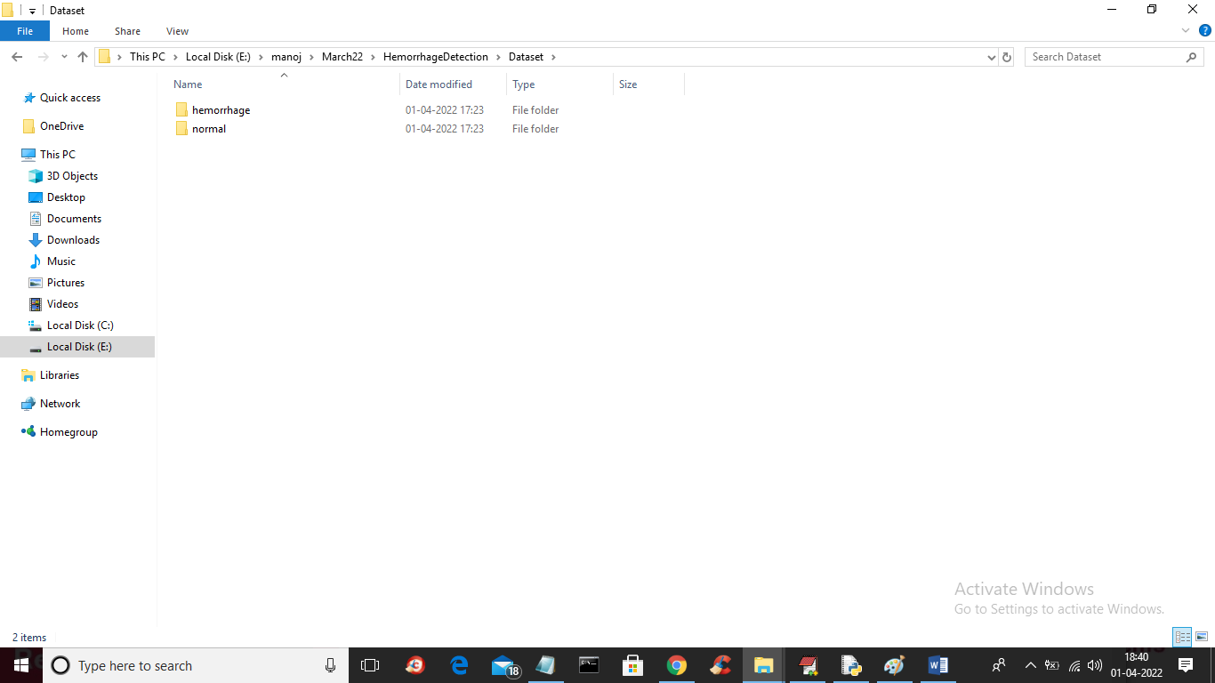
In above screen we have two types of folders such as ‘Haemorrhage’ and ‘Normal’ and just go inside any folder to view those images
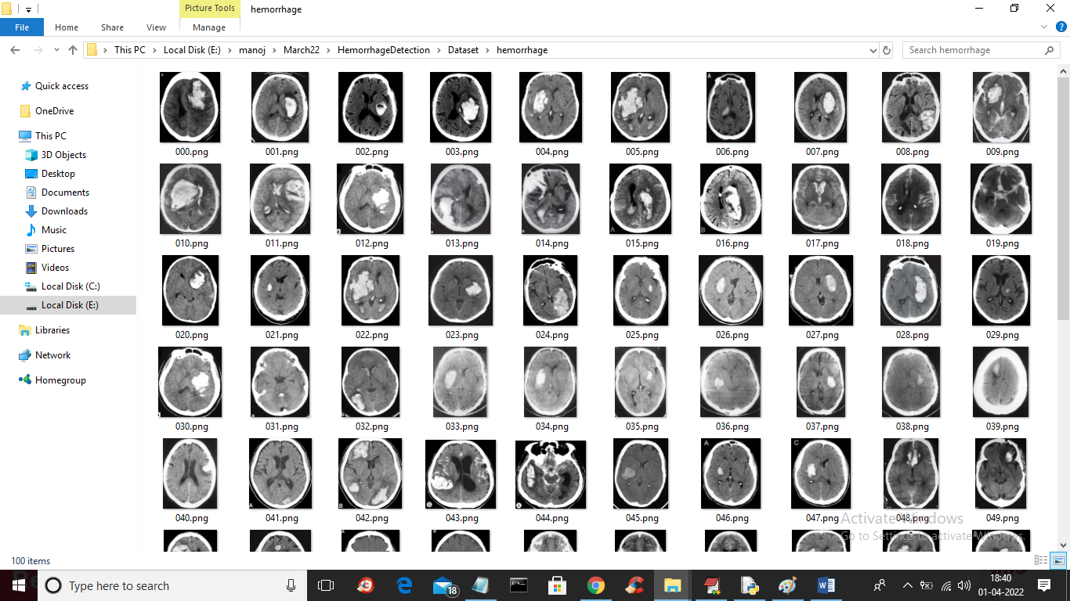
In above screen showing images from ‘Haemorrhage’ folder and we will used above images to train YOLO model.
To implement this project we have used following modules
- Upload CT Scans Dataset: using this module we will upload dataset to application
- Normalize CT Scans Images: using this module we will read all images and then resize images and then normalize pixels values and then split images into train and test where application will used 80% images for training and 20% images for testing
- Train Yolo Model: using this module we will input 80% training image to YOLO model for training and after training this model will be applied on 20% test images to calculate its correct prediction accuracy.
- Yolo Accuracy-Loss Graph: using this module we will plot YOLO accuracy for each epoch. To train YOLO we took 10 epoch and for each epoch we will plot accuracy and loss values
- Predict Haemorrhage from Test Image: using this module we will upload test image and then YOLO model will recognize whether uploaded image is normal or contains Haemorrhage
SCREEN SHOTS
To run project double click on ‘run.bat’ file to get below screen
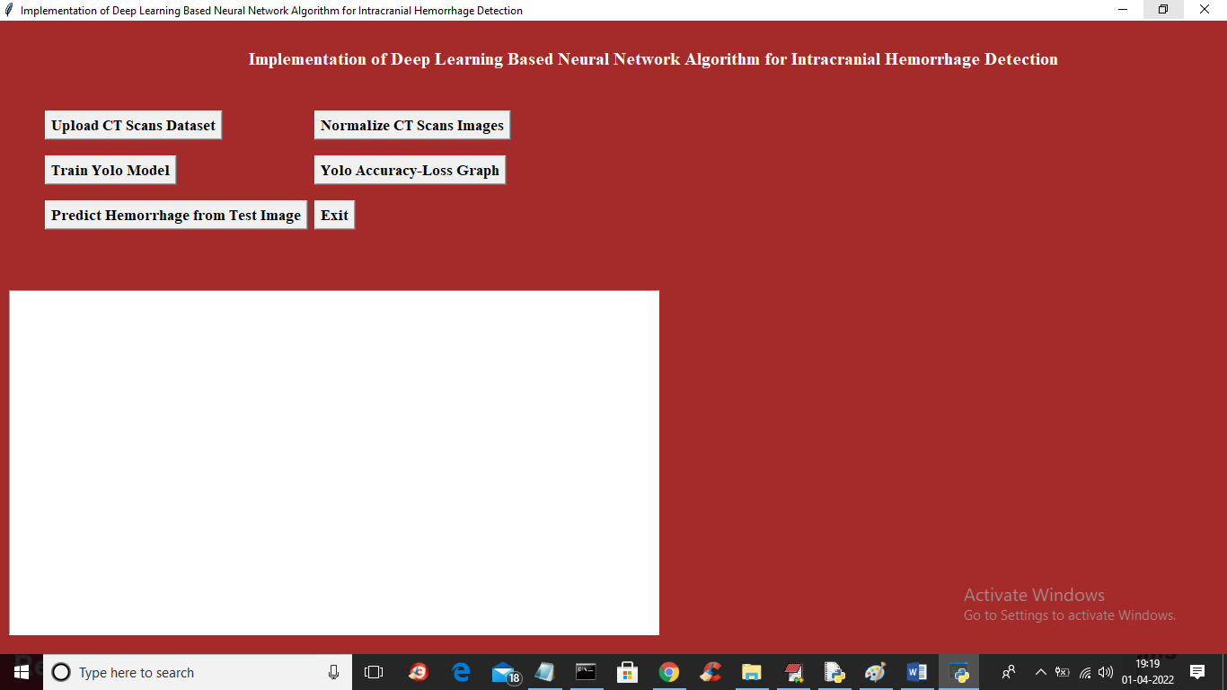
In above screen click on ‘Upload CT Scans Dataset’ button to upload dataset and to get below screen
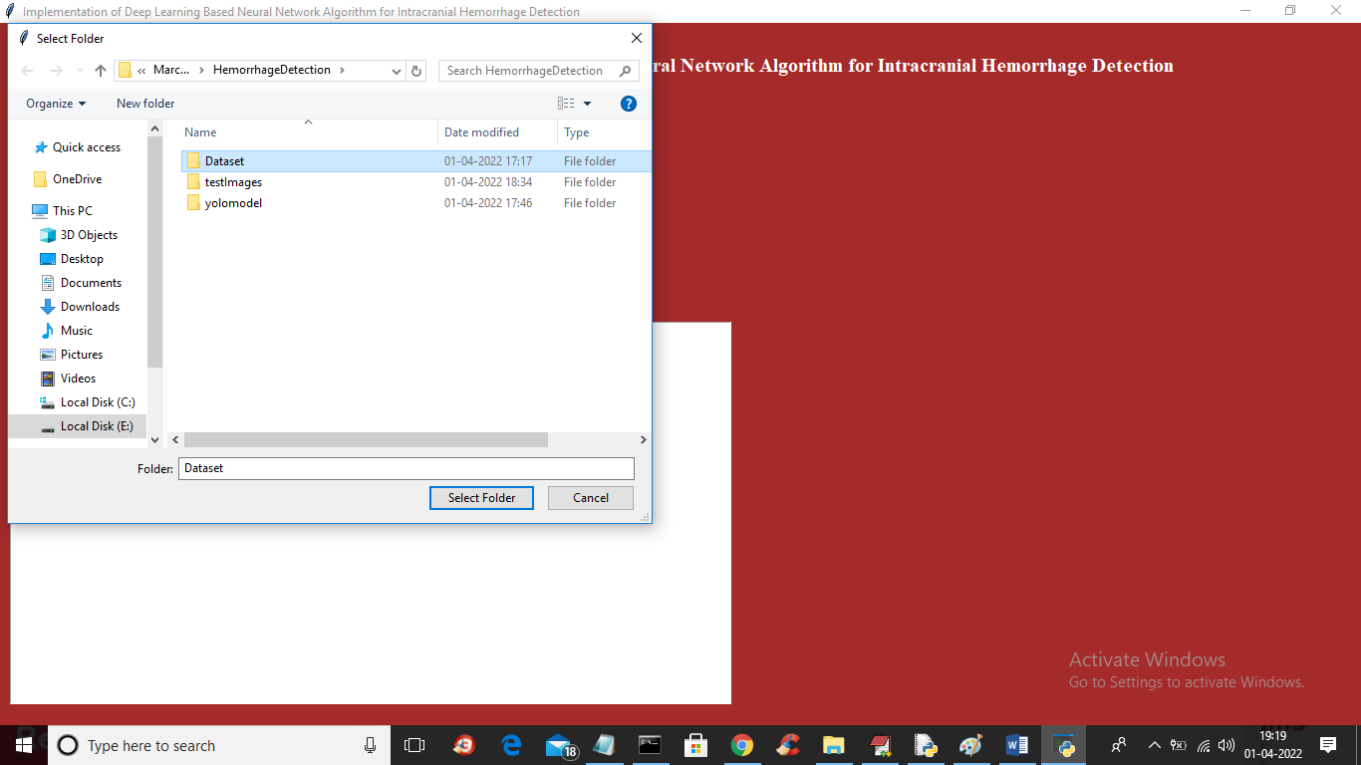
In above screen selecting and uploading ‘Dataset’ folder and then click on ‘Select Folder’ button to load dataset and to get below screen
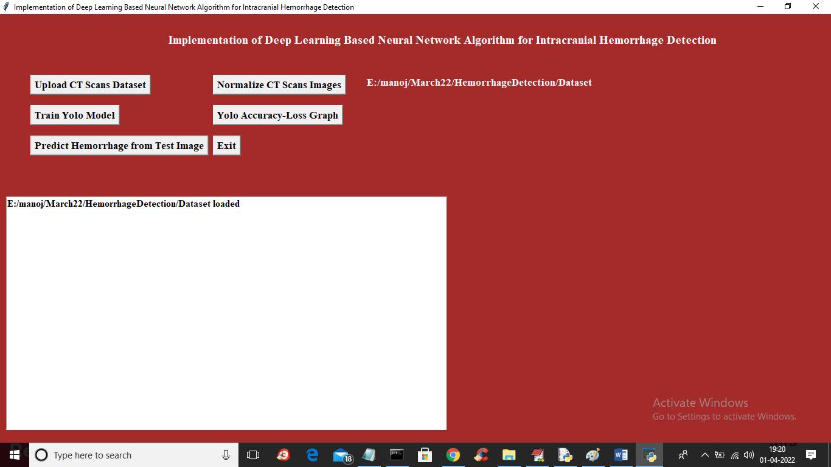
In above screen dataset loaded and now click on ‘Normalize Ct Scan Image’ button to read all images and then normalize and then split into train and test and get below output
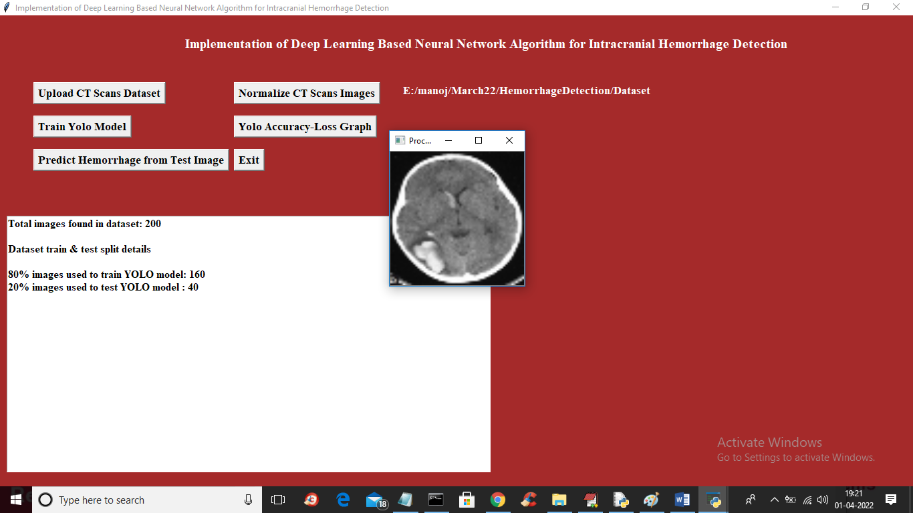
In above screen we can see dataset contains 200 images and application using 80% (160) images for training and 20% (40) images for testing and showing one sample normalize image and now close above image and then click on ‘Train Yolo Model’ button to train model and get below output
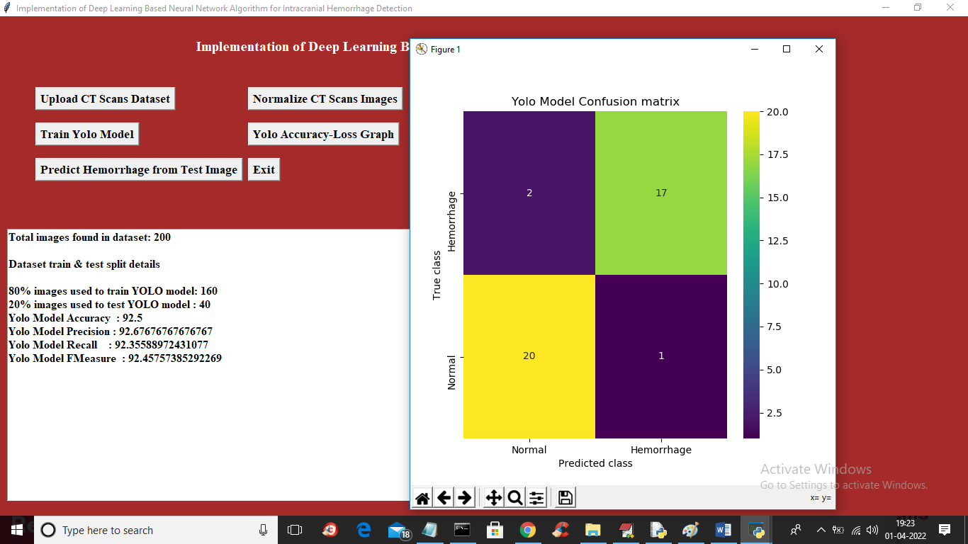
In above screen with YOLO model we got 92% accuracy and in confusion matrix x-axis represents predicted classes and y-axis represents original classes and in above graph we can see YOLO correctly predicted 20 image as Normal and only 2 images are incorrectly predicted and for Haemorrhage 17 are correctly predicted and only 1 is incorrectly predicted. Now close above graph and then click on ‘Predict Haemorrhage from Test Image’ button to upload test image recognize haemorrhage
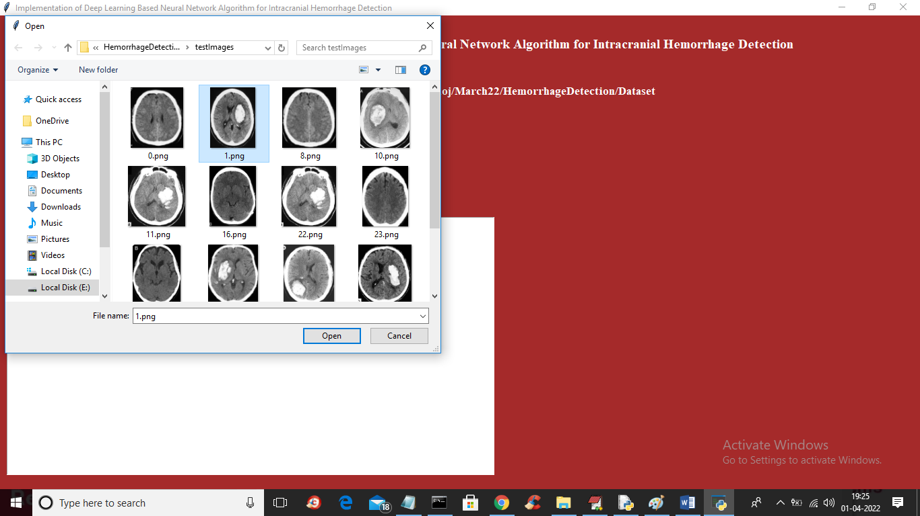
In above screen selecting and uploading 1.png and then click on ‘Open’ button to get below output
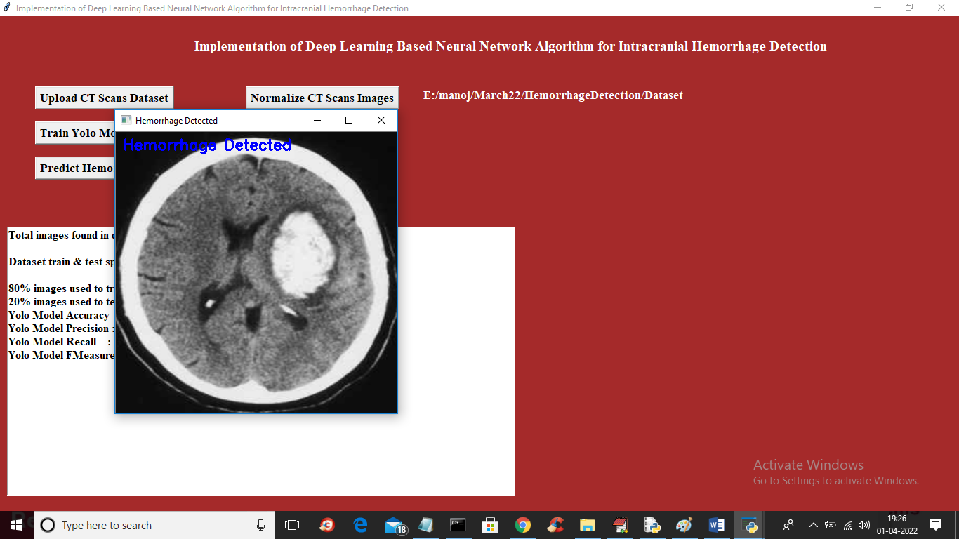
In above screen in blue colour text we can see Haemorrhage is detected and similarly you can upload and test other images
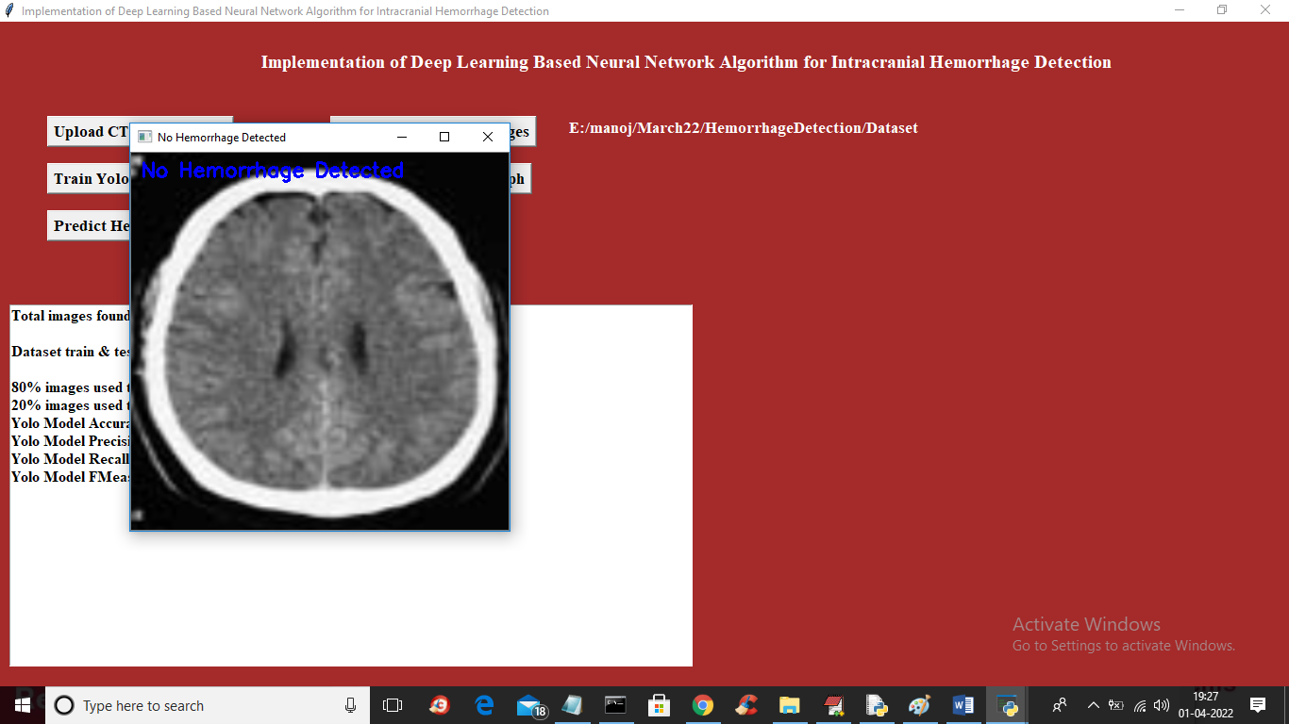
In above image NO Haemorrhage is detected
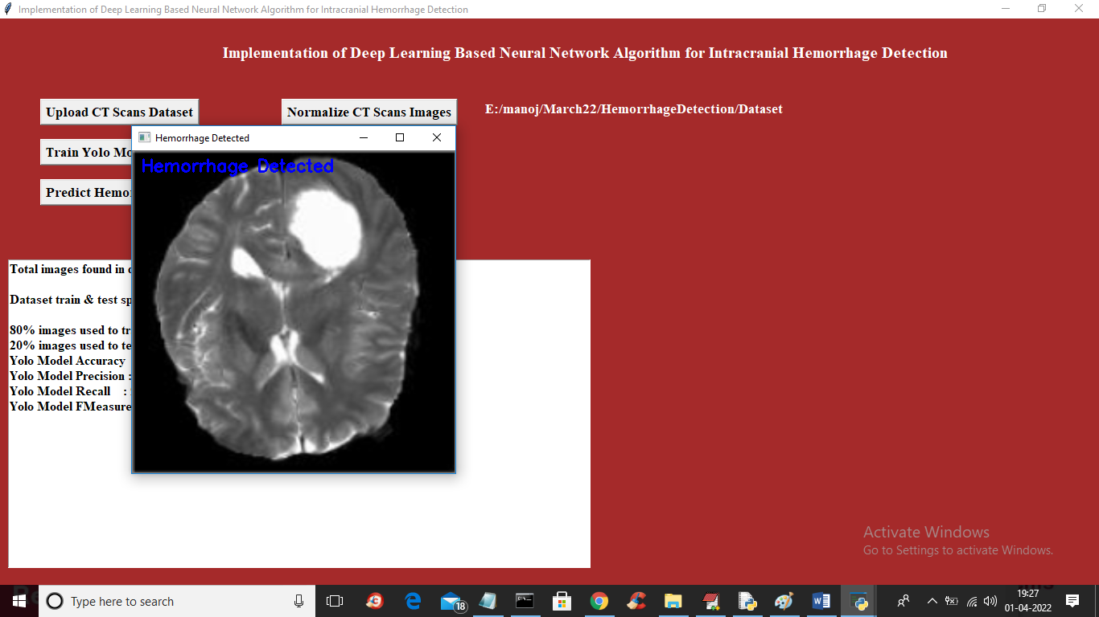
Now click on ‘Yolo Accuracy-Loss Graph’ button to get below graph
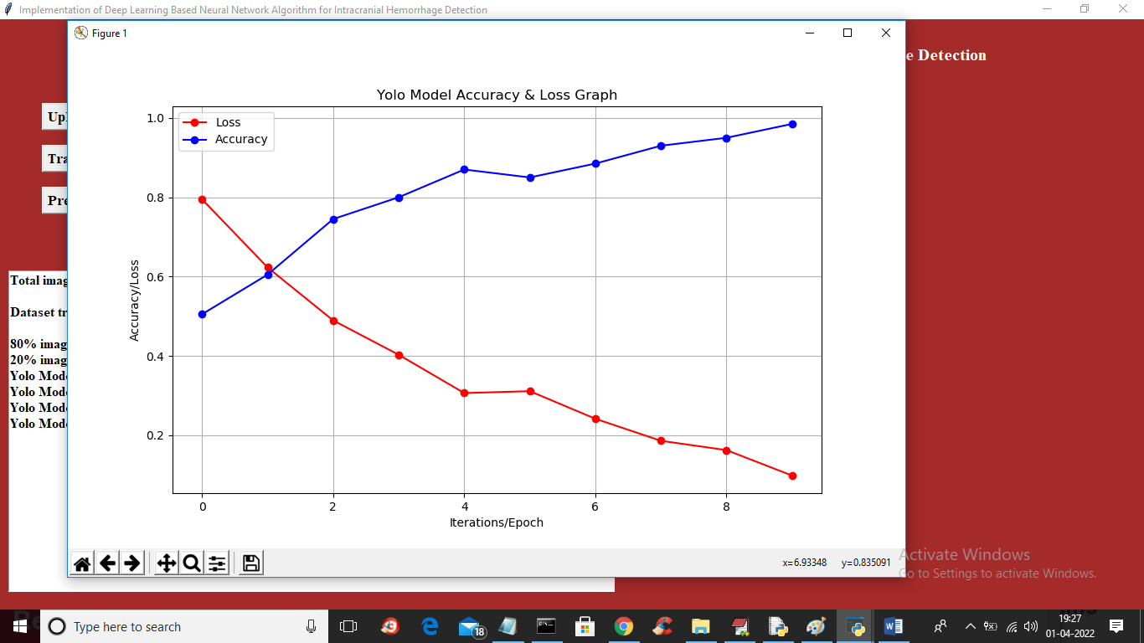
In above graph x-axis represents Epoch number and y-axis represents accuracy and loss values and in above graph blue line indicated accuracy and red line indicate LOSS and in above graph we can see with each increasing epoch accuracy got increase and loss get decrease.

