GetJob

**A**

**MINOR PROJECT-I SRS REPORT**

Submitted in partial fulfillment of the requirements

for the degree of

**BACHELOR OF TECHNOLOGY**

in

**COMPUTER SCIENCE & ENGINEERING**

By **GROUP NO. 1/37**

**NAME OF THE CANDIDATE’S WITH ENROLMENT NO.**

0536CS201012 Daksh Raj Singh

0536CS201014 Dikshant bhatiya

0187CS201022 Amandeep Singh

0187CS201048 Deepak kumar

Under the guidance of

**Name of Guide**

Ruchi jain

(Designation)



**Jul- Dec 2022**

**Department of COMPUTER SCIENCE & ENGINEERING Sagar Institute of Science & Technology (SISTec)**

**Bhopal (M.P.)**

**Approved by AICTE, New Delhi & Govt. of M.P.**

**Affiliated to Rajiv Gandhi Proudyogiki Vishwavidyalaya, Bhopal (M.P.)**

* 1. **Functional Requirements:**

1. **User Login**

* This feature is used by the user/admin to login into the system. A user/admin must log in with his user name and password to the system after registration. If they are invalid, the user is not allowed to enter the system.
* Username and password will be provided after user registration is confirmed.
* Password should be hidden from others while typing it in the field.

1. **Register New User**

* A new user will have to register in the system by providing essential details in order to apply in the job. The admin must accept a new user.
* The system must be able to verify and validate the information.
* The system must encrypt the password of the user to provide security.

1. **Search Jobs**

* The user can search for the desired jobs. He can view different jobs. After confirming the login in the search user can select it and apply by providing the necessary details.
* Job Seeker can view all available jobs
* Job seeker can apply to more than one jobs.
* Job seeker can view all applied jobs.
* Job seeker can update their profile information.
* Job seeker can retrieve their password if forgot.

1. **Upload Resume**

* The job seekers can upload their resumes and provide the necessary details if they are interested in jobs.

**Admin**

1. **Manage Users and Employers**

* The administrator can add users, delete users, and view users.

1. **Manage jobs**

* The administrator can add jobs, delete jobs, hide jobs, and view jobs.

1. **Manage details**

* The system must identify the login of the admin.
* Admin account should be secured so that only the owner of the portal can access that account.

➢ Admin approves the company registration.

➢ Admin can view all jobs.

➢ Admin approves the jobs posted by the company.

**1.2 Non-Functional Requirements:**

1. **Efficiency Requirement**

* When an “Online Job Portal and recruitment system” is implemented job seekers and employers can view and upload job vacancies respectively from their homes easily without any difficulty.

1. **Usability Requirement**

* The “Online Job Portal and recruitment system” is designed for a user-friendly environment and ease of use.

1. **Reliability Requirement**

* The system should provide a reliable environment for both employers and job seekers. All jobs should be reaching the admin without any errors and should be shown to the viewers.

1. **Implementation Requirement**

* Implementation of the system using HTML, CSS, JavaScript, and Bootstrap in the front end with Python, and Flask as the back end and it will be used for database connectivity. And the database part is developed by Sqlite3. Responsive web designing is used for making the portal compatible for any type of screen.
* Browser: Preferable Google Chrome or Mozilla Firefox

1. **Database Security**

* An unauthorized person cannot access the panel and database, and do not read and write the information.

1. **Availability**

* This “Online Job Portal and recruitment system” will be available online 24/7 a week.
* This website can be use of any users

# 1.3 E-R Diagram

# 1.4 Use Case Diagram

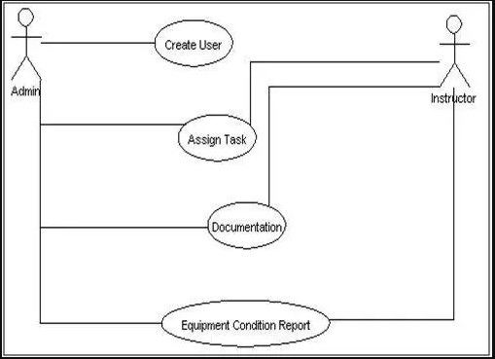

**Example of Use Case Diagram**

# 1.5 Class Diagram

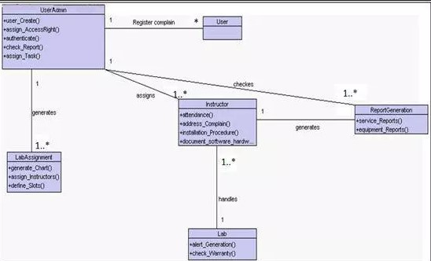

**Example of Class Diagram**

**Class Diagram Modules**

1.**Role of admin**:- Creates a user, assigns access rights, authenticates users, checks report, and assigns the task. These functions are used to keep track of various activities in labs.

2.**Service** **complaint:-** It includes complaint registration, assigning a task to the instructor, addressing complain. These functions may be used to register a complaint about improper conditions of devices (in the lab) to admin in order to get response/service.

3.**Report** **Generation:-** This module generates a service report and reports for the working condition of the equipment in the lab.

4.**Software or hardware maintenance:-** This module checks warranty of particular software generates alert messages and helps in proper documentation of available software or hardware in labs.

5.**Lab Assignment:-** This module defines slots, generates charts, assigns instructors, and would specify alternate instructor to particular labs.

# 1.6 Sequence diagram

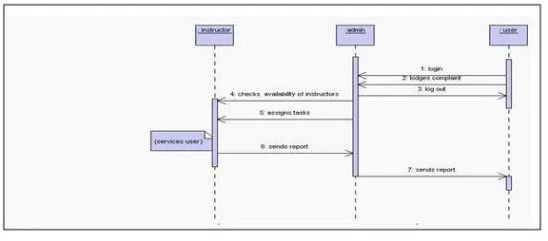

**Example of Sequence Diagram**

# 1.7 Component diagram

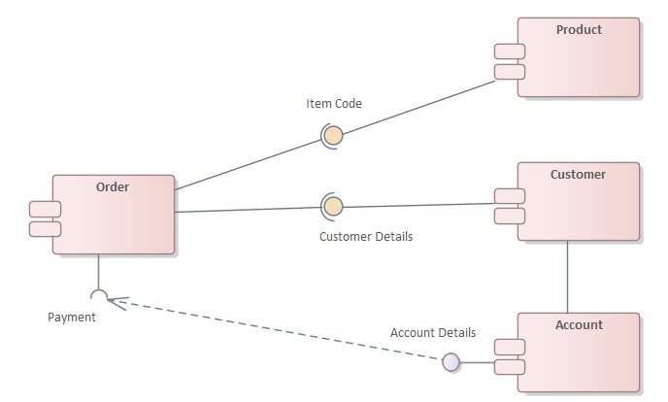

**Example of Component Diagram**