Currently main folder is not present.

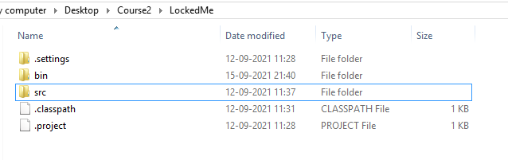

Eclipse screenshot-

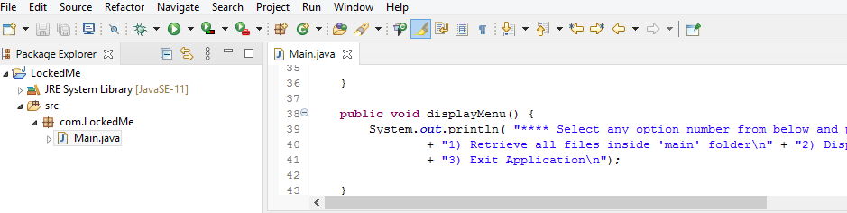

Clicking run created main folder in current directory and displayed welcome screen.

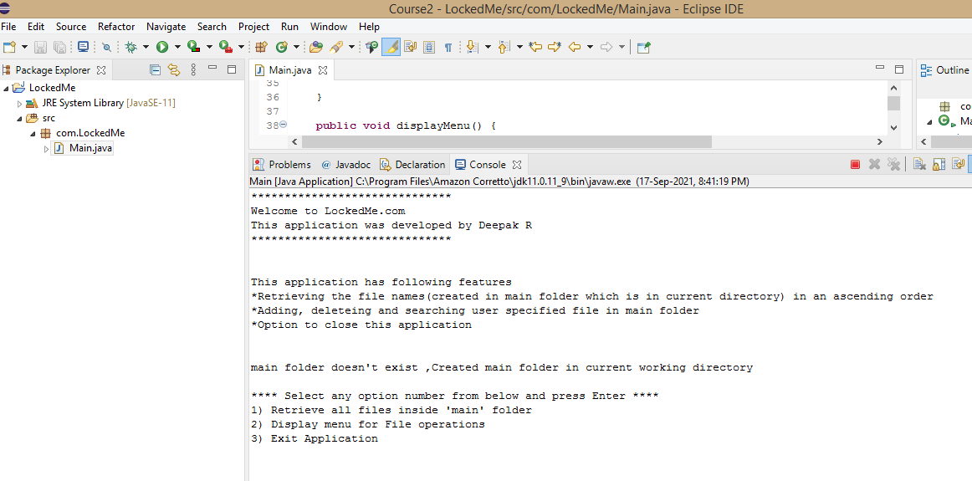

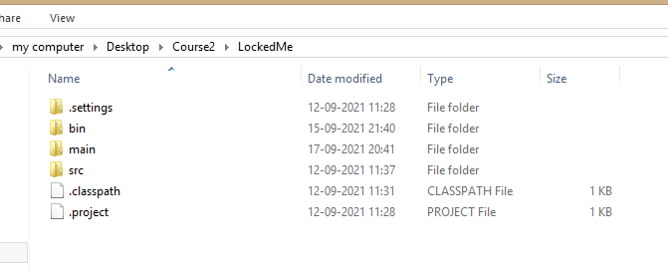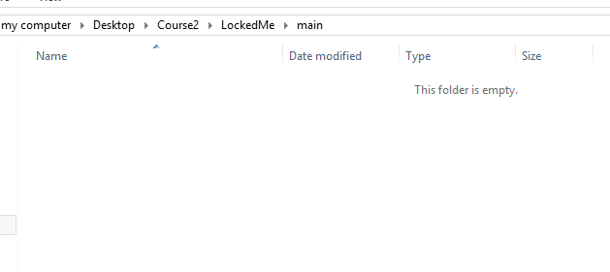

Adding files

Added 3 files-

Console output-

\*\*\*\* Select any option number from below and press Enter \*\*\*\*

1) Retrieve all files inside 'main' folder

2) Display menu for File operations

3) Exit Application

2

\*\*\*\* Select any option number from below and press Enter \*\*\*\*

1) Add a file to 'main' folder

2) Delete a file from 'main' folder

3) Search for a file from 'main' folder

4) Show Previous Menu

1

Enter the name of the file to be added to the 'main' folder

a.txt

a.txt created successfully

\*\*\*\* Select any option number from below and press Enter \*\*\*\*

1) Add a file to 'main' folder

2) Delete a file from 'main' folder

3) Search for a file from 'main' folder

4) Show Previous Menu

1

Enter the name of the file to be added to the 'main' folder

c.txt

c.txt created successfully

\*\*\*\* Select any option number from below and press Enter \*\*\*\*

1) Add a file to 'main' folder

2) Delete a file from 'main' folder

3) Search for a file from 'main' folder

4) Show Previous Menu

1

Enter the name of the file to be added to the 'main' folder

23.txt

23.txt created successfully

\*\*\*\* Select any option number from below and press Enter \*\*\*\*

1) Add a file to 'main' folder

2) Delete a file from 'main' folder

3) Search for a file from 'main' folder

4) Show Previous Menu

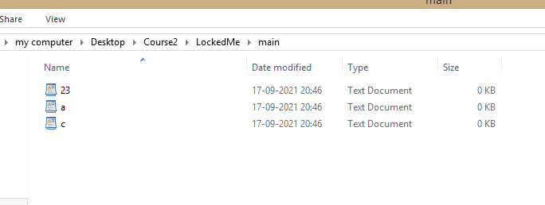

Deleing file-Deleting c.txt

\*\*\*\* Select any option number from below and press Enter \*\*\*\*

1) Add a file to 'main' folder

2) Delete a file from 'main' folder

3) Search for a file from 'main' folder

4) Show Previous Menu

2

Enter the name of the file need to be deleted from 'main' folder

c.txt

c.txt deleted successfully

\*\*\*\* Select any option number from below and press Enter \*\*\*\*

1) Add a file to 'main' folder

2) Delete a file from 'main' folder

3) Search for a file from 'main' folder

4) Show Previous Menu

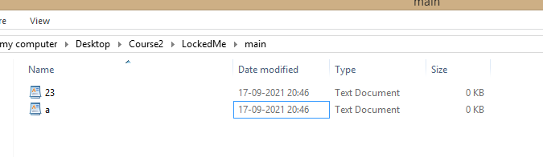

Searching file-a.txt-

\*\*\*\* Select any option number from below and press Enter \*\*\*\*

1) Add a file to 'main' folder

2) Delete a file from 'main' folder

3) Search for a file from 'main' folder

4) Show Previous Menu

3

Enter the name of the file to be searched from 'main' folder

a.txt

Success-File found in main directory

\*\*\*\* Select any option number from below and press Enter \*\*\*\*

1) Add a file to 'main' folder

2) Delete a file from 'main' folder

3) Search for a file from 'main' folder

4) Show Previous Menu

Going to previous menu-

\*\*\*\* Select any option number from below and press Enter \*\*\*\*

1) Add a file to 'main' folder

2) Delete a file from 'main' folder

3) Search for a file from 'main' folder

4) Show Previous Menu

4

\*\*\*\* Select any option number from below and press Enter \*\*\*\*

1) Retrieve all files inside 'main' folder

2) Display menu for File operations

3) Exit Application

Displaying files in ascending order-

\*\*\*\* Select any option number from below and press Enter \*\*\*\*

1) Retrieve all files inside 'main' folder

2) Display menu for File operations

3) Exit Application

1

Displaying all files in ascending order

23.txt

a.txt

\*\*\*\* Select any option number from below and press Enter \*\*\*\*

1) Retrieve all files inside 'main' folder

2) Display menu for File operations

3) Exit Application

Exiting application-

\*\*\*\* Select any option number from below and press Enter \*\*\*\*

1) Retrieve all files inside 'main' folder

2) Display menu for File operations

3) Exit Application

3

Program exited successfully.

And it is terminated-

