Login page-New users can sign up, Existing users can sign in. Admin credentials are added before only in database.

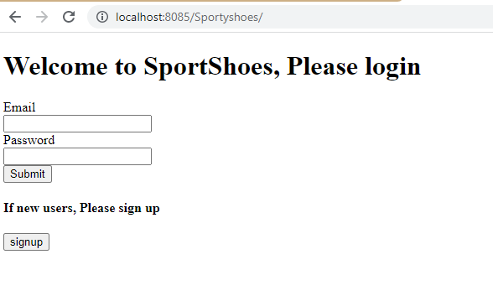

Signup-New user, Clicking submit will add new user data to database.

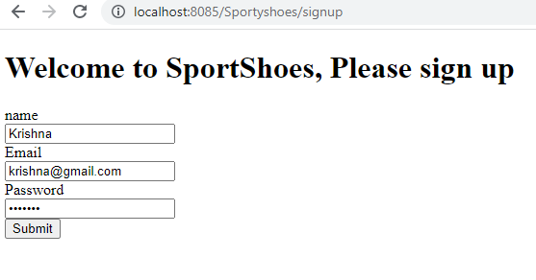

Current users list in database-Admin will have roleid=1, Other users will have roleid=2

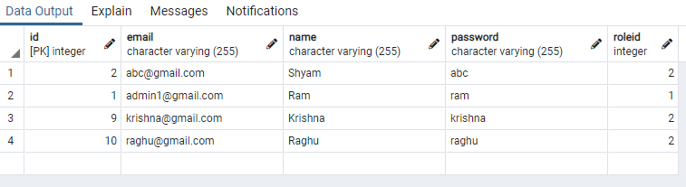

Signing with admin credentials-

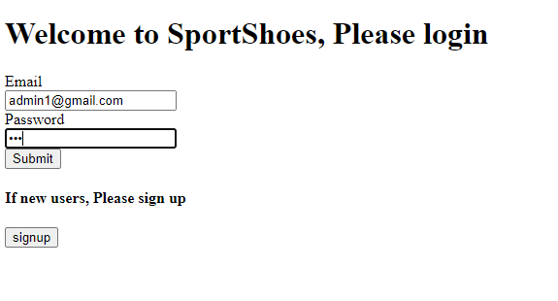

Admin page-

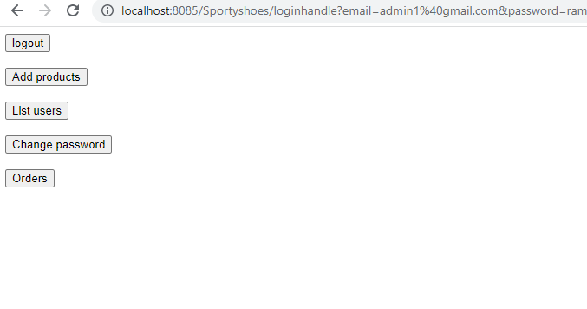

Admin can see all users by clicking list users button-

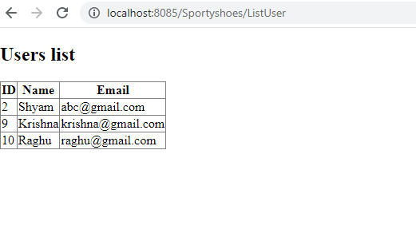

Admin can change his password-(changing from ram to Ram)

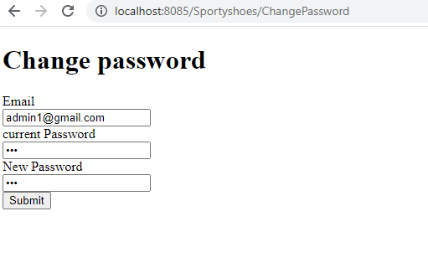

Password is updated in database-

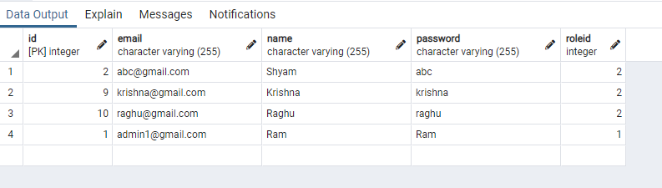

Admin can add products by clicking add products-By filling form provided, Admin can add products by categorizing men and women products.

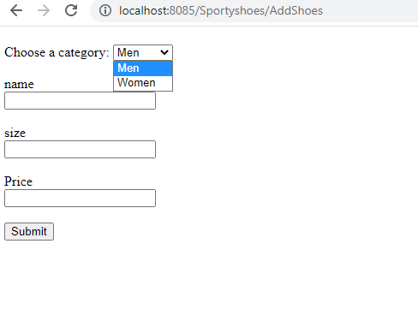

Adding product using form-

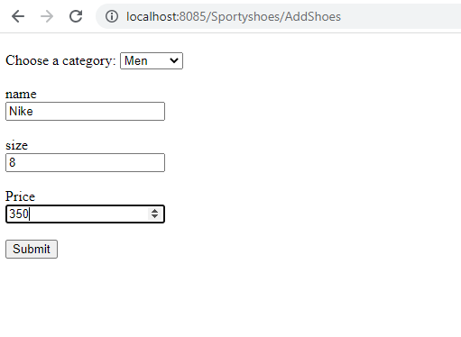

Current products list in database added by using form provided-Men shoes will have category=1 and women shoes will have category=2

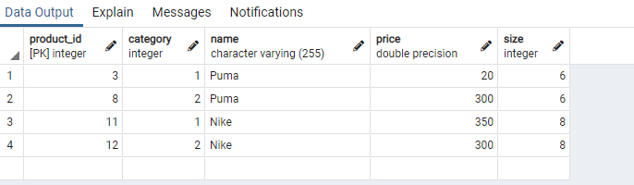

Clicking logout-Will logout and provide login page-

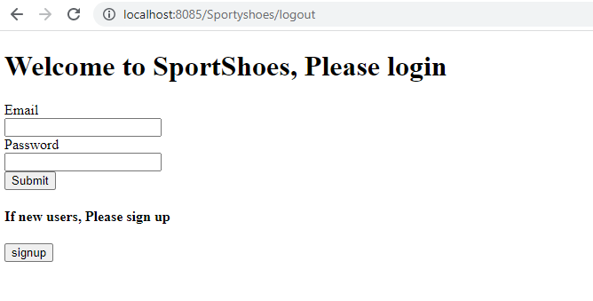

Now signing with Krishna credentials-User can select Men shoes or Women shoes button

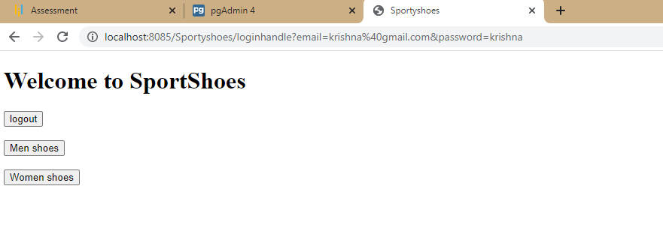

Clicking Men shoes-

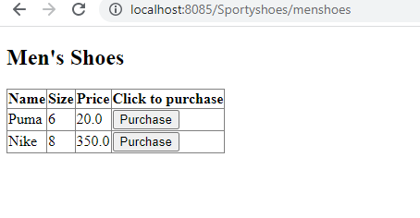

Clicking purchase-Will add data to orders list-

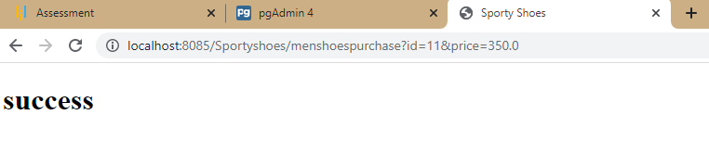

Similar results for Womens shoes-

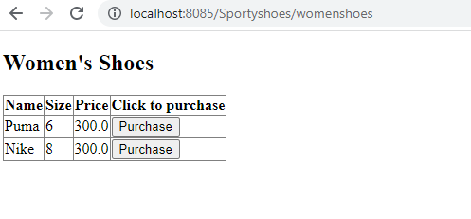

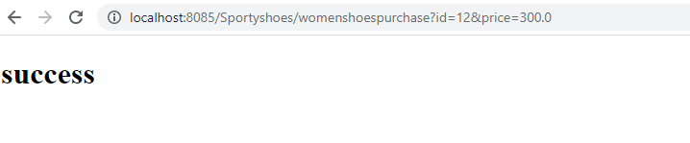

Clicking logout-Will logout and load sign in page

Now lets see Purchase reports from admin page-

Clicking Orders button from admin page-Shows all orders list filtered by category and date

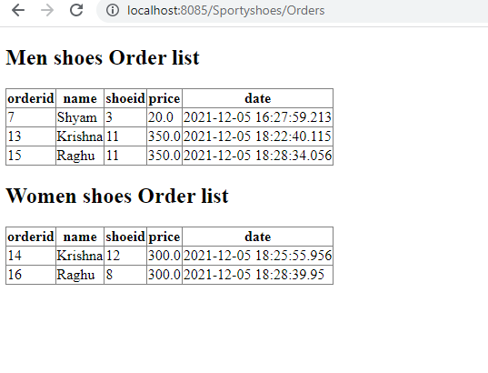

Orders table from database-

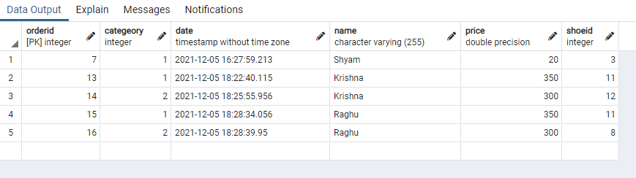

Covered all input and output screenshots in this file.

Thank You.