**Learning Management System**

**Internship Report**

**Internship for MCA-IV**

Submitted in partial fulfillment of the requirements

For the degree of

**Master of Computer Application**

By

**DEEPAK RAGHVENDRA RATHORE**

**20MCA014**

Guided By

**DR. SAURIN PARIKH**

**DEPARTMENT OF COMPUTER SCIENCE & ENGINEERING**



**DEPARTMENT OF COMPUTER SCIENCE & ENGINEERING**

**Ahmedabad 382481**

CERTIFICATE

This is to certify that the major project entitled “Learning Management System” submitted by DEEPAK RAGHVENDRA RATHORE (20MCA014), towards the partial fulfillment of the requirements for the degree of Master of Computer Application of Nirma University is the record of work carried out by him/her under my supervision and guidance. In my opinion, the submitted work has reached a level required for being accepted for examination.



|  |  |
| --- | --- |
| Dr. Saurin Parikh Associate Professor  Computer Science and Engineering Dept., Institute of Technology,  Nirma University, Ahmedabad | Dr. Madhuri Bhavsar, Professor and HOD,  Computer Science and Engineering Dept., Institute of Technology,  Nirma University, Ahmedabad |



Director

Institute of Technology,

Nirma University,

Ahmedabad

**Statement of Originality**

I, Deepak Raghvendra Rathore, Roll no: 20MCA014, give undertaking that the Major Project entitled “**Learning Management System”** submitted by me, towards the partial fulfilment of the requirements for the degree of Master of Computer Application of Institute of Technology, Nirma University, Ahmedabad, contains no material that has been awarded for any degree or diploma in any university or school in any territory to the best of my knowledge. It is the original work carried out by me and I give assurance that no attempt of plagiarism has been made. It contains no material that is previously published or written, except where reference has been made. I understand that in the event of any similarity found subsequently with any published work or any dissertation work elsewhere; it will result in severe disciplinary action.



Signature of Student

Date: 10-05-2022

Place: Vadodara, Gujarat

Endorsed by

Dr. Saurin Parikh

(Signature of Guide)

**Index**

|  |  |  |
| --- | --- | --- |
| **Chapter** | **Title** | **Page No** |
|  | **ACKNOWLEDGMENT** | **VI** |
|  | **ABSTRACT** | **VII** |
|  | **LIST OF FIGURES** | **VIII** |
|  | **LIST OF TABLES** | **X** |
| **1** | **INTRODUCTION** | **1** |
|  | **1.1 ABOUT THE COMPANY** | **1** |
|  | 1.1.1 Introduction of the company | **1** |
|  | 1.1.2 Services for Tech Needs | **1** |
|  | 1.1.3 Quality policy | **1** |
|  | **1.2 THE SYSTEM** | **2** |
|  | 1.2.1 Definition of system | **2** |
|  | 1.2.2 Purpose and objectives | **2** |
|  | 1.2.3 About present system | **2** |
|  | 1.2.4 Proposed system | **2** |
|  | **1.3 PROJECT PROFILE** | **3** |
|  | 1.3.1 Project title | **3** |
|  | 1.3.2 Scope of project | **3** |
|  | 1.3.3 Hardware/Software environment in company | **3** |
| **2** | **SYSTEM ANALYSIS** | **4** |
|  | **2.1 FEASIBILITY STUDY** | **4** |
|  | 2.1.1 Operational feasibility | **4** |
|  | 2.1.2 Technical feasibility | **4** |
|  | 2.1.3 Financial and Economical feasibility | **4** |
|  | 2.1.4 Handling Infeasible Projects | **4** |
|  | **2.2 CONTEXT DIAGRAM** | **5** |
|  | **2.3 DATA FLOW DIAGRAMS** | **6** |
|  | 2.3.1 First level DFD | **6** |
|  | 2.2.2 Second level DFD | **7** |
| **3** | **SYSTEM DESIGN** | **9** |
|  | 3.1 Activity Diagrams | **9** |
|  | 3.2 Use case diagram | **14** |
|  | 3.3 Entity-Relationship diagram | **16** |
|  | 3.3 Data dictionary | **17** |
| **4** | **USER MANUALS** | **21** |
| **5** | **TESTING** | **36** |
| **6** | **FUTURE ENHANCEMENT** | **38** |
| **7** | **APPENDIX** | **39** |
| **8** | [**BIBLIOGRAPHY**](https://docs.google.com/document/d/1dY6JGzmR7Q1JIV2dHl-r7IB6XcWGiIAw7oXNZ069D5A/edit#heading=h.6zdbqfauyy3m) | **40** |

**ACKNOWLEDGEMENT**

I would like to thank Dr. Saurin Parikh and Dr. Smita Agrawal who provided me guidelines throughout the course of the internship.

I would like to thank Ms. Bhumika Pandya Mam for her valuable and constructive suggestions during the planning and development of this Project work. Her constant support has been very much appreciated. I am thankful to and fortunate enough to get constant encouragement, support and guidance from all company employees of RISHABH SOFTWARE PVT. LTD who helped me in successfully completing the project work.

Not missing the opportunity to thanks the MCA department for giving me the opportunity to gain hands-on experience and understand the need for experience and a professional environment.

I would also like to thank my family and friends for their help and encouragement during my studies and especially during my internship.

Thanks and Regards,

Deepak Rathore (20MCA014)

**ABSTRACT**

The Learning Management System, abbreviated as LMS, is a platform that helps provide  
online content for learning purposes. A technical definition for this would be, a Learning Management System (LMS) is a web-based software used to facilitate the delivery of online or face to face courses.

Learning Management System is a platform where every training related work will be managed. The Proposed system will provide course to authorize and registered users in Course section where they can view the courses, and download the materials. The system will help to schedule training and keeping a record of attendees in the training which will help in verifying the criteria for certification.

This way the system is designed is such that it will help Rishabh software Pvt. Ltd in facilitating trainings

**LIST OF FIGURES**

|  |  |  |
| --- | --- | --- |
| **Sr. No** | **Figure Name** | **Page Number** |
| 1 | Figure 2.2 Context Diagram | 5 |
| 2 | Figure 2.3.1 First Level DFD | 6 |
| 3 | Figure 2.3.2.1 Second Level DFD-1 | 7 |
| 4 | Figure 2.3.2.2 Second Level DFD-2 | 8 |
| 5 | Figure 3.1.1 Admin Login Activity | 9 |
| 6 | Figure 3.1.2 User Login Activity | 10 |
| 7 | Figure 3.1.3 Admin- Add Course Activity | 11 |
| 8 | Figure 3.1.4 Admin- Training Activity | 12 |
| 9 | Figure 3.1.5 Trainer- Creating Assessment Activity | 13 |
| 10 | Figure 3.2 Use Case Diagram | 14 |
| 11 | Figure 3.3 ER Diagram | 16 |
| 12 | Figure 4.1.1 Admin-Login page | 21 |
| 13 | Figure 4.1.2 Admin-Dashboard page | 21 |
| 14 | Figure 4.1.3 Admin-Authorize user landing page | 22 |
| 15 | Figure 4.1.4 Admin-Authorize user add page | 23 |
| 16 | Figure 4.1.5 Admin-Batch landing page | 23 |
| 17 | Figure 4.1.6 Admin-Add Batch page | 24 |
| 18 | Figure 4.1.7 Admin-Course landing page | 24 |
| 19 | Figure 4.1.8 Admin-Add Course page | 25 |
| 20 | Figure 4.1.9 Admin-Schedule Training landing page | 25 |
| 21 | Figure 4.1.10 Admin- Schedule Training page | 26 |
| 22 | Figure 4.2.1 Trainer Login Page | 27 |
| 23 | Figure 4.2.2 Trainer Register Page | 27 |
| 24 | Figure 4.2.3 Trainer Dashboard page | 28 |
| 25 | Figure 4.2.4 Trainer-Trainings page | 28 |
| 26 | Figure 4.2.5 Trainer-attendance Page | 29 |
| 27 | Figure 4.2.6 Trainer –Mark Attendance page | 29 |
| 28 | Figure 4.2.7 Trainer – Assessments Page | 30 |
| 29 | Figure 4.2.8 Trainer- Create Assessment page | 30 |
| 30 | Figure 4.2.9 Trainer- view Assessment Page | 31 |
| 31 | Figure 4.3.1 Trainee –dashboard page | 32 |
| 32 | Figure 4.3.2 Trainee – Courses Page | 32 |
| 33 | Figure 4.3.3 Trainee- Trainings Page | 33 |
| 34 | Figure 4.3.4 Trainee -Attendance Page | 33 |
| 35 | Figure 4.3.5 Trainee- Assessments Page | 34 |
| 36 | Figure 4.3.6 Trainee-Give Assessments Page | 34 |
| 37 | Figure 4.3.7 Trainee-Assessments Result Page | 35 |

**LIST OF TABLES**

|  |  |  |
| --- | --- | --- |
| **Sr. No** | **Table Name** | **Page Number** |
| 1 | Table 3.2.1 Admin (L&D Manager) use case description | 13 |
| 2 | Table 3.2.2 Trainer use case description | 14 |
| 3 | Table 3.2.3 Trainee use case description | 15 |
| 4 | Table 5.1 Registration module | 16 |
| 5 | Table 5.2 login module | 17 |

**1. INTRODUCTION**

**1.1 ABOUT THE COMPANY**

**1.1.1 Introduction of the company**

Rishabh Software PVT. LTD. established in Year 2000.

• From the start, the vision was clear – to empower businesses with world-class software Solutions.

• They did this by tapping into local talent in their home state of Gujarat by building a

Platform for budding software developers to grow and nurture their careers.

• They did this by tapping into local talent in their home

• They set their CMMI level-3 with 1000+ successful projects.

**1.1.2 Services for Tech Needs**

Data Analytics

• Cloud Applications

• Enterprise Software

• Digital Experience

• Enterprise Mobile Application

• Software Testing and QA

• DevOps Services

• Digital Process Automation

**1.1.3 Quality Policy**

Rishabh is committed to provide timely and reliable services in Software Solutions through customer centric approach and using state-of-art technology

* IT Training by helping in enhancement of skills and expertise
* Achieve customer satisfaction
* Through continual improvement in their performance by effective deployment of international standards for quality management
* Encouraging teamwork and providing an environment conducive to individual and group growth and development

**1.2 THE SYSTEM**

**1.2.1 Definition of system**

Learning Management System is a platform where three different types of users perform various activities related to trainings. The system provides a platform where the trainees can learn courses by themselves by viewing or downloading the course content and can also by attending the face-to-face session whose details will be shown in the system when they are created by the admin. The system is also used to store attendance and assessments that are created by the trainer and also displays the marks of the trainee for better understanding the trainee progress, basically the system helps in facilitating trainings and course content with keeping a track record of it.

**1.2.2 Purpose and objectives**

To develop and deliver a robust, configurable, user-friendly LMS application, which will help the organization internal stakeholders to:

* Track the training progress, plan trainings, facilitate trainings and assess the effectiveness of the trainings conducted.
* To reduce manual activities and time consumed in facilitating trainings and conducting pre/post assessments. To avoid collapsing of two schedule training with respect to time, venue and availability of the trainer.
* To store course data at one place so every trainee can access it whenever needed

**1.2.3 About present system**

The current system includes all manual work and all the trainings that are carried out are schedule manually by checking the availability of the trainer, venue and timings. The attendance and assessments are taken manually and are stored in a file manually.

**1.2.4 Proposed system**

The Proposed system will eliminate the manual work and will help to facilitate trainings more efficiently and time saving. The proposed system will also collect the data and store it at one place which can be accessed through anywhere.

**1.3 PROJECT PROFILE**

**1.3.1 Project title**

Learning Management System

**1.3.2 Scope of project**

The purpose of the Learning Management System is to improve the learning process for Trainees and manage the training activity smoothly.

The three basic user of the system are

1. L&D manager (Admin)

2. Learner (Trainee)

3. Trainer

The benefits of having LMS is that Trainees can learn the course as per their convenience.

The system will manage the flow of training as it will assign the trainer as per their availability and every registered trainee will get to see the details in the system regarding it, so there will be no miss communication.

The system will be designed in such a way that it will hold all the details of all the physical trainings conducted like numbers of attendees, venue, date, time etc.

The system will be able to store assessments' and generate marks. The attendance will also be marked in the system of the trainees

**1.3.4 Hardware/Software environment in company**

**Processor:** Intel(R) Core(TM) i5-7200U CPU @ 2.50HGz 2.71 GHz  
**Memory:** 8GB

**Software Environment**

Frontend: HTML, CSS, JavaScript, JQuery, Bootstrap

Framework: Laravel

Backend: PHP, SQL

Database: MySQL

**2. SYSTEM ANALYSIS**

**2.1 FEASIBILITY STUDY**

2.1.1 Operational feasibility

The system is designed in such a way that the organization needs can be met as it covers all the aspect that are currently needed to facilitate the trainings. As providing training to the Fresher’s is a new initiative by the organization the system will help in all the task to be carried out, hence the operational feasibility study shows that the system will meet the and satisfy the current requirement of the organization

2.1.2 Technical feasibility

All the technical resources required to for the system are present in the organization, the project is 100% technically feasible for the organization.

2.1.3 Financial and Economical feasibility

The study was carried out and the expected outcome was beneficial as the system aims to provide training assistant and carry out various activities like taking attendance and assessments and the system also store the data of the trainee at one place which will reduce the storage cost of external entities.

2.1.4 Handling Infeasible projects

We have validated the scalability of the project and also estimated time, cost, scope and quality of the project. We have overcome challenges regarding the same and thereby eliminating the chances of the project being infeasible. Thus the current project is highly feasible.

**2.2 CONTEXT DIAGRAM**

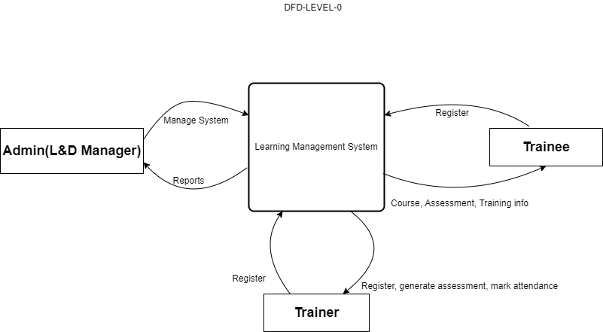

Figure: 2.2 Context Diagram

**Description**: The Flow of the System has three entities, the Admin, The Trainee and The trainer. The admin will manage the system such as managing user, batch, course, trainings and generating reports whereas the Trainee will view his assigned trainings, mark attendance and create assessments. The Trainee will view courses, give assessment, view assessment marks and training such as training scheduled and attendance

**2.3 DATA FLOW DIAGRAMS**

2.3.1 First level DFD

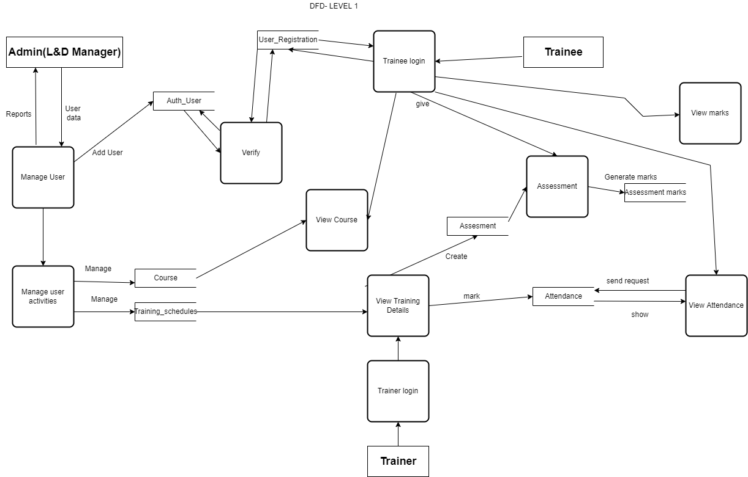

Figure: 2.3.1 First level DFD

2.3.2 Second level DFD

2.3.2.1 Second level DFD-1

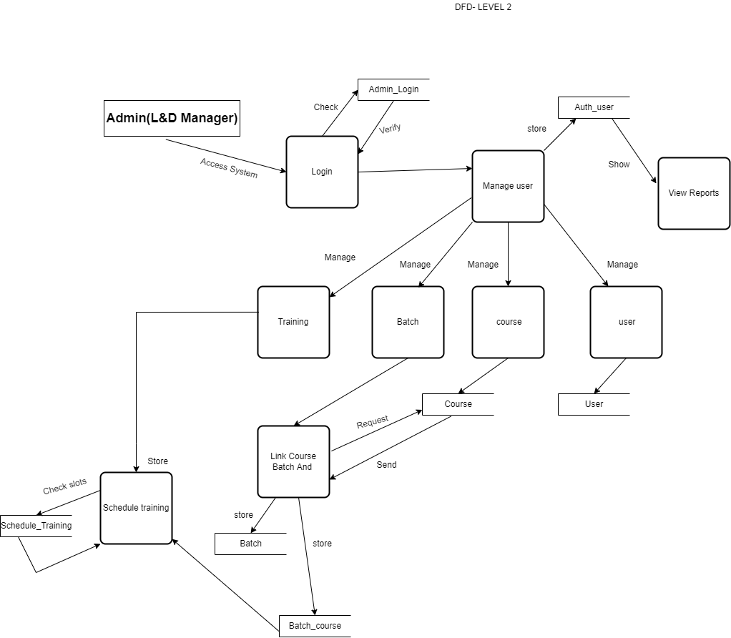

Figure: 2.3.2.1 Second level DFD-1

2.3.2.2 Second level DFD-2

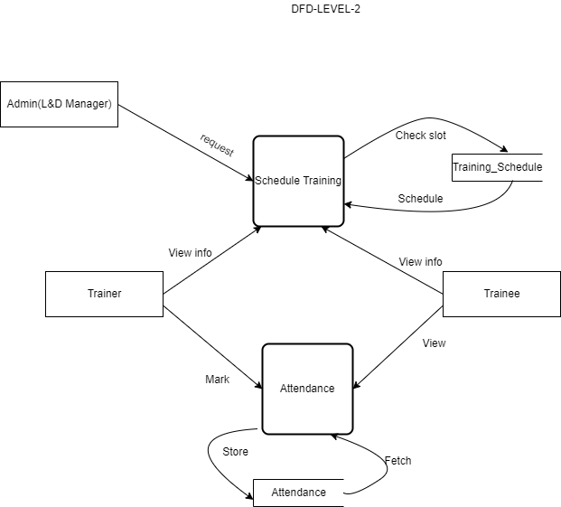

Figure 2.3.2.2 Second level DFD-2

**3. SYSTEM DESIGN**

**3.1 Activity Diagrams**

3.1.1 Admin Login Activity

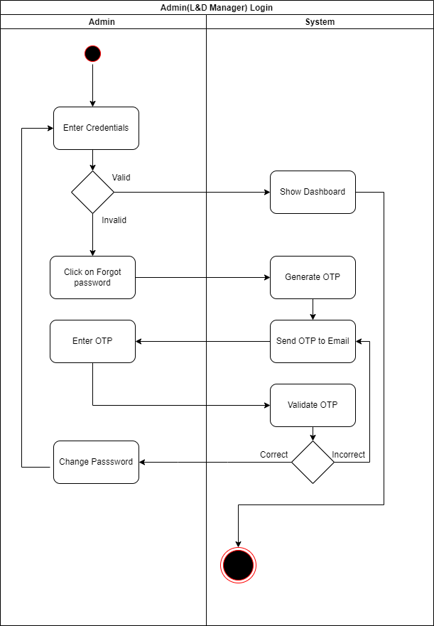

Figure 3.1.1 Admin Login Activity

**Description**: This is admin activity. The flow of activity will be as shown above when admin logs in to the system. The admin will enter credentials and if the credentials are valid, he will be redirect to dashboard page of admin. If he forgets his password he can reset it by clicking on forget password. An OTP will be sent to registered mail and will be validate. The admin will then be allowed to change the password and login into the system by entering credentials.

3.1.2 User Login Activity

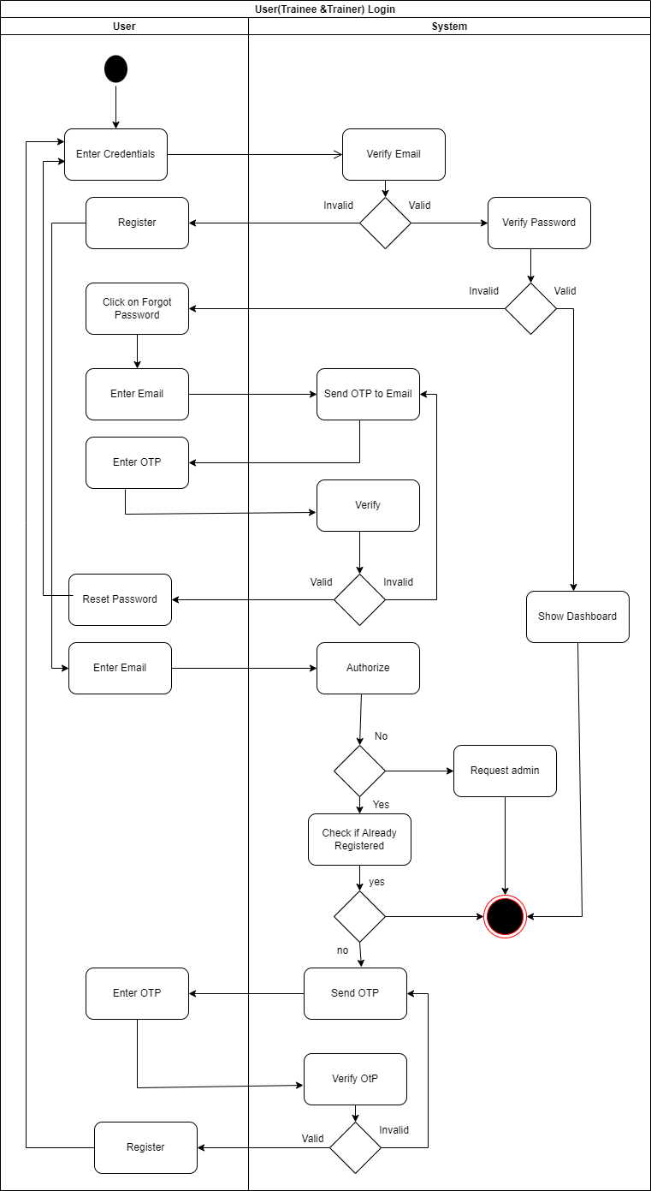

Figure 3.1.2 User Login Activity

**Description:** This is User login Activity which will be same for the trainer and trainee. The user will first enter credentials, email will be first verified at the backend. If it’s valid then it will verify password. If both are correct than the user will be logged in

If the email is invalid, then it will ask to register, the user will enter the email id and an OTP will be sent to it if the email is authorized by the admin to register. If the password is invalid then the user can click on forget password link and an OTP will be sent to the user to reset the password.

3.1.3 Admin - Add course Activity

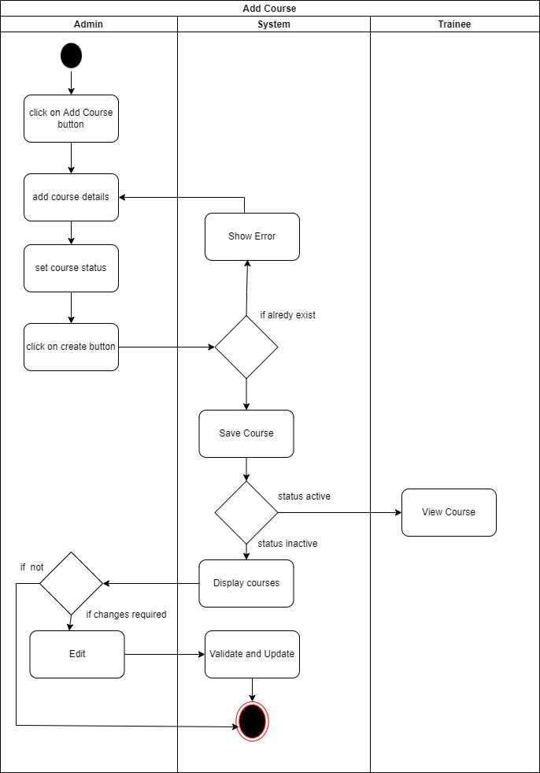

Figure 3.1.3 Admin - Add course Activity

**Description:** This is adding course activity for admin. The admin will add the course details by clicking on create course button and the system will check if the course already exists or not. If it does not exist the course will be store in the system and the allotted trainee will be able to see the course material

3.1.4 Admin – Training Scheduling

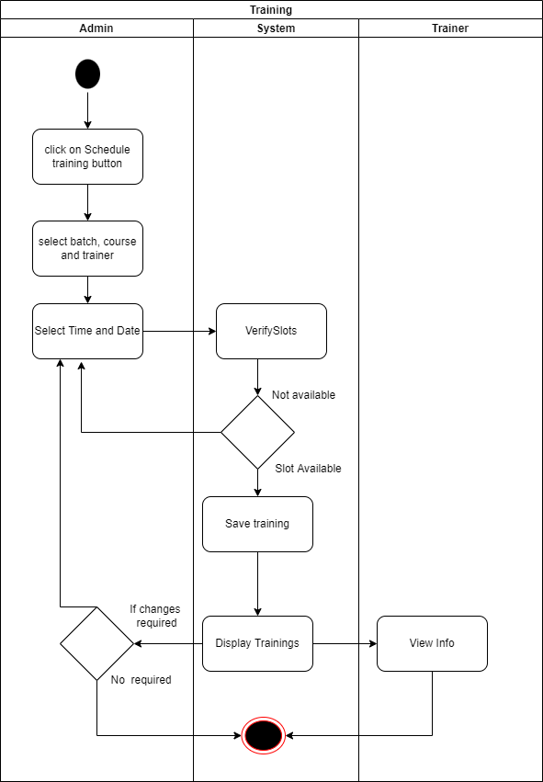

Figure: 3.1.4 Admin – Training Scheduling

**Description**: This is activity fir admin to schedule trainings. The admin will click on schedule training button and a form will open where he will select for which batch and course will be the trainings need to be schedule. The admin will select date and time if the date and time conflicts with other trainings. It will prompt a message and the admin has to again select date and time and click on save button. The trainings will be show to trainee and trainers

3.1.5 Trainer-Creating Assessment Activity

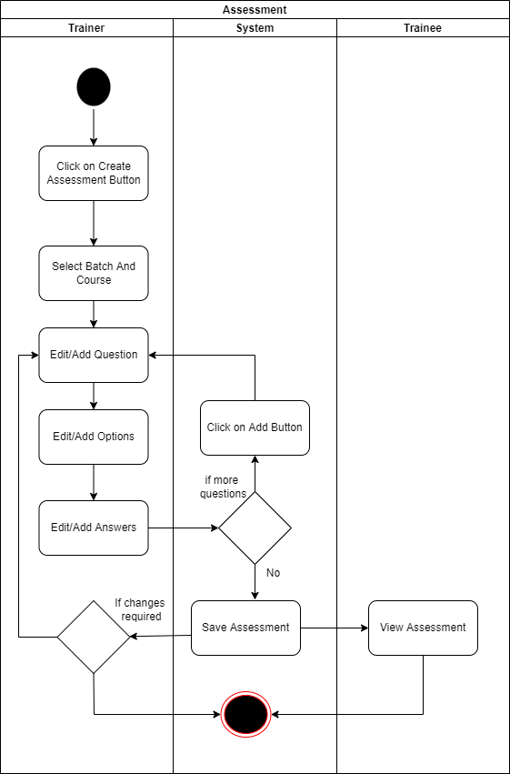

Figure: 3.1.5 Trainer-Creating Assessment Activity

**Description:** This is Activity of Trainer for Creating an Assessment in the system**.** The trainer will click on add assessment button and add the questions and answer as per the need by clicking on add more question button, it will load on client side through java script than he will save the assessment and the assessment will be displayed to the assigned trainee

**3.2 Use case diagram**

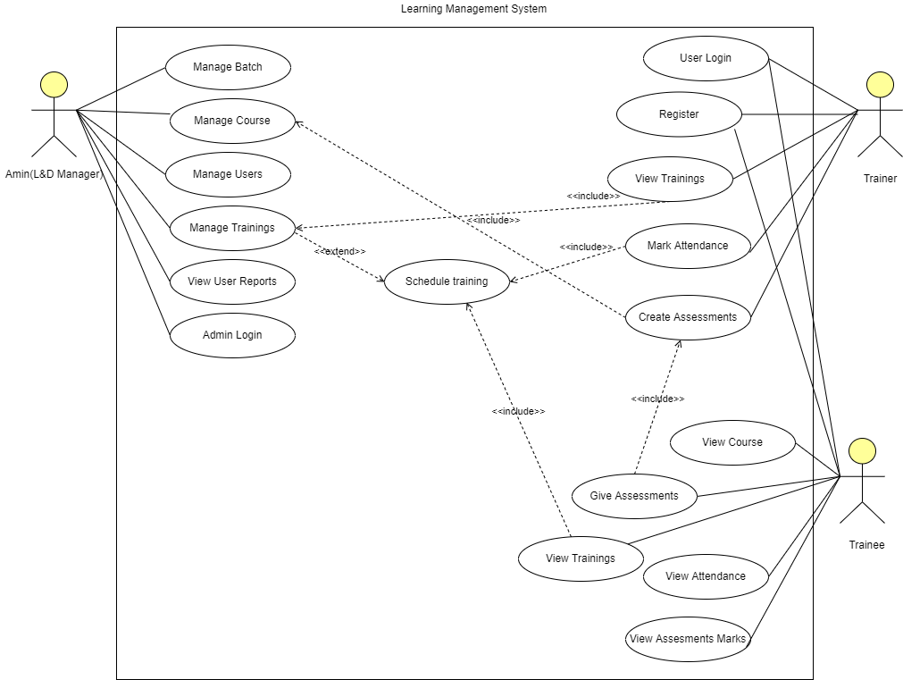

Figure: 3.2 Use Case Diagram

**Description of Use Cases**

Actor: Admin (L&D Manager)

|  |  |
| --- | --- |
| Use case | Description |
| Manage Batch | Adding, Updating or deleting a batch and linking course to batches |
| Manage Course | Adding, Updating or deleting a Course and adding course pdf materials |
| Manage Users | Authorizing a user to use the system |
| Manage Trainings | Schedule the trainings according to the availability of date time and venue |
| View User Reports | View reports of all the users of the system |
| Admin Login | Login in to the system by default id and password, password can be change by sending OTP. |

Table 3.2.1 Admin (L&D Manager) use case description

Actor: Trainer

|  |  |
| --- | --- |
| Use case | Description |
| User login | Login in to the system by entering credentials |
| Register | Registering if first time using the system and if authorized by the admin |
| View Trainings | View all the trainings that are schedule in 3 section i.e. today’s trainings, upcoming trainings and previous training |
| Mark Attendance | Marking attendance of previous training and present day’s training |
| Create Assessments | Creating assessments for trainees |

Table 3.2.2 Trainer use case description

Actor: Trainee

|  |  |
| --- | --- |
| Use case | Description |
| User login | Login in to the system by entering credentials |
| Register | Registering if first time using the system and if authorized by the admin |
| View Course | View and download the allotted course |
| View Trainings | View the allotted trainings |
| Give Assessments | Give the allotted assessments |
| View Attendance | View attendance of respective trainings |
| View Assessments Marks | View marks of submitted assessments |

Table 3.2.3 Trainee use case description

3.3 Entity-Relationship diagram

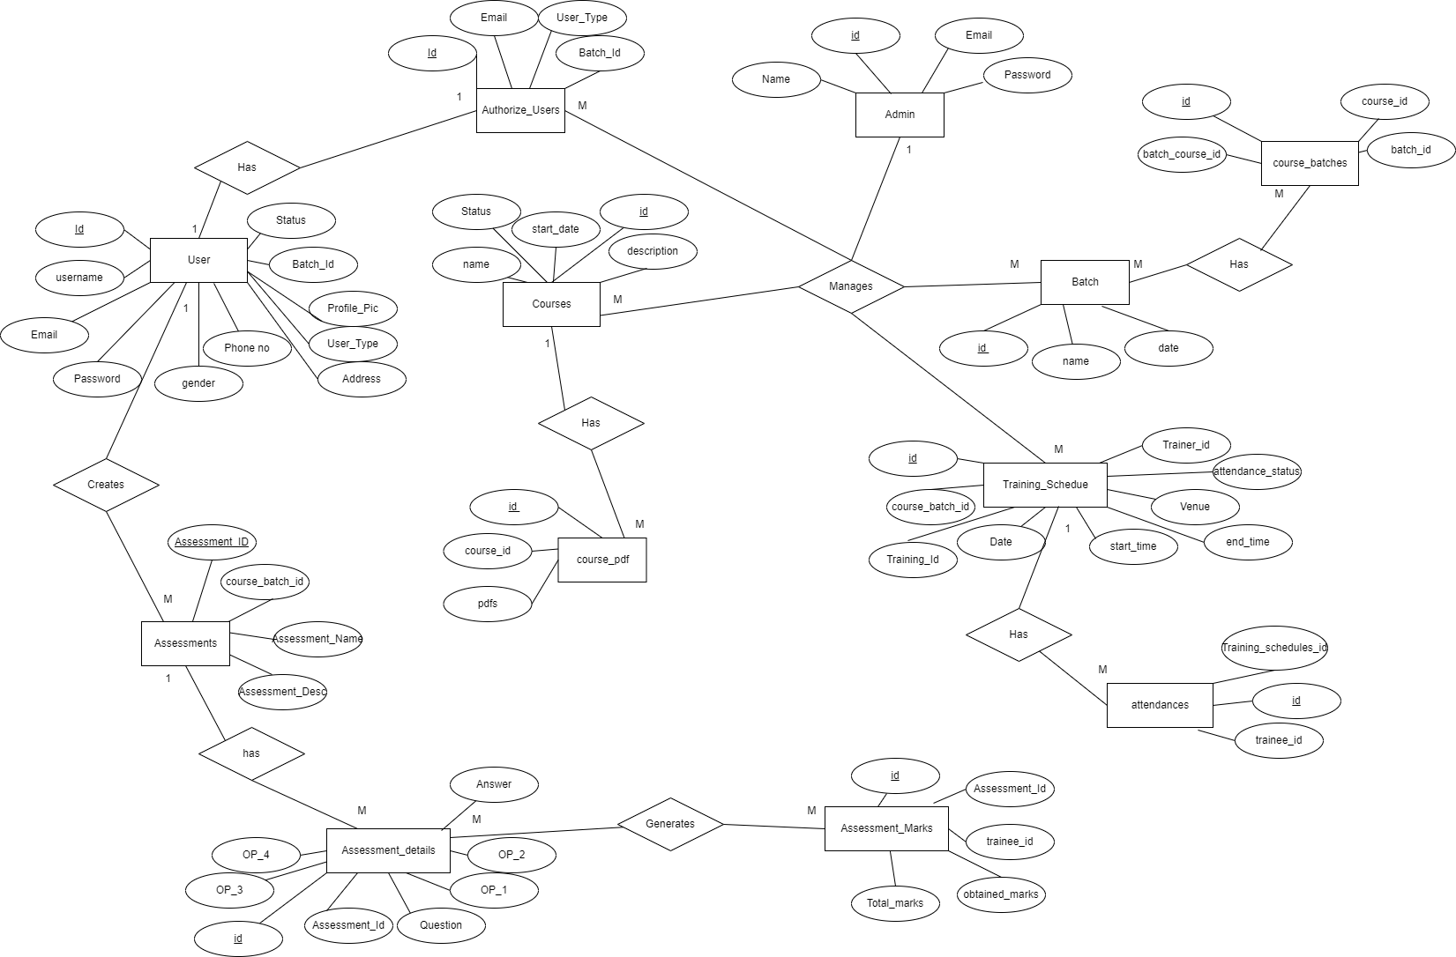

Figure 3.3 ER Diagram

3.3 Data dictionary

Admins

|  |  |  |  |  |
| --- | --- | --- | --- | --- |
| Field Name | Data type | Constraint | Description | Example |
| id (Primary) | bigint(20) | Primary Key | Id of admin | 001 |
| email | varchar(191) | NOT NULL | Email of admin | admin@admin.com |
| password | text | NOT NULL | Password of admin | admin |

Users

|  |  |  |  |  |
| --- | --- | --- | --- | --- |
| Field Name | Data type | Constraint | Description | Example |
| id (Primary) | bigint(20) | Primary Key | User unique id | 2 |
| username | varchar(191) | Not Null | User first name and last name combined | Meet Agrawal |
| email | varchar(191) | Not Null | Email of user verified by OTP | meetagrawal39@gmail.com |
| password | text | Not Null | Password of user | PeLeSMYdXz+lyShQflVRp50S1O  6IrhNHFSwjI4Iti9o= |
| gender | varchar(191) | Not Null | Gender of user | male |
| phone_no | varchar(191) | Not Null | Phone no of user | 9898562741 |
| address | text | Not Null | Address of user | anandvan society |
| user_type | varchar(191) | Not Null | Trainee or trainer | Trainee |
| status | enum('1', '0') | Not Null | 0 if active 1 if inactive | 0 |
| profile_pic | varchar(191) | Not Null | Profile pic url | Media/Profile_pics/1650183670_1.jpg |
| batch_id | varchar(191) | Foreign key | Batch id if the user is a trainee | 2022 |

Authorize users

|  |  |  |  |  |
| --- | --- | --- | --- | --- |
| Field Name | Data type | Constraint | Description | Example |
| id (Primary) | bigint(20) | Primary Key | Id of authorized user | 02 |
| email | varchar(191) | Not Null | email of authorized user | meet@gmial.com |
| user_type | varchar(191) | Not Null | Trainee or trainer | Trainee |
| batch_id | varchar(191) | Foreign Key |  | 2022 |

Courses

|  |  |  |  |  |
| --- | --- | --- | --- | --- |
| Field Name | Data type | Constraint | Description | Example |
| id | varchar(191) | Primary Key | Course id | 101 |
| name | varchar(191) | Not Null | Course name | HTML |
| status | varchar(191) | Not Null | Course status active or inactive | inactive |
| description | varchar(191) | Not Null | About course | Hypertext markup language and basics |
| start_date | timestamp | Not Null | Course starting date | 2022-01-10 |

Batches

|  |  |  |  |  |
| --- | --- | --- | --- | --- |
| Field Name | Data type | Constraint | Description | Example |
| id | varchar(191) | Primary Key | Batch id | 2020 |
| name | varchar(191) | Not Null | Batch name | 2020-freshers |
| date | timestamp | Not Null | Batch start date | 2020-01-10 |

Course batches

|  |  |  |  |  |
| --- | --- | --- | --- | --- |
| Field Name | Data type | Constraint | Description | Example |
| id (Primary) | bigint(20) | Primary Key | Course batch link id | 10 |
| batch_course_id | varchar(191) | Not Null Unique | Course batch link name | 2020_101 |
| course_id | varchar(191) | Foreign key | Course id to link with batch | 101 |
| batch_id | varchar(191) | Foreign key | Batch id | 2020 |

Course pdfs

|  |  |  |  |  |
| --- | --- | --- | --- | --- |
| Field Name | Data type | Constraint | Description | Example |
| id (Primary) | bigint(20) | Primary Key | Id of course and pdf auto incremented | 35 |
| course_id | varchar(191) | Foreign Key | Course id | 101 |
| pdf | varchar(191) | Not Null | Pdf to link with course | Media/PDFs/1650359251_1.pdf |

Training schedules

|  |  |  |  |  |
| --- | --- | --- | --- | --- |
| Field Name | Data type | Constraint | Description | Example |
| id (Primary) | bigint(20) | Primary Key | Id of training scheduled | 17 |
| course_batch_id | varchar(191) | Foreign key | For which batch and which course | 2022_104 |
| date | timestamp | Not Null | Date of training | 2022-05-10 |
| start_time | time | Not Null | Starting time | 14:00 |
| end_time | time | Not Null | Ending time | 15:00 |
| venue | varchar(191) | Not Null | Venue of training | Nalanda |
| trainer_id | varchar(191) | Foreign key | Id of trainer taking the training | 26 |
| attendance_status | varchar(191) | Not Null | Status of attendace(pending or done) | pending |

Attendances

|  |  |  |  |  |
| --- | --- | --- | --- | --- |
| Field Name | Data type | Constraint | Description | Example |
| id (Primary) | bigint(20) | Primary Key | Id of attendance | 4 |
| training_schedules_id | varchar(191) | Foreign key | Id of trainings whose attendance is taken | 10 |
| trainee_id | varchar(191) | Foreign key | Trainer id who took attendance | 2 |

Assessments

|  |  |  |  |  |
| --- | --- | --- | --- | --- |
| Field Name | Data type | Constraint | Description | Example |
| id (Primary) | bigint(20) | Primary Key | Id auto increment | 1 |
| course_batch_id | varchar(191) | Foreign key | Assement created for which course and batch | 2022_105 |
| assessment_id | varchar(191) | Not Null | Assessment id | 2022_105_das |
| assessment_desc | varchar(191) | Not Null | Description of assessment | Assessment on functions |
| created_by | varchar(191) | Not Null | Trainer id | 26 |

Assessment details

|  |  |  |  |  |
| --- | --- | --- | --- | --- |
| Field Name | Data type | Constraint | Description | Example |
| id (Primary) | bigint(20) | Primary Key | Id auto increment | 6 |
| assessment_id | varchar(191) | Foreign key | Assessment id | 2022_105_das |
| question | varchar(191) | Not Null | Questions | SQL database follows which of the following principles? |
| op1 | varchar(191) | Not Null | Option of the question | ACID |
| op2 | varchar(191) | Not Null | Option of the question | AGILE |
| op3 | varchar(191) | Not Null | Option of the question | SQL |
| op4 | varchar(191) | Not Null | Option of the question | DBMS |
| answer | varchar(191) | Not Null | Answer of the question | ACID |

Assessment marks

|  |  |  |  |  |
| --- | --- | --- | --- | --- |
| Field Name | Data type | Constraint | Description | Example |
| id (Primary) | bigint(20) | Primary Key | Id | 1 |
| assessment_id | varchar(191) | Foreign key | Assessment id | 2022_105_das |
| trainee_id | varchar(191) | Foreign Key | Trainee id | 2 |
| total_marks | varchar(191) | Not Null | Total marks of quiz | 10 |
| obtained_marks | varchar(191) | Not Null | Marks obtained | 8 |

**4. USER MANUALS**

4.1 Admin

4.1.1 Admin Login page

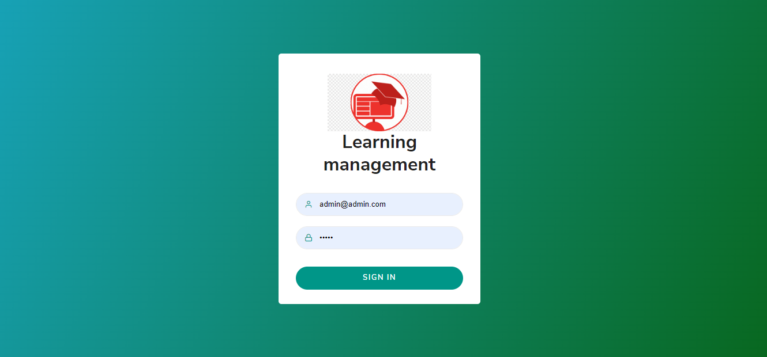

Figure: 4.1.1 Admin Login page

**Description**: The first page for admin. The admin will enter the credentials and will be redirected to the admin dashboard after successful login

4.1.2 Admin Dashboard page

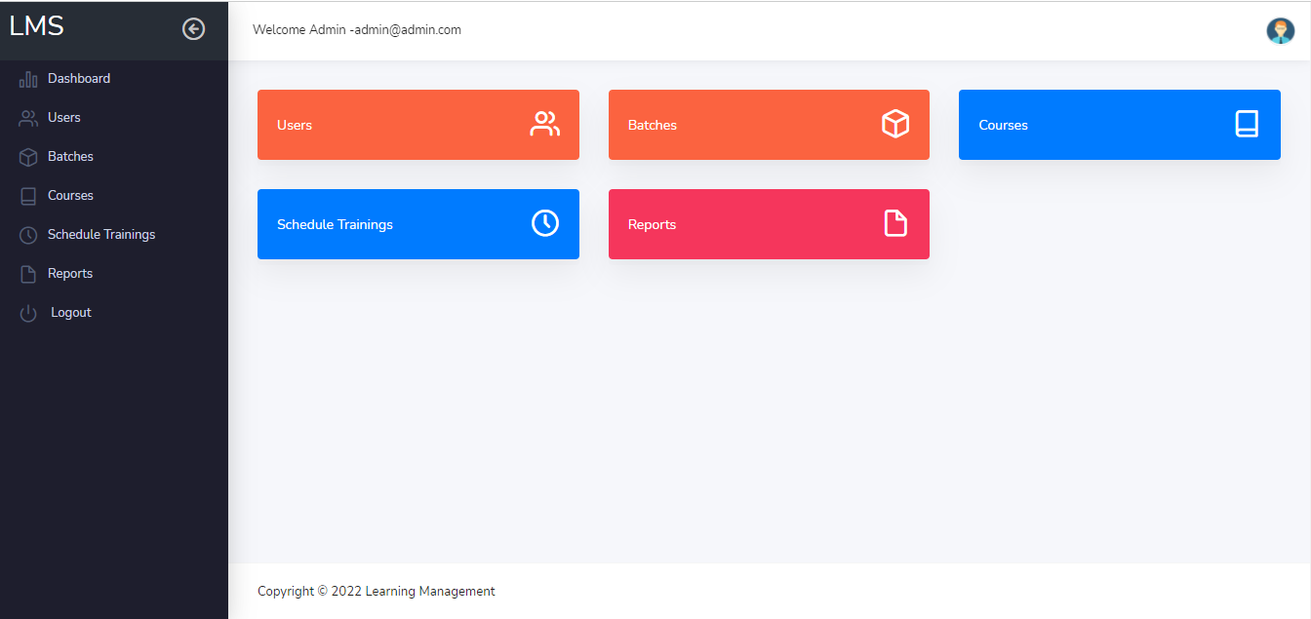

Figure: 4.1.2 Admin Dashboard page

**Description**: The admin dashboard has all the functionalities of the admin. Both the sidebar and the dashboard items will navigate to the same page of respective functionalities after clicking on it. The admin can logout from side bar as well from the top right corner by clicking in the profile pic a dropdown item will show logout option.

4.1.3 Admin Authorize user landing page

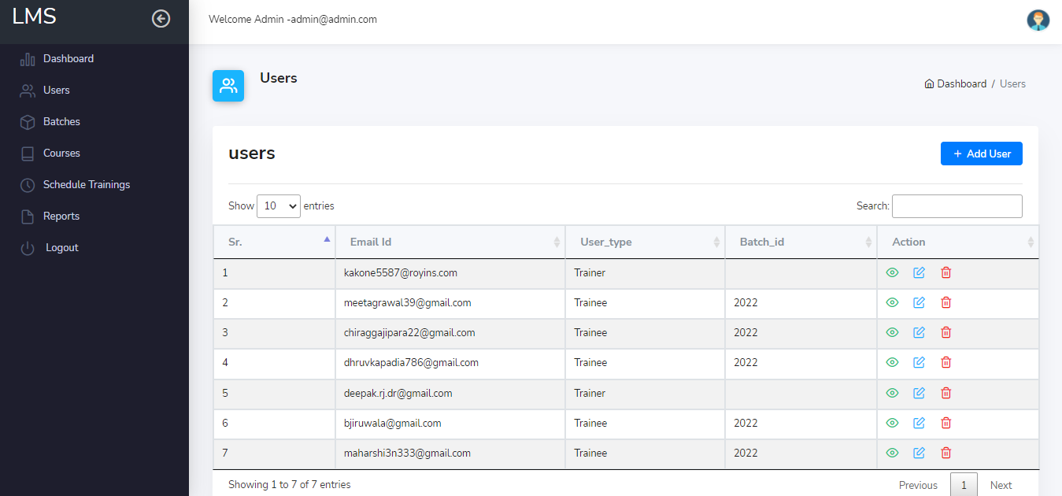

Figure: 4.1.3 Admin-Authorize user landing page

**Description**: by clicking on user from dashboard or side bar this page will open. Here the admin can view all the authorize users of the system and can view edit or delete them from the system. The add user button will let the admin to authorize a new user. The user can also be searched by typing the field name in search bar for which the result needs to be displayed.

4.1.4 Admin-Authorize user add page

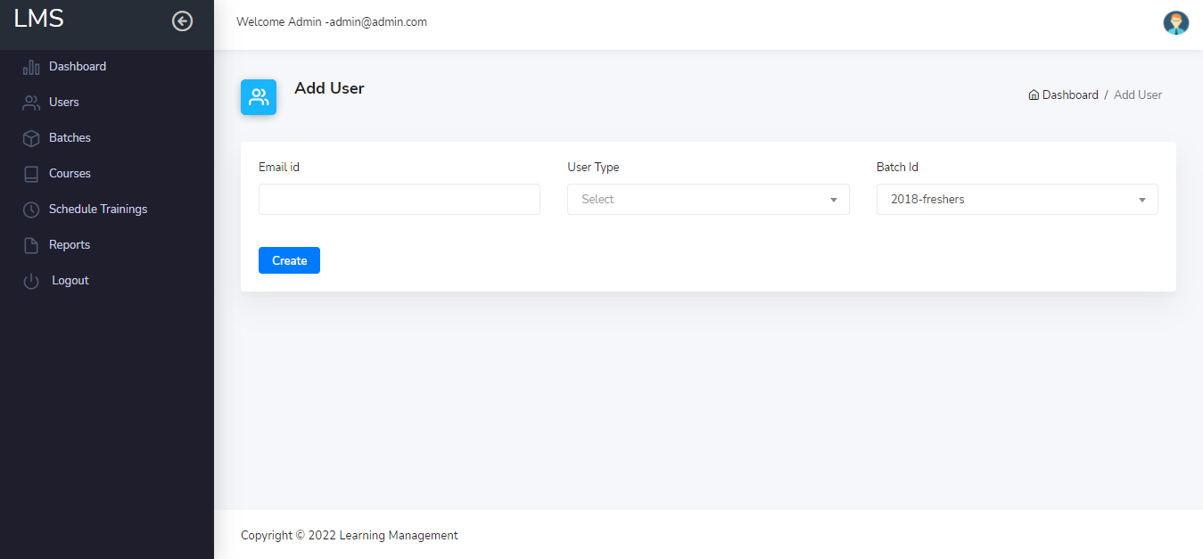

Figure: 4.1.4 Admin -Authorize user add page

**Description**: the admin will enter the email id of the user what needs to be authorized, the user type i.e. trainer or trainee and if the user is a trainee that he will specify the batch of the user.by clicking on the create button the user will be added to the system and then he/she can register in the system.

4.1.5 Admin -Batch landing page

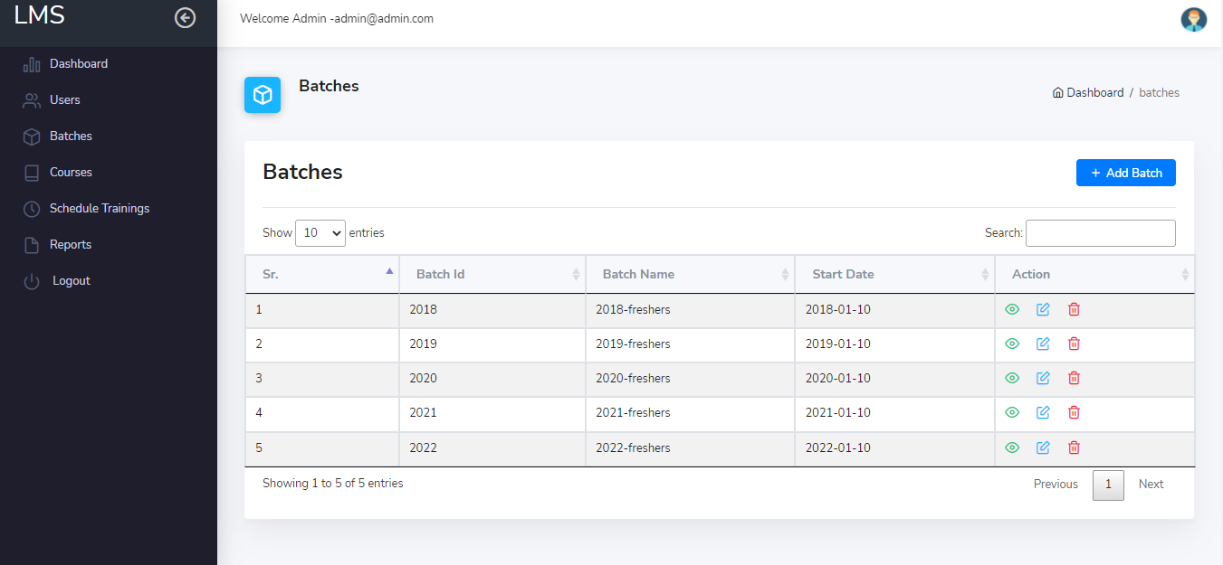

Figure: 4.1.5 Admin -Batch landing page

**Description**: by clicking on batch from dashboard or side bar this page will open. Here the admin can view all the batches created in the system and can view edit or delete them from the system. The add batch button will let the admin to create a new batch. The batch can also be searched by typing the field name in search bar for which the result needs to be displayed

4.1.6 Admin -Add Batch Page

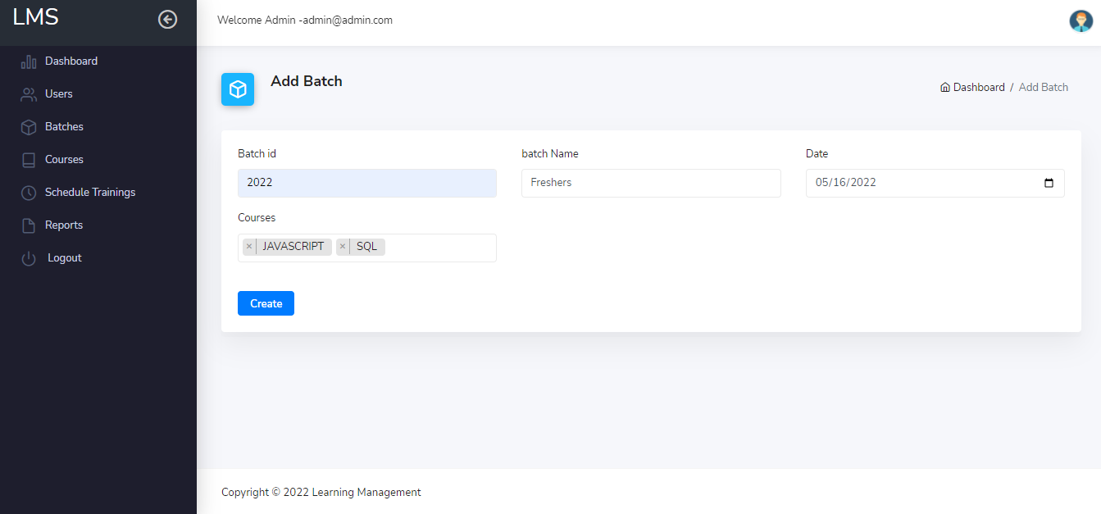

Figure: 4.1.6 Admin -Add Batch Page

**Description**: the admin will enter the Batch id, batch name and date of which the batch will start. The admin will than allocate course to the batch that are created in the system and will click on create button to add batch in the system.

4.1.7 Admin- Course landing page

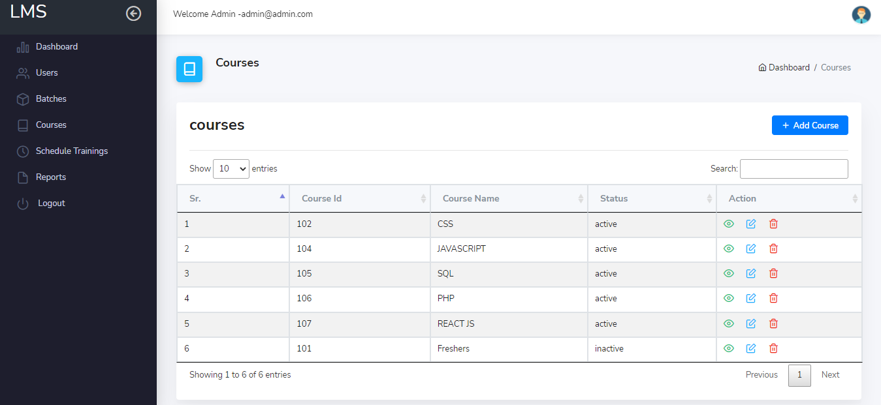

Figure: 4.1.7 Admin -Course landing page

**Description**: by clicking on courses from dashboard or side bar this page will open. Here the admin can view all the courses created in the system and can view edit or delete them from the system. The add course button will let the admin to create a new course. The course can also be searched by typing the field name in search bar for which the result needs to be displayed

4.1.8 Admin -Add course page

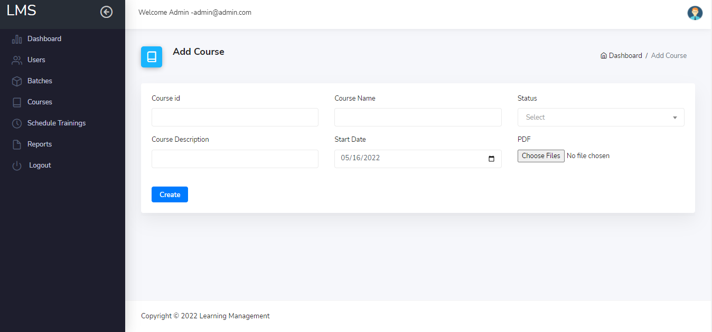

Figure: 4.1.8 Admin -Add course page

**Description**: the admin will enter the course id, course name, status, course description and start date. The admin will than add course material in the form of pdf from the local drive and will click on create button to add course in the system.

4.1.9 Admin -Schedule training landing page

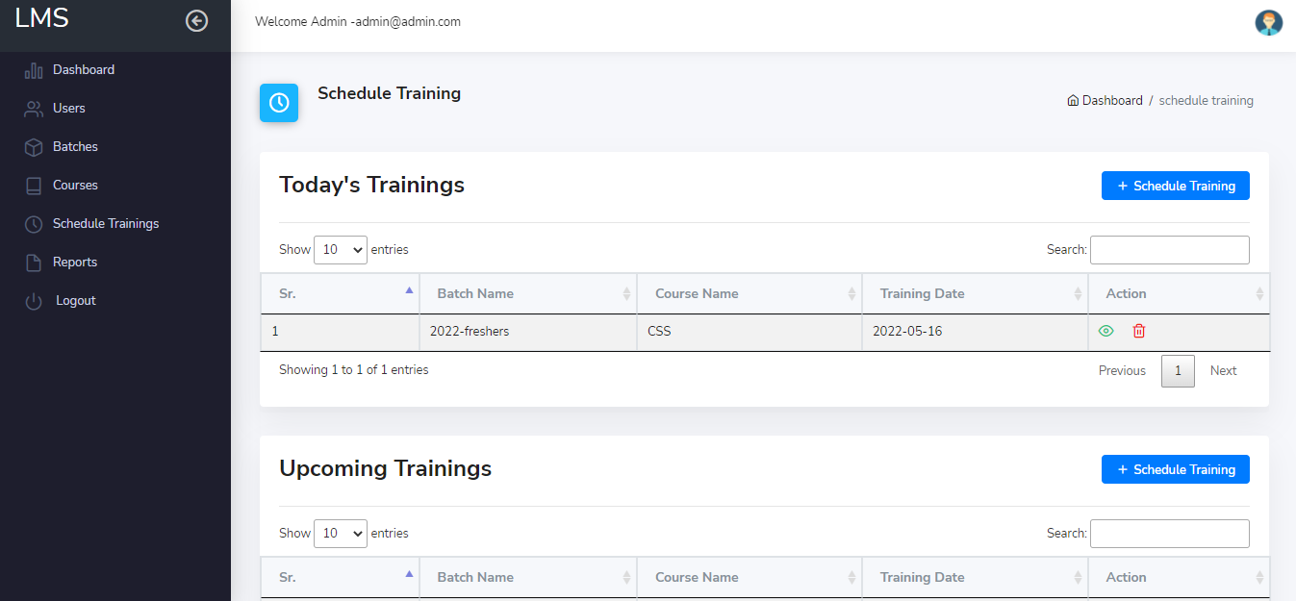

Figure: 4.1.9 Admin -Schedule training landing page

**Description**: The admin will be able to see the Trainings that are created for current date, previous date and upcoming dates. By clicking on schedule training he can schedule a new training. The trainings can also be searched by typing the field name in search bar for which the result needs to be displayed

4.1.10 Admin -Schedule training page

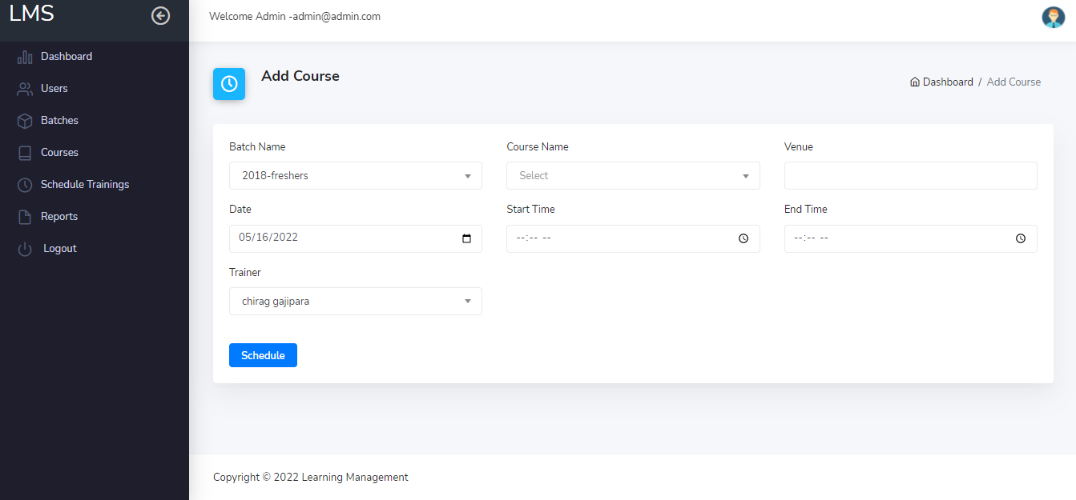

Figure: 4.1.10 Admin -Schedule training page

**Description**: here the admin will enter details for scheduling the training, the system will check the date, time, venue and trainer availability to avoid conflicts and then if there are no conflict then the training will be scheduled successfully.

4.2 Trainer

4.2.1 Trainer Login Page

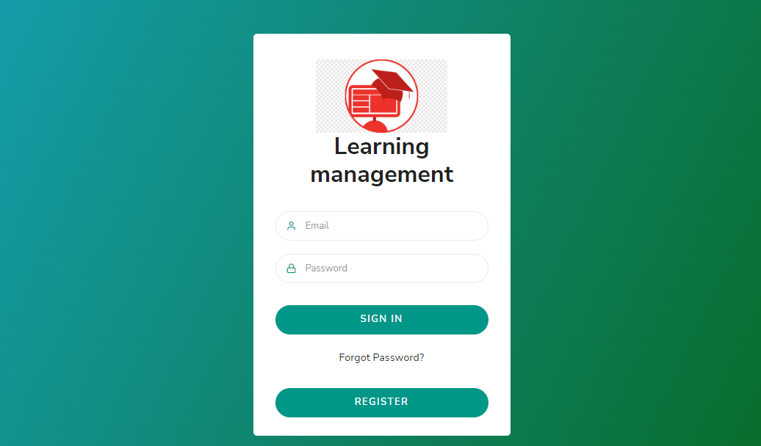

Figure 4.2.1 Trainer Login page

**Description**: Login for users (Trainee and Trainer) by clicking on sign, if the user is trainer he would be redirected to trainer dashboard and if it’s a trainee he will be redirected to trainee dashboard.

4.2.2 Trainer Register Page

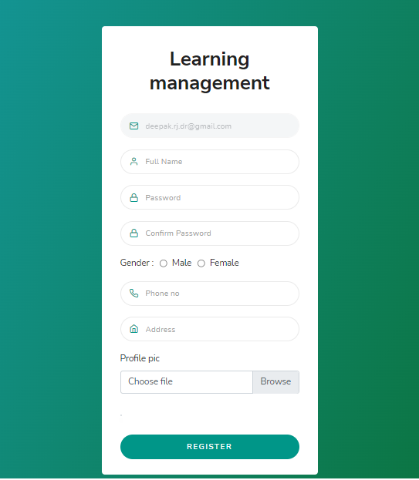

Figure: 4.2.2 Trainer Register page

**Description**: The user will register if he/she is authorized in the system and will be redirected to login page after registering.

4.2.3 Trainer Dashboard Page

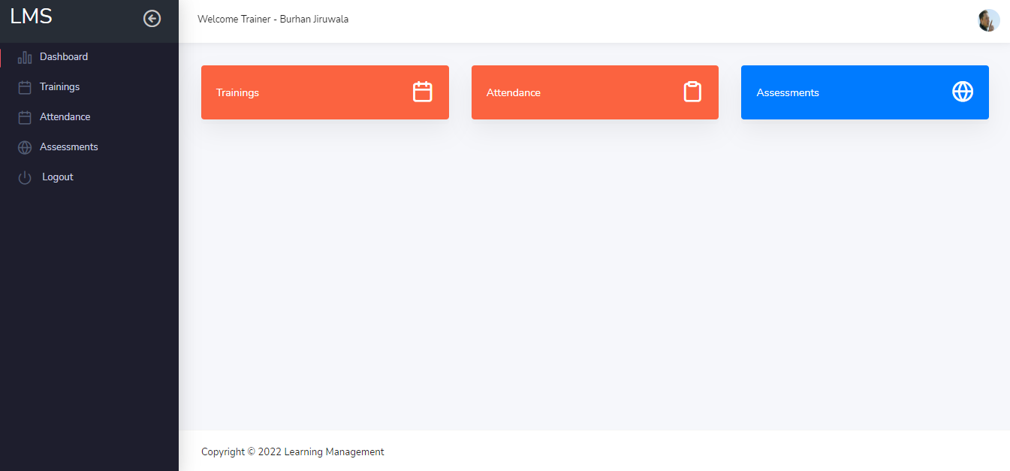

Figure: 4.2.3 Trainer Dashboard page

**Description:** The Trainer Dashboard has Trainings, Attendance and Assessments which can be accessed by side bar and main menus as well

4.2.4 Trainer-Trainings Page

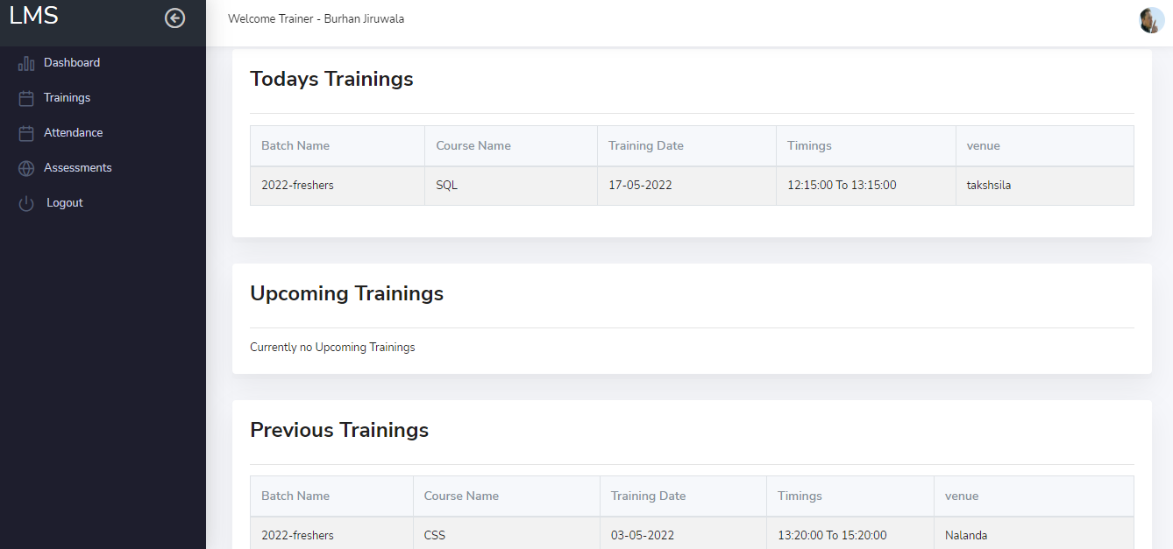

Figure: 4.2.4 Trainer-Trainings page

**Description:** The trainings will be shown that are created by the admin according to its time. If it’s on current date it will be shown in today’s trainings and so on.

4.2.5 Trainer-attendance Page

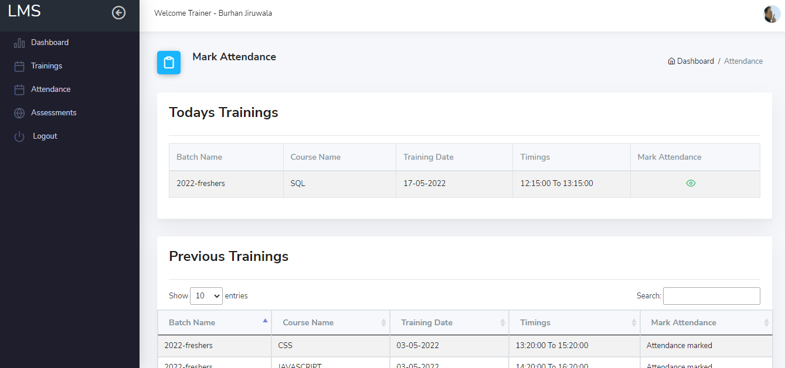

Figure: 4.2.5 Trainer-attendance page

**Description:** the trainer can mark the trainee attendance for the current date or the previous dates that are left by mistake

4.2.6 Trainer –Mark Attendance Page

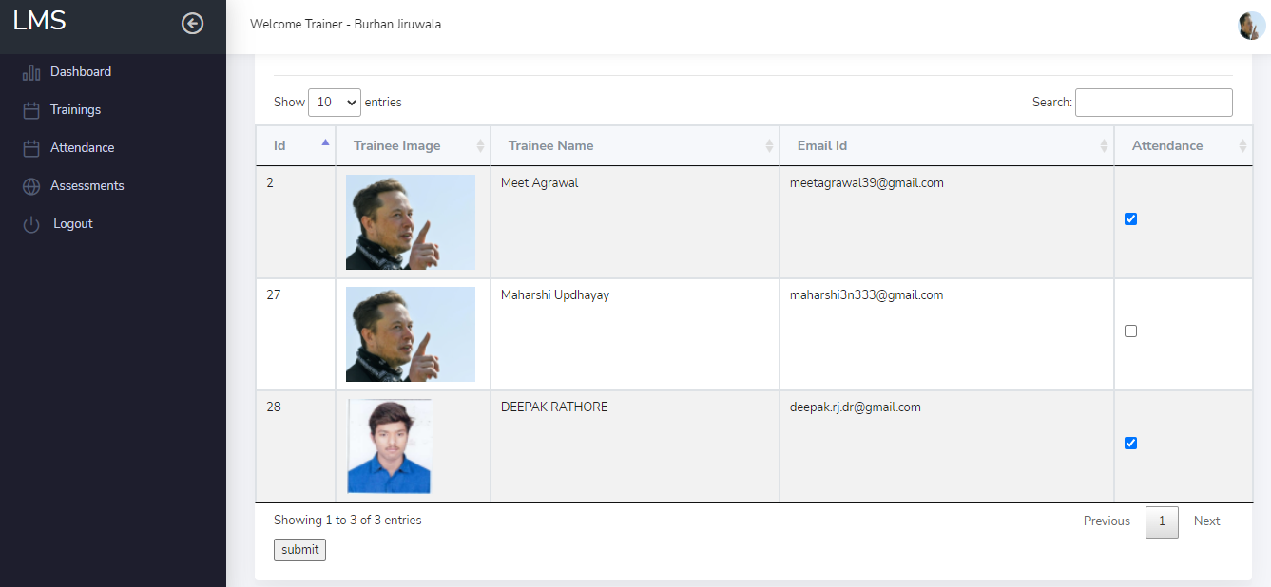

Figure: 4.2.6 Trainer –Mark Attendance page

**Description:** clicking on mark attendance, the system will load all the attendees of the trainings.The attendance will be marked of those trainees whose attendance is tick marked

4.2.7 Trainer – Assessments Page

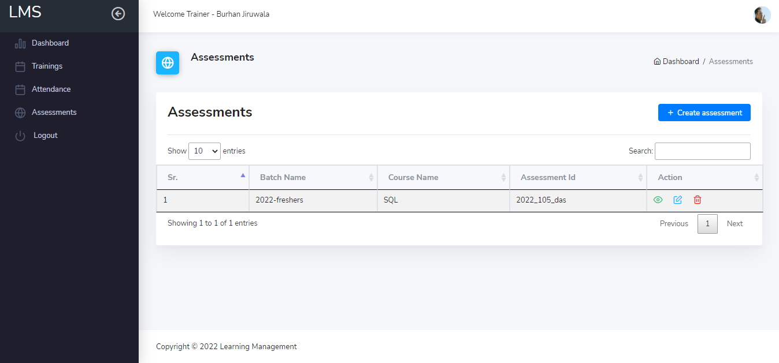

Figure: 4.2.7 Trainer – Assessments page

**Description:** The trainer can view all the assessments that are created till date. Also he can modify it or delete it from the system.

4.2.8 Trainer- Create Assessment Page

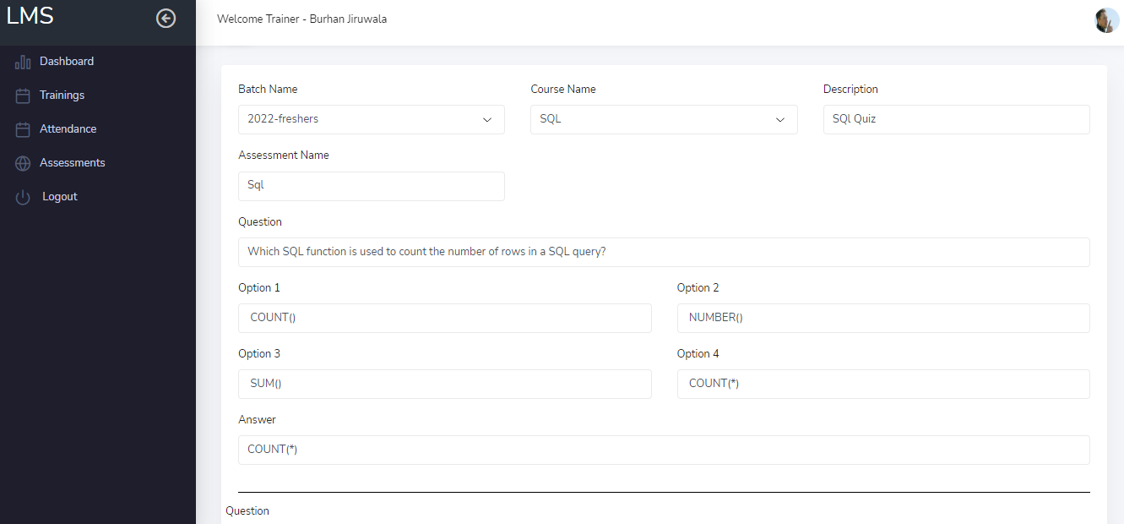

Figure: 4.2.8 Trainer- Create Assessment page

**Description:** by clicking on create assessments the trainer will be directed to from where he/she can add the details of the assessments

4.2.9 Trainer- view Assessment Page

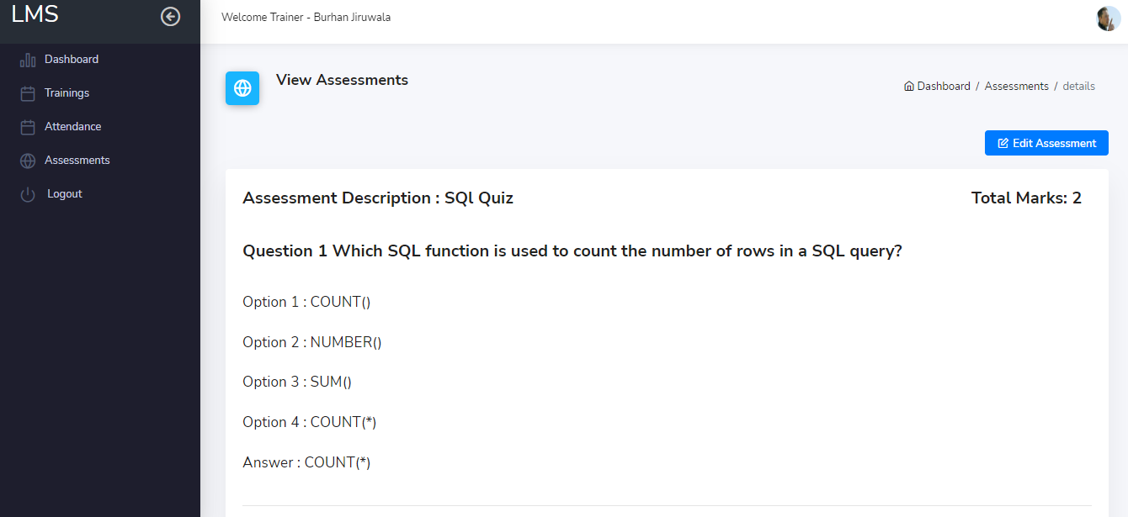

Figure: 4.2.9 Trainer- view Assessment page

**Description:** The trainer can also view the assessments after it is created

4.3 Trainee

4.3.1 Trainee –dashboard Page

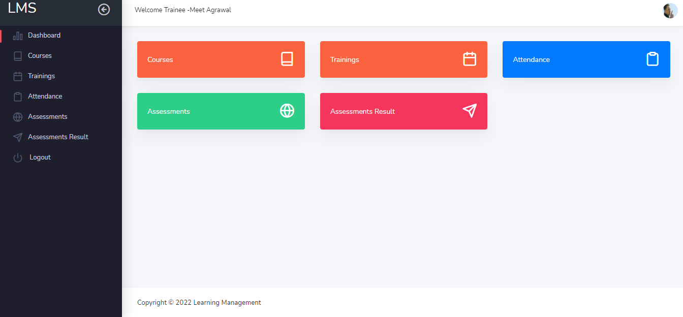

Figure: 4.3.1 Trainee –dashboard page

**Description:** the trainee dashboard will have courses, trainings, attendance, assessments and results.

4.3.2 Trainee – Courses Page

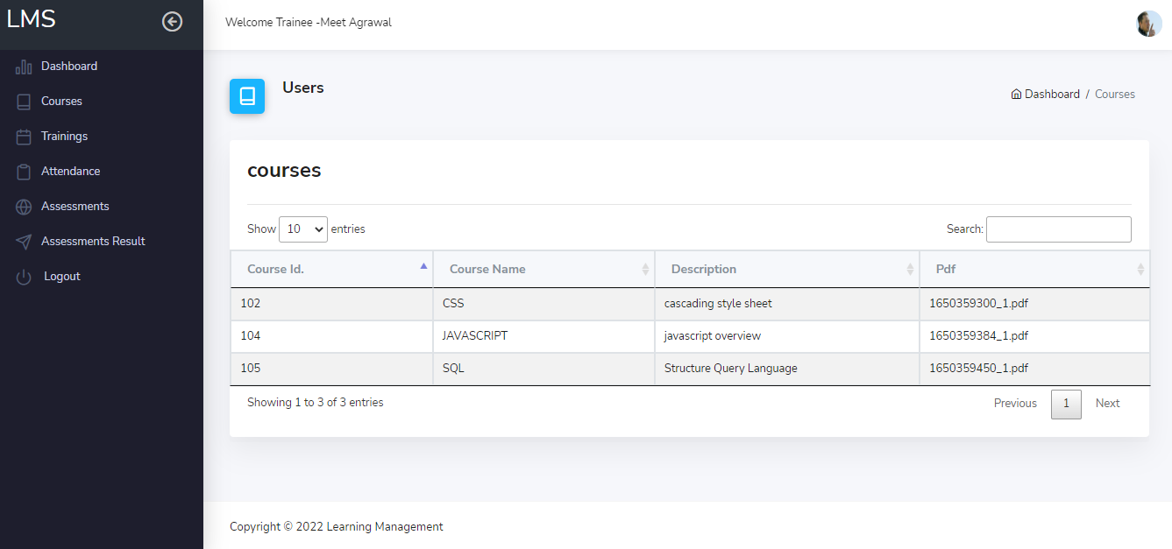

Figure: 4.3.2 Trainee – Courses page

**Description:** the trainee can view the courses allotted to his batch and can also search them from search bar

4.3.3 Trainee- Trainings Page

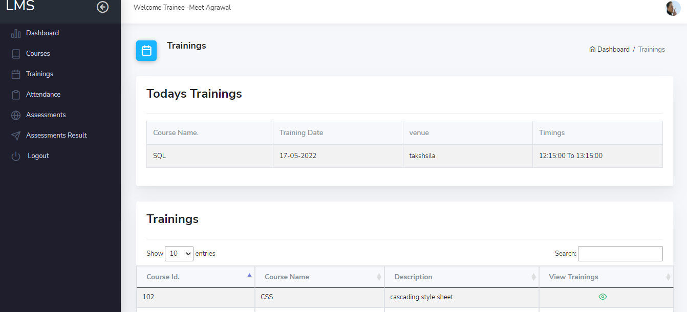

Figure: 4.3.3 Trainee- Trainings page

**Description:** the trainee can view the trainings from here which are been scheduled.

4.3.4 Trainee -Attendance Page

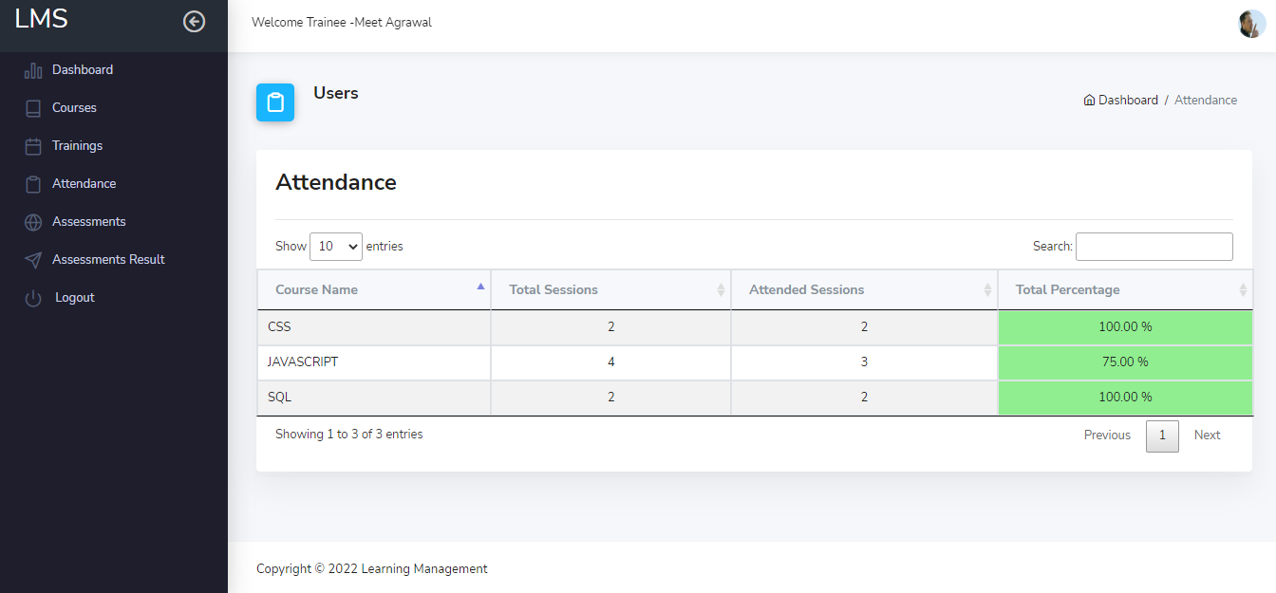

Figure: 4.3.4 Trainee -Attendance page

**Description:** the attendance of the trainings which are scheduled and the trainer has taken attendance of will be show here as total session and total attended sessions

4.3.5 Trainee- Assessments Page

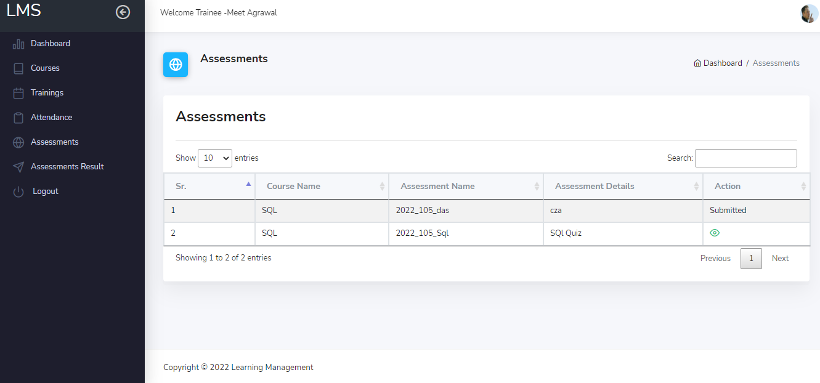

Figure: 4.3.5 Trainee- Assessments page

**Description:** The trainee can view the created assessment and can give them, once the assessment is given the Action will show it as submitted and he/she cannot give it again.

4.3.6 Trainee-Give Assessments Page

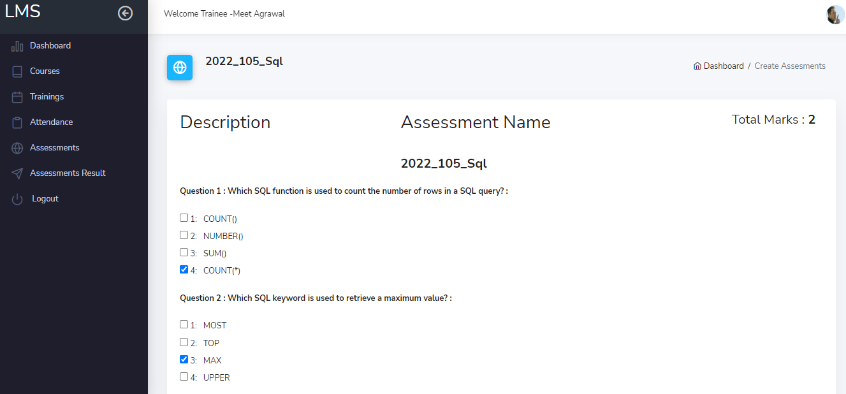

Figure: 4.3.6 Trainee-Give Assessments page

**Description:** the trainee will give assessments by clicking on one of the option of each question and after completing it he/she will click on submit button

4.3.7 Trainee-Assessments Result Page

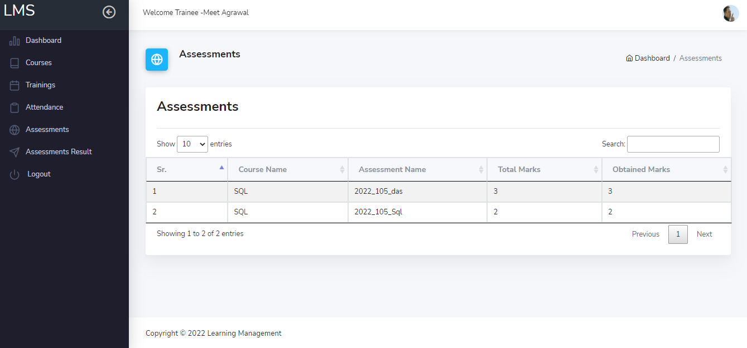

Figure: 4.3.7 Trainee-Assessments Result page

**Description:** The result or score of the assessment will be shown here.

**5. TESTING**

|  |  |  |  |  |  |  |
| --- | --- | --- | --- | --- | --- | --- |
| **Project Name:** | | Learning Management System | |  |  |  |
| **Module Name** | | Registration | |  |  |  |
| **date of creation** | | 1/5/2022 | |  |  |  |
| **TEST SUIT ID** | | **TS001** | |  |  |  |
| **TEST CASE ID** | **TEST CASE SUMMARY** | **PREQUISITES** | **TEST SCRIPT/PROCEDURE** | **TEST DATA** | **EXPECTED RESULT** | **STATUS** |
| **TC_REG_001** | Blank Submit | none | 1. Go to the system URL 2. Go to register now link 3. Keep all the fields blank and press submit | null | it should show error message and do not get registered | Passed |
| **TC_REG_002** | email id type check | none | 1. Enter only a name in email id 2. Fill the form 3. press submit | Deepak | It should show error  "please include an @ in email address" and do not get registered | passed |
| **TC_REG_003** | email id exist check | have an registered email id | 1. Enter existing email-id 2. Fill the form 3. press submit | deepak.rj.dr@gmail.com | It should show error “email already exist and do not get registered | passed |
| **TC_REG_004** | password and different confirm password check | none | 1. Fill the form 2. Enter password 3. Enter confirm password 4. press submit | password: 1234 confirm password:123 | it should show error “password and confirm password does not match and do not get registered | passed |
| **TC_REG_005** | Registration submit check | none | 1 fill the form with proper details 2. press submit | all data for registration | it should show registered successfully and should redirect to login page | passed |
| **TC_REG_006** | Registration details inserted in database check | none | 1. go to login page 2. enter registered email id and password 3 click on login | email id:deepak.rj.dr@gmail.com password:1234 | it should let the user login and redirect to home page | passed |

Table 5.1 Registration module

|  |  |  |  |  |  |  |
| --- | --- | --- | --- | --- | --- | --- |
| **Project Name** | | Learning Management System | |  |  |  |
| **Module Name** | | Login | |  |  |  |
| **date of creation** | | 1/5/2022 | |  |  |  |
| **TEST SUIT ID** | | **TS002** | |  |  |  |
| **TEST CASE ID** | **TEST CASE SUMMARY** | **PREQUISITES** | **TEST SCRIPT/PROCEDURE** | **TEST DATA** | **EXPECTED RESULT** | **STATUS** |
| **TC_LOG_001** | Blank Submit | none | 1. Go to the login URL 2. Keep all the fields blank and press submit | null | it should show error message and not allow to login | Passed |
| **TC_LOG_002** | login check with wrong password | registered email id | 1. Enter email id 2. enter wrong password | email id:deepak.rj.dr@gmail.com password:1234566 | should show error message wrong Password | Passed |
| **TC_LOG_003** | login with wrong email | any registered password | 1. Enter email id 2. enter wrong password | email id:deepak@gmail.com password:1234 | should show error user does not exist | Passed |
| **TC_LOG_004** | login check with correct credentials | correct id and password | 1. Enter email id 2. enter password | email id:deepak.rj.dr@gmail.com password:1234 | should login and redirect to home page | Passed |

Table 5.2 login module

**6. FUTURE ENHANCEMENT**

Thereare many features that can be added in the system in the future. We can say that the system which is developed is at a very basic level of its capability. The system will be added with more functionalities in the future such as

The time record of the trainee of how much time he/she has spent on course while accessing the documents.

The functionality to review the assessment given by the trainee and can raise a dispute if something ambiguous is found in the question.

The functionality to send an Email to the authorize users of training that are scheduled and the assessments that are created.

The scheduled trainings can be linked with the default calendar in the system for showing the reminder.

**7. APPENDIX**

While working on the Learning Management System various tools and technologies were used to make the development process easier are listed below.

1. Laravel Framework

The main reason to choose this framework is because of the file structure and its model-view-controller design pattern which makes the flow of the system very easy due to which the project was completed in expected period of time.

2. PHP

PHP is a server-side text language embedded in HTML. Used for managing dynamic content, information and session tracking.

3. SQL

SQL is used to create, delete, modify database and web resources in a database management system and to store, retrieve, update data on a website. SQL is a common language for creating, accessing, and deciphering a website management system

4. HTML

It is Hyper Text Markup Language used to design web pages.it is basically a combination of Hypertext and Markup languages.it defines a link between web pages. Marking language is used to describe a text document within a tag that describes the structure of web pages

5. Bootstrap

It is a free and open source framework for creating websites and web applications.it is used to make the system more responsive and attractive. It provides easy to use structure which has helped in building the system more systematically.

6. JavaScript

It is a cross-platform scripting language used to make webpage more interactive

7. JQuery

It is basically a JavaScript library which simplifies the JavaScript programming.in this project it is used at some places where there was requirement of using it

**8. BIBLIOGRAPHY**

Rishabh Software. 2022. Custom Software Development Company | Rishabh Software. [online] Available at: <https://www.rishabhsoft.com/> [Accessed 10 Feb 2022].

Laravel.com. 2022. Laravel - The PHP Framework For Web Artisans. [online] Available at: <https://laravel.com/docs/9.x/installation> [Accessed 25 Feb 2022].

Datatables.net. 2022. Data Tables example - Bootstrap 4. [online] Available at: <https://datatables.net/examples/styling/bootstrap4> [Accessed 25 March 2022].

Softwaretestinghelp.com 2022. [online] Available at: <https://www.softwaretestinghelp.com/how-to-write-effective-test-cases-test-cases-procedures-and-definitions/> [Accessed 20 April 2022].