Terraform Docs

AWS Configure cmd: -
aws configure –profile profile_name
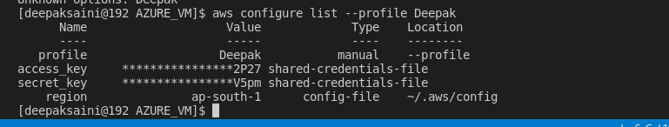
aws configure list-profiles

