Terraform Docs

AWS Configure cmd: -

aws configure –profile profile_name

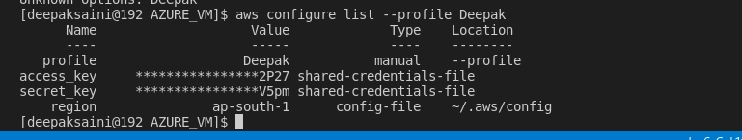

aws configure list-profiles