Project Doccument

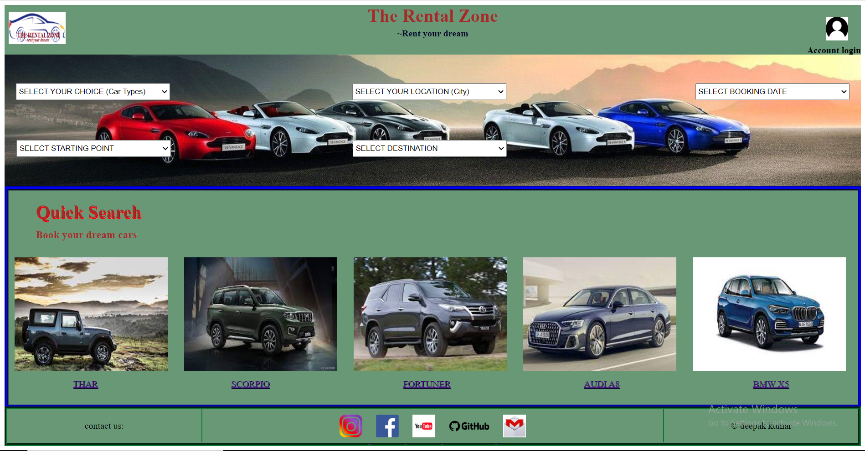

**Project name: THE RENTAL ZONE**

**Present by: -** **DEEPAK KUMAR**

THE RENTAL ZONE is a rental car service website where user can books car on rent and buy or sell a car. This website is mainly focused on rular areas as well as urban areas.

**Goals**

1. Homepage
2. Product catgories (Booking / Buy or Sell)
3. Profile page (login/ logout)
4. Order page
5. Payement page
6. Rating reviews nag suggetion page

**Navigation bar (on top)**

* Company Name
* Login /create account
* Company Logo

**Menu bar**

A horizontal division below navigation bar where different selection buttons are available to select such as: -

* Select your choices (Car types)
* Select your location
* Select your booking date
* Select your starting point
* Select your destination

**Quick search**

A horizontal division below menu bar where different categories of cars are available to see and for booking as demand on that location.

**Footer**

In this section contact details and copyrights details are available.

**Technologies used in this project**

1. HTML
2. CSS
3. JAVASCRIPT
4. BOOTSTRAP

Thanks, and Regards

**DEEPAK KUMAR**

