

**SUPERMARKET** A person buying ordinary

**MANAGEMENT**  products in a supermarket

**SYSTEM**  is in touchwith his emotions

Project Report

**Deepak Pradip**

Class XII: Science IP

**SUPERMARKET MANAGEMENT SYSTEM: -**

**Aim: -**The aim and the main idea behind this project is to make super market

management much more efficient but using the data in tables in visualization

using graphs, histograms and bar charts too.

**Introduction and what our project does:**

This project can generate a bill for customers and as for the admin users, it can

calculate stock needed and current stock available, it can automatically notify

when stock is less and reorder, it can tell the employee details and allows us to

add / remove any employees, it stores customer details and also allows us to

create and admin account with login and logout options including admin

account recovery.

A supermarket management system helps the staff of the supermarket to keep

records of goods purchased by customers and goods purchased from

wholesale retailers.

**Importance of a Supermarket Management System: -**

* A Supermarket management system is an efficient and easy to use

system that even people with little to no computer knowledge can use it.

* This system uses computers to help ease the workload of the workers and reduce the amount of human errors
* The staff can also give out membership cards and the benefits of the card can be more easily managed

**Advantages of a Supermarket Management System: -**

* Reduced manual labor
* Checking stock of products is easier
* Reduced chances of error
* Easier to use, manage and record

**User Modules: -**

* Billing
* Stock (Calculate leftovers and notify when stock is less than minimum level and Ability to Reorder)
* Employees
* Customers
* Admin [Login & Logout (Acc. Creation and Recovery)]

**Tables Used: -**

**Billing Table(GUI)**

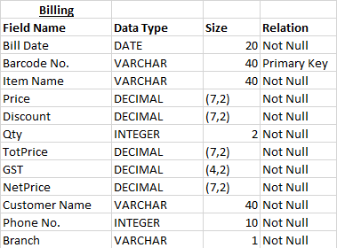

* **Stock Inventory (2 branches A&B)**

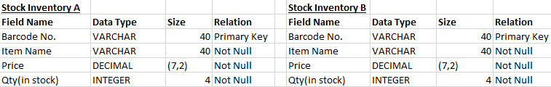

* **Employees Table**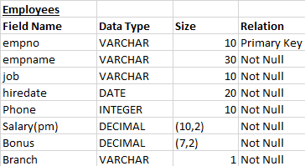
* **Customer Table**

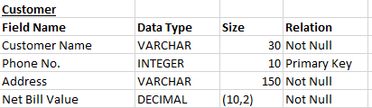

* **Admin**

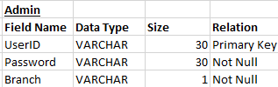

**Data Visualization (Using Graphs): -**

* Category-wise Monthly Sales (sales in crockery, groceries, stationeries)
* Monthly Expenditure Vs Monthly Profit
* Monthly Sales of Branch A Vs That of Branch B

**Data Analysis: -**

1. High Value Customers
2. Fast Moving Items
3. Slow Moving Items
4. No. of people in each job in each branch
5. No of aisles with their specific items from the store

**Python & MySQL**

Python is a popular programming language, created by Guido van Rossum and released in 1991.

It has various uses including

* Web development (server side)
* Software development
* 3D animation (Blender [based on python])
* Data Analytics

***What can python do?***

* Create web applications
* Create workflows
* Handle bigdata and perform complex mathematics
* Machine Learning

***Why Python?***

* Cross-Platform compatibility
* Simple and straightforward syntax while at the same time being compact as well.
* Easy to install and run.
* Python can be written in many IDEs (Integrated Development Environment like Visual Studio Code, PyCharm, Net Beans, etc.)
* Python runs on an interpreter system, meaning that code can be executed as soon as its written. This means prototyping can be very quick.
* Has numerous libraries that help it in creating tables to help visualize the data in tables using graphs and charts.

**Python Syntax compared to other computer languages**

* Easy to learn as compared to other languages.
* Python is dynamically typed that means one has to only assign a value to a variable at runtime, python interpreter will detect the datatype on itself.
* Readability of python code is more since it resembles the actual English language.
* Python is free and open source.
* Python is more memory and resource efficient.

**SQL** is a standard language for accessing and manipulating and creating databases.

***What is SQL?***

* SQL stands for Structured Query Language
* It is used in Database Management Software (DBMS) as a means to give commands called ‘Queries’ to access, manipulate and create databases.

***What can SQL do?***

* Execute Queries
* Create databases
* Create tables within databases
* Delete tables
* Retrieve data from tables
* Insert records into tables
* Update records of tables
* Delete records from tables

***Using SQL in your website/program***

* An RDBMS program (Heidi SQL, MySQL, PostgreSQL)
* To use a server-side scripting language like PHP or ASP
* Use SQL to get the data what you want
* Use HTML/CSS for styling the user interface of the webpage

The data stored in RDBMS are in the form of database objects called ‘Tables’.

A table is a collection of related data entries and it consists of columns and rows.

**CONCLUSION: -**

A **Supermarket Management System** is one of the various ways computers help the present-day Supermarket become more efficient and direct more of their workforce towards improving the overall user experience and keeping things in order while the system takes care of the job of number crunching and assist the employees in doing their job better.