Utilising Dynamic Motor Control Index to Identify Age-Related Differences in Neuromuscular Control
Laura Burke, Liudmila Khokhlova, Brendan O’Flynn, Salvatore Tedesco*
Tyndall National Institute, University College Cork, Lee Maltings Complex, Dyke Parade, T12R5CP Cork, Ireland
*Corresponding author’s email: salvatore.tedesco@tyndall.ie

Abstract
xxxx

Introduction
Muscle Synergy (MS) analysis has been used extensively in the neuroscience, sport science and rehabilitation fields to gain greater insight into motor control [1]. The Central Nervous System (CNS) recruits the muscles needed for movement in groups known as muscle synergies. This optimises movement by allowing the muscles and joints to operate as a coordinated unit to accomplish a movement goal [2]. These muscle groupings are not fixed synergies for the range of one’s life. A multitude of reasons can cause these synergies to shift and regroup, combine or divide. An example of this is post muscle injury. The CNS regroups the muscles in the synergies to give the injured muscle a less weight-bearing role [3-4]. Although this new grouping of synergies may be less optimal in the long term, short-term use allows quicker healing of the injured muscle [5]. The leading MS analysis methods, where MS are extracted using non-negative matrix factorisation (NNMF) or principal component analysis (PCA), have shown differences in the number of muscle synergy present before and after an injury [6]. Furthermore, it has been seen that often the muscle synergies will not return to their previous most optimal state after rehabilitation for said injury [6].
It is well known that older people are more prone to trips, falls, and general poor balance [7-9]. While age-related declines in gait and balance control have been documented [10-11], the same cannot be said for muscle synergies. Numerous studies explored the age-related modifications to muscle function/coordination through the use of surface electromyography (sEMG) sensors monitoring muscle activity during walking. When compared to a younger sample, studies suggest that there is no significant difference in the muscle synergies of that of a young person and that of an old person [12]. Even more complex tasks, such as walking upstairs, could not differentiate the neuromuscular control of a young population and an old population based on the number of MS extracted [13]. Although extracting MS from sEMG activity using dimensionality reduction techniques has been considered a gold standard for observing injury-related differences in muscle synergies, the same cannot be said regarding age-related differences. Clinical evaluation of elderly people’s muscle function is largely carried out through functional assessments such as studying gait and physical energy [14]. Research suggests neuromuscular control declines first, and functional impairments follow [15-16]. Therefore, implementing reliable neuromuscular analysis into these evaluations may allow us to identify these impairments before they even begin to affect physical function. Rehabilitation and preventative measures can then be taken to improve muscular function before the issue becomes too serious.
This study utilises a novel analysis method, called the Dynamic Motor Control Index (DMCI), to explore its ability to identify age-related differences in muscle synergies. It was recently used in 2021 to explore its ability as a method of marking neuromotor impairments in older adults in a way that does not rely on the number of muscle synergies [17]. However, the study was restricted in terms of exercise used and is the one of the only studies of its type. While the study by Collimore et al. [17] showed promising results, the average DMCI score of the young adult population and the old adult population overlapped significantly (100 ± 10 compared to 96.4 ± 10). Although Collimore et al. ’s study was successful at distinguishing the age groups based on the DMCI index, this study aims to reduce the overlap of DMCI scores by using more complex exercises which may better distinguish age-related differences. Ultimately, this study aims to further explore the potential of DMCI and its relation to the difficulty of the exercises.
The manuscript is structured as follows: Section 2 provides details on the mathematical characterization of MS and the rationale behind the DMCI index, Section 3 and Section 4 describe the experimental protocol and the processing approach used for MS extraction, respectively. Results are presented in Section 5 and discussed in Section 6. Finally, conclusions are drawn in Section 7.

- Muscle Synergy Analysis and DMCI Index
The aim of MS analysis is to reduce the number of dimensions (muscles) of the sEMG signal to a limited set of smaller, more meaningful variables referred to as synergies. This can be obtained through dimensionality reduction techniques, such as NNMF or PCA [18]. The outcome of this operation aims to provide insights into the neural strategies for movement and functional outcomes of muscle activities. For instance, those with a fewer number of muscle synergies (one or two) have greater co-activation between their muscles and thus, less optimal muscle control [19], while those with three or four muscle synergies (i.e., less co-contraction) are thought to have more optimal neuromuscular control [20-21].
The EMG activity of $m$ muscles at a given time $e(t)$ is acquired through the linear combination of a number of synergy vectors, which are then scaled in amplitude by an activation coefficient [22], as shown in Equation (1):

$e\left(t\right)= \sum_{j=1}^{s}{c_{j}\left(t\right)w_{j}+residual}$ (1)

Where $s$ is the number of synergies, which must be less or equal to the number of muscles at a given time, j is the synergy index, $c_{j}(t)$ is the activation coefficient and w is the synergy vectors.
This can be rewritten into matrix form, Equation (2):

$E=W×C+residual$ (2)

This depiction of the EMG data separates the spatial W and temporal C components and defines their dimensionality as the minimal number of vectors necessary to explain most of the data variance (or variance accounted for, VAF) [18]. A graphical depiction of the procedure is shown in Figure 1.

Muscle synergy analysis consists of three main stages: EMG recording, EMG processing, and synergy extraction. In literature there is a wide variability in the methods performed in each of these stages. sEMG and intramuscular EMG have been used successfully, with preference leaning towards sEMG due to its non-invasive nature [1]. The EMG data can be processed in an immense multitude of approaches, with many authors reporting that their results are sensitive to their chosen methodology. Choices in normalization methods for the EMG amplitude, band pass filtering threshold frequencies and sampling rate all play a part in producing a signal best suited for MS extraction. In terms of muscle synergy extraction, while NNMF [23-24] and PCA [25-26] are the leading methods, some studies do utilise independent component analysis (ICA) [27].

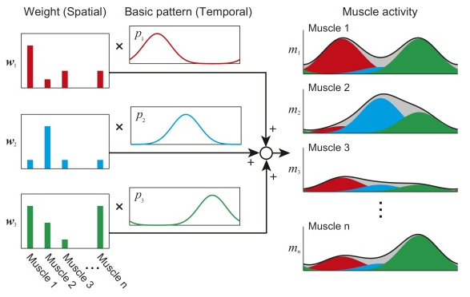
Figure 1. MS model: Muscle activation patterns are produced by basic activation pattern with distribution weights [28]. The weighs define the direction of the synergy vectors and show how much each muscle increases its activation when a synergy is activated. The temporal structure expresses the activation coefficients as a sequence in time relevant to each other [18].

The DMCI analysis method was developed in the context of neuromuscular control when studying the gait in people with cerebral palsy (CP) [29]. It has since been used in two other studies regarding CP patients, children, and adults [30-31]. The DMCI is a summary metric of muscle co-activation during walking. Rather than computing the number of muscle synergies that correlate to a predefined VAF threshold, the DMCI constrains the number of muscle synergies to one and scales the VAF score to a z-score based on a control group. In the case of investigating age-related differences between a younger group and an older group, the young group represents the control group. Therefore, the higher the DMCI score, the more complex the neuromuscular ability is [29].
It can be thus expected, as also shown in Collimore et al. ’s [17] study, that younger people have a higher DMCI than older people since older people have more co-activation of their muscles.
This method is further verified in da Silva Costa et al.’s study [20] where the single synergy VAF score differed between younger adults and older adults in a balancing exercise. In comparison, when muscle synergies were analysed, the number of synergies did not differ between the two groups [20].

Single synergy’s VAF values are computed using the same extraction methods as traditional MS analysis (NNMF, PCA etc.). As mentioned, the single synergy VAF value is then converted to a z-score with the young adult group as the control group, as depicted in Equation (3):

$DMCI=100+10\left(\frac{AVG VAF_{1synergy-Control}-VAF_{1synergy-Exp}}{SD V{AF}_{1Synergy-Control}}\right)$ (3)

Where $AVG VAF_{1Synergy-control}$ is the average of the one synergy VAF of the whole young adult control group, $VAF_{1Synergy-Exp}$ is the one synergy VAF value of each individual in all groups within the study, and $SD VAF_{1synergy-control}$is the standard deviation of the single synergy VAF value of the young adult control group [29].

While results in [17] proved that DMCI can identify age-related differences in neuromuscular control between an older and younger sample population, there was significant overlap in the presented results. Younger adults (27 ± 3 years) had an average DMCI score of 100 ± 10 while ‘young-old’ adults (73 ± 3 years) and ‘old-old’ adults (78 ± 2 years) had an average DMCI score of 96.4 ± 10.79 and 88.9 ± 9.67, respectively [17]. Statistical analysis showed that this method was capable of observing significant differences between the young adults and the old-old adults. It was not, however, able to distinguish between the young-old and old-old age group. It was hypnotised that this inability may be due to the simplicity of the walking task and suggested that other walking tasks that varied in complexity may be the key to identifying age-related impairments at an earlier age [17]. Therefore, as the main goal for clinicians is to identify age-related deficits as young as possible less senior participants should be recruited to investigate if those findings are extendable also to other age ranges.
In summary, this study aims to extend the scope of this research by utilising the same analysis methods in Collimore et al. ’s study with less senior participants and the addition of more complex exercises, such as incline walking, walking up stairs and lateral stepping up stairs, as it is suggested that more complex tasks will reduce the overlap seen in the DMCI of the different age groups. The hypothesis is that more complex tasks can create more distinguishable groupings of the DMCI score with little overlap, thus promoting this analysis method more confidently as a useful means of examining neuromuscular control in adults.

3. Experimental Protocol

3.1 Study Population
The study was conducted according to the guidelines of the Declaration of Helsinki and was approved by the Clinical Research Ethics Committee of the Cork Teaching Hospitals at the University College Cork (Ref. number: ECM 4 (e) 17/05/2022 & ECM 3 (kkk) 17/05/2022). Data from 30 participants was collected. Participants were grouped into two groups: ‘young’ (18-49 years) and ‘old’ (50-65 years). The study did not have gender-related exclusion criteria and excluded subjects with a body mass index (BMI) above 35. Moreover, the subjects in the young control group were excluded if they had any history of knee injury/disorders in any knee, while participants in the older group were included if presented healthy knees, or knees which had sufficiently recovered from past knee trauma and are capable of preforming daily tasks with ease. A summary of the anthropometric measures of the 30 recruited subjects are shown in Table I.

Table I. Participants’ anthropometric measures
 | Number of participants | Gender (M/F) | Age (years) | Height (cm) | Weight (kg)
Young Adults | 16 | 9 / 7 | 27.93 ± 7.5 | 171.93 ± 6.86 | 75.19 ± 14
Older Adults | 15 | 9 / 6 | 56.07 ± 6.37 | 175.24 ± 8.47 | 78.54 ± 8.92

3.2 Muscles and Instrumentation
In this study, the primary muscles in the participant’s dominant leg were included for analysis. The tensor fasciae latae was removed from the protocol as sEMG sensors had to be placed in the iliac region which was reported by several participants to be uncomfortably close to the suprapubic region. The final list of muscles included rectus femoris, vastus lateralis, vastus medialis, biceps femoris caput longus, lateral gastrocnemius, medial gastrocnemius, soleus, semitendinosus, tibialis anterior, peroneus longus, erector spinae, gluteus maximus, and gluteus medius.
Gold-standard off-the-shelf FREEEMG electromyography Units (BTS Bioengineering S.p.A., Italy, CE Class IIa, FDA registered device, https://www.btsbioengineering.com/products/freeemg/) was adopted for data collection. Sensors were attached to the skin of the participants over the muscles of interest using adhesive electrodes. Sensors were placed according to the SENIAM guidelines (http://www.seniam.org/). EMG sensors placements are shown in Figure 2.
7
8
6
5
4
3
2
Off-the-shelf Xsens (Xsens Technologies B.V., Enschede, Netherlands) inertial sensors were also adopted to collect orientation data (e.g., pitch, roll, yaw). Inertial sensors were placed using elastic straps around the thigh, calf, and foot of the participant as shown in Figure 3.

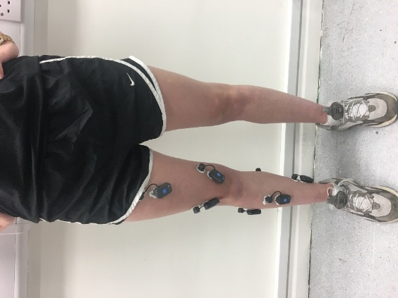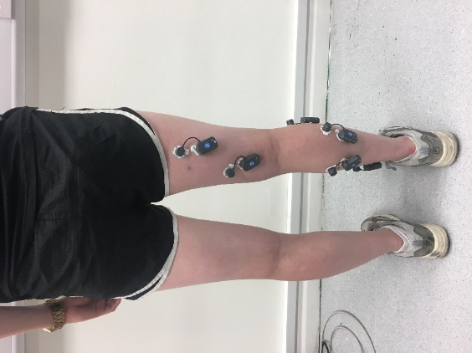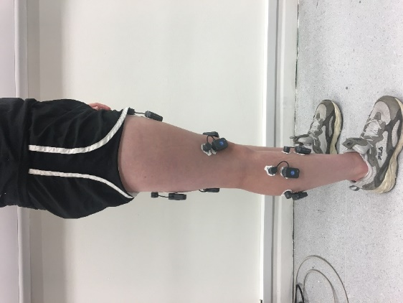
Figure 2. EMG sensor placement
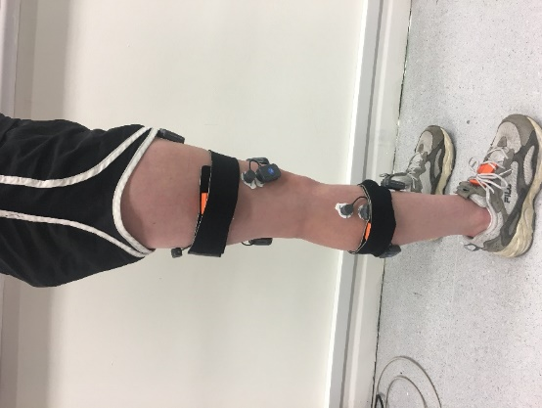
Figure 3. XSens sensor placement
3.3 Protocol Exercises
Given the large number of sensors adopted, data from the participant’s dominant leg only were collected. Participants were asked not to lean on equipment to aid balance unless completely necessary. Three participants in the old group required balance/stability aid during the exercises. Any exercise was practised if requested by the participant. The list of exercises considered in this study are described below. Figure 4 shows examples of participant undergoing exercise trials.

Flat walking
The treadmill was set to 4 km/h. Data collection began 10 seconds after the participant started walking to ensure the treadmill was at the correct speed and 40-50 seconds of data were collected. The treadmill was then turned off and participants came to a complete stop with feet around shoulder width apart and legs straight.

Incline walking
The treadmill was set to an incline of 5 deg and a speed of 3.5 km/h. Data collection began 10 seconds after the participant started walking to ensure the treadmill was at the correct speed and 40-50 seconds of data were collected. The treadmill was then turned off and participants came to a complete stop with feet around shoulder width apart and legs straight.

Step Forward
This exercise required the use of a staircase. The participant was to begin with both feet close together on the ground. The dominant leg was considered as the leading foot. Data collection commenced and participants were advised to start the exercise. The participants stepped onto the first step of the staircase with their leading foot. Their trailing foot followed so that both feet were then on the same step. The participants were asked to pause for two seconds and then to repeat the movement onto the second step, where both feet finished on the second step and then onto the third step. Participants were asked to stay on this third step until the researcher indicated the data collection was finished.
Handrails could be used by the participants only if absolutely necessary but subjects were advised not to lean onto it and use it merely as a balance aid in order not to take away the effort needed from the legs.

Step Lateral
This exercise required the use of a staircase. The participant was to begin with both feet close together on the ground, facing sideways so that the stairs were on either their left or right hand side based on their dominate leg (e.g., the dominant leg was supposed to be the closest to the step). Data collection commenced and participants were advised to start the exercise. The participant steps sideways onto the first step with their leading foot. Their trailing foot followed so that both feet were sideways on the same step. The participants were asked to pause for two seconds and then to repeat the movement onto the second step, where both feet finished sideways on the second step, and then again onto the third step. Participants were asked to stay on this third step until the researcher indicated the data collection was finished.

Figure 4. Examples of participant undergoing exercise trials (walking, steps lateral, steps forward)

4. MS Processing Parameters

4.1 Data pre-processing

Normalisation
Utilising a maximal voluntary contraction is one of the most powerful and popular normalisation method within EMG processing [32] as it allows researchers to observe the relative activation level of a muscle by expressing the amplitude of the muscle signal during a given exercise as a percentage of a reference EMG value (with the reference EMG being the peak/mean value/s of an EMG signal recorded during a participant’s isometric maximal voluntary contraction [33]).
As muscle impairments and neuromuscular disfunctions (such as osteoarthritis, cerebral palsy, stroke, etc.) may not allow patients to be able to voluntarily contract on command, this may result in data values that could be greater than 100% of the normalised value with this normalisation process [34-35]. To remain inclusive to all subjects, it was elected to normalise the EMG signal to the maximum activation experienced during the exercise trial of which the EMG data was collected from.

Filtering
Filtering methods followed those in Collimore’s study [17]. The EMG signals were filtered through a 4th order high-pass Butterworth filter with cut-off frequency at 40Hz. It was then detrended (e.g., the sample mean was subtracted from each observation so that they are mean zero), rectified, and passed through a 4th order low-pass Butterworth filter with cut-off at 4 Hz.

Time Normalisation
For the two walking exercises, the middle 30 strides were used for signal processing. Gait cycles were identified and recorded through the Xsens inertial sensors and motion data was imported. Data was then oversampled to 1000 Hz to match the sampling rate of the EMG signals. The pitch angle obtained by the inertial sensors data was isolated and the first and last five seconds of the recording were removed. The centre maximum peak was located as the beginning of the middle stride. The 30 strides (identified as the 31 peaks) around this centre were located and the corresponding EMG signals were saved and used for MS extraction. All data outside of these 30 strides was discarded. Figure 5 shows in detail this pre-processing step.

BTS FREEEMG software and Xsens system were synchronised using a hardware trigger. All data processing steps were completed using custom MATLAB software (The MathWorks Inc., Natick, MA, USA).

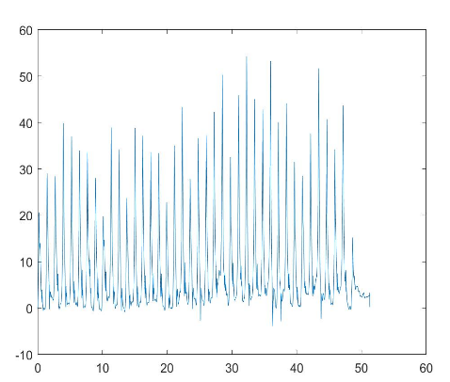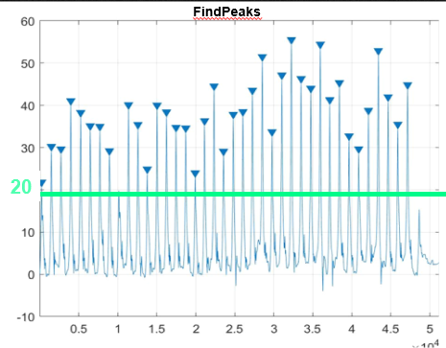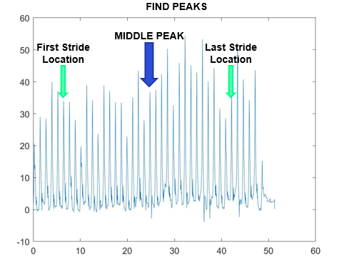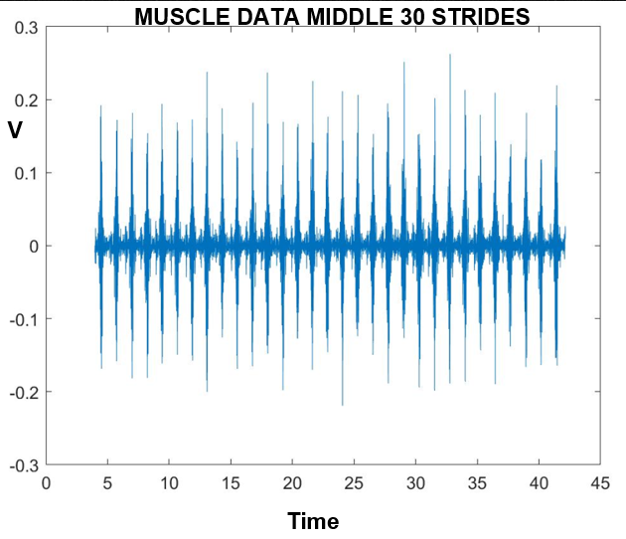
Figure 5. Raw pitch data is upsampled to 1000 Hz (top left) with each peak representing the beginning of a walking stride. Peaks are found using the findpeak function in Matlab with a minimum peak amplitude threshold set to 20 deg (top right). First and last stride locations are found 15 peaks to the left and to the right of the middle peak (bottom left). EMG data associated to the selected data (bottom right).


4.2 Muscle Synergy Extraction
The median is the middle peak.
The first stride location is found 15 peaks to the left of the middle peak. The last of the 30 strides occur 15 peaks to the right of the middle peak.
This study utilises NNMF to extract synergies from the collected muscle signals. This is the most popular extraction method, being used in over 62% of studies during 1999 to 2018 [24]. NNMF constrains the synergies to be positive values, namely the algorithm iterates an initial matrix that is non-negative D into two matrices W and C (Section 2 of this manuscript). The algorithm updates these matrices with the multiplicative rules [24], as shown in Equation (4)

$W_{ik}←W_{ik}\frac{{\left(DC^{T}\right)}_{ik}}{{\left(WCC^{T}\right)}_{ik}}$ and $C_{kj}←C_{kj}\frac{{\left(W^{T}D\right)}_{kj}}{{\left(WW^{T}C\right)}_{kj}}$ (4)

This avoids the non-increasing trend of the Frobenius norm (e.g., the square root of the sum of the squares of the elements of the matrix [36]) of the error matrix D-WC for each iteration.
The variance accounted for (VAF) statistically compared the reconstructed and original muscle patterns [37] and defines the dimensionality of the muscle data in terms of the smallest number of vectors required to explain most of the variability in the data [38]. The user predefines a threshold which consistently ranges from 80-95% in the literature [18]. In this study, VAF was set to a threshold of 95% based on observation of MS extraction results.
Once extracted, the single synergy value was adopted for the DMCI calculation, along with the number of muscle synergies present as the corresponding VAF value based on the stated threshold.

4.3 Statistical Analysis
Binomial regression was adopted to test if DMCI was significantly predictive of age group after adjusting for the number of muscle synergies and also tested their interaction. The significance level was set at 0.05. Multinomial logistic regression used the same predictors to compare the young adult and old adult group and also tested the predictor’s interaction [17]. Statistical Package for the Social Sciences (SPSS) version 25 was used for the statistical analysis.

5. Results

Step Forward Group | Average DMCI Score
Young Adults (18-49y) | 100 +-10
Older Adults (50-64y) | 97.94 +- 9.15

Step Lateral Group | Average DMCI Score
Young Adults (18-49y) | 100 +-10
Older Adults (50-64y) | 98.18 +- 6.15

It appears that despite stairs being classified as a more complex task, the DMCI score is similar to those in Collimore’s walking study. However, binary linear regression shows that the DMCI in this case is not significantly able to identify age related differences in DMCI for both steps forward and steps lateral.
The Regression was unable to accurately predict a participant’s age group based on the DMCI or number of muscle synergies. The accuracy was in the range of 60-65% in both instances.
The difference in age between the oldest participant in the young adult group to the youngest participant in the older adult group is 1 year. This is a vast contrast to the 30year difference in Collimore’s study. Therefore, the young adult group was remade to only hold participants between the ages of 18 to 27 years. This group only has 8 participants in it.

Step Forward Group | Average DMCI Score
Young Adults (18-27y) | 89.9667 +- 28
Older Adults (50-64y) | 97.94 +- 9.15

Step Lateral Group | Average DMCI Score
Young Adults (18-27y) | 99.22 +- 9.4
Older Adults (50-64y) | 98.18 +- 6.15

Although the difference between age groups seems smaller, the regression model preferred this set up. It gave a significance level of 0.134 which is still not significant but an improvement from the previous grouping. The accuracy of prediction was also increased to 78%. One obvious issue however is the young adults DMCI for step forward is now lower than the older adult score – this goes against the literature which states the young adults have a higher DMCI score than the older adults (Collimore et al., 2021).
Plotting the results for the under 27y age group to the older adult’s group clearly shows the huge amount of overlap in the two result groups.
It is clear that despite the more complex exercise, the DMCI failed to identify age related differences in neuromuscular control.

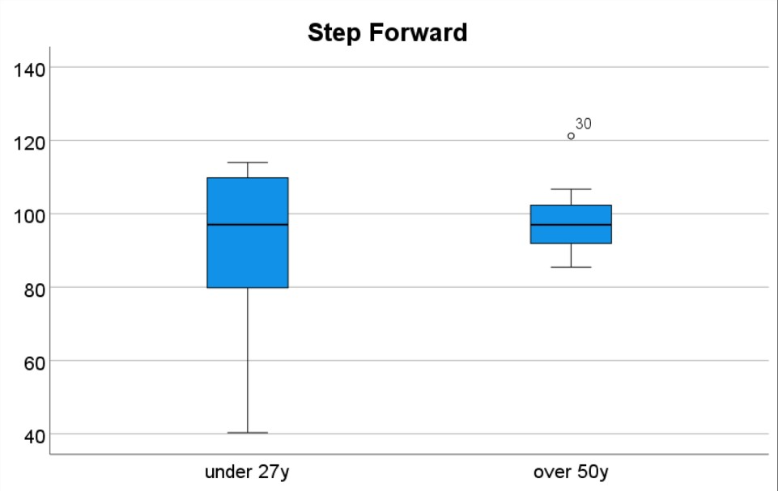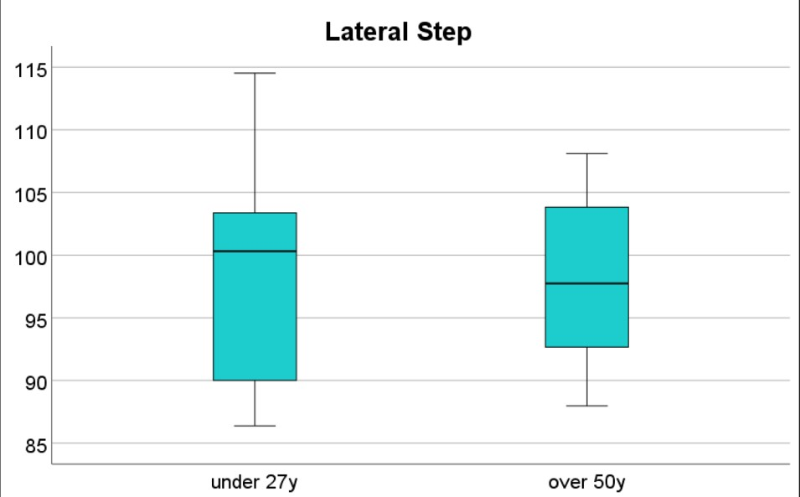

6. Discussion
As mentioned, these are just preliminary results. I now wish to continue analysis of the step data to check its ability to identify age related differences via the DMCI score. I will perform more regression, and multinominal regression to see what the results produce. I also want to try reprocessing the data with a VAF of 90% (compared to 95%) as that would produce a different number of synergies for the threshold VAF. As the number of muscle synergies is used in the regression model, this may help significance levels.
Data sets will be published along with the findings of this paper.

7. Conclusion
Although preliminary data analysis does not show promising results for this method, it is still too soon to tell. The method itself is still far too novel with only 4 papers reported and of which only one in the area of normal muscle function. This method has the potential to promote healthier, more optimal muscle function in older people’s standard of living.

Acknowledgments
The authors would like to thank all the participants who voluntarily took part in the study.

Funding
This work was supported in part by the Science Foundation Ireland which are Co-Funded through the European Regional Development Fund under Grant 12/RC/2289-P2-INSIGHT and Grant 16/RC/3918-CONFIRM. Aspects of this publication have also emanated from research supported by a research grant from the Disruptive Technologies Innovation Fund (DTIF) project HOLISTICS funded by Enterprise Ireland (EI).

References

[1] Hug, F. Can muscle coordination be precisely studied by surface electromyography?. Journal of Electromyography and Kinesiology, 2011, 21, 1, 1–12

[2] Abd, A. T., Singh, R. E., Iqbal, K., & White, G. A Perspective on Muscle Synergies and Different Theories Related to Their Adaptation. Biomechanics, 2021, 1, 2, 253–263.

[3] Hodges, P. W., & Tucker, K. Moving differently in pain: A new theory to explain the adaptation to pain. Pain, 2011, 152(SUPPL.3).

[4] Lund, J. P., Donga, R., Widmer, C. G., & Stohler, C. S. The pain-adaptation model: a discussion of the relationship between chronic musculoskeletal pain and motor activity. Can J Physiol Pharmacol, 1991, 69, 5, 683-694

[5] Schache, A. G., Kim, H. J., Morgan, D. L., & Pandy, M. G. Hamstring muscle forces prior to and immediately following an acute sprinting-related muscle strain injury. Gait & Posture, 2010, 32, 1, 136–140.

[6] Avrillon, S., Hug, F., & Guilhem, G. Bilateral differences in hamstring coordination in previously injured elite athletes. J Appl Physiol, 2020, 128, 688–697.

[7] Häkkinen, K., Kraemer, W. J., Kallinen, M., Linnamo, V., Pastinen, U. M., & Newton, R. U. Bilateral and unilateral neuromuscular function and muscle cross-sectional area in middle-aged and elderly men and women. The Journals of Gerontology. Series A, Biological Sciences and Medical Sciences, 1996, 51(1)

[8] Pijnappels, M., van der Burg, J. C. E., Reeves, N. D., & van Dieën, J. H. Identification of elderly fallers by muscle strength measures. European Journal of Applied Physiology, 2008, 102, 5, 585–592.

[9] Montero-Fernandez N. Serra-Rexach J.A. Role of exercise on sarcopenia in the elderly. European Journal of Physical and Rehabilitation Medicine, 2013, 49, 1, 131-43

[10] Era, P., & Heikkinen, E. Postural Sway During Standing and Unexpected Disturbance of Balance in Random Samples of Men of Different Ages. Journal of Gerontology, 1985, 40, 3, 287–295.

[11] Springer, S., Giladi, N., Peretz, C., Yogev, G., Simon, E. S., & Hausdorff, J. M. Dual-tasking effects on gait variability: The role of aging, falls, and executive function. Movement Disorders, 2006, 21, 7, 950–957.

[12] Monaco, V., Ghionzoli, A., & Micera, S. Age-related modifications of muscle synergies and spinal cord activity during locomotion. Journal of Neurophysiology, 2010, 104, 4, 2092–2102.

[13] Baggen, R. J., Dieën, J. H. van, Roie, E. van, Verschueren, S. M., Giarmatzis, G., Delecluse, C., & Dominici, N. Age-related differences in muscle synergy organization during step ascent at different heights and directions. Applied Sciences, 2020, 10, 6.

[14] Soubra, R., Chkeir, A., & Novella, J. L. A Systematic Review of Thirty-One Assessment Tests to Evaluate Mobility in Older Adults. BioMed Research International, 2019.

[15] Clark, D. J., Pojednic, R. M., Reid, K. F., Patten, C., Pasha, E. P., Phillips, E. M., & Fielding, R. A. Longitudinal Decline of Neuromuscular Activation and Power in Healthy Older Adults. The Journals of Gerontology: Series A, 2013, 68, 11, 1419–1425.

[16] Dingwell, J. B., Salinas, M. M., & Cusumano, J. P. Increased gait variability may not imply impaired stride-to-stride control of walking in healthy older adults. Gait & Posture, 2017, 55, 131–137.

[17] Collimore, A. N., Aiello, A. J., Pohlig, R. T., & Awad, L. N. The Dynamic Motor Control Index as a Marker of Age-Related Neuromuscular Impairment. Frontiers in Aging Neuroscience, 2021, 13.

[18] Turpin, N. A., Uriac, S., & Dalleau, G. How to improve the muscle synergy analysis methodology? European Journal of Applied Physiology, 2021, 121, 4, 1009–1025.

[19] Schmitz, A., Silder, A., Heiderscheit, B., Mahoney, J., & Thelen, D. G. Differences in lower-extremity muscular activation during walking between healthy older and young adults. Journal of Electromyography and Kinesiology : Official Journal of the International Society of Electrophysiological Kinesiology, 2009, 19, 6, 1085.

[20] da Silva Costa, A. A., Moraes, R., Hortobágyi, T., & Sawers, A. Older adults reduce the complexity and efficiency of neuromuscular control to preserve walking balance. Experimental Gerontology, 2020, 140, 111050.

[21] Hortobágyi, T., & DeVita, P. Mechanisms responsible for the age-associated increase in coactivation of antagonist muscles. Exercise and Sport Sciences Reviews, 2006, 34, 1, 29–35.

[22] Ting, L.H., and Chvatal S.A. Decomposing muscle activity in motor tasks - Motor control: theories, experiments, and applications, 2010

[23] Lee, D. D., & Seung, H. S. Learning the parts of objects by non-negative matrix factorization. Nature, 1999, 401, 6755, 788–791.

[24] Rabbi, M. F., Pizzolato, C., Lloyd, D. G., Carty, C. P., Devaprakash, D., & Diamond, L. E. Non-negative matrix factorisation is the most appropriate method for extraction of muscle synergies in walking and running. Scientific Reports, 2020, 10, 1.

[25] Jackson, J. E. A Use’s Guide to Principal Components, 1991

[26] Ranganathan, R., & Krishnan, C. Extracting synergies in gait: using EMG variability to evaluate control strategies. Journal of Neurophysiology, 2012, 108, 5, 1537.

[27] Rasoo, G., Iqbal, K., Bouaynaya, N., & White, G. Real-Time Task Discrimination for Myoelectric Control Employing Task-Specific Muscle Synergies. IEEE Transactions on Neural Systems and Rehabilitation Engineering, 2016, 24, 1, 98–108.

[28] Aoi, S., & Funato, T. Neuromusculoskeletal models based on the muscle synergy hypothesis for the investigation of adaptive motor control in locomotion via sensory-motor coordination. Neuroscience Research, 2016, 104, 88–95.

[29] Steele, K. M., Rozumalski, A., & Schwartz, M. H. Muscle synergies and complexity of neuromuscular control during gait in cerebral palsy. Developmental Medicine and Child Neurology, 2015, 57, 12, 1176–1182.

[30] Schwartz, M. H., Rozumalski, A., & Steele, K. M. Dynamic motor control is associated with treatment outcomes for children with cerebral palsy. Developmental Medicine and Child Neurology, 2016, 58, 11, 1139–1145.

[31] Shuman, B. R., Goudriaan, M., Desloovere, K., Schwartz, M. H., & Steele, K. M. Muscle synergies demonstrate only minimal changes after treatment in cerebral palsy. Journal of NeuroEngineering and Rehabilitation, 2019, 16, 1, 1–10.

[32] Rubega, M., di Marco, R., Zampini, M., Formaggio, E., Menegatti, E., Bonato, P., Masiero, S., & del Felice, A. Muscular and cortical activation during dynamic and static balance in the elderly: A scoping review. Aging Brain, 2021, 1, 100013.

[33] Meldrum, D., Cahalane, E., Conroy, R., Fitzgerald, D., & Hardiman, O. Maximum voluntary isometric contraction: Reference values and clinical application. Amyotroph Lateral Scler. 2007, 8, 1, 47-55.

[34] Halaki, M., & Ginn, K. Normalization of EMG Signals: To Normalize or Not to Normalize and What to Normalize to? Computational Intelligence in Electromyography Analysis - A Perspective on Current Applications and Future Challenges. 2012

[35] Perry, Jacquelin., Burnfield, J. M., & Cabico, L. M. Gait Analysis: Normal and Pathological Function. Journal of Sports Science & Medicine, 2010, 9, 2, 353.

[36] Ford, W. Algorithms. Numerical Linear Algebra with Applications, 2015, 163–179.

[37] Tresch, M. C., Cheung, V. C. K., & D’Avella, A. Matrix factorization algorithms for the identification of muscle synergies: Evaluation on simulated and experimental data sets. Journal of Neurophysiology, 2006, 95, 4, 2199–2212.

[38] Kubota, K., Hanawa, H., Yokoyama, M., Kita, S., Hirata, K., Fujino, T., Kokubun, T., Ishibashi, T., & Kanemura, N. Usefulness of Muscle Synergy Analysis in Individuals with Knee Osteoarthritis during Gait. IEEE Transactions on Neural Systems and Rehabilitation Engineering, 2021, 29, 239–248.

