**PROJECT**

**FLOOD MONITORING AND WARNING SYSTEM**

**NTRODUCTION**

**A flood monitoring system is used to monitor a rise in water levels. The system comprises sensors that are deployed in cities or any area of interest. The sensors can be connected to either the main electricity or can be solar-powered. These sensors are deployed on bridges, wells, lakes, or beaches to measure water levels in real-time and continuously send data remotely to the centralized data system management via different networks such as GSM, mobile cell networks, or Wi-Fi.**

Over the past few years, IoT has become one of the most important technologies of the 21st century. Now that we can connect everyday objects—kitchen appliances, cars, thermostats, baby monitors—to the internet via embedded devices, seamless communication is possible between people, processes, and things.

By means of low-cost computing, the cloud, big data, analytics, and mobile technologies, physical things can share and collect data with minimal human intervention. In this hyperconnected world, digital systems can record, monitor, and adjust each interaction between connected things. The physical world meets the digital world—and they cooperate.

## What technologies have made IoT possible?

While the idea of IoT has been in existence for a long time, a collection of recent advances in a number of different technologies has made it practical.

* **Access to low-cost, low-power sensor technology.** Affordable and reliable sensors are making IoT technology possible for more manufacturers.
* **Connectivity.** A host of network protocols for the internet has made it easy to connect sensors to the cloud and to other “things” for efficient data transfer.
* **Cloud computing platforms.** The increase in the availability of cloud platforms enables both businesses and consumers to access the infrastructure they need to scale up without actually having to manage it all.
* **Machine learning and analytics.** With advances in machine learning and analytics, along with access to varied and vast amounts of data stored in the cloud, businesses can gather insights faster and more easily. The emergence of these allied technologies continues to push the boundaries of IoT and the data produced by IoT also feeds these technologies.
* **Conversational artificial intelligence (AI).** Advances in neural networks have brought natural-language processing (NLP) to IoT devices (such as digital personal assistants Alexa, Cortana, and Siri) and made them appealing, affordable, and viable for home use.

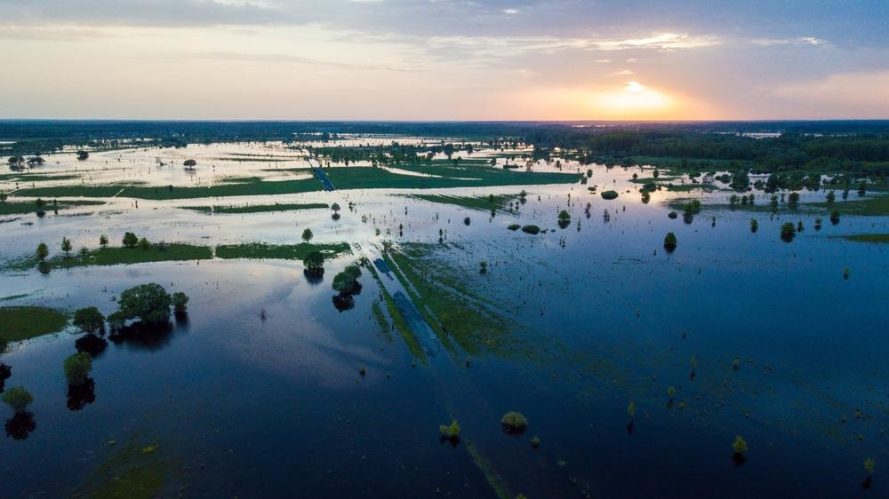

**Causes of Flooding and the Importance of Flood Monitoring**

A flood can be described as an overflow of water in an area considered to be relatively dry. They can cause considerable damage to property and the environment, including crops and wildlife, and are an additional financial cost.

Floods can be caused by natural disasters or water pipe breaks. In the United States, it is reported that more than 800 floods are triggered by water pipe breaks, leading to excessive damage which can amount to well over $15,000 for homeowners. Flooding is also associated with the development of mold which can appear within 24 hours.

Overflowing rivers can lead to flooding the areas along the river. If heavy precipitation is received upstream of a river, the large water volumes can flood the houses of people who live along the river downstream, even if it did not rain severely there.

Broken dams can also lead to flooding. Aging dams, which can be overwhelmed by high levels of water, can fail and unleash torrents of water to the unsuspecting residents, causing devastating flooding.

Melting snow and ice after a heavy snowfall and other forms of precipitation can lead to flooding once temperatures begin to warm.

**Climate Change and Flood Monitoring**

Connecting climate change to flooding is challenging as a result of limited data on floods, making it difficult to measure or compare against climate-driven trends today. The Intergovernmental Panel on Climate Change (IPCC) has noted that it is increasingly clear that climate change has detectibly influenced several water-related variables that directly contribute to flooding.[Download a free copy](https://www.azocleantech.com/industry-focus/agritech-ebook?src=content-embed)

The changing climate has had a profound effect on weather patterns. In an area such as Washington DC, which has been historically wet, the changes such as a rise in atmospheric temperatures can lead to more severe precipitation and storms. Combined, these factors are the fuel to other extreme weather incidents such as landslides and flooding.

Part of this is the result of more water vapor being present in the air due to higher humidity, with the increasing temperatures allowing more water to exist as a gas. Another reason is increased evaporation due to increased atmospheric temperatures facilitating evaporation in the water cycle.

**Benefits of Flood Monitoring**

Because of the devastating effects that floods can have on people and their environments, flood monitoring systems have been developed to help prepare and warn people of emanating danger. The systems can help prevent excessive damage and loss as a result of flooding and possibly save lives.

Some benefits of using a flood monitoring system include:

* High reliability as data is sent in real-time
* Timely detection of flood risks
* Tailored solutions that can easily be integrated with external development at any level such as connectivity, user application, and device.

Data collected using a flood monitoring system can be used in future studies for weather patterns and climate change.

Flood monitoring systems also have total integration and adaptation with emergency plans. They consume less energy and can be powered with solar energy. Flood monitoring system equipment is highly resilient and has a long working life span, making it very convenient and cost-effective.

**Challenges Faced in Flood Monitoring**

**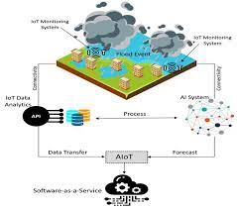**

Flood risk information can be acquired via past flood records that occurred in the area, surveying assets and people exposed to floods, and the use of predictive modeling.

The use of historical flood records is often unavailable. To understand the vulnerable areas, expensive mapping and surveys need to be carried out and have to be constantly updated with dynamic urban growth. Predictive modeling also requires the collection of data sets such as land use, topography, exposure, and soil types.

This task requires the availability of highly skilled staff who can run simulations and analyze the collected data. In rural areas, flood monitoring systems may not be available and rely on human observers as opposed to sensors.

**New Developments and the Future of Flood Monitoring**

Many western European countries were recently subjected to severe flooding which resulted in huge economic losses and multiple deaths. Floods have become a frequent threat as a result of climate change, but with the development of artificial intelligence (AI), a much more advanced flood detection system has been developed based on deep computer algorithms.

The development of smart cameras and sensor technology helps detect the water levels and measure the probability of flooding even before the floods happen.

With much more research being carried out to improve flood monitoring systems, many governments are investing in much quicker methods of detection. Aside from real-time analysis, visualization will also help emergency authorities to showcase current conditions, allowing citizens to take action and prepare adequately.

**Design**

**Long-term rainfall and melting snow have raised water levels and flooded city roads, causing flooding. Frequent and extreme flooding is inevitable and endangers community safety. Areas that are low-lying or near rivers and lakes are more vulnerable to flooding than normal areas. To reduce hazards from flooding, a flood warning system should be in place near any major waterway. Flood warning systems can help communities and transportation prepare for this serious threat. Timely and accurate early warning can save property and lives.**

**All countries in the world attach great importance to flood warning systems. In 1854, France established the world’s first flood warning system on the Seine River. In 1966, the United States used remote sensing technology to improve data collection and processing methods in the Mississippi River flood control project. Many developed countries have established automatic flood warning systems on many rivers. Some developing countries have also established such systems on some rivers.**

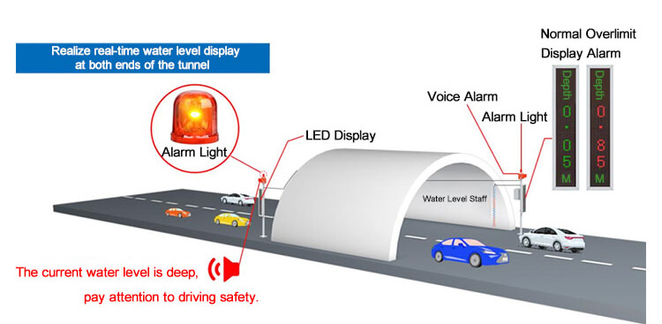

## What is a flood warning system?

The flood warning system monitors the weather and water level and issues warnings in order to prevent flood disasters and effectively use water resources. Including data monitoring, transmission, processing and analysis.

The flood warning system utilizes computer technology, database technology, communication technology, and sensor technology. Powered by [IoT technology](https://www.renkeer.com/iot-sensors-applications/" \t "_blank), rainfall and water levels are monitored and floods are predicted. Early warning of impending flooding can save lives and reduce extensive property damage. Predict potential flood disasters and provide scientific information for effectively preventing flood disasters.

The real time flood monitoring and warning system include liquid level sensors, [meteorological sensors](https://www.renkeer.com/meteorological-sensors/), communication equipment, and data collectors. And data acquisition, archiving, processing, and management software designed for flood warnings.

## How do flood warning systems work?

Monitoring of river rainfall, water level and flow velocity at important measuring points upstream. The monitoring data is transmitted to the software platform through wired or wireless signals. After data processing and analysis, the flood dynamics can be grasped in time, and the mathematical model can be used to make future coastal flood forecasts. Provide enough time for the community or transit station to take action. Reduce property and life loss.

[Flood Monitoring System With IoT Sensors](https://www.renkeer.com/flood-monitoring-system-with-iot-sensors/)

## Two types of flood warning systems

There are many automated flood monitoring system types. The functions that can be realized vary from system to system. The number of stations, their location, and the hydrological sensors used at each station differ from region to region. If you want to monitor low-lying roads, a waterlogged sensor is best. If you want to monitor changes in a nearby river, water level staff and [level sensors](https://www.renkeer.com/product/water-level-sensor/) are the way to go.

### Road flood warning system

The road flood alarm system is a device that buries the water sensor on the ground to monitor the groundwater depth. Once the water depth exceeds the set value, the alarm will be used to remind the staff to drain water in time and remind pedestrians to pay attention to the water depth. The station adopts highly integrated equipment to monitor the water accumulation in various low-lying road sections in the urban area in real time and realize automatic alarms. By integrating data from various monitoring points, we can know the waterlogging status for the entire urban area and carry out drainage scheduling in a timely manner.

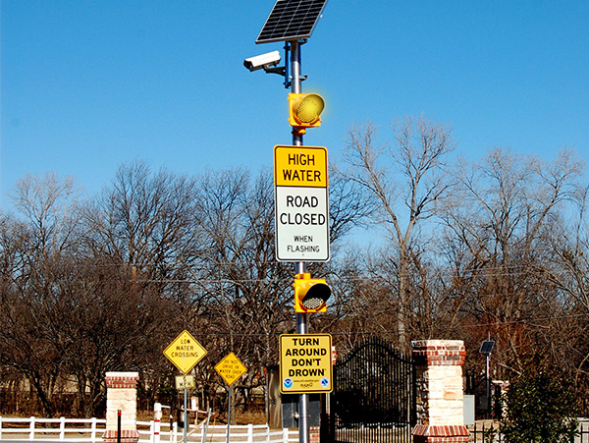

The road flood alarm system can be used in low-lying intersections, underpass bridges, overpasses, bridge holes, tunnels, and other places to provide protection for people’s travel safety. It can be used in river courses, irrigation canals, underground drainage pipeline networks, and other places to provide data support for urban drainage work. It can also be used in underground garages to prevent floods and protect people’s property.

#### System composition

The road flood monitoring station includes LORA buried water sensor, rain gauge, monitoring master station (including LED display, horn, alarm, telemetry, waterproof box, 2m pole, etc.) and a comprehensive environmental monitoring cloud platform.

**LORA buried water sensor**: It is a measuring unit with a 304 stainless steel shell. Built-in water level detection module (water depth, water status), Bluetooth configuration module, LORA wireless communication module and built-in lithium battery. Its principle is based on the liquid-mediated ultrasonic sensor. Measure the duration of the sound wave from emission to reception, and combine the compensated sound velocity to obtain the distance traveled by the sound wave. Calculate the current liquid level height according to the time difference from the time the ultrasonic waves are emitted to the water surface echoes are received from the installed measuring points.

**Rain gauge**: The [tipping bucket rain gauge](https://www.renkeer.com/product/stainless-steel-rain-gauge/) is most commonly used in flood monitoring stations, which has high measurement accuracy and is easy to install. It can be used in an outdoor environment for a long time. It is usually installed on top to avoid surrounding objects from blocking rainwater from falling. The rain gauge is used to measure the rainfall in the current environment and provide data support for the flood warning system.

**LCD display screen**: 102cm\*22cm LED red and green dual-color display screen, the unit board dot matrix is 16\*96, and the display mode is the vertical display. It is convenient for pedestrians and vehicles to see the depth in tunnels, highways, and other places.

**Speaker and alarm**: Neither the alarm nor the speaker will work when the water level does not exceed the set limit. When the limit is exceeded, the speaker works, the broadcast content is consistent with the display content, and the alarm works at the same time. Once the limit is exceeded, the alarm and the speaker broadcast three times, and after three times, it is judged whether the limit is exceeded. The interval between each broadcast is fixed at 5S.

**Telemetry**: It is inside the waterproof box. It is a transfer server developed by our company that is suitable for remote monitoring equipment and transmits data through the 4G communication module. The water level value and remaining power can be uploaded in real time through 4G or RJ45.

**Waterproof box**: The waterproof box is mainly used to protect important electrical components from rain damage. It adopts a high-strength sheet metal box and a white plastic-sprayed anti-rust shell. Resistant to long-term rain and snow, and solar radiation. It can work outdoors for a long time. Even under direct sunlight, it can ensure a constant temperature inside the box.

**Pole**: It is high-strength stainless steel, which mainly plays a supporting role.

**Data Platform**: The Flood Monitoring Station includes a robust and reliable network data collection and management software platform to facilitate 24×7 enabled real-time monitoring, visualization and web-based decision management. Every important parameter on the project can be monitored and managed in real time. At the same time realize platform-based remote control..

#### Advantages

**Wide measurement range**

One telemetry in this flood monitoring system can be connected to 32 water sensors, and can collect water level information from 32 different locations at the same time. The measurement range is very wide. The "one-to-many supervision model" allows us to monitor various locations in the city in real time.

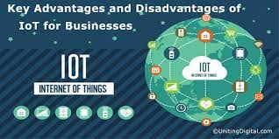

**Long transmission distance**

Data platforms can view trends in real time or in graph form. Real-time alerts can be sent via text or email when measured data exceeds set values In the past, in order to detect the water level in different places, we always ran here and there. Now, the measuring point is at this end, and the terminal display is at that end. LoRa wireless transmission, no wiring problem. The LoRa signal has strong penetrating ability, and the distance can reach up to 1000 meters.

**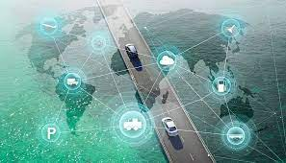**

**Simple Bluetooth configuration**

The sensors at the site can be configured via Bluetooth. We just use the magnet to rotate 3 times or more clockwise around the teflon, click the software to connect the device. Connect the upper measuring point, modify the transmission frequency, reception frequency, transmission/reception spreading factor, data upload interval, system time, water immersion threshold and other parameters. You can also view real-time water level data.

**Remote data viewing**

Telemetry will upload water level information and battery power to the monitoring platform, so that customers can view the data on their mobile phones or computers anytime, anywhere. The monitoring platform has powerful functions, real-time data, remote alarm, historical data export, parameter setting, map viewing, etc. You can also view the scene through video. In addition, it also has functions such as large-screen visualization, account authority classification, information sharing, manual, timing, and automatic control.

**Multiple alarm methods**

The safety thresholds can be set separately on the sensor and the monitoring platform. When the accumulated water at the measuring point exceeds the set safety value, the alarm function will be automatically turned on. On-site: The font on the LED two-color display turns red, and the current water level is displayed in real time. Sound and light alarms and loudspeakers will remind passing pedestrians to pay attention to safety. On the monitoring platform: the monitoring interface will alarm with redness, pop-up window, sound, etc. Remotely send alarms to us by email, text message, phone call, etc. Confirm the specific location through the electronic map so that we can make timely countermeasures and reduce losses.

### River flood warning system

This flood warning system is used to measure changes in the water level of rivers and water bodies to predict flood damage. This flood alarm system has protective measures such as lightning protection and anti-jamming. Various technologies such as derating, electromagnetic compatibility, and outlier elimination are adopted. Enhance the resistance of the monitoring station to the field environment, making it more adaptable to various harsh environments in the field.

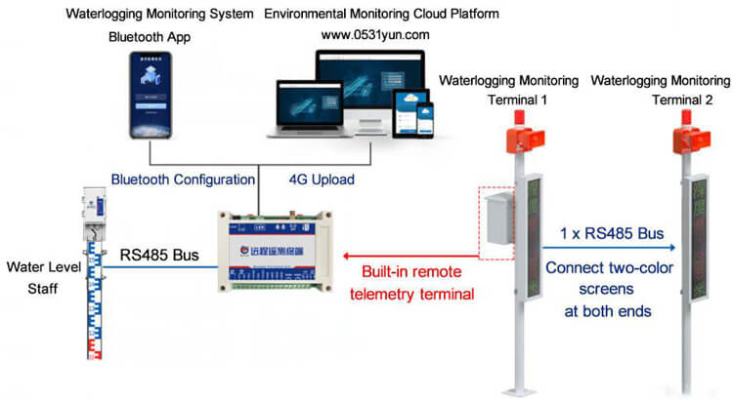

#### System composition

The river flood monitoring station includes a [level staff](https://youtu.be/ZVkI80UYaVc), a two-color LED display, a waterproof box (including telemetry), an alarm light, a horn, a two-meter pole, and a solar power supply system (optional). Among them, the water level staff transmits the measured water level information to the telemetry through [rs485](https://www.renkeer.com/what-is-rs485/)communication. Telemetry transmits the water level value to the background server through the 4G communication module. At the same time, the detected water level can be displayed on the LED screen in real-time, and the horn and alarm will be triggered if the water level exceeds the limit. Remind the staff to arrange flood control work in time.

[**Water level staff**](https://www.renkeer.com/product/water-level-staff/): Adopt an advanced processor chip as a controller. The range supports customization, and the data is obtained by measuring the water level, which has extremely high precision and anti-interference ability. Various working modes can be modified according to the site conditions. The casing adopts advanced production technology, and stainless steel is used as the casing protection material. The interior is specially treated with high-sealing materials so that the product is not affected by the external environment such as mud, corrosive liquid, pollutants, and sediment.

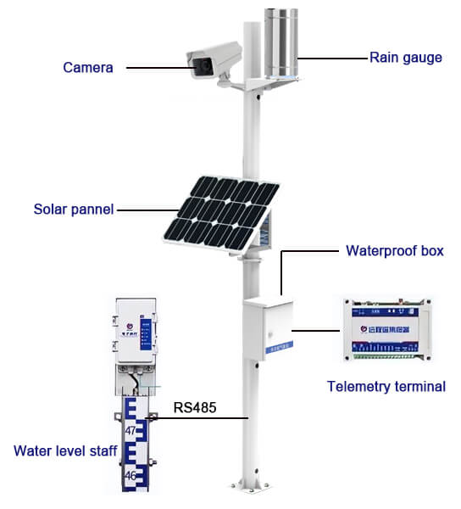

**Rain gauge**: Used to monitor the effect of rainfall on water level changes.

**Solar panels and storage batteries**: Monitoring sites are mostly installed in mountainous areas with complex terrains, far away from the grid and need to be powered by cables. Installing solar panels does not require laying complicated wires. It is quick to install and can be installed and used at any time, which not only provides convenience but also saves costs. So solar power becomes the best choice. When the battery is fully charged, the site can be guaranteed to work continuously for 7 days in rainy days.

**Telemetry**: It is inside the waterproof case and is used for data transmission.

**Waterproof box**: used to protect telemetry, monitoring host and other non-waterproof electrical components.

**Pole**: The micro-connecting hole design is added to the pole body, and the wiring is inside the pole. Effectively avoid damage to equipment lines caused by ultraviolet rays and birds and insects. There is an inspection port on the rod body, which is not only convenient for inspection and maintenance, but also convenient for configuration.

**Optional camera**: In order to understand the changes in the water around the site, the flood monitoring station can be equipped with an optional Haikang camera, and the monitoring screen can be uploaded to the data platform through the network character superimposed device, and the environment can be monitored by video.

**Software platform**: The river flood monitoring station can be configured not only through the remote cloud platform, but also through the on-site Bluetooth connection APP configuration. Upload target address, target port, water level deviation, water level threshold, water level hysteresis, delay time, data upload interval, ICCID value, etc.

## The importance of flood warning systems

Flood monitoring is to prevent floods from harming the environment. Flood alarm stations are set up to provide real-time data on rivers, lakes, reservoirs or other water bodies. Flood warning systems can provide real-time water regime data to workers to take action before flood disasters occur to prevent loss of property and lives.

According to the law of flood formation and movement. Use real-time hydrological and meteorological data to predict future flood development. Water workers and ambulance crews must know when flooding is expected, where it is likely to go, and how severe it will be. Only in this way can the community be protected to the greatest extent.

A real-time flood warning system can predict flood occurrence, direction and severity. Empowering communities to respond faster and more effectively so they can protect their own citizens. Accurate forecasts and effective measures are the best defenses against floods as they allow for more informed decisions.

## Flood warning systems advantages

### Alarm is accurate

The monitoring platform intelligently analyzes the measurement video and data, and excludes climate and environmental factors. Avoid manual monitoring errors and reduce false positives and false negatives in the video surveillance system.

### Real-time alarms

Using intelligent video analysis and network technology to measure the lake in real time, the alarm information can be displayed on the monitoring client interface, and the alarm information can also be pushed to the mobile terminal.

### Long-term monitoring

The flood monitoring system can perform 7×24 uninterrupted monitoring outdoors, and it can work normally even in severe weather conditions, reducing labor costs.

### Storage function

Record the water level changes at monitoring points in real time, and store the alarm information in the server database, including time, location, snapshot, video, etc.

**Step 1**: **Connecting 5v and GND of Arduino to the Breadboard for power connection to other components.**

**Step 2**: **Connecting LED’s**

**For Green LED:**

* VCC of  Green Colour LED to Digital Pin ‘10’ of the Arduino.
* GND of Green Colour LED to the GND of Arduino.

**For Orange LED:**

* VCC of  Orange Colour LED to Digital Pin ‘11’ of the Arduino.
* GND of Orange Colour LED to the GND of Arduino.

**For Red LED:**

* VCC of  Red Colour LED to Digital Pin ‘12’ of the Arduino.
* GND of Red Colour LED to the GND of Arduino.

**Step 3**: **Connecting Buzzer**

* VCC of  Buzzer to Digital Pin ‘13’ of the Arduino.
* GND of Buzzer to the GND of Arduino.

**Step 4**: **Connecting HC-SR04 Ultrasonic Sensor**

* VCC of Ultrasonic Sensor to 5v of Arduino.
* GND of Ultrasonic Sensor to GND of Arduino.
* Echo of Ultrasonic Sensor to Digital Pin ‘8’ of Arduino.
* Trig of Ultrasonic Sensor to Digital Pin ‘9’ of Arduino.

**Step 5: Connecting Bolt WiFi Module**

* 5v of Bolt WiFi Module to 5v of Arduino.
* GND of Bolt WiFi Module to GND of Arduino.
* TX of Bolt WiFi Module to RX of Arduino.
* RX of Bolt WiFi Module to TX of Arduino.

**Step 6: Connecting LM35 Temperature Sensor**

* VCC of LM35 to 5v of Bolt WiFi Module.
* Output Pin of LM35 to Pin ‘A0’ of  Bolt WiFi Module.
* GND of LM35 to GND of Bolt WiFi Module.

**Step 7:Connecting 16×2 LCD  Display**

* Pin 1,3,5,16 of 16×2 LCD to GND of Arduino.
* Pin 2,15 of 16×2 LCD to 5v of Arduino.
* Pin 4 of 16×2 LCD to Digital Pin ‘2’ of Arduino.
* Pin 6 of 16×2 LCD to Digital Pin ‘3’ of Arduino.
* Pin 11 of 16×2 LCD to Digital Pin ‘4’ of Arduino.
* Pin 12 of 16×2 LCD to Digital Pin ‘5’ of Arduino.
* Pin 13 of 16×2 LCD to Digital Pin ‘6’ of Arduino.
* Pin 14 of 16×2 LCD to Digital Pin ‘7’ of Arduino.

After doing the hardware connection put all the hardware components in one box.

Also attach LM35 Temperature Sensor on the side of the container.

Also attach Ultrasonic sensor on the top of the container.

## Software Programming

After the successful completion of hardware setup. Now it’s the time to do software setup for the project. For that you have to first Download and Install Arduino IDE and Python IDE from the link given above in the software apps and online services section. Also Creating account on various online app services and noting down the important keys and id’s. Below all the steps given to create account on online app services and noting down the keys.

**Step 1**:**Creating an account on Twillo and setting up Twillo for sending Sms alerts.**

* Visit <https://www.twilio.com/>.
* Create account by clicking sign up, fill required details.
* Confirm your email.
* You will need to authenticate your phone number on which the sms alerts will be notified.
* Enter the code sent to your phone
* When prompted ” Do you write code?” Click yes
* Select python as your programming language
* When prompted “What is your target today? “Choose” Twilio as a project.
* When prompted “What do you want to do first? “Choose” Send or receive a message.
* My First Twilio Project Dashboard page will open. Now you can Edit your Project as “My Project”.
* Get a trial number and save it somewhere and then choose to use this number.
* You will see the ACCOUNT SID and AUTH TOKEN.
* We will need Account Sid, Auth Token and Trial Number of these so save them somewhere.

**Step 2**:**Creating an account on Mailgun and setting up Mailgun for sending Email alerts.**

* Visit <https://www.mailgun.com/>.
* Create an account by clicking on the start sending option and by filling up details.
* Verifying your Account.
* Once you have verified your Email after that you have add your phone number.
* After Entering your number. Click on send activation code. After some time you will receive one OTP. Enter the OTP. Click on Enter.
* After Creating account on Mailgun go to the overview option. Click on API and Click on Python.
* After doing this so you will receive API Key and Sandbox URL. Save this both credentials somewhere you will be further using in this project.

**Step 4:Creating an account on Bolt Cloud and Bolt Android App and Link the Bolt Module to Cloud.**

* Visit [https://cloud.boltiot.com](https://cloud.boltiot.com/).
* Create account using Email-Id and password.(Use the same email which was used to order hardware kit also use same email for app for linking the hardware to cloud.)
* After creating account on cloud. Then Download Bolt Android App from playstore.
* Create a account on the Bolt app with the same email-Id then use the mobile hotspot for linking the Bolt WiFi module to cloud.
* After successful linking of the device to the cloud then go to the cloud website. The Bolt device will show the device as online.
* Go to API section make the API as enable. Copy the API and save somewhere.
* Also copy the Bolt Device Id which is present on Bolt IoT dashboard and save it somewhere.

**Bolt Device Id**

**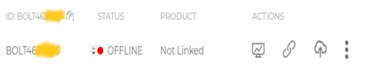**

**API Key**

**Step 5: Coding**

After setting online app services and saving the keys somewhere. Now most important is to write code and allow sensors attached to microcontroller to take specific decisions.

Basically this project contains two editors to write the code. First is Arduino IDE in that we will write the arduino code. Second the Python IDE in that we will write the configuration file and the main code. Also the download link of both the editor can find above in the online app services section.

**Step 5.1: Writing the code in the Arduino IDE**

* Open the Arduino IDE(Downloaded from the above section).
* Click on new file. Choose the correct file path to save the file. Give appropirate name to the file and add .ino extention to the file and save the file.
* Now the core part of the project is writing code for Arduino Uno. Below this line complete code is given. You can refer the below code.
* After writing the code. Verify the code and then upload the code to the specific Arduino using USB Cable type A. Remember while uploading select specific board you want to upload.

**Step 5.2: Writing the code in Python IDE.**

* For writing python code we will be using python IDE.
* In this project we will be making two python files. One will be saved in the name of conf.py and other will be main.py.
* **conf.py:** The file consists of important Api keys, Device id of Bolt IoT WiFi Module. Also it consists of important keys of Twillo and Mailgun respectively which will be further usefull in this project.
* Below is the complete structure of conf.py file. Make sure that you add the updated Bolt API key, device id and Mailgun and Twillo details respectively.

THANK YOU!