EGAILE System Architecture
Architecture 1.0 | 16 October 2026 | Diagram 1 of 2
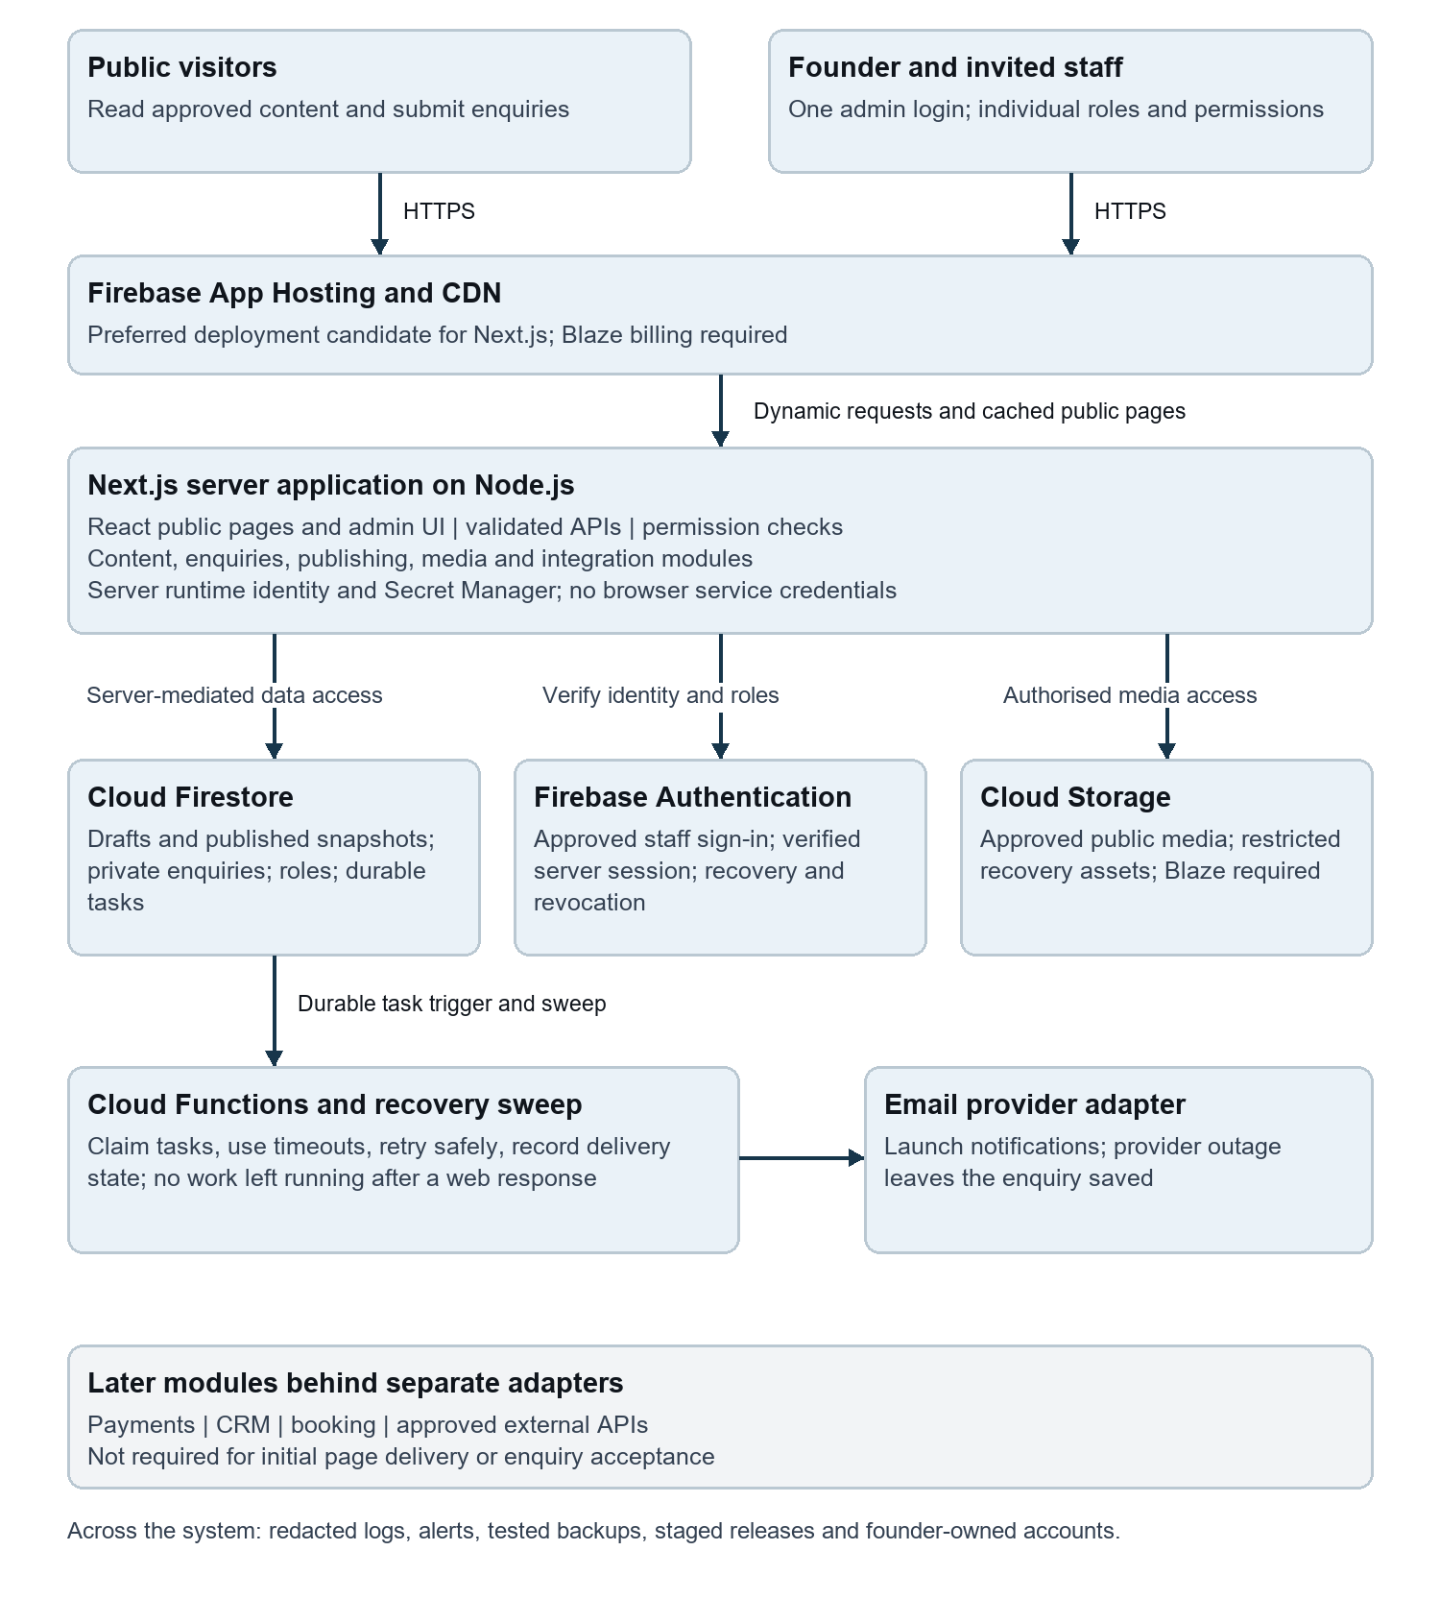
Proposed Firebase architecture. Solid arrows show principal launch flows. The grey module is later scope. No production resources are deployed by this document.

EGAILE Reliability and Integration Flow
Architecture 1.0 | 16 October 2026 | Diagram 2 of 2
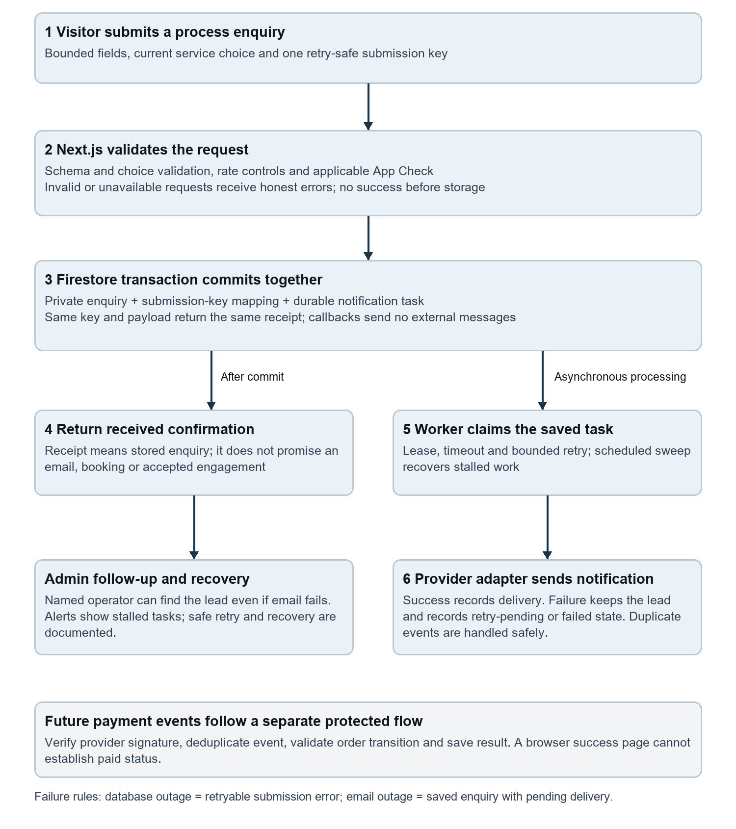
Proposed enquiry acceptance and recovery flow. Confirmation follows the database commit; notification processing runs separately. Future payments have a separate verified event boundary.

