SMART CAMPUS PARKING AND
TRAFFIC MANAGEMENT SYSTEM
CSA0925 – Programming in Java

Student Name | Register Number
G Sai Deepak | 192311432
I. MD IMTHIAZ | 192521360

Assignment Report

GITHUB LINK: https://github.com/Imthiaz-123/smartparkingsystem,
https://github.com/DeepakGontla/CSA0925-JAVA-PROGRAMMING/blob/main/SmartCampusParking%20(3).zip

Pseudo code:
The pseudocode below represents the submitted implementation: Java Swing desktop interface, JDBC persistence, and MySQL database. The report describes the actual source structure rather than the AWT implementation used in the reference report.
SYSTEM: SMART CAMPUS PARKING AND TRAFFIC MANAGEMENT SYSTEM
TECHNOLOGY: Java Swing + JDBC + MySQL

MODULE 1: DATABASE CONNECTION
CLASS DatabaseConnection
CONSTANT URL = "jdbc:mysql://localhost:3306/smart_campus_parking"
CONSTANT USER = "root"
CONSTANT PASSWORD = "<configured database password>"

FUNCTION getConnection()
RETURN DriverManager.getConnection(URL, USER, PASSWORD)

MAIN
TRY
connection = getConnection()
IF connection is not NULL
PRINT "Database connected successfully!"
CLOSE connection
CATCH SQLException
PRINT "Database connection failed!"

MODULE 2: APPLICATION ENTRY
CLASS Main
FUNCTION main(args)
RUN DashboardFrame on Swing Event Dispatch Thread

MODULE 3: DASHBOARD
CLASS DashboardFrame EXTENDS JFrame
CREATE navigation controls
Dashboard, Users, Vehicles, Parking, Reservations,
Entry / Exit, Payments, Violations, Reports

FUNCTION loadDashboardData()
total = DashboardDao.getTotalSlots()
occupied = DashboardDao.getOccupiedSlots()
available = DashboardDao.getAvailableSlots()
reserved = DashboardDao.getReservedSlots()
statuses = DashboardDao.getSlotStatuses()

DISPLAY metric cards
DISPLAY live parking slot grid

FOR EACH slot
IF status = OCCUPIED
use occupied visual state
ELSE IF status = RESERVED
use reserved visual state
ELSE
use available visual state

MODULE 4: USER MANAGEMENT
CLASS UsersFrame
INPUT full name, user type, department, phone, email
ON ADD
validate input
INSERT user record
refresh table
ON UPDATE
UPDATE selected user
refresh table
ON DELETE
DELETE selected user
refresh table

MODULE 5: VEHICLE MANAGEMENT
CLASS VehiclesFrame
INPUT user id, vehicle number, vehicle type, model, color
ON ADD
VehicleDao.addVehicle(...)
refresh table
ON UPDATE
VehicleDao.updateVehicle(...)
refresh table
ON DELETE
VehicleDao.deleteVehicle(...)
refresh table

MODULE 6: PARKING SLOT MANAGEMENT
CLASS ParkingFrame
LOAD slots with zone information
DISPLAY slot number, zone, type, status, floor and active state

ON UPDATE STATUS
ParkingDao.updateSlotStatus(slotId, selectedStatus)
refresh table

MODULE 7: RESERVATION MANAGEMENT
CLASS ReservationsFrame
INPUT vehicle id, slot id, reserved-from, reserved-until, status

ON ADD
ReservationDao.addReservation(...)
refresh table

ON UPDATE
ReservationDao.updateReservation(...)
refresh table

ON DELETE
ReservationDao.deleteReservation(...)
refresh table

MODULE 8: ENTRY / EXIT
CLASS EntryExitDao
FUNCTION recordEntry(vehicleId, slotId)
INSERT parking session with
entry_time = NOW()
parking_status = ACTIVE
calculated_amount = 0

FUNCTION recordExit(sessionId)
UPDATE session
exit_time = NOW()
duration_minutes = TIMESTAMPDIFF(MINUTE, entry_time, NOW())
parking_status = COMPLETED

CLASS EntryExitFrame
DISPLAY active and completed parking sessions
PROVIDE RECORD ENTRY and RECORD EXIT operations

MODULE 9: PAYMENTS
CLASS PaymentDao
ADD payment using session id, amount, payment method,
payment status and transaction reference
UPDATE payment
DELETE payment
LOAD all payment records

MODULE 10: VIOLATIONS
CLASS ViolationDao
ADD violation with vehicle id, session id, violation type,
description, fine amount and status
UPDATE violation
DELETE violation
LOAD all violations

MODULE 11: REPORTS
CLASS ReportDao
GET total users
GET total vehicles
GET total sessions
GET completed sessions
GET total parking revenue
GET total violations
GET total fines
GET session report
GET violation report

CLASS ReportsFrame
DISPLAY summary cards
DISPLAY Parking Session Report
DISPLAY Violation Report
PROVIDE Refresh Reports

MODULE 12: NAVIGATION
DashboardFrame receives selected menu item
IF Users -> open UsersFrame
IF Vehicles -> open VehiclesFrame
IF Parking -> open ParkingFrame
IF Reservations -> open ReservationsFrame
IF Entry / Exit -> open EntryExitFrame
IF Payments -> open PaymentsFrame
IF Violations -> open ViolationsFrame
IF Reports -> open ReportsFrame

Class Diagram:
The class diagram represents the major presentation, data-access and database-support components found in the submitted project.
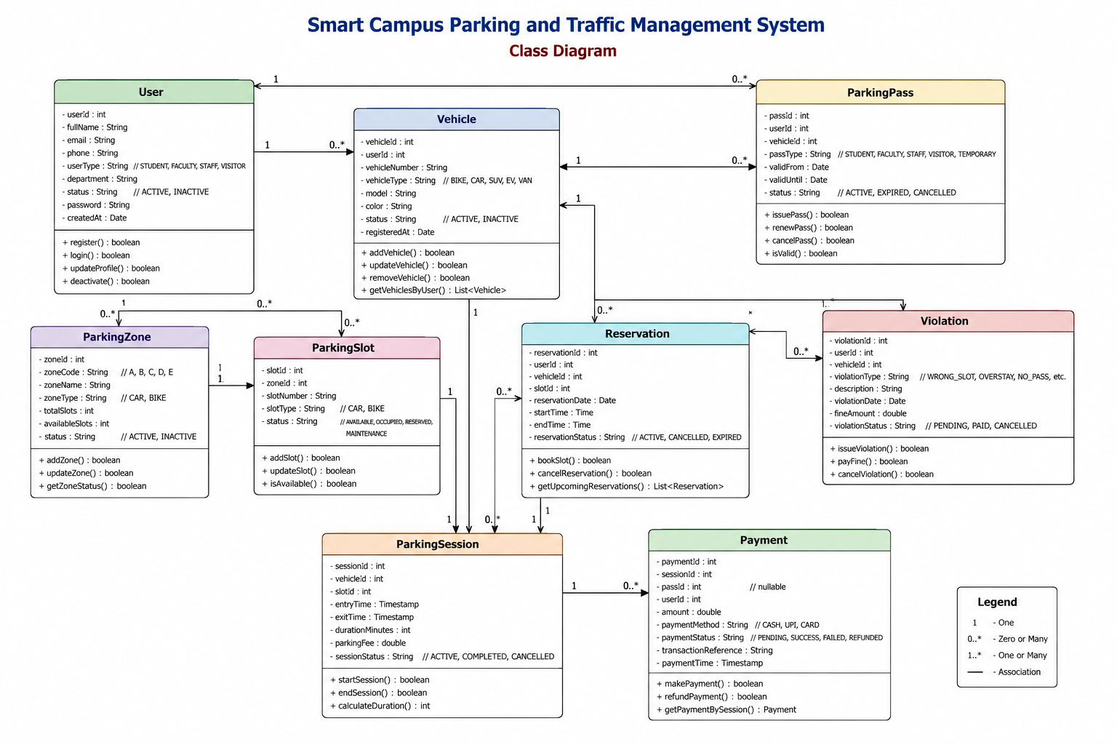
Figure 1: Class Diagram

Use Case Diagram:
The use case view captures the administrator's interaction with the major Smart Campus Parking modules.
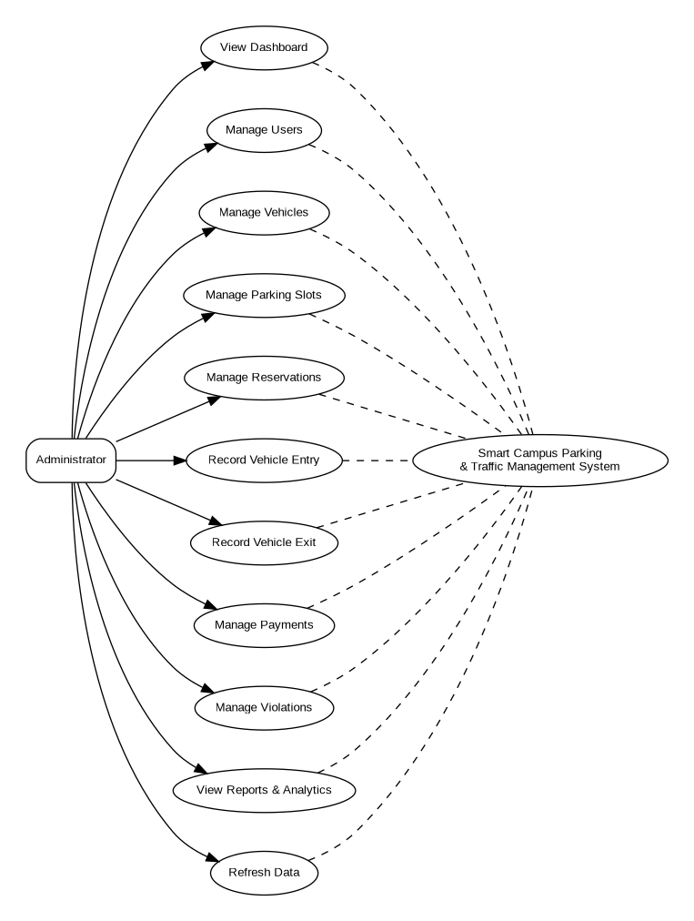
State Diagram:
The state flow focuses on a parking slot/session lifecycle: availability, reservation, occupancy through entry, completion through exit, and return to an available state.
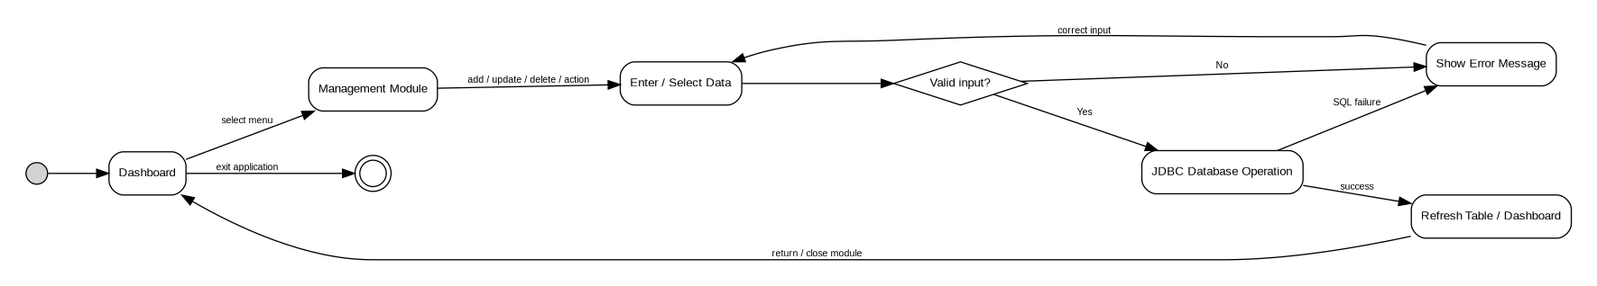
Figure 3: State Diagram

Source Code:
The following source-code section contains the Java files supplied in the SmartCampusParking project archive. Database credentials are intentionally represented by a configuration placeholder.
Main.java
import ui.DashboardFrame;

import javax.swing.SwingUtilities;

public class Main {

public static void main(String[] args) {

SwingUtilities.invokeLater(() -> {
DashboardFrame dashboard = new DashboardFrame();
dashboard.setVisible(true);
});
}
}

TestDatabase.java
import dao.UserDao;

import java.util.List;

public class TestDatabase {

public static void main(String[] args) {

UserDao userDAO = new UserDao();

System.out.println("===== USER DATABASE TEST =====");

List<String[]> users = userDAO.getAllUsers();

if (users.isEmpty()) {
System.out.println("No users found.");
} else {

for (String[] user : users) {

System.out.println(
"ID: " + user[0] +
" | Name: " + user[1] +
" | Type: " + user[2] +
" | Department: " + user[3] +
" | Phone: " + user[4] +
" | Email: " + user[5] +
" | Status: " + user[6]
);
}
}

System.out.println("==============================");
}
}

DashboardTest.java
import dao.DashboardDao;

import java.util.Map;

public class DashboardTest {

public static void main(String[] args) {

DashboardDao dashboardDAO = new DashboardDao();

System.out.println("===== DASHBOARD DATABASE TEST =====");

System.out.println(
"Total Slots : " +
dashboardDAO.getTotalSlots()
);

System.out.println(
"Occupied Slots : " +
dashboardDAO.getOccupiedSlots()
);

System.out.println(
"Available Slots: " +
dashboardDAO.getAvailableSlots()
);

System.out.println(
"Reserved Slots : " +
dashboardDAO.getReservedSlots()
);

System.out.println("\n===== SLOT STATUS =====");

Map<String, String> slots =
dashboardDAO.getSlotStatuses();

for (Map.Entry<String, String> entry :
slots.entrySet()) {

System.out.println(
entry.getKey() +
" -> " +
entry.getValue()
);
}

System.out.println(
"=============================="
);
}
}

db/DatabaseConnection.java
package db;

import java.sql.Connection;
import java.sql.DriverManager;
import java.sql.SQLException;
import db.DatabaseConnection;

public class DatabaseConnection {

private static final String URL =
"jdbc:mysql://localhost:3306/smart_campus_parking";

private static final String USER =
"root";

private static final String PASSWORD =
"<configured database password>";
public static Connection getConnection() throws SQLException {
return DriverManager.getConnection(URL, USER, PASSWORD);
}
public static void main(String[] args) {
try {
Connection connection = getConnection();

if (connection != null) {
System.out.println("Database connected successfully!");
}
connection.close();
} catch (SQLException e) {
System.out.println("Database connection failed!");
e.printStackTrace();
}
}
}

util/DbUtil.java
package util;

import db.DatabaseConnection;

import java.sql.Connection;
import java.sql.SQLException;

public class DbUtil {
public static Connection getConnection() throws SQLException {
return DatabaseConnection.getConnection();
}

public static void closeConnection(Connection connection) {
if (connection != null) {
try {
connection.close();
} catch (SQLException e) {
System.out.println("Error while closing database connection.");
}
}
}

}

dao/DashboardDao.java
package dao;

import db.DatabaseConnection;

import java.sql.Connection;
import java.sql.PreparedStatement;
import java.sql.ResultSet;
import java.sql.SQLException;
import java.util.LinkedHashMap;
import java.util.Map;

public class DashboardDao {

// Get total number of parking slots
public int getTotalSlots() {

String sql = "SELECT COUNT(*) FROM parking_slots";

try (Connection connection = DatabaseConnection.getConnection();
PreparedStatement statement = connection.prepareStatement(sql);
ResultSet result = statement.executeQuery()) {

if (result.next()) {
return result.getInt(1);
}

} catch (SQLException e) {
e.printStackTrace();
}

return 0;
}

// Get occupied slots
public int getOccupiedSlots() {

String sql =
"SELECT COUNT(*) FROM parking_slots WHERE status = 'OCCUPIED'";

try (Connection connection = DatabaseConnection.getConnection();
PreparedStatement statement = connection.prepareStatement(sql);
ResultSet result = statement.executeQuery()) {

if (result.next()) {
return result.getInt(1);
}

} catch (SQLException e) {
e.printStackTrace();
}

return 0;
}

// Get available slots
public int getAvailableSlots() {

String sql =
"SELECT COUNT(*) FROM parking_slots WHERE status = 'AVAILABLE'";

try (Connection connection = DatabaseConnection.getConnection();
PreparedStatement statement = connection.prepareStatement(sql);
ResultSet result = statement.executeQuery()) {

if (result.next()) {
return result.getInt(1);
}

} catch (SQLException e) {
e.printStackTrace();
}

return 0;
}

// Get reserved slots
public int getReservedSlots() {

String sql =
"SELECT COUNT(*) FROM parking_slots WHERE status = 'RESERVED'";

try (Connection connection = DatabaseConnection.getConnection();
PreparedStatement statement = connection.prepareStatement(sql);
ResultSet result = statement.executeQuery()) {

if (result.next()) {
return result.getInt(1);
}

} catch (SQLException e) {
e.printStackTrace();
}

return 0;
}

// Get every parking slot and its current status
public Map<String, String> getSlotStatuses() {

Map<String, String> slotStatuses = new LinkedHashMap<>();

String sql =
"SELECT slot_number, status " +
"FROM parking_slots " +
"ORDER BY slot_id";

try (Connection connection = DatabaseConnection.getConnection();
PreparedStatement statement = connection.prepareStatement(sql);
ResultSet result = statement.executeQuery()) {

while (result.next()) {

String slotNumber =
result.getString("slot_number");

String status =
result.getString("status");

slotStatuses.put(slotNumber, status);
}

} catch (SQLException e) {
e.printStackTrace();
}

return slotStatuses;
}
}

dao/EntryExitDao.java
package dao;

import db.DatabaseConnection;

import java.sql.*;
import java.util.ArrayList;
import java.util.List;

public class EntryExitDao {

// =========================================================
// GET ALL PARKING SESSIONS
// =========================================================

public List<Object[]> getAllSessions() {

List<Object[]> sessions = new ArrayList<>();

String sql =
"SELECT " +
"ps.session_id, " +
"ps.vehicle_id, " +
"v.vehicle_number, " +
"ps.slot_id, " +
"s.slot_number, " +
"ps.entry_time, " +
"ps.exit_time, " +
"ps.duration_minutes, " +
"ps.parking_status, " +
"ps.calculated_amount " +
"FROM parking_sessions ps " +
"JOIN vehicles v ON ps.vehicle_id = v.vehicle_id " +
"JOIN parking_slots s ON ps.slot_id = s.slot_id " +
"ORDER BY ps.session_id DESC";

try (
Connection connection =
DatabaseConnection.getConnection();

PreparedStatement statement =
connection.prepareStatement(sql);

ResultSet result =
statement.executeQuery()
) {

while (result.next()) {

sessions.add(
new Object[]{
result.getInt("session_id"),
result.getInt("vehicle_id"),
result.getString("vehicle_number"),
result.getInt("slot_id"),
result.getString("slot_number"),
result.getTimestamp("entry_time"),
result.getTimestamp("exit_time"),
result.getObject("duration_minutes"),
result.getString("parking_status"),
result.getBigDecimal("calculated_amount")
}
);
}

} catch (SQLException e) {

e.printStackTrace();
}

return sessions;
}

// =========================================================
// RECORD ENTRY
// =========================================================

public boolean recordEntry(
int vehicleId,
int slotId) {

String sql =
"INSERT INTO parking_sessions " +
"(vehicle_id, slot_id, entry_time, parking_status, calculated_amount) " +
"VALUES (?, ?, NOW(), 'ACTIVE', 0.00)";

try (
Connection connection =
DatabaseConnection.getConnection();

PreparedStatement statement =
connection.prepareStatement(sql)
) {

statement.setInt(1, vehicleId);
statement.setInt(2, slotId);

return statement.executeUpdate() > 0;

} catch (SQLException e) {

e.printStackTrace();

return false;
}
}

// =========================================================
// RECORD EXIT
// =========================================================

public boolean recordExit(int sessionId) {

String sql =
"UPDATE parking_sessions " +
"SET exit_time = NOW(), " +
"duration_minutes = TIMESTAMPDIFF(MINUTE, entry_time, NOW()), " +
"parking_status = 'COMPLETED' " +
"WHERE session_id = ? " +
"AND parking_status = 'ACTIVE'";

try (
Connection connection =
DatabaseConnection.getConnection();

PreparedStatement statement =
connection.prepareStatement(sql)
) {

statement.setInt(1, sessionId);

return statement.executeUpdate() > 0;

} catch (SQLException e) {

e.printStackTrace();

return false;
}
}

// =========================================================
// GET ACTIVE SESSIONS
// =========================================================

public List<Object[]> getActiveSessions() {

List<Object[]> sessions = new ArrayList<>();

String sql =
"SELECT " +
"ps.session_id, " +
"ps.vehicle_id, " +
"v.vehicle_number, " +
"ps.slot_id, " +
"s.slot_number, " +
"ps.entry_time, " +
"ps.parking_status " +
"FROM parking_sessions ps " +
"JOIN vehicles v ON ps.vehicle_id = v.vehicle_id " +
"JOIN parking_slots s ON ps.slot_id = s.slot_id " +
"WHERE ps.parking_status = 'ACTIVE' " +
"ORDER BY ps.entry_time";

try (
Connection connection =
DatabaseConnection.getConnection();

PreparedStatement statement =
connection.prepareStatement(sql);

ResultSet result =
statement.executeQuery()
) {

while (result.next()) {

sessions.add(
new Object[]{
result.getInt("session_id"),
result.getInt("vehicle_id"),
result.getString("vehicle_number"),
result.getInt("slot_id"),
result.getString("slot_number"),
result.getTimestamp("entry_time"),
result.getString("parking_status")
}
);
}

} catch (SQLException e) {

e.printStackTrace();
}

return sessions;
}

// =========================================================
// CALCULATE PARKING DURATION
// =========================================================

public int getDurationMinutes(int sessionId) {

String sql =
"SELECT TIMESTAMPDIFF(" +
"MINUTE, entry_time, NOW()" +
") AS duration " +
"FROM parking_sessions " +
"WHERE session_id = ?";

try (
Connection connection =
DatabaseConnection.getConnection();

PreparedStatement statement =
connection.prepareStatement(sql)
) {

statement.setInt(1, sessionId);

try (ResultSet result = statement.executeQuery()) {

if (result.next()) {
return result.getInt("duration");
}
}

} catch (SQLException e) {

e.printStackTrace();
}

return 0;
}
}

dao/ParkingDao.java
package dao;

import db.DatabaseConnection;

import java.sql.*;
import java.util.ArrayList;
import java.util.List;

public class ParkingDao {

public List<Object[]> getAllSlots() {

List<Object[]> slots = new ArrayList<>();

String sql =
"SELECT ps.slot_id, " +
"pz.zone_code, " +
"pz.zone_name, " +
"ps.slot_number, " +
"ps.slot_type, " +
"ps.status, " +
"ps.floor_no, " +
"ps.is_active " +
"FROM parking_slots ps " +
"JOIN parking_zones pz ON ps.zone_id = pz.zone_id " +
"ORDER BY ps.slot_id";

try (
Connection con =
DatabaseConnection.getConnection();

PreparedStatement ps =
con.prepareStatement(sql);

ResultSet rs =
ps.executeQuery()
) {

while (rs.next()) {

slots.add(
new Object[]{
rs.getInt("slot_id"),
rs.getString("zone_code"),
rs.getString("zone_name"),
rs.getString("slot_number"),
rs.getString("slot_type"),
rs.getString("status"),
rs.getInt("floor_no"),
rs.getBoolean("is_active")
}
);
}

} catch (SQLException e) {

e.printStackTrace();
}

return slots;
}

public boolean updateSlotStatus(
int slotId,
String status) {

String sql =
"UPDATE parking_slots " +
"SET status = ? " +
"WHERE slot_id = ?";

try (
Connection con =
DatabaseConnection.getConnection();

PreparedStatement ps =
con.prepareStatement(sql)
) {

ps.setString(1, status);
ps.setInt(2, slotId);

return ps.executeUpdate() > 0;

} catch (SQLException e) {

e.printStackTrace();
return false;
}
}
}

dao/PaymentDao.java
package dao;

import db.DatabaseConnection;

import java.sql.*;
import java.util.ArrayList;
import java.util.List;

public class PaymentDao {

public List<Object[]> getAllPayments() {

List<Object[]> payments = new ArrayList<>();

String sql =
"SELECT payment_id, session_id, amount, " +
"payment_method, payment_status, " +
"transaction_reference, payment_time " +
"FROM payments ORDER BY payment_id";

try (
Connection connection = DatabaseConnection.getConnection();
PreparedStatement statement = connection.prepareStatement(sql);
ResultSet result = statement.executeQuery()
) {

while (result.next()) {

payments.add(new Object[]{
result.getInt("payment_id"),
result.getInt("session_id"),
result.getBigDecimal("amount"),
result.getString("payment_method"),
result.getString("payment_status"),
result.getString("transaction_reference"),
result.getTimestamp("payment_time")
});
}

} catch (SQLException e) {
e.printStackTrace();
}

return payments;
}

public boolean addPayment(
int sessionId,
double amount,
String paymentMethod,
String paymentStatus,
String transactionReference) {

String sql =
"INSERT INTO payments " +
"(session_id, amount, payment_method, " +
"payment_status, transaction_reference) " +
"VALUES (?, ?, ?, ?, ?)";

try (
Connection connection = DatabaseConnection.getConnection();
PreparedStatement statement =
connection.prepareStatement(sql)
) {

statement.setInt(1, sessionId);
statement.setDouble(2, amount);
statement.setString(3, paymentMethod);
statement.setString(4, paymentStatus);

if (transactionReference == null ||
transactionReference.trim().isEmpty()) {

statement.setNull(
5,
Types.VARCHAR
);

} else {

statement.setString(
5,
transactionReference.trim()
);
}

return statement.executeUpdate() > 0;

} catch (SQLException e) {
e.printStackTrace();
return false;
}
}

public boolean updatePayment(
int paymentId,
int sessionId,
double amount,
String paymentMethod,
String paymentStatus,
String transactionReference) {

String sql =
"UPDATE payments SET " +
"session_id = ?, " +
"amount = ?, " +
"payment_method = ?, " +
"payment_status = ?, " +
"transaction_reference = ? " +
"WHERE payment_id = ?";

try (
Connection connection = DatabaseConnection.getConnection();
PreparedStatement statement =
connection.prepareStatement(sql)
) {

statement.setInt(1, sessionId);
statement.setDouble(2, amount);
statement.setString(3, paymentMethod);
statement.setString(4, paymentStatus);

if (transactionReference == null ||
transactionReference.trim().isEmpty()) {

statement.setNull(
5,
Types.VARCHAR
);

} else {

statement.setString(
5,
transactionReference.trim()
);
}

statement.setInt(6, paymentId);

return statement.executeUpdate() > 0;

} catch (SQLException e) {
e.printStackTrace();
return false;
}
}

public boolean deletePayment(int paymentId) {

String sql =
"DELETE FROM payments WHERE payment_id = ?";

try (
Connection connection = DatabaseConnection.getConnection();
PreparedStatement statement =
connection.prepareStatement(sql)
) {

statement.setInt(1, paymentId);

return statement.executeUpdate() > 0;

} catch (SQLException e) {
e.printStackTrace();
return false;
}
}
}

dao/ReportDao.java
package dao;

import db.DatabaseConnection;

import java.sql.*;
import java.util.ArrayList;
import java.util.List;

public class ReportDao {

public int getTotalUsers() {
return getCount(
"SELECT COUNT(*) FROM users"
);
}

public int getTotalVehicles() {
return getCount(
"SELECT COUNT(*) FROM vehicles"
);
}

public int getTotalSessions() {
return getCount(
"SELECT COUNT(*) FROM parking_sessions"
);
}

public int getCompletedSessions() {
return getCount(
"SELECT COUNT(*) FROM parking_sessions " +
"WHERE parking_status = 'COMPLETED'"
);
}

public int getTotalViolations() {
return getCount(
"SELECT COUNT(*) FROM violations"
);
}

public double getTotalRevenue() {
return getDouble(
"SELECT COALESCE(SUM(calculated_amount),0) " +
"FROM parking_sessions " +
"WHERE parking_status = 'COMPLETED'"
);
}

public double getTotalFines() {
return getDouble(
"SELECT COALESCE(SUM(fine_amount),0) " +
"FROM violations"
);
}

public List<Object[]> getSessionReport() {

List<Object[]> list = new ArrayList<>();

String sql =
"SELECT session_id, vehicle_id, slot_id, " +
"reservation_id, entry_time, exit_time, " +
"duration_minutes, parking_status, calculated_amount " +
"FROM parking_sessions " +
"ORDER BY session_id";

try (
Connection connection =
DatabaseConnection.getConnection();

PreparedStatement statement =
connection.prepareStatement(sql);

ResultSet result =
statement.executeQuery()
) {

while (result.next()) {

list.add(new Object[]{
result.getInt("session_id"),
result.getInt("vehicle_id"),
result.getInt("slot_id"),
result.getObject("reservation_id"),
result.getTimestamp("entry_time"),
result.getTimestamp("exit_time"),
result.getObject("duration_minutes"),
result.getString("parking_status"),
result.getBigDecimal("calculated_amount")
});
}

} catch (SQLException e) {
e.printStackTrace();
}

return list;
}

public List<Object[]> getViolationReport() {

List<Object[]> list = new ArrayList<>();

String sql =
"SELECT violation_id, vehicle_id, session_id, " +
"violation_type, description, fine_amount, " +
"violation_time, status " +
"FROM violations " +
"ORDER BY violation_id";

try (
Connection connection =
DatabaseConnection.getConnection();

PreparedStatement statement =
connection.prepareStatement(sql);

ResultSet result =
statement.executeQuery()
) {

while (result.next()) {

list.add(new Object[]{
result.getInt("violation_id"),
result.getInt("vehicle_id"),
result.getObject("session_id"),
result.getString("violation_type"),
result.getString("description"),
result.getBigDecimal("fine_amount"),
result.getTimestamp("violation_time"),
result.getString("status")
});
}

} catch (SQLException e) {
e.printStackTrace();
}

return list;
}

private int getCount(String sql) {

try (
Connection connection =
DatabaseConnection.getConnection();

PreparedStatement statement =
connection.prepareStatement(sql);

ResultSet result =
statement.executeQuery()
) {

if (result.next()) {
return result.getInt(1);
}

} catch (SQLException e) {
e.printStackTrace();
}

return 0;
}

private double getDouble(String sql) {

try (
Connection connection =
DatabaseConnection.getConnection();

PreparedStatement statement =
connection.prepareStatement(sql);

ResultSet result =
statement.executeQuery()
) {

if (result.next()) {
return result.getDouble(1);
}

} catch (SQLException e) {
e.printStackTrace();
}

return 0.0;
}
}

dao/ReservationDao.java
package dao;

import db.DatabaseConnection;

import java.sql.*;
import java.util.ArrayList;
import java.util.List;

public class ReservationDao {

public List<Object[]> getAllReservations() {

List<Object[]> reservations = new ArrayList<>();

String sql =
"SELECT r.reservation_id, " +
"r.vehicle_id, " +
"v.vehicle_number, " +
"r.slot_id, " +
"ps.slot_number, " +
"r.reserved_from, " +
"r.reserved_until, " +
"r.reservation_status " +
"FROM reservations r " +
"JOIN vehicles v ON r.vehicle_id = v.vehicle_id " +
"JOIN parking_slots ps ON r.slot_id = ps.slot_id " +
"ORDER BY r.reservation_id";

try (
Connection con =
DatabaseConnection.getConnection();

PreparedStatement ps =
con.prepareStatement(sql);

ResultSet rs =
ps.executeQuery()
) {

while (rs.next()) {

reservations.add(
new Object[]{
rs.getInt("reservation_id"),
rs.getInt("vehicle_id"),
rs.getString("vehicle_number"),
rs.getInt("slot_id"),
rs.getString("slot_number"),
rs.getTimestamp("reserved_from"),
rs.getTimestamp("reserved_until"),
rs.getString("reservation_status")
}
);
}

} catch (SQLException e) {
e.printStackTrace();
}

return reservations;
}

public boolean addReservation(
int vehicleId,
int slotId,
Timestamp reservedFrom,
Timestamp reservedUntil,
String status) {

String sql =
"INSERT INTO reservations " +
"(vehicle_id, slot_id, reserved_from, reserved_until, reservation_status) " +
"VALUES (?, ?, ?, ?, ?)";

try (
Connection con =
DatabaseConnection.getConnection();

PreparedStatement ps =
con.prepareStatement(sql)
) {

ps.setInt(1, vehicleId);
ps.setInt(2, slotId);
ps.setTimestamp(3, reservedFrom);
ps.setTimestamp(4, reservedUntil);
ps.setString(5, status);

return ps.executeUpdate() > 0;

} catch (SQLException e) {

e.printStackTrace();

return false;
}
}

public boolean updateReservation(
int reservationId,
int vehicleId,
int slotId,
Timestamp reservedFrom,
Timestamp reservedUntil,
String status) {

String sql =
"UPDATE reservations SET " +
"vehicle_id=?, " +
"slot_id=?, " +
"reserved_from=?, " +
"reserved_until=?, " +
"reservation_status=? " +
"WHERE reservation_id=?";

try (
Connection con =
DatabaseConnection.getConnection();

PreparedStatement ps =
con.prepareStatement(sql)
) {

ps.setInt(1, vehicleId);
ps.setInt(2, slotId);
ps.setTimestamp(3, reservedFrom);
ps.setTimestamp(4, reservedUntil);
ps.setString(5, status);
ps.setInt(6, reservationId);

return ps.executeUpdate() > 0;

} catch (SQLException e) {

e.printStackTrace();

return false;
}
}

public boolean deleteReservation(
int reservationId) {

String sql =
"DELETE FROM reservations " +
"WHERE reservation_id=?";

try (
Connection con =
DatabaseConnection.getConnection();

PreparedStatement ps =
con.prepareStatement(sql)
) {

ps.setInt(1, reservationId);

return ps.executeUpdate() > 0;

} catch (SQLException e) {

e.printStackTrace();

return false;
}
}
}

dao/UserDao.java
package dao;

import db.DatabaseConnection;
import util.DbUtil;

import java.sql.*;
import java.util.ArrayList;
import java.util.List;

public class UserDao {

private DatabaseConnection DBUtil;

// SELECT
public List<String[]> getAllUsers() {

List<String[]> users = new ArrayList<>();

String sql = "SELECT user_id, full_name, user_type, department, phone, email, status " +
"FROM users ORDER BY user_id";

try (Connection con = DBUtil.getConnection();
Statement stmt = con.createStatement();
ResultSet rs = stmt.executeQuery(sql)) {

while (rs.next()) {

String[] user = {
String.valueOf(rs.getInt("user_id")),
rs.getString("full_name"),
rs.getString("user_type"),
rs.getString("department"),
rs.getString("phone"),
rs.getString("email"),
rs.getString("status")
};

users.add(user);
}

} catch (SQLException e) {
System.out.println("Error while fetching users.");
e.printStackTrace();
}

return users;
}

// INSERT
public boolean addUser(
String fullName,
String userType,
String department,
String phone,
String email) {

String sql = "INSERT INTO users " +
"(full_name, user_type, department, phone, email) " +
"VALUES (?, ?, ?, ?, ?)";

try (Connection con = DBUtil.getConnection();
PreparedStatement ps = con.prepareStatement(sql)) {

ps.setString(1, fullName);
ps.setString(2, userType);
ps.setString(3, department);
ps.setString(4, phone);
ps.setString(5, email);

return ps.executeUpdate() > 0;

} catch (SQLException e) {
System.out.println("Error while adding user.");
e.printStackTrace();
return false;
}
}

// UPDATE
public boolean updateUser(
int userId,
String fullName,
String userType,
String department,
String phone,
String email) {

String sql = "UPDATE users SET " +
"full_name = ?, " +
"user_type = ?, " +
"department = ?, " +
"phone = ?, " +
"email = ? " +
"WHERE user_id = ?";

try (Connection con = DBUtil.getConnection();
PreparedStatement ps = con.prepareStatement(sql)) {

ps.setString(1, fullName);
ps.setString(2, userType);
ps.setString(3, department);
ps.setString(4, phone);
ps.setString(5, email);
ps.setInt(6, userId);

return ps.executeUpdate() > 0;

} catch (SQLException e) {
System.out.println("Error while updating user.");
e.printStackTrace();
return false;
}
}

// DELETE
public boolean deleteUser(int userId) {

String sql = "DELETE FROM users WHERE user_id = ?";

try (Connection con = DBUtil.getConnection();
PreparedStatement ps = con.prepareStatement(sql)) {

ps.setInt(1, userId);

return ps.executeUpdate() > 0;

} catch (SQLException e) {
System.out.println("Error while deleting user.");
e.printStackTrace();
return false;
}
}
}

dao/VehicleDao.java
package dao;

import db.DatabaseConnection;

import java.sql.*;

public class VehicleDao {

public ResultSet getAllVehicles(Connection con) throws SQLException {

String sql =
"SELECT v.vehicle_id, v.user_id, u.full_name, " +
"v.vehicle_number, v.vehicle_type, v.model, " +
"v.color, v.status " +
"FROM vehicles v " +
"JOIN users u ON v.user_id = u.user_id " +
"ORDER BY v.vehicle_id";

PreparedStatement ps =
con.prepareStatement(sql);

return ps.executeQuery();
}

public boolean addVehicle(
int userId,
String vehicleNumber,
String vehicleType,
String model,
String color) {

String sql =
"INSERT INTO vehicles " +
"(user_id, vehicle_number, vehicle_type, model, color) " +
"VALUES (?, ?, ?, ?, ?)";

try (
Connection con =
DatabaseConnection.getConnection();

PreparedStatement ps =
con.prepareStatement(sql)
) {

ps.setInt(1, userId);
ps.setString(2, vehicleNumber);
ps.setString(3, vehicleType);
ps.setString(4, model);
ps.setString(5, color);

return ps.executeUpdate() > 0;

} catch (SQLException e) {
e.printStackTrace();
return false;
}
}

public boolean updateVehicle(
int vehicleId,
int userId,
String vehicleNumber,
String vehicleType,
String model,
String color) {

String sql =
"UPDATE vehicles SET " +
"user_id=?, " +
"vehicle_number=?, " +
"vehicle_type=?, " +
"model=?, " +
"color=? " +
"WHERE vehicle_id=?";

try (
Connection con =
DatabaseConnection.getConnection();

PreparedStatement ps =
con.prepareStatement(sql)
) {

ps.setInt(1, userId);
ps.setString(2, vehicleNumber);
ps.setString(3, vehicleType);
ps.setString(4, model);
ps.setString(5, color);
ps.setInt(6, vehicleId);

return ps.executeUpdate() > 0;

} catch (SQLException e) {
e.printStackTrace();
return false;
}
}

public boolean deleteVehicle(int vehicleId) {

String sql =
"DELETE FROM vehicles WHERE vehicle_id=?";

try (
Connection con =
DatabaseConnection.getConnection();

PreparedStatement ps =
con.prepareStatement(sql)
) {

ps.setInt(1, vehicleId);

return ps.executeUpdate() > 0;

} catch (SQLException e) {
e.printStackTrace();
return false;
}
}
}

dao/ViolationDao.java
package dao;

import db.DatabaseConnection;

import java.sql.*;
import java.util.ArrayList;
import java.util.List;

public class ViolationDao {

public List<Object[]> getAllViolations() {

List<Object[]> violations = new ArrayList<>();

String sql =
"SELECT violation_id, vehicle_id, session_id, " +
"violation_type, description, fine_amount, " +
"violation_time, status " +
"FROM violations ORDER BY violation_id";

try (
Connection connection = DatabaseConnection.getConnection();
PreparedStatement statement =
connection.prepareStatement(sql);
ResultSet result = statement.executeQuery()
) {

while (result.next()) {

Object sessionId =
result.getObject("session_id");

violations.add(new Object[]{
result.getInt("violation_id"),
result.getInt("vehicle_id"),
sessionId,
result.getString("violation_type"),
result.getString("description"),
result.getBigDecimal("fine_amount"),
result.getTimestamp("violation_time"),
result.getString("status")
});
}

} catch (SQLException e) {
e.printStackTrace();
}

return violations;
}

public boolean addViolation(
int vehicleId,
Integer sessionId,
String violationType,
String description,
double fineAmount,
String status) {

String sql =
"INSERT INTO violations " +
"(vehicle_id, session_id, violation_type, " +
"description, fine_amount, status) " +
"VALUES (?, ?, ?, ?, ?, ?)";

try (
Connection connection =
DatabaseConnection.getConnection();

PreparedStatement statement =
connection.prepareStatement(sql)
) {

statement.setInt(1, vehicleId);

if (sessionId == null) {
statement.setNull(2, Types.INTEGER);
} else {
statement.setInt(2, sessionId);
}

statement.setString(3, violationType);
statement.setString(4, description);
statement.setDouble(5, fineAmount);
statement.setString(6, status);

return statement.executeUpdate() > 0;

} catch (SQLException e) {
e.printStackTrace();
return false;
}
}

public boolean updateViolation(
int violationId,
int vehicleId,
Integer sessionId,
String violationType,
String description,
double fineAmount,
String status) {

String sql =
"UPDATE violations SET " +
"vehicle_id = ?, " +
"session_id = ?, " +
"violation_type = ?, " +
"description = ?, " +
"fine_amount = ?, " +
"status = ? " +
"WHERE violation_id = ?";

try (
Connection connection =
DatabaseConnection.getConnection();

PreparedStatement statement =
connection.prepareStatement(sql)
) {

statement.setInt(1, vehicleId);

if (sessionId == null) {
statement.setNull(2, Types.INTEGER);
} else {
statement.setInt(2, sessionId);
}

statement.setString(3, violationType);
statement.setString(4, description);
statement.setDouble(5, fineAmount);
statement.setString(6, status);
statement.setInt(7, violationId);

return statement.executeUpdate() > 0;

} catch (SQLException e) {
e.printStackTrace();
return false;
}
}

public boolean deleteViolation(int violationId) {

String sql =
"DELETE FROM violations WHERE violation_id = ?";

try (
Connection connection =
DatabaseConnection.getConnection();

PreparedStatement statement =
connection.prepareStatement(sql)
) {

statement.setInt(1, violationId);

return statement.executeUpdate() > 0;

} catch (SQLException e) {
e.printStackTrace();
return false;
}
}
}

ui/DashboardFrame.java
package ui;

import dao.DashboardDao;

import javax.swing.*;
import java.awt.*;
import java.util.Map;

public class DashboardFrame extends JFrame {

// =========================================================
// DASHBOARD COMPONENTS
// =========================================================

private JLabel totalSlotsLabel;
private JLabel occupiedLabel;
private JLabel availableLabel;
private JLabel reservedLabel;

private JPanel slotsPanel;

private final DashboardDao dashboardDao;

// =========================================================
// CONSTRUCTOR
// =========================================================

public DashboardFrame() {

dashboardDao = new DashboardDao();

setTitle(
"Smart Campus Parking & Traffic Management"
);

setSize(1200, 750);

setLocationRelativeTo(null);

setDefaultCloseOperation(
JFrame.EXIT_ON_CLOSE
);

setLayout(
new BorderLayout()
);

createHeader();

createSidebar();

createDashboard();

loadDashboardData();
}

// =========================================================
// HEADER
// =========================================================

private void createHeader() {

JPanel header =
new JPanel(
new BorderLayout()
);

header.setPreferredSize(
new Dimension(1200, 70)
);

header.setBorder(
BorderFactory.createEmptyBorder(
10,
15,
10,
15
)
);

JLabel title =
new JLabel(
"SMART CAMPUS PARKING"
);

title.setFont(
new Font(
"Arial",
Font.BOLD,
25
)
);

JLabel admin =
new JLabel(
"Administrator | Logout"
);

admin.setFont(
new Font(
"Arial",
Font.PLAIN,
15
)
);

header.add(
title,
BorderLayout.WEST
);

header.add(
admin,
BorderLayout.EAST
);

add(
header,
BorderLayout.NORTH
);
}

// =========================================================
// SIDEBAR
// =========================================================

private void createSidebar() {

JPanel sidebar =
new JPanel();

sidebar.setPreferredSize(
new Dimension(220, 680)
);

sidebar.setLayout(
new GridLayout(
9,
1,
5,
5
)
);

String[] menuItems = {

"Dashboard",
"Users",
"Vehicles",
"Parking",
"Reservations",
"Entry / Exit",
"Payments",
"Violations",
"Reports"

};

for (String item : menuItems) {

JButton button =
createMenuButton(item);

sidebar.add(button);
}

add(
sidebar,
BorderLayout.WEST
);
}

// =========================================================
// MENU BUTTON
// =========================================================

private JButton createMenuButton(
String text) {

JButton button =
new JButton(text);

button.setFont(
new Font(
"Arial",
Font.BOLD,
14
)
);

button.setFocusPainted(false);

button.setCursor(
new Cursor(
Cursor.HAND_CURSOR
)
);

button.addActionListener(
e -> handleMenu(text)
);

return button;
}

// =========================================================
// DASHBOARD
// =========================================================

private void createDashboard() {

JPanel mainPanel =
new JPanel(
new BorderLayout(
15,
15
)
);

mainPanel.setBorder(
BorderFactory.createEmptyBorder(
20,
20,
20,
20
)
);

// -----------------------------------------------------
// HEADING
// -----------------------------------------------------

JLabel heading =
new JLabel(
"Parking Overview"
);

heading.setFont(
new Font(
"Arial",
Font.BOLD,
22
)
);

mainPanel.add(
heading,
BorderLayout.NORTH
);

// -----------------------------------------------------
// CENTER
// -----------------------------------------------------

JPanel centerPanel =
new JPanel(
new BorderLayout(
15,
15
)
);

// -----------------------------------------------------
// DASHBOARD CARDS
// -----------------------------------------------------

JPanel cardsPanel =
new JPanel(
new GridLayout(
1,
4,
15,
15
)
);

totalSlotsLabel =
new JLabel(
"0",
SwingConstants.CENTER
);

occupiedLabel =
new JLabel(
"0",
SwingConstants.CENTER
);

availableLabel =
new JLabel(
"0",
SwingConstants.CENTER
);

reservedLabel =
new JLabel(
"0",
SwingConstants.CENTER
);

cardsPanel.add(
createCard(
"TOTAL SLOTS",
totalSlotsLabel
)
);

cardsPanel.add(
createCard(
"OCCUPIED",
occupiedLabel
)
);

cardsPanel.add(
createCard(
"AVAILABLE",
availableLabel
)
);

cardsPanel.add(
createCard(
"RESERVED",
reservedLabel
)
);

centerPanel.add(
cardsPanel,
BorderLayout.NORTH
);

// -----------------------------------------------------
// SLOT PANEL
// -----------------------------------------------------

slotsPanel =
new JPanel(
new GridLayout(
0,
5,
10,
10
)
);

JPanel parkingPanel =
new JPanel(
new BorderLayout()
);

parkingPanel.setBorder(
BorderFactory.createTitledBorder(
"Live Parking Slot Status"
)
);

parkingPanel.add(
slotsPanel,
BorderLayout.CENTER
);

centerPanel.add(
parkingPanel,
BorderLayout.CENTER
);

mainPanel.add(
centerPanel,
BorderLayout.CENTER
);

add(
mainPanel,
BorderLayout.CENTER
);
}

// =========================================================
// DASHBOARD CARD
// =========================================================

private JPanel createCard(
String title,
JLabel valueLabel) {

JPanel card =
new JPanel(
new BorderLayout()
);

card.setBorder(
BorderFactory.createLineBorder(
Color.GRAY,
1
)
);

JLabel titleLabel =
new JLabel(
title,
SwingConstants.CENTER
);

titleLabel.setFont(
new Font(
"Arial",
Font.BOLD,
13
)
);

valueLabel.setFont(
new Font(
"Arial",
Font.BOLD,
30
)
);

card.add(
titleLabel,
BorderLayout.NORTH
);

card.add(
valueLabel,
BorderLayout.CENTER
);

return card;
}

// =========================================================
// LOAD DASHBOARD DATA
// =========================================================

private void loadDashboardData() {

try {

int total =
dashboardDao.getTotalSlots();

int occupied =
dashboardDao.getOccupiedSlots();

int available =
dashboardDao.getAvailableSlots();

int reserved =
dashboardDao.getReservedSlots();

totalSlotsLabel.setText(
String.valueOf(total)
);

occupiedLabel.setText(
String.valueOf(occupied)
);

availableLabel.setText(
String.valueOf(available)
);

reservedLabel.setText(
String.valueOf(reserved)
);

loadSlotStatuses();

} catch (Exception e) {

showError(
"Unable to load dashboard data.",
e
);
}
}

// =========================================================
// LOAD SLOT STATUS
// =========================================================

private void loadSlotStatuses() {

slotsPanel.removeAll();

Map<String, String> slotStatuses =
dashboardDao.getSlotStatuses();

for (
Map.Entry<String, String> entry :
slotStatuses.entrySet()
) {

String slotNumber =
entry.getKey();

String status =
entry.getValue();

JButton slotButton =
new JButton(
"<html><center>"
+ slotNumber
+ "<br>"
+ status
+ "</center></html>"
);

slotButton.setFont(
new Font(
"Arial",
Font.BOLD,
13
)
);

setSlotColor(
slotButton,
status
);

slotButton.addActionListener(
e ->
showSlotDetails(
slotNumber,
status
)
);

slotsPanel.add(
slotButton
);
}

slotsPanel.revalidate();

slotsPanel.repaint();
}

// =========================================================
// SLOT COLOR
// =========================================================

private void setSlotColor(
JButton button,
String status) {

if (status == null) {

button.setBackground(
Color.LIGHT_GRAY
);

button.setOpaque(true);

return;
}

switch (status.toUpperCase()) {

case "AVAILABLE":

button.setBackground(
Color.GREEN
);

break;

case "OCCUPIED":

button.setBackground(
Color.RED
);

break;

case "RESERVED":

button.setBackground(
Color.YELLOW
);

break;

default:

button.setBackground(
Color.LIGHT_GRAY
);

break;
}

button.setOpaque(true);
}

// =========================================================
// SLOT DETAILS
// =========================================================

private void showSlotDetails(
String slot,
String status) {

JOptionPane.showMessageDialog(
this,

"Parking Slot : "
+ slot
+ "\nCurrent Status : "
+ status,

"Slot Information",

JOptionPane.INFORMATION_MESSAGE
);
}

// =========================================================
// MENU HANDLER
// =========================================================

private void handleMenu(
String menu) {

// -----------------------------------------------------
// DASHBOARD
// -----------------------------------------------------

if (menu.equals("Dashboard")) {

loadDashboardData();

return;
}

// -----------------------------------------------------
// USERS
// -----------------------------------------------------

if (menu.equals("Users")) {

openUsers();

return;
}

// -----------------------------------------------------
// VEHICLES
// -----------------------------------------------------

if (menu.equals("Vehicles")) {

openVehicles();

return;
}

// -----------------------------------------------------
// PARKING
// -----------------------------------------------------

if (menu.equals("Parking")) {

openParking();

return;
}

// -----------------------------------------------------
// RESERVATIONS
// -----------------------------------------------------

if (menu.equals("Reservations")) {

openModule(
"ReservationsFrame",
"Reservations"
);

return;
}

// -----------------------------------------------------
// ENTRY / EXIT
// -----------------------------------------------------

if (menu.equals("Entry / Exit")) {

openModule(
"EntryExitFrame",
"Entry / Exit"
);

return;
}

// -----------------------------------------------------
// PAYMENTS
// -----------------------------------------------------

if (menu.equals("Payments")) {

openModule(
"PaymentsFrame",
"Payments"
);

return;
}

// -----------------------------------------------------
// VIOLATIONS
// -----------------------------------------------------

if (menu.equals("Violations")) {

openModule(
"ViolationsFrame",
"Violations"
);

return;
}

// -----------------------------------------------------
// REPORTS
// -----------------------------------------------------

if (menu.equals("Reports")) {

openModule(
"ReportsFrame",
"Reports"
);
}
}

// =========================================================
// OPEN USERS
// =========================================================

private void openUsers() {

UsersFrame usersFrame =
new UsersFrame();

usersFrame.setVisible(true);
}

// =========================================================
// OPEN VEHICLES
// =========================================================

private void openVehicles() {

VehiclesFrame vehiclesFrame =
new VehiclesFrame();

vehiclesFrame.setVisible(true);
}

// =========================================================
// OPEN PARKING
// =========================================================

private void openParking() {

ParkingFrame parkingFrame =
new ParkingFrame();

parkingFrame.setVisible(true);
}

// =========================================================
// OPEN FUTURE MODULE
// =========================================================

private void openModule(
String className,
String moduleName) {

try {

Class<?> frameClass =
Class.forName(
"ui." + className
);

Object object =
frameClass
.getDeclaredConstructor()
.newInstance();

if (object instanceof JFrame) {

JFrame frame =
(JFrame) object;

frame.setVisible(true);

} else {

JOptionPane.showMessageDialog(
this,
moduleName
+ " module is not a JFrame."
);
}

} catch (ClassNotFoundException e) {

JOptionPane.showMessageDialog(
this,

moduleName
+ " module is not created yet.\n\n"
+ "We will create it next.",

moduleName,

JOptionPane.INFORMATION_MESSAGE
);

} catch (Exception e) {

showError(
"Unable to open "
+ moduleName
+ " module.",
e
);
}
}

// =========================================================
// ERROR MESSAGE
// =========================================================

private void showError(
String message,
Exception e) {

JOptionPane.showMessageDialog(

this,

message
+ "\n\n"
+ e.getMessage(),

"Database Error",

JOptionPane.ERROR_MESSAGE
);
}
}

ui/EntryExitFrame.java
package ui;

import dao.EntryExitDao;

import javax.swing.*;
import javax.swing.table.DefaultTableModel;
import java.awt.*;
import java.util.List;

public class EntryExitFrame extends JFrame {

private JTextField vehicleIdField;
private JTextField slotIdField;

private JTable sessionTable;
private DefaultTableModel tableModel;

private int selectedSessionId = -1;

private final EntryExitDao entryExitDAO;

public EntryExitFrame() {

entryExitDAO = new EntryExitDao();

setTitle("Smart Campus Parking - Entry / Exit");
setSize(1200, 700);
setLocationRelativeTo(null);
setDefaultCloseOperation(JFrame.DISPOSE_ON_CLOSE);

createUI();
loadSessions();
}

// =========================================================
// CREATE UI
// =========================================================

private void createUI() {

setLayout(new BorderLayout(10, 10));

// -----------------------------------------------------
// TITLE
// -----------------------------------------------------

JLabel title =
new JLabel(
"ENTRY / EXIT MANAGEMENT",
SwingConstants.CENTER
);

title.setFont(
new Font("Arial", Font.BOLD, 24)
);

title.setBorder(
BorderFactory.createEmptyBorder(
15, 10, 10, 10
)
);

add(title, BorderLayout.NORTH);

// -----------------------------------------------------
// MAIN PANEL
// -----------------------------------------------------

JPanel mainPanel =
new JPanel(new BorderLayout(10, 10));

mainPanel.setBorder(
BorderFactory.createEmptyBorder(
10, 15, 15, 15
)
);

// -----------------------------------------------------
// ENTRY FORM
// -----------------------------------------------------

JPanel formPanel =
new JPanel(
new GridLayout(2, 2, 10, 10)
);

formPanel.setBorder(
BorderFactory.createTitledBorder(
"Vehicle Entry"
)
);

vehicleIdField = new JTextField();

slotIdField = new JTextField();

formPanel.add(
new JLabel("Vehicle ID:")
);

formPanel.add(vehicleIdField);

formPanel.add(
new JLabel("Slot ID:")
);

formPanel.add(slotIdField);

// -----------------------------------------------------
// BUTTONS
// -----------------------------------------------------

JPanel buttonPanel =
new JPanel(
new FlowLayout(
FlowLayout.CENTER,
10,
10
)
);

JButton entryButton =
new JButton("RECORD ENTRY");

JButton exitButton =
new JButton("RECORD EXIT");

JButton refreshButton =
new JButton("REFRESH");

JButton clearButton =
new JButton("CLEAR");

entryButton.addActionListener(
e -> recordEntry()
);

exitButton.addActionListener(
e -> recordExit()
);

refreshButton.addActionListener(
e -> loadSessions()
);

clearButton.addActionListener(
e -> clearForm()
);

buttonPanel.add(entryButton);
buttonPanel.add(exitButton);
buttonPanel.add(refreshButton);
buttonPanel.add(clearButton);

JPanel topPanel =
new JPanel(new BorderLayout());

topPanel.add(
formPanel,
BorderLayout.CENTER
);

topPanel.add(
buttonPanel,
BorderLayout.SOUTH
);

mainPanel.add(
topPanel,
BorderLayout.NORTH
);

// -----------------------------------------------------
// TABLE
// -----------------------------------------------------

String[] columns = {
"Session ID",
"Vehicle ID",
"Vehicle Number",
"Slot ID",
"Slot Number",
"Entry Time",
"Exit Time",
"Duration (Min)",
"Status",
"Amount"
};

tableModel =
new DefaultTableModel(
columns,
0
) {

@Override
public boolean isCellEditable(
int row,
int column) {

return false;
}
};

sessionTable =
new JTable(tableModel);

sessionTable.setRowHeight(28);

sessionTable.setSelectionMode(
ListSelectionModel.SINGLE_SELECTION
);

sessionTable.getSelectionModel()
.addListSelectionListener(
e -> selectSession()
);

JScrollPane scrollPane =
new JScrollPane(sessionTable);

scrollPane.setBorder(
BorderFactory.createTitledBorder(
"Parking Entry / Exit Records"
)
);

mainPanel.add(
scrollPane,
BorderLayout.CENTER
);

add(
mainPanel,
BorderLayout.CENTER
);
}

// =========================================================
// LOAD SESSIONS
// =========================================================

private void loadSessions() {

tableModel.setRowCount(0);

List<Object[]> sessions =
entryExitDAO.getAllSessions();

for (Object[] session : sessions) {

tableModel.addRow(session);
}
}

// =========================================================
// RECORD ENTRY
// =========================================================

private void recordEntry() {

String vehicleText =
vehicleIdField.getText().trim();

String slotText =
slotIdField.getText().trim();

if (vehicleText.isEmpty() ||
slotText.isEmpty()) {

JOptionPane.showMessageDialog(
this,
"Please enter Vehicle ID and Slot ID."
);

return;
}

try {

int vehicleId =
Integer.parseInt(vehicleText);

int slotId =
Integer.parseInt(slotText);

boolean success =
entryExitDAO.recordEntry(
vehicleId,
slotId
);

if (success) {

JOptionPane.showMessageDialog(
this,
"Vehicle entry recorded successfully!"
);

clearForm();
loadSessions();

} else {

JOptionPane.showMessageDialog(
this,
"Unable to record vehicle entry.",
"Error",
JOptionPane.ERROR_MESSAGE
);
}

} catch (NumberFormatException e) {

JOptionPane.showMessageDialog(
this,
"Vehicle ID and Slot ID must be numbers."
);
}
}

// =========================================================
// RECORD EXIT
// =========================================================

private void recordExit() {

if (selectedSessionId == -1) {

JOptionPane.showMessageDialog(
this,
"Please select an ACTIVE session from the table."
);

return;
}

int choice =
JOptionPane.showConfirmDialog(
this,
"Record exit for Session ID "
+ selectedSessionId
+ "?",
"Confirm Exit",
JOptionPane.YES_NO_OPTION
);

if (choice != JOptionPane.YES_OPTION) {
return;
}

boolean success =
entryExitDAO.recordExit(
selectedSessionId
);

if (success) {

JOptionPane.showMessageDialog(
this,
"Vehicle exit recorded successfully!"
);

clearForm();
loadSessions();

} else {

JOptionPane.showMessageDialog(
this,
"Unable to record exit.\n"
+ "The session may already be completed.",
"Error",
JOptionPane.ERROR_MESSAGE
);
}
}

// =========================================================
// SELECT SESSION
// =========================================================

private void selectSession() {

int row =
sessionTable.getSelectedRow();

if (row == -1) {
return;
}

selectedSessionId =
Integer.parseInt(
tableModel
.getValueAt(row, 0)
.toString()
);

vehicleIdField.setText(
tableModel
.getValueAt(row, 1)
.toString()
);

slotIdField.setText(
tableModel
.getValueAt(row, 3)
.toString()
);
}

// =========================================================
// CLEAR
// =========================================================

private void clearForm() {

selectedSessionId = -1;

vehicleIdField.setText("");
slotIdField.setText("");

sessionTable.clearSelection();
}
}

ui/ParkingFrame.java
package ui;

import dao.ParkingDao;

import javax.swing.*;
import javax.swing.table.DefaultTableModel;
import java.awt.*;
import java.util.List;

public class ParkingFrame extends JFrame {

private JTable parkingTable;
private DefaultTableModel tableModel;

private JComboBox<String> statusBox;

private final ParkingDao parkingDAO =
new ParkingDao();

private int selectedSlotId = -1;

public ParkingFrame() {

setTitle(
"Smart Campus Parking - Parking Management"
);

setSize(1200, 700);

setLocationRelativeTo(null);

setDefaultCloseOperation(
JFrame.DISPOSE_ON_CLOSE
);

createUI();

loadSlots();
}

private void createUI() {

setLayout(
new BorderLayout(10, 10)
);

// =====================================================
// TITLE
// =====================================================

JLabel title =
new JLabel(
"PARKING MANAGEMENT",
SwingConstants.CENTER
);

title.setFont(
new Font(
"Arial",
Font.BOLD,
26
)
);

title.setBorder(
BorderFactory.createEmptyBorder(
15,
10,
10,
10
)
);

add(
title,
BorderLayout.NORTH
);

// =====================================================
// CONTROL PANEL
// =====================================================

JPanel controlPanel =
new JPanel(
new FlowLayout(
FlowLayout.CENTER,
15,
10
)
);

JLabel statusLabel =
new JLabel(
"Change Slot Status:"
);

statusLabel.setFont(
new Font(
"Arial",
Font.BOLD,
14
)
);

statusBox =
new JComboBox<>(
new String[]{
"AVAILABLE",
"OCCUPIED",
"RESERVED"
}
);

JButton updateButton =
new JButton(
"UPDATE STATUS"
);

JButton refreshButton =
new JButton(
"REFRESH"
);

updateButton.addActionListener(
e -> updateStatus()
);

refreshButton.addActionListener(
e -> loadSlots()
);

controlPanel.add(statusLabel);

controlPanel.add(statusBox);

controlPanel.add(updateButton);

controlPanel.add(refreshButton);

// =====================================================
// TABLE
// =====================================================

String[] columns = {

"Slot ID",
"Zone",
"Zone Name",
"Slot Number",
"Slot Type",
"Status",
"Floor",
"Active"

};

tableModel =
new DefaultTableModel(
columns,
0
) {

@Override
public boolean isCellEditable(
int row,
int column) {

return false;
}
};

parkingTable =
new JTable(
tableModel
);

parkingTable.setRowHeight(28);

parkingTable.setSelectionMode(
ListSelectionModel.SINGLE_SELECTION
);

parkingTable
.getSelectionModel()
.addListSelectionListener(
e -> selectSlot()
);

JScrollPane scrollPane =
new JScrollPane(
parkingTable
);

scrollPane.setBorder(
BorderFactory.createTitledBorder(
"Parking Slots"
)
);

add(
controlPanel,
BorderLayout.CENTER
);

add(
scrollPane,
BorderLayout.SOUTH
);

// Fix layout so table gets proper space

JPanel mainPanel =
new JPanel(
new BorderLayout(
10,
10
)
);

mainPanel.setBorder(
BorderFactory.createEmptyBorder(
10,
15,
15,
15
)
);

mainPanel.add(
controlPanel,
BorderLayout.NORTH
);

mainPanel.add(
scrollPane,
BorderLayout.CENTER
);

add(
mainPanel,
BorderLayout.CENTER
);
}

// =========================================================
// LOAD SLOTS
// =========================================================

private void loadSlots() {

tableModel.setRowCount(0);

List<Object[]> slots =
parkingDAO.getAllSlots();

for (Object[] slot : slots) {

tableModel.addRow(slot);
}
}

// =========================================================
// SELECT SLOT
// =========================================================

private void selectSlot() {

int row =
parkingTable.getSelectedRow();

if (row == -1) {
return;
}

selectedSlotId =
Integer.parseInt(
tableModel
.getValueAt(
row,
0
)
.toString()
);

String currentStatus =
tableModel
.getValueAt(
row,
5
)
.toString();

statusBox.setSelectedItem(
currentStatus
);
}

// =========================================================
// UPDATE STATUS
// =========================================================

private void updateStatus() {

if (selectedSlotId == -1) {

JOptionPane.showMessageDialog(
this,
"Please select a parking slot first."
);

return;
}

String status =
statusBox
.getSelectedItem()
.toString();

boolean success =
parkingDAO.updateSlotStatus(
selectedSlotId,
status
);

if (success) {

JOptionPane.showMessageDialog(
this,
"Parking slot status updated!"
);

selectedSlotId = -1;

loadSlots();

} else {

JOptionPane.showMessageDialog(
this,
"Unable to update parking slot."
);
}
}
}

ui/PaymentsFrame.java
package ui;

import dao.PaymentDao;

import javax.swing.*;
import javax.swing.table.DefaultTableModel;
import java.awt.*;
import java.math.BigDecimal;

public class PaymentsFrame extends JFrame {

private JTextField sessionIdField;
private JTextField amountField;
private JComboBox<String> methodComboBox;
private JComboBox<String> statusComboBox;
private JTextField transactionField;

private JTable paymentTable;
private DefaultTableModel tableModel;

private int selectedPaymentId = -1;

private final PaymentDao paymentDao;

public PaymentsFrame() {

paymentDao = new PaymentDao();

setTitle("Smart Campus Parking - Payment Management");
setSize(1200, 700);
setLocationRelativeTo(null);
setDefaultCloseOperation(JFrame.DISPOSE_ON_CLOSE);

createUI();
loadPayments();
}

private void createUI() {

setLayout(new BorderLayout(10, 10));

JLabel title = new JLabel(
"PAYMENT MANAGEMENT",
SwingConstants.CENTER
);

title.setFont(
new Font("Arial", Font.BOLD, 25)
);

title.setBorder(
BorderFactory.createEmptyBorder(
15, 10, 10, 10
)
);

add(title, BorderLayout.NORTH);

JPanel mainPanel =
new JPanel(new BorderLayout(10, 10));

mainPanel.setBorder(
BorderFactory.createEmptyBorder(
10, 15, 15, 15
)
);

// ================= FORM =================

JPanel formPanel =
new JPanel(
new GridLayout(5, 2, 10, 10)
);

formPanel.setBorder(
BorderFactory.createTitledBorder(
"Payment Details"
)
);

sessionIdField = new JTextField();
amountField = new JTextField();

methodComboBox =
new JComboBox<>(
new String[]{
"CASH",
"UPI",
"CARD"
}
);

statusComboBox =
new JComboBox<>(
new String[]{
"PENDING",
"SUCCESS",
"FAILED",
"REFUNDED"
}
);

transactionField = new JTextField();

formPanel.add(new JLabel("Session ID:"));
formPanel.add(sessionIdField);

formPanel.add(new JLabel("Amount:"));
formPanel.add(amountField);

formPanel.add(new JLabel("Payment Method:"));
formPanel.add(methodComboBox);

formPanel.add(new JLabel("Payment Status:"));
formPanel.add(statusComboBox);

formPanel.add(new JLabel("Transaction Reference:"));
formPanel.add(transactionField);

// ================= BUTTONS =================

JPanel buttonPanel =
new JPanel(
new FlowLayout(
FlowLayout.CENTER,
10,
10
)
);

JButton addButton =
new JButton("ADD");

JButton updateButton =
new JButton("UPDATE");

JButton deleteButton =
new JButton("DELETE");

JButton clearButton =
new JButton("CLEAR");

addButton.addActionListener(
e -> addPayment()
);

updateButton.addActionListener(
e -> updatePayment()
);

deleteButton.addActionListener(
e -> deletePayment()
);

clearButton.addActionListener(
e -> clearForm()
);

buttonPanel.add(addButton);
buttonPanel.add(updateButton);
buttonPanel.add(deleteButton);
buttonPanel.add(clearButton);

JPanel topPanel =
new JPanel(new BorderLayout());

topPanel.add(
formPanel,
BorderLayout.CENTER
);

topPanel.add(
buttonPanel,
BorderLayout.SOUTH
);

mainPanel.add(
topPanel,
BorderLayout.NORTH
);

// ================= TABLE =================

String[] columns = {
"Payment ID",
"Session ID",
"Amount",
"Method",
"Status",
"Transaction Reference",
"Payment Time"
};

tableModel =
new DefaultTableModel(
columns,
0
) {

@Override
public boolean isCellEditable(
int row,
int column) {

return false;
}
};

paymentTable =
new JTable(tableModel);

paymentTable.setRowHeight(25);

paymentTable.setSelectionMode(
ListSelectionModel.SINGLE_SELECTION
);

paymentTable.getSelectionModel()
.addListSelectionListener(
e -> selectPayment()
);

JScrollPane scrollPane =
new JScrollPane(paymentTable);

scrollPane.setBorder(
BorderFactory.createTitledBorder(
"Payment Records"
)
);

mainPanel.add(
scrollPane,
BorderLayout.CENTER
);

add(
mainPanel,
BorderLayout.CENTER
);
}

// ================= LOAD =================

private void loadPayments() {

tableModel.setRowCount(0);

for (Object[] payment :
paymentDao.getAllPayments()) {

tableModel.addRow(payment);
}
}

// ================= ADD =================

private void addPayment() {

if (!validateForm()) {
return;
}

try {

int sessionId =
Integer.parseInt(
sessionIdField
.getText()
.trim()
);

double amount =
Double.parseDouble(
amountField
.getText()
.trim()
);

String method =
methodComboBox
.getSelectedItem()
.toString();

String status =
statusComboBox
.getSelectedItem()
.toString();

String transaction =
transactionField
.getText()
.trim();

boolean success =
paymentDao.addPayment(
sessionId,
amount,
method,
status,
transaction
);

if (success) {

JOptionPane.showMessageDialog(
this,
"Payment added successfully!"
);

clearForm();
loadPayments();

} else {

showError(
"Unable to add payment."
);
}

} catch (NumberFormatException e) {

showError(
"Session ID and Amount must be valid numbers."
);
}
}

// ================= UPDATE =================

private void updatePayment() {

if (selectedPaymentId == -1) {

showError(
"Please select a payment first."
);

return;
}

if (!validateForm()) {
return;
}

try {

int sessionId =
Integer.parseInt(
sessionIdField
.getText()
.trim()
);

double amount =
Double.parseDouble(
amountField
.getText()
.trim()
);

String method =
methodComboBox
.getSelectedItem()
.toString();

String status =
statusComboBox
.getSelectedItem()
.toString();

String transaction =
transactionField
.getText()
.trim();

boolean success =
paymentDao.updatePayment(
selectedPaymentId,
sessionId,
amount,
method,
status,
transaction
);

if (success) {

JOptionPane.showMessageDialog(
this,
"Payment updated successfully!"
);

clearForm();
loadPayments();

} else {

showError(
"Unable to update payment."
);
}

} catch (NumberFormatException e) {

showError(
"Session ID and Amount must be valid numbers."
);
}
}

// ================= DELETE =================

private void deletePayment() {

if (selectedPaymentId == -1) {

showError(
"Please select a payment first."
);

return;
}

int choice =
JOptionPane.showConfirmDialog(
this,
"Are you sure you want to delete this payment?",
"Confirm Delete",
JOptionPane.YES_NO_OPTION
);

if (choice != JOptionPane.YES_OPTION) {
return;
}

boolean success =
paymentDao.deletePayment(
selectedPaymentId
);

if (success) {

JOptionPane.showMessageDialog(
this,
"Payment deleted successfully!"
);

clearForm();
loadPayments();

} else {

showError(
"Unable to delete payment."
);
}
}

// ================= SELECT =================

private void selectPayment() {

int row =
paymentTable.getSelectedRow();

if (row == -1) {
return;
}

selectedPaymentId =
Integer.parseInt(
tableModel
.getValueAt(row, 0)
.toString()
);

sessionIdField.setText(
tableModel
.getValueAt(row, 1)
.toString()
);

amountField.setText(
tableModel
.getValueAt(row, 2)
.toString()
);

methodComboBox.setSelectedItem(
tableModel
.getValueAt(row, 3)
.toString()
);

statusComboBox.setSelectedItem(
tableModel
.getValueAt(row, 4)
.toString()
);

Object transaction =
tableModel.getValueAt(row, 5);

transactionField.setText(
transaction == null
? ""
: transaction.toString()
);
}

// ================= VALIDATE =================

private boolean validateForm() {

if (sessionIdField.getText().trim().isEmpty()) {

showError(
"Please enter Session ID."
);

return false;
}

if (amountField.getText().trim().isEmpty()) {

showError(
"Please enter Amount."
);

return false;
}

try {

int sessionId =
Integer.parseInt(
sessionIdField
.getText()
.trim()
);

double amount =
Double.parseDouble(
amountField
.getText()
.trim()
);

if (sessionId <= 0) {

showError(
"Session ID must be greater than 0."
);

return false;
}

if (amount <= 0) {

showError(
"Amount must be greater than 0."
);

return false;
}

} catch (NumberFormatException e) {

showError(
"Session ID and Amount must be valid numbers."
);

return false;
}

return true;
}

// ================= CLEAR =================

private void clearForm() {

selectedPaymentId = -1;

sessionIdField.setText("");
amountField.setText("");
transactionField.setText("");

methodComboBox.setSelectedIndex(0);
statusComboBox.setSelectedIndex(0);

paymentTable.clearSelection();
}

private void showError(String message) {

JOptionPane.showMessageDialog(
this,
message,
"Error",
JOptionPane.ERROR_MESSAGE
);
}
}

ui/ReportsFrame.java
package ui;

import dao.ReportDao;

import javax.swing.*;
import javax.swing.table.DefaultTableModel;
import java.awt.*;
import java.util.List;

public class ReportsFrame extends JFrame {

private JLabel usersLabel;
private JLabel vehiclesLabel;
private JLabel sessionsLabel;
private JLabel completedLabel;
private JLabel revenueLabel;
private JLabel violationsLabel;
private JLabel finesLabel;

private JTable sessionTable;
private JTable violationTable;

private DefaultTableModel sessionModel;
private DefaultTableModel violationModel;

private final ReportDao reportDao;

public ReportsFrame() {

reportDao = new ReportDao();

setTitle("Smart Campus Parking - Reports & Analytics");
setSize(1300, 750);
setLocationRelativeTo(null);
setDefaultCloseOperation(JFrame.DISPOSE_ON_CLOSE);

createUI();
loadReportData();
}

private void createUI() {

setLayout(new BorderLayout(10, 10));

JLabel title = new JLabel(
"REPORTS & ANALYTICS",
SwingConstants.CENTER
);

title.setFont(
new Font("Arial", Font.BOLD, 25)
);

title.setBorder(
BorderFactory.createEmptyBorder(
15, 10, 10, 10
)
);

add(title, BorderLayout.NORTH);

JPanel mainPanel =
new JPanel(new BorderLayout(10, 10));

mainPanel.setBorder(
BorderFactory.createEmptyBorder(
10, 15, 15, 15
)
);

// ================= SUMMARY CARDS =================

JPanel summaryPanel =
new JPanel(
new GridLayout(2, 4, 10, 10)
);

usersLabel = new JLabel(
"0",
SwingConstants.CENTER
);

vehiclesLabel = new JLabel(
"0",
SwingConstants.CENTER
);

sessionsLabel = new JLabel(
"0",
SwingConstants.CENTER
);

completedLabel = new JLabel(
"0",
SwingConstants.CENTER
);

revenueLabel = new JLabel(
"₹0.00",
SwingConstants.CENTER
);

violationsLabel = new JLabel(
"0",
SwingConstants.CENTER
);

finesLabel = new JLabel(
"₹0.00",
SwingConstants.CENTER
);

summaryPanel.add(
createCard("TOTAL USERS", usersLabel)
);

summaryPanel.add(
createCard("TOTAL VEHICLES", vehiclesLabel)
);

summaryPanel.add(
createCard("TOTAL SESSIONS", sessionsLabel)
);

summaryPanel.add(
createCard("COMPLETED SESSIONS", completedLabel)
);

summaryPanel.add(
createCard("PARKING REVENUE", revenueLabel)
);

summaryPanel.add(
createCard("TOTAL VIOLATIONS", violationsLabel)
);

summaryPanel.add(
createCard("TOTAL FINES", finesLabel)
);

JButton refreshButton =
new JButton("REFRESH REPORTS");

refreshButton.setFont(
new Font("Arial", Font.BOLD, 13)
);

refreshButton.addActionListener(
e -> loadReportData()
);

summaryPanel.add(refreshButton);

mainPanel.add(
summaryPanel,
BorderLayout.NORTH
);

// ================= REPORT TABS =================

JTabbedPane tabbedPane =
new JTabbedPane();

// ---------- SESSION REPORT ----------

String[] sessionColumns = {
"Session ID",
"Vehicle ID",
"Slot ID",
"Reservation ID",
"Entry Time",
"Exit Time",
"Duration (Min)",
"Status",
"Amount"
};

sessionModel =
new DefaultTableModel(
sessionColumns,
0
) {

@Override
public boolean isCellEditable(
int row,
int column) {

return false;
}
};

sessionTable =
new JTable(sessionModel);

sessionTable.setRowHeight(25);
sessionTable.setAutoResizeMode(
JTable.AUTO_RESIZE_OFF
);

JScrollPane sessionScrollPane =
new JScrollPane(sessionTable);

tabbedPane.addTab(
"Parking Session Report",
sessionScrollPane
);

// ---------- VIOLATION REPORT ----------

String[] violationColumns = {
"Violation ID",
"Vehicle ID",
"Session ID",
"Violation Type",
"Description",
"Fine Amount",
"Violation Time",
"Status"
};

violationModel =
new DefaultTableModel(
violationColumns,
0
) {

@Override
public boolean isCellEditable(
int row,
int column) {

return false;
}
};

violationTable =
new JTable(violationModel);

violationTable.setRowHeight(25);
violationTable.setAutoResizeMode(
JTable.AUTO_RESIZE_OFF
);

JScrollPane violationScrollPane =
new JScrollPane(violationTable);

tabbedPane.addTab(
"Violation Report",
violationScrollPane
);

mainPanel.add(
tabbedPane,
BorderLayout.CENTER
);

add(
mainPanel,
BorderLayout.CENTER
);
}

private JPanel createCard(
String title,
JLabel valueLabel) {

JPanel panel =
new JPanel(new BorderLayout());

panel.setBorder(
BorderFactory.createLineBorder(
Color.GRAY,
1
)
);

JLabel titleLabel =
new JLabel(
title,
SwingConstants.CENTER
);

titleLabel.setFont(
new Font(
"Arial",
Font.BOLD,
12
)
);

valueLabel.setFont(
new Font(
"Arial",
Font.BOLD,
24
)
);

panel.add(
titleLabel,
BorderLayout.NORTH
);

panel.add(
valueLabel,
BorderLayout.CENTER
);

return panel;
}

// ================= LOAD REPORT DATA =================

private void loadReportData() {

usersLabel.setText(
String.valueOf(
reportDao.getTotalUsers()
)
);

vehiclesLabel.setText(
String.valueOf(
reportDao.getTotalVehicles()
)
);

sessionsLabel.setText(
String.valueOf(
reportDao.getTotalSessions()
)
);

completedLabel.setText(
String.valueOf(
reportDao.getCompletedSessions()
)
);

revenueLabel.setText(
String.format(
"₹%.2f",
reportDao.getTotalRevenue()
)
);

violationsLabel.setText(
String.valueOf(
reportDao.getTotalViolations()
)
);

finesLabel.setText(
String.format(
"₹%.2f",
reportDao.getTotalFines()
)
);

loadSessionReport();
loadViolationReport();
}

// ================= SESSION REPORT =================

private void loadSessionReport() {

sessionModel.setRowCount(0);

List<Object[]> sessions =
reportDao.getSessionReport();

for (Object[] session : sessions) {

sessionModel.addRow(session);
}
}

// ================= VIOLATION REPORT =================

private void loadViolationReport() {

violationModel.setRowCount(0);

List<Object[]> violations =
reportDao.getViolationReport();

for (Object[] violation : violations) {

violationModel.addRow(violation);
}
}
}

ui/ReservationsFrame.java
package ui;

import dao.ReservationDao;

import javax.swing.*;
import javax.swing.table.DefaultTableModel;
import java.awt.*;
import java.sql.Timestamp;
import java.text.SimpleDateFormat;
import java.util.List;

public class ReservationsFrame extends JFrame {

private JTextField vehicleIdField;
private JTextField slotIdField;
private JTextField fromField;
private JTextField untilField;

private JComboBox<String> statusBox;

private JTable table;
private DefaultTableModel tableModel;

private int selectedReservationId = -1;

private final ReservationDao reservationDAO =
new ReservationDao();

private final SimpleDateFormat dateFormat =
new SimpleDateFormat(
"yyyy-MM-dd HH:mm:ss"
);

public ReservationsFrame() {

setTitle(
"Smart Campus Parking - Reservations"
);

setSize(1200, 700);

setLocationRelativeTo(null);

setDefaultCloseOperation(
JFrame.DISPOSE_ON_CLOSE
);

createUI();

loadReservations();
}

private void createUI() {

setLayout(
new BorderLayout(
10,
10
)
);

// =====================================================
// TITLE
// =====================================================

JLabel title =
new JLabel(
"RESERVATION MANAGEMENT",
SwingConstants.CENTER
);

title.setFont(
new Font(
"Arial",
Font.BOLD,
26
)
);

title.setBorder(
BorderFactory.createEmptyBorder(
15,
10,
10,
10
)
);

add(
title,
BorderLayout.NORTH
);

// =====================================================
// FORM
// =====================================================

JPanel formPanel =
new JPanel(
new GridLayout(
5,
2,
10,
10
)
);

formPanel.setBorder(
BorderFactory.createTitledBorder(
"Reservation Details"
)
);

vehicleIdField =
new JTextField();

slotIdField =
new JTextField();

fromField =
new JTextField(
"2026-08-31 09:00:00"
);

untilField =
new JTextField(
"2026-08-31 13:00:00"
);

statusBox =
new JComboBox<>(
new String[]{
"PENDING",
"CONFIRMED",
"COMPLETED",
"CANCELLED"
}
);

formPanel.add(
new JLabel("Vehicle ID:")
);

formPanel.add(
vehicleIdField
);

formPanel.add(
new JLabel("Slot ID:")
);

formPanel.add(
slotIdField
);

formPanel.add(
new JLabel("Reserved From:")
);

formPanel.add(
fromField
);

formPanel.add(
new JLabel("Reserved Until:")
);

formPanel.add(
untilField
);

formPanel.add(
new JLabel("Status:")
);

formPanel.add(
statusBox
);

// =====================================================
// BUTTONS
// =====================================================

JButton addButton =
new JButton("ADD");

JButton updateButton =
new JButton("UPDATE");

JButton deleteButton =
new JButton("DELETE");

JButton clearButton =
new JButton("CLEAR");

JButton refreshButton =
new JButton("REFRESH");

addButton.addActionListener(
e -> addReservation()
);

updateButton.addActionListener(
e -> updateReservation()
);

deleteButton.addActionListener(
e -> deleteReservation()
);

clearButton.addActionListener(
e -> clearForm()
);

refreshButton.addActionListener(
e -> loadReservations()
);

JPanel buttonPanel =
new JPanel(
new FlowLayout(
FlowLayout.CENTER,
10,
10
)
);

buttonPanel.add(addButton);
buttonPanel.add(updateButton);
buttonPanel.add(deleteButton);
buttonPanel.add(clearButton);
buttonPanel.add(refreshButton);

JPanel topPanel =
new JPanel(
new BorderLayout()
);

topPanel.add(
formPanel,
BorderLayout.CENTER
);

topPanel.add(
buttonPanel,
BorderLayout.SOUTH
);

// =====================================================
// TABLE
// =====================================================

String[] columns = {

"Reservation ID",
"Vehicle ID",
"Vehicle Number",
"Slot ID",
"Slot Number",
"Reserved From",
"Reserved Until",
"Status"

};

tableModel =
new DefaultTableModel(
columns,
0
) {

@Override
public boolean isCellEditable(
int row,
int column) {

return false;
}
};

table =
new JTable(tableModel);

table.setRowHeight(28);

table.setSelectionMode(
ListSelectionModel.SINGLE_SELECTION
);

table.getSelectionModel()
.addListSelectionListener(
e -> selectReservation()
);

JScrollPane scrollPane =
new JScrollPane(table);

scrollPane.setBorder(
BorderFactory.createTitledBorder(
"Reservations"
)
);

JPanel mainPanel =
new JPanel(
new BorderLayout(
10,
10
)
);

mainPanel.setBorder(
BorderFactory.createEmptyBorder(
10,
15,
15,
15
)
);

mainPanel.add(
topPanel,
BorderLayout.NORTH
);

mainPanel.add(
scrollPane,
BorderLayout.CENTER
);

add(
mainPanel,
BorderLayout.CENTER
);
}

// =========================================================
// LOAD RESERVATIONS
// =========================================================

private void loadReservations() {

tableModel.setRowCount(0);

List<Object[]> reservations =
reservationDAO
.getAllReservations();

for (Object[] reservation :
reservations) {

tableModel.addRow(
reservation
);
}
}

// =========================================================
// ADD
// =========================================================

private void addReservation() {

if (!validateForm()) {
return;
}

try {

boolean success =
reservationDAO.addReservation(

Integer.parseInt(
vehicleIdField
.getText()
.trim()
),

Integer.parseInt(
slotIdField
.getText()
.trim()
),

Timestamp.valueOf(
fromField
.getText()
.trim()
),

Timestamp.valueOf(
untilField
.getText()
.trim()
),

statusBox
.getSelectedItem()
.toString()
);

if (success) {

JOptionPane.showMessageDialog(
this,
"Reservation added successfully!"
);

clearForm();

loadReservations();

} else {

JOptionPane.showMessageDialog(
this,
"Unable to add reservation."
);
}

} catch (Exception e) {

showError(
"Invalid reservation data.",
e
);
}
}

// =========================================================
// UPDATE
// =========================================================

private void updateReservation() {

if (selectedReservationId == -1) {

JOptionPane.showMessageDialog(
this,
"Please select a reservation first."
);

return;
}

if (!validateForm()) {
return;
}

try {

boolean success =
reservationDAO.updateReservation(

selectedReservationId,

Integer.parseInt(
vehicleIdField
.getText()
.trim()
),

Integer.parseInt(
slotIdField
.getText()
.trim()
),

Timestamp.valueOf(
fromField
.getText()
.trim()
),

Timestamp.valueOf(
untilField
.getText()
.trim()
),

statusBox
.getSelectedItem()
.toString()
);

if (success) {

JOptionPane.showMessageDialog(
this,
"Reservation updated successfully!"
);

clearForm();

loadReservations();
}

} catch (Exception e) {

showError(
"Invalid reservation data.",
e
);
}
}

// =========================================================
// DELETE
// =========================================================

private void deleteReservation() {

if (selectedReservationId == -1) {

JOptionPane.showMessageDialog(
this,
"Please select a reservation first."
);

return;
}

int choice =
JOptionPane.showConfirmDialog(
this,
"Delete selected reservation?",
"Confirm Delete",
JOptionPane.YES_NO_OPTION
);

if (choice != JOptionPane.YES_OPTION) {
return;
}

boolean success =
reservationDAO
.deleteReservation(
selectedReservationId
);

if (success) {

JOptionPane.showMessageDialog(
this,
"Reservation deleted successfully!"
);

clearForm();

loadReservations();

} else {

JOptionPane.showMessageDialog(
this,
"Unable to delete reservation."
);
}
}

// =========================================================
// SELECT
// =========================================================

private void selectReservation() {

int row =
table.getSelectedRow();

if (row == -1) {
return;
}

selectedReservationId =
Integer.parseInt(
tableModel
.getValueAt(
row,
0
)
.toString()
);

vehicleIdField.setText(
tableModel
.getValueAt(
row,
1
)
.toString()
);

slotIdField.setText(
tableModel
.getValueAt(
row,
3
)
.toString()
);

fromField.setText(
tableModel
.getValueAt(
row,
5
)
.toString()
);

untilField.setText(
tableModel
.getValueAt(
row,
6
)
.toString()
);

statusBox.setSelectedItem(
tableModel
.getValueAt(
row,
7
)
.toString()
);
}

// =========================================================
// VALIDATION
// =========================================================

private boolean validateForm() {

if (
vehicleIdField
.getText()
.trim()
.isEmpty()
||
slotIdField
.getText()
.trim()
.isEmpty()
) {

JOptionPane.showMessageDialog(
this,
"Vehicle ID and Slot ID are required."
);

return false;
}

try {

Integer.parseInt(
vehicleIdField
.getText()
.trim()
);

Integer.parseInt(
slotIdField
.getText()
.trim()
);

Timestamp from =
Timestamp.valueOf(
fromField
.getText()
.trim()
);

Timestamp until =
Timestamp.valueOf(
untilField
.getText()
.trim()
);

if (!until.after(from)) {

JOptionPane.showMessageDialog(
this,
"Reserved Until must be after Reserved From."
);

return false;
}

} catch (Exception e) {

JOptionPane.showMessageDialog(
this,
"Use date format:\n"
+ "yyyy-MM-dd HH:mm:ss"
);

return false;
}

return true;
}

// =========================================================
// CLEAR
// =========================================================

private void clearForm() {

selectedReservationId = -1;

vehicleIdField.setText("");
slotIdField.setText("");

fromField.setText(
"2026-08-31 09:00:00"
);

untilField.setText(
"2026-08-31 13:00:00"
);

statusBox.setSelectedIndex(0);

table.clearSelection();
}

// =========================================================
// ERROR
// =========================================================

private void showError(
String message,
Exception e) {

JOptionPane.showMessageDialog(
this,
message
+ "\n\n"
+ e.getMessage(),
"Error",
JOptionPane.ERROR_MESSAGE
);
}
}

ui/UsersFrame.java
package ui;

import db.DatabaseConnection;

import javax.swing.*;
import javax.swing.table.DefaultTableModel;
import java.awt.*;
import java.sql.*;

public class UsersFrame extends JFrame {

private JTextField nameField;
private JComboBox<String> typeComboBox;
private JTextField departmentField;
private JTextField phoneField;
private JTextField emailField;
private JTextField searchField;

private JTable userTable;
private DefaultTableModel tableModel;

private int selectedUserId = -1;

public UsersFrame() {

setTitle("Smart Campus Parking - User Management");
setSize(1200, 700);
setLocationRelativeTo(null);
setDefaultCloseOperation(JFrame.DISPOSE_ON_CLOSE);

createUI();
loadUsers();
}

// =========================================================
// CREATE USER INTERFACE
// =========================================================

private void createUI() {

setLayout(new BorderLayout(0, 0));

// =====================================================
// TITLE
// =====================================================

JLabel title = new JLabel(
"USER MANAGEMENT",
SwingConstants.CENTER
);

title.setFont(new Font("Arial", Font.BOLD, 28));
title.setForeground(new Color(35, 55, 75));

title.setBorder(
BorderFactory.createEmptyBorder(
20, 10, 15, 10
)
);

add(title, BorderLayout.NORTH);

// =====================================================
// MAIN PANEL
// =====================================================

JPanel mainPanel = new JPanel(new BorderLayout(10, 10));

mainPanel.setBorder(
BorderFactory.createEmptyBorder(
5, 18, 18, 18
)
);

// =====================================================
// FORM PANEL
// =====================================================

JPanel formPanel = new JPanel(
new GridBagLayout()
);

formPanel.setBorder(
BorderFactory.createTitledBorder(
BorderFactory.createLineBorder(
new Color(150, 175, 200)
),
"User Details"
)
);

GridBagConstraints gbc =
new GridBagConstraints();

gbc.insets =
new Insets(7, 10, 7, 10);

gbc.fill =
GridBagConstraints.HORIZONTAL;

gbc.weightx = 0;

// -----------------------------------------------------
// FULL NAME
// -----------------------------------------------------

gbc.gridx = 0;
gbc.gridy = 0;

JLabel nameLabel =
new JLabel("Full Name:");

nameLabel.setFont(
new Font("Arial", Font.BOLD, 14)
);

formPanel.add(nameLabel, gbc);

nameField = new JTextField();
nameField.setPreferredSize(
new Dimension(300, 32)
);

gbc.gridx = 1;
gbc.weightx = 1;

formPanel.add(nameField, gbc);

// -----------------------------------------------------
// USER TYPE
// -----------------------------------------------------

gbc.gridx = 0;
gbc.gridy = 1;
gbc.weightx = 0;

JLabel typeLabel =
new JLabel("User Type:");

typeLabel.setFont(
new Font("Arial", Font.BOLD, 14)
);

formPanel.add(typeLabel, gbc);

typeComboBox =
new JComboBox<>(
new String[]{
"STUDENT",
"FACULTY",
"STAFF",
"VISITOR"
}
);

typeComboBox.setPreferredSize(
new Dimension(300, 32)
);

gbc.gridx = 1;
gbc.weightx = 1;

formPanel.add(typeComboBox, gbc);

// -----------------------------------------------------
// DEPARTMENT
// -----------------------------------------------------

gbc.gridx = 0;
gbc.gridy = 2;
gbc.weightx = 0;

JLabel departmentLabel =
new JLabel("Department:");

departmentLabel.setFont(
new Font("Arial", Font.BOLD, 14)
);

formPanel.add(departmentLabel, gbc);

departmentField = new JTextField();
departmentField.setPreferredSize(
new Dimension(300, 32)
);

gbc.gridx = 1;
gbc.weightx = 1;

formPanel.add(departmentField, gbc);

// -----------------------------------------------------
// PHONE
// -----------------------------------------------------

gbc.gridx = 0;
gbc.gridy = 3;
gbc.weightx = 0;

JLabel phoneLabel =
new JLabel("Phone:");

phoneLabel.setFont(
new Font("Arial", Font.BOLD, 14)
);

formPanel.add(phoneLabel, gbc);

phoneField = new JTextField();
phoneField.setPreferredSize(
new Dimension(300, 32)
);

gbc.gridx = 1;
gbc.weightx = 1;

formPanel.add(phoneField, gbc);

// -----------------------------------------------------
// EMAIL
// -----------------------------------------------------

gbc.gridx = 0;
gbc.gridy = 4;
gbc.weightx = 0;

JLabel emailLabel =
new JLabel("Email:");

emailLabel.setFont(
new Font("Arial", Font.BOLD, 14)
);

formPanel.add(emailLabel, gbc);

emailField = new JTextField();
emailField.setPreferredSize(
new Dimension(300, 32)
);

gbc.gridx = 1;
gbc.weightx = 1;

formPanel.add(emailField, gbc);

// =====================================================
// BUTTON PANEL
// =====================================================

JPanel buttonPanel =
new JPanel(
new FlowLayout(
FlowLayout.CENTER,
15,
8
)
);

JButton addButton =
new JButton("ADD USER");

JButton updateButton =
new JButton("UPDATE");

JButton deleteButton =
new JButton("DELETE");

JButton clearButton =
new JButton("CLEAR");

Dimension buttonSize =
new Dimension(120, 38);

addButton.setPreferredSize(buttonSize);
updateButton.setPreferredSize(buttonSize);
deleteButton.setPreferredSize(buttonSize);
clearButton.setPreferredSize(buttonSize);

addButton.setFont(
new Font("Arial", Font.BOLD, 13)
);

updateButton.setFont(
new Font("Arial", Font.BOLD, 13)
);

deleteButton.setFont(
new Font("Arial", Font.BOLD, 13)
);

clearButton.setFont(
new Font("Arial", Font.BOLD, 13)
);

addButton.addActionListener(
e -> addUser()
);

updateButton.addActionListener(
e -> updateUser()
);

deleteButton.addActionListener(
e -> deleteUser()
);

clearButton.addActionListener(
e -> clearForm()
);

buttonPanel.add(addButton);
buttonPanel.add(updateButton);
buttonPanel.add(deleteButton);
buttonPanel.add(clearButton);

// =====================================================
// TOP SECTION
// =====================================================

JPanel topSection =
new JPanel(new BorderLayout(0, 5));

topSection.add(
formPanel,
BorderLayout.CENTER
);

topSection.add(
buttonPanel,
BorderLayout.SOUTH
);

// =====================================================
// SEARCH PANEL
// =====================================================

JPanel searchPanel =
new JPanel(
new FlowLayout(
FlowLayout.LEFT,
10,
8
)
);

searchPanel.setBorder(
BorderFactory.createTitledBorder(
"Search"
)
);

JLabel searchLabel =
new JLabel("Search User:");

searchLabel.setFont(
new Font("Arial", Font.BOLD, 14)
);

searchField =
new JTextField(28);

searchField.setPreferredSize(
new Dimension(280, 32)
);

JButton searchButton =
new JButton("SEARCH");

JButton refreshButton =
new JButton("REFRESH");

searchButton.setPreferredSize(
new Dimension(110, 32)
);

refreshButton.setPreferredSize(
new Dimension(110, 32)
);

searchButton.addActionListener(
e -> searchUsers()
);

refreshButton.addActionListener(
e -> {
searchField.setText("");
loadUsers();
}
);

searchPanel.add(searchLabel);
searchPanel.add(searchField);
searchPanel.add(searchButton);
searchPanel.add(refreshButton);

// =====================================================
// TABLE
// =====================================================

String[] columns = {
"ID",
"Name",
"Type",
"Department",
"Phone",
"Email",
"Status"
};

tableModel =
new DefaultTableModel(
columns,
0
) {

@Override
public boolean isCellEditable(
int row,
int column) {

return false;
}
};

userTable =
new JTable(tableModel);

userTable.setRowHeight(28);

userTable.setFont(
new Font("Arial", Font.PLAIN, 13)
);

userTable.getTableHeader().setFont(
new Font("Arial", Font.BOLD, 13)
);

userTable.getTableHeader().setPreferredSize(
new Dimension(0, 32)
);

userTable.setSelectionMode(
ListSelectionModel.SINGLE_SELECTION
);

userTable.setAutoResizeMode(
JTable.AUTO_RESIZE_ALL_COLUMNS
);

userTable.getSelectionModel()
.addListSelectionListener(
e -> selectUser()
);

JScrollPane scrollPane =
new JScrollPane(userTable);

scrollPane.setBorder(
BorderFactory.createTitledBorder(
"Registered Users"
)
);

// =====================================================
// CENTER CONTENT
// =====================================================

JPanel contentPanel =
new JPanel(new BorderLayout(0, 8));

contentPanel.add(
searchPanel,
BorderLayout.NORTH
);

contentPanel.add(
scrollPane,
BorderLayout.CENTER
);

// =====================================================
// ADD EVERYTHING
// =====================================================

mainPanel.add(
topSection,
BorderLayout.NORTH
);

mainPanel.add(
contentPanel,
BorderLayout.CENTER
);

add(
mainPanel,
BorderLayout.CENTER
);
}

// =========================================================
// LOAD USERS
// =========================================================

private void loadUsers() {

tableModel.setRowCount(0);

String sql =
"SELECT user_id, full_name, user_type, " +
"department, phone, email, status " +
"FROM users ORDER BY user_id";

try (
Connection connection =
DatabaseConnection.getConnection();

PreparedStatement statement =
connection.prepareStatement(sql);

ResultSet result =
statement.executeQuery()
) {

while (result.next()) {

tableModel.addRow(
new Object[]{
result.getInt("user_id"),
result.getString("full_name"),
result.getString("user_type"),
result.getString("department"),
result.getString("phone"),
result.getString("email"),
result.getString("status")
}
);
}

} catch (SQLException e) {

showError(
"Unable to load users.",
e
);
}
}

// =========================================================
// ADD USER
// =========================================================

private void addUser() {

if (!validateForm()) {
return;
}

String sql =
"INSERT INTO users " +
"(full_name, user_type, department, phone, email) " +
"VALUES (?, ?, ?, ?, ?)";

try (
Connection connection =
DatabaseConnection.getConnection();

PreparedStatement statement =
connection.prepareStatement(sql)
) {

statement.setString(
1,
nameField.getText().trim()
);

statement.setString(
2,
typeComboBox.getSelectedItem().toString()
);

statement.setString(
3,
departmentField.getText().trim()
);

statement.setString(
4,
phoneField.getText().trim()
);

statement.setString(
5,
emailField.getText().trim()
);

statement.executeUpdate();

JOptionPane.showMessageDialog(
this,
"User added successfully!"
);

clearForm();
loadUsers();

} catch (SQLException e) {

showError(
"Unable to add user.",
e
);
}
}

// =========================================================
// UPDATE USER
// =========================================================

private void updateUser() {

if (selectedUserId == -1) {

JOptionPane.showMessageDialog(
this,
"Please select a user from the table first."
);

return;
}

if (!validateForm()) {
return;
}

String sql =
"UPDATE users SET " +
"full_name = ?, " +
"user_type = ?, " +
"department = ?, " +
"phone = ?, " +
"email = ? " +
"WHERE user_id = ?";

try (
Connection connection =
DatabaseConnection.getConnection();

PreparedStatement statement =
connection.prepareStatement(sql)
) {

statement.setString(
1,
nameField.getText().trim()
);

statement.setString(
2,
typeComboBox.getSelectedItem().toString()
);

statement.setString(
3,
departmentField.getText().trim()
);

statement.setString(
4,
phoneField.getText().trim()
);

statement.setString(
5,
emailField.getText().trim()
);

statement.setInt(
6,
selectedUserId
);

statement.executeUpdate();

JOptionPane.showMessageDialog(
this,
"User updated successfully!"
);

clearForm();
loadUsers();

} catch (SQLException e) {

showError(
"Unable to update user.",
e
);
}
}

// =========================================================
// DELETE USER
// =========================================================

private void deleteUser() {

if (selectedUserId == -1) {

JOptionPane.showMessageDialog(
this,
"Please select a user from the table first."
);

return;
}

int choice =
JOptionPane.showConfirmDialog(
this,
"Are you sure you want to delete this user?",
"Confirm Delete",
JOptionPane.YES_NO_OPTION
);

if (choice != JOptionPane.YES_OPTION) {
return;
}

String sql =
"DELETE FROM users WHERE user_id = ?";

try (
Connection connection =
DatabaseConnection.getConnection();

PreparedStatement statement =
connection.prepareStatement(sql)
) {

statement.setInt(
1,
selectedUserId
);

statement.executeUpdate();

JOptionPane.showMessageDialog(
this,
"User deleted successfully!"
);

clearForm();
loadUsers();

} catch (SQLException e) {

showError(
"Unable to delete user.\n" +
"The user may be referenced by another table.",
e
);
}
}

// =========================================================
// SEARCH USERS
// =========================================================

private void searchUsers() {

String keyword =
searchField.getText().trim();

if (keyword.isEmpty()) {

loadUsers();
return;
}

tableModel.setRowCount(0);

String sql =
"SELECT user_id, full_name, user_type, " +
"department, phone, email, status " +
"FROM users " +
"WHERE full_name LIKE ? " +
"OR user_type LIKE ? " +
"OR department LIKE ? " +
"OR phone LIKE ? " +
"OR email LIKE ? " +
"ORDER BY user_id";

try (
Connection connection =
DatabaseConnection.getConnection();

PreparedStatement statement =
connection.prepareStatement(sql)
) {

String searchPattern =
"%" + keyword + "%";

for (int i = 1; i <= 5; i++) {
statement.setString(
i,
searchPattern
);
}

ResultSet result =
statement.executeQuery();

while (result.next()) {

tableModel.addRow(
new Object[]{
result.getInt("user_id"),
result.getString("full_name"),
result.getString("user_type"),
result.getString("department"),
result.getString("phone"),
result.getString("email"),
result.getString("status")
}
);
}

result.close();

} catch (SQLException e) {

showError(
"Unable to search users.",
e
);
}
}

// =========================================================
// SELECT USER FROM TABLE
// =========================================================

private void selectUser() {

int row =
userTable.getSelectedRow();

if (row == -1) {
return;
}

selectedUserId =
Integer.parseInt(
tableModel
.getValueAt(row, 0)
.toString()
);

nameField.setText(
tableModel
.getValueAt(row, 1)
.toString()
);

typeComboBox.setSelectedItem(
tableModel
.getValueAt(row, 2)
.toString()
);

Object department =
tableModel.getValueAt(row, 3);

departmentField.setText(
department == null
? ""
: department.toString()
);

phoneField.setText(
tableModel
.getValueAt(row, 4)
.toString()
);

emailField.setText(
tableModel
.getValueAt(row, 5)
.toString()
);
}

// =========================================================
// VALIDATE FORM
// =========================================================

private boolean validateForm() {

if (nameField.getText().trim().isEmpty()) {

JOptionPane.showMessageDialog(
this,
"Please enter the full name."
);

return false;
}

if (phoneField.getText().trim().isEmpty()) {

JOptionPane.showMessageDialog(
this,
"Please enter the phone number."
);

return false;
}

if (emailField.getText().trim().isEmpty()) {

JOptionPane.showMessageDialog(
this,
"Please enter the email."
);

return false;
}

return true;
}

private void clearForm() {

selectedUserId = -1;

nameField.setText("");
departmentField.setText("");
phoneField.setText("");
emailField.setText("");

typeComboBox.setSelectedIndex(0);

userTable.clearSelection();
}

private void showError(
String message,
SQLException e) {

JOptionPane.showMessageDialog(
this,
message +
"\n\nDatabase Error:\n" +
e.getMessage(),
"Database Error",
JOptionPane.ERROR_MESSAGE
);
}
}

ui/VehiclesFrame.java
package ui;

import dao.VehicleDao;
import dao.VehicleDao;
import db.DatabaseConnection;

import javax.swing.*;
import javax.swing.table.DefaultTableModel;
import java.awt.*;
import java.sql.*;

public class VehiclesFrame extends JFrame {

private JTextField userIdField;
private JTextField numberField;
private JComboBox<String> typeBox;
private JTextField modelField;
private JTextField colorField;

private JTable table;
private DefaultTableModel model;

private int selectedId = -1;

private final VehicleDao vehicleDAO =
new VehicleDao();

public VehiclesFrame() {

setTitle("Smart Campus Parking - Vehicle Management");
setSize(1150, 700);
setLocationRelativeTo(null);
setDefaultCloseOperation(JFrame.DISPOSE_ON_CLOSE);

createUI();
loadVehicles();
}

private void createUI() {

setLayout(new BorderLayout(10, 10));

JLabel title =
new JLabel(
"VEHICLE MANAGEMENT",
SwingConstants.CENTER
);

title.setFont(
new Font("Arial", Font.BOLD, 26)
);

add(title, BorderLayout.NORTH);

JPanel form =
new JPanel(
new GridLayout(5, 2, 10, 10)
);

form.setBorder(
BorderFactory.createTitledBorder(
"Vehicle Details"
)
);

userIdField = new JTextField();
numberField = new JTextField();

typeBox =
new JComboBox<>(
new String[]{
"CAR",
"BIKE",
"EV"
}
);

modelField = new JTextField();
colorField = new JTextField();

form.add(new JLabel("User ID:"));
form.add(userIdField);

form.add(new JLabel("Vehicle Number:"));
form.add(numberField);

form.add(new JLabel("Vehicle Type:"));
form.add(typeBox);

form.add(new JLabel("Make / Model:"));
form.add(modelField);

form.add(new JLabel("Color:"));
form.add(colorField);

JButton add =
new JButton("ADD");

JButton update =
new JButton("UPDATE");

JButton delete =
new JButton("DELETE");

JButton clear =
new JButton("CLEAR");

add.addActionListener(e -> addVehicle());
update.addActionListener(e -> updateVehicle());
delete.addActionListener(e -> deleteVehicle());
clear.addActionListener(e -> clearForm());

JPanel buttons = new JPanel();

buttons.add(add);
buttons.add(update);
buttons.add(delete);
buttons.add(clear);

JPanel top =
new JPanel(
new BorderLayout()
);

top.add(form, BorderLayout.CENTER);
top.add(buttons, BorderLayout.SOUTH);

String[] columns = {
"ID",
"User ID",
"Owner",
"Vehicle Number",
"Type",
"Model",
"Color",
"Status"
};

model =
new DefaultTableModel(
columns,
0
) {
public boolean isCellEditable(
int row,
int column) {
return false;
}
};

table = new JTable(model);

table.setRowHeight(27);

table.getSelectionModel()
.addListSelectionListener(
e -> selectVehicle()
);

JScrollPane scroll =
new JScrollPane(table);

JPanel center =
new JPanel(
new BorderLayout(10, 10)
);

center.add(
top,
BorderLayout.NORTH
);

center.add(
scroll,
BorderLayout.CENTER
);

add(
center,
BorderLayout.CENTER
);
}

private void loadVehicles() {

model.setRowCount(0);

try (
Connection con =
DatabaseConnection.getConnection()
) {

ResultSet rs =
vehicleDAO.getAllVehicles(con);

while (rs.next()) {

model.addRow(
new Object[]{
rs.getInt("vehicle_id"),
rs.getInt("user_id"),
rs.getString("full_name"),
rs.getString("vehicle_number"),
rs.getString("vehicle_type"),
rs.getString("model"),
rs.getString("color"),
rs.getString("status")
}
);
}

rs.close();

} catch (SQLException e) {
showError(e);
}
}

private void addVehicle() {

if (!validateForm())
return;

boolean success =
vehicleDAO.addVehicle(
Integer.parseInt(
userIdField.getText().trim()
),
numberField.getText().trim(),
typeBox.getSelectedItem().toString(),
modelField.getText().trim(),
colorField.getText().trim()
);

if (success) {

JOptionPane.showMessageDialog(
this,
"Vehicle added successfully!"
);

clearForm();
loadVehicles();

} else {

JOptionPane.showMessageDialog(
this,
"Unable to add vehicle."
);
}
}

private void updateVehicle() {

if (selectedId == -1) {

JOptionPane.showMessageDialog(
this,
"Select a vehicle first."
);

return;
}

if (!validateForm())
return;

boolean success =
vehicleDAO.updateVehicle(
selectedId,
Integer.parseInt(
userIdField.getText().trim()
),
numberField.getText().trim(),
typeBox.getSelectedItem().toString(),
modelField.getText().trim(),
colorField.getText().trim()
);

if (success) {

JOptionPane.showMessageDialog(
this,
"Vehicle updated successfully!"
);

clearForm();
loadVehicles();
}
}

private void deleteVehicle() {

if (selectedId == -1) {

JOptionPane.showMessageDialog(
this,
"Select a vehicle first."
);

return;
}

int choice =
JOptionPane.showConfirmDialog(
this,
"Delete selected vehicle?",
"Confirm Delete",
JOptionPane.YES_NO_OPTION
);

if (choice != JOptionPane.YES_OPTION)
return;

if (vehicleDAO.deleteVehicle(selectedId)) {

JOptionPane.showMessageDialog(
this,
"Vehicle deleted successfully!"
);

clearForm();
loadVehicles();
}
}

private void selectVehicle() {

int row =
table.getSelectedRow();

if (row == -1)
return;

selectedId =
Integer.parseInt(
model.getValueAt(
row, 0
).toString()
);

userIdField.setText(
model.getValueAt(
row, 1
).toString()
);

numberField.setText(
model.getValueAt(
row, 3
).toString()
);

typeBox.setSelectedItem(
model.getValueAt(
row, 4
).toString()
);

modelField.setText(
model.getValueAt(
row, 5
).toString()
);

colorField.setText(
model.getValueAt(
row, 6
).toString()
);
}

private boolean validateForm() {

if (userIdField.getText().trim().isEmpty()
|| numberField.getText().trim().isEmpty()) {

JOptionPane.showMessageDialog(
this,
"User ID and Vehicle Number are required."
);

return false;
}

try {

Integer.parseInt(
userIdField.getText().trim()
);

} catch (NumberFormatException e) {

JOptionPane.showMessageDialog(
this,
"User ID must be a number."
);

return false;
}

return true;
}

private void clearForm() {

selectedId = -1;

userIdField.setText("");
numberField.setText("");
modelField.setText("");
colorField.setText("");

typeBox.setSelectedIndex(0);

table.clearSelection();
}

private void showError(SQLException e) {

JOptionPane.showMessageDialog(
this,
"Database Error:\n" +
e.getMessage(),
"Error",
JOptionPane.ERROR_MESSAGE
);
}
}

ui/ViolationsFrame.java
package ui;

import dao.ViolationDao;

import javax.swing.*;
import javax.swing.table.DefaultTableModel;
import java.awt.*;

public class ViolationsFrame extends JFrame {

private JTextField vehicleIdField;
private JTextField sessionIdField;
private JComboBox<String> typeComboBox;
private JTextField descriptionField;
private JTextField fineAmountField;
private JComboBox<String> statusComboBox;

private JTable violationTable;
private DefaultTableModel tableModel;

private int selectedViolationId = -1;

private final ViolationDao violationDao;

public ViolationsFrame() {

violationDao = new ViolationDao();

setTitle(
"Smart Campus Parking - Violation Management"
);

setSize(1250, 700);
setLocationRelativeTo(null);

setDefaultCloseOperation(
JFrame.DISPOSE_ON_CLOSE
);

createUI();
loadViolations();
}

private void createUI() {

setLayout(
new BorderLayout(10, 10)
);

// ================= TITLE =================

JLabel title =
new JLabel(
"VIOLATION MANAGEMENT",
SwingConstants.CENTER
);

title.setFont(
new Font(
"Arial",
Font.BOLD,
25
)
);

title.setBorder(
BorderFactory.createEmptyBorder(
15,
10,
10,
10
)
);

add(
title,
BorderLayout.NORTH
);

JPanel mainPanel =
new JPanel(
new BorderLayout(10, 10)
);

mainPanel.setBorder(
BorderFactory.createEmptyBorder(
10,
15,
15,
15
)
);

// ================= FORM =================

JPanel formPanel =
new JPanel(
new GridLayout(
6,
2,
10,
10
)
);

formPanel.setBorder(
BorderFactory.createTitledBorder(
"Violation Details"
)
);

vehicleIdField =
new JTextField();

sessionIdField =
new JTextField();

typeComboBox =
new JComboBox<>(
new String[]{
"WRONG_SLOT",
"OVERSTAY",
"NO_PASS"
}
);

descriptionField =
new JTextField();

fineAmountField =
new JTextField();

statusComboBox =
new JComboBox<>(
new String[]{
"UNPAID",
"PAID",
"WAIVED"
}
);

formPanel.add(
new JLabel("Vehicle ID:")
);

formPanel.add(
vehicleIdField
);

formPanel.add(
new JLabel("Session ID:")
);

formPanel.add(
sessionIdField
);

formPanel.add(
new JLabel("Violation Type:")
);

formPanel.add(
typeComboBox
);

formPanel.add(
new JLabel("Description:")
);

formPanel.add(
descriptionField
);

formPanel.add(
new JLabel("Fine Amount:")
);

formPanel.add(
fineAmountField
);

formPanel.add(
new JLabel("Status:")
);

formPanel.add(
statusComboBox
);

// ================= BUTTONS =================

JPanel buttonPanel =
new JPanel(
new FlowLayout(
FlowLayout.CENTER,
10,
10
)
);

JButton addButton =
new JButton("ADD");

JButton updateButton =
new JButton("UPDATE");

JButton deleteButton =
new JButton("DELETE");

JButton clearButton =
new JButton("CLEAR");

addButton.addActionListener(
e -> addViolation()
);

updateButton.addActionListener(
e -> updateViolation()
);

deleteButton.addActionListener(
e -> deleteViolation()
);

clearButton.addActionListener(
e -> clearForm()
);

buttonPanel.add(addButton);
buttonPanel.add(updateButton);
buttonPanel.add(deleteButton);
buttonPanel.add(clearButton);

JPanel topPanel =
new JPanel(
new BorderLayout()
);

topPanel.add(
formPanel,
BorderLayout.CENTER
);

topPanel.add(
buttonPanel,
BorderLayout.SOUTH
);

mainPanel.add(
topPanel,
BorderLayout.NORTH
);

// ================= TABLE =================

String[] columns = {
"Violation ID",
"Vehicle ID",
"Session ID",
"Violation Type",
"Description",
"Fine Amount",
"Violation Time",
"Status"
};

tableModel =
new DefaultTableModel(
columns,
0
) {

@Override
public boolean isCellEditable(
int row,
int column) {

return false;
}
};

violationTable =
new JTable(
tableModel
);

violationTable.setRowHeight(25);

violationTable.setSelectionMode(
ListSelectionModel.SINGLE_SELECTION
);

violationTable
.getSelectionModel()
.addListSelectionListener(
e -> selectViolation()
);

JScrollPane scrollPane =
new JScrollPane(
violationTable
);

scrollPane.setBorder(
BorderFactory.createTitledBorder(
"Violation Records"
)
);

mainPanel.add(
scrollPane,
BorderLayout.CENTER
);

add(
mainPanel,
BorderLayout.CENTER
);
}

// ================= LOAD =================

private void loadViolations() {

tableModel.setRowCount(0);

for (Object[] violation :
violationDao.getAllViolations()) {

tableModel.addRow(
violation
);
}
}

// ================= ADD =================

private void addViolation() {

if (!validateForm()) {
return;
}

try {

int vehicleId =
Integer.parseInt(
vehicleIdField
.getText()
.trim()
);

Integer sessionId =
getSessionId();

double fineAmount =
Double.parseDouble(
fineAmountField
.getText()
.trim()
);

String type =
typeComboBox
.getSelectedItem()
.toString();

String description =
descriptionField
.getText()
.trim();

String status =
statusComboBox
.getSelectedItem()
.toString();

boolean success =
violationDao.addViolation(
vehicleId,
sessionId,
type,
description,
fineAmount,
status
);

if (success) {

JOptionPane.showMessageDialog(
this,
"Violation added successfully!"
);

clearForm();
loadViolations();

} else {

showError(
"Unable to add violation."
);
}

} catch (NumberFormatException e) {

showError(
"Vehicle ID, Session ID and Fine Amount must be valid numbers."
);
}
}

// ================= UPDATE =================

private void updateViolation() {

if (selectedViolationId == -1) {

showError(
"Please select a violation first."
);

return;
}

if (!validateForm()) {
return;
}

try {

int vehicleId =
Integer.parseInt(
vehicleIdField
.getText()
.trim()
);

Integer sessionId =
getSessionId();

double fineAmount =
Double.parseDouble(
fineAmountField
.getText()
.trim()
);

String type =
typeComboBox
.getSelectedItem()
.toString();

String description =
descriptionField
.getText()
.trim();

String status =
statusComboBox
.getSelectedItem()
.toString();

boolean success =
violationDao.updateViolation(
selectedViolationId,
vehicleId,
sessionId,
type,
description,
fineAmount,
status
);

if (success) {

JOptionPane.showMessageDialog(
this,
"Violation updated successfully!"
);

clearForm();
loadViolations();

} else {

showError(
"Unable to update violation."
);
}

} catch (NumberFormatException e) {

showError(
"Vehicle ID, Session ID and Fine Amount must be valid numbers."
);
}
}

// ================= DELETE =================

private void deleteViolation() {

if (selectedViolationId == -1) {

showError(
"Please select a violation first."
);

return;
}

int choice =
JOptionPane.showConfirmDialog(
this,
"Are you sure you want to delete this violation?",
"Confirm Delete",
JOptionPane.YES_NO_OPTION
);

if (choice != JOptionPane.YES_OPTION) {
return;
}

boolean success =
violationDao.deleteViolation(
selectedViolationId
);

if (success) {

JOptionPane.showMessageDialog(
this,
"Violation deleted successfully!"
);

clearForm();
loadViolations();

} else {

showError(
"Unable to delete violation."
);
}
}

// ================= SELECT =================

private void selectViolation() {

int row =
violationTable.getSelectedRow();

if (row == -1) {
return;
}

selectedViolationId =
Integer.parseInt(
tableModel
.getValueAt(
row,
0
)
.toString()
);

vehicleIdField.setText(
tableModel
.getValueAt(row, 1)
.toString()
);

Object sessionId =
tableModel
.getValueAt(row, 2);

sessionIdField.setText(
sessionId == null
? ""
: sessionId.toString()
);

typeComboBox.setSelectedItem(
tableModel
.getValueAt(row, 3)
.toString()
);

Object description =
tableModel
.getValueAt(row, 4);

descriptionField.setText(
description == null
? ""
: description.toString()
);

Object fine =
tableModel
.getValueAt(row, 5);

fineAmountField.setText(
fine == null
? "0"
: fine.toString()
);

statusComboBox.setSelectedItem(
tableModel
.getValueAt(row, 7)
.toString()
);
}

// ================= VALIDATE =================

private boolean validateForm() {

if (vehicleIdField
.getText()
.trim()
.isEmpty()) {

showError(
"Please enter Vehicle ID."
);

return false;
}

if (fineAmountField
.getText()
.trim()
.isEmpty()) {

showError(
"Please enter Fine Amount."
);

return false;
}

try {

int vehicleId =
Integer.parseInt(
vehicleIdField
.getText()
.trim()
);

double fine =
Double.parseDouble(
fineAmountField
.getText()
.trim()
);

if (vehicleId <= 0) {

showError(
"Vehicle ID must be greater than 0."
);

return false;
}

if (fine < 0) {

showError(
"Fine Amount cannot be negative."
);

return false;
}

if (!sessionIdField
.getText()
.trim()
.isEmpty()) {

int sessionId =
Integer.parseInt(
sessionIdField
.getText()
.trim()
);

if (sessionId <= 0) {

showError(
"Session ID must be greater than 0."
);

return false;
}
}

} catch (NumberFormatException e) {

showError(
"Please enter valid numeric values."
);

return false;
}

return true;
}

// ================= SESSION ID =================

private Integer getSessionId() {

String text =
sessionIdField
.getText()
.trim();

if (text.isEmpty()) {
return null;
}

return Integer.parseInt(text);
}

// ================= CLEAR =================

private void clearForm() {

selectedViolationId = -1;

vehicleIdField.setText("");
sessionIdField.setText("");
descriptionField.setText("");
fineAmountField.setText("");

typeComboBox.setSelectedIndex(0);
statusComboBox.setSelectedIndex(0);

violationTable.clearSelection();
}

private void showError(String message) {

JOptionPane.showMessageDialog(
this,
message,
"Error",
JOptionPane.ERROR_MESSAGE
);
}
}

Table Creation:
The submitted archive did not contain a standalone SQL/DDL file. The following database evidence is therefore included from the provided MySQL Workbench screenshots. The schema shown uses the smart_campus_parking database and includes the project tables used by the application.
Users table
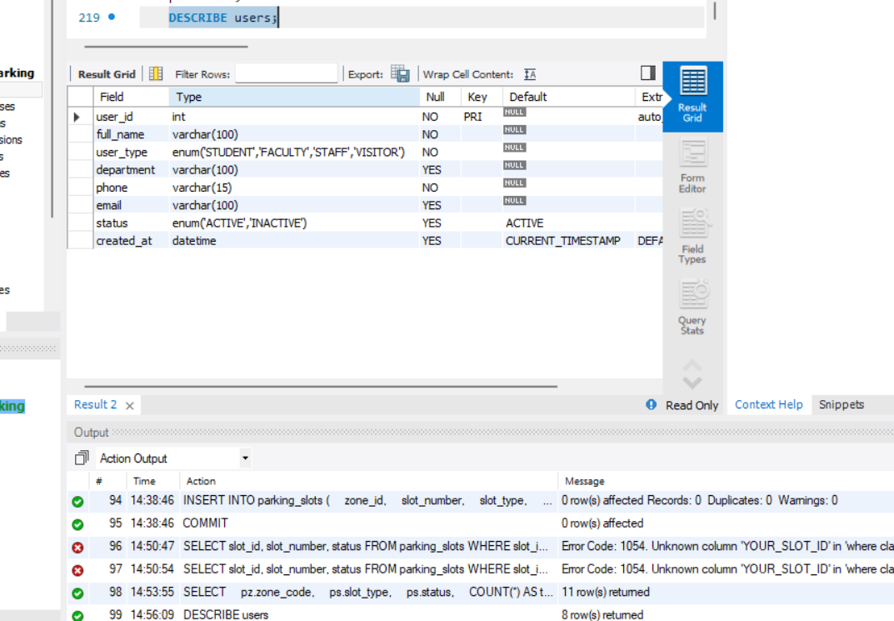
Users table

Vehicles table
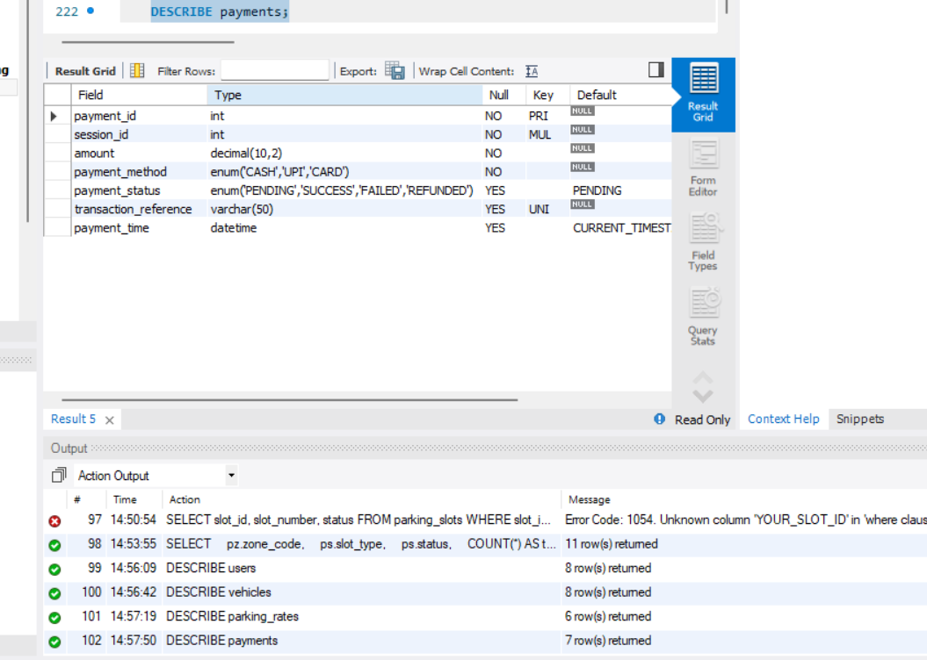
Vehicles table

Parking rates table
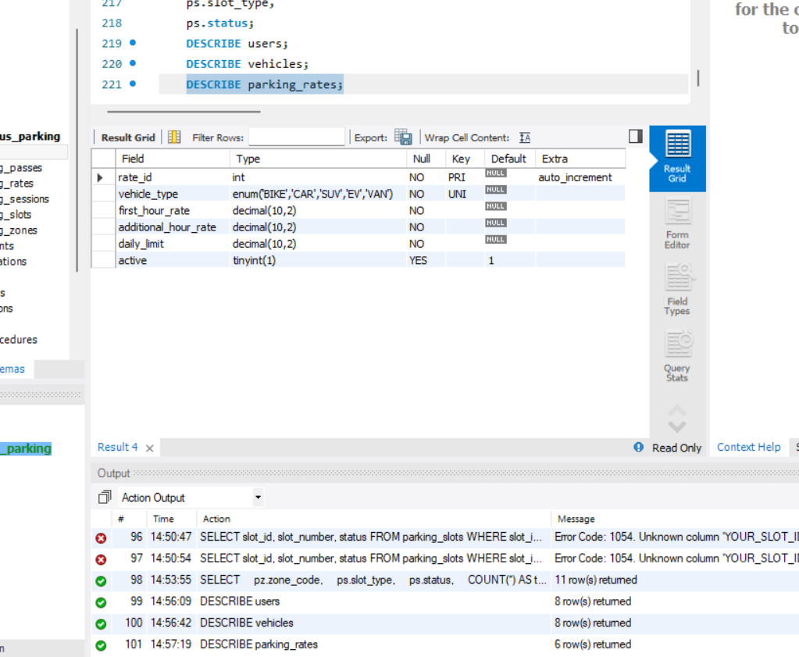
Parking rates table

Parking sessions table
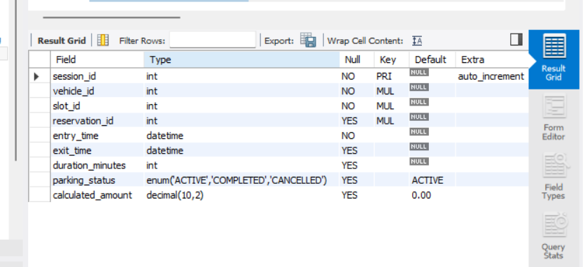
Parking sessions table

Payments table
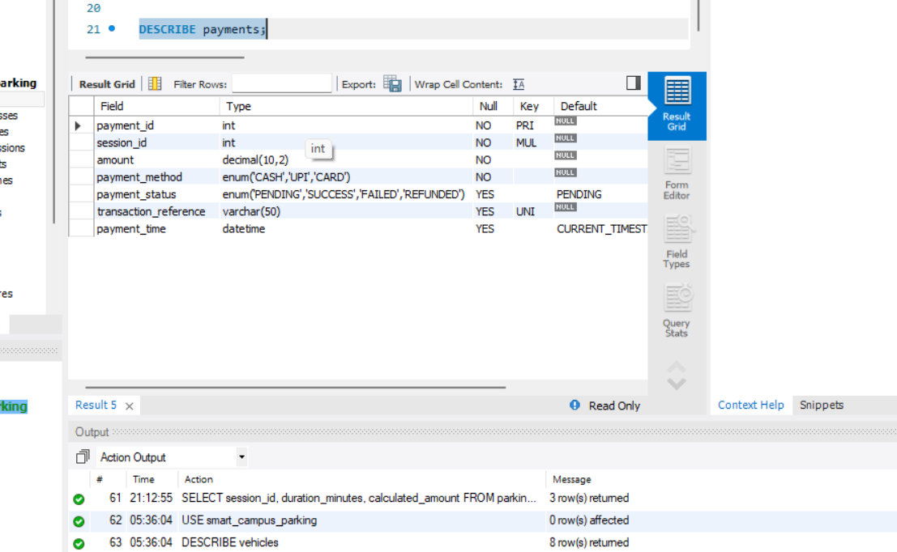
Payments table

Violations table
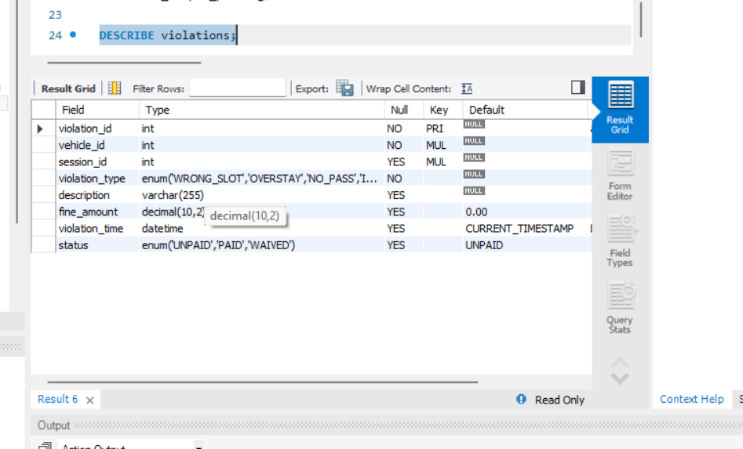
Violations table

Parking zones data
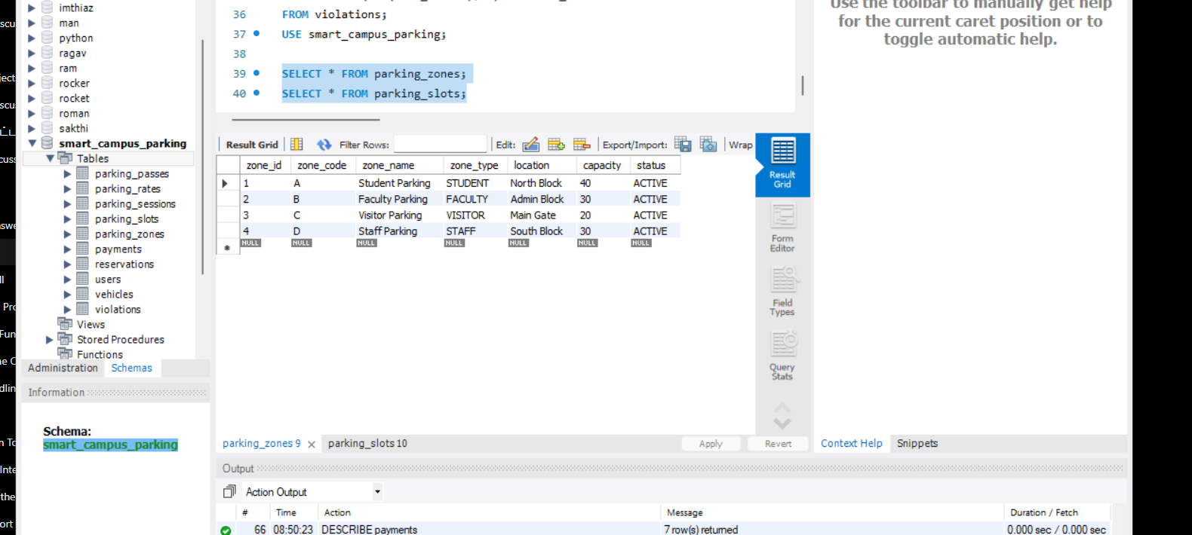
Parking zones data

Parking slots data
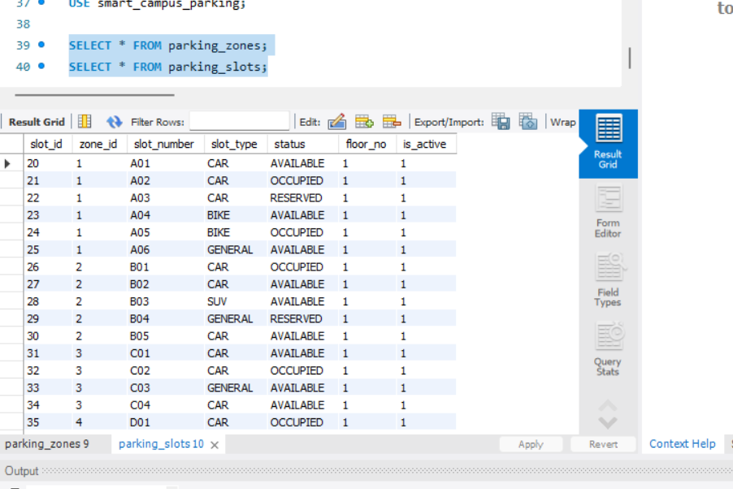
Parking slots data

Output / User Interface:
The supplied project screenshots demonstrate the Swing desktop interface and database-backed modules. The following figures are selected from the provided project evidence and show successful application screens or meaningful database results.
Dashboard – Parking Overview
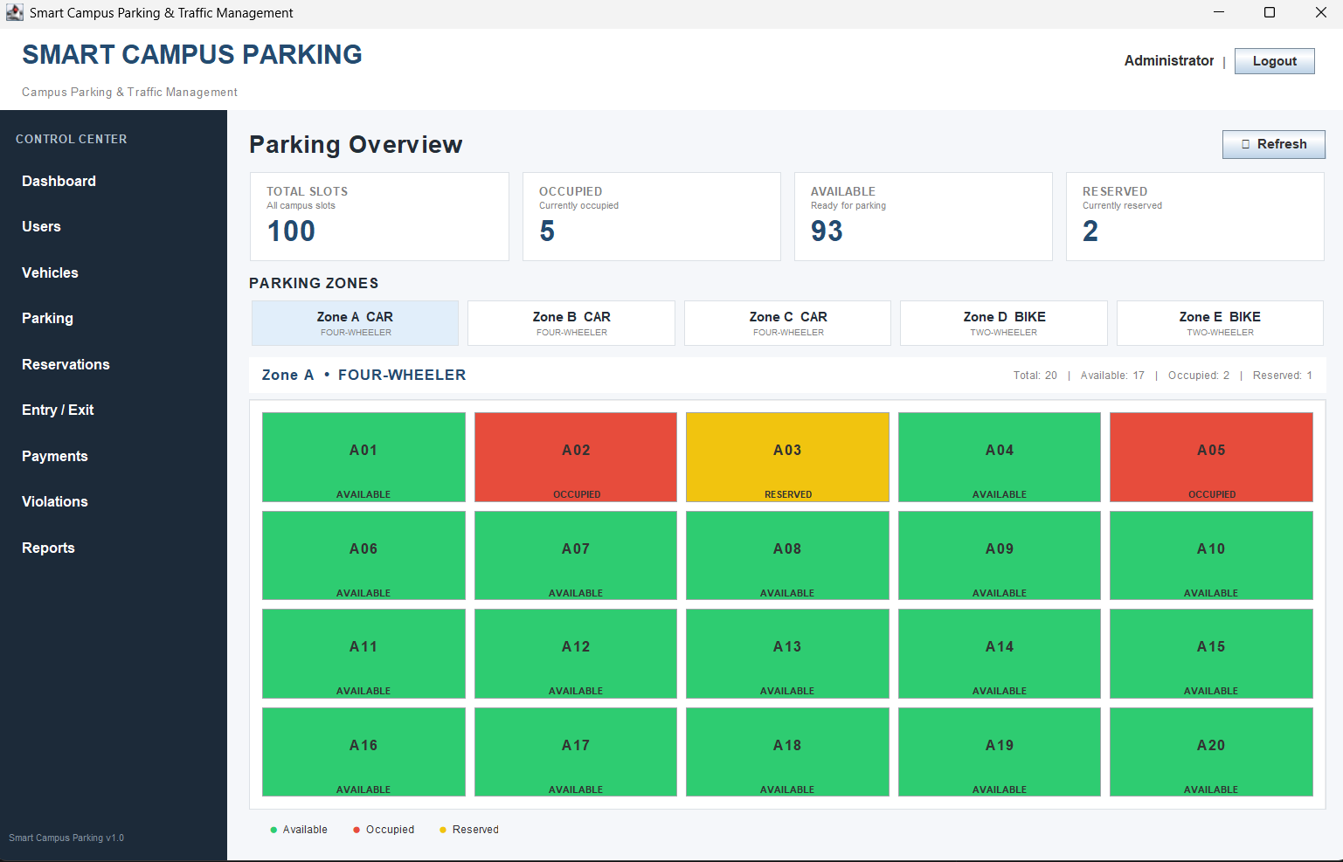
Dashboard – Parking Overview

Dashboard – Live Parking Slot Status

Dashboard – Live Parking Slot Status

User Management
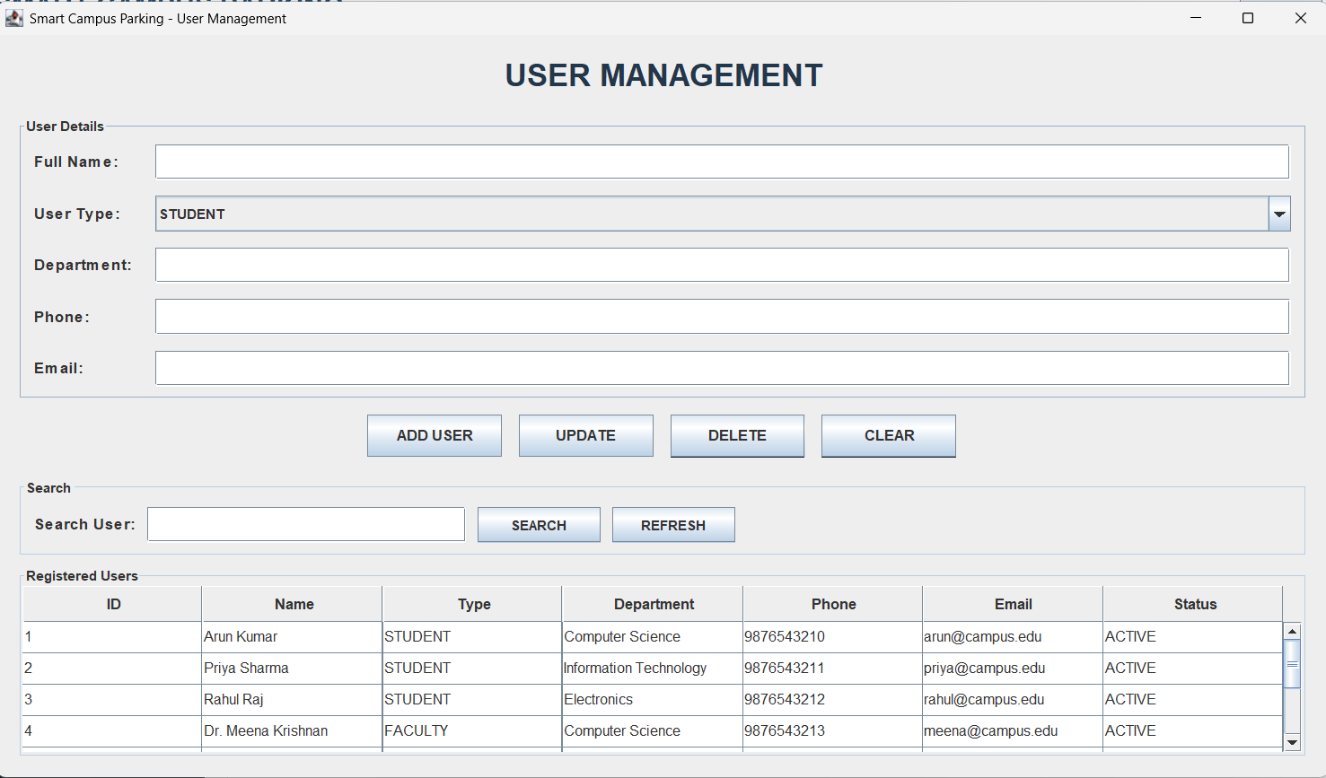
User Management

Vehicle Management
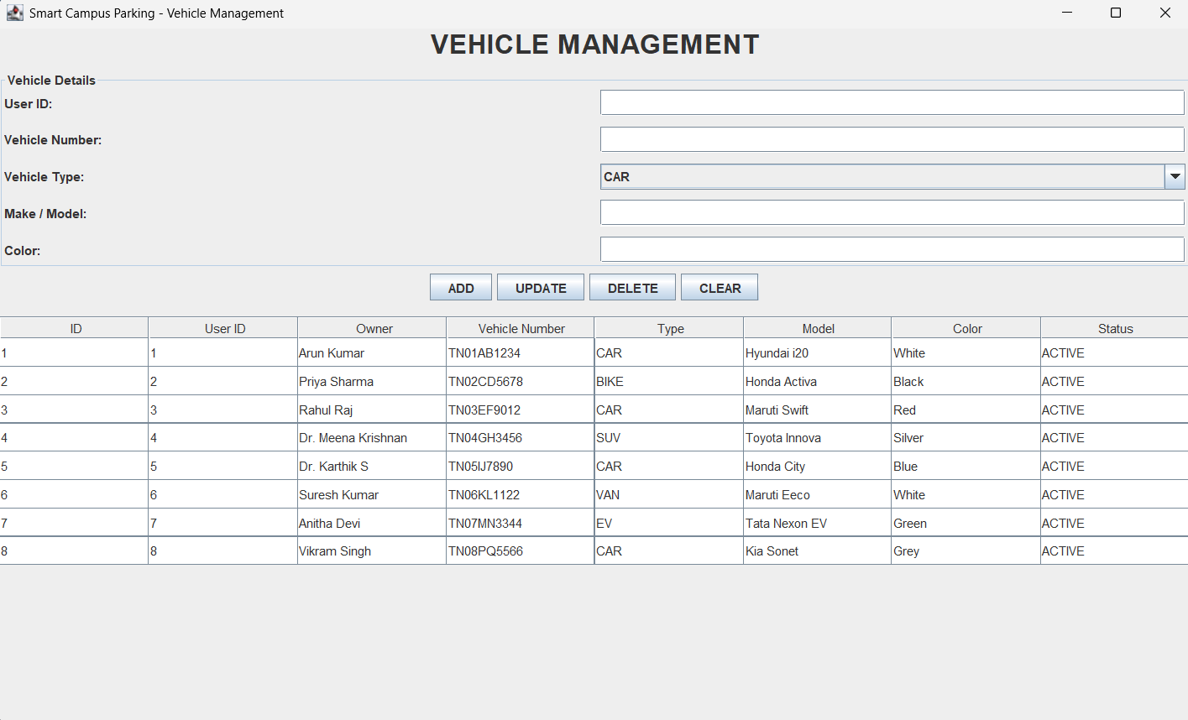
Vehicle Management

Reports & Analytics
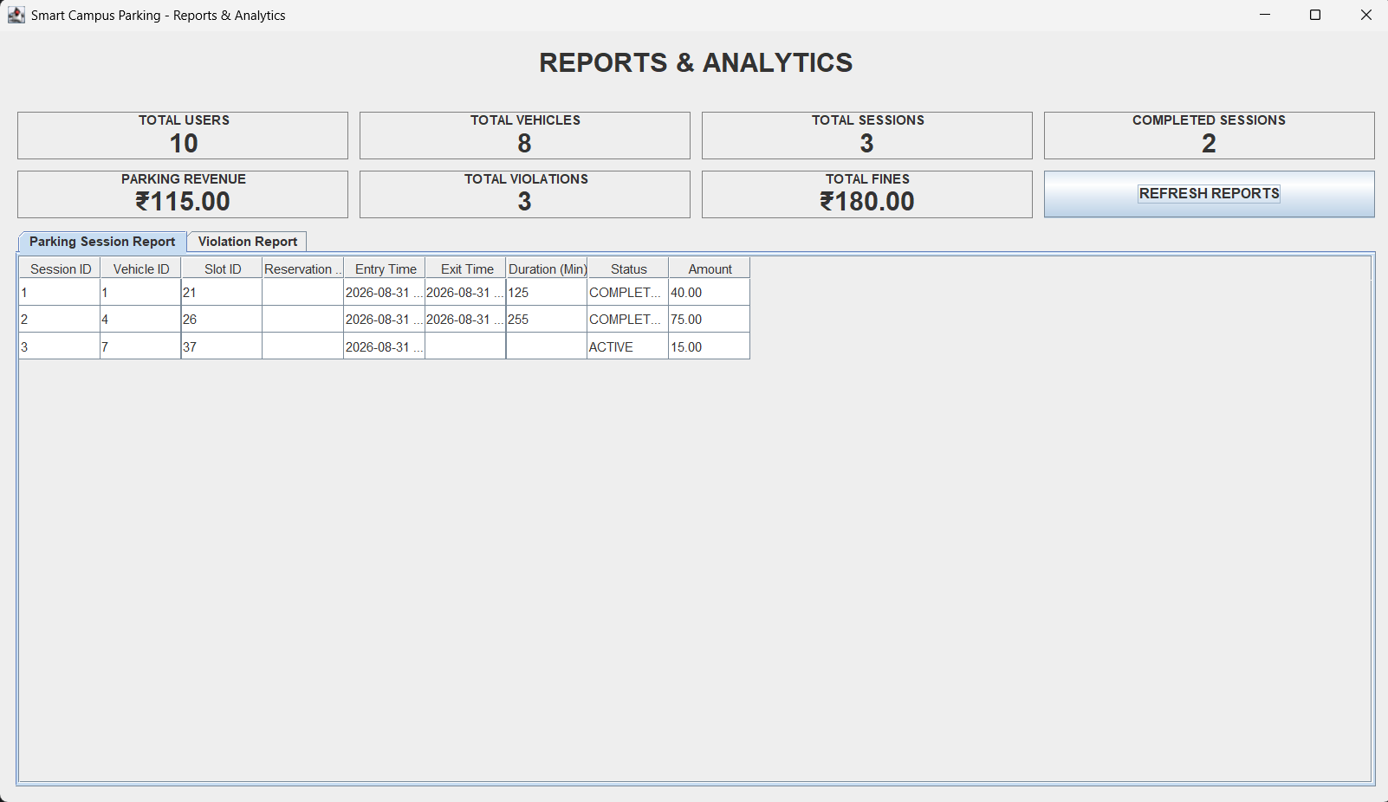
Reports & Analytics

Parking Slot Status Query
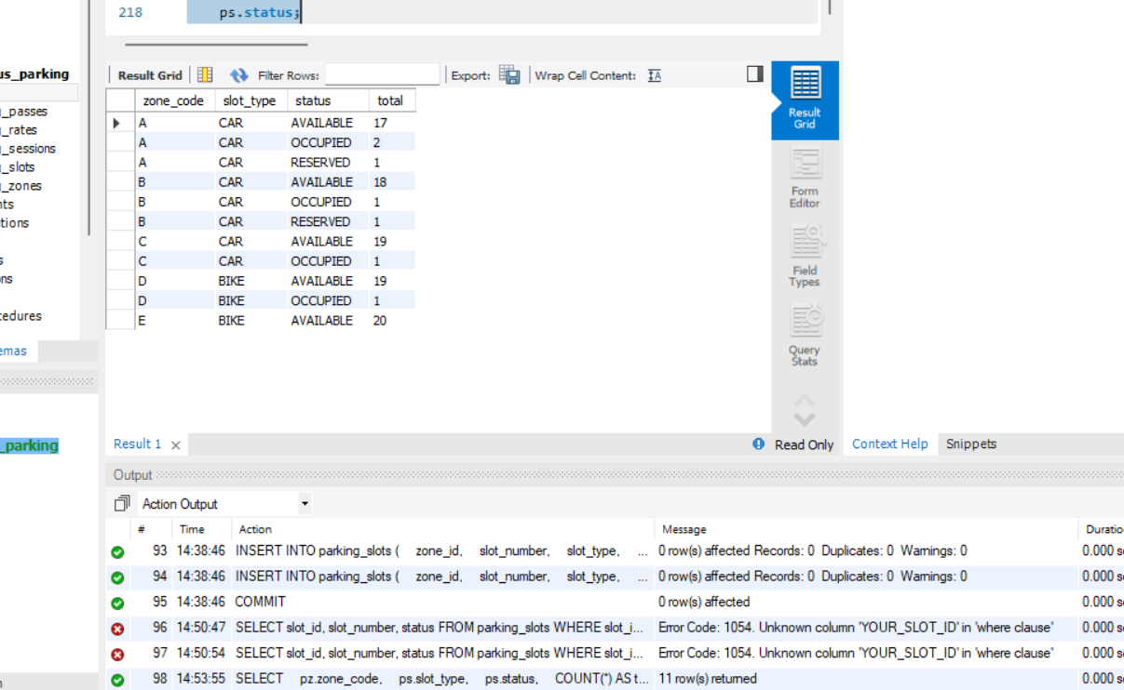
Parking Slot Status Query

Parking Revenue Result
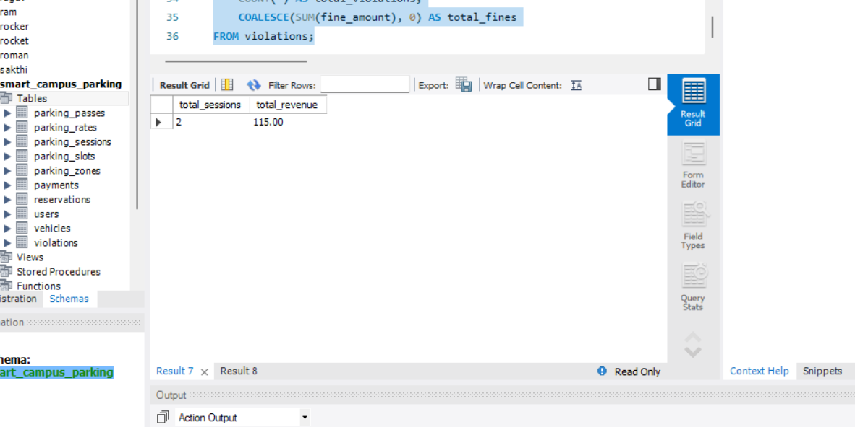
Parking Revenue Result

Violation Summary Result
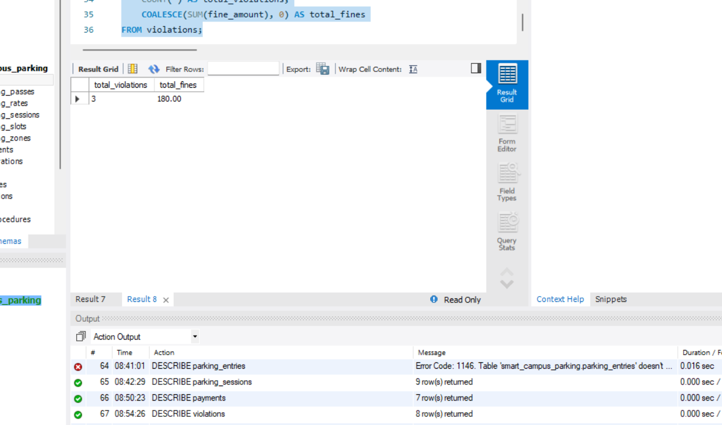
Violation Summary Result

Implemented Module Summary:
Module | Main Java Component | Functionality
Dashboard | DashboardFrame / DashboardDao | Live slot counts, availability summary, navigation and slot-status grid.
Users | UsersFrame / UserDao | Create, update, delete and view campus users.
Vehicles | VehiclesFrame / VehicleDao | Register vehicles against users and maintain vehicle details.
Parking | ParkingFrame / ParkingDao | View parking slots with zone information and update status.
Reservations | ReservationsFrame / ReservationDao | Create, modify and remove parking reservations.
Entry / Exit | EntryExitFrame / EntryExitDao | Record vehicle entry/exit and parking-session duration.
Payments | PaymentsFrame / PaymentDao | Maintain session payments and transaction information.
Violations | ViolationsFrame / ViolationDao | Record fines/violations and maintain their status.
Reports | ReportsFrame / ReportDao | Display user, vehicle, session, revenue and violation summaries.

Individual Contribution:
The contribution split below is separated by the major module groups represented in the submitted implementation, so the report contains a complete individual-contribution section without leaving placeholders.
G Sai Deepak – Individual Contribution
Student Name | G Sai Deepak
Register Number | 192311432
Project Title | Smart Campus Parking and Traffic Management System
Individual Role/Contribution | Dashboard and user-facing management modules
Contribution | 50%
Modules/Tasks Completed | • Dashboard interface and live parking overview  • User Management module  • Vehicle Management module  • Parking Slot Management interface  • Reservation Management interface  • UI navigation integration and functional testing
Brief Description of Work | Worked on the Swing presentation layer for the core administrative workflows. The contribution covered the dashboard experience, CRUD-oriented management screens, slot visualization, reservations, and integration of the navigation flow between modules.  Outcome/Learning: Developed practical understanding of Java Swing GUI construction, event-driven programming, JDBC-backed forms, table-based data presentation, and integration of multiple modules into one desktop application.

I. MD IMTHIAZ – Individual Contribution
Student Name | I. MD IMTHIAZ
Register Number | 192521360
Project Title | Smart Campus Parking and Traffic Management System
Individual Role/Contribution | Database connectivity, DAO layer and transaction/report modules
Contribution | 50%
Modules/Tasks Completed | • MySQL database connection setup  • DashboardDao and supporting DAO architecture  • Entry / Exit module  • Payment Management module  • Violation Management module  • Report and analytics data access  • Database integration and testing
Brief Description of Work | Worked on the persistence and data-access side of the system and on the modules that depend heavily on parking-session data. The contribution covered database connectivity, DAO queries, entry/exit records, payments, violations, and report aggregation.  Outcome/Learning: Strengthened skills in JDBC, SQL queries, DAO-based persistence, relational data handling, session and payment records, exception handling, and combining database results with Swing interfaces.

Conclusion:
The Smart Campus Parking and Traffic Management System is implemented as a Java Swing desktop application connected to a MySQL database through JDBC. The project brings together user management, vehicle registration, parking-slot monitoring, reservations, entry/exit tracking, payments, violations, and reporting in a single administrative control center.
The submitted implementation demonstrates the use of Java GUI programming, event handling, JDBC connectivity, SQL queries, DAO-based database access, tabular data presentation, and module-to-module navigation. The included diagrams, source code, database evidence, output screens, and individual contribution pages document the project in the same major sequence as the supplied reference report.
Database credentials are represented using a configuration placeholder in this report for security. The supplied project archive did not contain a separate SQL/DDL script, so database screenshots are presented as the available table-creation/schema evidence.

