SAVEETHA INSTITUTE OF MEDICAL AND TECHNICAL SCIENCES
DEPARTMENT OF COMPUTER SCIENCE AND ENGINEERING
CAPSTONE PROJECT REPORT
CROSS-UTILITY SMART CAMPUS RESOURCE MONITOR:
INTEGRATED ENERGY COMPETITION AND WATER LEAKAGE DETECTION
Course Code and Course Name
CSA0925 – PROGRAMMING WITH JAVA
Submitted by
G SAI DEEPAK
Register No.: 192311432
Under the Supervision of
Dr C SivaSankar
Academic Year: 2026–2027

CERTIFICATE
This is to certify that G Sai Deepak (Register No. 192311432), student of the Department of Computer Science and Engineering, Saveetha Institute of Medical and Technical Sciences, has completed the Capstone Project entitled “CROSS-UTILITY SMART CAMPUS RESOURCE MONITOR: INTEGRATED ENERGY COMPETITION AND WATER LEAKAGE DETECTION” for the course CSA0925 – PROGRAMMING WITH JAVA under the supervision of Dr C SivaSankar.
Project Title: CROSS-UTILITY SMART CAMPUS RESOURCE MONITOR: INTEGRATED ENERGY COMPETITION AND WATER LEAKAGE DETECTION
Student: G Sai Deepak (192311432)
Course: CSA0925 – PROGRAMMING WITH JAVA
Supervisor: Dr C SivaSankar
Student Signature: G Sai Deepak
Register No.: 192311432
Supervisor Signature: Dr C SivaSankar
Date: ____________________

DECLARATION
I, G Sai Deepak (Register No. 192311432), declare that this Capstone Project Report entitled “CROSS-UTILITY SMART CAMPUS RESOURCE MONITOR: INTEGRATED ENERGY COMPETITION AND WATER LEAKAGE DETECTION” is prepared as documentation of the work undertaken for CSA0925 – PROGRAMMING WITH JAVA.
I further declare that the technical descriptions, implementation details, screenshots and contribution statements in this report are intended to represent the actual CampusPulse project. External sources used for background and related work are acknowledged in the References section.
Student Signature: G Sai Deepak
Register No.: 192311432
Date: ____________________

ACKNOWLEDGEMENT
I express my sincere gratitude to Saveetha Institute of Medical and Technical Sciences and the Department of Computer Science and Engineering for providing the academic environment and facilities required for completing this capstone project.
I am grateful to Dr C SivaSankar, my project supervisor, for guidance and academic support throughout the project. I also acknowledge the project team members and faculty involved in CSA0925 – PROGRAMMING WITH JAVA.
I further acknowledge the development tools, project materials and technical documentation that supported the implementation and evaluation of the CampusPulse web application.

ABSTRACT
CampusPulse is a web-based campus resource monitoring application developed to bring electricity consumption, water consumption, water anomaly detection, alerts, hostel efficiency ranking and report generation into a single administrative interface. The project addresses the practical need for a centralized mechanism through which hostel-level utility readings can be recorded, reviewed and interpreted rather than being handled as disconnected records. The implementation uses Java 21 with Spring Boot 3.3.5 for the web layer and service logic, together with HTML, CSS and JavaScript for the browser interface. The current implementation uses an in-memory data store and seeded demonstration data, making it suitable for demonstration and functional evaluation without an external database.
The system provides role-based access for ADMIN, STAFF and STUDENT users. Administrative users can manage accounts and hostel details, staff users can manage utility readings, alerts and reports, while students have read-only access. Utility consumption is calculated from the difference between current and previous meter readings. Readings are classified into NORMAL, WARNING or CRITICAL states according to utility-specific thresholds. Water anomaly detection is implemented as a rule-based process that compares water consumption against an expected value and assigns a severity level when the difference exceeds the configured threshold. The application also computes hostel efficiency rankings using electricity usage, water usage and hostel capacity, and it can generate CSV-based reports for utility usage, water anomalies, alert history and energy-efficiency ranking.
The supplied implementation includes a browser interface, REST-style API endpoints, HTTP-session authentication, service-layer separation and deployment support through Docker and Render configuration. Demonstration data in the implementation covers five hostels and six days of seeded electricity and water readings. The project therefore demonstrates how Java-based web application development can be applied to a practical campus resource monitoring problem while keeping the architecture modular and extendable. A future production version should replace the in-memory stores with persistent storage, use secure password hashing, connect to actual meter or sensor data, and introduce stronger validation and operational monitoring.
Keywords: Campus resource monitoring, electricity monitoring, water anomaly detection, hostel ranking, Java, Spring Boot, REST API, web application, role-based access, CSV reporting.

TABLE OF CONTENTS
Updating table of contents...
CERTIFICATE ii
DECLARATION iii
ACKNOWLEDGEMENT iv
ABSTRACT v
LIST OF FIGURES viii
LIST OF TABLES ix
LIST OF ABBREVIATIONS x
CHAPTER 1 – INTRODUCTION 1
CHAPTER 2 – LITERATURE REVIEW AND RELATED WORK 7
CHAPTER 3 – REQUIREMENTS ANALYSIS 10
CHAPTER 4 – SYSTEM ANALYSIS AND DESIGN 14
CHAPTER 5 – TECHNOLOGIES AND TOOLS 19
CHAPTER 6 – SYSTEM IMPLEMENTATION 22
CHAPTER 7 – TESTING AND VALIDATION 27
CHAPTER 8 – RESULTS AND DISCUSSION 30
CHAPTER 9 – PROJECT MANAGEMENT AND TEAM 34
CHAPTER 10 – CONCLUSION AND FUTURE ENHANCEMENTS 37
REFERENCES 40
APPENDICES 41

LIST OF FIGURES
Figure 4.1: CampusPulse Web Application Architecture
Figure 4.2: Functional Workflow of CampusPulse
Figure 8.1: CampusPulse Admin Dashboard
Figure 8.2: Electricity Usage Monitoring Interface
Figure 8.3: Hostel Ranking – Energy Efficiency Leaderboard

LIST OF TABLES
Table 2.1: Comparative Analysis of Related Approaches
Table 3.1: Functional Requirements
Table 3.2: Non-Functional Requirements
Table 3.3: Hardware and Software Requirements
Table 5.1: Technologies and Tools
Table 7.1: Test Cases Derived from Implemented Behaviour
Table 8.1: Demonstration Data Summary
Table 8.2: Seeded Hostel Efficiency Results
Table 9.1: Individual Contribution of G Sai Deepak

LIST OF ABBREVIATIONS
Abbreviation | Full Form
API | Application Programming Interface
CSS | Cascading Style Sheets
CSV | Comma-Separated Values
CRUD | Create, Read, Update and Delete
HTML | HyperText Markup Language
HTTP | HyperText Transfer Protocol
IDE | Integrated Development Environment
JAR | Java Archive
REST | Representational State Transfer
SDG | Sustainable Development Goal
UI | User Interface
URL | Uniform Resource Locator

CHAPTER 1 – INTRODUCTION

1.1 Background
Educational campuses operate as resource-intensive communities. Hostel buildings require continuous electricity and water for lighting, fans, appliances, sanitation and other daily activities. When utility readings are stored separately or reviewed manually, it becomes difficult to identify unusual consumption, compare hostels and respond to possible wastage.
CampusPulse was developed as a centralized browser-based monitoring application for hostel utility information. The implementation brings electricity and water readings, anomaly information, alerts, efficiency ranking and reports into a common interface. The application converts raw readings into indicators such as consumption, status, anomaly severity and comparative efficiency.

1.2 Problem Context
The project context is hostel-level resource management. Each hostel has capacity and occupancy information, while utility readings contain previous meter values, current meter values, calculated consumption, utility type, date, unit and status. Administrators and staff need mechanisms for entering readings, filtering records and viewing operational information. The project also addresses two related needs: encouraging energy efficiency through hostel ranking and highlighting unusually high water consumption through rule-based anomaly detection.

1.3 Problem Statement
A campus utility management process that lacks a centralized monitoring interface may make it difficult to compare hostel consumption, identify abnormal water usage and maintain a clear history of operational alerts. CampusPulse therefore provides a web application that consolidates hostel electricity and water readings, derives useful indicators, supports role-based operations and presents the information through dashboards, alerts, rankings and reports.

1.4 Motivation
The motivation is to demonstrate how a Java-based web application can convert utility records into actionable administrative information. Instead of presenting only raw meter readings, the system calculates consumption, classifies reading status, detects water anomalies using explicit rules, ranks hostels by an efficiency score and generates reports.

1.5 Aim
The aim of CampusPulse is to develop a centralized Java-based web application for monitoring hostel electricity and water usage, detecting abnormal water consumption, comparing hostel efficiency and supporting administrative resource-management activities through role-based dashboards and reports.

1.6 Objectives
- Design a browser-based interface for centralized campus utility monitoring.
- Implement Java service components for utility reading management, anomaly detection, alert handling, hostel ranking and report generation.
- Calculate utility consumption from previous and current meter readings and classify readings according to configured thresholds.
- Detect water consumption anomalies using rule-based threshold comparison and assign severity levels.
- Provide role-based access for ADMIN, STAFF and STUDENT users.
- Provide hostel efficiency rankings based on electricity usage, water usage and hostel capacity.
- Generate CSV reports for utility usage, water anomalies, alert history and energy-efficiency ranking.
- Document the implemented system and the individual contribution of G Sai Deepak.

1.7 Scope
The implemented scope includes browser-based login, dashboard visualization, utility reading management, water monitoring, anomaly detection, alerts, hostel efficiency ranking, report generation, user-account administration and hostel management. The current implementation is demonstration-oriented and stores application data in memory. It does not claim direct integration with physical electricity meters, water sensors, a persistent production database or machine-learning-based leak prediction.

1.8 Target Users / Stakeholders
Stakeholder | Role | Relevant Functions
Administrator | ADMIN | Dashboard, user management, hostel management, monitoring, alerts, rankings and reports.
Staff | STAFF | Utility reading entry/update/delete, water anomaly detection, alert management and report generation.
Student | STUDENT | Read-only access to monitoring, alerts, anomalies and rankings.
Campus / Hostel Management | Operational stakeholder | Uses aggregated information for resource monitoring and comparison.

1.9 Existing System
The project addresses a class of existing approaches in which utility information may be recorded as separate meter readings, spreadsheets or manually reviewed records. Such approaches can provide underlying numbers but do not necessarily provide a unified role-aware dashboard, automatic status classification, water anomaly rules, comparative hostel ranking and report generation in one application.

1.10 Limitations of Existing System
- Utility readings can remain disconnected from decision-support indicators.
- Manual comparison of multiple hostels can be time-consuming.
- Unusual water consumption may not be highlighted automatically.
- Different user roles may not have clearly separated permissions.
- Report preparation may require manual consolidation of records.

1.11 Proposed System
CampusPulse proposes a Java and Spring Boot web application with a browser-based front end. The browser communicates with REST-style API endpoints. The server applies role checks and delegates operations to service components. Utility readings are represented as Java model objects, stored in memory and processed by the utility, alert, ranking and report services.

1.12 Advantages of Proposed System
- Centralized monitoring of electricity and water consumption.
- Clear separation of ADMIN, STAFF and STUDENT access.
- Automatic calculation of consumption from meter readings.
- Threshold-based reading status classification.
- Rule-based detection of water anomalies.
- Comparative hostel efficiency ranking.
- CSV report generation for operational use.
- Modular Java service structure that can be extended with persistent storage in future.

1.13 Project Contributions
The project contribution is the implementation of the CampusPulse web application and its supporting Java services. For G Sai Deepak, the recorded individual contribution is web application development, frontend/backend support, and presentation/documentation responsibilities. The final evidence for each individual task should be attached through screenshots, source-code references, GitHub history or other verifiable project artefacts.

1.14 Sustainable Development Goal (SDG) Alignment
The project directly relates to SDG 7 (Affordable and Clean Energy) through electricity monitoring and energy-efficiency ranking. It also supports SDG 6 (Clean Water and Sanitation) through water consumption monitoring and possible-leak alerting, and SDG 12 (Responsible Consumption and Production) through resource-efficiency monitoring.

1.15 SDG Target Mapping
Project Objective | SDG | Keyword | Expected Contribution
Monitor electricity usage and compare hostel efficiency | SDG 7 | energy efficiency | Improved visibility of electricity consumption and comparative performance.
Monitor water usage and identify abnormal consumption | SDG 6 | water management | Earlier identification of unusually high water usage.
Provide consumption records and reports | SDG 12 | resource efficiency | More structured review of resource consumption.

1.16 Project Impact and Sustainability
The immediate impact is informational: the application organizes utility data into a form that can support monitoring and comparison. Environmental sustainability is addressed by making resource consumption visible and by highlighting abnormal water usage. The present implementation is a software monitoring and decision-support prototype rather than a complete physical sensing infrastructure.

1.17 Methodology Overview
An iterative development approach is appropriate because the application consists of multiple connected modules. The repository history shows an initial web-application implementation followed by a subsequent commit that fixed dashboard login and API parameter handling. This demonstrates iterative refinement. A formal institutional Gantt chart or sprint record was not included in the supplied ZIP.

1.18 Report Organization
Chapter 1 introduces the project. Chapter 2 reviews related work. Chapter 3 documents requirements. Chapter 4 presents system design. Chapter 5 describes technologies and tools. Chapter 6 explains implementation and algorithms. Chapter 7 presents testing and validation. Chapter 8 discusses results and evidence. Chapter 9 documents project management and individual contribution. Chapter 10 concludes the report and identifies future enhancements.

CHAPTER 2 – LITERATURE REVIEW AND RELATED WORK

2.1 Introduction
The literature review examines campus sustainability, smart water monitoring and anomaly/leak detection approaches relevant to CampusPulse. The purpose is to identify broader approaches and position the current implementation without claiming that the project reproduces research systems.

2.2 Existing Solutions
Campus sustainability research treats universities as resource-intensive environments in which energy and water management can be improved through technical and organizational measures. Smart water research uses monitoring information to identify abnormal behaviour and possible leakage.

2.3 Research Papers / Technical Literature
A 2023 study on sustainable university campuses notes that campuses can be compared with small towns in terms of resource consumption and discusses technical measures for improving water and energy efficiency.
A 2023 systematic review of smart water networks examined real operational networks using high-frequency pressure and acoustic sensors. It identified leak detection and localization as important applications and highlighted challenges in transferring site-specific approaches.
A 2024 review of water-distribution leakage detection discusses data limitations and categorizes data-driven approaches into unsupervised anomaly detection, semi-supervised anomaly detection and supervised classification. It emphasizes that data availability is an important practical issue.
A 2024 systematic review of machine-learning applications for smart water metering anomaly detection emphasizes continuous measurement and data availability. These studies show a movement toward sensor-rich and data-driven systems, while CampusPulse currently uses a simpler deterministic rule-based method.

2.4 Existing Technologies and Approaches
Approach | Typical Inputs | Analysis | Typical Output | Relation to CampusPulse
Manual / spreadsheet monitoring | Meter readings | Manual comparison | Tables / summaries | CampusPulse automates calculation and presentation.
Smart water monitoring | Pressure, flow or acoustic data | Model- or sensor-based analysis | Leak indication/localization | CampusPulse uses consumption rules rather than physical sensor localization.
Data-driven anomaly detection | Time-series / labelled data | ML or statistical methods | Anomaly class / probability | CampusPulse currently uses deterministic thresholds.
Campus dashboard approach | Aggregated utility data | KPIs and visualization | Dashboard / reports | CampusPulse follows this decision-support pattern.

2.5 Comparative Analysis
Research-grade smart water systems may use physical sensing, hydraulic modelling or machine learning, whereas the supplied CampusPulse implementation is intentionally lighter. It accepts utility readings through the application, computes consumption and applies explicit rules. Its strength is simplicity and transparency. Its limitation is that it does not localize a physical leak, learn from historical data or estimate leak probability.

2.6 Research / Technology Gap
The gap addressed by the project is the integration of multiple campus-resource management functions into one Java web application. The supplied implementation combines electricity monitoring, water monitoring, rule-based water anomaly detection, alerts, hostel efficiency ranking, role management and report generation.

2.7 Summary
The reviewed literature supports the importance of monitoring energy and water resources and demonstrates a progression from conventional monitoring toward sensor-based and data-driven systems. CampusPulse provides a practical software-prototype position with centralized monitoring and rule-based decision support.

CHAPTER 3 – REQUIREMENTS ANALYSIS

3.1 Introduction
Requirements were derived from the functions implemented in the CampusPulse source code and browser interface. The requirements therefore describe the actual system rather than a generic campus-management product.

3.2 Stakeholder Analysis
Stakeholder | Needs | System Response
ADMIN | Full management access | Account management, hostel management and access to all monitoring modules.
STAFF | Operational utility management | Add/update/delete readings, detect anomalies, manage alerts and generate reports.
STUDENT | View resource information | Read-only access to monitoring, anomalies, alerts and rankings.

3.3 Functional Requirements
ID | Functional Requirement | Priority
FR01 | Authenticate users using username, password and role verification | High
FR02 | Maintain HTTP session after successful login | High
FR03 | Display dashboard utility statistics and alerts | High
FR04 | View and filter electricity/water readings | High
FR05 | Add, update and delete utility readings for authorized users | High
FR06 | Calculate consumption from current and previous readings | High
FR07 | Assign NORMAL, WARNING or CRITICAL reading status | High
FR08 | Display water monitoring data and anomalies | High
FR09 | Run rule-based water anomaly detection | High
FR10 | Create and manage alerts | High
FR11 | Calculate and display hostel efficiency rankings | High
FR12 | Generate and save CSV reports | Medium
FR13 | Manage user accounts as ADMIN | Medium
FR14 | Update hostel information as ADMIN | Medium
FR15 | Provide role-based navigation and permissions | High

3.4 Non-Functional Requirements
Category | Requirement
Usability | Clear navigation, labels, tables and status indicators.
Performance | Lightweight operation for the demonstration-scale in-memory dataset.
Security | Role checks prevent unauthorized modification and administration.
Reliability | Invalid reading values are rejected with user-facing errors.
Maintainability | Business functions are separated into service and model classes.
Scalability | Architecture permits replacement of in-memory storage with persistence.

3.5 Hardware Requirements
The application is a web application and does not require specialized client hardware. A standard computer capable of running a modern browser is sufficient for demonstration. Server execution requires a Java 21 runtime. No physical electricity or water sensor hardware is included in the supplied ZIP.

3.6 Software Requirements
Software / Tool | Confirmed Use
Java | Java 21
Spring Boot | Spring Boot 3.3.5
Spring Web | REST-style web API
HTML | Browser page structure
CSS | Browser styling
JavaScript | Client-side interaction and API calls
Maven | Project build configuration
Docker | Containerization support
Render | Deployment configuration
Git | Repository and development history

3.7 Constraints
- Data is held in memory and resets on restart.
- Demo credentials are fixed in the current AuthenticationService.
- Passwords are demonstration values rather than production password hashes.
- No persistent database is included.
- Water leakage is inferred from consumption rules rather than physical sensors.
- Formal performance and user-acceptance metrics require actual test evidence.

3.8 Assumptions and Dependencies
The application assumes valid hostel IDs, valid dates and non-negative meter readings. A current meter reading must not be lower than its previous reading. The web layer depends on Spring Boot and Java 21. The browser interface depends on the server API endpoints under /api.

3.9 Use Cases
Use Case | Actor | Description
Login | ADMIN / STAFF / STUDENT | Authenticate and establish a session.
Monitor Utilities | All authenticated users | View utility readings and filters.
Manage Readings | STAFF / ADMIN | Add, update or delete utility readings.
Detect Water Anomalies | STAFF / ADMIN | Run rule-based anomaly detection.
Manage Alerts | STAFF / ADMIN | Update alert status or delete alerts.
View Ranking | All authenticated users | View hostel efficiency ranking.
Generate Reports | STAFF / ADMIN | Generate or save CSV reports.
Manage Accounts | ADMIN | Add, enable/disable and delete accounts.
Manage Hostels | ADMIN | Update hostel details.

3.10 Feasibility Analysis
Feasibility | Assessment
Technical | Feasible because the project packages a Java 21/Spring Boot web application.
Economic | Demonstration implementation requires no commercial database or physical sensor hardware.
Operational | Role-based pages support different operational responsibilities.
Schedule | Modular structure supports incremental implementation.

3.11 Requirements Traceability Matrix
Requirement | Design / Module | Implementation Evidence | Validation
FR04–FR07 | Utility Monitoring | UtilityService + utility UI | Consumption and status rules
FR08–FR09 | Water Monitoring | AlertService + water UI | Anomaly endpoint and anomaly table
FR10 | Alerts | AlertService + alert UI | Status update/delete endpoints
FR11 | Hostel Ranking | RankingService + ranking UI | Ranked entries and efficiency percentage
FR12 | Reports | ReportService + reports UI | CSV generation and save endpoint
FR15 | Authentication / API | CampusPulseApi + session checks | Role-based endpoint restrictions

3.12 Summary
The requirements analysis shows that the supplied implementation is a demonstration-level web application with clear functional modules. The main limitations are in-memory storage, demonstration authentication and rule-based anomaly detection.

CHAPTER 4 – SYSTEM ANALYSIS AND DESIGN

4.1 Introduction
CampusPulse follows a layered structure. The browser interface communicates with a Spring Boot REST API. The API performs session and role checks and delegates business operations to service classes. The service layer operates on Java domain models and an in-memory data store. Report generation converts current data into CSV/text content.

4.2 System Architecture
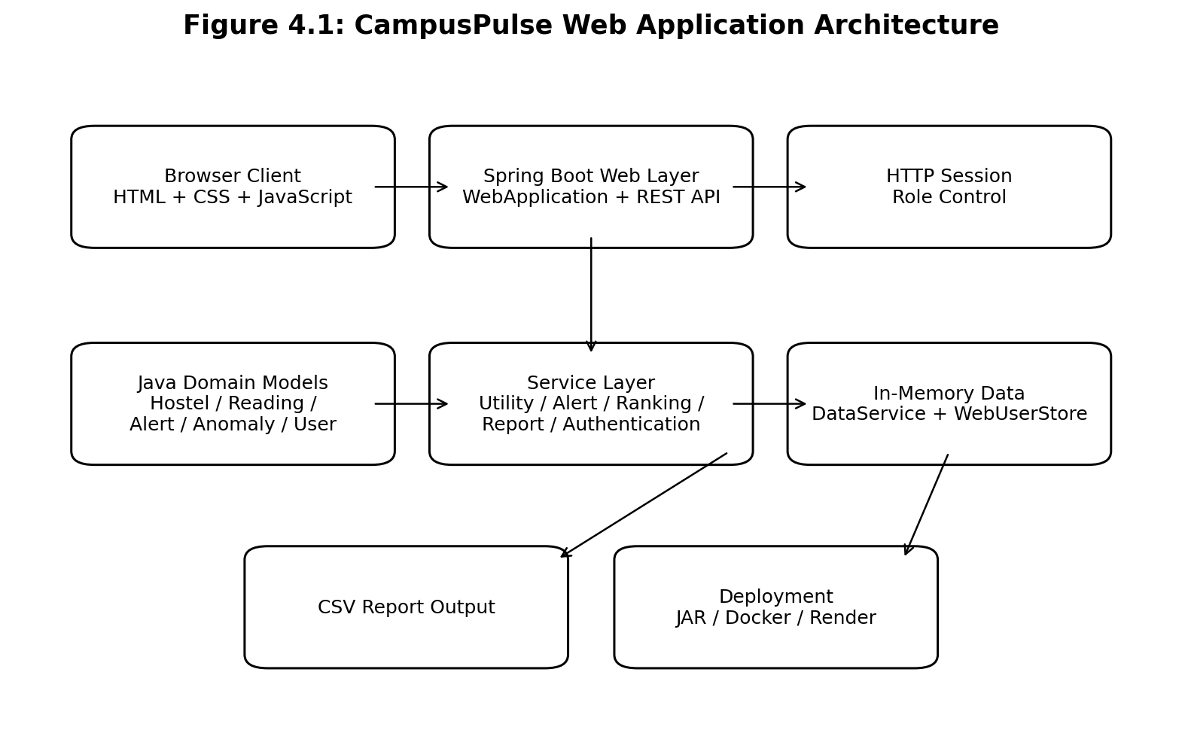
Figure 4.1: CampusPulse Web Application Architecture
The architecture is supported directly by the project structure. The web package contains WebApplication, CampusPulseApi, WebModels and WebUserStore. The service package contains authentication, data, utility, alert, ranking and report services. The model package represents hostels, readings, anomalies, alerts, users and reports. Static resources contain the browser interface.

4.3 System Workflow
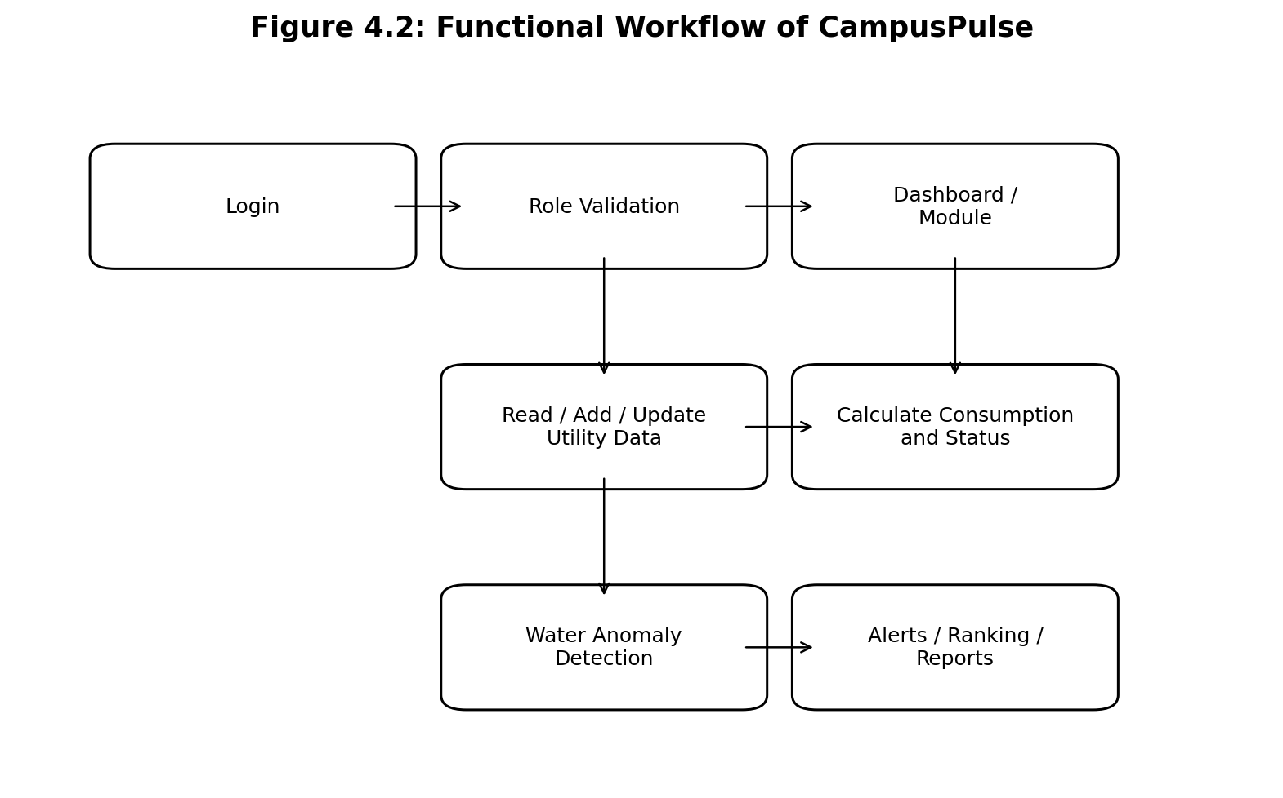
Figure 4.2: Functional Workflow of CampusPulse
A user authenticates through the browser. The API validates credentials and stores the authenticated user in the HTTP session. Reading operations are validated before being stored. Consumption and status are derived from meter values. Water anomaly detection evaluates water readings against configured rules. Rankings and dashboard statistics are calculated from current data. Reports can be generated and saved as CSV files.

4.4 Data Flow Diagram
Logical flow: User → Browser UI → REST API → Service Layer → In-Memory Data → Service Layer → REST Response → Browser UI. Report flow: User → Report Form → Report API → ReportService → CSV File. A formal DFD drawing can be added if the faculty requires a specific notation.

4.5 Use Case Diagram
The principal actors are ADMIN, STAFF and STUDENT. ADMIN has the broadest set of operations. STAFF can perform operational changes but does not have administrative account or hostel-management privileges. STUDENT has read-only access. These restrictions are implemented in CampusPulseApi.

4.6 Class Diagram
The class structure is centered on Hostel, UtilityReading, WaterAnomaly, Alert, User, UserAccount, RankingEntry and Report. Service classes consume and produce these objects. WebModels provides request records for login, reading, alert, report, hostel and account operations.

4.7 Sequence Diagram
Representative utility-reading sequence: Browser submits reading → CampusPulseApi receives JSON → requireStaff validates session → UtilityService validates input → UtilityReading is created → DataService stores the object → API returns success/error → Browser refreshes the table.

4.8 Activity Diagram
The utility-reading activity consists of selecting a hostel, entering a date and meter values, submitting the form, validating input, calculating consumption, determining status, storing the reading and refreshing the displayed records.

4.9 Component Diagram
Main components are Browser Client, Web API, Authentication Service, Utility Service, Alert Service, Ranking Service, Report Service, Data Service and Web User Store.

4.10 Database Design
No relational database is present. DataService maintains in-memory lists for hostels, utility readings, water anomalies and alerts. WebUserStore maintains user-account objects.

4.11 ER Diagram
Because there is no persistent database schema, a conventional relational ER diagram is not implemented. The logical entities are Hostel, UtilityReading, WaterAnomaly, Alert, User and Report. A future database can link readings, anomalies and alerts to hostels through hostel identifiers.

4.12 User Interface Design
The interface uses a login page followed by a sidebar-based application layout. Navigation includes Dashboard, Utility Monitoring, Water Monitoring, Alerts, Hostel Ranking and Reports. ADMIN users additionally receive User Management and Hostel Management.

4.13 Front-End Design
The front end is implemented with index.html, app.js and app.css. JavaScript uses fetch() to communicate with /api endpoints, dynamically renders pages and tables, applies status pills and updates charts. Displayed values are escaped before being inserted into generated HTML.

4.14 Back-End Design
WebApplication is annotated with @SpringBootApplication and creates service beans. CampusPulseApi is annotated with @RestController and @RequestMapping("/api"). Endpoints validate input, check the current session and delegate work to services.

4.15 API Design
Endpoint Group | Methods / Purpose
/api/login | POST – authenticate
/api/logout | POST – invalidate session
/api/session | GET – session check
/api/dashboard | GET – dashboard statistics
/api/readings | GET/POST – view/filter and add readings
/api/readings/{id} | PUT/DELETE – update or delete reading
/api/anomalies | GET – list anomalies
/api/anomalies/detect | POST – run detection
/api/alerts | GET – list alerts
/api/alerts/{id}/status | PUT – update alert status
/api/rankings | GET – ranking information
/api/reports/generate | POST – generate report
/api/reports/save | POST – generate and save report
/api/accounts | GET/POST – admin account operations
/api/hostels/{id} | PUT – admin hostel update

4.16 Security Design
The application implements session-based access control. Successful authentication places the User object into the HTTP session. requireLogin protects authenticated functions. requireStaff prevents STUDENT users from modifying operational data. requireRole restricts administrative functions to ADMIN users. application.properties sets HTTP-only and SameSite=Lax cookie properties. The README identifies the credentials and data stores as demonstration implementations.

4.17 Design Decisions and Justification
- Spring Boot provides a Java web application and embedded-server structure.
- HTML/CSS/JavaScript provide a direct browser interface.
- Service classes separate business rules from HTTP handling.
- In-memory storage keeps the demonstration self-contained.
- Explicit threshold rules make status and anomaly decisions transparent.
- CSV output provides a simple report format.

4.18 Summary
The system design is modular and consistent with the supplied source code. It is suitable for demonstration and provides clear extension points for database persistence, sensor integration and stronger authentication.

CHAPTER 5 – TECHNOLOGIES AND TOOLS

5.1 Introduction
The technology stack was identified from pom.xml, README-WEB.md, application.properties and the source structure. The web implementation is based on Java 21 and Spring Boot 3.3.5 with HTML, CSS and JavaScript for the browser client.

5.2 Programming Languages
Java is the primary server-side language. Java model classes, service classes and REST API classes form the core application logic. JavaScript is used for browser interaction and API communication. HTML defines page structure and CSS defines presentation.

5.3 Front-End Technologies
Technology | Purpose | Alternative | Reason for Selection
HTML | Page structure | Template engine | Simple browser delivery.
CSS | Visual styling | UI framework | Custom stylesheet is included.
JavaScript | Dynamic UI and API calls | Front-end framework | Lightweight client using fetch and DOM updates.

5.4 Back-End Technologies
Technology | Purpose | Alternative | Reason for Selection
Java 21 | Application logic | Older Java release | Specified by project build.
Spring Boot 3.3.5 | Web application framework | Other Java web framework | Provides embedded server and configuration.
Spring Web | REST endpoints | Other web framework | Included dependency for REST controllers.

5.5 Database Technologies
No external database is used. DataService and WebUserStore store data in memory. The README identifies this as a temporary/demo arrangement.

5.6 Frameworks and Libraries
The confirmed framework dependency is spring-boot-starter-web. The browser client does not depend on a separately packaged JavaScript framework in the supplied source.

5.7 Development Environment
The README describes local execution through VS Code/PowerShell and references a Maven installation bundled with IntelliJ IDEA. The project is structured as a Maven project.

5.8 Git and GitHub
The ZIP contains a Git repository. The visible history contains two commits: an initial CampusPulse web application commit and a later commit titled “Fix dashboard login and API parameter handling.” This history should not be used as evidence of G Sai Deepak's individual contribution unless matching authorship or other evidence is available.

5.9 Testing Tools
No dedicated automated test source directory is present. Functional validation can be performed through the browser and API. A packaged JAR is present in the archive.

5.10 Deployment Environment
Dockerfile and render.yaml are included. The README describes deployment as a Render Web Service using Docker. application.properties configures 0.0.0.0 and the PORT environment variable with 8080 as the default.

5.11 Technology Selection and Justification
The stack provides a direct mapping to the course context: Java implements application logic, Spring Boot exposes it through a web API, and standard browser technologies provide the UI. The modular structure allows the same service logic to support dashboard, utility, alert, ranking and report functions.

5.12 Summary
The confirmed stack is Java 21, Spring Boot 3.3.5, Spring Web, HTML, CSS, JavaScript, Maven, Git and deployment support through Docker/Render. The major architectural limitations are lack of persistent storage and production authentication.

CHAPTER 6 – SYSTEM IMPLEMENTATION

6.1 Introduction
The implementation is divided into model, service and web layers, with a static browser client. This section describes the modules present in the supplied ZIP.

6.2 Project Module Structure
Package / Module | Main Responsibility
campuspulse.model | Domain entities and enumerations.
campuspulse.service | Authentication, data, utility, alert, ranking and report business logic.
campuspulse.web | Spring Boot startup, REST API, request models and web-side user store.
src/main/resources/static | HTML, CSS and JavaScript browser client.
src/main/resources | Application configuration and supporting CSS.

6.3 Module-wise Implementation
- Authentication Module – validates username/password and associates the authenticated user with ADMIN, STAFF or STUDENT.
- Dashboard Module – aggregates electricity, water, active alerts, anomalies, hostel count, average efficiency and best-hostel information.
- Utility Monitoring Module – performs reading CRUD operations, filtering and consumption calculation.
- Water Monitoring Module – displays water readings and anomalies and provides the anomaly-detection action.
- Alert Module – lists alerts, updates alert status and deletes alerts for authorized users.
- Ranking Module – calculates hostel electricity and water totals, derives an efficiency score and sorts hostels.
- Report Module – generates utility, anomaly, alert-history and efficiency-ranking reports and saves them as CSV.
- Administration Module – permits ADMIN users to manage accounts and hostel details.

6.4 Front-End Implementation
The front end is implemented in app.js as a page-driven browser interface. Navigation is generated according to the authenticated role. API requests use fetch() with same-origin credentials. Data is rendered into tables and dashboard cards, with status pills, filters, report forms and chart rendering.

6.5 Back-End Implementation
WebApplication starts the application and exposes service beans. CampusPulseApi maps endpoints under /api. Business logic is delegated to service classes rather than being placed entirely inside the controller.

6.6 Database Implementation
There is no database implementation. DataService creates five seeded hostels and generates six days of electricity and water readings for each hostel. It also seeds five water anomalies and five alerts. These records are in memory and reset when the application restarts.

6.7 API Implementation
The REST API covers authentication, dashboard, hostels, readings, anomalies, alerts, rankings, reports and accounts. WebModels provides request records for login, reading, alert, report, hostel and account operations.

6.8 Authentication and Authorization
AuthenticationService defines demonstration accounts for admin, staff and student. The login endpoint checks username and password and verifies that the selected role matches the account's actual role. The session stores the User object. Endpoint guards enforce read-only access for students and administrative access for admins.

6.9 Error Handling
Validation returns descriptive errors for invalid hostel selection, missing dates, negative readings and current readings below previous readings. The API converts invalid data into HTTP 400 responses and unauthorized or forbidden requests into HTTP 401/403 responses.

6.10 Security Implementation
The implementation includes session-based role checks, HTTP-only session cookies and SameSite=Lax configuration. The client escapes displayed values before inserting them into generated HTML. The README identifies demo authentication and in-memory stores as unsuitable for real public production deployment.

6.11 Important Algorithms / Pseudocode

Algorithm 1: Utility Consumption and Status Classification
Input: Utility type, previous reading, current reading. Output: Consumption and reading status.
- Validate that the hostel exists and the date is present.
- Reject the reading if current value is less than previous value.
- Reject negative meter values.
- Compute consumption = current reading − previous reading.
- For electricity, warning boundary = 100 kWh and critical boundary = 130 kWh.
- For water, warning boundary = 260 L and critical boundary = 320 L.
- Assign NORMAL, WARNING or CRITICAL according to the applicable threshold.
- Store the UtilityReading object.

Algorithm 2: Water Anomaly Detection
Input: Water utility readings. Output: Detected WaterAnomaly records and selected alerts.
- Select readings whose utility type is WATER.
- Set the expected usage value used by the rule.
- Compute difference = actual consumption − expected consumption.
- If difference is greater than 100, create an anomaly.
- Assign severity according to the configured difference ranges.
- If severity is HIGH or CRITICAL, create a WATER_LEAK alert.
- Store the anomaly and alert in the in-memory data store.

Algorithm 3: Hostel Efficiency Ranking
Input: Hostels and utility readings. Output: Sorted ranking entries.
- For each hostel, sum electricity consumption.
- For each hostel, sum water consumption.
- Compute score = capacity × 10 − (electricity × 0.5 + water × 0.1).
- Clamp the score at zero if necessary.
- Convert to efficiency percentage using score / 1000 × 100 and clamp to 0–100%.
- Sort entries in descending score order and assign ranks.

Algorithm 4: Report Generation
Input: Report type, optional date range and optional hostel filter. Output: Report object and optional CSV file.
- Select the report builder for the requested type.
- Filter records when a hostel or date range is provided.
- Build CSV/text content with headings and data rows.
- Create a Report object containing metadata and content.
- When saving, create the reports directory and write a timestamped CSV file.

6.12 GitHub Repository Structure
The repository contains source code, build configuration, deployment files, Git history and generated target artefacts. The final report should include the actual repository URL supplied by the project team; it is not safely inferable from the ZIP alone.

6.13 Implementation Challenges and Solutions
Challenge | Implemented Solution
Role-specific access | Session-based role checks in CampusPulseApi.
Invalid utility readings | Validation before creating UtilityReading objects.
Different utility thresholds | Utility-specific warning and critical thresholds.
Comparative hostel performance | RankingService calculates a combined efficiency score.
Operational reporting | ReportService generates and saves CSV reports.
Browser/server integration | JavaScript fetch calls communicate with /api endpoints.

6.14 Summary
The implementation demonstrates a modular Java web application in which browser, REST API and service layers work together. The core monitoring functions are implemented without an external database.

CHAPTER 7 – TESTING AND VALIDATION

7.1 Introduction
Testing is separated into implemented behaviour and formal evidence. The source code provides validation rules and endpoint restrictions that can be converted into test cases. A final academic submission should use actual execution records, screenshots or logs for claimed results.

7.2 Testing Strategy
A layered strategy is appropriate: unit-level verification of service rules, API-level verification of endpoint behaviour, system testing through the browser, role-based access testing and report-output validation.

7.3 Unit Testing
No JUnit test suite is included in the supplied source tree. The principal service rules to unit-test are consumption calculation, reading status classification, water anomaly thresholds, ranking calculations and report generation.

7.4 Integration Testing
Integration testing should verify the browser-to-API-to-service path for login, reading management, anomaly detection, alerts, ranking and reports.

7.5 System Testing
System testing should confirm that the packaged web application serves the static index page, establishes sessions after login and exposes the required API operations.

7.6 Functional Testing
Test ID | Req. | Scenario | Input | Expected Result | Actual Result | Status
TC01 | FR01 | Valid admin login | admin / admin123 / ADMIN | Dashboard opens | To be recorded | Pending evidence
TC02 | FR01 | Invalid password | Wrong password | 401 / login error | To be recorded | Pending evidence
TC03 | FR15 | Student write attempt | STUDENT + add reading | 403 Forbidden | To be recorded | Pending evidence
TC04 | FR06 | Valid reading | 1000, 1110 | Consumption = 110 | To be recorded | Pending evidence
TC05 | FR07 | High electricity | Consumption > 130 | CRITICAL | To be recorded | Pending evidence
TC06 | FR07 | High water | Consumption > 320 | CRITICAL | To be recorded | Pending evidence
TC07 | FR06 | Invalid sequence | Current < previous | Validation error | To be recorded | Pending evidence
TC08 | FR09 | Water anomaly | Difference > 100 | Anomaly created | To be recorded | Pending evidence
TC09 | FR10 | High anomaly | HIGH/CRITICAL | Alert created | To be recorded | Pending evidence
TC10 | FR11 | Ranking | Seeded readings | Sorted ranking | To be recorded | Pending evidence
TC11 | FR12 | Generate report | Report selected | Preview returned | To be recorded | Pending evidence
TC12 | FR12 | Save report | Valid request | CSV written | To be recorded | Pending evidence

7.7 Performance Testing
No measured response-time or load-test results are supplied. Because the current dataset is demonstration-sized and stored in memory, production performance claims require controlled measurement.

7.8 Security Testing
Security testing should include incorrect credentials, role mismatch, student attempts to modify data, unauthenticated protected-endpoint access and non-admin attempts to access administrative endpoints.

7.9 Usability Testing
The supplied screenshots demonstrate sidebar navigation, cards, tables, filters and status indicators. Formal usability testing with participants or satisfaction scores has not been supplied.

7.10 Test Cases
The test cases are derived directly from implemented behaviour and are not presented as completed empirical results. The team should execute them and replace pending fields with actual observations.

7.11 Test Results
The archive contains implementation screenshots but no formal test-result document. This report therefore avoids claiming a universal pass rate.

7.12 Defect Identification and Resolution
The Git history records a commit titled “Fix dashboard login and API parameter handling,” indicating that login/API behaviour was refined after the initial web implementation.

7.13 Requirements Validation
Functional coverage maps directly from requirements to source modules: utility CRUD to UtilityService and /api/readings; anomaly detection to AlertService and /api/anomalies/detect; ranking to RankingService and /api/rankings; reporting to ReportService and report endpoints.

7.14 User Acceptance Testing
No signed or quantified user-acceptance record is present in the supplied ZIP. Add faculty/team demonstration or acceptance evidence if required.

7.15 Summary
The source implementation contains explicit validation rules sufficient to define meaningful functional and security tests. Actual execution evidence should be attached before final submission.

CHAPTER 8 – RESULTS AND DISCUSSION

8.1 Introduction
Results in this report distinguish implementation evidence from demonstration data. The screenshots show application interfaces, while source code contains seeded data that can reproduce the displayed hostel totals and rankings. These figures are demonstration values, not measurements from a live campus utility infrastructure.

8.2 Implementation Results
The project archive contains a packaged Spring Boot JAR and the web resources required for the application. The source structure implements login, dashboard, utility monitoring, water monitoring, alerts, hostel ranking, reports, user management and hostel management.

8.3 User Interface Results
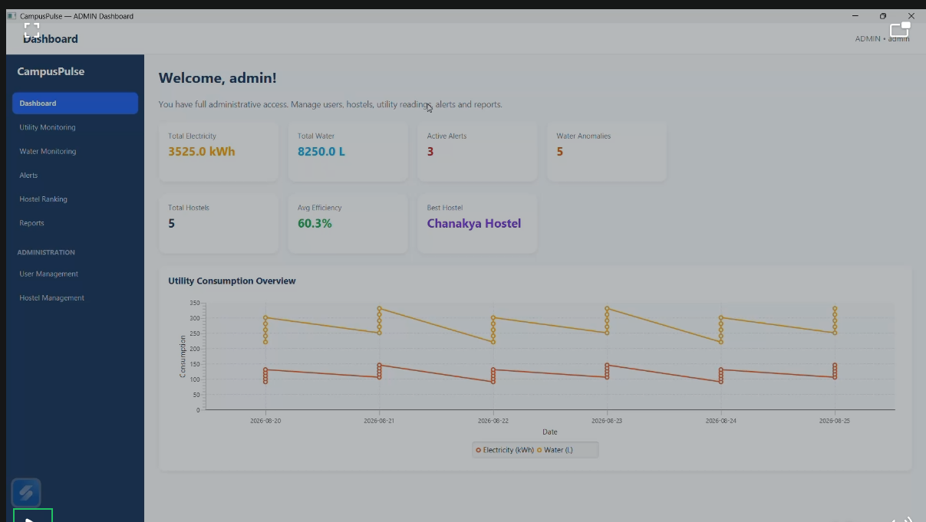
Figure 8.1: CampusPulse Admin Dashboard
The dashboard screenshot shows summary cards for electricity, water, active alerts, water anomalies, total hostels, average efficiency and best hostel, together with a utility consumption chart.
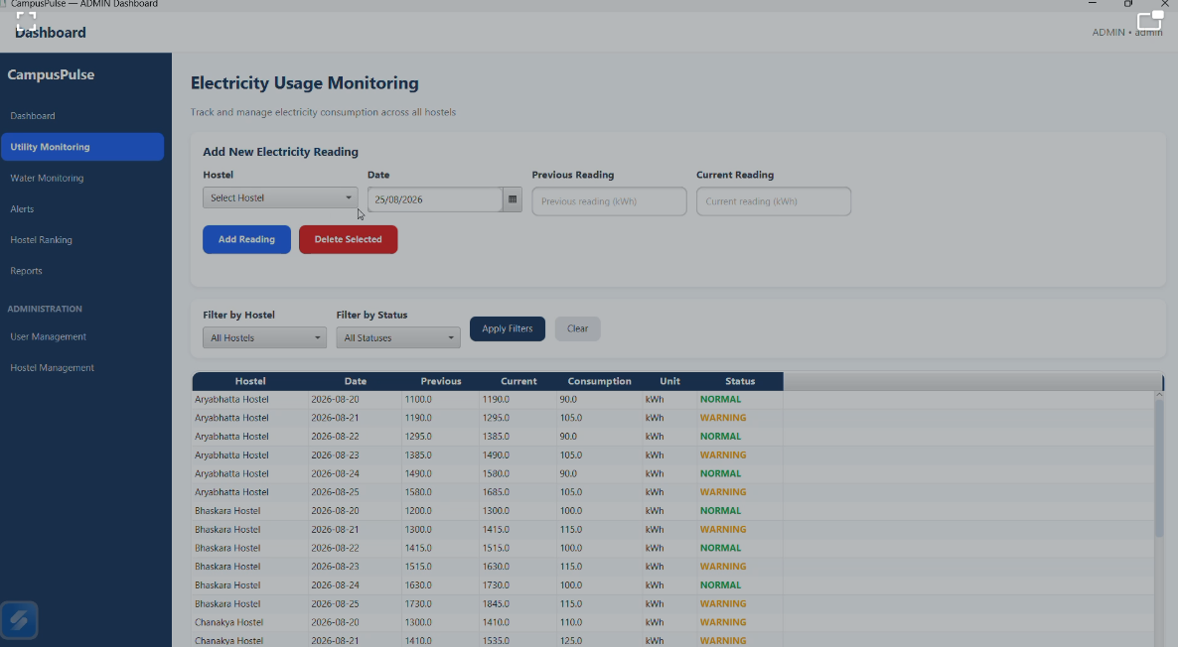
Figure 8.2: Electricity Usage Monitoring Interface
The electricity monitoring screen provides hostel selection, date, previous and current readings, filters and a table containing consumption, unit and status.
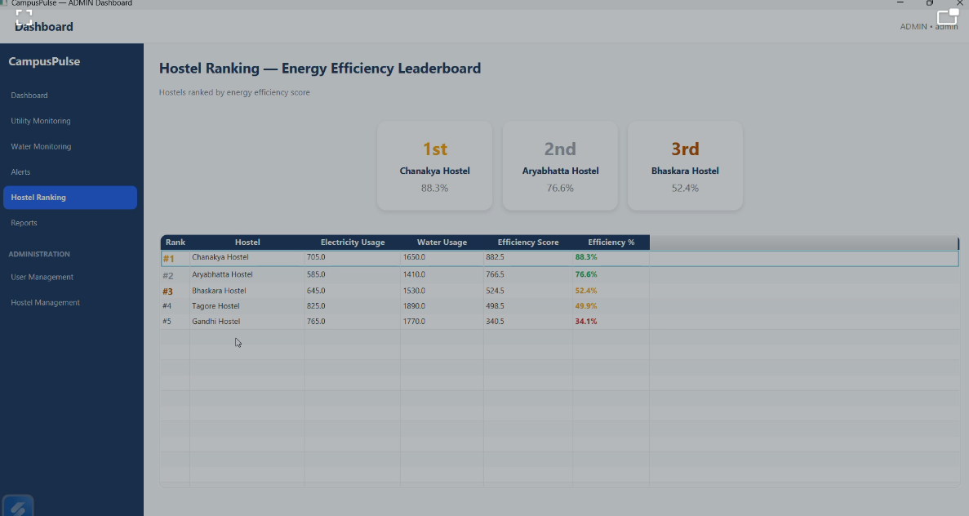
Figure 8.3: Hostel Ranking – Energy Efficiency Leaderboard
The hostel-ranking screen shows rank, hostel, electricity usage, water usage, efficiency score and efficiency percentage. The displayed order is consistent with the RankingService calculation.

8.4 Functional Results
The seeded demonstration data contains five hostels. For each hostel, six electricity readings and six water readings are generated relative to the runtime date. Consumption is the difference between current and previous readings.

8.5 Performance Results
No controlled performance benchmark is supplied. The current implementation should not be used to claim production-scale throughput or latency.

8.6 Comparison with Existing System
Capability | Conventional / Manual | CampusPulse
Centralized dashboard | Usually separate | Provided
Automatic consumption calculation | May require manual calculation | Provided
Reading status classification | Manual review | Rule-based
Water anomaly flagging | Manual review / separate tool | Built into application
Hostel efficiency ranking | Manual comparison | Automatic ranking service
Role-based access | May be external | Built into application
CSV report generation | Manual compilation | Built into report service

8.7 Achievement of Objectives
Objective | Evidence in Implementation | Status
Browser-based monitoring | Static web client + Spring Boot API | Implemented
Java service layer | UtilityService, AlertService, RankingService, ReportService | Implemented
Consumption and status calculation | UtilityService and UtilityReading | Implemented
Water anomaly detection | AlertService.detectAnomalies() | Implemented
Role-based access | AuthenticationService + session guards | Implemented
Hostel ranking | RankingService | Implemented
CSV reporting | ReportService | Implemented
Individual contribution evidence | Contribution statement supplied; artefacts still required | Partially documented

8.8 Discussion of Findings
The implementation demonstrates that a compact Java application can combine several campus-resource monitoring functions without a complex technology stack. The rule-based processing is transparent: consumption is calculated from meter readings, status is determined by explicit thresholds, and anomaly severity is determined from the difference between actual and expected water usage. The ranking mechanism adds a comparative element.
The results must be interpreted within the project's limitations. Seeded data is not live utility data, the water-leak rule is not a physical leak sensor, and the application has no persistent database. These constraints make the system appropriate as a functional prototype while defining clear future work.

8.9 Limitations
- In-memory storage resets on restart.
- Authentication uses demonstration credentials and is not production-grade.
- No password hashing or persistent identity store is included.
- No physical utility sensors are integrated.
- Water anomaly detection is deterministic and threshold-based.
- No formal performance benchmark or user-acceptance dataset is supplied.
- Git history does not by itself establish G Sai Deepak's individual contribution.

8.10 Summary
The supplied evidence confirms a web-oriented design with integrated monitoring modules and a Java service architecture. The screenshots demonstrate the interface, while source code supports the calculations and business rules.

CHAPTER 9 – PROJECT MANAGEMENT AND TEAM CONTRIBUTION

9.1 Introduction
This chapter documents project-management and individual-contribution information supported by the supplied repository and the contribution statement provided for G Sai Deepak. It intentionally avoids assigning unverified work.

9.2 Project Planning
The repository structure indicates an iterative implementation process. A formal project plan, sprint board or institutional Gantt chart was not included in the ZIP.

9.3 Project Timeline
Stage | Work | Evidence Available
Stage 1 | Initial CampusPulse web application | Git commit: Initial CampusPulse web application
Stage 2 | Dashboard/login and API correction | Git commit: Fix dashboard login and API parameter handling
Stage 3 | Demonstration and documentation | Supplied screenshots; formal evidence to add
Stage 4 | Final testing and submission preparation | To be completed with actual test evidence

9.4 Work Breakdown Structure
Work Package | Main Activities
WP1 | Requirement understanding and project setup
WP2 | Web interface development
WP3 | Java REST API and service integration
WP4 | Utility monitoring
WP5 | Water anomaly and alert handling
WP6 | Hostel ranking and reporting
WP7 | Testing and validation
WP8 | Presentation and documentation

9.5 Team Roles and Responsibilities
The supplied materials do not provide verified names and roles for the other team members. Therefore, only the confirmed individual contribution for G Sai Deepak is documented.

9.6 Individual Contributions
Student | Role | Major Responsibilities | Deliverables
G Sai Deepak (192311432) | Web application development / frontend-backend support / presentation & documentation | Web application development; frontend/backend support; presentation and documentation responsibilities | Relevant web modules, UI/support work, presentation materials and documentation evidence – exact module ownership to be confirmed.

9.7 GitHub Contribution
The ZIP contains a Git repository with two visible commits, but the visible commit author is not G Sai Deepak. Therefore, this report does not attribute those commits to him. The final report should include screenshots of his actual GitHub contributions, commit history, branches, pull requests or file-level evidence if available.

9.8 Risk Management
Risk | Impact | Mitigation
Data loss on restart | Demonstration data resets | Use persistent database in production.
Unauthorized access | Incorrect role could access protected functions | Session-based role checks.
Invalid readings | Incorrect consumption/status | Input validation and threshold classification.
False water-leak indication | High usage may not be a physical leak | Use sensor/hydraulic evidence and richer models.
Deployment differences | Runtime configuration may differ | Use environment-based port and container deployment.

9.9 Challenges Encountered
The implementation records a later correction to dashboard login and API parameter handling. The web conversion also retained legacy JavaFX source while excluding it from the web build. README-WEB.md identifies the JavaFX source as legacy and excluded from the web build.

9.10 Solutions Implemented
- Introduced a dedicated Spring Boot WebApplication entry point.
- Added REST endpoints through CampusPulseApi.
- Separated request payload structures into WebModels.
- Added role-aware navigation and server-side session checks.
- Implemented utility, alert, ranking and report services.
- Provided Docker and Render deployment configuration.

9.11 Project Management Methodology
The available repository evidence supports iterative refinement rather than a fully documented formal methodology. If the team used Scrum, Agile, Waterfall or another formal method, its actual records should be added rather than inferred.

9.12 Summary
The project demonstrates modular development and iterative correction. G Sai Deepak's stated contribution is web application development, frontend/backend support and presentation/documentation. The final submission should strengthen this chapter with personal GitHub evidence and specific deliverables.

CHAPTER 10 – CONCLUSION AND FUTURE ENHANCEMENTS

10.1 Introduction
CampusPulse demonstrates a Java-based web application for integrated hostel utility monitoring. The system combines electricity and water monitoring with anomaly detection, alerts, efficiency ranking, role-based access and reporting.

10.2 Project Summary
The project addresses fragmented utility information by presenting readings and derived indicators in a centralized browser interface. Java 21 and Spring Boot provide the server-side application structure, while HTML, CSS and JavaScript implement the browser client. The service layer separates authentication, data, utility, alert, ranking and report responsibilities.

10.3 Achievement of Objectives
The supplied source confirms implementation of the principal objectives: browser-based monitoring, Java service logic, utility consumption calculation, threshold-based status classification, water anomaly detection, role-based access, hostel ranking and CSV reporting. The remaining evidence gap concerns formal testing records and proof of the individual contribution.

10.4 Key Findings
- Utility readings can be converted into consumption and status indicators through deterministic rules.
- A combined electricity/water/capacity score can provide a comparative hostel leaderboard.
- Water anomaly rules can generate operational alerts when configured thresholds are exceeded.
- Role-based access can be implemented at the API layer using HTTP sessions.
- A modular service architecture provides extension points for persistent storage and sensor integration.

10.5 Project Contributions
The project contributes a centralized software platform for campus utility visibility. The individual contribution of G Sai Deepak is focused on web application development, frontend/backend support, and presentation/documentation. Exact file-level ownership should be documented with evidence.

10.6 Limitations
The current implementation is demonstration-oriented. Its primary limitations are in-memory storage, demonstration authentication, absence of physical sensor integration, deterministic anomaly rules and lack of formal performance/user-acceptance evidence.

10.7 Future Enhancements
- Replace in-memory stores with a persistent database.
- Implement secure password hashing and production identity management.
- Integrate live electricity and water meter/sensor data.
- Use time-series analytics or machine-learning models for adaptive anomaly detection.
- Add leak localization using flow, pressure or acoustic measurements where appropriate.
- Add historical trend analysis, export formats and scheduled reporting.
- Add automated unit and integration test suites.
- Introduce audit logs and stronger production security controls.
- Deploy with persistent storage and operational observability.

10.8 Recommendations
For academic evaluation, the project should be presented with actual screenshots, source-code evidence and test results. For production deployment, persistent storage, secure authentication, sensor integration and stronger validation should be treated as prerequisites.

10.9 Final Conclusion
CampusPulse provides a practical demonstration of how Java programming and web application technologies can create an integrated campus resource monitoring system. It brings utility readings, water anomaly detection, alerts, hostel efficiency comparison and reporting into a single role-aware application. The project establishes a software foundation for cross-utility monitoring while its limitations define a clear path toward a more robust production system.

REFERENCES
[1] Saveetha Institute of Medical and Technical Sciences, “Capstone Project Report Preparation Guidelines and Report Template for Students,” Academic Year 2026–2027.
[2] Spring, “Developing Your First Spring Boot Application,” Spring Boot Documentation, accessed 2026.
[3] M. M. Polycarpou, I. Mareels, A. F. Taha and D. G. Eliades, “Special section: Smart water systems,” Annual Reviews in Control, vol. 55, 2023, pp. 390–391.
[4] B. Z. Rousso, M. Lambert and J. Gong, “Smart water networks: A systematic review of applications using high-frequency pressure and acoustic sensors in real water distribution systems,” Journal of Cleaner Production, vol. 410, 2023, article 137193.
[5] “Addressing data limitations in leakage detection of water distribution systems: Data creation, data requirement reduction, and knowledge transfer,” Water Research, vol. 267, 2024, article 122471.
[6] M. N. Kanyama, F. Bhunu Shava, A. M. Gamundani and A. Hartmann, “Machine learning applications for anomaly detection in Smart Water Metering Networks: A systematic review,” Physics and Chemistry of the Earth, Parts A/B/C, vol. 134, 2024, article 103558.
[7] “Preliminary Approach for the Development of Sustainable University Campuses: A Case Study Based on the Mitigation of Greenhouse Gas Emissions,” Sustainability, vol. 15, no. 6, 2023, article 5518.
[8] CampusPulse project source code and README-WEB.md, supplied project archive, 2026.

APPENDICES

Appendix A – Pseudocode
The pseudocode for utility classification, water anomaly detection, ranking and report generation is included in Chapter 6.

Appendix B – Important Source Code
The complete source code should not be duplicated in the main report. The final submission should include the source-code archive or verified repository URL.

Appendix C – Database Scripts
Not applicable to the current implementation because no external database is used.

Appendix D – Additional Screenshots
The supplied screenshots are included in Chapter 8. Add Water Monitoring, Alerts, Reports, User Management and Hostel Management screenshots if available.

Appendix E – Testing Evidence
[Insert actual executed test screenshots, API responses and completed test-case results.]

Appendix F – GitHub Evidence
[Insert verified GitHub repository URL and screenshots showing G Sai Deepak's actual contributions.]

Appendix G – Individual Contribution
Student: G Sai Deepak (192311432)
Recorded contribution: Web application development, frontend/backend support and presentation/documentation responsibilities.
[Insert evidence: authored files, screenshots, GitHub commits, pull requests, presentation slides and documentation pages.]

Appendix H – User Manual
1. Start the Spring Boot application. 2. Open the application in a browser. 3. Sign in with an authorized account. 4. Use the sidebar to open monitoring modules. 5. Authorized staff/admin users can manage readings, alerts and reports according to role. 6. Students have read-only access.

Appendix I – Installation / Deployment Guide
README-WEB.md documents Maven packaging, Spring Boot execution, local URL access and Docker/Render deployment. The final report should include the verified commands and deployment URL used by the project team.

Appendix J – Similarity Report
[Insert the final institutional similarity report here.]

