Secure Programming Assignment2

Language used:- Python,html

Dependencies required :-

1)Django

2)django-crispy-forms

3)Pillow

Terminal commands to run program:-

* python manage.py makemigrations
* python manage.py migrate
* python manage.py runserver

**Note:-**Check the terminal directory should be in parent of manage.py

Proceed to url propted in terminal

**Sample images:-**

Sharing a file from user name revanth1:-

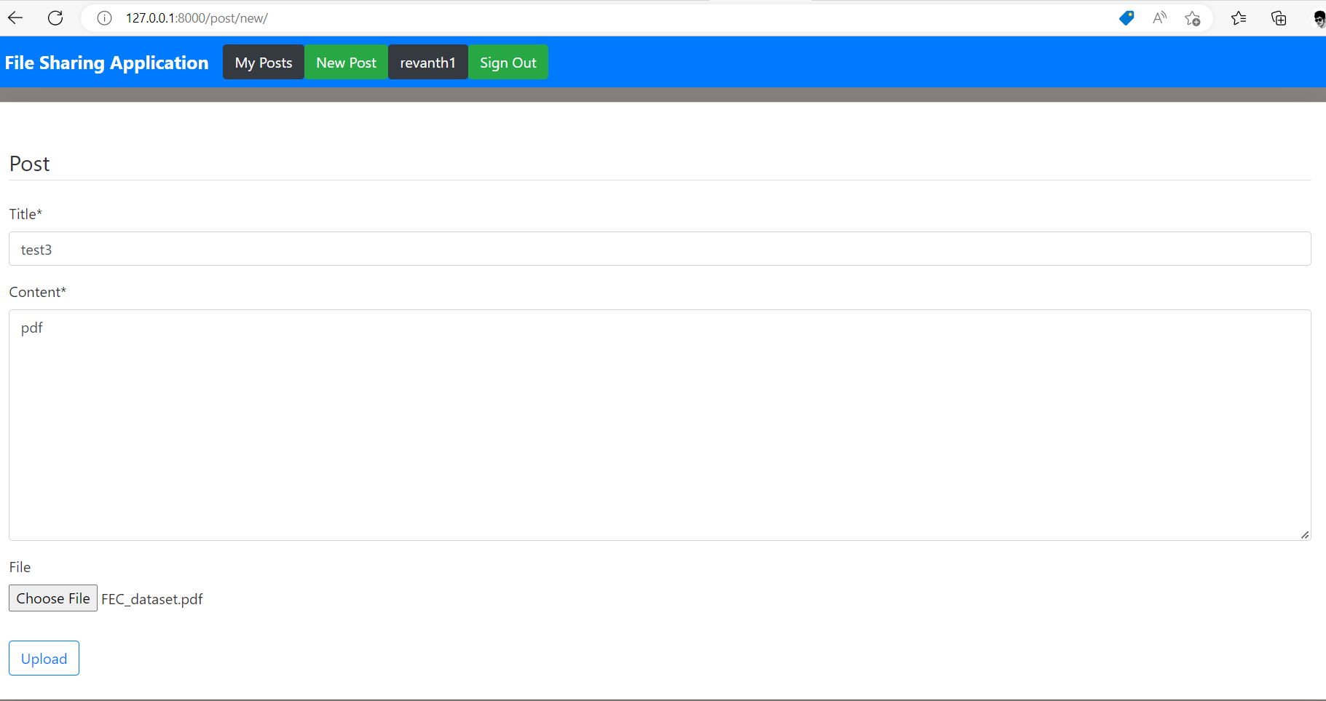

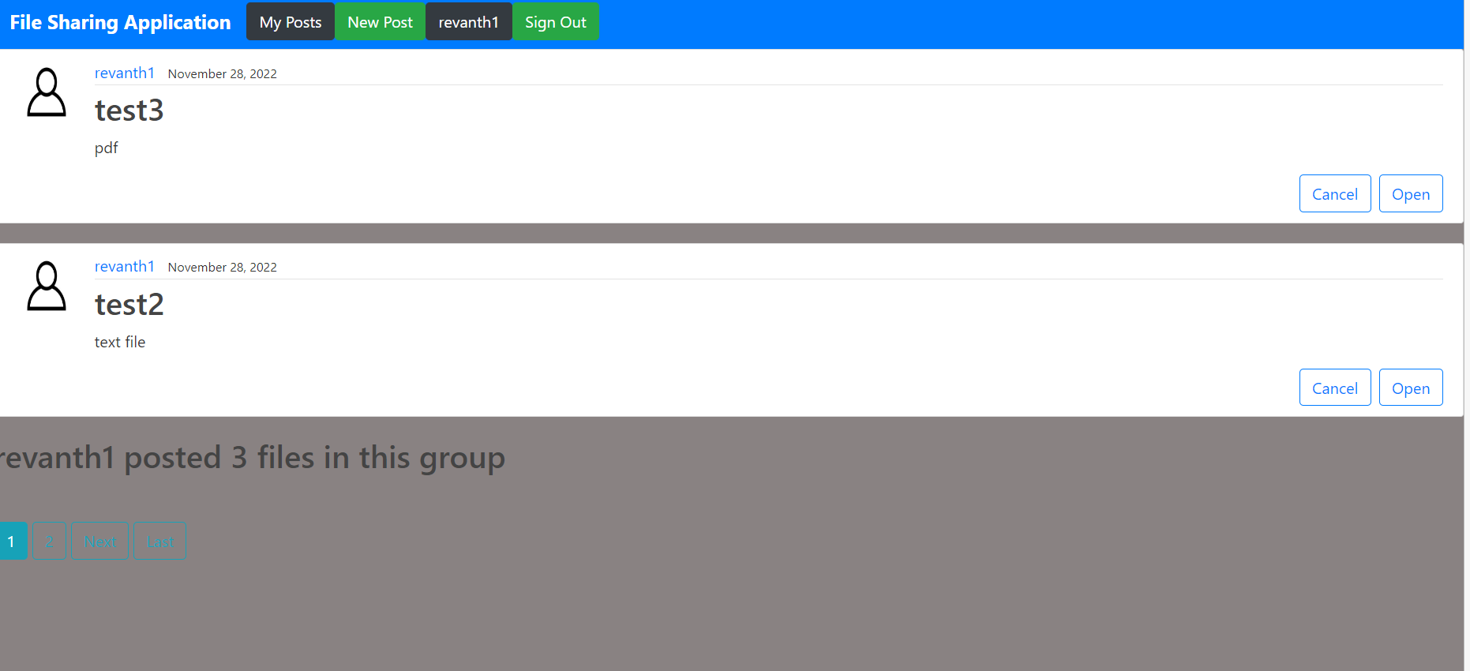

Test3 is posted and user revanth1 has already posted 3 files

Group Homepage:-

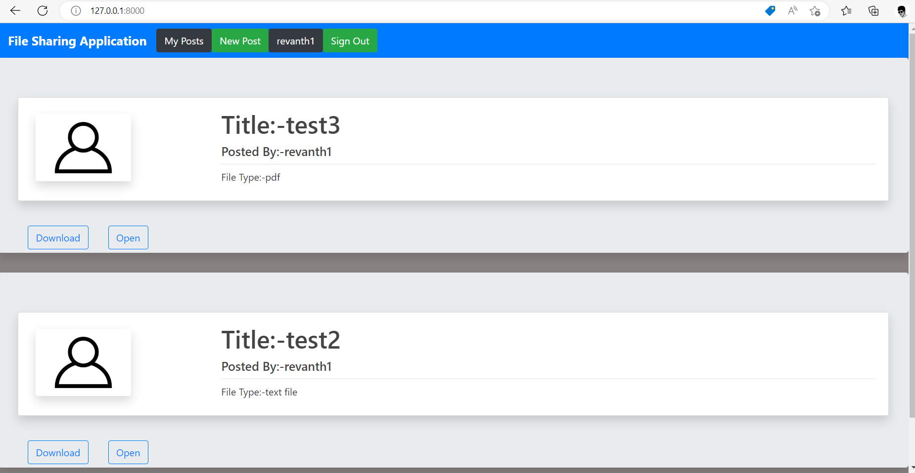

Download from home page:-

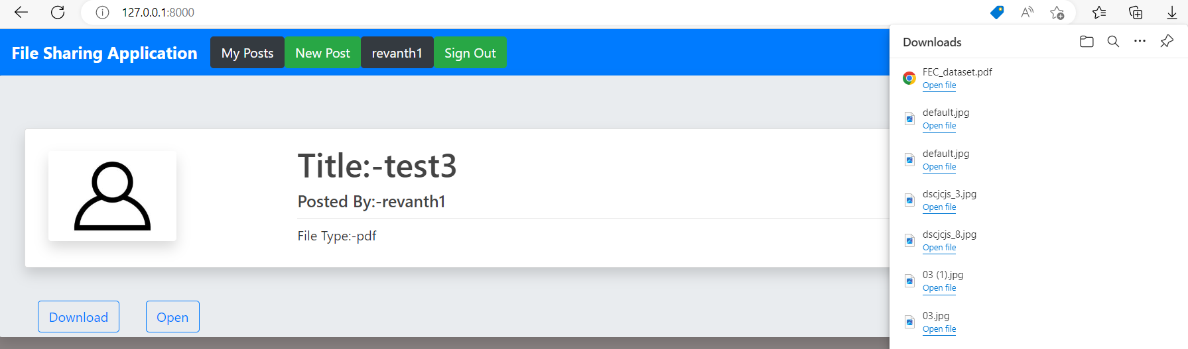

Remove test3 post

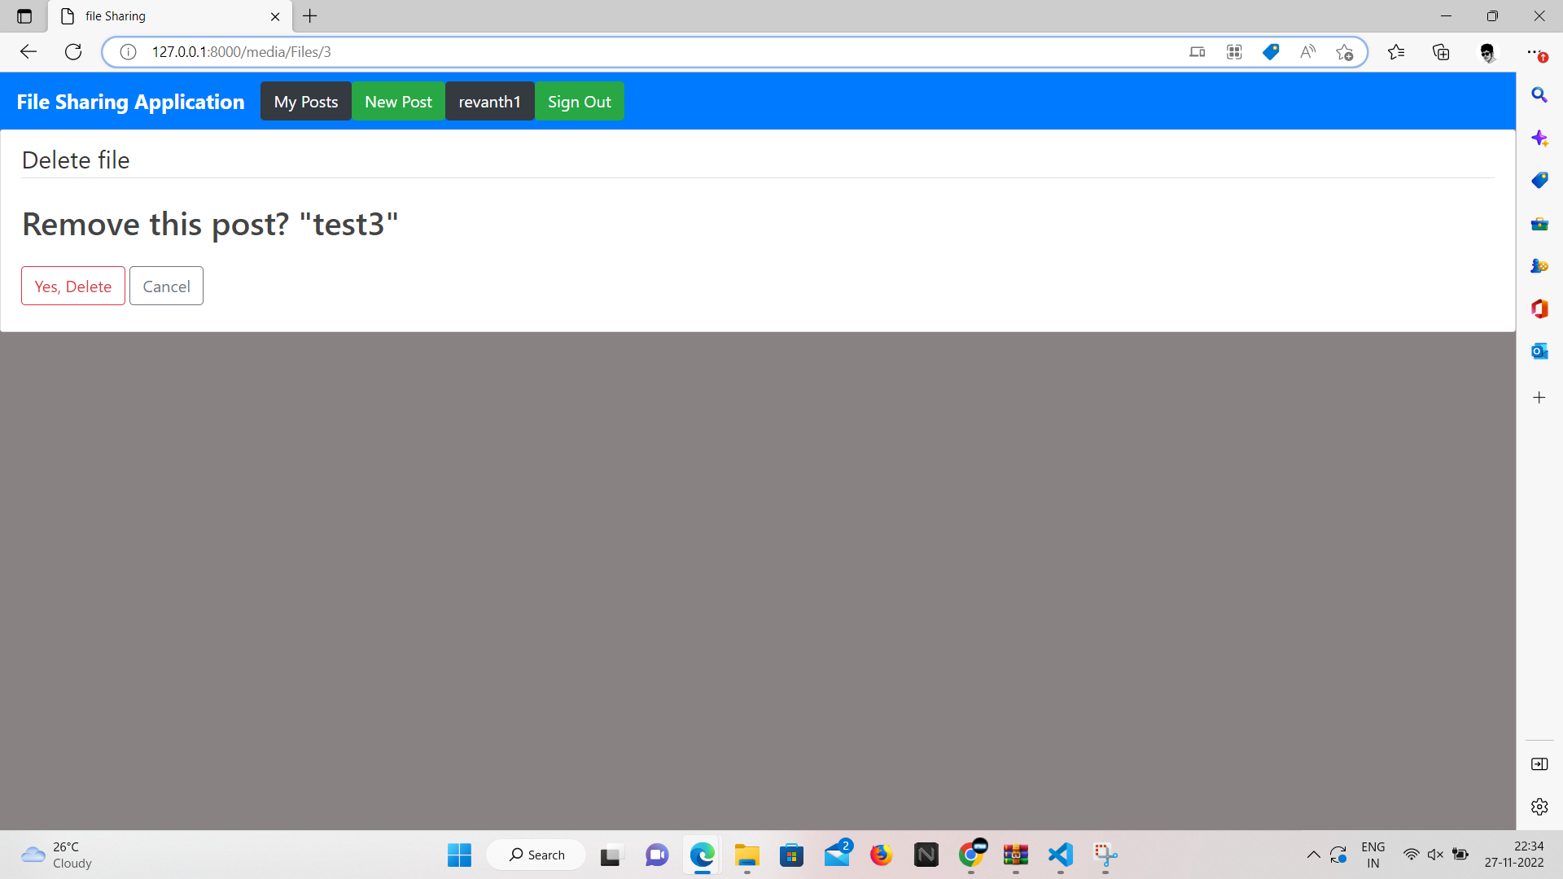

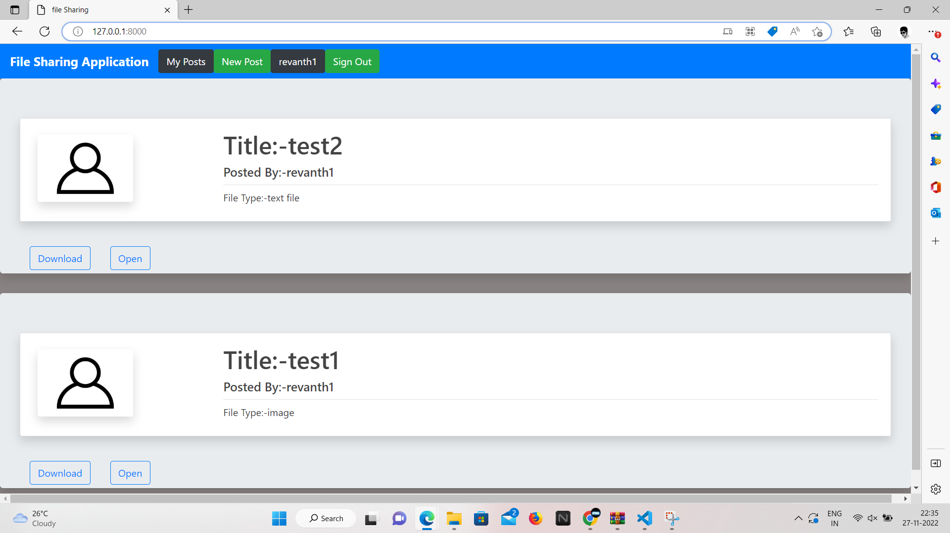

Logout:-

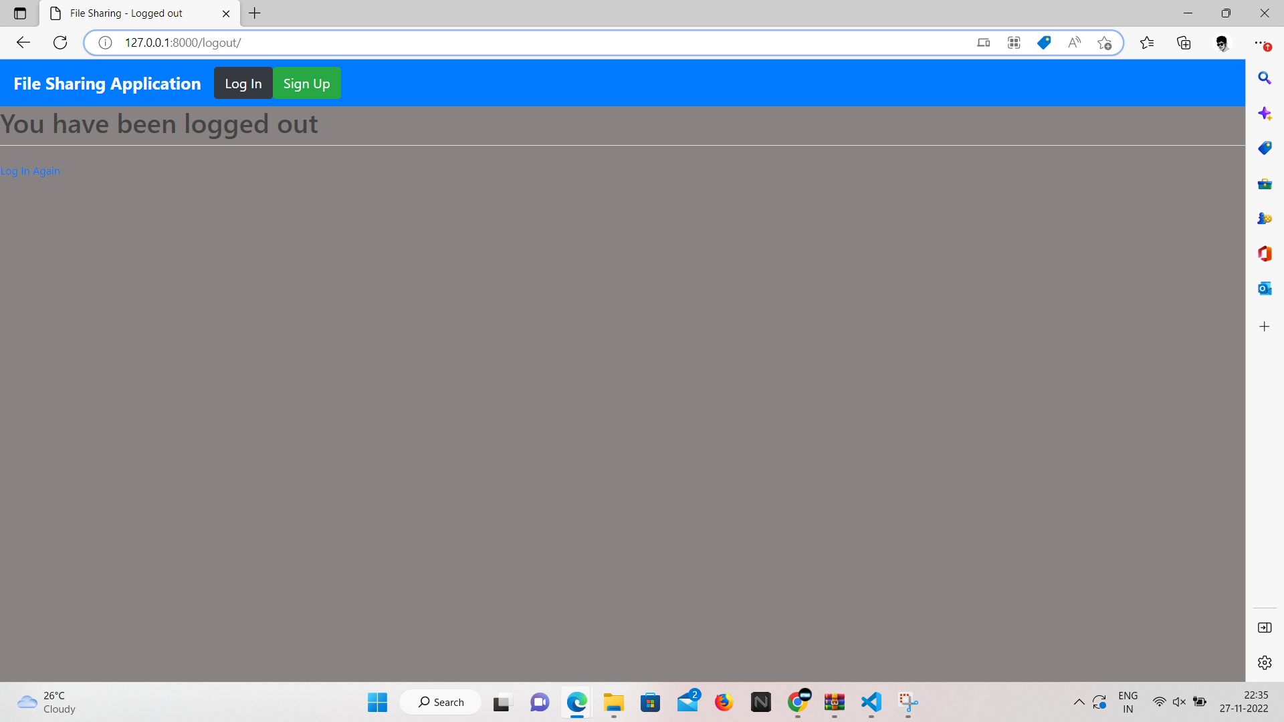

Signup new user name ganesh:-

Some validations for password field

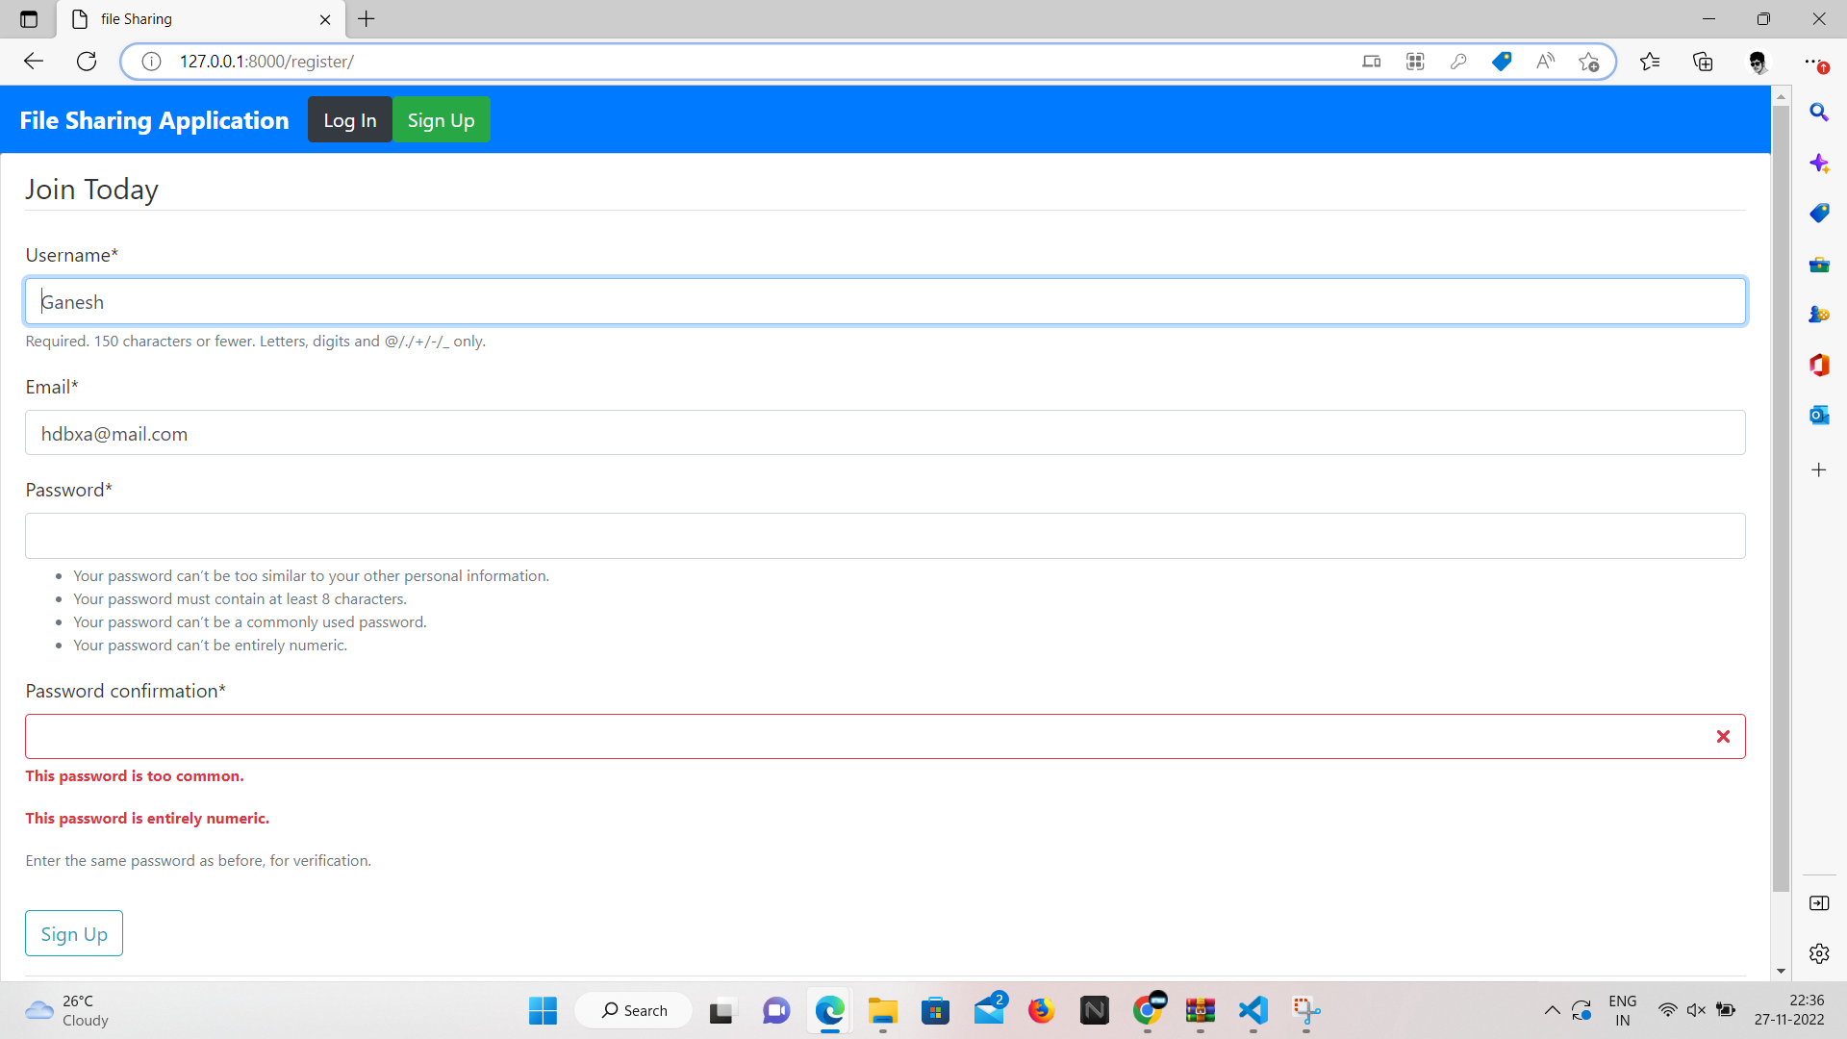

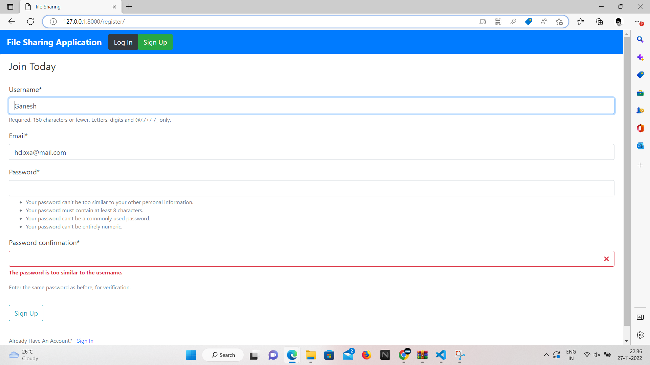

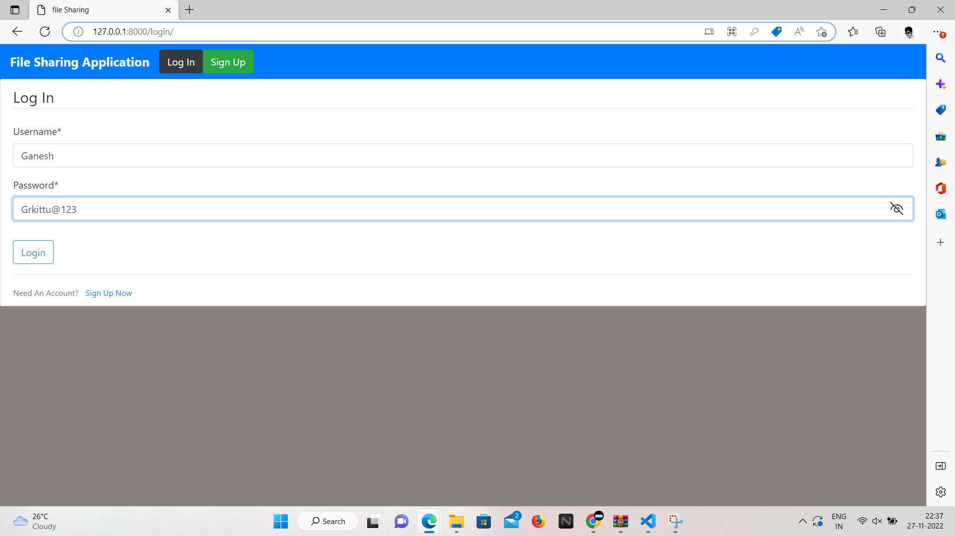

Post file from Ganesh:-

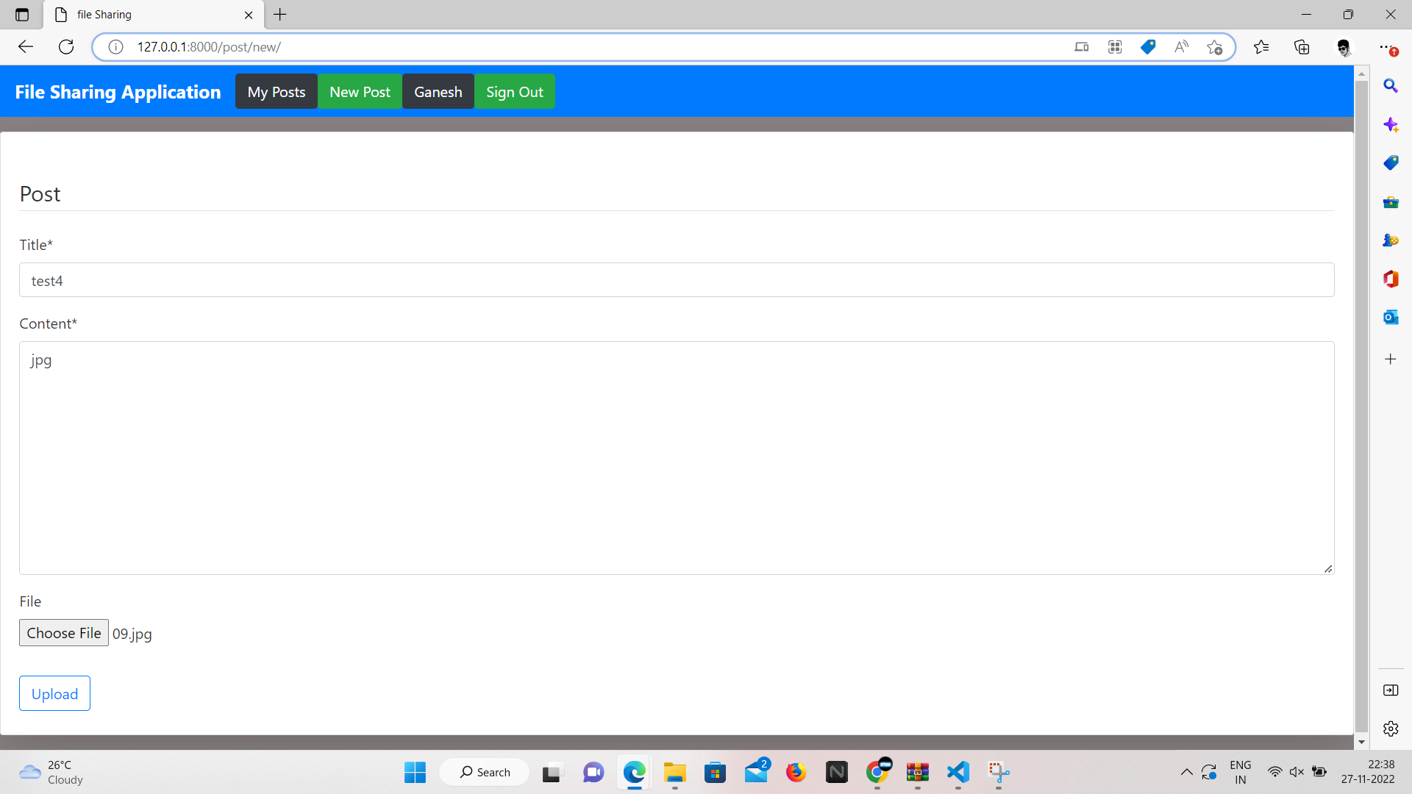

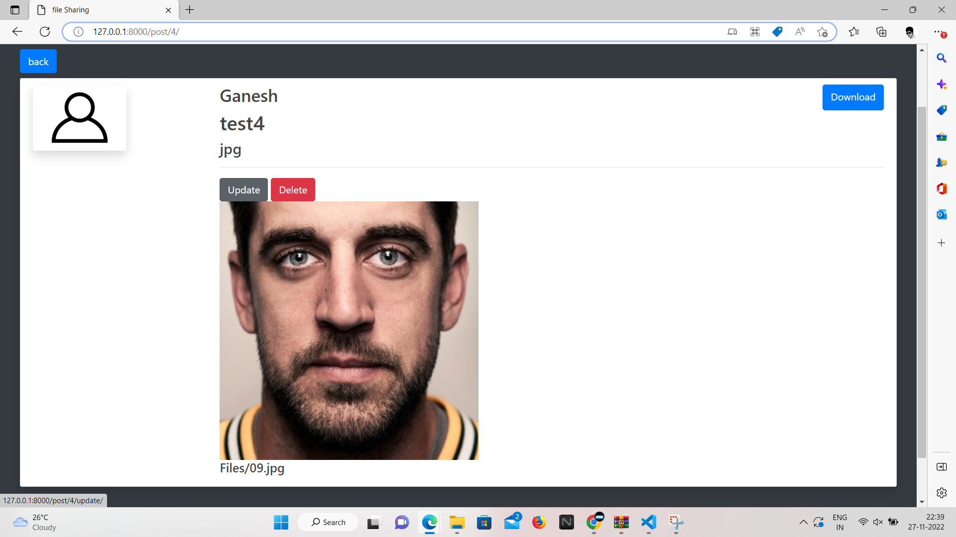

Group Homepage:-

