A PROJECT REPORT ON
FRONT-END DEVELOPMENT
Submitted to
NTPC LIMITED, TALCHER KANIHA, ODISHA
As a partial fulfillment of the
Degree of B. Tech

NATIONAL THERMAL POWER GOVERNMENT COLLEGE OF ENGINEERING
CORPORATION LIMITED KALAHANDI, BHAWANIPATNA
SUPERVISED BY: SUBMITTED BY:
MR. YOGESH VERMA Deepak Kumar Kar
DGM (RLI) Roll no: 2401110049
NTPC Ltd/TSTPS ,Kaniha Talcher 4th semester (CSE)

CERTIFICATE
- To whomsoever it may concern-
This is to certify that DEEPAK KUMAR KAR (2401110049/24) second year student of B. tech Computer Science & Engineering, GOVERNMENT COLLEGE OF ENGINEERING KALAHANDI, BHAWANIPATNA has successfully completed his training for the purpose of final dissertation as partial fulfillment for the Bachelor of Engineering degree in Computer Science and Engineering. They have worked with the "SOFTWARE DEVELOPMENT GROUP'' of Department of I.T. at TSTPS Kaniha, from 08 June 2026 to 07 July 2026 as per the requirement of Department of I.T.
They have taken genuine interest in working in the project while their training. They were found to be sincere, hardworking & their performance is excellent. They bear a good moral character.
I wish them success in all their future endeavors.

ACKNOWLEDGEMENT
It is not possible to prepare a project report without the assistance and encouragement of other people. This one is certainly no exception. At the very outset of this report, I would like to express my sincere and heartfelt obligation towards all the people who have helped me in this endeavor. Without their active guidance, help, cooperation, and encouragement, I would not have made headway in my industrial training.
I am ineffably indebted to Mr. Yogesh Verma, DGM (RLI), for his conscientiousness and encouragement to accomplish this assignment.
I am extremely thankful and express my gratitude to all my faculty guides. extend my gratitude to NTPC Ltd., Kaniha, and the HR-EDC Department of NTPC Ltd., Kaniha, for giving me this opportunity.
I also acknowledge, with a deep sense of reverence, my gratitude towards my parents, who have always supported me morally as well as economically.
Any omission in this brief acknowledgement does not mean a lack of gratitude.

Thanking You,
DEEPAK KUMAR KAR

Contents
COMPANY PROFILE
Introduction
Overview of TSTPS
Coal fired Thermal Power Plant
Working of Thermal Power Plant
Advantages And Disadvantages
Role of IT department
INTRODUCTION
HTML
CSS
JAVASCRIPT
SYSTEM DESIGN
A Website To Buy Plants
A Login Form with Password Validation
A Food Ordering Website
IMPLEMENTATIONS
Coding for Website To Buy Plants
Coding for Login Form with Password Validation
Coding for Food Ordering Website
CONCLUSION

HTML
HTML stands for Hypertext Markup Language. It is used to design web pages using a markup language. HTML is a combination of Hypertext and Markup language. Hypertext defines the link between web pages. A markup language is used to define the text document within the tag which defines the structure of web pages. This language is used to annotate (make notes for the computer) text so that a machine can understand it and manipulate text accordingly. Most markup languages (e.g. HTML) are human-readable. The language uses tags to define what manipulation has to be done on the text.
HTML page structure: The basic structure of an HTML page is laid out below. It contains the essential building-block elements (i.e. doctype declaration, HTML, head, title, and body elements) upon which all web pages are created.
<!DOCTYPE html>: This is the document type declaration (not technically a tag). It declares a document as being an HTML document. The doctype declaration is not case-sensitive.
<html>: This is called the HTML root element. All other elements are contained within it.
<head>: The head tag contains the “behind the scenes” elements for a webpage. Elements within the head aren’t visible on the front-end of a webpage. HTML elements used inside the <head> element include:
<style>-This html tag allows us to insert styling into our webpages and make them appealing to look at with the help of CSS.
<title>-The title is what is displayed on the top of your browser when you visit a website and contains the title of the webpage that you are viewing.
<base>-It specifies the base URL for all relative URL’s in a document.
<noscript>– Defines a section of HTML that is inserted when the scripting has been turned off in the user’s browser.
<script>-This tag is used to add functionality in the website with the help of JavaScript.
<meta>-This tag encloses the meta data of the website that must be loaded every time the website is visited. For e.g.: - the metadata charset allows you to use the standard UTF-8 encoding in your website. This in turn allows the users to view your webpage in the language of their choice. It is a self closing tag.
<link>– The ‘link’ tag is used to tie together HTML, CSS, and JavaScript. It is self closing.
<body>: The body tag is used to enclose all the visible content of a webpage. In other words, the body content is what the browser will show on the front-end.

CSS
Cascading Style Sheets (CSS) is a powerful tool used in web development to control the visual appearance of HTML documents. CSS allows you to define the layout, colors, fonts, and other visual aspects of your web pages, making them more visually appealing and user-friendly.
In the context of creating reports, CSS can be an invaluable asset. By applying CSS styles to your report, you can enhance its readability, structure, and overall presentation. Whether you're creating a simple document or a complex report with multiple sections and elements, CSS provides a flexible and efficient way to customize the appearance to suit your needs.
Benefits of Using CSS in Reports:
Consistency: CSS enables you to establish consistent styles across multiple pages or sections of your report. By defining styles for headings, paragraphs, lists, and other elements, you can ensure a unified look and feel throughout the document.
Flexibility: CSS allows you to separate the presentation layer (CSS) from the content layer (HTML). This separation provides flexibility, as you can easily modify the visual aspects of your report without altering the underlying content. It also enables you to reuse CSS styles across different reports, saving time and effort.
Customization: With CSS, you have precise control over the appearance of your report. You can choose fonts, colors, spacing, borders, and other visual properties to match your desired style or branding. This customization capability helps create professional-looking reports that effectively convey information.
Responsive Design: Reports are often viewed on different devices and screen sizes. CSS provides responsive design techniques that allow your report to adapt and display appropriately on various devices, such as desktops, tablets, and smartphones. This ensures a consistent user experience across different platforms.
Accessibility: CSS supports accessibility features, allowing you to create reports that are inclusive and accessible to all users. You can utilize CSS to enhance readability by adjusting font sizes, contrast ratios, and adding alternative text for images, making your report more usable for people with visual impairments or other disabilities.

JAVASCRIPT
JavaScript is a lightweight, cross-platform, single-threaded, and interpreted compiled programming language which is also known as the scripting language for webpages. It is well-known for the development of web pages, and many non-browser environments also use it. JavaScript is a weakly typed language (dynamically typed). JavaScript can be used for Client-side developments as well as Server-side developments. JavaScript is both an imperative and declarative type of language. JavaScript contains a standard library of objects, like Array, Date, and Math, and a core set of language elements like operators, control structures, and statements.
JavaScript Introduction
Client-side: It supplies objects to control a browser and its Document Object Model (DOM). Like if client-side extensions allow an application to place elements on an HTML form and respond to user events such as mouse clicks, form input, and page navigation. Useful libraries for the client side are AngularJS, ReactJS, VueJS, and so many others.
Server-side: It supplies objects relevant to running JavaScript on a server. For if the server-side extensions allow an application to communicate with a database, and provide continuity of information from one invocation to another of the application, or perform file manipulations on a server. The useful framework which is the most famous these days is node.js.
Imperative language – In this type of language we are mostly concerned about how it is to be done. It simply controls the flow of computation. The procedural programming approach, object, oriented approach comes under this as async await we are thinking about what is to be done further after the async call.
Declarative programming – In this type of language we are concerned about how it is to be done, basically here logical computation requires. Her main goal is to describe the desired result without direct dictation on how to get it as the arrow function does.
JavaScript can be added to your HTML file in two ways:
Internal JS: We can add JavaScript directly to our HTML file by writing the code inside the <script> tag. The <script> tag can either be placed inside the <head> or the <body> tag according to the requirement.
External JS: We can write JavaScript code in another files having an extension.js and then link this file inside the <head> tag of the HTML file in which we want to add this code.

CODE FOR FOOD ORDERING WEBSITE
<!DOCTYPE html>
<html>
<head>
<title>Food Ordering Website</title>
<style>
body {
font-family: Arial, sans-serif;
background-image: url("C:\Users\KIIT\Downloads\images (1).jpeg");
background-size: cover;
background-position: center;
}

header {
background-color: #333;
color: #fff;
padding: 20px;
text-align: center;
}

h1 {
margin: 0;
}

main {
max-width: 800px;
margin: 0 auto;
padding: 20px;
background-color: rgba(255, 255, 255, 0.8);
}

.item {
display: flex;
margin-bottom: 40px;
}

.item img {
width: 200px;
height: 200px;
object-fit: cover;
margin-right: 20px;
}

.item-info {
flex: 1;
}

.item h2 {
margin-bottom: 10px;
}

.item p {
margin-bottom: 20px;
}

.item button {
padding: 10px 20px;
background-color: #333;
color: #fff;
border: none;
cursor: pointer;
}
</style>
</head>
<body>
<header>
<h1>Food Ordering Website</h1>
</header>

<main>
<div class="item">
<img src="path-to-image1.jpg" alt="Food 1">
<div class="item-info">
<h2>Food 1</h2>
<p>Description of Food 1. Lorem ipsum dolor sit amet, consectetur adipiscing elit.</p>
<p>Price: $9.99</p>
<button>Add to Cart</button>
</div>
</div>

<div class="item">
<img src="path-to-image2.jpg" alt="Food 2">
<div class="item-info">
<h2>Food 2</h2>
<p>Description of Food 2. Lorem ipsum dolor sit amet, consectetur adipiscing elit.</p>
<p>Price: $12.99</p>
<button>Add to Cart</button>
</div>
</div>

<div class="item">
<img src="path-to-image3.jpg" alt="Food 3">
<div class="item-info">
<h2>Food 3</h2>
<p>Description of Food 3. Lorem ipsum dolor sit amet, consectetur adipiscing elit.</p>
<p>Price: $14.99</p>
<button>Add to Cart</button>
</div>
</div>
</main>
</body>
</html>

CODE FOR WEBSITE FOR BUYING PLANTS
<!DOCTYPE html>
<html>
<head>
<title>Plant Shop</title>
<style>
body {
font-family: Arial, sans-serif;
background-image: url("C:\Users\KIIT\Downloads\images (1).jpeg");
background-size: cover;
background-position: center;
}

header {
background-color: #333;
color: #fff;
padding: 20px;
text-align: center;
display: flex;
align-items: center;
justify-content: center;
}

header img {
width: 50px;
height: 50px;
margin-right: 10px;
}

main {
max-width: 800px;
margin: 0 auto;
padding: 20px;
}

h1 {
text-align: center;
}

.product {
display: flex;
margin-bottom: 40px;
}

.product img {
width: 200px;
height: 200px;
object-fit: cover;
margin-right: 20px;
}

.product-info {
flex: 1;
}

.product h2 {
margin-bottom: 10px;
}

.product p {
margin-bottom: 20px;
}

.product button {
padding: 10px 20px;
background-color: #333;
color: #fff;
border: none;
cursor: pointer;
}
</style>
</head>
<body>
<header>
<img src="plant-icon.png" alt="Plant Icon">
<h1>Plant Shop</h1>
</header>

<main>
<div class="product">
<img src="path-to-image1.jpg" alt="Plant 1">
<div class="product-info">
<h2>Plant 1</h2>
<p>Description of Plant 1. Lorem ipsum dolor sit amet, consectetur adipiscing elit.</p>
<p>Price: $19.99</p>
<button>Add to Cart</button>
</div>
</div>

<div class="product">
<img src="path-to-image2.jpg" alt="Plant 2">
<div class="product-info">
<h2>Plant 2</h2>
<p>Description of Plant 2. Lorem ipsum dolor sit amet, consectetur adipiscing elit.</p>
<p>Price: $24.99</p>
<button>Add to Cart</button>
</div>
</div>

<div class="product">
<img src="path-to-image3.jpg" alt="Plant 3">
<div class="product-info">
<h2>Plant 3</h2>
<p>Description of Plant 3. Lorem ipsum dolor sit amet, consectetur adipiscing elit.</p>
<p>Price: $14.99</p>
<button>Add to Cart</button>
</div>
</div>
</main>
</body>
</html>

CODE FOR LOGIN FORM WITH PASSWORD VALIDATION
<!DOCTYPE html>
<html>
<head>
<title>Login Form</title>
<style>
body {
font-family: Arial, sans-serif;
}
.container {
max-width: 300px;
margin: 0 auto;
padding: 20px;
background-color: #f2f2f2;
border-radius: 5px;
}

h2 {
text-align: center;
}

.form-group {
margin-bottom: 10px;
}

label {
display: block;
font-weight: bold;
margin-bottom: 5px;
}

input[type="password"] {
width: 100%;
padding: 8px;
border-radius: 3px;
border: 1px solid #ccc;
}

.error {
color: red;
font-size: 14px;
margin-top: 5px;
}

.button-container {
text-align: center;
margin-top: 20px;
}

button {
padding: 10px 20px;
background-color: #333;
color: #fff;
border: none;
cursor: pointer;
}
</style>
</head>
<body>
<div class="container">
<h2>Login Form</h2>
<form id="loginForm" onsubmit="validateForm(event)">
<div class="form-group">
<label for="username">Username</label>
<input type="text" id="username" required>
</div>
<div class="form-group">
<label for="password">Password</label>
<input type="password" id="password" required>
<div class="error" id="passwordError"></div>
</div>
<div class="button-container">
<button type="submit">Login</button>
</div>
</form>
</div>

<script>
function validateForm(event) {
event.preventDefault(); // Prevent form submission

// Get the username and password input elements
var usernameInput = document.getElementById("username");
var passwordInput = document.getElementById("password");

// Get the username and password values
var username = usernameInput.value;
var password = passwordInput.value;

// Check if the username and password are correct
if (username === "diptimaaye" && password === "123456789") {
// Clear any existing error message
document.getElementById("passwordError").innerHTML = "";

// TODO: Perform login logic here
// You can redirect the user to another page or display a success message

alert("Login successful!");
} else {
document.getElementById("passwordError").innerHTML = "Invalid username or password.";
}
}
</script>
</body>
</html>

SYSTEM DESIGN

Plant Shopping Website:
HTML: Structure the website using HTML elements to create sections, product listings, shopping cart displays, and checkout forms.
CSS: Apply CSS styles to customize the appearance of the website, including product images, pricing, buttons, and responsive layouts.
JavaScript: Implement client-side interactions like adding items to the shopping cart, updating quantities, and validating form inputs. You can also use JavaScript to fetch product data from a server using APIs.

EXAMPLE:
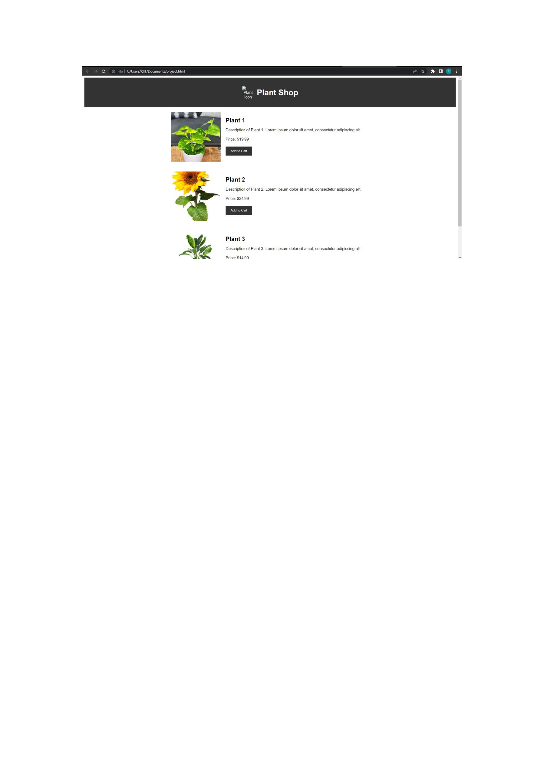
Login Form with Password Validation:
HTML: Create an HTML form with input fields for username and password, along with appropriate labels and error message placeholders.
CSS: Style the form elements, including input fields, labels, buttons, and error messages, using CSS to make them visually appealing and user-friendly.
JavaScript: Implement client-side password validation logic to check for password strength requirements (e.g., minimum length, special characters). You can use JavaScript event listeners to trigger the validation and display appropriate error messages.

EXAMPLE:


Food Ordering Website:
HTML: Structure the website using HTML elements to create sections, menus, order forms, and checkout processes.
CSS: Apply CSS styles to customize the appearance of the website, including menu item layouts, pricing displays, cart summaries, and responsive designs.
JavaScript: Implement client-side interactions like adding menu items to the cart, updating quantities, calculating order totals, and form validation. JavaScript can also handle dynamic updates based on user selections.
In each case, HTML provides the structure of the webpages, CSS is responsible for the styling and visual presentation, and JavaScript adds interactivity and functionality to enhance the user experience. These front-end technologies work together to create engaging and dynamic web applications.

EXAMPLE:
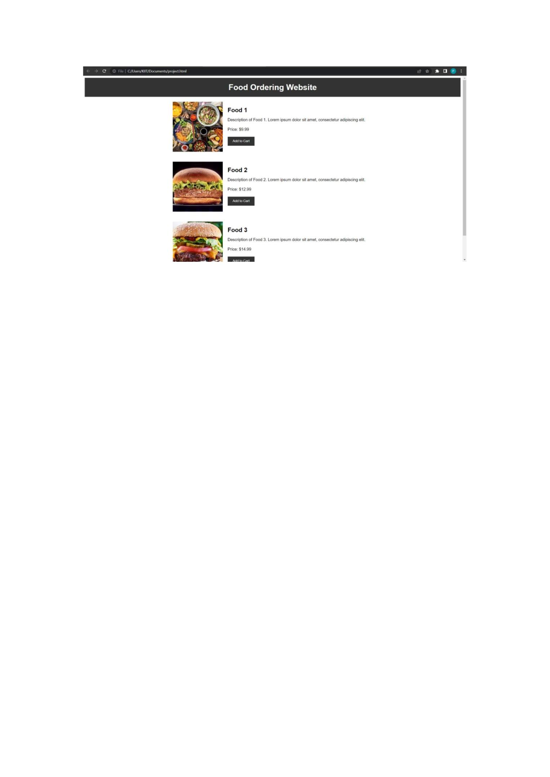


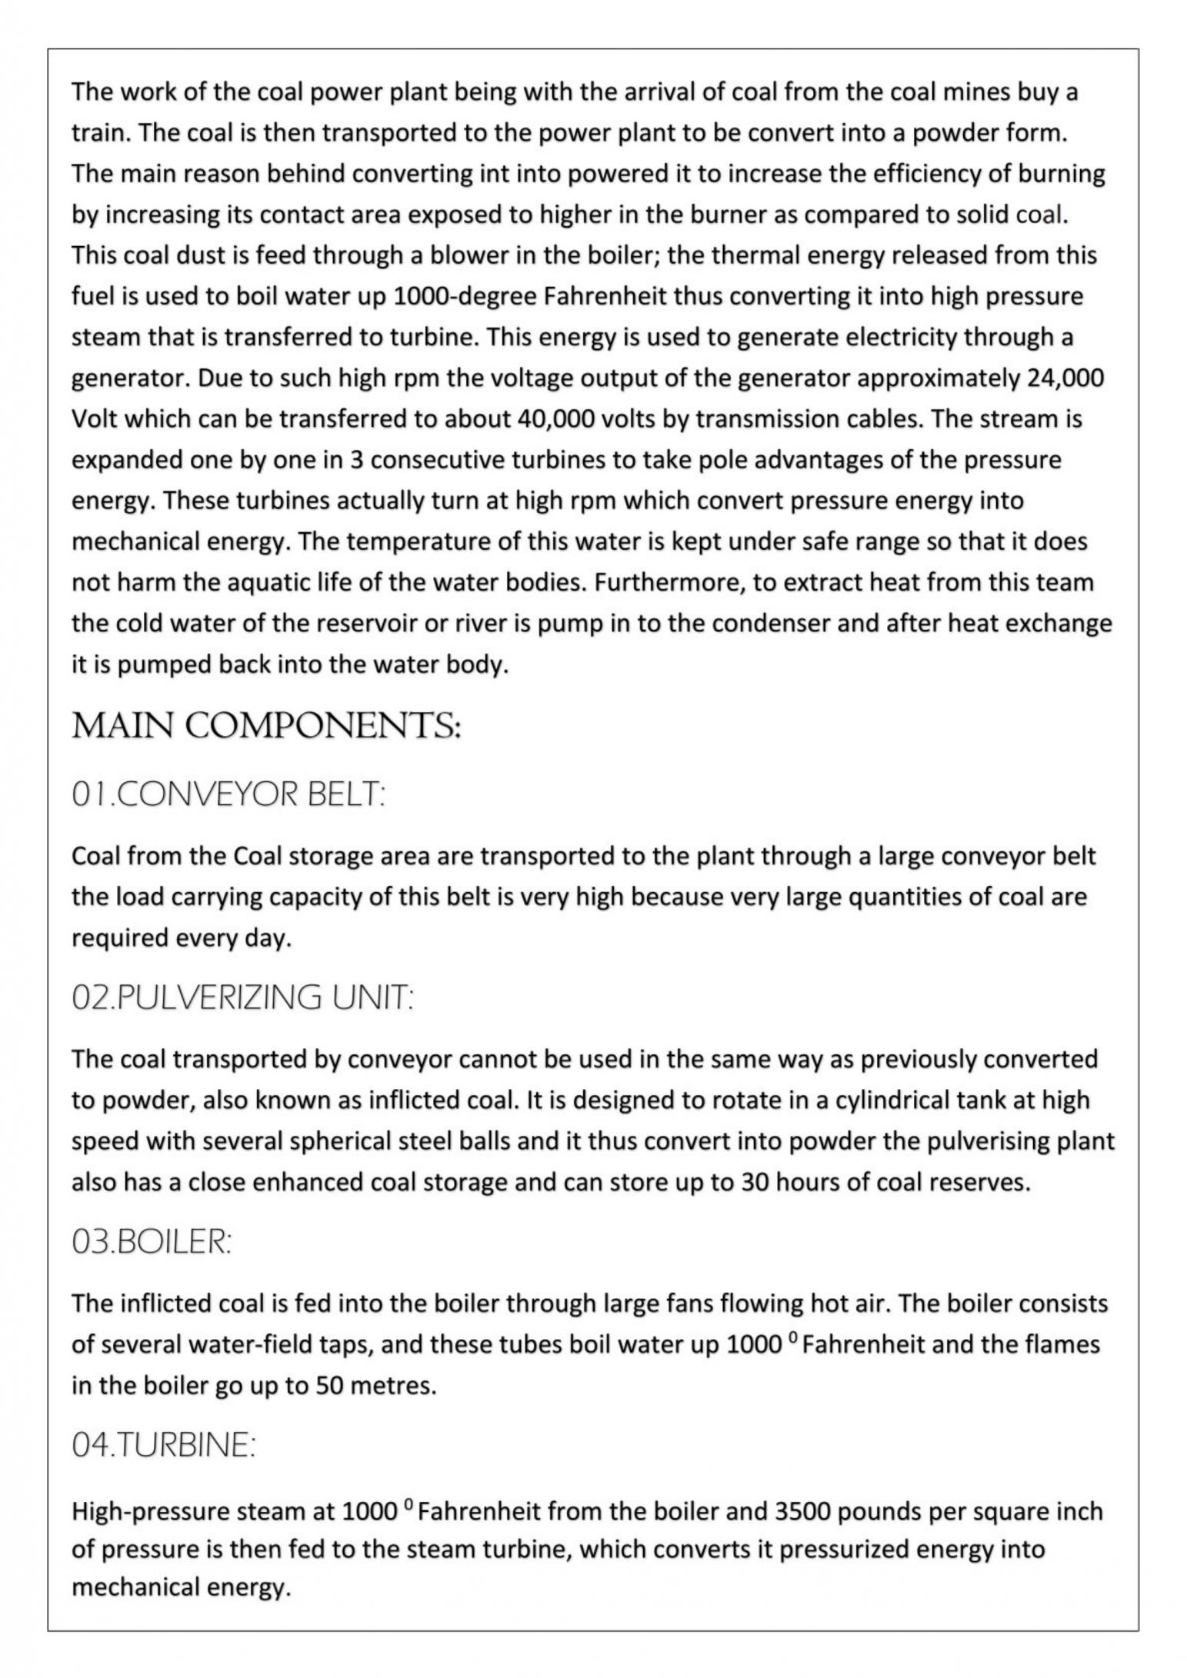
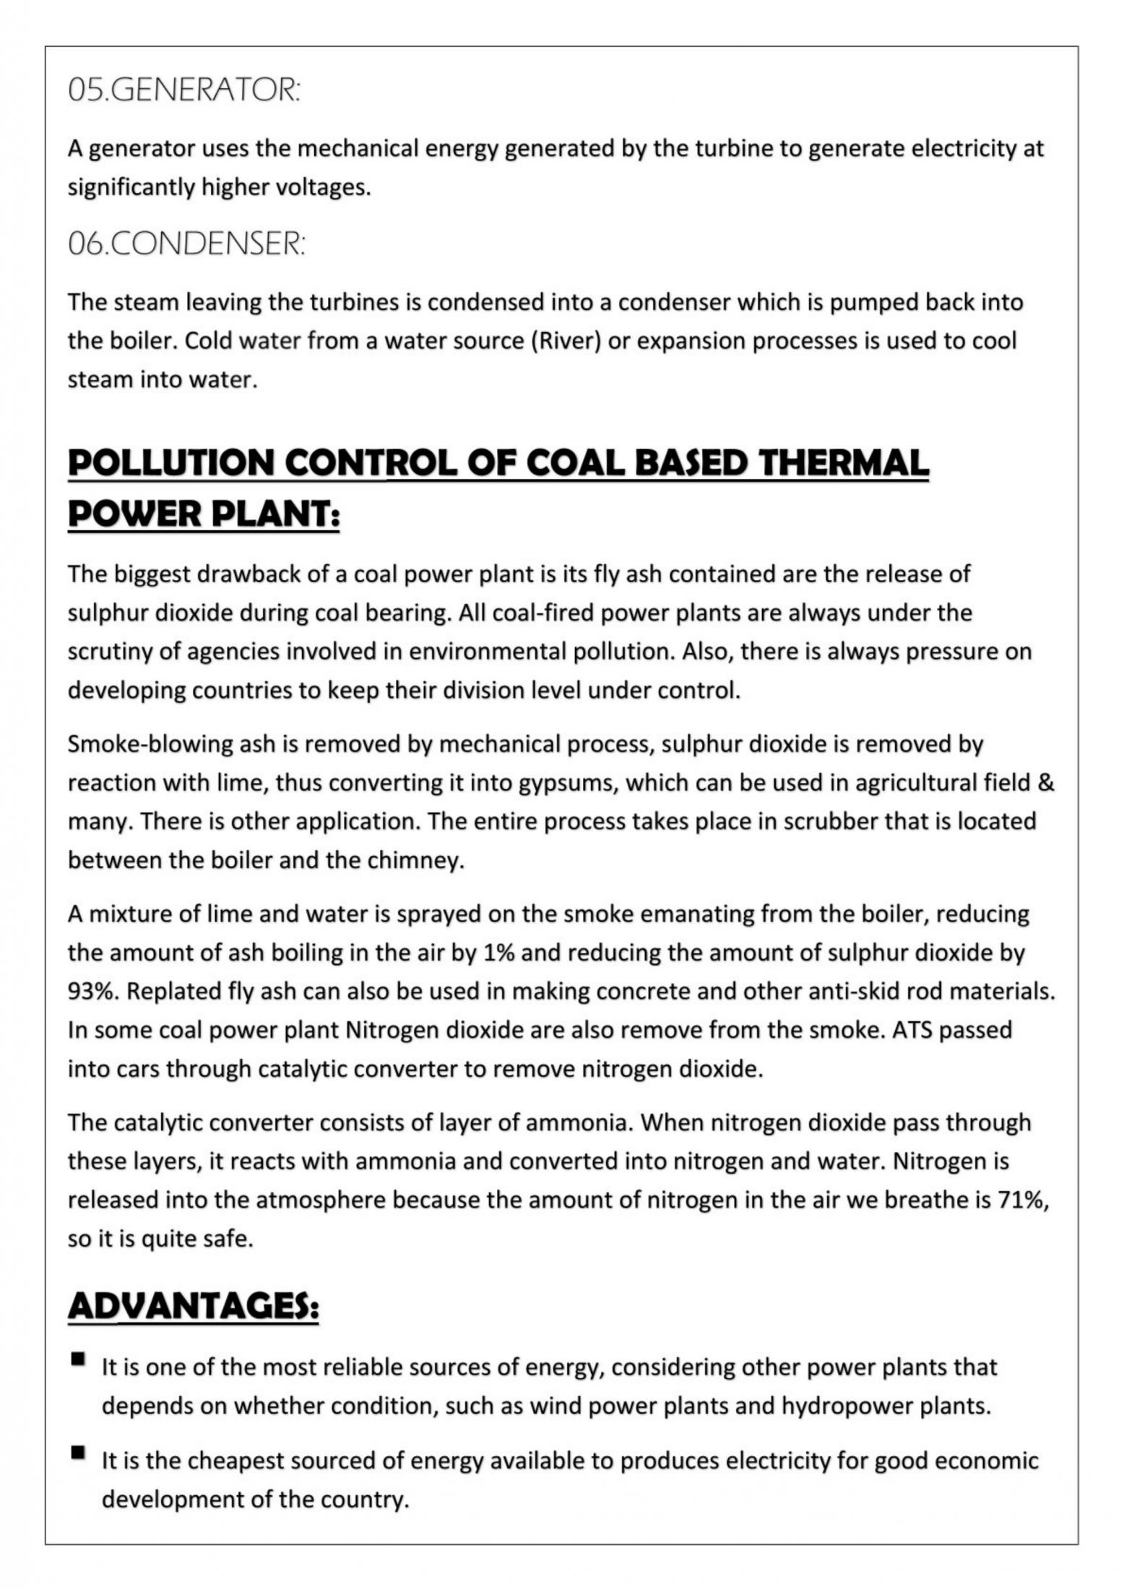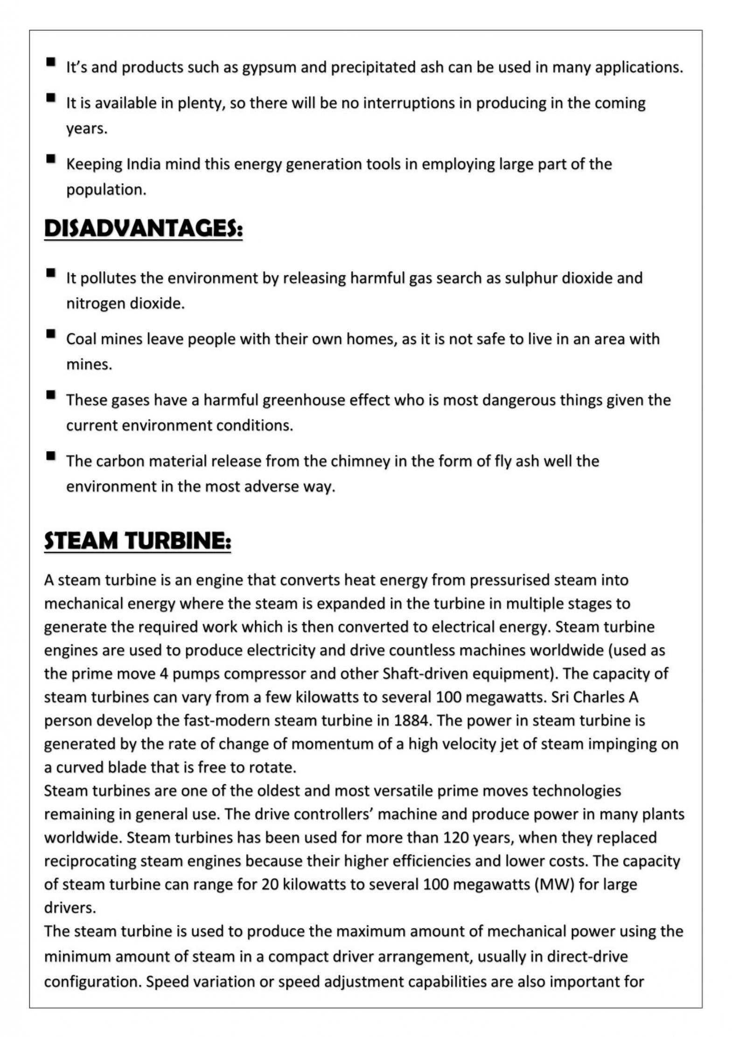

Role of IT DEPARTMENT:
The IT department of NTPC primarily has the responsibility of buying and supporting physical interlaces for the plant and providing connectivity to the entire NIPC campus by linking the various départements operating at its Kaniha project and it also connects the Kantha project with all its existing projects and with the SAP centre at NOIDA.
Initially, before the SAP centre was created. the communication department at Kantha was localized and catered to all the internal nodes of the Kaniha project. After the creation of the SAP centre at NOIDA, all the information has become centralized and the day-to-day operational records of all the plants are solely maintained by it. The communication with the SAP centre is supposed to be through VSAT communication, but considering a few technical hindrances and certain constraints imposed by the Government of India, the data transfer rate through VSAT communication is extremely slow (i.e. around 512 KBPS). Hence the IT department has taken a leased line from BSNL, which enables data transfer at 2MBPS, to connect the Kaniha plant to the SAP centre and to the other projects of NTPC.
The IT department at NTPC, Kaniha is a service-based department and their basic role is monitoring and informing the service provider in the case of any technical breakdown conceding the data communication process. They have 2 UNIX servers, one Windows server, one Oracle server and one GSM server, to collect the entire database from the various departments operating in the plant. They also maintain a regular backup of the entire collected database by using the RAID concept, where disks of size 24 GB were used to record the data and they were stored for future reference in the event of any technical breakdown. Recently they have acquired a device that can store up to 400 GB of data and hence minimizes the number of such 24 GB disks used. With the increased usage of PCs in the plant, the need for maintaining them on a regular basis was felt; hence they were given this additional responsibility of maintaining all the PCs being used in the plant, this also included maintaining a stock and servicing of the computer peripherals.

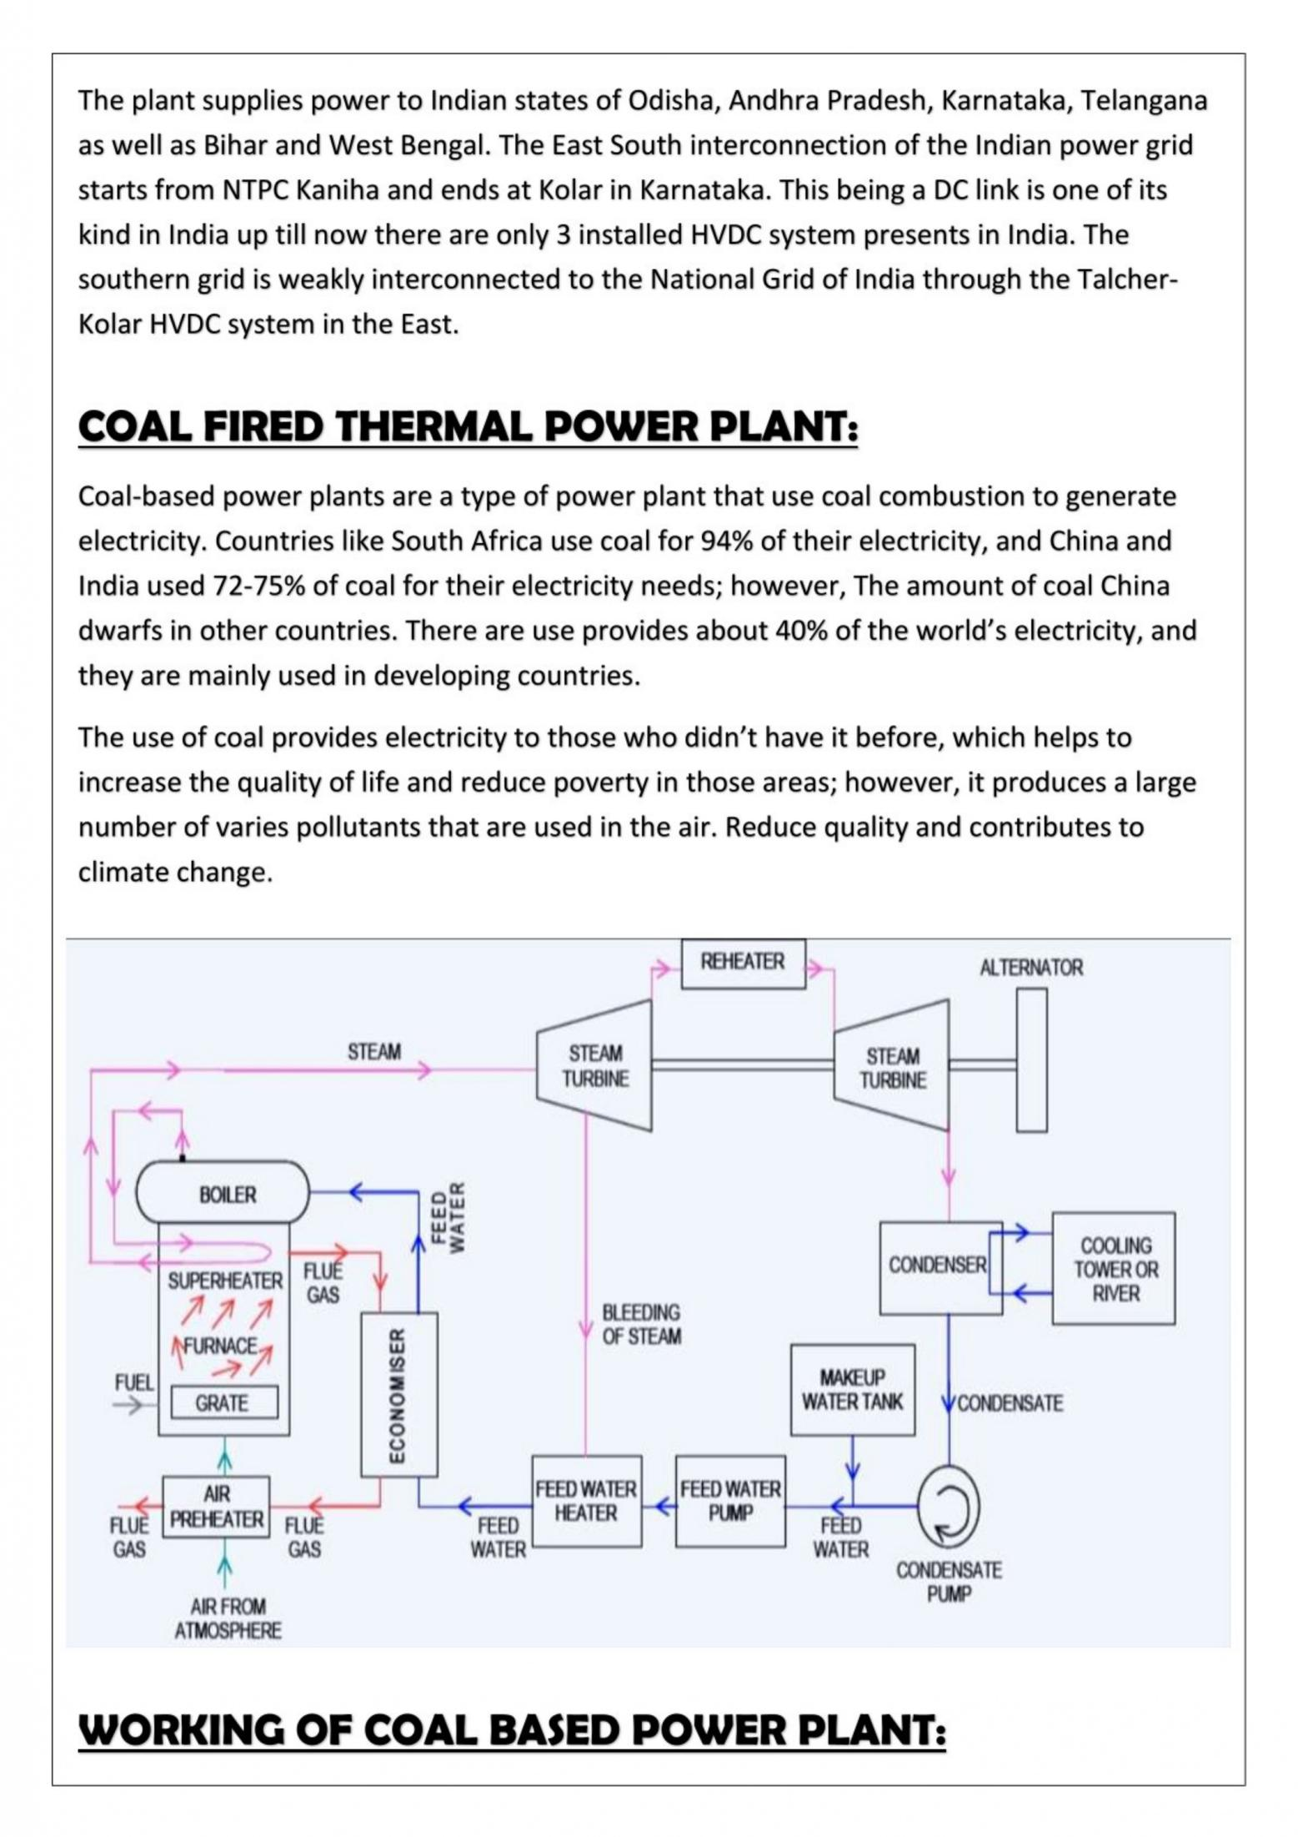
Conclusion

The industrial study at NTPC Kaniha provided valuable practical knowledge about the generation of electrical power in a thermal power plant.
During the study, the working and importance of major sections such as the Coal Handling Plant, boiler, turbine, generator, condenser, cooling system, DM plant, ash handling plant and switchyard were understood in detail.
The visit also provided practical exposure to important electrical equipment and plant operations. During the training, the generator, exciter system, transformers and control rooms were observed and studied. The visit helped in understanding how different sections of the plant are monitored, controlled and coordinated for efficient and reliable power generation.
Overall, the training enhanced practical understanding of thermal power generation and its importance in meeting the growing energy demands of the country.

