A report on Design and implement of electronic frills using shift resisters//counters

Project Submitted By
Name |  | Reg. No. | Roll Number
K.Thavasrinithi |  | 12408278 | 05
Pavan kumar siddanthapu |  | 12408713 | 06
Anubhav Savita |  | 12408839 | 07
Deepak Kumar Mohapatra |  | 12408830 | 08
Section | E2402(G-1)

Programme :- Electronics and communication engineering
Course code :- ECE233
Course name :- Digital Logic Design Lab

Submitted To :- Dr. Gurleen Kaur Walia
Date of submission:- 01-05-2025

Introduction
This project, “Electronic Frills using Shift Registers and Counters,” demonstrates how digital logic components can be used to generate visually appealing LED patterns in a matrix format. This is achieved using basic digital ICs like the 555 timer and CD4017 Decade Counters to sequence a grid of LEDs.
Unlike traditional display drivers or microcontroller-based LED control, this design uses purely hardware logic to create animation-like effects across a 7×7 LED matrix. This not only showcases fundamental principles of clock generation, counting, and LED driving, but also serves as a decorative circuit for applications such as electronic decorations, moving signboards, or pattern generators.
The CD4017 counters receive clock pulses from a 555 timer configured in astable mode, resulting in sequential output signals. These outputs are wired to drive LED rows and columns in a pattern determined by the design logic.

Research Lab
We began the project by understanding how shift registers and counters work, especially ICs like CD4017 and the 555 timer. Online platforms and datasheets were used to gather information about the following:
- Clock generation using the 555 timer
- Sequential LED control using the CD4017 counter
- Designing and simulating circuits using Proteus
- LED matrix wiring for wave or chaser effects
We finalized the idea of using three CD4017 counters to control 49 LEDs in a 7×7 matrix, driven by a single clock source.

Work
Component List
Component | Specification/Value | Quantity
Timer IC - | 555 | 1
Decade Counter | - CD4017 | 3
LED - | 5mm Red | 49
Capacitor - | 100 µF | 1
Resistor - | 100 Ω | 1
Power Supply - | 12V Battery | 1
Breadboard | – | 2
Jumper Wires | – | Multiple

Module-1st (Lab-2nd)
Circuit Diagram Development
In the second lab session, we created the schematic in Proteus. The 555 timer was configured in astable mode to generate a continuous clock pulse. This clock pulse was fed into three cascaded CD4017 decade counters to create a wide sequential output across 30 output lines.
The CD4017 counters were wired in such a way that the outputs could drive different LED rows/columns, generating dynamic lighting patterns.
Key Activities:
- Placed and connected the 555 timer circuit.
- Configured three CD4017 ICs for extended sequencing.
- Laid out a 7×7 LED matrix using red LEDs.
- Verified power supply and signal flow in simulation.

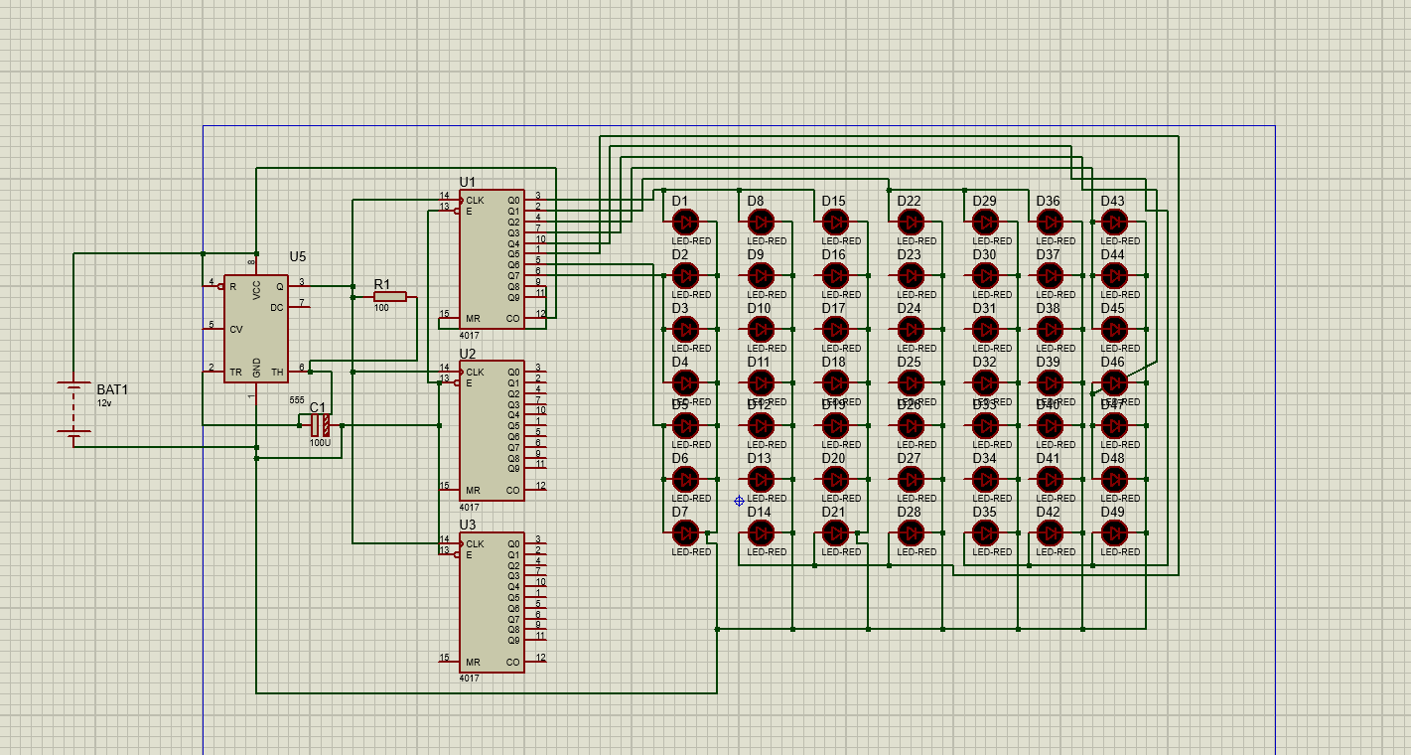
Module-2nd (Lab-3rd)
Simulation and Testing
The focus in Lab-3 was verifying simulation results and ensuring the LED patterns behaved as expected. We checked the sequencing output of the 4017 counters and confirmed that each LED row lit up in order.
Key Activities:
- Validated timing and pulse generation from the 555 timer.
- Ensured each LED received proper current and pulsed according to design.
- Fixed issues like short circuits and floating outputs.
- Modified capacitor values to control pulse speed.

Module-3rd (Lab-4th)
Hardware Implementation – Phase 1
We transferred the circuit from simulation to a physical breadboard setup. Components were placed, and wiring was done carefully to match the simulation layout.
Key Activities:
- Assembled 555 timer and counters on breadboard.
- Connected 49 LEDs in 7×7 layout with proper orientation.
- Used current-limiting resistors for LED protection.
- Adjusted pulse rate for visible light animation effects.

Module-4th (Lab-5th)
Hardware Completion and Final Testing
In this final phase, the complete hardware was tested thoroughly for performance, reliability, and pattern quality.
Key Activities:
- Verified correct sequencing of LEDs on the breadboard.
- Tuned clock frequency using capacitor and resistor values.
- Observed stable LED animation without flickering.
- Documented results and confirmed match with simulation.
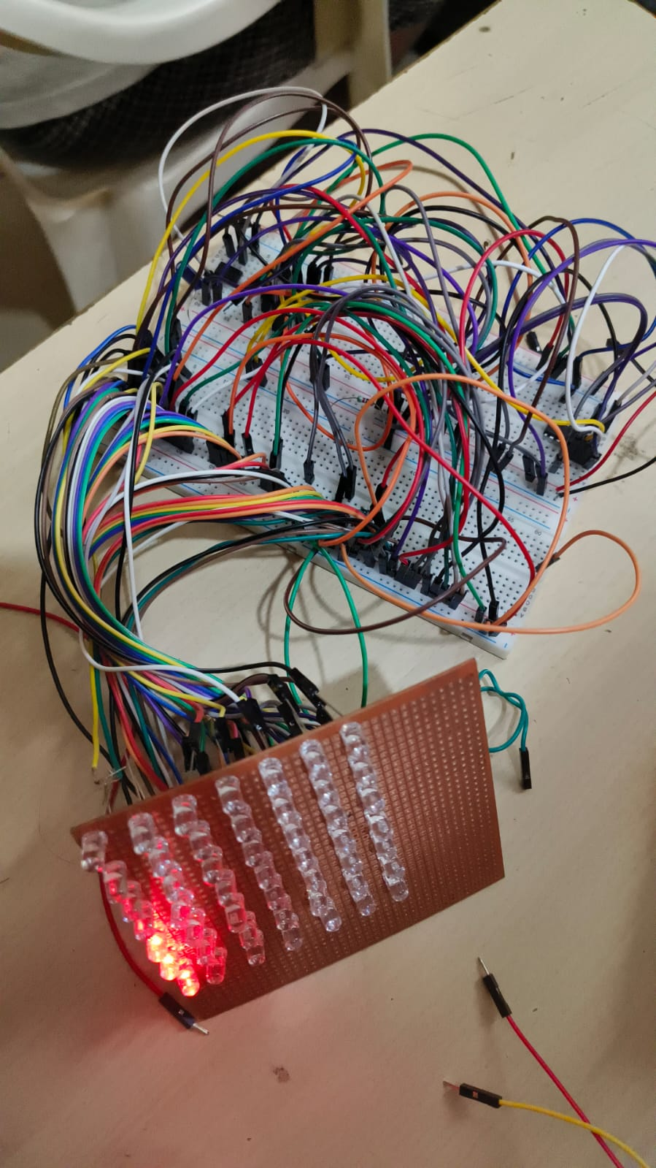

Advantages
- Simple Design – No microcontroller or complex programming required.
- Low Cost – Uses common and affordable ICs and components.
- Good for Learning – Helps understand pulse generation, sequencing, and digital logic.
- Attractive Output – Eye-catching LED patterns make it ideal for decoration.
- Scalable – More LEDs or counters can be added for bigger effects.

Conclusion
The “Electronic Frills using Shift Registers/Counters” project successfully demonstrated the use of a 555 timer and CD4017 counters to create animated LED effects. The circuit's simplicity and visual appeal make it a great educational and decorative tool. Both simulation and hardware tests confirmed the effectiveness of the design in creating sequential lighting effects without programming.

Applications
- Decorative Lighting Systems – Diwali lights, stage decorations, etc.
- LED Signboards – Moving lights for advertisements.
- Educational Kits – For teaching basic digital electronics.
- Timing and Sequence Control – In logic-based automation systems.
- Art Installations – Tech-art using light and timing logic.

References
- Datasheet – CD4017 Decade Counter (Texas Instruments)
- Datasheet – 555 Timer IC (Texas Instruments)
- Proteus Design Suite – Circuit Simulation Software
- Practical Digital Logic lectures and lab experience

