Lack of Accuracy in Promoting the Acclaim of Cosmetic Brands on Online Social Media using Novel Nearness Algorithm Comparing Centrality Score Algorithm

Lack of Accuracy in Developing the Popularity of Cosmetic Brands on Online Social Media using Novel K Mode Algorithm Comparing Nearness Algorithm

Lack of Efficiency in Enhancing the Acceptance Rate of cosmetic brands on Online Social Media using Novel Centrality Score Algorithm Comparing Betweenness Centrality Algorithm

Lack of Accuracy in developing the Reputation of Cosmetic Brands on online social media using Novel Betweenness Centrality Algorithm Comparing K Mode Algorithm

Architecture:

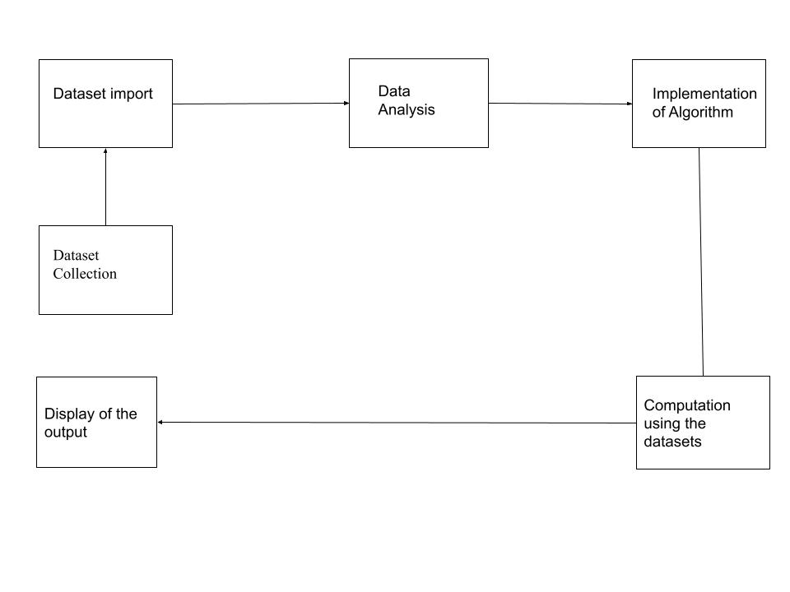

Modules for code:

Data Import:

The data from the dataset need to import in the matplotlib and the other dependencies should be given

Statistics:

From the representation of the data the values are getting analysed and displayed using the function df. head()

Data Exploratory analysis:

The data exploratory analysis is done with the help of the data visualization tool such as Gephi and SPSS tool.