BESTENLIST DAY 1 task

1.create GitHub account

GitHub Account link - [DeepakM2001 (github.com)](https://github.com/DeepakM2001)

2.create linkedin account

LinkedIn Account - [Deepak M | LinkedIn](https://www.linkedin.com/in/deepak-murugesan-2001/)

[3.download](http://3.download/) python ide -

Installed spyder IDE

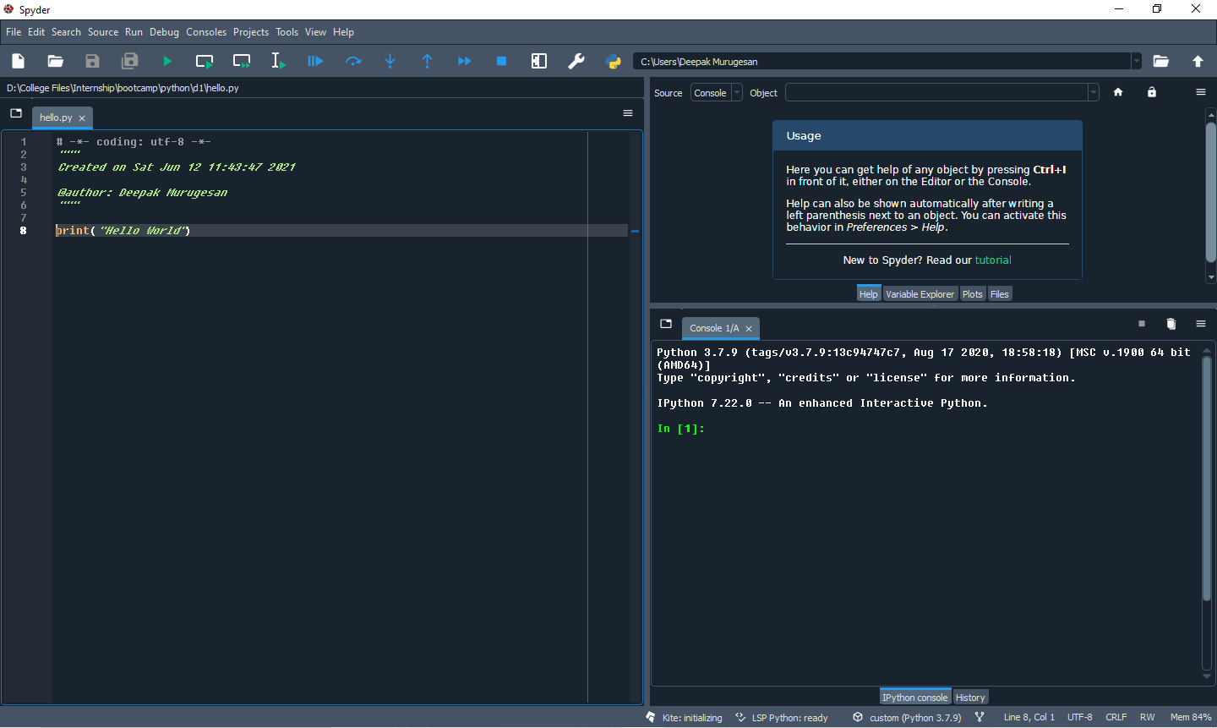

4.practice basic program today what we have seen (addition, maximum etc)

Maximum program:

# -*- coding: utf-8 -*-

"""

Created on Sat Jun 12 19:12:27 2021

@author: Deepak Murugesan

"""

number1 = 152

number2 = 142

maximum =max(number1,number2)

print(maximum)

Output:

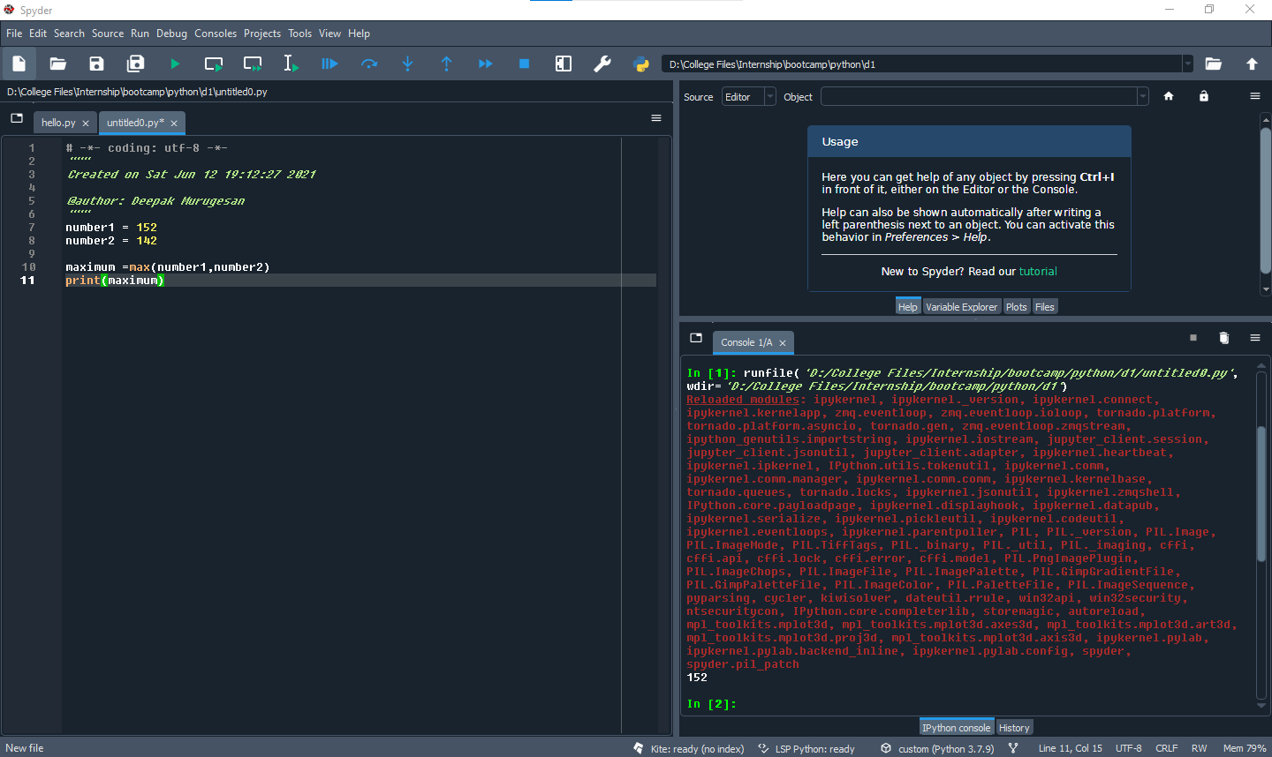

addition program:

# -*- coding: utf-8 -*-

"""

Created on Sat Jun 12 19:19:33 2021

@author: Deepak Murugesan

"""

num1 = int(input("Enter the value of the number1:"))

num2 = int(input("Enter the value of the number2:"))

sum = num1 + num2

print("the sum is :",sum)

Output:

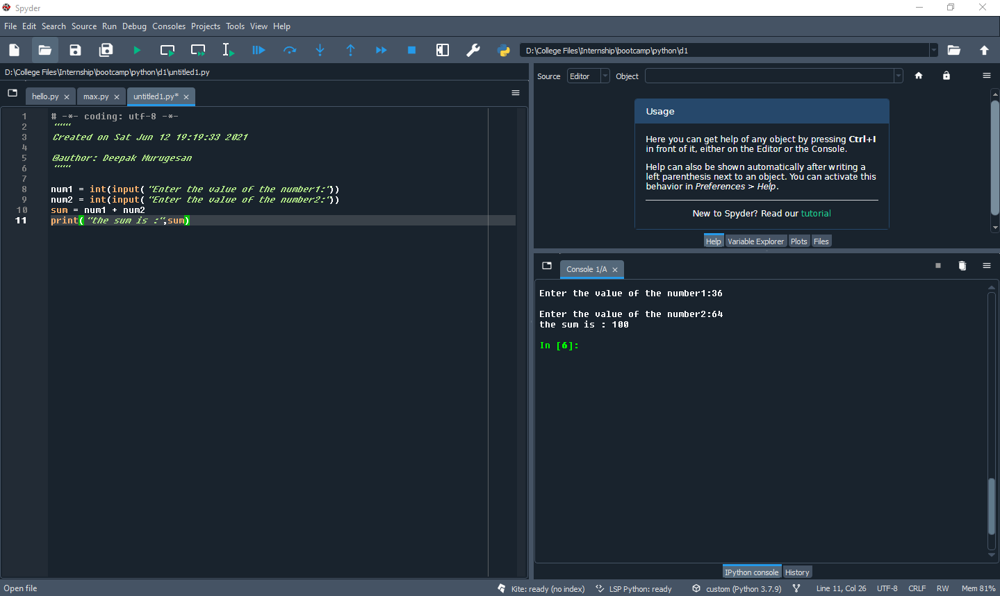

Factorial Program:

# -*- coding: utf-8 -*-

"""

Created on Sat Jun 12 19:29:59 2021

@author: Deepak Murugesan

"""

import math

def fact(n):

return(math.factorial(n))

num = int(input("Enter the number:"))

input = fact(num)

print("Factorial of", num, "is: ",input)

Output:

