# Analysis:

## 2.1 – Introduction

Analysis is the starting phase of the project lifecycle. It is the process used to gather the requirement for the system by asking to the user what should be include in the system. It helps to examine the information needs of end-user and enhances the system goals. This phase is used in this project is to find the actual problem occur on the dog care and pet shop center and find the solution to such problems.

The main phase which provides the complete requirements of the system is Analysis. Without this phase the system cannot be develop properly and also the requirement which the end-user want cannot be fulfill on the system. I choose waterfall model because It is simple and easy to understand and use. Analysis phase helps to determine whether to build the project or not.

## 2.2 – Analysis Methodology

Methodology helps to provide some guideline how the work can be develop in efficient and proper way. There are available of different types of methodology i.e. Hard, Soft and Combine. As this project is going to be develop for the needs of the people, I choose for Soft System Methodology. By using this methodology, there should be more focus on the people’s view than technical view. It is useful for dealing with the problems in complex and human situations.

**Advantages:**

* It helps to clarify the problem areas in a system.
* It considers the human factors in an organization.
* It provides the overview of the system.

The steps to be follow while applying SSM are:

* Analyze and create a rich picture.
* Characterize root definition of the important parts of the information system.
* Create a conceptual models of the system.
* Differentiate the concept of a new system and the old system.
* Define & choose the feasible options for development.
* Implement the new system.

1. **Rich Picture:**

Rich picture is a strategy of Soft System Methodology which illustrate the main element and the relationship related to the system that need to be considered in order to make improvement. It helps to understand the complexity of an entire situation. It helps to clear discussion of the entire situation in a board and shared the understanding of a situation. Rich picture consists of pictures, text and the symbols. And also defines the richness and complexity of a situation. It cannot be wrong in any situation.

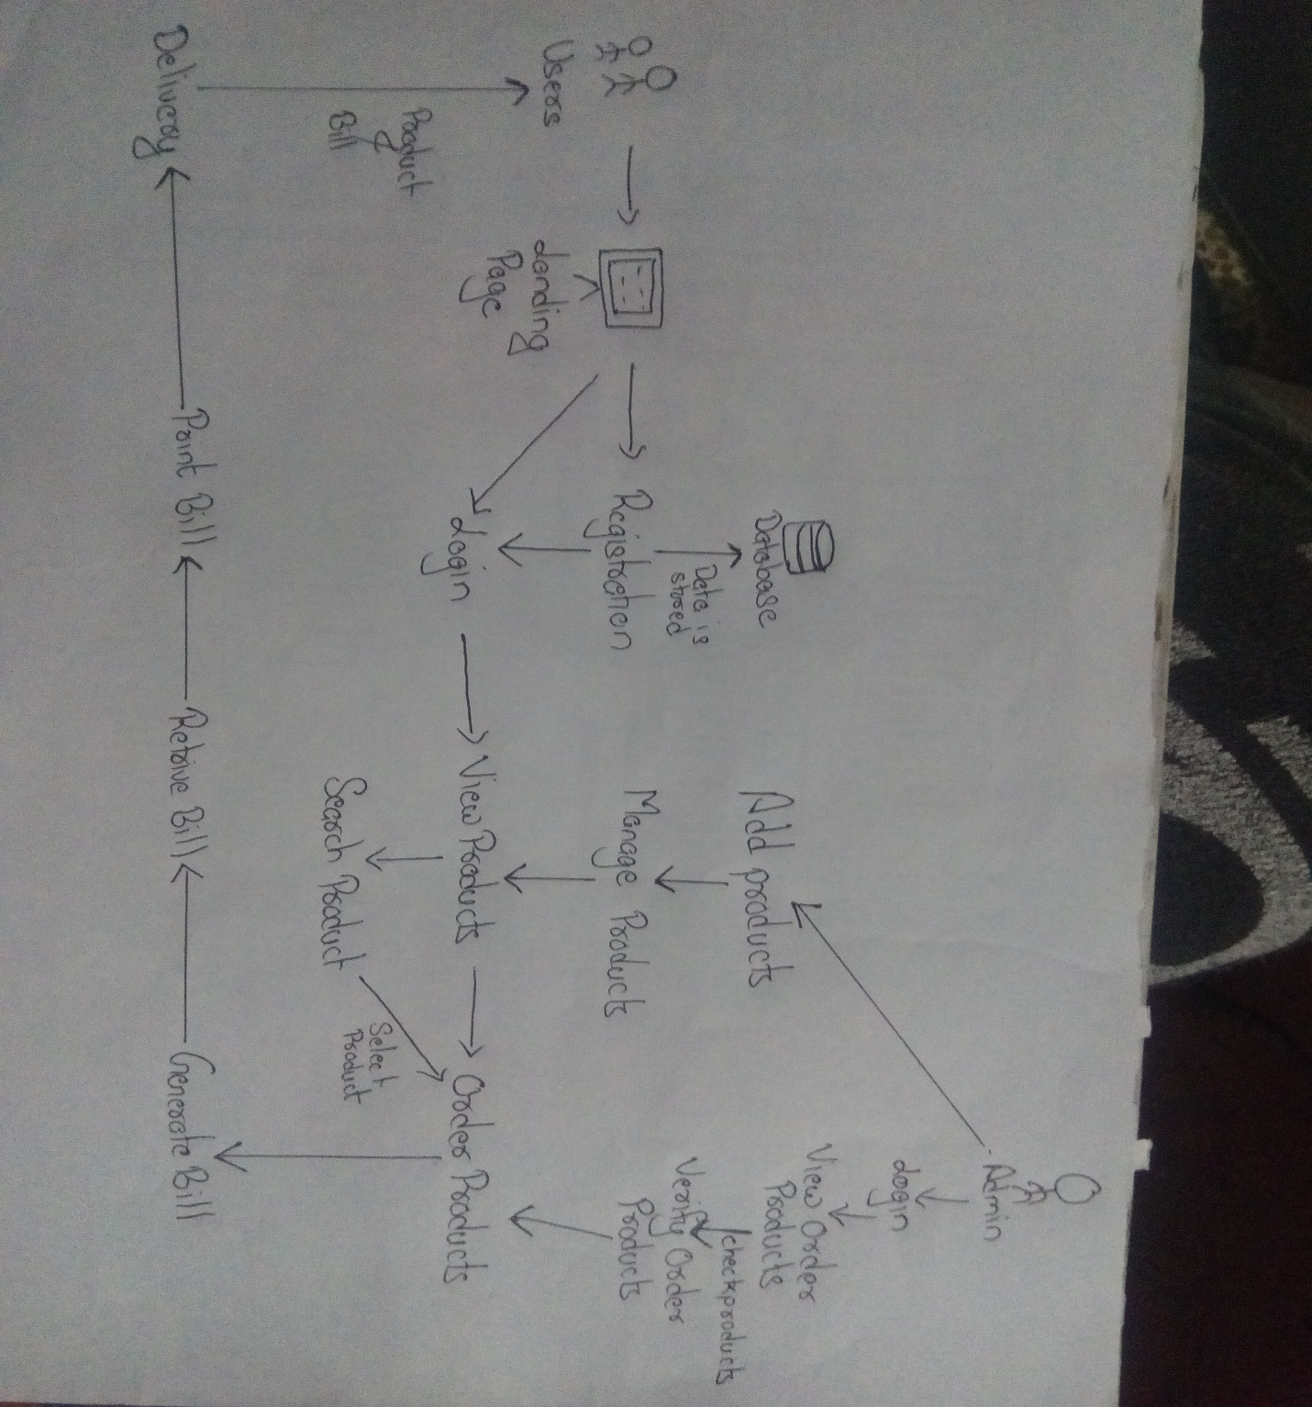

Figure : Rich Picture of "Street Dog Care and Pet Shop Center"

1. **Root Definition:**

Root Definition is the step of the SSM which helps to structure the description of the entire system. It clarifies the problem & the processes which are being held on the system. And also helps to describe the aims and the functions of the potential system which is to be develop.

**CATWOE:**

CATWOE is the methods of problem solving which asks to see the issues in a six different unique perspectives. This is an approach which provides the issues in a different way due which the issue can be easily be listed and understand.

CATWOE is described as follows:

* ***Customers/Clients***

Customer / Clients are the users and stakeholders to whom the system exists and who is the victims of the system output. Users is known as clients.

* ***Actors/Agents***

Actors/Agents is that person who perform the activities on the system. E.g. Admin manage the product details.

* ***Transformation***

Transformation is the process of bringing out the changes by the system. E.g. Customer search the products and system response to their request.

* ***World View***

Worldview refers to the process of what is going in and out the organization. The customer or user can order the products and also contact to the center from far places.

* ***Owners***

CATWOE helps to identify the owner of the system. Owner is a person who owns the problem in the system exist. Owner is mostly now as the admin of the system who has permission of change the data.

* ***Environment***

Environment is the important parts of the CATWOE under which the system works and which may harm or restrict the change of the system.

1. **Conceptual Model:**

Conceptual model is the representation of the systems model by the helps of the composition concept which makes people to understand and know the simulate of the model. It helps to represent the concept of the model. This types of model are constructed with the help of Rich picture and the root definition.

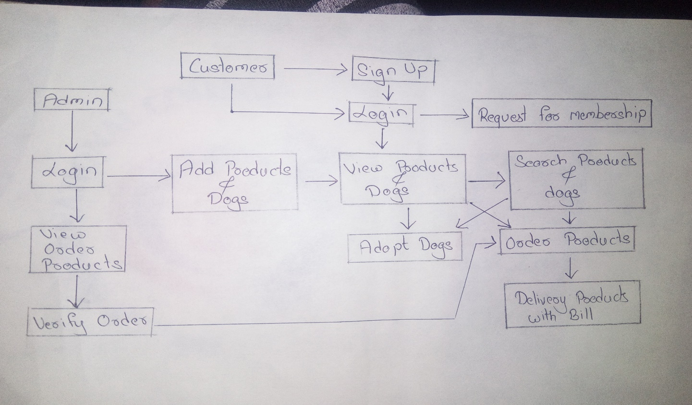

Figure : Conceptual Model of "Street Dog Care and Pet Shop Center"

## 2.3 – Feasibility Study

Feasibility study is the process in which the system analyst used to analyze whether software meet the organization requirement. It helps to determine the positive and negative outcomes of the project. After the complete of the feasibility study it provides whether the system should be implement or not.

The key steps for the different types of studies are:

1. **Technical Feasibility:**

Technical Feasibility mainly focuses on the technical assets that are available in an organization and helps to identify the resources are maintainable & profitable for the project. Technical assets like database, server, web domain are needed for the user and admin to record the data and access to the web domain.

1. **Economic Feasibility:**

Economic Feasibility focuses on the viable cost and benefits associated with the project. It directly involves on the cost / benefits analysis of the project. It helps to determine the economic benefits to the organization. For this project, the cost for the project is limited estimate. For this web application project, the domain name has affordable to have it. The assets related to the customer are also the order part.

1. **Operational Feasibility:**

Operational Feasibility undertake the study to analyse and determine whether and how effectively an organization needs can be met by completing the project. There is no risk while operating large number won’t be active at a same time.

1. **Schedule Feasibility:**

Schedule feasibility refers to the check of the project complete within a time or not. It helps to deliver the product in a time. For my project, Gantt Chart and Time estimation is created with the limited time in a chunk of the task and their task.

1. **Legal Feasibility:**

Legal Feasibility is carried out to check whether the proposed task conflicts with the legal rules / regulations. This types of study helps to analyze the legal issues which may affect the task.

## 2.4 – Requirement Analysis

Requirement analysis is the process which helps to find out the user expectation to build a new system or modify. It mostly focuses on the user expectation which must be include on the system. It involves communication with the system user to collect the all necessary requirements which is to be implement on the system.

### 2.4.1 – Functional Requirements

Functional requirement are the feature or function of the system which must be implement to enable the user to accomplish their works. It describes the system behavior under specific conditions. It must be clear for both development team and the users.

|  |  |  |  |  |
| --- | --- | --- | --- | --- |
| **F.R S.No** | **Functional Requirement** | **Description** | **Rational** | **Dependencies** |
| F.R 1 | Registration | Helps to register user details. | To register user details. |  |
| F.R 2 | Login | User should provide correct username/email and password for login to the system | To get authorized access to the system. | F.R 1 |
| F.R 3 | Add products | New products can be added. | To provide detail information about the product | F.R 2 |
| F.R 4 | Update products | The products details can be update. | To provide the correct information about the products. | F.R 2, F.R 3 |
| F.R 5 | Delete products | Out of stock or unavailable products can be delete. | To delete the unavailable product. | F.R 2, F.R 3 |
| F.R 6 | View products | User can view detail information about the products. | To know about the products in detail. | F.R 2, F.R 3, F.R 4, F.R 5 |
| F.R 7 | Order products | User can be able to order the product | To view the order product. | F.R 2, F.R 6 |
| F.R 8 | Search products | Product can be filter as the user wants. | Easy to search the product. | F.R 3 |
| F.R 9 | Retrieve bought products | User can see which product they have bought before. | Detail view of the product bought. | F.R 2, F.R 3, F.R 6 |
| F.R 10 | Generate bill | User can create a bill of they bought product. | Helps to list the bought items with their price. | F.R 7 |
| F.R 11 | Retrieve bill | User will get the final bill of the item they bought. | To finalized the item bill. | F.R 7, F.R 10 |
| F.R 12 | Print bill | User will able to print the bill. | To print the bill of the bought item. | F.R 10, F.R 11 |
| F.R 13 | Post Queries | User would be able to post the queries | To post the query about the product. | F.R 2, F.R 6, F.R 7 |
| F.R 14 | Post Comments | Other user can be able to reply to the queries. | To response to the users questions. | F.R 2, F.R 13 |
| F.R 15 | Delete post | The posted user should be able to delete the post. | To delete the post. | F.R 2, F.R 13, F.R 14 |
| F.R 16 | Request for a membership | Interested user can be able to request for the membership. | To request for the membership. | F.R 1, F.R 2 |
| F.R 17 | Update user profile | User can update their profile as they wants. | To update the user details. | F.R 1, F.R 2 |
| F.R 18 | Change Password | User should be able to change their authenticate password. | To change old password to new ones. | F.R 1, F.R 2 |
| F.R 19 | Automatic Delete User | User account will be delete automatically after the no active for 1years. | To delete the account for no active for 1 years. | F.R 1, F.R 2 |
| F.R 20 | Adopt Dog | User can able to adopt dogs from different places. | Helps to adopt dog for dog lover. | F.R 1, F.R 2 |
| F.R 21 | Logout | Log Out | Logout the user from the system. | F.R 2 |

### 2.4.2 – Non-Functional Requirements

Non-functional requirements describe how the system must behave and develop constraints of its functionality. It mostly specifies the systems quality characteristics. Testing is done to check how the system is working.

|  |  |  |  |  |
| --- | --- | --- | --- | --- |
| **N.F.R S.N** | **Non-Functional Requirement** | **Description** | **Rational** | **Dependencies** |
| N.F.R 1 | Security | The data on the system should be encrypted. | The high security measures should be manage. | F.R 1, F.R 2, F.R 20 |
| N.F.R 2 | 24X7 availability | System service must be 24X7 available so that user may be able to interact. | Provide 24X7 service to the user. | N/A |
| N.F.R 3 | Performance | System should be fast and run without any bugs | To run system completely. | N/A |
| N.F.R 4 | Portability | The system must be able to get access through any devices and any places. | Must not be depend on the single device. | N/A |
| N.F.R 5 | Reliability | System should provide accurate service | Reliable service. | F.R 3, F.R 4, F.R 5, F.R 6, F.R 7 |
| N.F.R 6 | Usability | System should be easy and understand to use. | Use of system should be easy. | F.R 3, F.R 4, F.R 5, F.R 6, F.R 7 |
| N.F.R 7 | Data Integrity | The data should have their originality. | Unauthorized access to the data should be restricted. | F.R 1, F.R 2 |
| N.F.R 8 | Implementation | Testing should be done to check the system is correct. | To make sure that the system is perfect to work. | N/A |
| N.F.R 9 | Scalability | System should be adequate to any change | Capacity to adequate | N/A |
| N.F.R 10 | Response Quickly | System should response to the user input | Give fast service | N/A |

### 2.4.3 – Moscow Prioritization

MoSCoW Prioritization is the prioritization process which helps to manage the requirement. It helps to determine which types of requirement is most needed to be implement on the system. This types of prioritization process help to decrease the risk of giving more time for the less priority requirement.

Importance of is prioritization:

* Helps to identify which requirement is most important and provide more time and efficient work for it.
* It is easiest way of requirement prioritization.

MoSCoW method is popularized by the DSDM community. Its easiest way to understand and manage the priorities. The MoSCoW stands for:

* M – Must Have: System must have this.
* S – Should Have: System should have this if at possible.
* C – Could Have: System could have this if it does not affect anything else.
* W – Won’t Have: System won’t have this time but would be added on the future.

Therefore, double “o” doesn’t have meaning. It is used to make pronounceable.

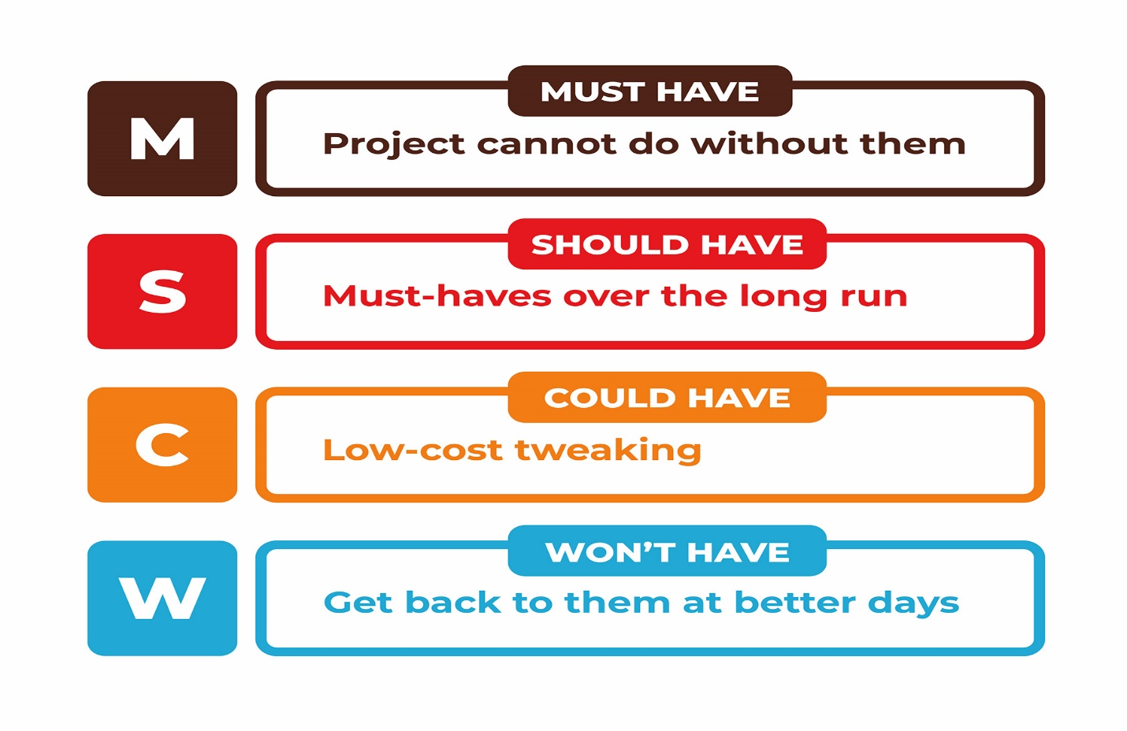

Figure : MoSCoW

**Functional Requirements MoSCoW Prioritization:**

|  |  |  |
| --- | --- | --- |
| **F.R S.No** | **Title** | **MoSCoW** |
| F.R 1 | Registration | Must Have |
| F.R 2 | Login | Must Have |
| F.R 3 | Add products | Must Have |
| F.R 4 | Update products | Must Have |
| F.R 5 | Delete products | Must Have |
| F.R 6 | View products | Must Have |
| F.R 7 | Order products | Must Have |
| F.R 8 | Search products | Should Have |
| F.R 9 | Retrieve bought products | Must Have |
| F.R 10 | Generate bill | Should Have |
| F.R 11 | Retrieve bill | Should Have |
| F.R 12 | Print bill | Should Have |
| F.R 13 | Post Queries | Must Have |
| F.R 14 | Post Comments | Must Have |
| F.R 15 | Delete post | Must Have |
| F.R 16 | Request for a membership | Should Have |
| F.R 17 | Update user profile | Should Have |
| F.R 18 | Change Password | Could Have |
| F.R 19 | Automatic Delete User | Could Have |
| F.R 20 | Adopt Dog | Must Have |
| F.R 21 | Logout | Must Have |

**Non-Functional Requirements MoSCoW Prioritization:**

|  |  |  |
| --- | --- | --- |
| **N.F.R S.No** | **Title** | **MoSCoW** |
| N.F.R 1 | Security | Should Have |
| N.F.R 2 | 24X7 availability | Won’t Have |
| N.F.R 3 | Performance | Must Have |
| N.F.R 4 | Portability | Must Have |
| N.F.R 5 | Reliability | Must Have |
| N.F.R 6 | Usability | Should Have |
| N.F.R 7 | Data Integrity | Should Have |
| N.F.R 8 | Implementation | Should Have |
| N.F.R 9 | Scalability | Could Have |
| N.F.R 10 | Response Quickly | Could Have |

### 2.4.4 – System Requirement Specification

The description of the computer components is known as hardware specifications. Hardware requirement consists of the processor, display size, graphics card, etc. The hardware and the software requirement for the web applications are given below:

**Hardware:**

* **Processor:** Minimum 2 GHz
* **RAM:** Minimum 2 GB
* **Hard Disk:** Minimum 10GB

**Software:**

* **OS:** Windows XP, Windows 7 and above.
* **Database:** MySQL
* **Browser:** Google Chrome, Mozilla Firefox.

## 2.5 – Use Case Diagram

Use case diagram is the graphical representation of external user interaction to the elements of a system to attain particular goals. It helps to identify, organize and clarify the system requirement. It shows the relationship between the user and the system.

* Advantages:
* It helps to clarify the functional requirement.
* It is easy to understand and draw.
* It represents whole system into a single diagram.
* Disadvantage:
* It cannot capture non-functional requirements.
* Structure and flow are poorly identified.
* The design is not in systematic.

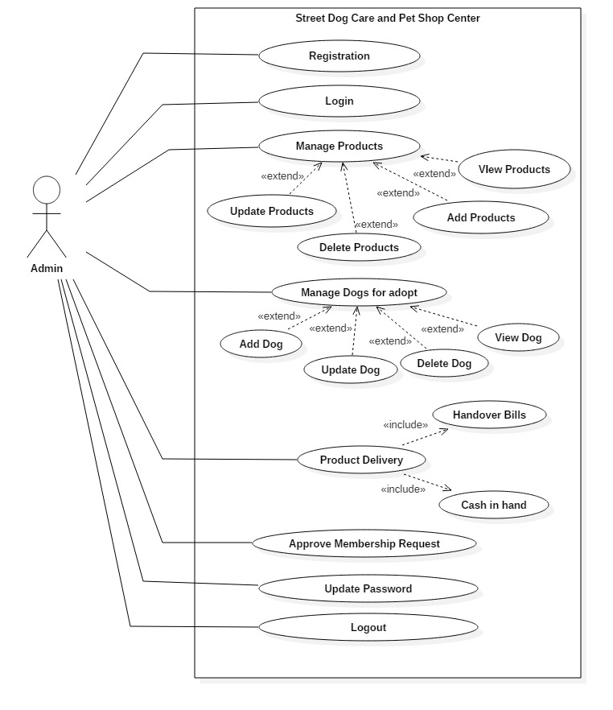

Figure : Use Case Diagram of Admin

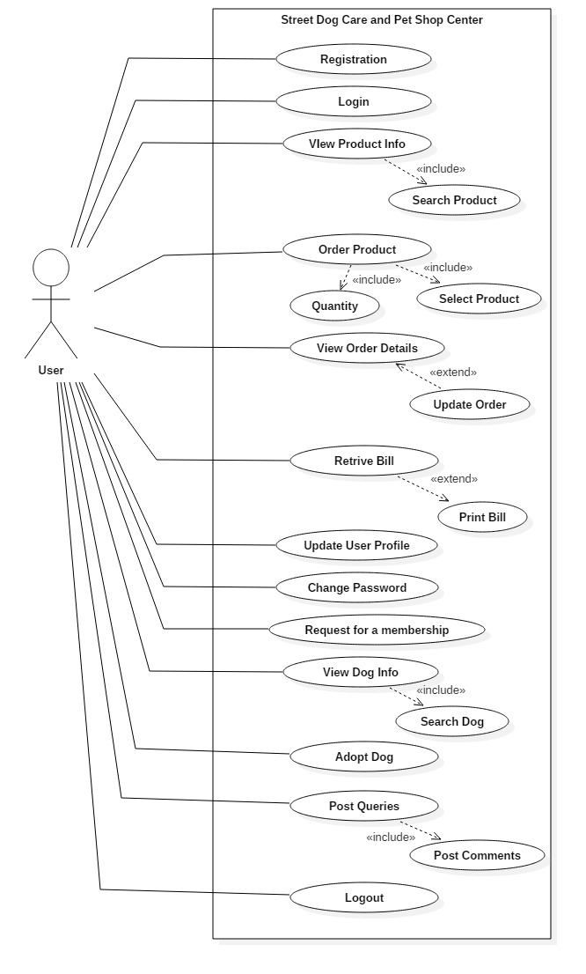

Figure : Use Case Diagram of User

The above use case diagram describes the following information:

* Street Dog Care and Pet Shop Center is the name of the system which can be used by the two user admin and the customer. The system includes the view of the pet products and the dogs which can be an adopt by the pet lovers. Customer can able to view the products and dogs but they have to login for the other processes i.e. buy products, adopt dog, etc. They can also post queries and comment on the product. They can also logout from the system.
* Admin plays a vital role in this system. They have a permission to add, delete, update and view the detail information of the system and also they can get access to the whole system. Admin also approve the membership request from the user for the care of street dog.
* User are mostly two types: Registered and Unregistered.

**Registered user:** They can get access to the system and order the products, update their profile, request for the street dog care membership, and view their ordered products. If they don’t want to get access for a short time they can logout from the system.

**Unregistered User:** They can view the products and the dogs which can be an adopt by the pet lover. They can able to view whole system but cannot get access to the system for other process.

## 2.6 – NLA & Initial Class Diagram

* **NLA:**

Natural Language Analysis is the steps which is to be followed for identify and analyze the candidate class, methods and the attributes for the scenario with the help of noun, verbs and adjectives. Firstly, identify nouns by removing duplicate, and inappropriate candidates.

**“Street Dog Care and Pet Shop Center”** is located at Teku, Kathmandu which aim is to care a street dog with who is suffering from different disease and also the products related to the pet can be order by using the application from any places through online. The administrator can add, update, delete and view the products details and the dogs which can be adopt by the dog lovers. And also the membership request for the street dog can be approved by the admin as their bio data. Customer can create account and login with their email and password to get access to the system. If the user is created they can update their profile, change password, view products and dog to be adopt, order the products, adopt dogs. Admin can view the customer’s details and also the order details by the customer’s. Customer can search, view and order the product which they want. Customer can view the ordered product by them before, total price of the product, and update the order made by them. As the order product by the customer, Admin can view and verify the products. Then the bills of the product will be creating and deliver. Customer can create a question and other user can reply the comment to the questions. People who wants to be the member of the street dog care then they can register their account and request for the membership.

By using this application, people from different places can adopt the homeless dogs. And also buy the products related to the pets. If anyone who wants donate the funds they can easily get the bank information from the application and then deposit to the bank account.

|  |  |  |
| --- | --- | --- |
| **Nouns** | **Adjectives** | **Verbs** |
| Registration, Login, Account, Customer, Product, Shop, User, Order, Admin, Member, Dog, System | Username, Password, Email, Queries, Comments, Membership | Add, Update, Delete, Search, View, adopt, Calculate, |

**Candidate Class:**

|  |  |
| --- | --- |
| **Candidate Class** | **Reasons** |
| Admin | * Admin add, update, delete and view the pet product and the dogs that can be adopt. * Admin can verify the order of the products. * Admin can approve or reject the membership request for street dog care. * Admin can manage user’s profile. |
| User | User can view the product and order/buy it through online, update profile, view ordered product details, post queries, post comments. |
| Product | It functions like add, update, delete products derails. |
| Dogs | It functions like add, update, delete dog details and adopt dog. |
| Order | Date, quantity, total amount of the products are include. |
| Member | User can send their documents and their bio for the membership of street dog care including full name, email etc. |

**Operations:**

Add, Update, Delete, Search, View and Calculate.

* **Initial Class Diagram:**

Initial Class Diagram is a type of static structure diagram which represents the structure of the system with their class, attributes and operations. It is a set of class and the relationships between the classes. It helps to model the object oriented system and create a relationship between the classes. Access modifier like Public (+) and Private (-) is used for access level control of classes.

At the process of NLA, class, attributes and operations for the system is filtered. The listed classes, attributes and operations are illustrate in the class diagram. The initial class diagram for “Street Dog Care and Pet Shop Center” is shown below:

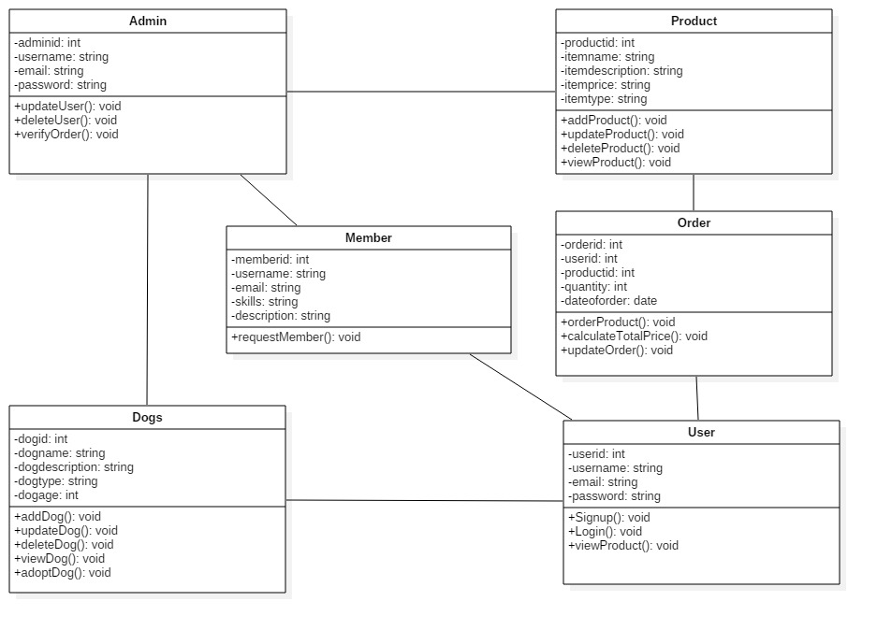

Figure : Initial Class Diagram of "Street Dog Care and Pet Shop Center"