**We firmly believe in Rocky Balboa’s mantra – “One step at a time. One punch at a time. One round at a time”.**

**Round One consists of 10 steps. To help you formulate and protect your invention, we would want you to complete the below 10 steps, not by ducking the questions, but by getting on the offensive and giving solid answers, so that you can go proceed to the next rounds i.e. of Drafting and Prosecution.**

**3…... 2…… 1…… Go**!

**Step 1. About the Invention**

**1.1. How would you describe your invention if you had only one phrase?**

**Hint:** This will be the title of your invention. Titles can be long, but we recommend keeping it short and to the point. A title that is a paragraph is boring and is not what people expect to see, isn’t it?

**Example Answers:**

* Reclinable Chair with multiple adjustments
* Blockchain based currency exchange platform
* User activity based recommendation engine
* Frictionless ball bearings with lubrication
* Method of Treatment of Cancer using EGFR
* Method of Preparation of luminous liquid

**Your Answer:**

**Decentralized real-time on-road smart contract system for vehicle movement negotiation.**

**1.2. What category do you think your invention belongs to?**

Choose among these:

1. Product 2. Process/Method 3. Product and Process

4. Software 5. Software and System

**Answer:**

5. Software and System

(I see some elements of “2. Process/Method” as well)

**1.3. What technical fields do you think your invention falls in?**

**Hint:** This answer will help us categorize the idea/invention. It could be a software program based on AI or a Chemical molecule, or a mechanical device used in automotive. Be as specific as possible. Also, it could be categorized under multiple technical fields too.

**Example Answers:**

* Reclinable Chair with multiple adjustments - Mechanical, ergonomics
* Blockchain based currency exchange platform - Software, Blockchain
* User activity based recommendation engine - Computer Software, AI
* Frictionless ball bearings with lubrication - Mechanical, Fluids
* Method of Treatment of Cancer using EGFR - Biotechnology, Healthcare
* Method of Preparation of luminous liquid - Physics, Optical Science

**Your Answer:**

Software, Blockchain

**Step 2 – Need for the Invention**

**Top of Form**

**2.1. What is the pain-point that you’re trying to solve or what was the need for the invention?**

**Hint:** This is to identify why and how your invention is unique and novel. This is really important because, to obtain a patent an invention must be new and it must not be obvious to a person. To answer this, first you need to think about the problems and pain-points your invention is solving. Explain what inspired you to come up with the invention.

Try to explain it clearly and unambiguously, don’t try to beat around the bush. Explain the need your invention solves by highlighting the key benefits provided by your invention.

We understand that your answer to this question may overlap with information you would provide. Nevertheless, answer this question, do not be afraid to repeat the same or similar information in the next steps.

**Example:**

Reclining office chairs are well known. There are certain disadvantages associated with the conventional form of reclining office chair. One of the disadvantages is that as the occupant of the chair reclines rearwardly, his head drops in height. Another difficulty with conventional reclining chairs is that relative movement between the back portion and the seat portion may lead to frictional grabbing of occupant's shirt, thereby pulling out the occupant's shirt from his trousers. Another common feature of reclinable chairs is the use of recline springs to resist rearward recline. Adjustment mechanisms are often provided to adjust the spring tension of the recline springs to suit the build of the occupant of the chair. Where such adjustment mechanism operate directly against the action of the spring, e.g., by way of a rotatable knob, generally a large number of turns of the knob are required in order to gradually stiffen the spring. Otherwise, the knob would be too stiff to turn in order to bring about the required adjustment.

It is therefore an object of the present invention to provide a chair which overcomes or at least addresses some of these disadvantages.

**Your Answer:**

1. Currently, no method exists to negotiate with other vehicles on the road in real-time.
2. Currently, there is no incentive for drivers on the road to exhibit a certain behavior (apart from the negative penalties associated with traffic rule violations)
3. Currently, no method exists to streamline traffic or vehicle movement apart from traffic lights or signboards.
4. Traffic authorities currently can’t communicate with vehicles on an individual basis.

# **Step 3 – A Brief Summary**

**Top of Form**

**3.1. Briefly, describe your invention in general terms.**

**Hint:** Yes, you guessed it right, this would be the Abstract. We are asking for a brief overview. Hold on, don’t wake your inner Shakespeare yet, there is still time for that. Try to explain your invention in one paragraph (okay, two at the most), being sure to include the important aspects. Try to complete your answer in approximately 150 words. Let it capture the essence of your invention in a straight-forward way, in such a way that you’re giving an elevator pitch.

**Example Answer:**

A reclinable chair which includes a supporting frame and a seat portion which is foldable about a transverse fold to define a rearward portion behind the transverse fold and a forward portion, forward of the transverse fold. The seat portion is supported above the supporting frame by its rear portion. The chair also includes a reclinable back portion and a recline mechanism with which the back portion is connected for reclining action of the back portion. The recline mechanism is further linked to the rear portion of the seat portion such that when it is reclined, the rear portion is moved to increase in rear tilt angle. The entire mechanism further includes multiple adjustable mechanisms to adjust the positions of each part according to the user requirement, based on the user’s comfort.

**Your Answer:**

The proposal is to have a negotiation system, where drivers (or vehicles) can negotiate with other vehicles around to follow certain behavior. All such behaviors should be within the legal traffic regulations of the region. In return for favorable behavior, the vehicles/drivers of the surrounding area could be provided monetary/non-monetary benefits. Any driver/vehicle should be able to get on-board such a system and negotiate without any central approver.

Such a system could be used by individual vehicles or traffic management authorities or emergency vehicles.

**Step 4 – General Description**

**4.1. Describe the basic version of your invention. Please include key aspects, important components and the functionality of your invention. Describe the most essential parts needed for your invention to work.**

**Hint:** This question asks you to describe only what is absolutely necessary for the invention to work. Mainly focus just on the base version of the invention. This will be the fancy description of the version of your invention which (1) must be complete and must work for the intended purpose, and (2) it must have at least one unique feature compared to the existing ones. Your answer should include the name of each part/step of your invention along with its technical description. One more thing, describe how everything is related, how it works and how everything comes together to perform the desired function and how each step is connected.

Your answer to this question might be similar to your answer to Question 3, but no it is not. That was just an abstract. Wake your inner Shakespeare up, start writing but don’t write fiction, just explain your invention. Don’t just cut and paste your answer to Question 3 here, please. You know what, do not ever refer to your answer to Question 3, be creative. You have come up with the invention, writing about it will be a cakewalk for you, right?

**Example:**

The present invention there is of a chair including: a supporting frame; a seat portion which is foldable about a transverse fold to define a rearward portion behind the transverse fold and a forward portion, forward of the transverse fold, the seat portion being supported above the supporting frame by its rearward portion; a reclinable back portion; and a recline mechanism with which the back portion is connected for reclining action of the back portion, the recline mechanism being operably linked to the rearward portion of the seat portion such that on reclining action of the back portion, the rearward portion is moved to increase in rearward tilt angle and to obtain a net increase in height above the supporting frame, with a consequent folding of the seat portion about the transverse fold line under the weight of the occupant.

In order to achieve a foldable seat portion, the seat portion may be flexible. The seat portion may be constructed of a flexible material such as plastic. In a preferred form of the invention, the seat portion may comprise a panel which has apertures, e.g., slots to enhance its flexibility. The slotted pattern may extend across the entirety of the panel with a specific arrangement of slots provided to increase comfort for the seat occupant. Alternatively, the slotted pattern may simply exist in a specific zone to provide flexing about the transverse fold. The transverse fold may be shaped as a straight line, depending upon the arrangement of the slots or apertures in the seat panel or according to the manner in which the seat portion is supported. The transverse fold may alternatively take the shape of a curve lying in the plane of the seat portion.

Where the seat portion takes the form of a panel, stiffening webs may be provided which offer little resistance to flexing towards the forward edge of the seat portion and greater resistance to flexing towards the rear of the seat portion. The resistance offered may progressively increase from the front edge of the seat portion towards the rear. Accordingly, the stiffening webs may be tapered to offer the varying resistance.

**Your Answer:**

The system shall consist of a minimum of the following components:

1. Vehicle-to-vehicle communication module: A compact electronic device will be placed on the dash-board of the car willing to participate in Smart-Road Contracts. Data from each vehicle(when approved from the driver/owner) will be uploaded to a blockchain based ledger. This electronic device with short radio will be used as a medium for smart on-road negotiation.
2. Location and lane tracking module: Sensors(GPS, inertial sensor and Camera) will be used for lane tracking and positioning of the vehicle. This will be the vital component which will help us to:

i) Identify the region and associate them with regional traffic regulations.

ii) Identify the lane(fast/slow moving lane) and relative traffic density localized to the vehicle region.

1. Linkage to a payment (monetary / non-monetary) method: An application could be linked to the existing system which will act as payment gateway for negotiations in the form of vouchers or money. In addition the system can be used for toll payments. The payment gateway should have automatic approvals for the transactions considering the situation of the driver. In case of vouchers, the type of vouchers will be decided by the algorithm in the payment gateway. The payments will be made only after the vehicle overtakes and moves further reaching the predefined(set by user) distance between the vehicles.
2. A ledger to keep track of all negotiations: A block chain based ledger will keep track of the location of the car, negotiations made and the payments. This is a common database without any sole owner. The user information is anonymously fed with a username or a digital signature.
3. A system to input budget limits for negotiation: The driver/owner of the vehicle can enter the limits for the negotiation with the module installed in the vehicle. The driver/owner can set the upper and lower limits for the incoming and outgoing payments.
4. Legal and traffic rules of the geographic region: Based on the location of the vehicle the traffic rules of the region will be considered from the central database. This database needs to be updated regularly.
5. Negotiation Module: A software algorithm for negotiation is available in the electronic device, which is directly linked to the payment gateway. Initially negotiation thresholds(if any) and acceptable iterations as desired by the user(preset values) are taken from the ledger. The user can choose an automatic or manual decision making for transactions based on his/her convenience.

(***Fig. 1 & 2*** provide more details about the working method of the system)

Add more details as to what each module consists of, how are they linked to/ related to each other (how they communicate with each other etc, or what module communicates with what.)

**Step 5 – Other Features**

**5.1. Describe the other features of your invention.**

**Hint:** The answer to this question is basically building upon your answer to the previous question. We had asked you to describe the quintessential features in the previous question. Now we are asking you to describe the other features of your invention, which may even be optional. What else could your invention have?

Take your time, think outside the box, imagine all possible scenarios, think about what could be added to the core invention.

For example, if you were describing a chair you might say that it has a seat, four legs connected to the underside of the seat at or near the corners and a back that is connected to the top side of the seat. Now, after describing the basic structure you are ready to define the optional features. The chair could optionally have wheels, arms, Further, the seat could have padding, be covered with a fabric or leather or vinyl.

Yes, we are trying to extract as much detail from you as possible, because who else can explain the invention better than you?

**Your Answer:**

Such a negotiation system could be implemented outside the on-road scenario as well. It could, in general, be applied to any queue management system or negotiation situation.

A mobile application can be used instead of the communication device(which is used in vehicles) for initial communication and the payment gateway can still remain the same. All the actors should have the application for negotiation within a certain radius. GPS is an important need in such scenarios.

Example: Airport scenario

1. An individual can communicate with other passengers in front of the queue to board the flight faster.
2. An individual can negotiate with another passenger to get a window/aisle seat at a certain price.

In addition, road lanes can be priced using this system (as a replacement to road toll booths). The price of certain lanes can change dynamically, thereby controlling traffic flow.

This is an example of working of the system. Are there any other parts or functionality that is needed to perform the particular task?

**Step 6 – Detailed Description**

**6.1 Describe your invention in as much detail as possible.**

**Hint:** We are asking you to describe your invention in as much detail as possible. You might say you have already done that in the previous steps, but my friend, sometimes, one punch is not enough to knock your opponent down. And please don’t just copy+paste your previous answers.

To explain in detail, the best way to describe a bike is to explain it like we used to do when we were kids, at school. You explained everything, no matter how obvious. This is exactly what you need to do. Describe how everything is related, how various components fit together or the various steps involved, using as much detail as possible. Explain your invention with so much detail that you will bore the knowledgeable reader to death. And don’t worry, we won’t get bored.

Imagine you are explaining your invention to a blind person. This is a tough task no doubt, but why we are asking this is because you will invariably find creative and enlightening ways to verbally get your message across. We know you can do this. Bring out Shakespeare and the J.K Rowling in you. But of course, limit yourself to your invention.

**Your Answer:**

In order to better understand our proposal, let us have a look at some scenarios.   
 **Scenario 1**: A driver is in a hurry (***Fig. 2***) and is willing to pay a small amount to the vehicles in front of him so that they allow him to overtake them (in return for the incentive).

The driver willing to overtake will trigger the module for negotiations. The device will gather information from the ledger regarding the thresholds and the iteration limits of the drivers in front and start negotiating based on the user inputs and negotiating module. If the negotiation is successful and the driver succeeds to overtake, the payment will automatically be completed by the system through the payment gateway and its algorithm after the vehicle moves a predefined distance.   
 **Scenario 2**: An Ambulance or emergency vehicle is making its way to its destination. Vehicles around it are more likely to make way if they get an incentive for positive behavior. (Ex: coupons for medical purchase)

The process will be similar to scenario 1, except that the payment may be in the form of vouchers or coupons.   
 **Scenario 3**: Traffic police want to re-route a portion of the vehicles to prevent traffic from getting worse. The re-routed vehicles are more likely to voluntarily take a different route in return for an incentive. This scenario can also be further extended to make certain roads cheaper (or expensive) to ease traffic flow and prevent congestion, paving the way for dynamic pricing of roads.

In this case, the driver willing to overtake is replaced by the traffic police who wants to control traffic congestion. Here the communication device could be a mobile device. The traffic police then can trigger negotiations with the drivers based on the traffic information. Rerouting can be tracked based on the GPS locations after which payments can be initiated. The other processes remain the same as explained in scenario 1 & 2.

To enable the above-mentioned scenarios, we propose a decentralized real-time on-road smart contract system. This system would handle these transactions seamlessly. In addition, such a system would form the basis for an automatic on-road smart contract system for autonomous vehicles in the future.

The alternate uses of the system and the required elements are as mentioned in section 5.1.

Explain in detail how it works, For example, in scenario 3 “The re-routed vehicles are more likely to voluntarily take a different route in return for an incentive”

How is the re-routing calculated? What module does this? What module calculates the incentives?

Also add details on any alternative way of developing the system, Alternate uses of the system (other than in vehicles), This is important to increase the scope and ambit of your invention

**Step 7 – We know your invention is better. But how?**

**7.1. Explain what is missing/lacking/inferior in the existing solutions.**

**Hint:** Enough of describing your own invention. Now its time to show how your invention is better than the other solutions or inventions that you know about. In most of the cases there will be something that is available on the market to does what your invention does. Of course, we know your invention is superior some way, let us know how. Explain what is deficient, missing, lacking, insufficient, undesirable and/or inferior about other products which are similar.

NO, you don’t have to describe the other inventions. Just describe what is lacking in them. Sigh of relief?

If there actually exists nothing else, you have our respect. We salute you. Just mention the same.

**Your Answer:**

Here, I list down the other adjacent solutions and then explain what is lacking in them functionally in order to perform vehicle-to-vehicle negotiation.

1. Traffic lights: Control vehicle movement on a large scale, but cannot deal with vehicles on an individual basis
2. Person-to-person (driver-to-driver / vehicle-to-vehicle) negotiation: Isn’t possible in a driving scenario because of the following reasons
   1. Contact details of the drivers around is not available
   2. High number of vehicles around – humanly not possible to negotiate

**Step 8 – Physical/Structural Difference**

**8.1. Keeping the structure of your invention in mind, please describe how your invention different than other available solutions/inventions.**

**Hint:** In the previous question you described what is lacking with respect to other known solutions or inventions. Now this question asks you to describe what makes your invention different than other available solutions or inventions that you identified based on the structure or composition of your invention. Now describe how your invention different than other available solutions or inventions that you have identified. Focus primarily on the differences that make your invention superior and/or more desirable. List each and every difference you can think of with respect to functionality and usage.

**Your Answer:**

* Vehicle-to-vehicle communication modules exist but are standalone systems.
  + The main difference with the proposed solution is that the applications built on top of the communication modules.
* Decentralized systems (Ex: Blockchain) exist but haven’t been applied in the context of on-road traffic negotiations.

**Step 9 – Functional Difference**

**9.1 With regard to the functionality and use, tell us how your invention is different than other available inventions/solutions.**

**Hint:** In the previous question you described how your invention is better functionally. Now describe how your invention different than other available solutions or inventions that you have identified in the functionality. Focus primarily on the differences that make your invention superior and/or more desirable. List each and every difference you can think of with respect to functionality and usage. By now we are already in awe of your invention. Do the same to the rest of the world.

**Example:** The disclosed chair is unique because it gives multiple adjustment options. It also provides better lumbar support. And so on….

**Your Answer:**

The disclosed method is unique because of the following reasons:

1. Currently, no method exists to negotiate with other vehicles on the road in real-time.
2. Currently, there is no incentive for drivers on the road to exhibit a certain behavior (apart from the negative penalties associated with traffic rule violations)
3. Currently, no method exists to streamline traffic or vehicle movement apart from traffic lights or lane signboards.
4. Traffic authorities currently can’t communicate with vehicles on an individual basis.

**Step 10 – Diagrams and their short description**

**10.1. Attach the figures associated with the invention and also give a brief description.**

Hint: They say a picture is worth 1,000 words. It can help us understand your invention better. Be sure to enter a brief description for each figure. Your description shouldn’t be more than 1 sentence in length.

Example:

* FIG. 1 is a diagram illustrating a top view of the reclinable chair with multiple adjustments.
* FIG. 2 is a side view of the reclinable chair with multiple adjustments.
* FIG. 3 is a flow chart showing how to adjust the position of the reclinable chair.

**Your Answer:**

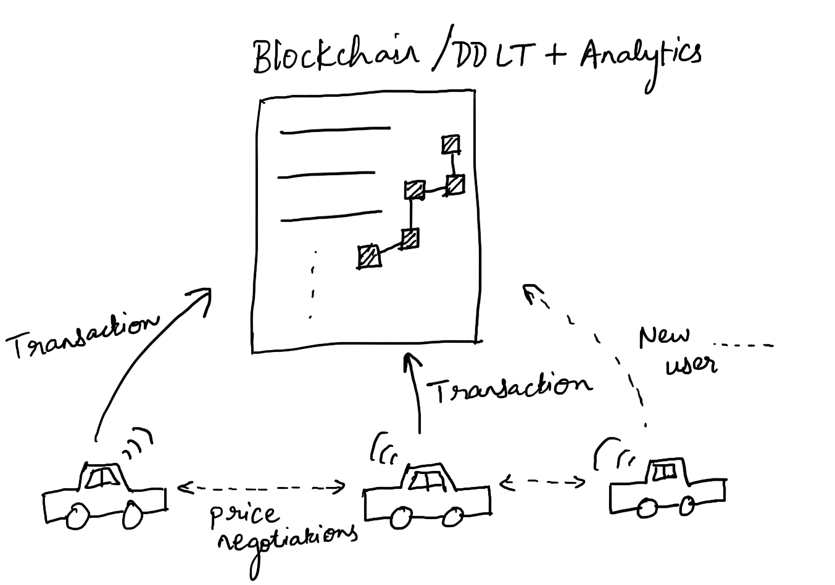

*Figure 1: Distributed system of negotiations between vehicles on-road - each transaction is recorded on the Blockchain or Digital Distributed Ledger Technology (DDLT)*

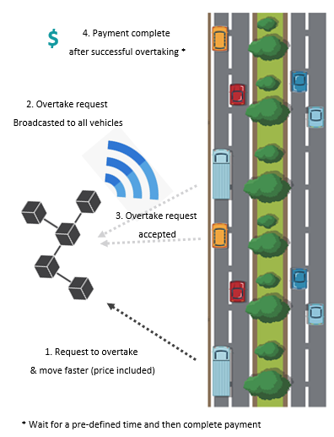

*Figure 2: Sequence of steps showing communication between negotiation initiator and vehicles around (****please read steps in chronological order from 1 to 4****)*

**Congratulations!**

**You have dodged every punch and have successfully completed this round.**