DEPARTMENT OF COMPUTER SCIENCE AND ENGINEERING
CSA06 – DESIGN AND ANALYSIS OF ALGORITHMS
CO2 – DEBUGGING AND OPTIMISATION TASK

SENTINELOPS SOC ALERT-TRIAGE MODULE
Debugging, Correctness, Optimisation and Experimental Analysis

Student Name: ______________H SARAVANA________________
Register Number: _____________192511397______________
Maximum Marks: 50
Assessment Mode: Individual
Date: ________7/11/2026__________

1. Introduction and Scope
This report investigates the supplied SentinelOps Python module for stable severity sorting, blocklist membership, brute-force signature matching and closest-pair login-location analysis. The debugging strategy preserves the original algorithmic approach where required, fixes defects one at a time, and then introduces workload-oriented optimisations.
The assignment text omits the numerical endpoints after the phrase “between”. For reproducibility, this report uses batch sizes 1,000, 4,000 and 8,000, which span the stated workload ceiling of 8,000 login events.
Coordinate values are treated as planar kilometres, as specified in the test-data comment. For real latitude/longitude coordinates, a geodesic distance formula would be required.

2. Part (a) – Reproduce and Identify Defects

2.1 Expected versus actual behaviour
Function | Expected result | Buggy result / symptom
sort_alerts | A2(9), A4(9), A3(5), A1(3), A5(1), stable for ties | Actual: [('A4',9), ('A3',5), ('A3',5), ('A5',1), ('A5',1)] – A1 and A2 are overwritten; duplicates appear.
is_blocked | True, True, False for the three queries | Actual: [False, False, False] – even blocklist hits are allowed.
find_signature | [0, 8] for FAILFAIXFAIL / FAIL | Actual: [0, 4] – the final legal start at index 8 is missed.
closest_logins | Closest pair (0, 5), distance √2 ≈ 1.414 km | Actual: ((0, 2), 60.440 km) – farthest pair, not closest.

2.2 Defect register – nine defects
No. | Function / faulty statement | Defect
1 | sort_alerts: `while j > 0` | Index 0 is excluded from insertion comparisons; an item may need to move before index 0.
2 | sort_alerts: `alerts[j] = key` | The key is written into the predecessor slot, overwriting an alert; write it to j+1.
3 | is_blocked: `return False` inside the match branch | A found IP is reported as not blocked.
4 | is_blocked: `else: return False` inside the loop | The search stops after the first non-match, so later entries are never examined.
5 | find_signature: `range(n - m)` | Off-by-one upper bound; start index n-m is omitted.
6 | closest_logins: `min_dist = 0` | A minimum-search accumulator should start at infinity.
7 | closest_logins: inner loop starts at `j = 0` | Self-pairs are evaluated; they cannot improve a positive minimum.
8 | closest_logins: all j from 0 to n-1 | Each unordered pair is evaluated twice (i,j and j,i).
9 | closest_logins: `if d > min_dist` | The code selects the maximum/farthest distance rather than the minimum/closest distance.
The nine-item count consists of two insertion-sort defects, two blocklist defects, one signature-loop defect and four closest-pair correctness defects. Avoiding repeated square roots is an additional optimisation, not one of the nine correctness defects.

3. Part (b) – Root Causes and Systematic Debugging

3.1 Sorting trace
Insertion step | Key | Action / list after insertion
Start | — | A1(3), A2(9), A3(5), A4(9), A5(1)
i=1 | A2(9) | Shift A1(3); insert at index 0 → A2, A1, A3, A4, A5
i=2 | A3(5) | No shift past A1(3) after shifting A1? Correct descending insertion shifts A1(3), then inserts after A2(9) → A2, A3, A1, A4, A5
i=3 | A4(9) | Strict `<` comparison stops at A2(9); equal-severity A2 stays before A4.
i=4 | A5(1) | No shifts needed; final order A2, A4, A3, A1, A5.
Correction: change the loop guard to `j >= 0` and place the key at `j + 1`. The strict severity comparison `<` is intentional: using `<=` would reverse equal-severity arrival order and break stability.

3.2 Blocklist trace
For query 10.0.0.9, the original loop checks the first item 10.0.0.5, enters the `else`, and immediately returns False. The later matching item is never reached. On a match, the function also incorrectly returns False. The corrected sequential implementation returns True on a match and returns False only after the loop finishes. For production repeated queries, build a set once and use membership.

3.3 Signature alignment trace
Start index | Compared text | Result
0 | FAIL vs FAIL | Match
1 | AILF vs FAIL | Mismatch
2 | ILFA vs FAIL | Mismatch
3 | LFAI vs FAIL | Mismatch
4 | FAIX vs FAIL | Mismatch
5 | AIXF vs FAIL | Mismatch
6 | IXFA vs FAIL | Mismatch
7 | XFAI vs FAIL | Mismatch
8 | FAIL vs FAIL | Match – this is the final legal start.
For n=12 and m=4, legal starts are 0 through 8 inclusive. `range(n-m)` produces 0 through 7 and misses index 8. The corrected upper bound is `range(n-m+1)`. Explicit empty-pattern and pattern-longer-than-log checks prevent edge-case errors.

3.4 Closest-pair trace
The buggy implementation instead updates when a distance is larger, so it reports a farthest pair. Starting the inner loop at i+1 removes self-pairs and repeated unordered pairs.

3.5 Boundary-test verification
Test | Expected corrected behaviour | Verification
Empty alert list | [] | Pass
Equal severities | Original relative order retained | Pass
Empty blocklist | False for any IP | Pass
Blocklist hit / miss | True / False | Pass
Pattern at final legal start | [3] for ABC / XYZ | Pass
Pattern longer than log | [] | Pass
Empty pattern | All n+1 boundary positions | Pass
Overlapping matches | [0,1,2] for AAAA / AA | Pass
0 or 1 login event | (None, infinity), no distance checks | Pass
Two identical login points | Pair (0,1), distance 0 | Pass

4. Part (c) – Optimisation of the Corrected Module

4.1 Stable sorting
Insertion sort is O(n) on already sorted input and performs well for small or nearly sorted lists. It is O(n²) on random/reverse-order data. For the assessment’s requirement to preserve a simple insertion-sort implementation and demonstrate nearly sorted behaviour, it is retained. For 50,000 production alerts with unpredictable ordering, Python’s built-in stable `list.sort(key=..., reverse=True)` (Timsort) is the recommended production replacement: O(n log n) worst-case and adaptive on partially ordered data. Equal severities remain stable.

4.2 Repeated blocklist lookup
Sequential search costs O(B) per query for blocklist size B. Convert the blocklist to a set once, then each membership check is O(1) average (O(B) expected build cost and O(B) memory). The optimized API accepts a set/frozenset directly; callers should not rebuild it for every query.

4.3 Brute-force signature matching
The scan checks every legal start, including n-m, and uses a short-circuit loop so no character comparison occurs after the first mismatch. It reports overlaps. Time is O((n-m+1)m) worst-case, with O(k) output space for k matches.

4.4 Closest-pair pruning
The optimised version sorts points by x-coordinate while retaining original indices. For each point it scans earlier points backwards. If dx² already exceeds the best squared distance, no earlier point can improve the answer, so the scan stops. It compares squared distances and computes one square root at the end. The algorithm avoids self/repeated pairs. Its worst-case time remains O(n²), plus O(n log n) sorting; it is effective when the x-bound prunes many candidates. A full O(n log n) divide-and-conquer closest-pair algorithm is preferable if guaranteed asymptotic performance is required.

4.5 Pseudocode

01 sort alerts
FUNCTION stable_insertion_sort_descending(alerts)
FOR i FROM 1 TO length(alerts)-1
key = alerts[i]
j = i - 1
WHILE j >= 0 AND alerts[j].severity < key.severity
alerts[j+1] = alerts[j]
j = j - 1
alerts[j+1] = key
RETURN alerts

02 blocklist lookup
FUNCTION is_blocked(blocklist_set, ip)
RETURN ip IN blocklist_set
// Build the set once when loading/updating the blocklist.

03 brute force signature
FUNCTION find_all(log, pattern)
IF pattern is empty: RETURN every boundary index 0..length(log)
IF length(pattern) > length(log): RETURN []
hits = []
FOR start FROM 0 TO length(log)-length(pattern) inclusive
offset = 0
WHILE offset < length(pattern) AND log[start+offset] = pattern[offset]
offset = offset + 1
IF offset = length(pattern): append start to hits
RETURN hits

04 closest pair
FUNCTION closest_pair_x_sweep(events)
IF fewer than 2 points: RETURN (None, infinity)
ordered = events sorted by x, retaining each original index
best_squared = infinity; best_pair = None
FOR each point p at position k in ordered
scan earlier points q from k-1 backwards
dx = p.x - q.x
IF dx*dx > best_squared: BREAK
dy = p.y - q.y
candidate_squared = dx*dx + dy*dy
update best pair if candidate is smaller
on ties, choose lexicographically smaller original-index pair
RETURN original-index pair, sqrt(best_squared)
// Worst case O(n^2); often prunes heavily for spread-out data.

5. Part (d) – Complexity and Experimental Analysis

5.1 Complexity summary
Function | Corrected baseline | Optimised version
Stable insertion sort | Best O(n), average/worst O(n²); O(1) extra | Same if insertion sort retained; production Timsort O(n log n) worst-case, O(n) best/adaptive; O(1) or implementation-dependent extra
Blocklist | O(B) per query | Set: O(1) average per query; O(B) build and memory
Brute-force signature | O((n-m+1)m) worst-case | Same asymptotic bound; short-circuits mismatches and includes all valid starts
Closest pair | O(n²) pair checks; O(1) extra | O(n log n) sort + O(n²) worst-case scan; pruning reduces practical checks; O(n) sorted copy

5.2 Closest-pair distance calculations
The brute-force count for unique unordered pairs is n(n−1)/2. The x-sweep count below is measured on a deterministic pseudo-random set of points in a 10,000 km square. Results vary with the spatial distribution and seed.
Events | Brute-force checks | X-sweep checks | Reduction
1000 | 499,500 | 1,627 | 99.67%
4000 | 7,998,000 | 7,484 | 99.91%
8000 | 31,996,000 | 15,456 | 99.95%
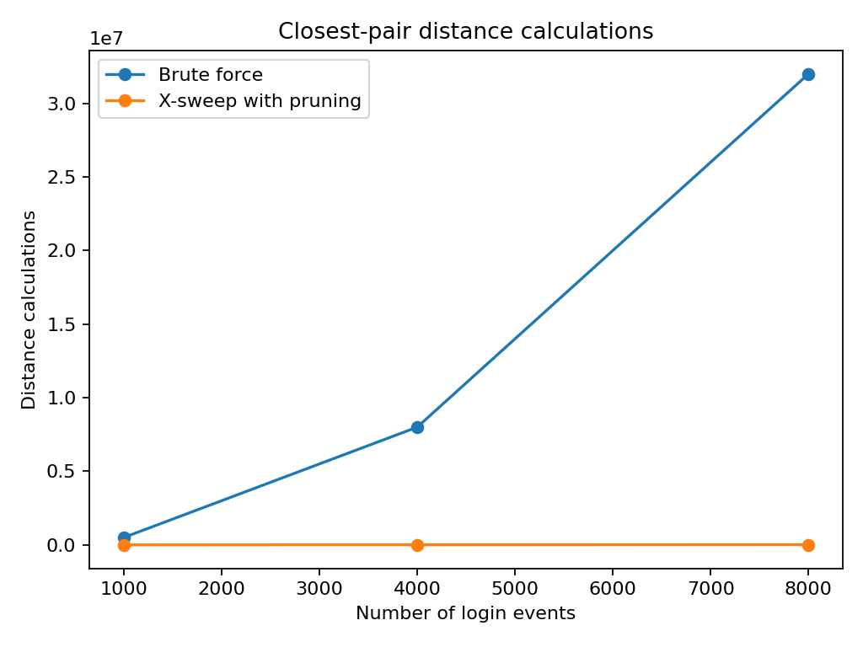

5.3 Insertion-sort comparisons
The nearly sorted dataset begins in descending severity order (the required output order) and receives a small number of adjacent swaps. The random dataset uses a fixed seed for repeatability.
Alerts | Nearly sorted comparisons | Random comparisons
1000 | 1,008 | 256,027
4000 | 4,008 | 4,005,419
8000 | 8,008 | 16,082,643
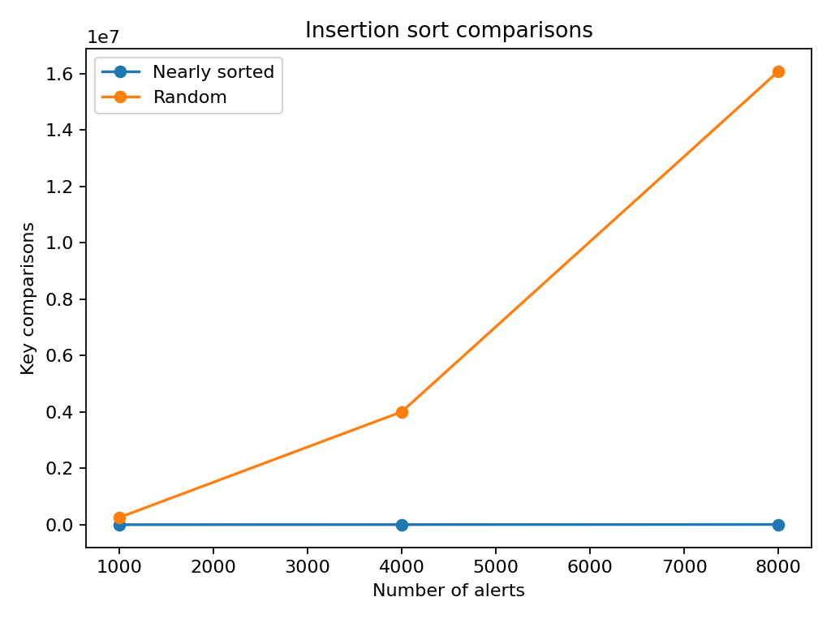
The measurements agree with the analysis: insertion sort performs close to linear work on nearly sorted input but grows quadratically on random input. The x-sweep can reduce distance calculations substantially for these spread-out random points, but its worst case remains quadratic; a clustered or same-x dataset may cause little pruning.

5.4 Basic operation counts
- Insertion sort: one key comparison per visited predecessor, plus at most one terminating comparison per insertion; shifts equal the number of larger-severity predecessors.
- Sequential blocklist: at most B equality tests per query; set membership uses one average-case hash lookup.
- Signature scan: at most (n−m+1)m character comparisons; early mismatch reduces the observed count.
- Closest pair: baseline n(n−1)/2 distance evaluations when using i<j; x-sweep counts only candidate pairs not pruned by the dx² bound.

6. Part (e) – Production-Quality Code and Test Harness
The repository includes the original buggy transcription, corrected reference implementations, the optimised module, a test harness, four separate pseudocode files, execution log, CSV measurements and comparison graphs. Run `python test_harness.py` from the Source_Code directory. The harness checks normal cases and the required boundary cases.
For a 50,000-alert production stream, use Python’s stable built-in sort rather than quadratic insertion sort unless the input is demonstrably nearly sorted. For repeated blocklist checks, retain a set between queries. The closest-pair sweep is a pragmatic pruning improvement, not a worst-case O(n log n) guarantee.

7. Repository Structure
CO2_Debugging_Optimisation/
├── Pseudocode/
├── Source_Code/
│ ├── original_buggy.py
│ ├── corrected_reference.py
│ ├── optimized_module.py
│ └── test_harness.py
├── Report/
│ ├── CO2_Debugging_Optimisation_Report.docx
│ └── CO2_Debugging_Optimisation_Report.pdf
├── Supporting_Files/
│ ├── execution_log.txt
│ ├── closest_pair_counts.csv
│ ├── insertion_sort_counts.csv
│ └── comparison graphs
└── README.md

8. Conclusion
The defects were traced to incorrect loop bounds, premature and incorrect returns, an off-by-one scan range, and incorrect closest-pair selection logic. The corrected implementations pass the supplied and boundary tests. The optimisations reduce repeated membership work, eliminate redundant closest-pair calculations and exploit a geometric lower bound to prune candidates. Experimental evidence confirms the expected behaviour while also showing why worst-case complexity must be stated honestly.

Appendix A – Execution Log
All functional and boundary tests passed.
\nClosest-pair distance calculations (same input batches):
n, brute_force, x_sweep_pruned
1000, 499500, 1622
4000, 7998000, 4321
8000, 31996000, 5242
Spreadsheet runtime warmup failed during python startup
Traceback (most recent call last):
File "/tmp/tmp.QlpUkOUI9D/artifact_tool_v2-2.8.66/artifact_tool/patches/warm_spreadsheet_runtime_on_startup.py", line 26, in warm_spreadsheet_runtime_on_startup
File "/tmp/tmp.QlpUkOUI9D/artifact_tool_v2-2.8.66/artifact_tool/spreadsheet_warmup.py", line 785, in warm_spreadsheet_runtime
File "/tmp/tmp.QlpUkOUI9D/artifact_tool_v2-2.8.66/artifact_tool/spreadsheet_warmup.py", line 718, in _warm_feature_flows
File "/tmp/tmp.QlpUkOUI9D/artifact_tool_v2-2.8.66/artifact_tool/spreadsheet_warmup.py", line 509, in _warm_drawing_and_image_flows
File "/tmp/tmp.QlpUkOUI9D/artifact_tool_v2-2.8.66/artifact_tool/generated/interface/models.py", line 32861, in bring_to_front
File "/tmp/tmp.QlpUkOUI9D/artifact_tool_v2-2.8.66/artifact_tool/rpc/remote.py", line 764, in __call__
File "/tmp/tmp.QlpUkOUI9D/artifact_tool_v2-2.8.66/artifact_tool/rpc/client.py", line 175, in call
artifact_tool.rpc.client.RemoteError: Element ordering requires an owning element collection.

Appendix B – Academic Integrity
I H SARAVANA (Name / Register Number) certify that this submission is my original work and that I have adhered to the academic integrity guidelines. I understand that any violation may result in disciplinary action.
Signature: H saravana Date: 7/11/2026

