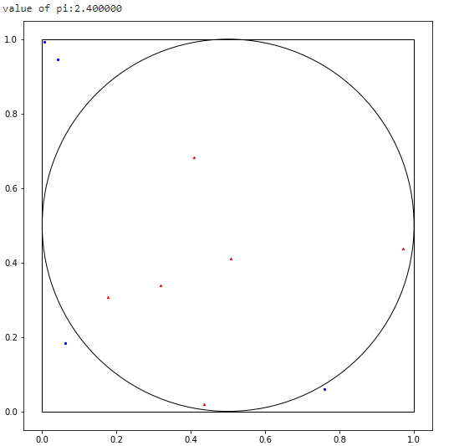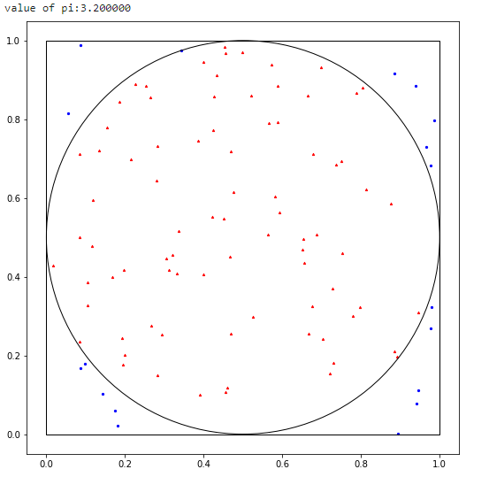

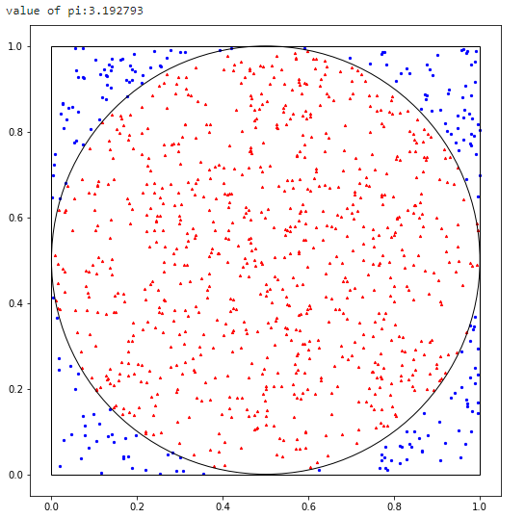

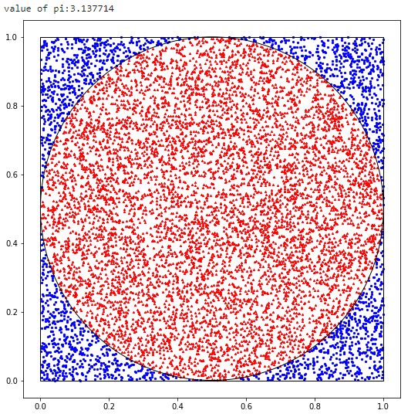

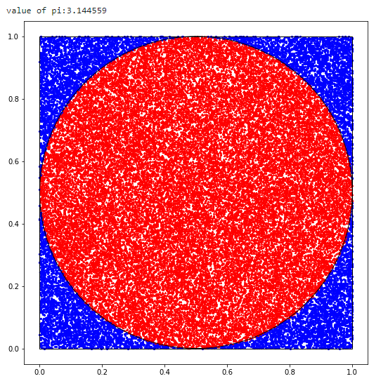

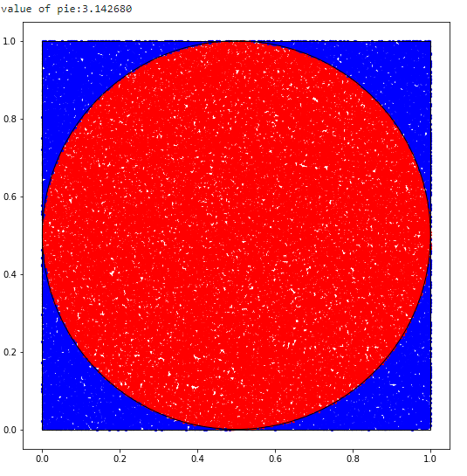

Program displays the graphs with different number of plots in a single execution.We might get the output slowly as it takes time to plot the values and display the output. Similarly the program displays the graph plots for 500000, 1000000, 5000000 points. My systems notebook kernel was unsupportive to run the large number of plots (Works in system with good RAM spec).We observe from the above that the pi value is more accurate as the number of plots in a graph increases.