R;.f/>RF’r Playwright Notes
1.To check whether node installed or not, if not installed Install and configure it.
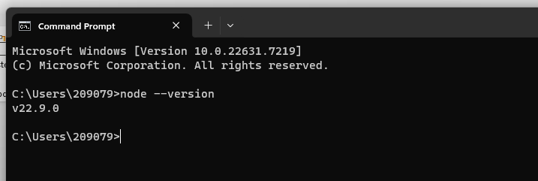
2.Create one Folder ex: Playwright_Automation.
3. Open it in VS Code
4.Open Terminal
5.Enter the command “npm init playwright” or “npm init playwright@latest”
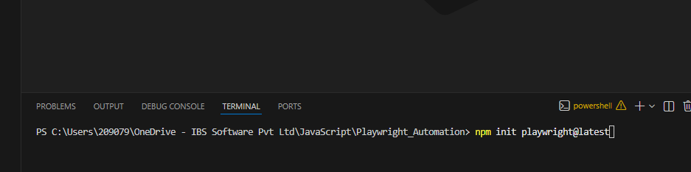
Choose Java script
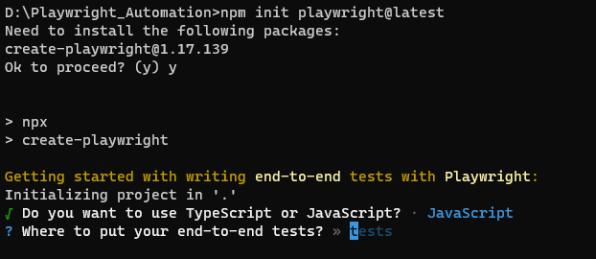
Give Y to GitHub action workflow
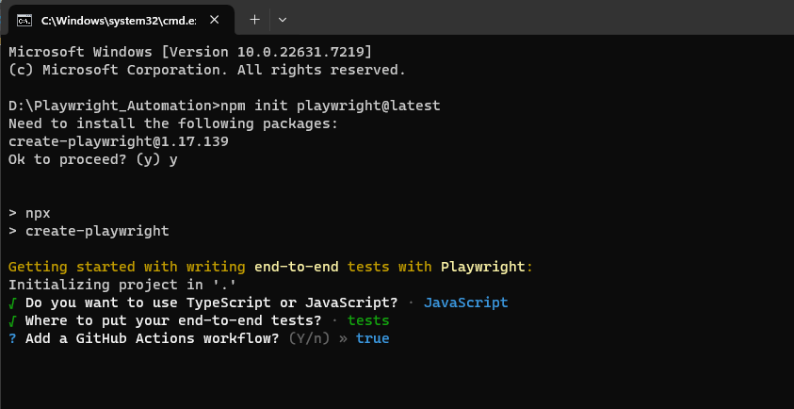

It will be installed successfully.
If you are using office laptop use below steps and command, because it won’t install browser extension
Verify it is there or not in this below path
C:\Users\209079\AppData\Local\ms-playwright
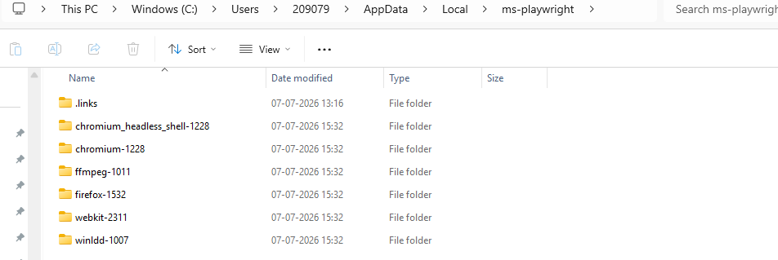
If it is not there use below procedure to install
- Go to this Path
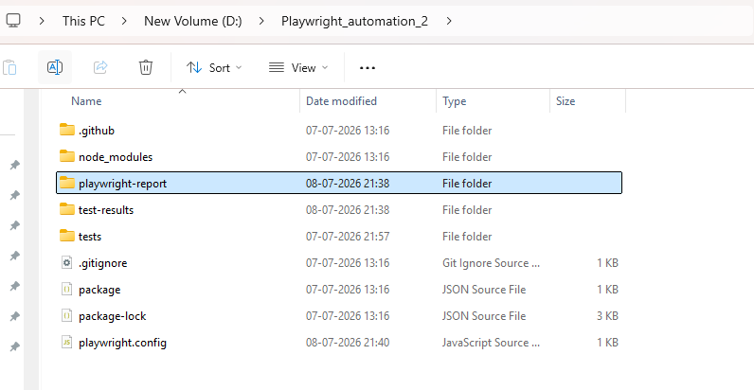
(i)Open Command prompt
(ii)set NODE_TLS_REJECT_UNAUTHORIZED=0
(iii)click Enter
(iv) npx playwright install

Using these 2 commands it will download browser extension, Check it in this path again

Note : Don’t use setx Use set. If you use setx it will consider as permanent Fix
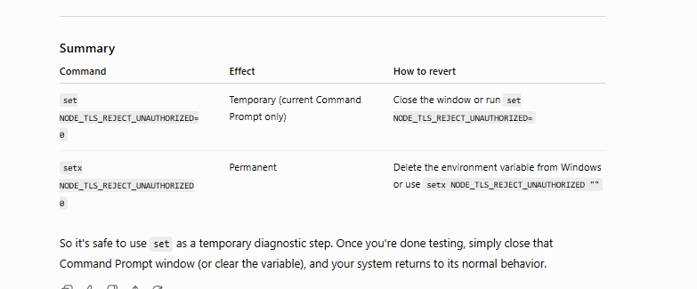
That’s it about the installation progress.
Difference between npm and npx
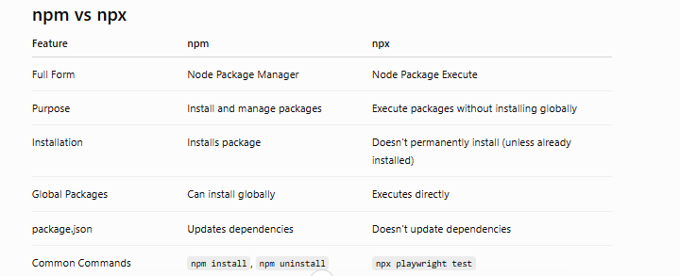
npm (Node Package Manager)
Think of npm as an App Store.
It is used to:
- Install packages
- Remove packages
- Update packages
- Manage dependencies
npx (Node Package Execute)
Think of npx as "Run this package."
It executes packages.
It first checks:
- Is it in node_modules?
- If yes → execute it.
- If not → temporarily download it and execute it.

After Installation the folder structure looks like this
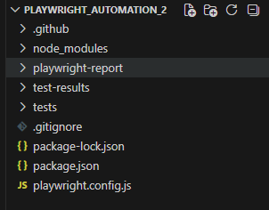

Playwright.Config.js- we can specify which test to run and which browser we can use etc.. declarations(Test Runner)
node_modules- where all playwright extensions present
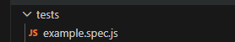
Test/example.spec.js – we can write new test cases here. Create new project using. spec.js extension.

Initially both Playwright.Config.js and example.spec.js have some examples

1. Test case structure and explanations
Taking extensions from playwright/test
const{test}
{}- declaring this denotes as playwright fixtures, without this it will be not a normal variable declaration
using test we can write a test cases

below snippet is a base structure to write Test case
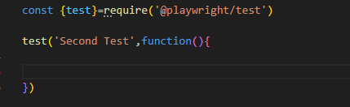

In JS everything are async, we must use await and async to wait for some time to execute the current line of Code

We have to pass the browser async function to access and launch
Way 1: use {browser} fixtures, Storing it in variables and launching the browser using URL
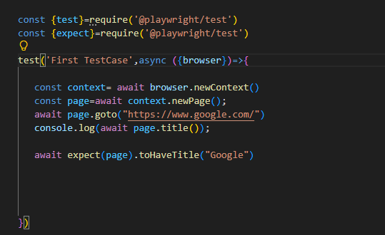
Way 2: using {page} fixture we can directly call launch the URL, no need of additional coding to initiate the browser.
test.only- to run a single test case in current js file
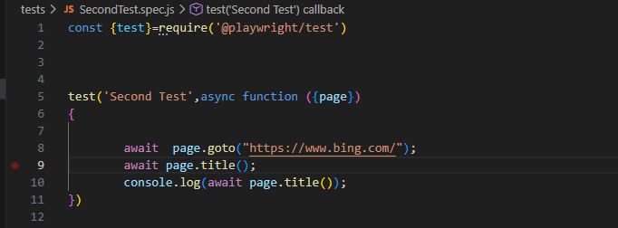

2.Config.js File
Basic configuration to run file
testDir: './tests' - To navigate the Test folder

testMatch: 'SecondTest.spec.js' - To navigate the specific Test case file

timeout: 40*1000, - The Default timeout is 30 seconds, we are providing
expect :{
timeout: 40*1000

}, -This block is a Time out we are providing for timeout
Default timeout of assertion in 5 seconds

reporter:'html', - Generate HTML report
use: {
browserName:"chromium",
headless:false
},
-To specify which browser and what mode of Run
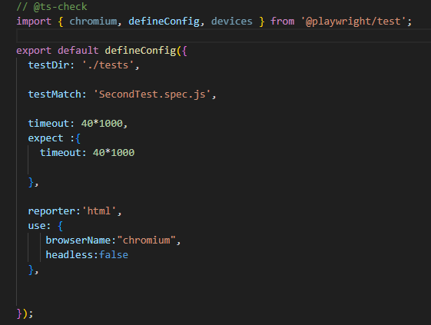

3.Asserting the Title
await expect(page).toHaveTitle("Title of the Page")

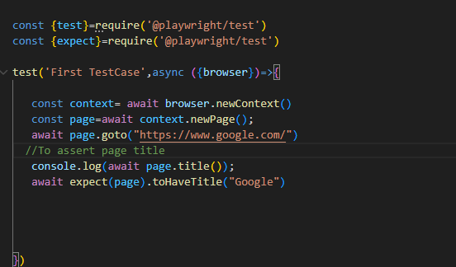
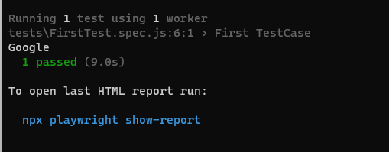

To Locate elements:
To locate elements playwright following two things
CSS and Xpath
CSS -> Recommended
To locate elements syntax,
Page.locator()

Id:
tagname#id or #id ex: input#username , #username
class:
tagname.class or .class ex: input.username , .username
bases on any attribute:
[type=’password’]
To send anything as input:
.fill(“Inputtext”)
To erase all
.fill(“”)
To get the text
.textContent()
To traverse from one to another use space
.btn span
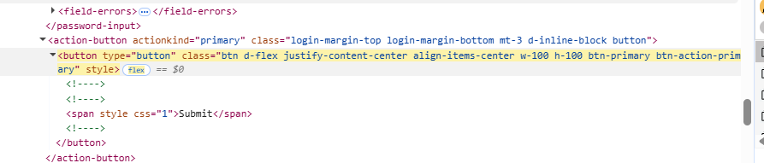

Example snapshot
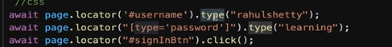
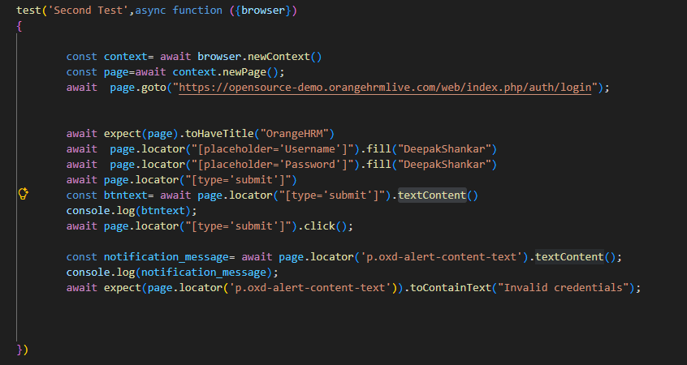.toContainsText() – To assert the text()

Comparison of navigation and get commands between selenium and playwrighrt
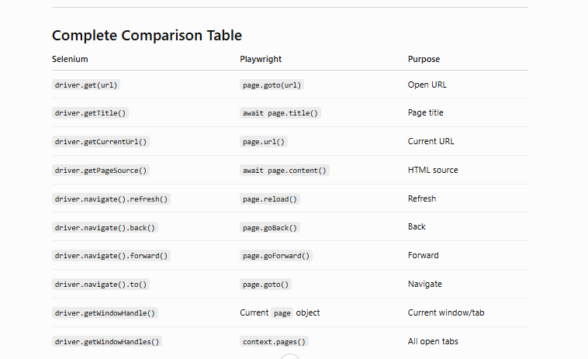
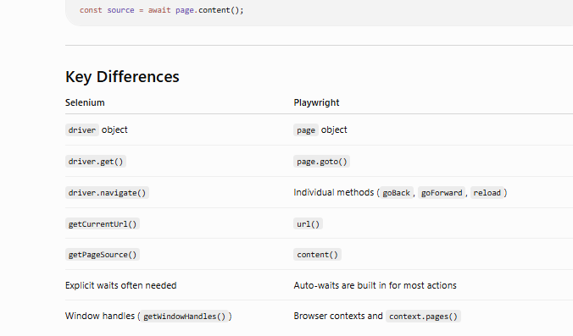

To validate N number of records
nth(0)- First record
first() - First record
last()- Llast record
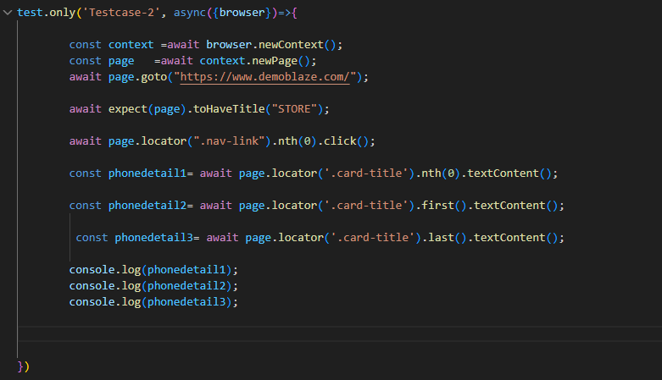

Wait and wait for():
Playwright have some Auto wait for some Actions, Check Auto-waiting | Playwright for more details
Here is the complete list of actionability checks performed for each action:
Action | Visible | Stable | Receives Events | Enabled | Editable
locator.check() | Yes | Yes | Yes | Yes | -
locator.click() | Yes | Yes | Yes | Yes | -
locator.dblclick() | Yes | Yes | Yes | Yes | -
locator.setChecked() | Yes | Yes | Yes | Yes | -
locator.tap() | Yes | Yes | Yes | Yes | -
locator.uncheck() | Yes | Yes | Yes | Yes | -
locator.hover() | Yes | Yes | Yes | - | -
locator.dragTo() | Yes | Yes | Yes | - | -
locator.screenshot() | Yes | Yes | - | - | -
locator.fill() | Yes | - | - | Yes | Yes
locator.clear() | Yes | - | - | Yes | Yes
locator.selectOption() | Yes | - | - | Yes | -
locator.selectText() | Yes | - | - | - | -
locator.scrollIntoViewIfNeeded() | - | Yes | - | - | -
locator.blur() | - | - | - | - | -
locator.dispatchEvent() | - | - | - | - | -
locator.focus() | - | - | - | - | -
locator.press() | - | - | - | - | -
locator.pressSequentially() | - | - | - | - | -
locator.setInputFiles() | - | - | - | - | -

Since allTextContents() not coming under auto wait we are following
waitforLoadState(‘networkidle) l
But this is flaky- Sometimes not work
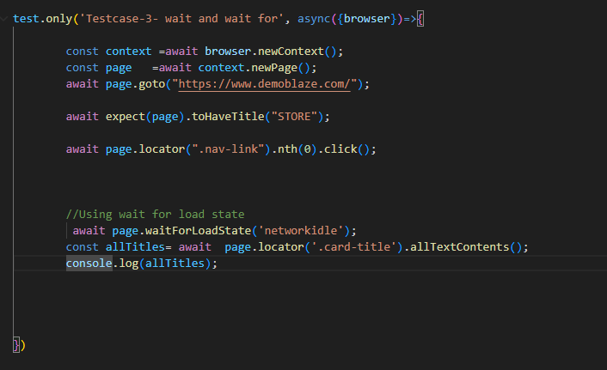

So we can use another method called waitfor()

4.Select, Radio button and checkboxes actions
Select:
If DOM Structure has Select Tag and Options, the go with SelectOption()
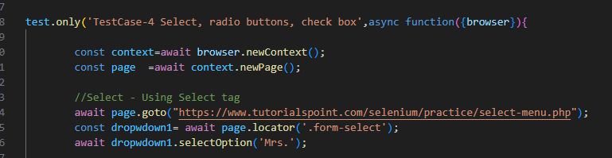
If it is a Custom dropdown then go with,
Click Dropdown 1st
Select Option by Click
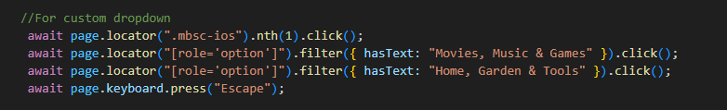
Note: .Filter, Chaining , Mouse Actions- concepts will cover later in a detail way

Radio Button:
General Click Operation
We can use tobeChecked(),not.tobeChecked(), ischecked(), tobeTruthy, tobeFalsy to Assert
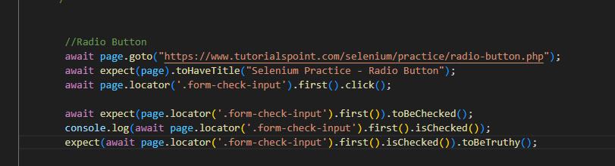
tobeChecked()- Assertion to check whether check or not- if not checked then script will fail
not.tobeChecked()- Assertion to check whether check or not- if it is checked then script will fail
ischecked()- Return only Boolean value. True or false (kind of Local assertion)
tobeTruthy, tobeFalsy- Assertion to check “isChecked()” Return value
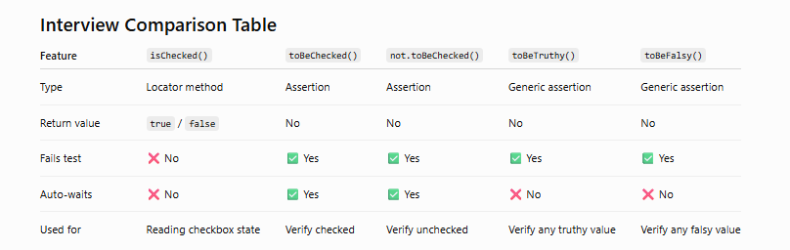
Which should you use?
- Use isChecked() when you need the checkbox state for your program logic, such as inside an if statement.
- Use toBeChecked() or not.toBeChecked() when you are writing test assertions. These are preferred because Playwright automatically waits for the expected state before failing the test.
- Use toBeTruthy() and toBeFalsy() for general JavaScript values (booleans, objects, strings, numbers, etc.), not specifically for checkboxes.
Best practice in Playwright: For verifying UI state, prefer toBeChecked()/not.toBeChecked() over checking isChecked() with toBeTruthy() or toBeFalsy(), because the dedicated assertions are more readable and include Playwright's built-in auto-waiting.
Check Box:
Use Uncheck()- To Uncheck the CheckBox
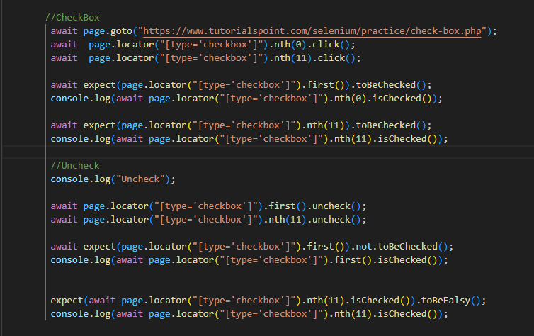

Await placement in the code
Use await whenever there is any action performed, otherwise it is not necessary to Use await
Rule:
Place await before any function that returns a Promise.

Playwright Method | Use await? | Reason
page.goto() | ✅ Yes | Navigation is async
locator() | ❌ No | Creates a locator object immediately
click() | ✅ Yes | Performs an async action
fill() | ✅ Yes | Performs an async action
check() | ✅ Yes | Performs an async action
uncheck() | ✅ Yes | Performs an async action
selectOption() | ✅ Yes | Performs an async action
hover() | ✅ Yes | Performs an async action
textContent() | ✅ Yes | Reads async data
innerText() | ✅ Yes | Reads async data
count() | ✅ Yes | Reads async data
isChecked() | ✅ Yes | Returns a Promise
isVisible() | ✅ Yes | Returns a Promise
isEnabled() | ✅ Yes | Returns a Promise
page.title() | ✅ Yes | Returns a Promise
page.url() | ❌ No | Returns a string synchronously
expect(locator).toBeVisible() | ✅ Yes | Assertion auto-waits
expect(locator).toBeChecked() | ✅ Yes | Assertion auto-waits

5.New Page navigation in another tab
Code to navigate page 1
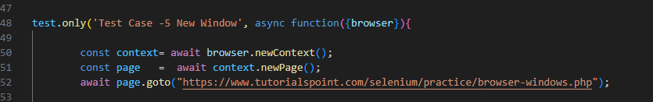

Clicking this Button allow to navigate next page
page.locator("[title='New Tab']").click()]

but before that it should wait for the page so create one Event for wait called waitforEvent(‘page’)

context.waitForEvent('page'),
page.locator("[title='New Tab']").click()

This Process is a repeated one until new page , so keep it in the promise. Once the Promise is Resolved then it will be moved to next step.

const [newpage]=await Promise.all(

[ context.waitForEvent('page'),
page.locator("[title='New Tab']").click()]

)
Once new page is opened, here checking the Title and textContent()
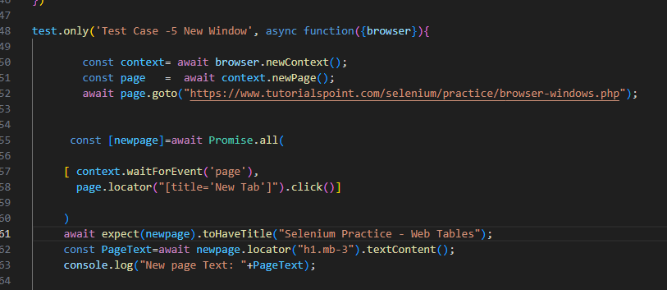

6.Difference between textContent() and inputValue()
textContent() → Gets the text inside an HTML element.
inputValue() → Gets the value of an <input>, <textarea>, or <select> element.
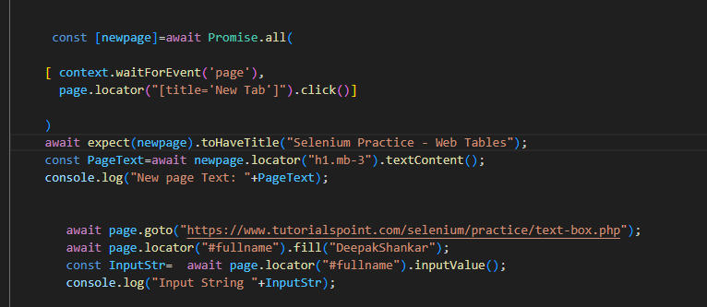
Output
New page Text: New Tab textContent()
Input String DeepakShankar- inputValue()
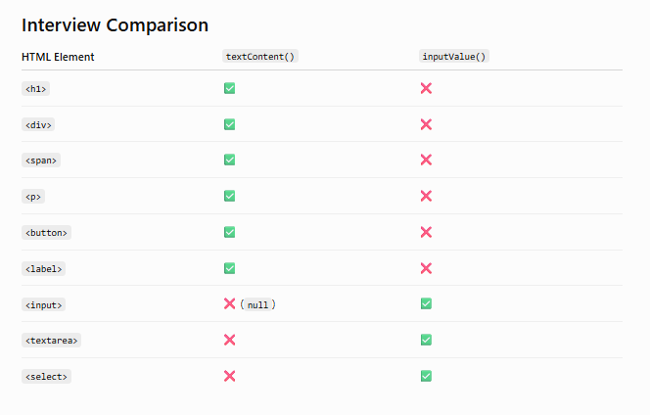
7.await page.pause()
await page.pause() is one of the most useful debugging features in Playwright.
It pauses the test execution and opens the Playwright Inspector, allowing you to inspect the page, execute the next step manually, and understand what's happening.
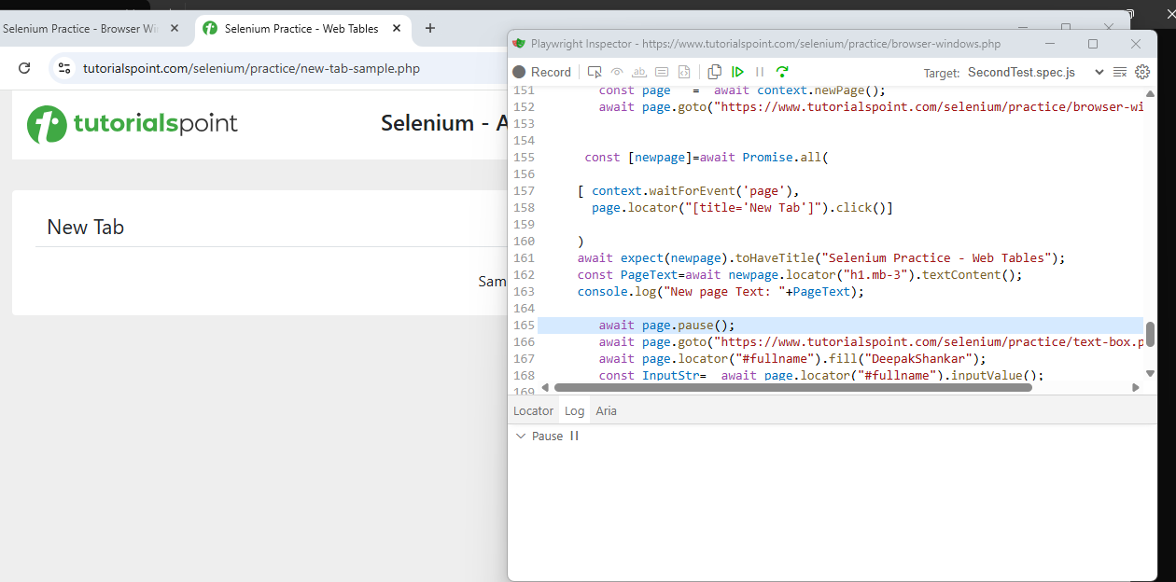
Click Resume in Playwright Inspector.
The test continues from the next line.

8. Locator Chaining,Locator using Text and Text using tag, waitfor()
(i)Locator Chaining
Locator chaining means finding an element inside another element.
Instead of searching the entire page, you first locate the parent element and then locate the child element.

Syntax: page.locator("parent").locator("child")

(ii) Locator using Text
Playwright provides built-in text locators.
Ex: await page.locator("text=Login").click();

(iii) Locator using Tag + Text
Sometimes multiple elements have the same text.
Instead of searching by text alone, specify the HTML tag.
Using hasText:
Syntax: Page.locator(“Tag”, {hasText:”text”})
const NokiaText= await page.locator("h2",{hasText:"Nokia lumia 1520"}).isVisible();
Syntax: Page.locator(“Tag”).filter({hasText:” text”})
const NokiaText= await page.locator("h2").filter({hasText:'Nokia lumia 1520'}).isVisible()

Using has-text():
Syntax: Page.locator(“tag:has-text(‘text’)”)
const NokiaText = await page.locator(“h2:has-text(‘Nokia lumia 1520’)”).isVisible(); has-text()

(iv) waitFor()
waitFor() waits until a locator satisfies a condition before continuing.
Syntax: await locator.waitFor();

Code Snippet:
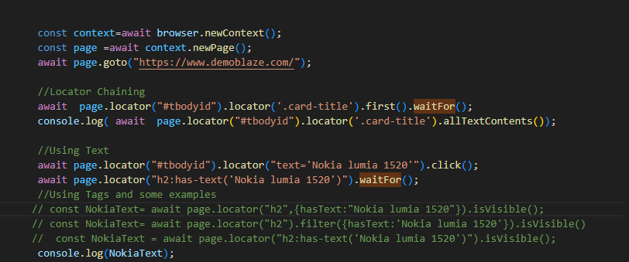

9.Auto Suggestion Handling
pressSequentially()- is a Playwright method used to type text into an input one character at a time, just like a real user typing on a keyboard.
It is especially useful for applications that trigger events such as autocomplete, search suggestions, or live validation on every keystroke.
{ delay: 200 }- Time gap between each character
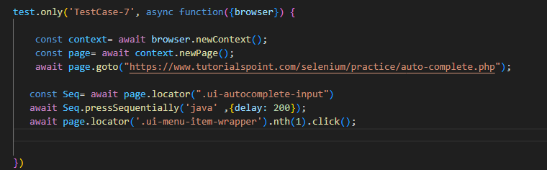
Note Difference between hastext and tohavetext()
hasText is used to locate the correct product card.
toHaveText() is used to assert that the product name is exactly what you expect.
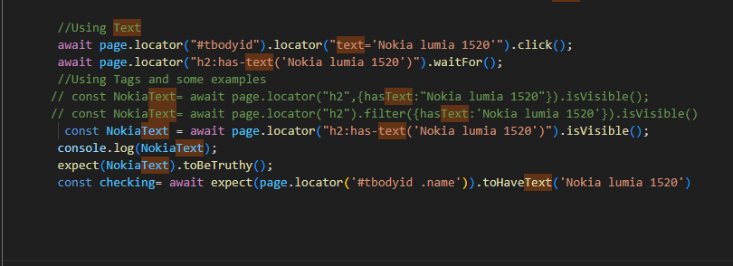

10.getbyLocators
These locate elements the way a user sees or interacts with them.
getByRole() – Locates elements by their ARIA role and accessible name (e.g., button, link, checkbox).
getByLabel() – Locates form controls using their associated label text.
getByPlaceholder() – Locates input fields using their placeholder text.
getByText() – Locates elements using their visible text on the page.
getByTestId() – Locates elements using the data-testid attribute for stable test automation.
getByTitle()- Locate elements using title attribute
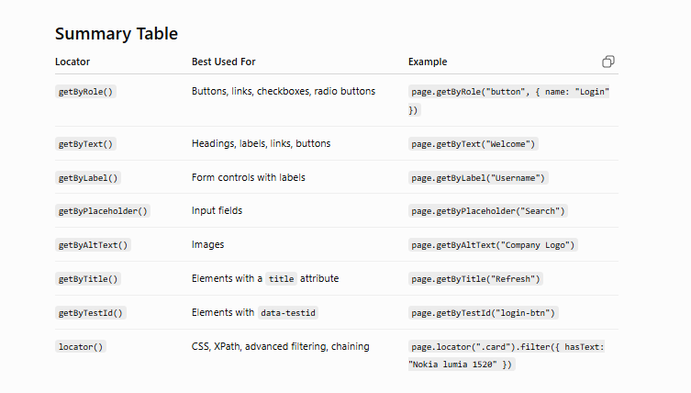
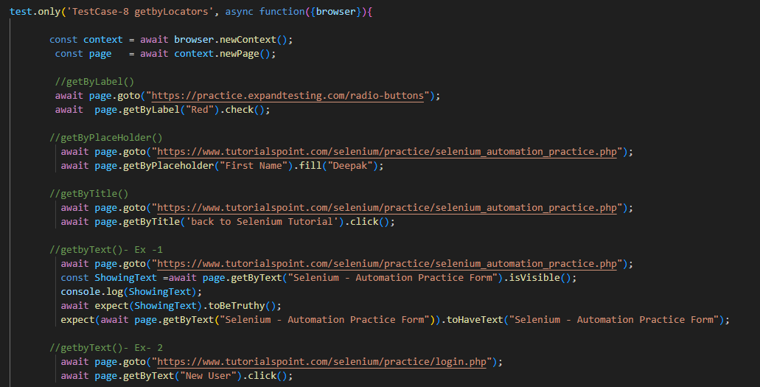

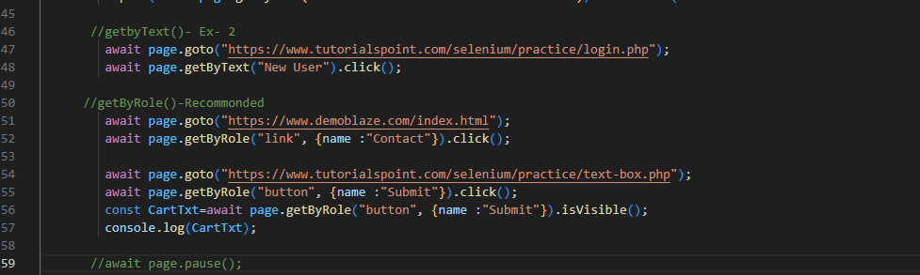

11.Playwright TimeOuts
Refer Official Document for More Information: Timeouts | Playwright
By Default it take Config file Timeouts

We can Set the timeOut based on our use case and Application Behaviours
1.Assertion TimeOuts
1.Setting Step level- for Single Line.
Setting TimeOut for the Particular line
2.Setting Test level- for Particular Test
Setting TimeOut for the Particular Test. We can use that for the Steps wherever we want
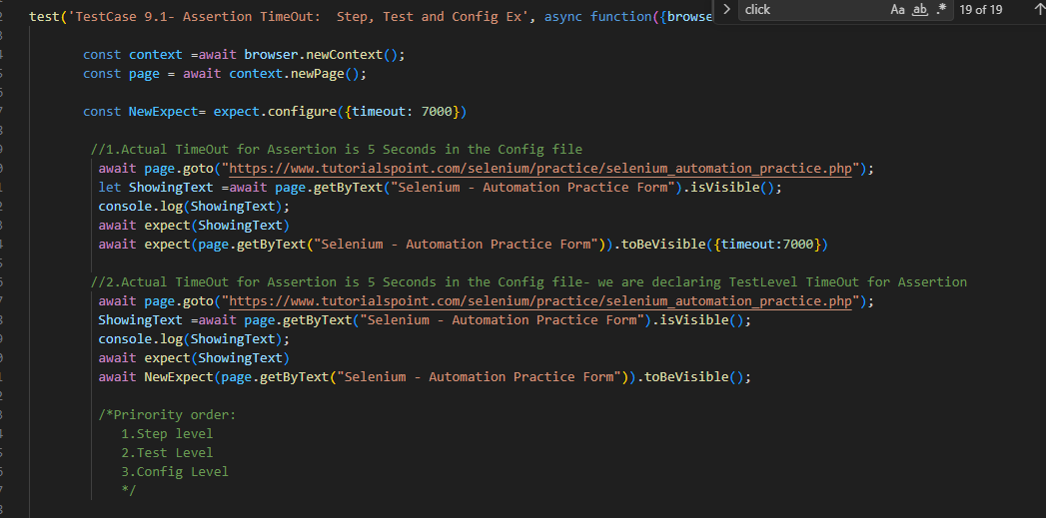
2.Navigation TimeOuts
1.Setting Step level- for Single Line.
Setting TimeOut for the Particular line
2.Setting Config level: Under use:{} we can define
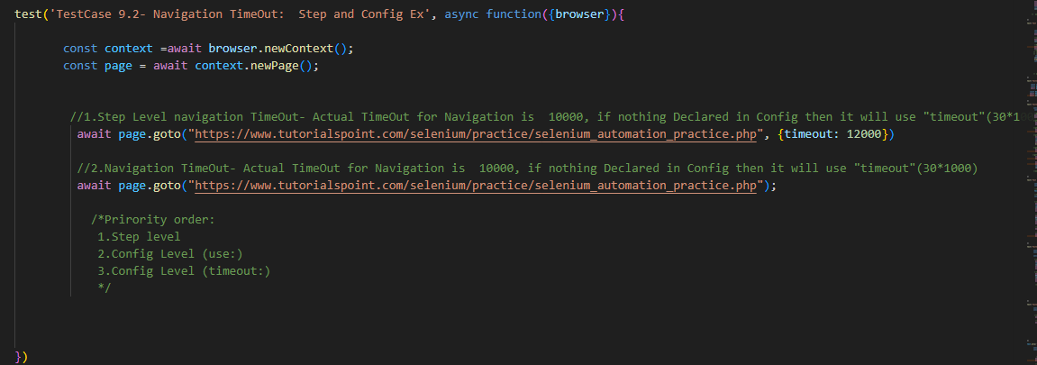
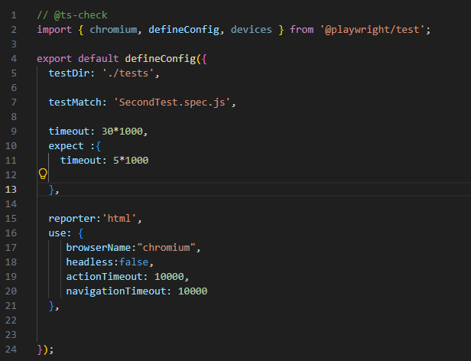

3.Action TimeOuts
1.Setting Step level- for Single Line.
Setting TimeOut for the Particular line
2.Setting Config level: Under use:{} we can define

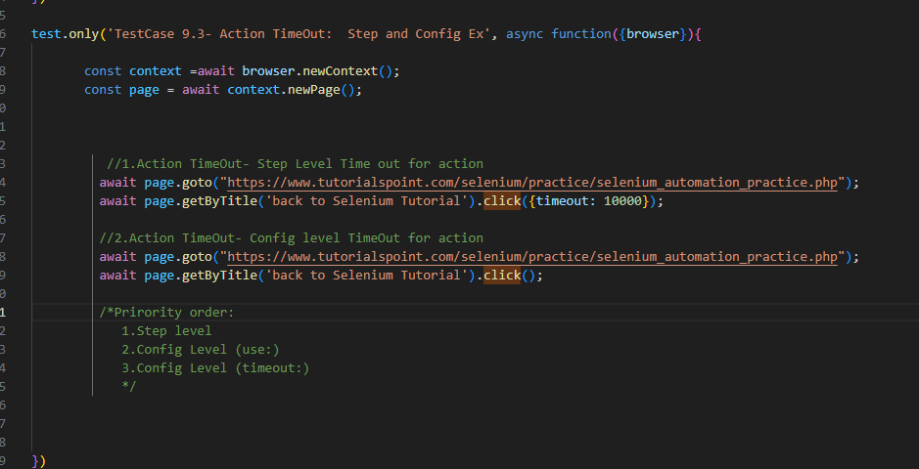
12.Playwright Test Run in UI mode
Command: npx playwright test --ui
Allow to Open UI mode, we can check each step and its respective actions
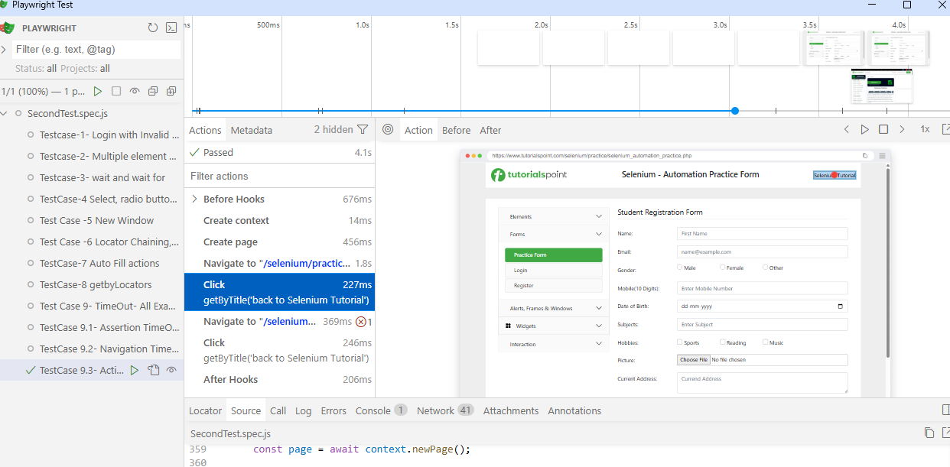

13.Playwright Test Run in debug mode
Command: npx playwright test -- debug
Allow to Open Debug mode
It will open both Debugger(Playwright inspector) and Browser
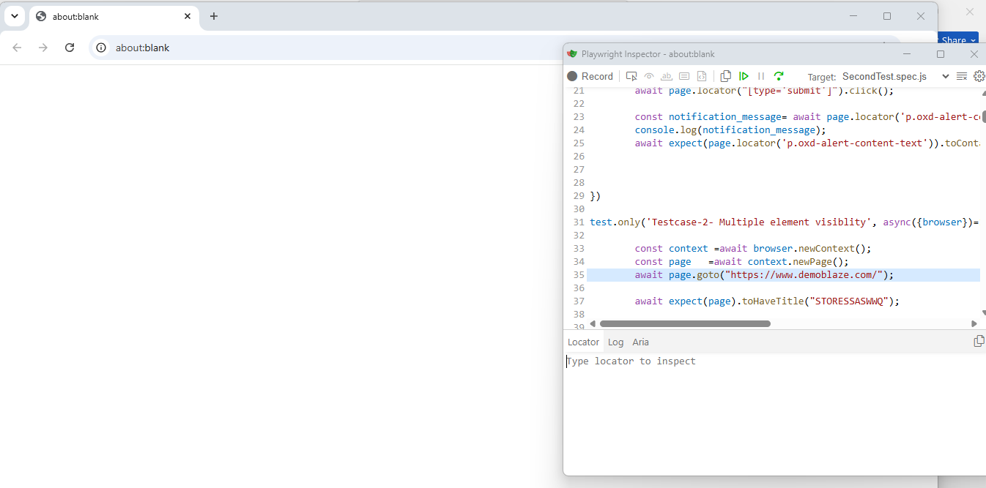
Using Step over we can execute each step
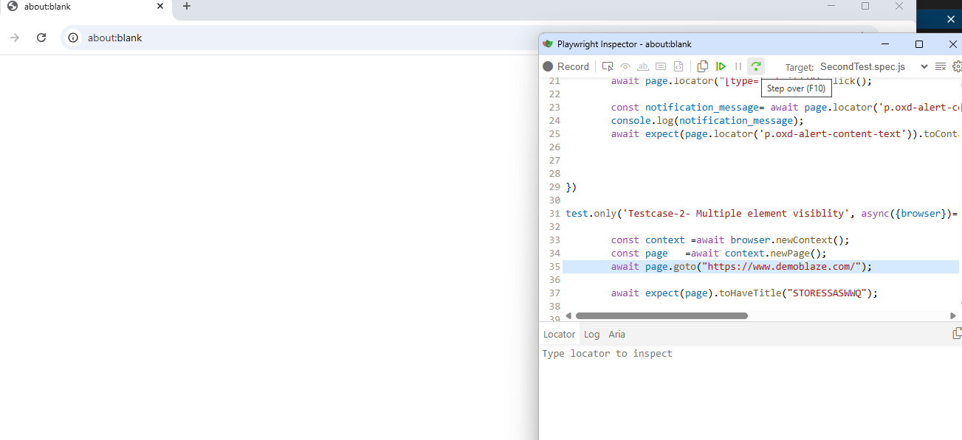
Using play button we can execute all the lines
Using inspect button we can inspect the locator
13.Playwright Test Run using codegen
Command: npx playwright codegen https://www.demoblaze.com/

Using Codegen we able to do record and playback
It will open both browser and Playwright inspector.
Using Record option- Allow to record and stop
Using inspect- Allow to Inspect and validate the locators
Using assertion for visible and validation – Allow to assert
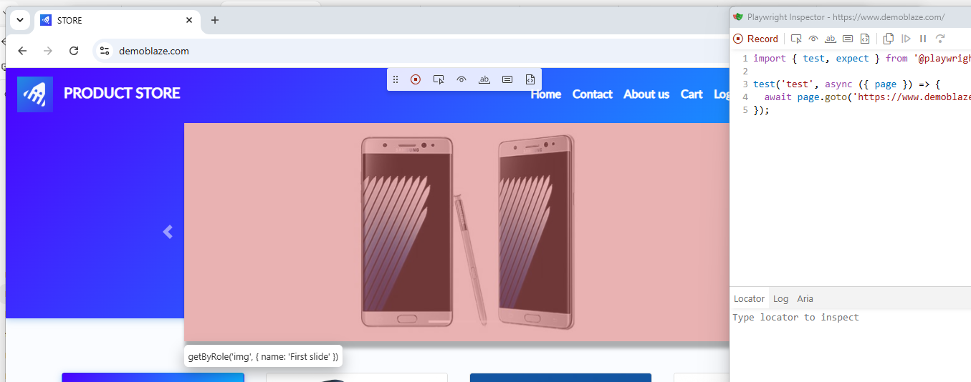

Code has been generated, now we can copy and modify the code according to our requirements
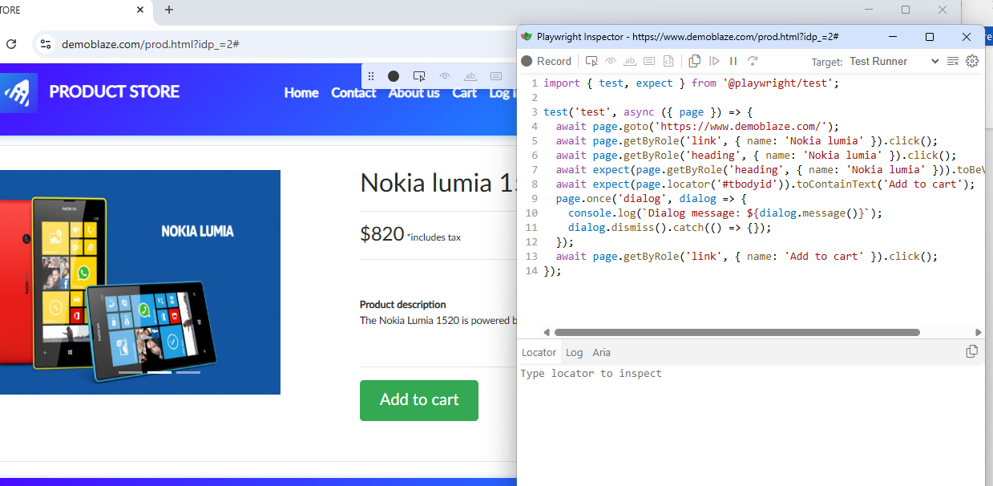

We can change the Language of the code using below option
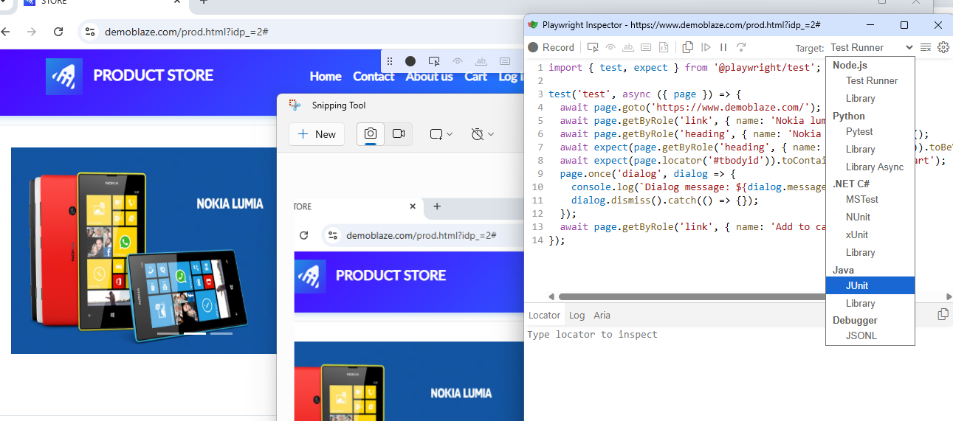
14.Test Traces, Screenshots, HTML Reports
Using screenshot and trace we able to
use: {
screenshot:'on',
trace:'on'
},
(i)Screenshot
This tells Playwright to capture a screenshot at the end of every test, whether the test passes or fails.
screenshot: 'off' // No screenshots (default)
screenshot: 'on' // Screenshot for every test
screenshot: 'only-on-failure' // Screenshot only if the test fails
(ii)Trace:
This records a trace for every test.
A trace includes:
- Every Playwright action
- Screenshots during execution
- DOM snapshots
- Network requests
- Console logs (where available)
- Timing information

trace: 'off' // No trace (default)
trace: 'on' // Record every test
trace: 'retain-on-failure' // Keep trace only if the test fails
trace: 'on-first-retry' // Record only on the first retry

(iii)report
Playwright proving reports for every run, either we can copy the path or will open the html report.
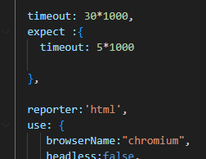
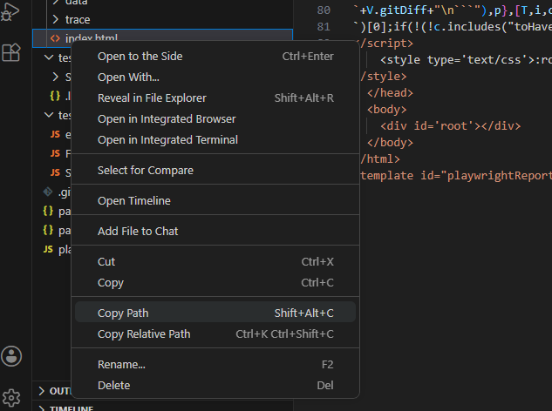

We can check failures using reports
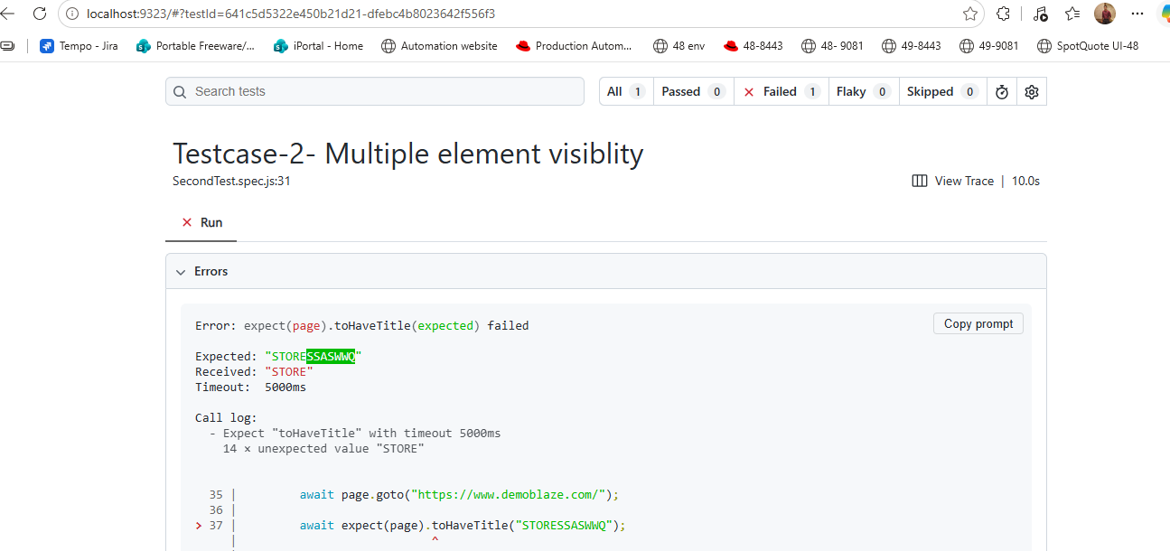
Test Step: where exactly fails
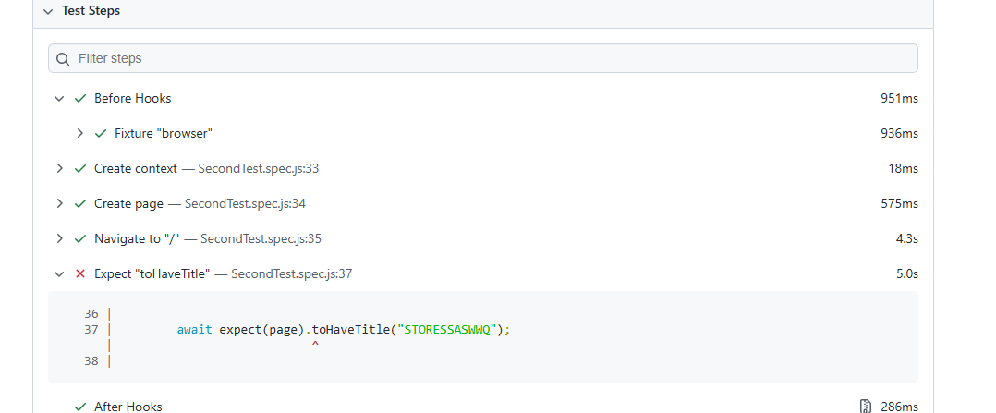
Screenshot zip provided for all steps
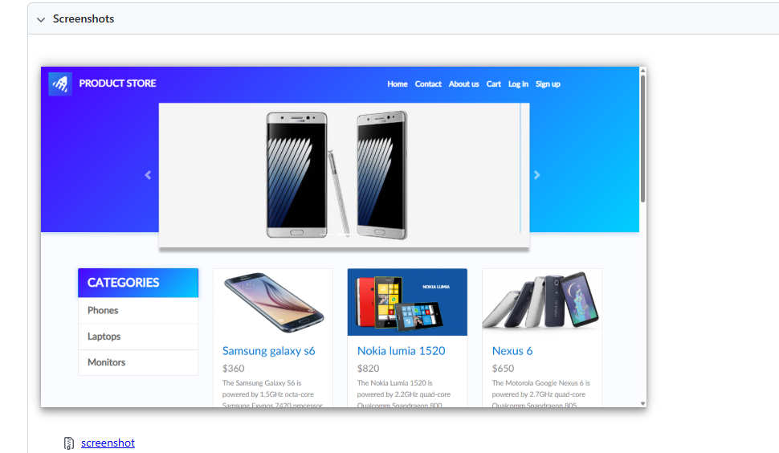
Using traces we can Trace each steps (both before and after)
Either download the Zip and Open it
Or Using Playwright Trace Viewer we can select file

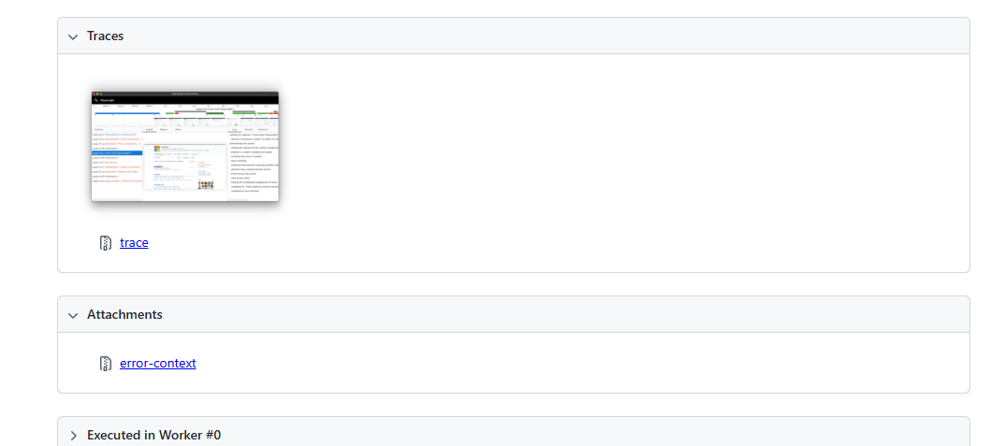

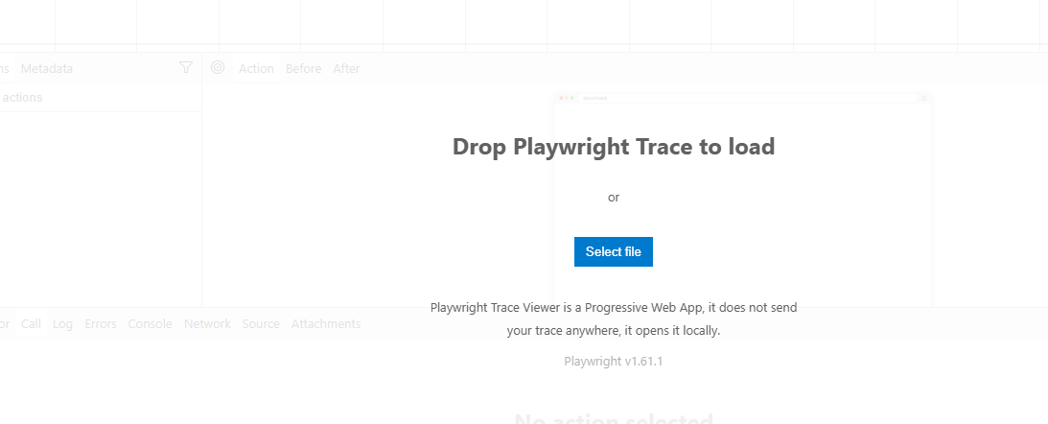
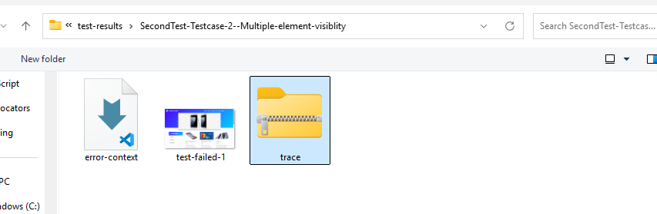
Path: D:\Playwright_automation_2\test-results\SecondTest-Testcase-2--Multiple-element-visiblity\trace.zip
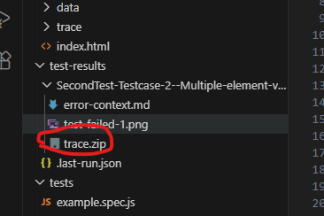
Using Before and After Actions we can check each steps
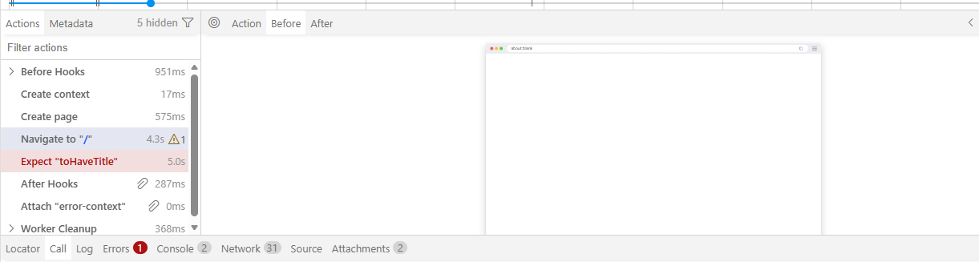
14.page -Forward,Backward,elements Visible and Hidden
Method | Purpose | Waits Automatically?
page.goBack() | Navigate to the previous page | Yes (waits for navigation)
page.goForward() | Navigate to the next page | Yes (waits for navigation)
expect(locator).toBeVisible() | Assert that an element is visible | ✅ Yes
expect(locator).toBeHidden() | Assert that an element is hidden or absent | ✅ Yes

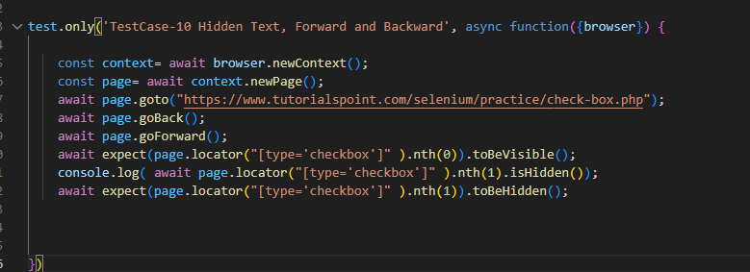

15.AlertBox and MouseHover
A dialog is a browser popup created by JavaScript, such as:
- Alert
- Confirm
- Prompt
Playwright handles these using the dialog event.
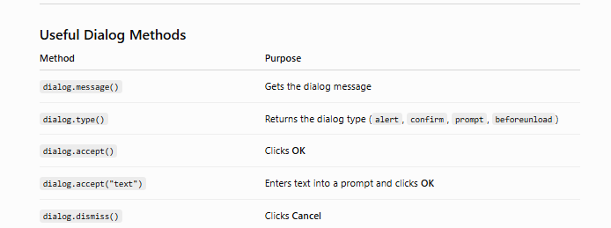

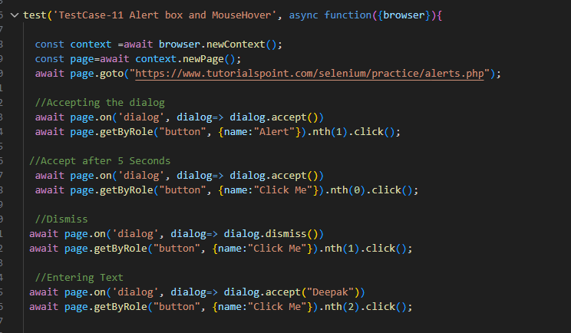

16.Frames
A frame (iframe) is a web page embedded inside another web page.
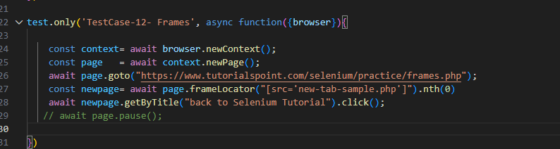
17.Screenshots
We can take screenshots using both page level and locators level as well
Compare screenshots
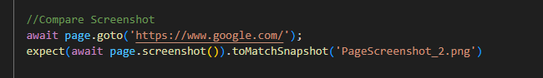
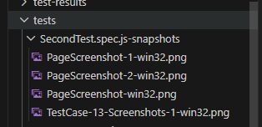
19.API TESTING USING PLAYWRIGHT:
To Declare API request
request: To create a request
get: GET Request declaration
if you are using Office laptop use this command before execution:
set NODE_TLS_REJECT_UNAUTHORIZED=0
To run: npx playwright test
npx playwright test tests/FirstTest.spec.js --headed
- GET Request
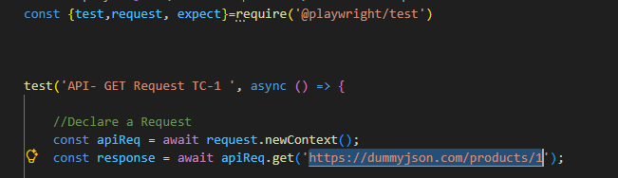

To Print JSON and its values
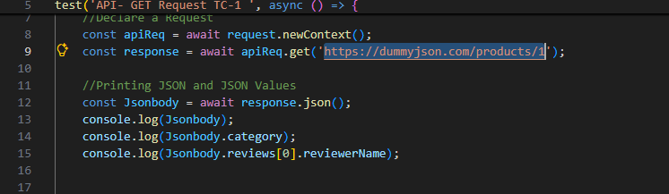

To Assert
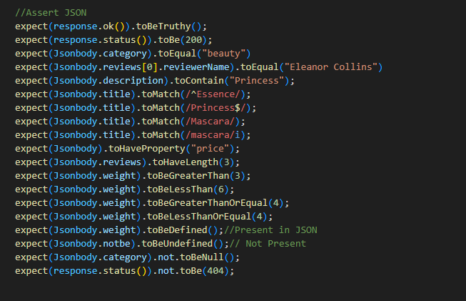
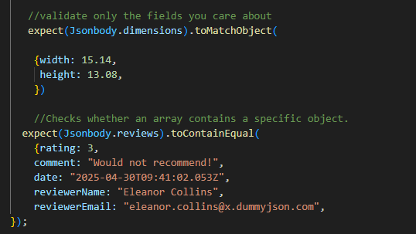
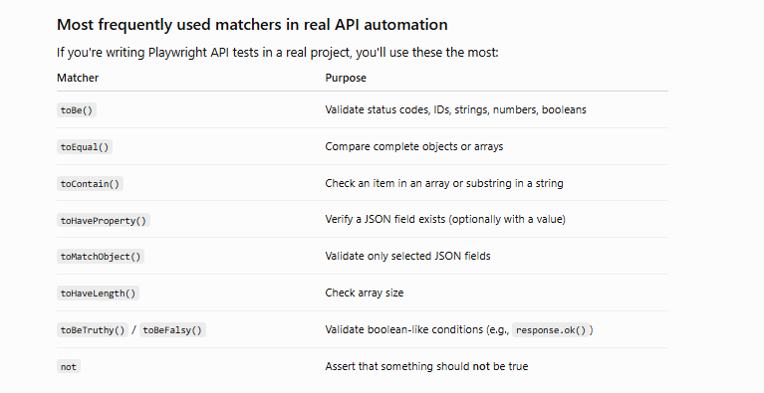

- POST Request:
If you want to Pass data, headers pass it using {}
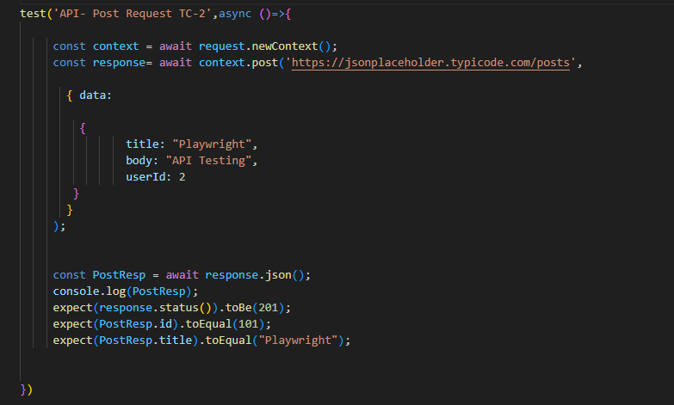
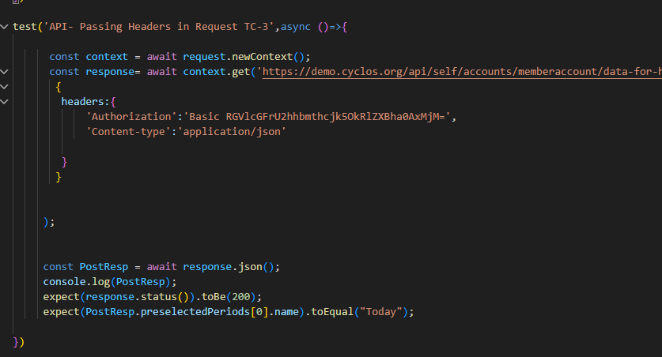
- Local Storage inputs
Steps:
Login Once
Store Session (Using Local Storage)

await context.storageState({path:'state.json'});
const webContext=await browser.newContext({storageState:'state.json'});

Storing Context information in state.json
Injecting that information into browser level, storing as a Variable “webContext”

Using that Stored Information we are creating new page
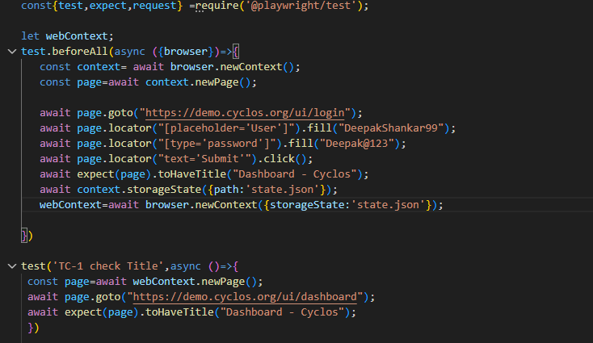

4.Injecting Fake Response while running
Steps:
Login
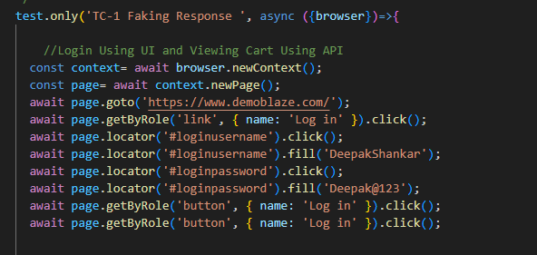
Passing View Cart data as a API request and checking Response
Navigating View Cart Section and Checking Cart available or not
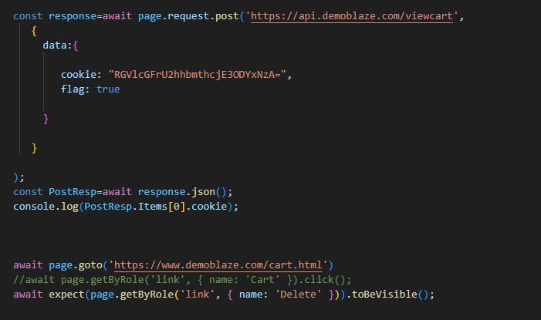

Faking Response by using routing the request
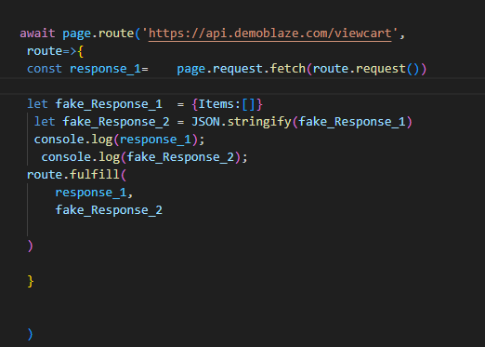

Now navigating to the view cart and check the availability
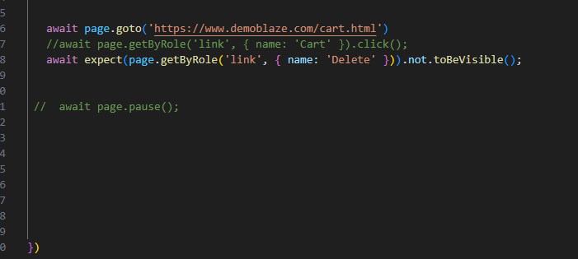

5.Injecting Fake request:
route.continue
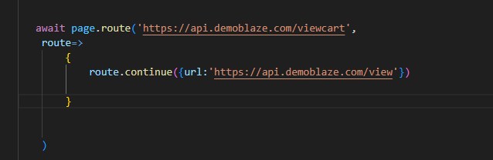

6.Restricting API
route.abort() => allow to restrict api’s using extensions
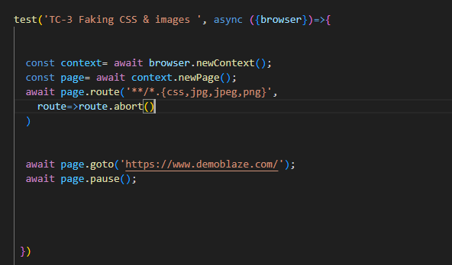

7. Listeners
Using listeners we can print the status , URL, etc.

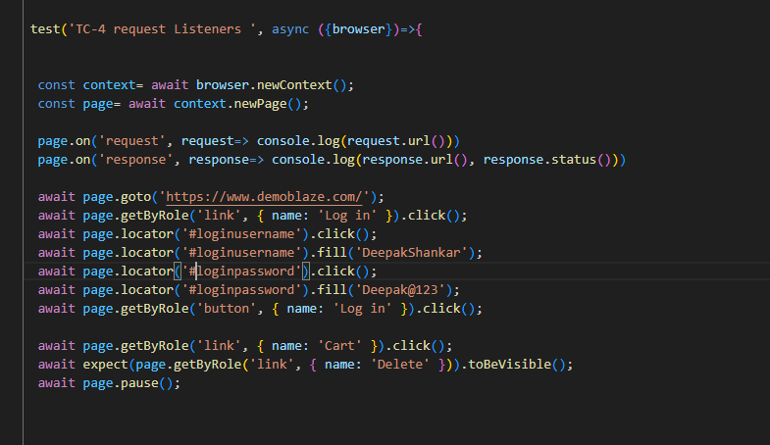

20.Excel Actions
Installation procedure
1.Create One Folder
2.”npm init”
3. Clicks enter for all
4.Give command as “npm install exceljs”

It will create a folder structure like this
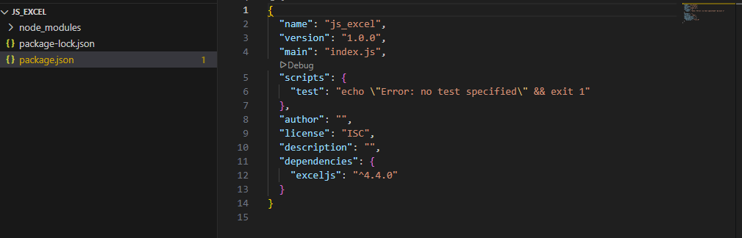
Present inside node_module
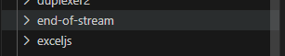
Folder structure
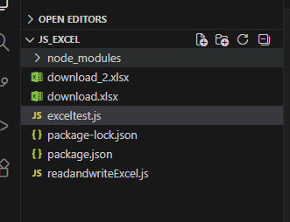
JavaScript code to Understand the Excel Read and write operation
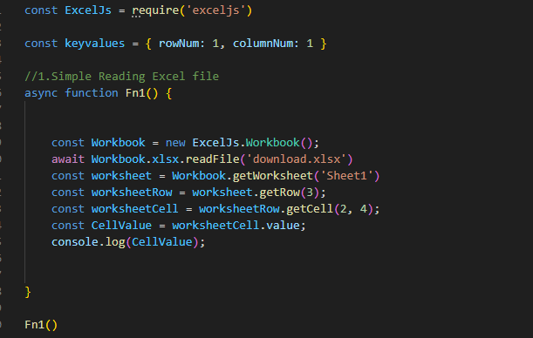
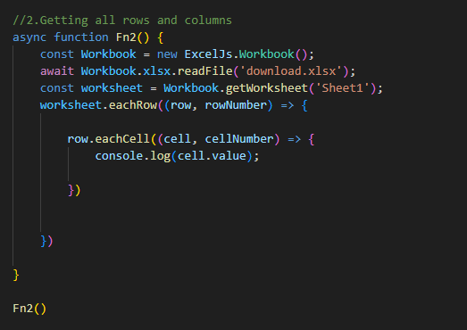
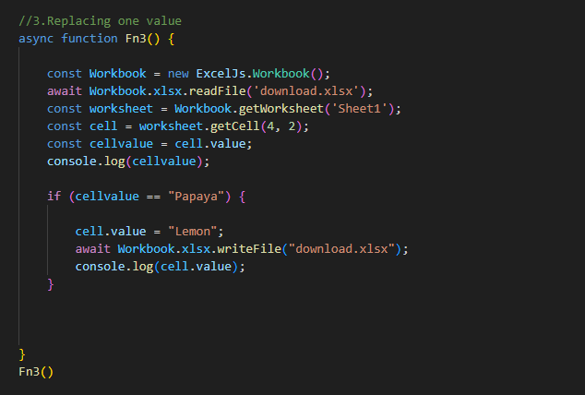
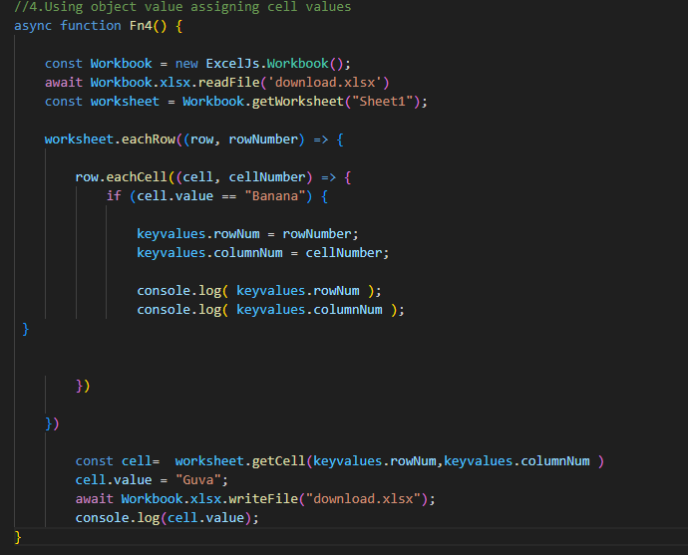

Read and write Excel by passing parameters
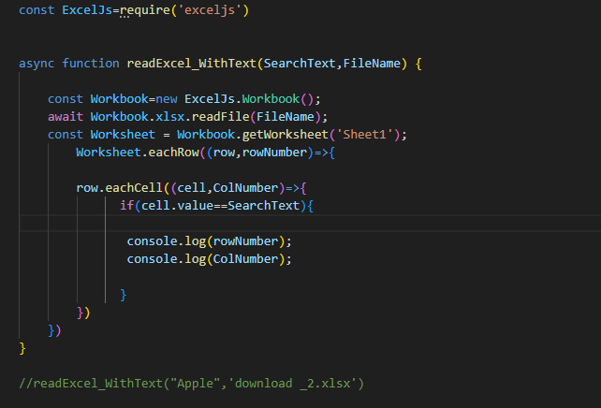
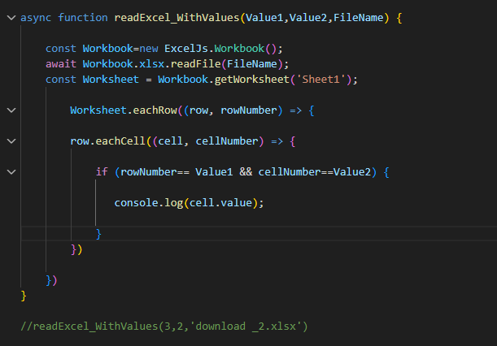
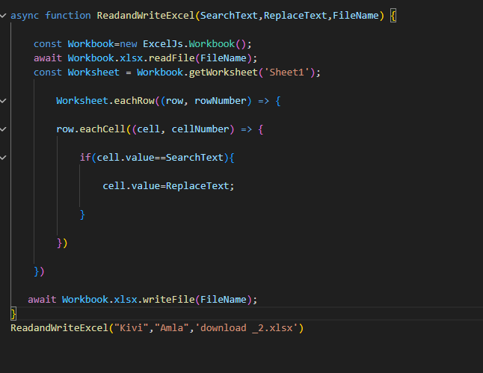
await page.waitForEvent("download");
-- Wait for download action
await readExcel_WithText("Apple",'/Users/209079/Downloads/download.xlsx')
await page.locator('#fileinput').click();
await page.locator('#fileinput').setInputFiles("/Users/209079/Downloads/download.xlsx")- to
-----Upload a File from local system
----- But the type should be file
