EV CHARGING DEMAND PREDICTION
Next-Hour Station-Level Electric Vehicle Charging Demand Forecasting

Project Report

Item | Details
Student | Deepak Timlapur
Project | EV Charging Demand Prediction
Domain | Data Science / Machine Learning
Application | Electric Vehicle Charging Infrastructure
Primary Task | Next-hour station-level demand forecasting
Interface | Streamlit
Selected Model | Gradient Boosting Regressor

1. Project Overview
EV Charging Demand Prediction is a machine-learning project designed to forecast the next hour's charging demand at individual electric vehicle charging stations. The project converts sparse charging-session observations into a complete station-by-hour time-series panel, creates leakage-safe historical features, evaluates baseline and regression models, and presents the results through an interactive Streamlit dashboard.

Objectives
- Analyze EV charging activity across stations, locations, vehicle types, and time periods.
- Aggregate raw charging observations into a station-level hourly forecasting dataset.
- Create historical lag and rolling features using only information available before the forecast hour.
- Prevent temporal data leakage by excluding contemporaneous demand-related variables from the model.
- Compare baseline forecasting methods with multiple machine-learning regression models.
- Select the model using validation-set MAE and evaluate it on a held-out chronological test period.
- Provide a visual Streamlit interface for exploring the dataset and model results.

Key Project Statistics
Measure | Value
Raw observations | 8,354
Original columns | 27
Charging stations | 20
Unique vehicles | 8,354
Station-hour panel | 41,780 rows
Usable target rows | 41,760
Model features | 16
Forecast target | Next-hour station-level charging demand

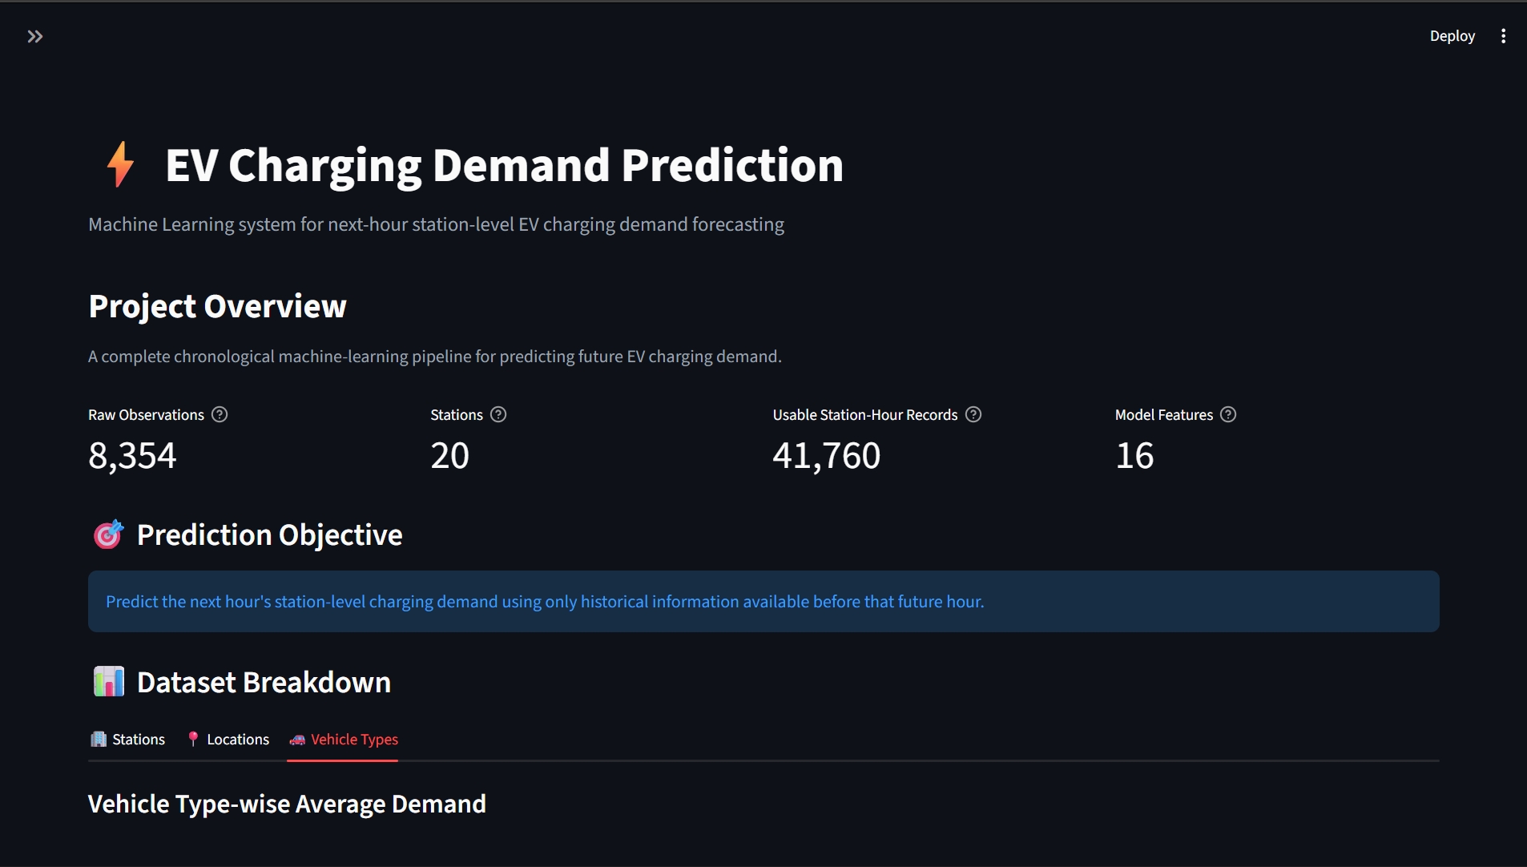
Figure 1. Streamlit project overview and dataset breakdown.

2. Project Structure
The project is organized into separate data-processing, feature-engineering, modeling, evaluation, forecasting, and interface components. This separation makes the workflow easier to reproduce, test, and maintain.
EV_Charging_Streamlit/
├── app.py
├── data/
│ └── EV_Charging_Demand_Dataset_Full.csv
├── models/
│ ├── selected_model.joblib
│ └── model_metadata.joblib
├── notebooks/
├── outputs/
│ ├── figures/
│ ├── predictions/
│ └── reports/
├── src/
│ ├── data_loader.py
│ ├── data_preprocessing.py
│ ├── feature_engineering.py
│ ├── eda.py
│ ├── train_test_split.py
│ ├── model_features.py
│ ├── models.py
│ ├── models_station_v2.py
│ ├── evaluation.py
│ └── forecasting.py
├── requirements.txt
├── README.md
└── .streamlit/
└── config.toml

Major Components
Component | Purpose
data_loader.py | Loads the dataset and performs basic validation.
data_preprocessing.py | Parses datetime fields, sorts observations, and validates preprocessing.
feature_engineering.py | Builds the complete station-hour panel and historical features.
train_test_split.py | Creates the chronological train, validation, and test sets.
model_features.py | Defines the canonical 16-feature modeling configuration.
models.py | Trains baselines and regression models and evaluates them.
evaluation.py | Generates model-performance figures and station-level error analysis.
forecasting.py | Generates the next-hour station-level forecast.
app.py | Provides the interactive Streamlit dashboard.

3. Dataset
The project uses the Electric Vehicle Charging Demand Dataset by Ziya, available on Kaggle. The dataset contains EV charging activity from urban and highway environments and includes station, vehicle, timing, charging, queue, energy, electricity-price, traffic, weather, and operational fields.
Dataset source: https://www.kaggle.com/datasets/ziya07/electric-vehicle-charging-demand-dataset

Dataset Characteristics
Characteristic | Value
Rows | 8,354
Columns | 27
Stations | 20
Vehicles | 8,354 unique vehicle IDs
Location types | Urban, Highway
Vehicle types | Car, Bus, Two-Wheeler
Timestamp range | 2025-01-01 00:00:00 to 2025-03-29 00:15:00
Missing values | 0
Duplicate rows | 0

Important Variables
Variable Group | Examples
Identifiers | station_id, vehicle_id, assigned_charger_id
Time | timestamp, arrival_time, charging_start_time, charging_end_time
Vehicle | vehicle_type, battery_capacity_kWh, initial_soc, final_soc
Charging | energy_consumed_kWh, charging_power_kW, charging_duration
Station conditions | queue_length, station_load, electricity_price
Environment | renewable_energy_ratio, traffic_density, weather_condition
Target-related | charging_demand

Dataset Analysis in the Dashboard
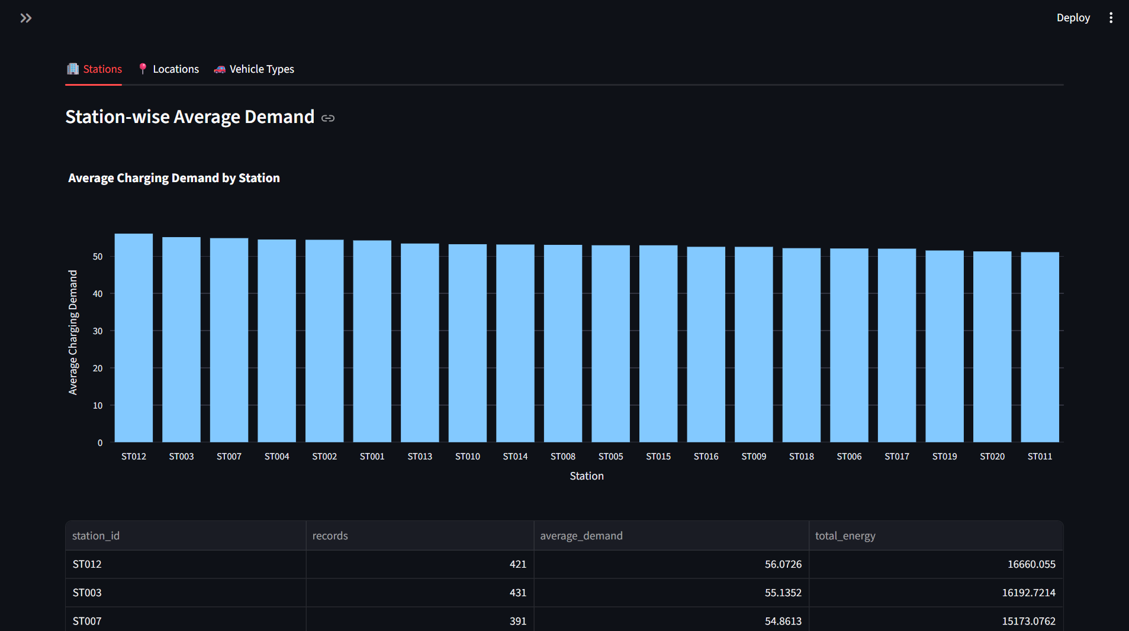
Figure 2. Station-wise average charging demand and station summary.
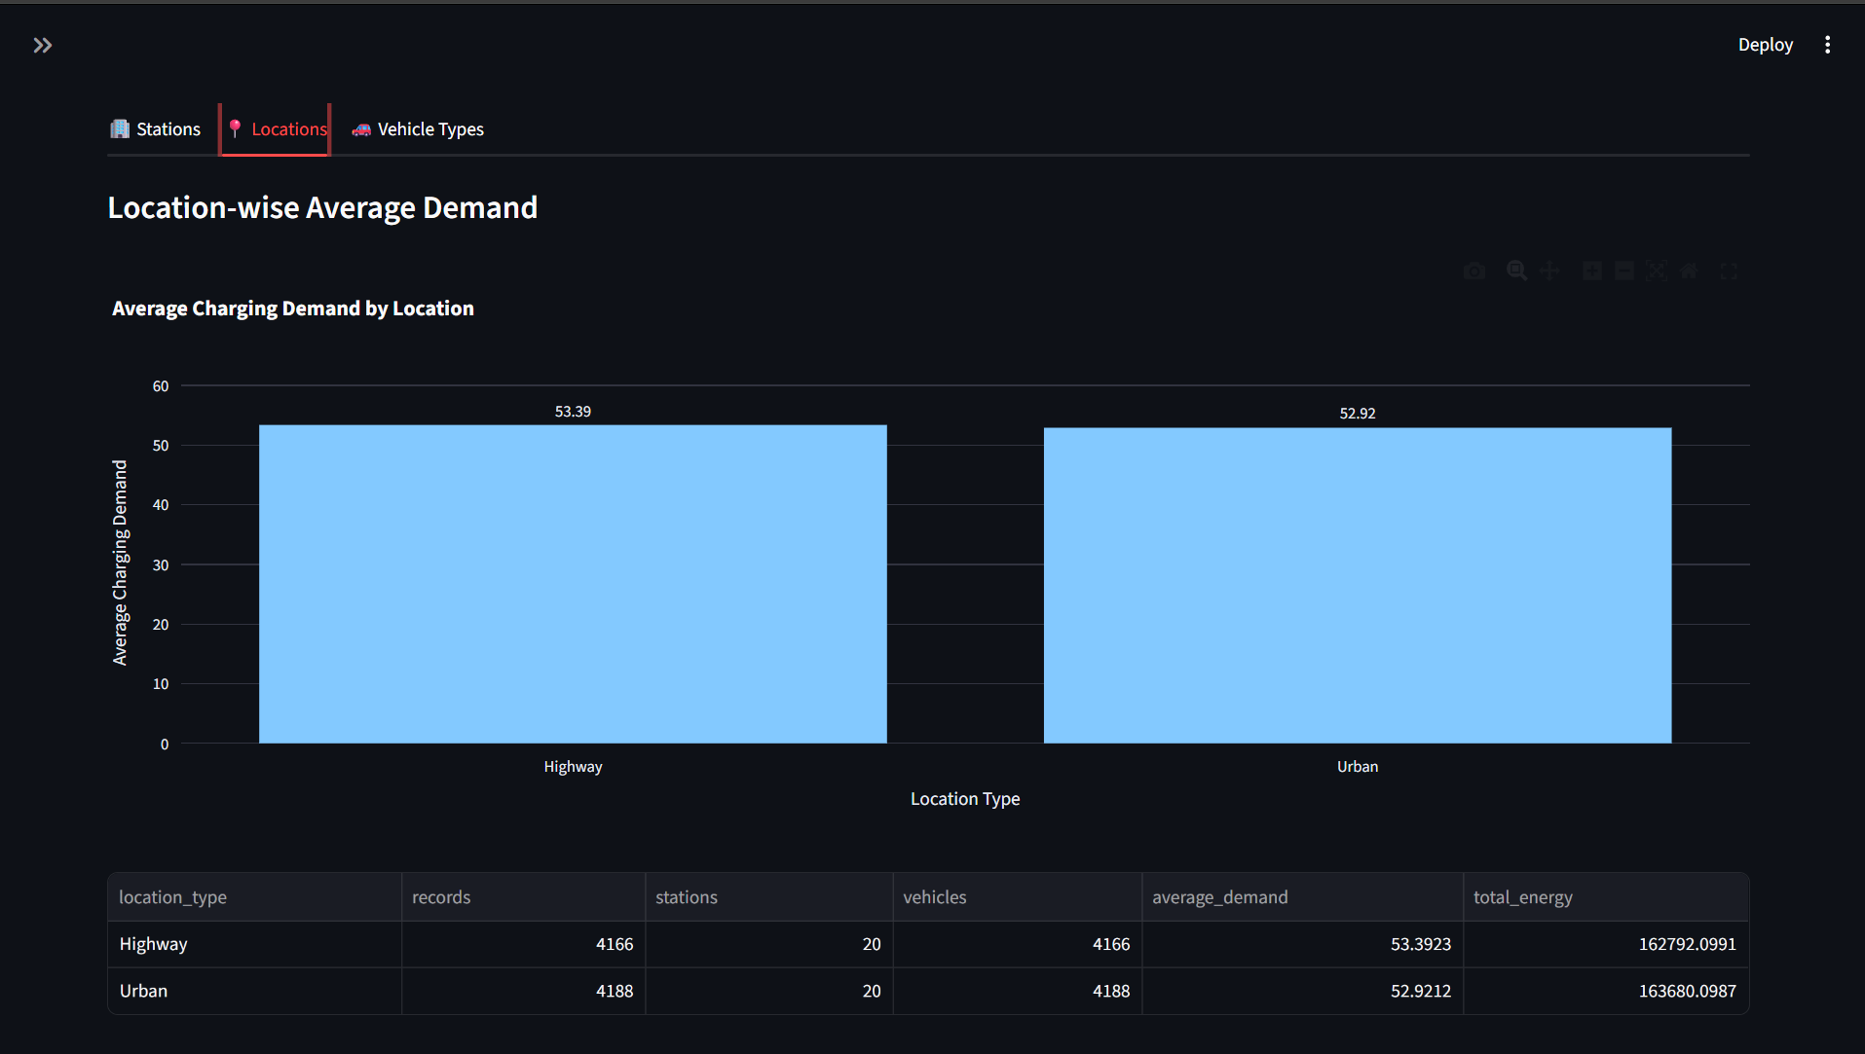
Figure 3. Location-wise average charging demand for Highway and Urban stations.
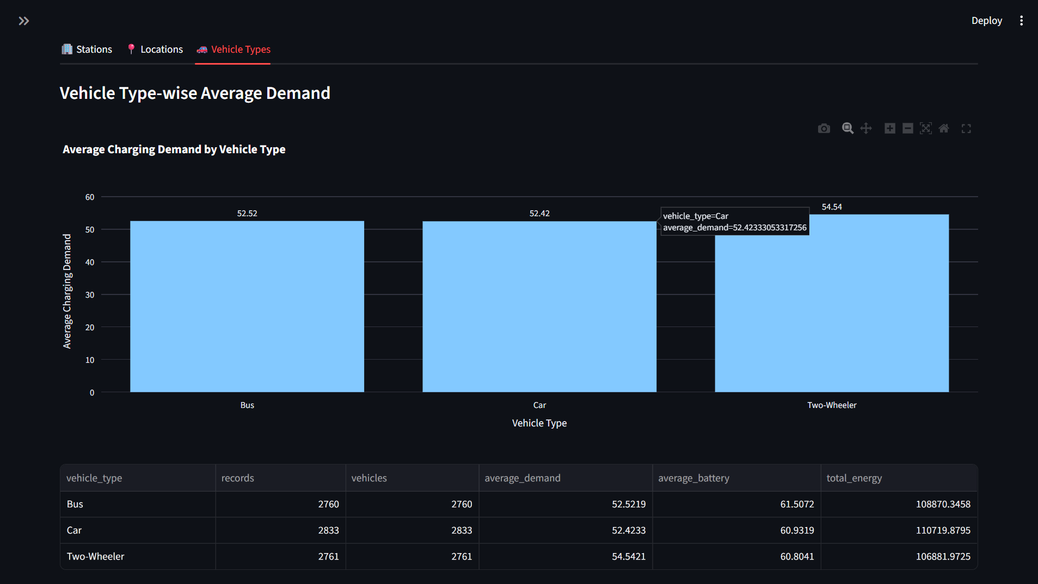
Figure 4. Vehicle-type average charging demand and vehicle summary.

4. Machine Learning Models
The forecasting problem is formulated as a supervised regression task. The target is `next_hour_demand`, defined as the next hourly charging demand for each station. The modeling pipeline uses a complete station × hour panel and historical information only.

Feature Engineering
- Calendar features: hour of day, day of week, day of month, month, and weekend indicator.
- Demand lags: 1-hour, 2-hour, 3-hour, and 24-hour historical demand.
- Station-load lags: 1-hour and 24-hour historical station load.
- Queue lags: 1-hour and 24-hour historical queue length.
- Historical rolling means: 3-hour, 6-hour, and 24-hour windows computed after shifting demand by one hour.

Leakage Prevention
Contemporaneous `charging_demand`, `station_load`, `queue_length`, `energy_consumed_kWh`, and `waiting_time` are excluded from the predictive feature set. Historical lagged versions are permitted because they represent information available before the forecast period.

Train / Validation / Test Strategy
A chronological global time split is used so that all stations belonging to the same target hour remain in the same split. The project uses approximately 70% of target hours for training, 15% for validation, and 15% for testing. No random shuffling is used.

Models Evaluated
Model | Role
Previous Hour | Forecasting baseline using the previous hour's demand.
Previous Day | Forecasting baseline using the previous day's demand.
Linear Regression | Linear regression benchmark.
Random Forest Regressor | Non-linear ensemble regression model.
Gradient Boosting Regressor | Sequential tree-boosting regression model.
HistGradientBoostingRegressor | Histogram-based gradient boosting model.

Validation Results
Model | MAE | RMSE | R² | MAPE (%)
Gradient Boosting | 16.0072 | 23.3062 | 0.0357 | 79.75
Linear Regression | 16.0179 | 23.6682 | 0.0055 | 74.64
HistGradientBoosting | 16.0273 | 23.3569 | 0.0315 | 79.74
Previous Day | 16.7119 | 33.2488 | -0.9626 | 90.58
Previous Hour | 16.7148 | 33.3274 | -0.9719 | 93.12
Random Forest | 17.0865 | 24.0808 | -0.0295 | 76.69

Gradient Boosting was selected using validation MAE. This is a dataset- and test-period-specific model selection result, not a claim that Gradient Boosting is universally the best forecasting algorithm.

Final Held-Out Test Performance
Metric | Gradient Boosting
MAE | 16.065038
RMSE | 23.460165
R² | 0.036521
MAPE | 80.046629%

MAPE is reported as a supplementary metric using non-zero actual values because the station-hour target contains zero-demand observations. The modest test R² indicates that substantial variation in next-hour demand remains unexplained by the available features.
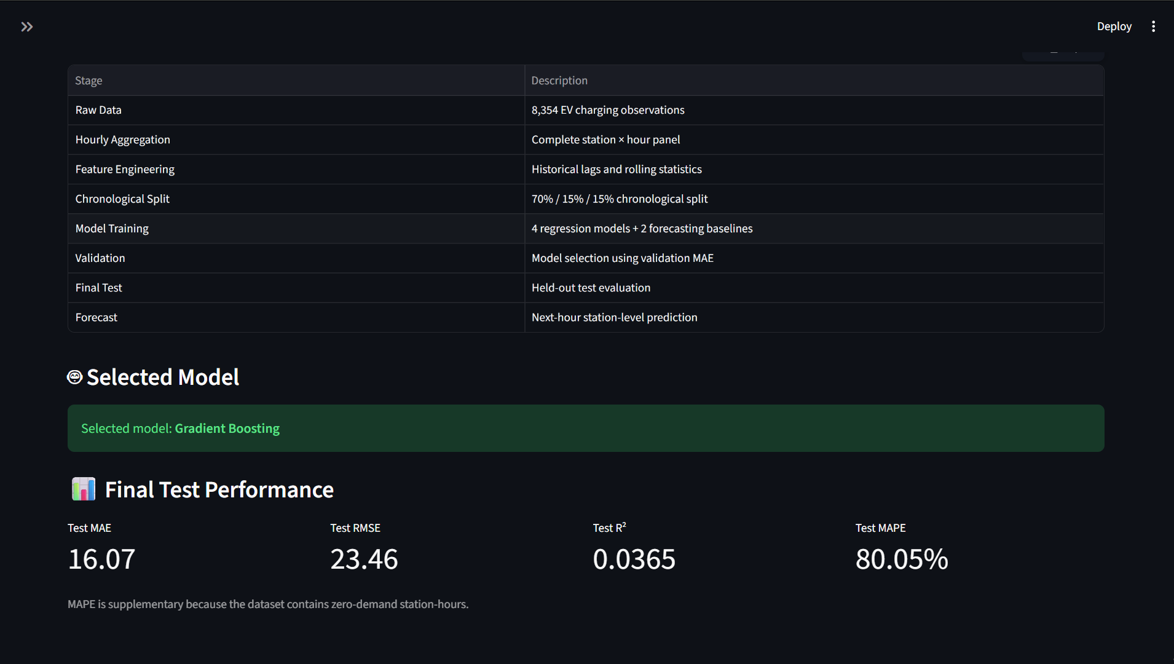
Figure 5. Streamlit model-training/performance view showing the selected model and final test metrics.

5. Frontend UI
The project uses Streamlit as its interactive frontend. The dashboard presents the dataset, forecasting workflow, model performance, station analysis, feature importance, and forecasting results in a dark-themed interface.

Main Dashboard Features
- Project Overview with key project statistics and prediction objective.
- Dataset Breakdown with station, location, and vehicle-type views.
- Station-wise demand visualization and summary table.
- Location-wise comparison between Highway and Urban observations.
- Vehicle-type analysis for Car, Bus, and Two-Wheeler categories.
- Model-training and final-test performance display.
- Forecast and model-analysis sections.
- Feature importance and methodology sections.

UI Screenshots
Figure 6. Project Overview and dataset breakdown.
Figure 7. Station-wise analysis view.
Figure 8. Location-wise analysis view.
Figure 9. Vehicle-type analysis view.
Figure 10. Model selection and final test performance view.

6. Sample Prediction Result
The forecasting module generates a next-hour prediction for each station using the latest model-ready historical observation available in the prepared station-hour dataset. The forecast shown below is a historical-endpoint demonstration from the project's verified forecasting run; it is not a live real-time forecast.
Station | Latest Observation | Forecast Hour | Predicted Demand | Category
ST001 | 2025-03-28 23:00 | 2025-03-29 00:00 | 5.49 | Low

The dashboard also reports the held-out test performance of the selected Gradient Boosting model: MAE 16.07, RMSE 23.46, R² 0.0365, and supplementary MAPE 80.05%.
Figure 11. Final model performance displayed in the Streamlit dashboard.

7. How to Run the Project

Prerequisites
- Python 3.10 or later.
- VS Code, Jupyter Notebook, or another Python development environment.
- The project dataset file: EV_Charging_Demand_Dataset_Full.csv.
- The project source code and trained model artifacts.

Step 1: Open the Project
Open the project directory in VS Code or PowerShell:
cd "C:\Users\Deepak\Downloads\EV_Charging_Streamlit"

Step 2: Create / Activate Virtual Environment
python -m venv .venv
.venv\Scripts\activate

Step 3: Install Dependencies
pip install -r requirements.txt

Step 4: Run the Streamlit Dashboard
streamlit run app.py
Streamlit will start the local web application and provide a browser URL. Open the displayed local URL to access the dashboard.

Step 5: Run the Jupyter Submission Notebook
jupyter notebook
Open `Deepak_EV_Charging_Demand_Prediction.ipynb` and execute the cells from top to bottom. The notebook performs the reproducible data analysis, feature engineering, model training, evaluation, and next-hour forecasting workflow.

Expected Project Outputs
- Validated dataset and exploratory-analysis outputs.
- Chronological train, validation, and test datasets.
- Trained Gradient Boosting model selected through validation MAE.
- Final test metrics and prediction results.
- Feature-importance and station-error analysis.
- Next-hour station-level forecast.
- Interactive Streamlit dashboard.

Final Note
The Streamlit interface is intended for interactive exploration and demonstration, while the submission notebook provides the reproducible academic code workflow. The model results should be interpreted for the supplied dataset and evaluation period.

