1. Ng new [Project name]
2. npm install bootstrap@4
3. npm install jquery@3.6.0
4. ng add @angular/material
5. npm install [popper.js@1.16.1](mailto:popper.js@1.16.1)
6. ng add @angular/cdk
7. npm install animate.css --save
8. npm install @angular/fire firebase –save
9. *$ npm i angular-cli-ghpages — save-dev*
10. npm install js-sha512
11. npm install --save font-awesome angular-font-awesome

or

ng add @fortawesome/angular-fontawesome {not sure}

1. ng add angular-datatables

**Need to configure these file and angular.json file to user bootstrap :**

 "styles": [

              "./node_modules/@angular/material/prebuilt-themes/indigo-pink.css",

              "./node_modules/font-awesome/css/font-awesome.min.css",

              "./node_modules/bootstrap/dist/css/bootstrap.min.css",

              "src/styles.css",

              "node_modules/datatables.net-dt/css/jquery.dataTables.css"

            ],

            "scripts": [

              "./node_modules/jquery/dist/jquery.min.js",

              "./node_modules/popper.js/dist/umd/popper.min.js",

              "./node_modules/bootstrap/dist/js/bootstrap.min.js",

              "node_modules/jquery/dist/jquery.js",

              "node_modules/datatables.net/js/jquery.dataTables.js"

            ]

**need to Import 2 module**

FormsModule,ReactiveFormsModule

import {HttpClientModule} from '@angular/common/http'

Need to create moduel for using angular material

import {NgModule} from '@angular/core'

import {MatButtonModule} from '@angular/material/button';

const md1=[

    MatButtonModule

]

@NgModule({

    imports:[md1],

    exports:[md1]

})

export class AngularMaterial{}

**How to router guard**

import {Injectable} from '@angular/core'

import { CanActivate, Router } from '@angular/router';

@Injectable()

export class LoginAuth implements CanActivate{

    constructor(private router:Router){

    }

    canActivate():boolean{

        this.router.navigate(["login"])

        return false

    }

}

**App.module =>**

providers: [LoginAuth],

**app-routing.module**

{path:"",component:HomeComponent,canActivate:[LoginAuth]},

**Data table**

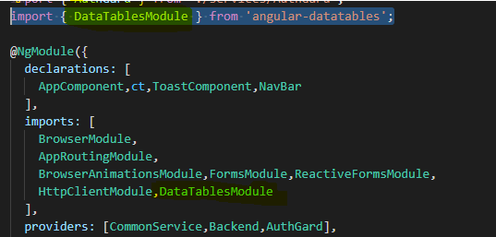

    <table datatable  [dtOptions]="dtOptions"

[dtTrigger]="dtTrigger"  class="row-border hover">

        <thead>

          <tr>

import { Subject } from 'rxjs';

  dtTrigger:Subject<any>=new Subject<any>();

    dtOptions: DataTables.Settings = {};

this.dtOptions = {

            pagingType: 'full_numbers',

            pageLength: 10,

            destroy: true,

            retrieve: true,

          };

 this.productListsubscription=backend.sendGetRequest("allProduct").subscribe((res:any)=>{

            this.productList=res.data;

            console.log(this.productList)

            this.dtTrigger.next();

        })

Rerendring

  @ViewChild(DataTableDirective, {static: false})

    dtElement: DataTableDirective;

  ngAfterViewInit(){

        this.dtOptions = {

            pagingType: 'full_numbers',

            pageLength: 10,

            destroy: true,

            retrieve: true

         };

         this.billingsrivce.dtElement=this.dtElement;

         this.billingsrivce.trigger.next();

    }

  this.dtElement.dtInstance.then((i:DataTables.Api)=>{

            i.destroy(false)

            if(!this.addifAlreadyExistInList(pro)){

                this.cartList.push(pro)

             }

            this.trigger.next();

        })

Tomcat page reload issue :

import { HashLocationStrategy, LocationStrategy } from '@angular/common';

 providers: [

    { provide: LocationStrategy, useClass: HashLocationStrategy}],

]

CHARts

npm install ng2-charts@2.4.2 –save

npm install chart.js

**import** { ChartsModule } **from** 'ng2-charts';

*// In your App's module:*

imports: [

   ChartsModule

]

Angular sementic

ng generate @angular/material:navigation <component-name>