Working with keyclock docker image.

docker run -p 8080:8080 -e KEYCLOAK_USER=admin -e KEYCLOAK_PASSWORD=admin quay.io/keycloak/keycloak:14.0.0

* User name : admin
* Password : admin

1. Create new relem and switch to that
2. Create new user
   1. Click user -> add user
   2. Fill details and crertinalias
   3. **http://localhost:8080/auth/realms/test/account/**
3. Create new oauth2 client.
   1. Click on client
      1. Enter client id
      2. Save
      3. <http://localhost:8080/auth/realms/test/protocol/openid-connect/auth?client_id=test-id&redirect_uri=https://www.google.com/&response_type=code&scope=openid>
   2. How to create token
      1. <http://localhost:8080/auth/realms/test/protocol/openid-connect/token> -- POST

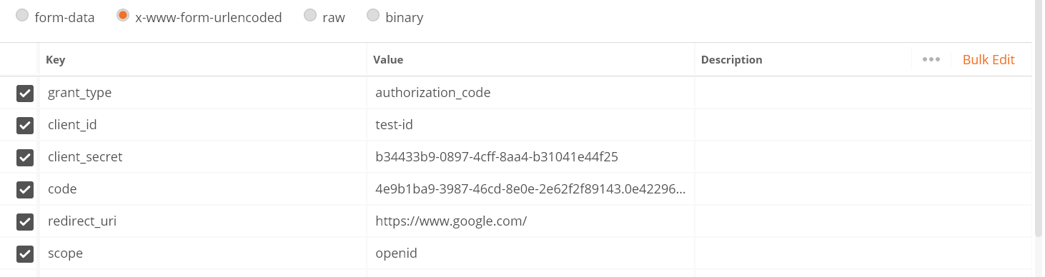

**How to create resource server.**



**genretate token and hit request**

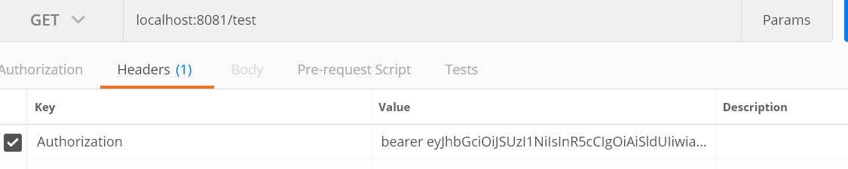

**How to get details from auth token**

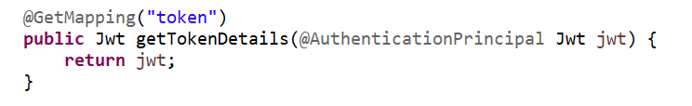

**Access based on scope :**

**Configuration**



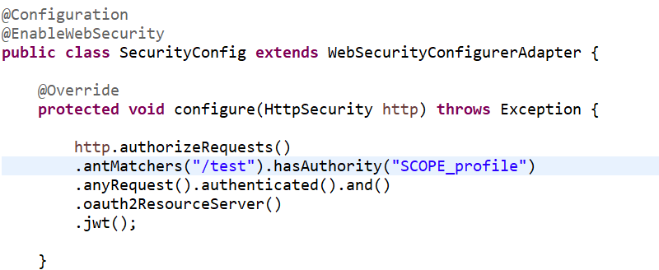

**Note : to access /test you need to generate token having scope of profile.**

**-**

**Role base accesss**

1. **Create new role in key clock server and assign to user**
2. **Change configuration and need to create a converter class**
   1. 

**Method level Security**

1. **Enable security**
   1. 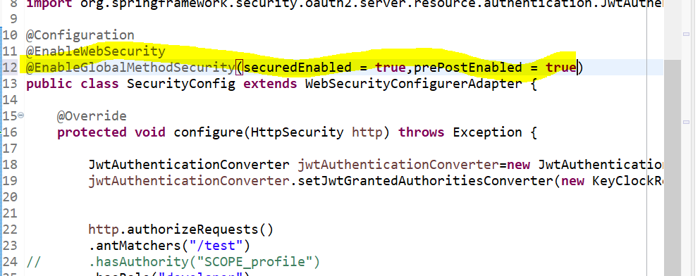
2. **Working with @Secured @pre @post** 
   1.  
   2. 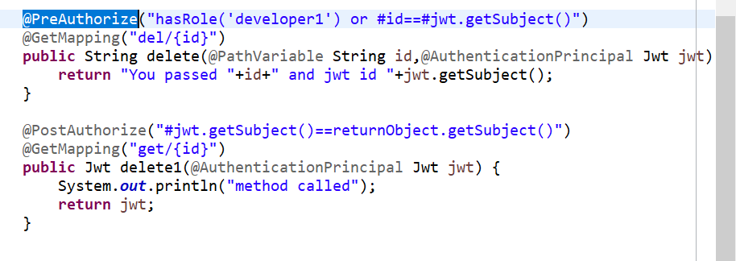

**Password grant type.**

1. **Enable direct access on** client
   1. 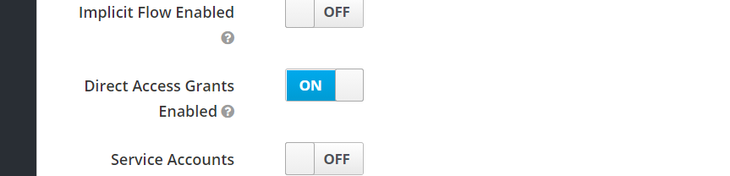
2. <http://localhost:5590/auth/realms/inventory/protocol/openid-connect/token>
3. 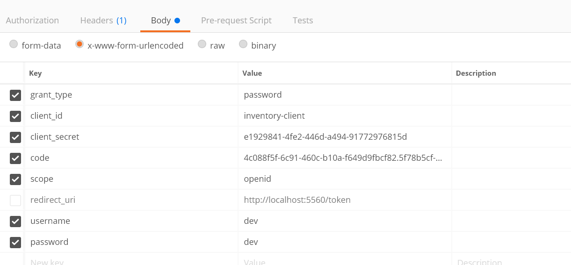
4. **Get access token**

**How to incese token access time**

