1. Write a PHP script which decodes the following JSON string.
Sample JSON code :
{"Title": "The Cuckoos Calling",
"Author": "Robert Galbraith",
"Detail": {
"Publisher": "Little Brown"
}}
Expected Output :
Title : The Cuckoos Calling
Author : Robert Galbraith
Publisher : Little Brown2.

Code :
Pat1.php:
<?php
$json = file_get_contents('book.json');
$data = json_decode($json, true);
echo "Title : " . $data['Title'] . "<br>";
echo "Author : " . $data['Author'] . "<br>";
echo "Publisher : " . $data['Detail']['Publisher'] . "<br>";
?>

book.json file

{
"Title": "The Cuckoos Calling",
"Author": "Robert Galbraith",
"Detail": {
"Publisher": "Little Brown2"
}
}
Output:

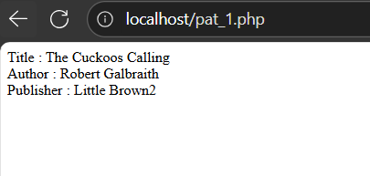

2. Create a PHP script that accepts a password string. The password must: • Be at least 8 characters long. • Contain at least one uppercase letter . • Contain at least one digit. • Contain at least one special character (e.g., @, #, $, %). If the password does not meet any of these conditions, throw a custom exception with a message like "Password must contain at least one uppercase letter". Handle the exception and display the error message.

Code:
<?php
class PasswordException extends Exception {}

function validatePassword($pwd) {
if(strlen($pwd) < 8) throw new PasswordException("Password must be at least 8 characters long.");
if(!preg_match('/[A-Z]/', $pwd)) throw new PasswordException("Password must contain at least one uppercase letter.");
if(!preg_match('/\d/', $pwd)) throw new PasswordException("Password must contain at least one digit.");
if(!preg_match('/[\@\#\$\%\&\*\!]/', $pwd)) throw new PasswordException("Password must contain at least one special character (@,#,$,%,&,*,!).");
return true;
}

if ($_SERVER['REQUEST_METHOD'] == 'POST') {
$pwd = $_POST['password'];
try {
validatePassword($pwd);
echo "Password is valid.<br>";
} catch (PasswordException $e) {
echo $e->getMessage() . "<br>";
}
}
?>
<form method="post">
<input type="password" name="password" placeholder="Enter password" required>
<input type="submit" value="Submit">
</form>

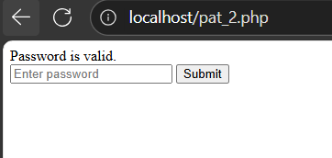

3. Add a “Remember Me” option that saves the username in a cookie.

Code:
<?php
if(isset($_POST['remember'])) {
setcookie("username", $_POST['username'], time()+3600);
echo "Username saved in cookie.<br>";
}
?>
<form method="post">
<input type="text" name="username" placeholder="Enter username">
<input type="checkbox" name="remember"> Remember Me
<input type="submit" value="Login">
</form>

Output:
