STEPS FOR CREATING SNAPSHOT AND INCREASING VOLUME OF ROOT DRIVE

1.Create a windows AMI connect to the machine using the RDP by the public ip.Right click on the local disk c and check the disk space(30gb)

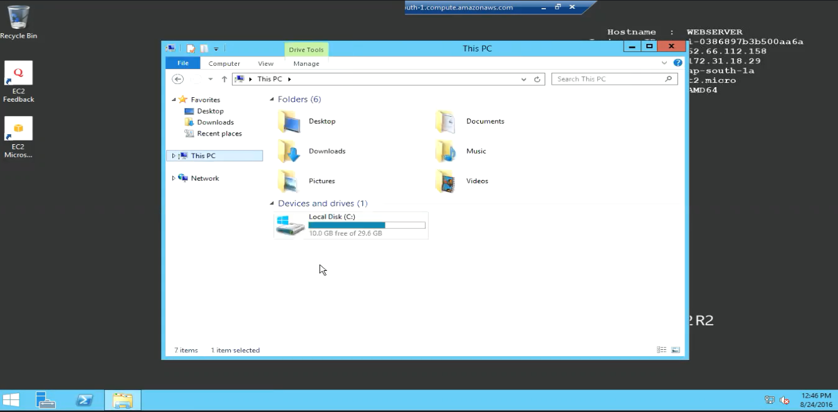

1.Click on the volumes change the name to webserver

2.Right click on volumes and click create snapshot name it as webserverwith50gb

give the extension

3.Click on the snapshot id

4.Right click on webserverwith50gb and click create volume

5.Give the range to extend as 50gb and make the availability zone same as the availability zone of the instance created

6.Create volume > click on volume

7.Give the name webwith50gb and go to the winodow’s instance right click and select stop

8.Right click on webserver and click detach

9.Click on the reload button on the right top

10.Click on the webwith50gb and click attach

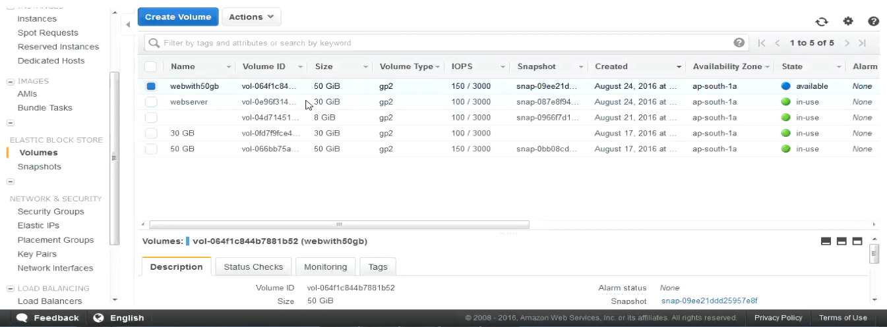

11.In the popup dialog box paste the

-instance with windows instance id

-device with root volume of webserver

12.Goto instance and Right click on it and select start .Connect to the windows AMI by using the public ip in RDP once the status checks are completed .

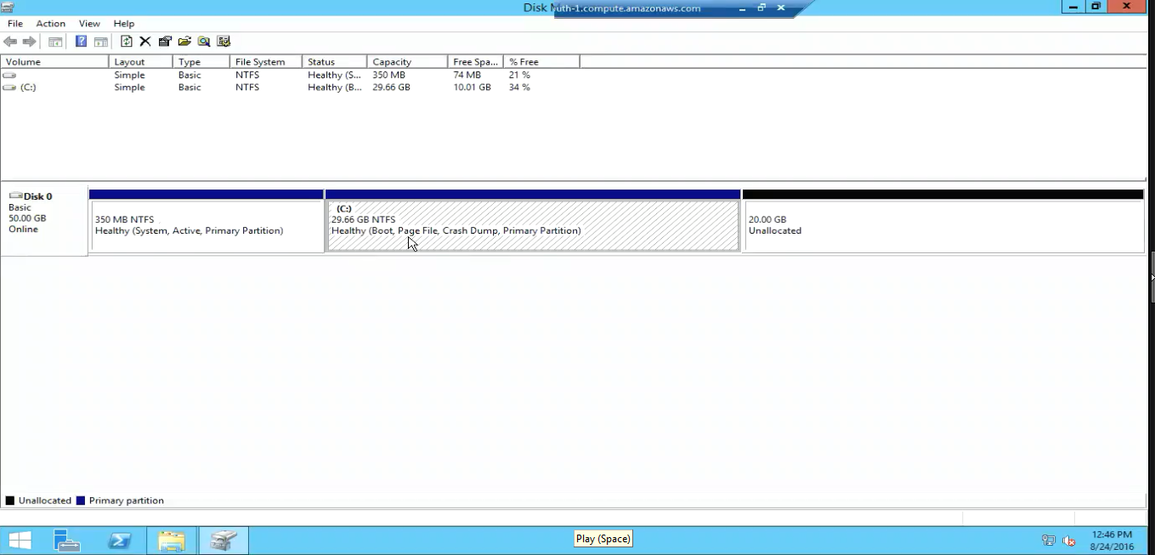

13. Type diskmgmt.msc on RUN and Right click on localdisk c

14.Click on extend volume click next >finish

15. Right click on the local disk c and check for the extended disk space(50gb)

