Creating/deleting/uploading a file to s3bucket from command line using python boto3

* S3bucket.py is my python file I have created, which takes two arguments.

1. a)Before Creating s3 bucket :

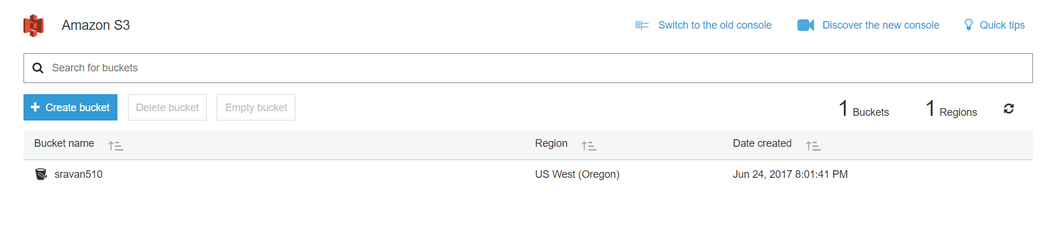

b) After creating s3 bucket :

command : ./s3bucket.py create-bucket sravan_first_510

First argument: create_bucket

Second argument: Unique_bucket_name

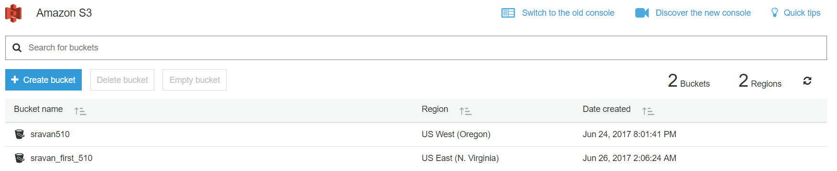

1. Uploading a new file to bucket :

Command : ./s3bucket.py upload-object sravan_first_510

First argument: upload-object

Second argument: Unique_bucket_name

After uploading hello.txt file to the s3 bucket

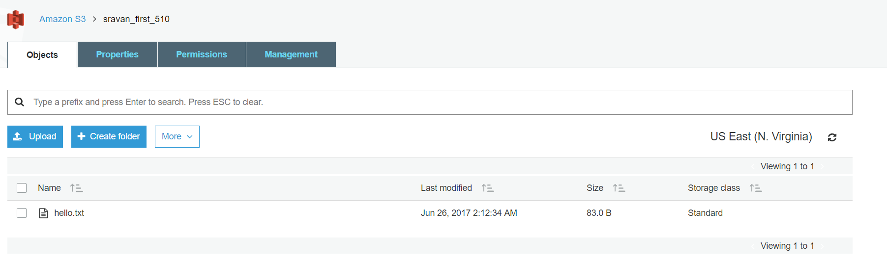

1. Deleting s3bucket :

Command : ./s3bucket.py delete-bucket sravan_first_510

First argument: delete-bucket

Second argument: Unique_bucket_name

After deleting sravan_first_510 bucket

