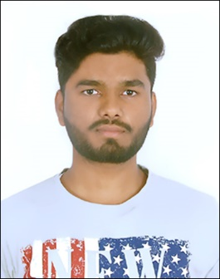

Deepak G Ghatteppanavar

MCA Postgraduate

A motivated and enthusiastic individual eager to showcase the skills required to be a prime part of an esteemed organization which enables me to showcase my inner potential and soar to new heights along with the company.



[deepakghatteppanavar@gmail.com](mailto:deepakghatteppanavar@gmail.com)

+919742851097



Hubli, India



https://www.linkedin.com/in/deepak-g-64147b242/

# SKILLS

TEAM WORK

QUICK LEARNING

PYTHON

C++

C

**EDUCATION**

JAVA

HTML5

JAVA

SQL

## MCA (CGPA: 7.84)

### KLE Technological University, Hubli.

*02/2022 - Present*, *Courses*

##### MCA

SEM1- 7.84

## BSc (74.67)

### KLE,s S K Arts & H S K Science Institute, Hubli.

*06/2018 – 06/2021 Courses*

##### PMCs

## PUC ( 69.5% )

### Konnur Science PU College, Yallatti

*07/2016 - 05/2018*,

*Courses*

PCMCs

## SSLC ( 83.04% )

### Jaycee English Medium School, Mahalingpur

*05/2016*,

# LANGUAGES

English

*Professional Working Proﬁciency*

##### Hindi

*Professional Working Proﬁciency*

##### Kannada

*Native or Bilingual Proﬁciency*

# PROJECTS

Technical Support Fundamentals (04/2022)

The Bits and Bytes of Computer Networking (06/2022)

Operating Systems and You: Becoming a Power User (07/2022)

.

# INTERESTS

PHOTOGRAPHY

# DEVELOPMENT TOOLS

CRICKET

CRICKET

CRICKET

#### Microsoft Visual Studio Code, Eclipse IDE, Google Colab

DRAWING

DRAWING

DRAWING

SPORTS

DRAWING

DRAWING

DRAWING

DRAWING

DRAWING

DRAWING

DRAWING

DRAWING

DRAWING

DRAWING

DRAWING

DRAWING

DRAWING