CAPSTONE PROJECT

On

Northwind traders

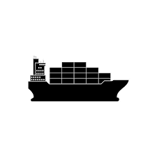

By

Deepak kag

Batch – DA4

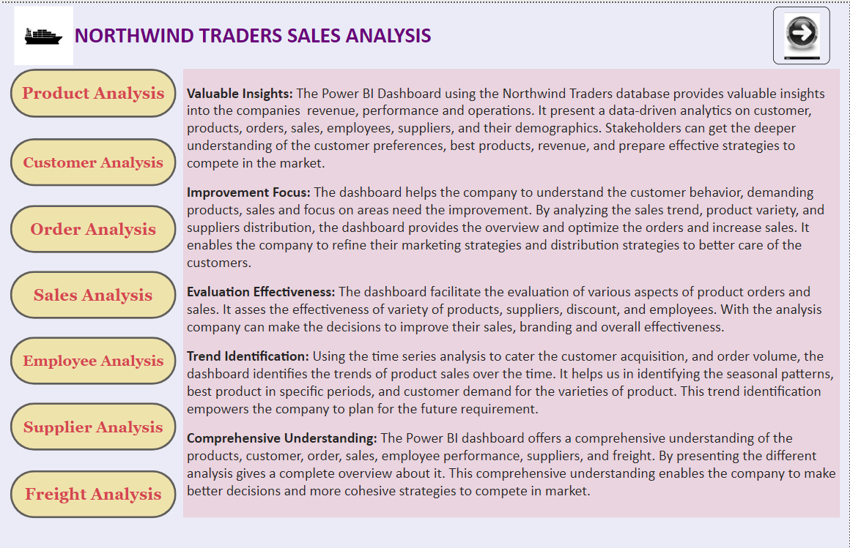**Project Overview:**

**Content**

Introduction - 4

Objective - 5

Analysis Scope - 6

Goal - 8

Insights and Recommendation - 9

Data Sourcing, Data Transformation, Data Cleaning, and Data Modelling - 10

ER Diagram - 12

Power BI Problem Statement - 13

EDA Problem Statement - 39

Conclusions - 54

**INTRODUCTION**

Northwind Traders is a fictional company specializing in the import and export of specialty foods worldwide. With a comprehensive sales database, the company strategically manages its expansion by considering a diverse group of stakeholders. The database encompasses crucial information, including customer and employee demographics, order details, product specifics, supplier details, and shipping company records. This robust data infrastructure empowers Northwind Traders to make informed managerial decisions and efficiently run its operations.

**OBJECTIVE**

The objective of this project is to design and implement a comprehensive Power BI Dashboard leveraging the rich dataset from the Northwind Traders database. This ambitious endeavour is driven by the desire to unlock valuable insights and facilitate informed decision-making for the company's stakeholders. The multifaceted nature of the Northwind Traders business, centred around the import and export of specialty foods from across the globe, necessitates a sophisticated analytical tool to make sense of the diverse and extensive data.

The creation of a dynamic and user-friendly Power BI Dashboard that provides a holistic view of various key aspects of the business. The dashboard aims to seamlessly integrate data related to customers, employees, orders, products, suppliers, and shipping companies. By consolidating these disparate datasets into a unified and visually intuitive interface.

Through the implementation of a robust Power BI Dashboard, the company aspires to not only gain a deeper understanding of its operations but also to foster a proactive and adaptive approach to business management. The amalgamation of diverse datasets into a cohesive and visually compelling platform is poised to elevate Northwind Traders' analytical capabilities, setting the stage for informed decision-making and sustained growth in the dynamic landscape of specialty food import and export.

**Top of Form**

**ANALYSIS & SCOPE**

The analysis is focused on dissecting various pivotal aspects within Northwind Traders operational framework. The key areas under scrutiny include product categories, product sales, the distribution of customers and employees, supplier relationships, order fulfilment timelines, and the consequential impact of discounts. The goal is to derive nuanced insights that will inform strategic decision-making and enhance the overall efficiency of the company's business processes.

The analysis involves a meticulous examination of product categories. By delving into the performance metrics of different product categories, the objective is to discern patterns and trends that can guide the company's inventory management and marketing strategies. Understanding which product categories are consistently high-performing or witnessing fluctuations over time is crucial for tailoring the product catalogue to meet market demands effectively. Time series analysis will be employed to track the trajectory of sales over specific periods. This approach provides a dynamic view, allowing for the identification of seasonal variations, emerging trends, and potential areas for revenue growth. The insights garnered from this analysis will serve as a foundation for optimizing sales strategies and maximizing revenue streams.

The distribution of customers and employees across various demographics and regions is another focal point. By mapping out these distributions, the analysis aims to uncover patterns in consumer behaviour, preferences, and workforce dynamics. Supplier relationships play a critical role in the success of Northwind Traders. This analysis will delve into the dynamics of supplier distribution and performance. Timely order processing and delivery are paramount in the competitive landscape of specialty food import and export.

**GOAL**

The goal for the development of this Power BI dashboard is to furnish a comprehensive and granular perspective on critical facets within Northwind Traders operational landscape. The dashboard aims to delve into key dimensions such as products, customers, their demographics, product reviews, costs, and employee performance, creating an integrated and accessible platform for data-driven decision-making.

The dashboard is designed to identify growth opportunities and position Northwind Traders competitively in the market. By analysing sales trends, customer feedback, and operational efficiency metrics, the dashboard serves as a strategic tool for recognizing areas of improvement and innovation. This forward-looking approach positions Northwind Traders to not only sustain its presence in the market but also to proactively pursue growth opportunities in a rapidly evolving business landscape.

**INSIGHTS & RECOMMENDATIONS**

The insights derived from the Power BI Dashboard offer a comprehensive understanding of Northwind Traders sales, performance, and operational dynamics. the analysis of customer-related data, which provides valuable insights into customer preferences and behaviours. By examining purchasing patterns, preferences, and demographics, the dashboard equips stakeholders with the knowledge needed to tailor marketing strategies, enhance customer engagement, and foster brand loyalty.

The analysis of products and sales performance is instrumental in identifying the best-performing products and revenue streams. Through visualizations and data analytics, stakeholders can pinpoint the products that resonate most with customers, enabling strategic decision-making regarding inventory management, marketing efforts, and product development.

The Power BI Dashboard delves into the realm of employee performance and supplier relationships. By assessing key performance indicators related to employees, stakeholders gain insights into the workforce's contributions to overall productivity and customer satisfaction. The analysis of suppliers provides valuable information on the reliability and efficiency of the supply chain, enabling informed decisions regarding procurement and operational optimization.

**DATA SOURCING, DATA TRANSFORMATION, DATA CLEANING & DATA MODELLING**

**I. Data Sourcing:** The Northwind data set was sourced from “<https://github.com/acciojob-data-analytics/NorthWind>”. The following file have a data folder includes the .csv files and .sql files. Both the file types can be directly load into MySQL workbench. For .csv file, first we have to create a schema > right click > Table Data Import Wizard > set the data file location path. For .sql file, go to server > Data Import > Import the files to the schemas.

Open the files to Power BI – Get data > text/csv file > load/transform files and in Get data > SQL Server > Enter the data base name to import the database from the SQL workbench.

**II. Data Transformation and Data Cleaning:** Once the data is loaded to Power BI, check the columns index for each table in the data base. In categories, customer table of data set, column indexes are correct. Remove the fax column in Customer table not required for the analysis. In Employees table column index is correct and removed the photo column because not required for the analysis. In Order detail table column indexing is correct and not have any redundant column, the Report to column have one null value for the Vice President but it will not affect our relationships and answers so there is no need to change this value. In Order table have a Region column with partial information so we filled that column by entering the mode value of the column. Also, in the Shippeddate column the null values are replaced by adding the average days taken for shipment and added to OrderDate to get the shipping dates. Ship postal code for the city name Cork was not there so we google it and fill the detail. Product table have corrected entries so no need for transformation. Suppliers table have the correct entries so need for transformation. In Supplier region column null values are filled by mode value of the column and fax column, and page column is being removed because not required for the analysis. The city names, Product names have some special characters in it so we replaced them by proper alphabetical letters.

**III. Data Modelling:** Firstly, after loading the data all the relations been eliminated and then we made the new relations on the basis of the data provided. The Customer table have CustomerID (Primary Key), Employees table have EmployeeID (Primary Key), Shippers (Primary Key) are linked to Order table with one-to-many relation. Orders table have OrderID (Primary Key) linked with orderdetails table with one-to-many relation. Supplier table have unique SupplierID, Categories have unique CategoryID linked with Products table with one-to-many relation. Products table have unique ProductID linked with orderdetails with one-to-many relation. This will give us a complete modelling for initializing our analysis and we get an ER diagram. For more clarification refer the ER diagram in the next page.

# **ER DIAGRAM**



Power bi problem statements

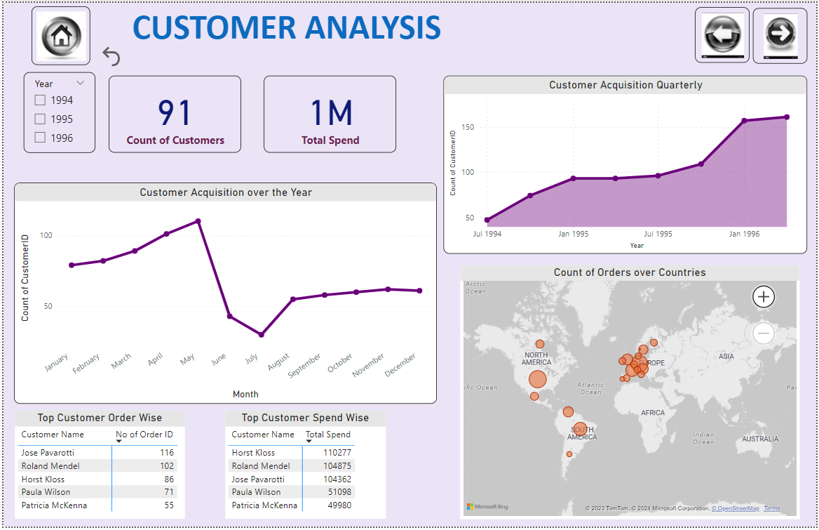

Customer Analysis gives the insights about the customer demographics, order placed, spend on the orders, and acquisition in the market over the years. The analysis tells the brief information about the customer to understand them in a better way and lead to make proper strategy for the customers. The customer categorisation offers the company to have a insights about the potential customers by visualizing there orders and spend on the products.

**Q1:** How does customer distribution vary across different regions or customer segments? Can we visualize it on a map or bar chart?

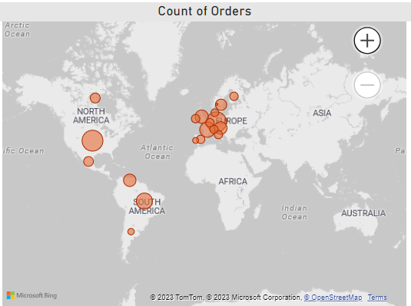

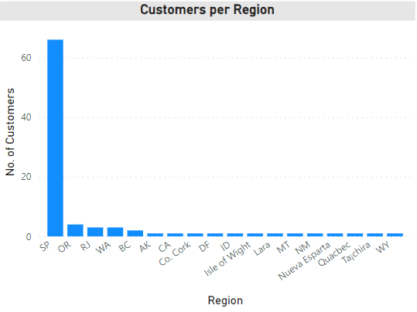

Gleaning from the customer analysis, it becomes apparent that the region named SP will have the highest number of customers. Apart from the remaining 17 regions. The SP region lies in UK. The other report showcases the demographic distribution of orders across the customer countries. The bubble size indicates the number of orders placed and number of bubbles indicates the customers in that region. The bubble intensity is high in the European continent and hance the number of customers is more in that region. Customer demographics gives the information about in understanding the distribution of customers across the world. The map represents the country names, continent and the customer residing in this regions help the company to understand about which region customer are placing the orders.

**Q2:** What is the trend in customer acquisition over time? Can we create a line chart or area chart to display it?

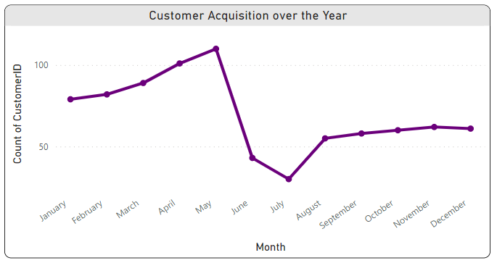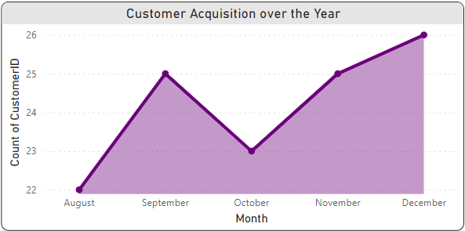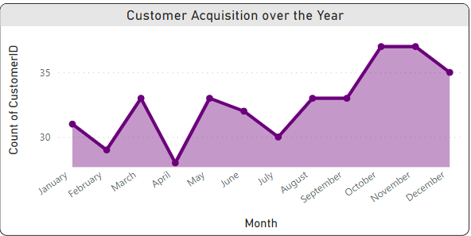

Gleaning from the customer analysis, it becomes apparent to visualize the customer acquisition over the years, quarters and months. In the year of 1994 shows a positive trend initially and becomes almost in the last quarter of the year. In year 1995 the no. of customers shows a positive trend throughout the year and contribute maximum to the sales, and in year 1996 initially in the 1st quarter the customers count increases and letter in the end of the 2nd quarter there is a sudden fall in the customer acquisition. Which opens a new lead for the other analysis to understand the fall of the customer count. Customer acquisition helps the company to understand about the requirement of products, availability of customers, and the new strategies implemented are in favor or oppose. This analysis helps the company to prepare and understand the market trend briefly.

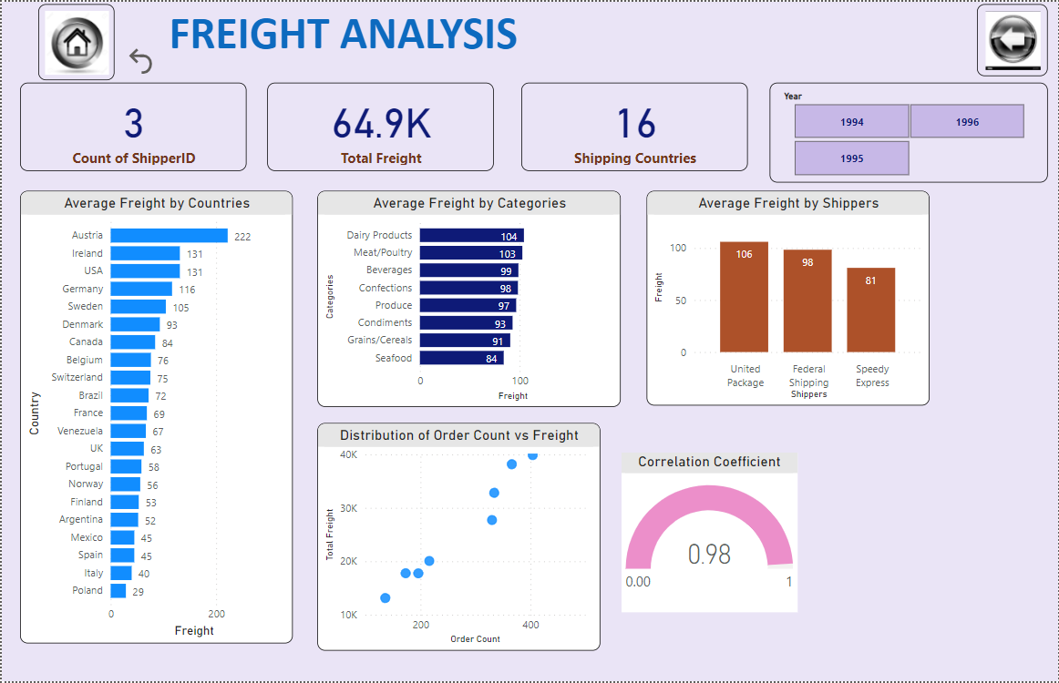

Freight analysis gives the insights about the charges associated with the order transport. This will help the company to make the supply chain better and optimise it and serve the customer in a better way. Freight analysis includes the shippers count, total spend on freight, export the product to countries, average charge offered by different countries, categories and shippers. It also showing the relationship between order counts and freight charges associated with it.

**Q3:** Can we visualize the distribution of customer demographics such as age, gender, or income using histograms or pie charts?

**Note**: There was no such data available in the database which tells us about the customer age, gender, and income. So, we did the analysis of freight to understand about the freight charges involved with the different product categories, shippers charging and understand the relationship between freight charge and quantity ordered.

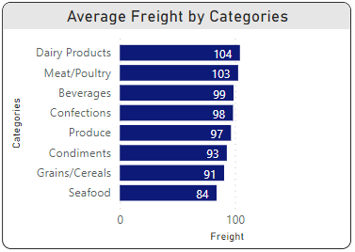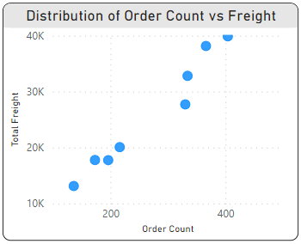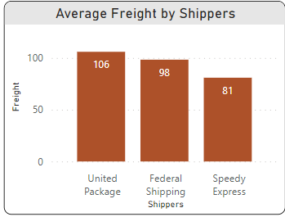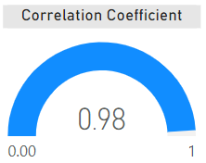

Gleaning from the Freight Analysis, it becomes apparent to visualize the freight charges are high for the category’s Dairy product, Meat/Poultry, Beverages, and Confections. The average cost for the shipping mode United packages is charging highest for the transport of the products. We also try to find the correlation between orders and freight charges, found that there is a +ve correlation between them with a value close to 1. The particular analysis helps us to understanding the shipping charges and which leads to make a better supply chain of products.

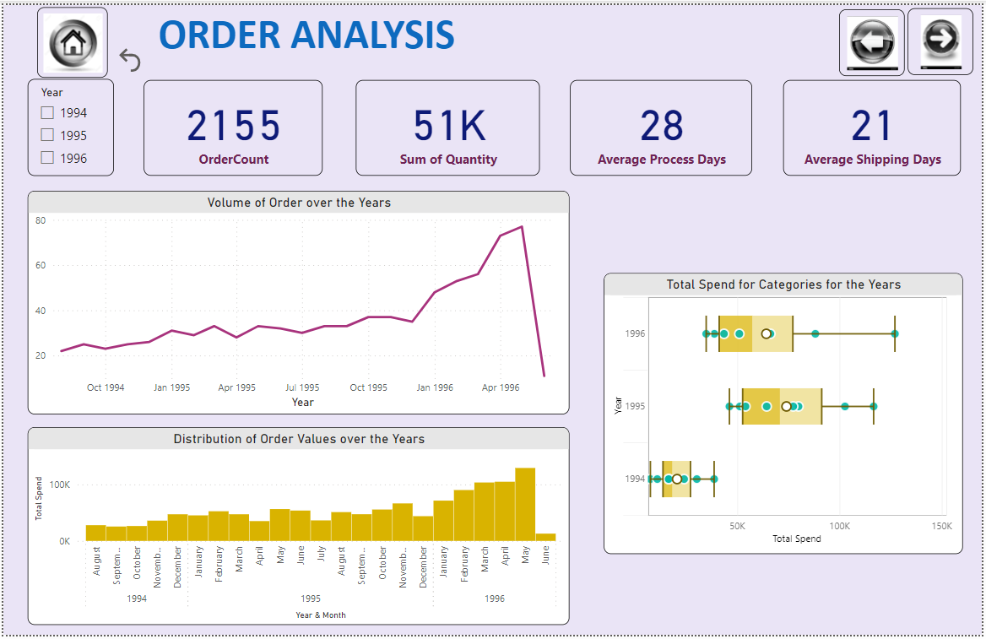

Order analysis gives the insights about the ordering of the products, total spend on the products, total order placed, processing time and shipping time of the products. Volume of order gives an information about the product requirement over the timeframe helps in understanding the product demand. Product distribution leads to provide the insights about the order value throughout the year.

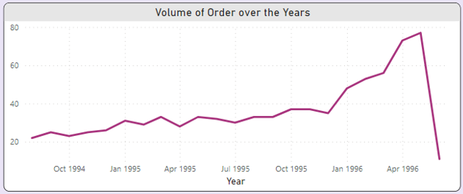**Q4:** How does order volume change over time? Can we create a time series chart or stacked bar chart to visualize it?

Gleaning from the Order Analysis, we can visualize the change in order volume over time. Order volume is defined as the number of customers offered a something within the time frame. In our case we have considered a period of 3 years for which a data has been provided. Order volume tells the insights of the customer purchasing behavior. From the plot we can understand that the order volume increases throughout the time period but in the end of 2nd quarter of year 1996 the order volume has a sudden fall. Because in this timeframe the customer acquisition falls leading to decrease in orders and leads to drop in the sales.

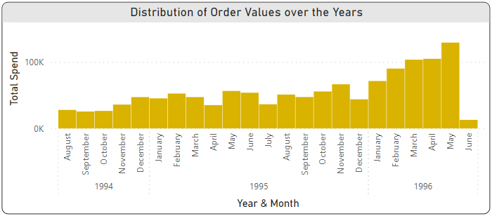**Q5:** What is the distribution of order values? Can we create a histogram or box plot to display it?

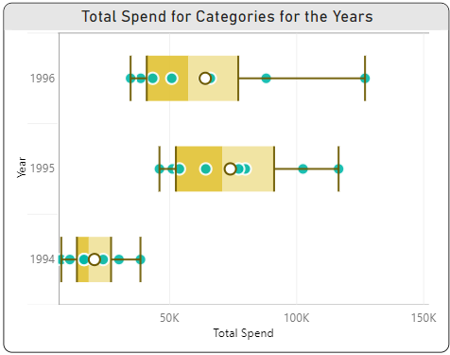

Gleaning from the Order Analysis, we can find out that the distribution of orders over the years. We can interpret from the graphs that the order value is increasing from the year 1994 to 1996. After the end of the 2nd quarter of 1996 there is a drop in demands. We have also visualized the order value across different categories and found that the category Beverages and Dairy Products are the one which have the huge demand and have a highest number of orders as compare to other categories. The mean value for the orders is 20.3K, 73.8K, and 64K in the year 1994, 1995 and 1996 respectively. From this visualization we understand that we have make changes in our strategies to overcome the drop in values after May 1996.

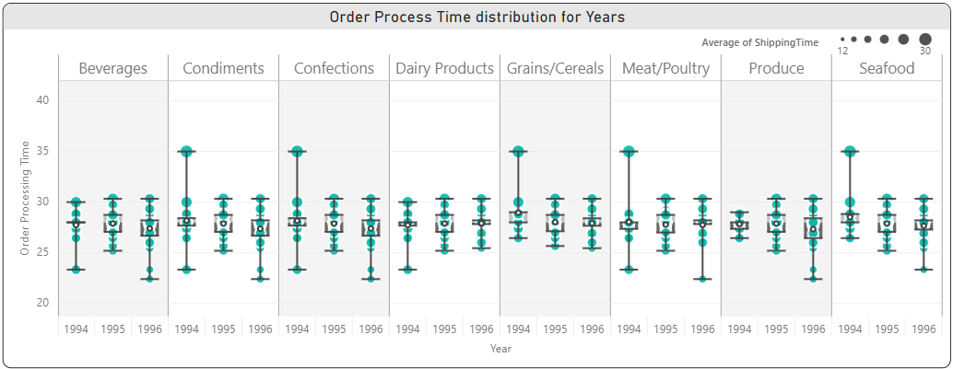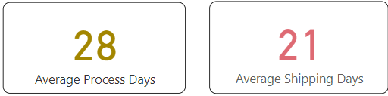**Q6:** Can we visualize the average order processing time or shipping duration using a bar chart or box plot?



Gleaning from the Order Analysis, we visualize and interpret the order processing time (required date – order date) which gives an idea about the in how much time the product is going to deliver. The box and whicker plot represent the distribution of order processing time over the years for different categories of product. We can understand that the strategies are implemented well throughout the years because the time is reducing for the next years. The average processing time of all the products is 28 days and shipping time (shipping date – order date) is 21 days. Order process and shipping time can help us in understanding the customer satisfaction also. There is a room to reduce the time to provide the better services.

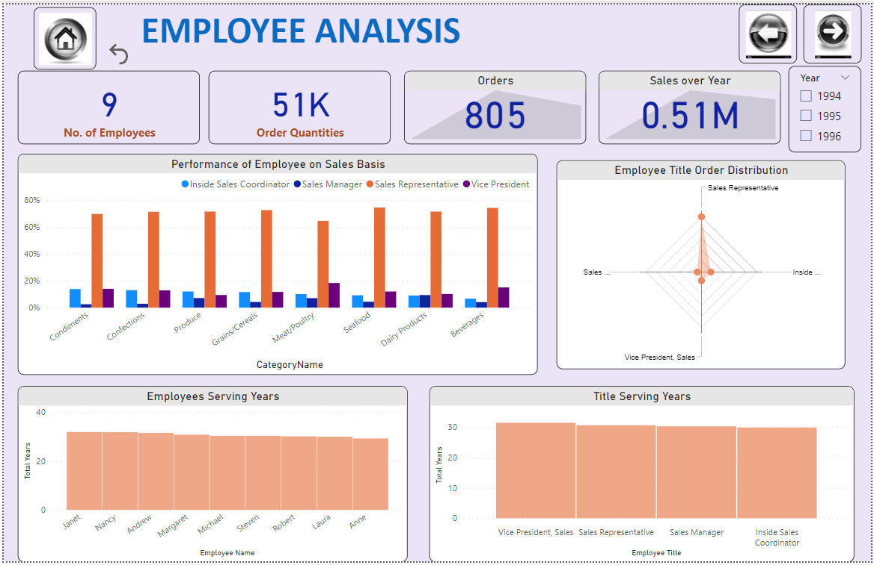

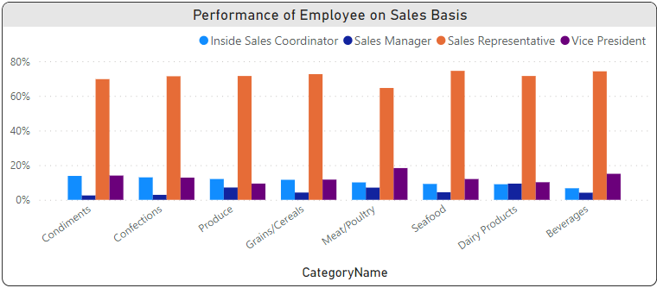**Q7:** How does employee productivity vary across different departments or job roles? Can we create a stacked bar chart or grouped column chart to visualize it?

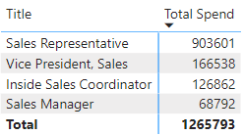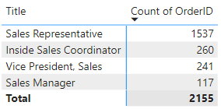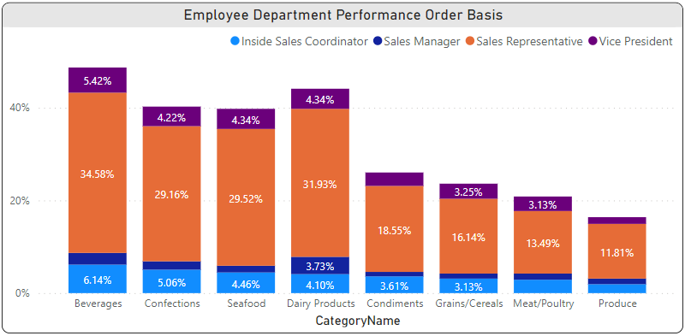

Gleaning from the Employee Analysis, one can infers from the visualization that the employee with title Sales Representative have handled more than 50% of the order and contributing a more than 60% in the revenue. We have total 9 employees to handle 2155 orders. The employee which handles the more orders contribute more in the order sales. Among the orders maximum orders handled in year 1995. The employee productivity helps the company to get the insights of their workforce working, the targets they are achieving in order to provide a better service to the customer. The better employees can lead them to stand in front of the other competitive traders in food supply chain business.

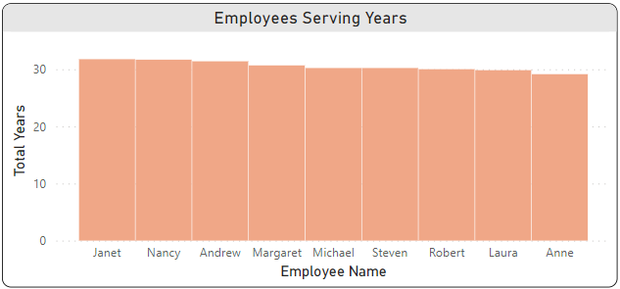**Q8:** What is the distribution of employee tenure? Can we create a histogram or box plot to display it?

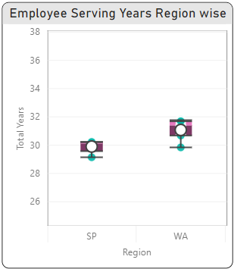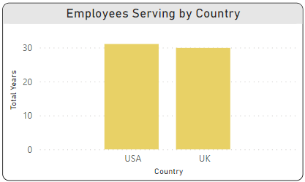

In the database there was no data provided for the serving time of the employees, so we assumed this year 2023 is the last day of the service. By considering this timeline we did our analysis. We can interpret from the plots that Employees average service time is nearly 30 years. The employees belong to country USA have an average service time is 31.1 years and for UK is 29.9 years.

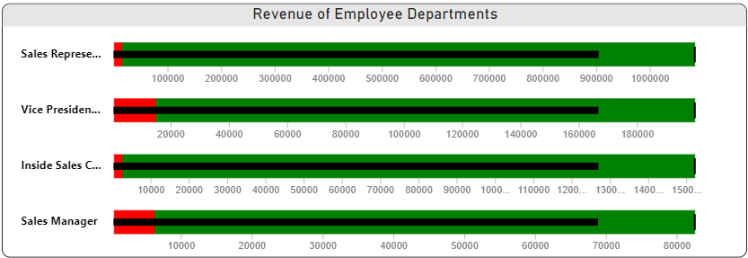**Q9:** Can we visualize employee performance ratings or KPIs using a radar chart or bullet graph?

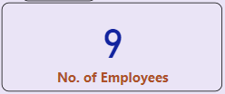

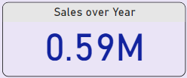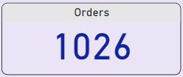

Gleaning from the Employee Analysis, to interpret the performance ratings of the employee we don’t have a direct data for it but we tried to visualize using the contribution in sales, and order handling leads to best employee. We have plotted a bullet chart to analyze the sales for the employee titles and set the target values. We found that 71% revenue share contributed by employee title Sales Representative, followed by vice president and least for the sales manager. The KPIs indicates the number of employee and orders, and sales for the year 1995. We have set a target value of sales to be 20% more to have a visualization of achieved value and goal value for the next quarter, or year.

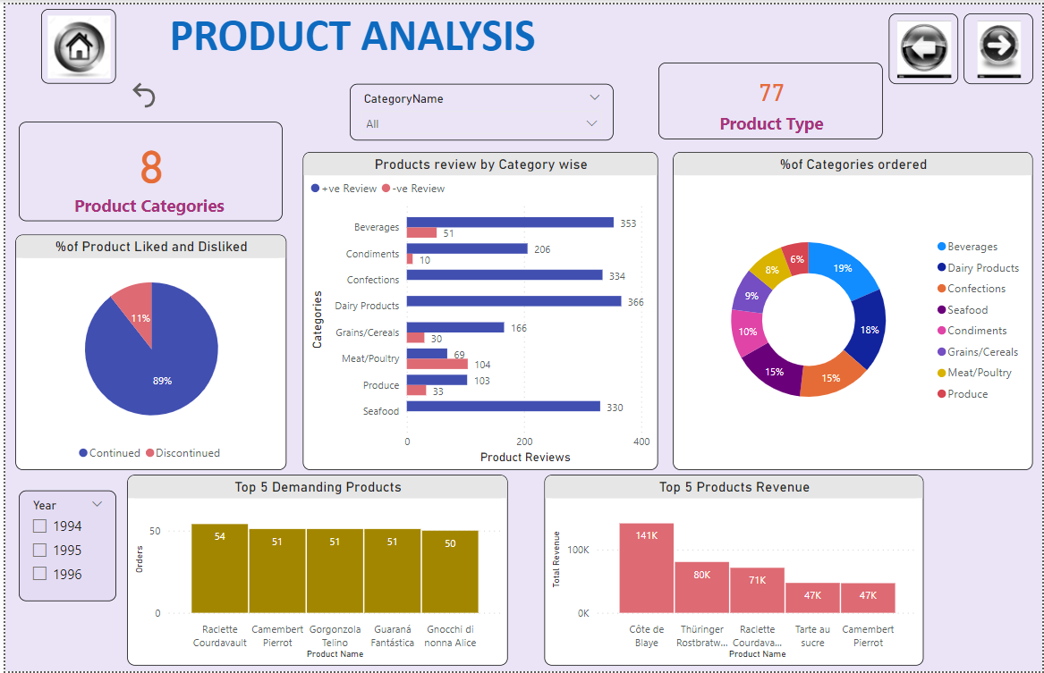

Product analysis tales the insights of the product information, including the variety of products available, different categories of product, product review, product demand, and famous product among the customer in the market. This analysis helps the company to invent some products, the trend of product in the market and development of new products. Products are the one which company can offer to different customer ad if have a wide range of products then company accommodate more customers in the market and leads to increase in sales and revenue of the company.

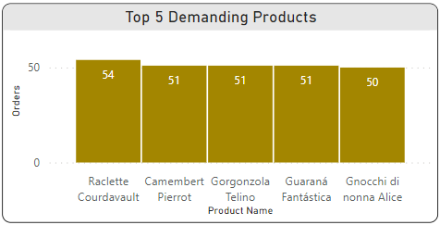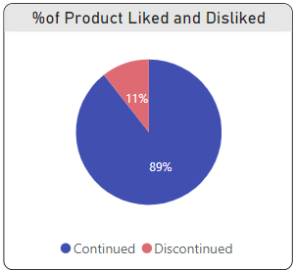**Q10:** What is the distribution of product ratings or reviews? Can we create a histogram or stacked bar chart to visualize it?

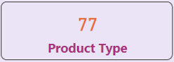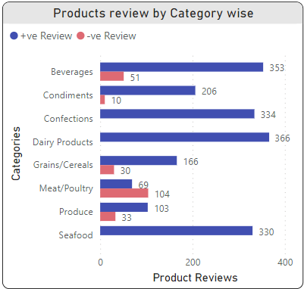

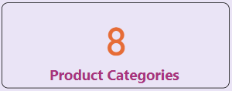

Gleaning from the Product Analysis, we can interpret that there is total 77 unique products grouped in 7 categories. Some products are liked by customer and continued for the next year and it goes on for the next years. The database has a data for the 3 years of timeline shows that there are 11% of products are disliked by customer, due to their negative ratings. There are the categories confections, dairy products, grains/cereals, and seafood are the once which have only +ve reviews and other remaining categories have –ve reviews.

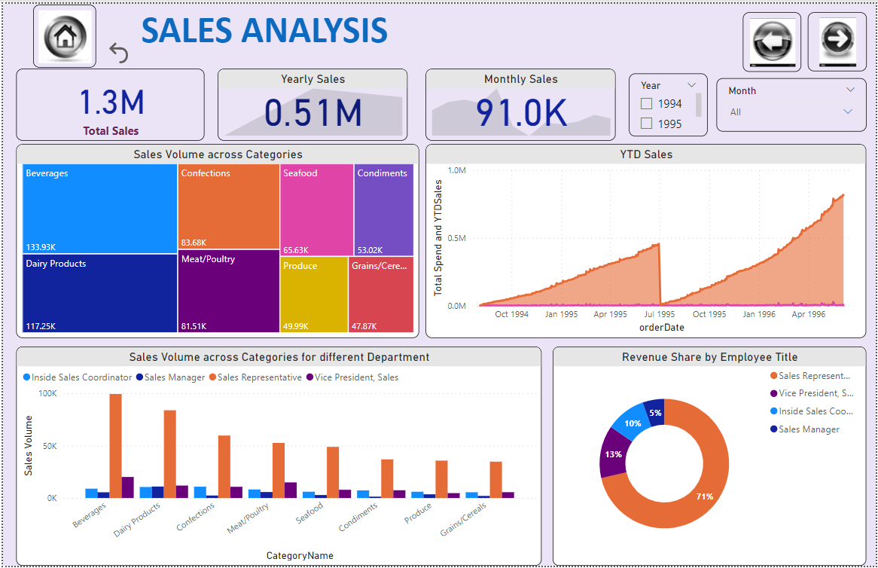

One of very import analysis for the company while analysing their sales data. Sales analysis gives the overview of the total sales, yearly, and monthly sales. How different categories are performing in the market, share of products in the market, and also analysing the sales till the year end. **We have considered a month of June is the year end month.**

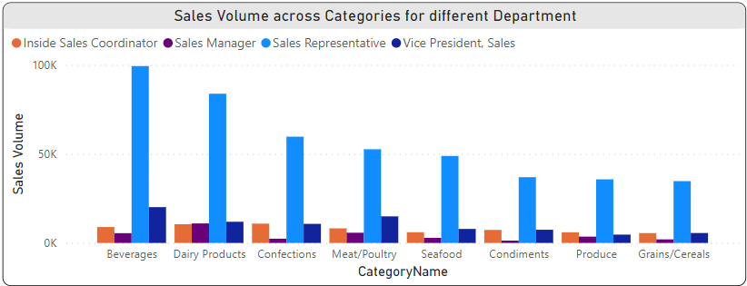**Q11:** How does the sales volume vary across different product categories? Can we create a bar chart or tree map to display it?

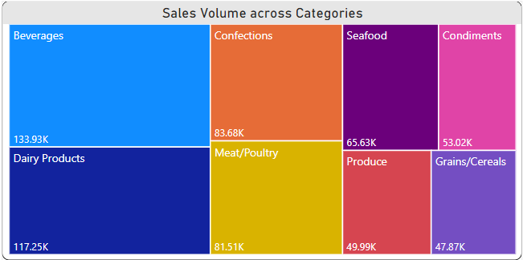

Gleaning from the Sales Analysis, we can interpret from the bar chart and tree map between the sales and categories. The category Beverages have the highest sales value, followed by dairy products, confections and meat/poultry and least by grains/cereal. The contribution to sales by different sales title employee to different categories represents the maximum share by sales representative among each category and least shared by sales manager among each category.

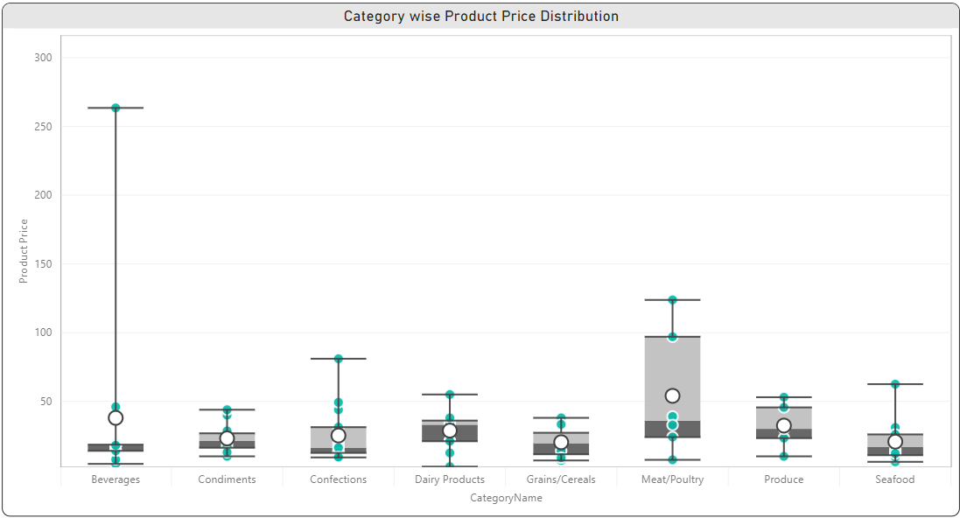**Q12:** Can we visualize the pricing distribution of products using a box plot or violin plot?

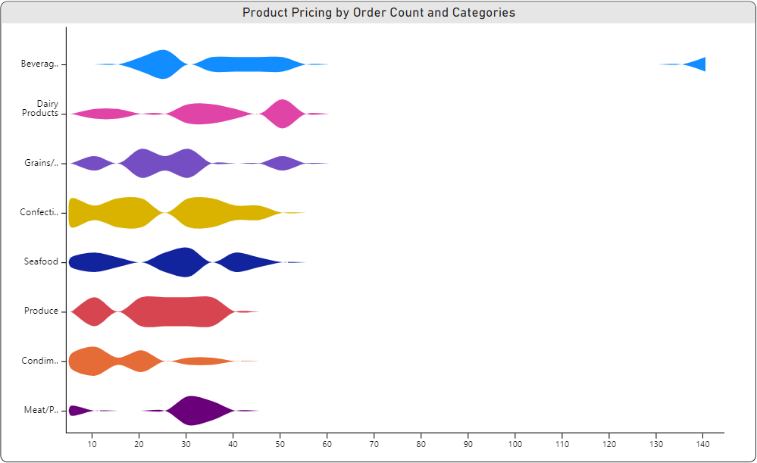

The box plot and violin plot show the distribution of pricing of products among the different categories. The plot between categories and product unit prices represents that the category beverages is the one has some products whose pricing is much higher than the other product due to which have a median value lie outside the 2nd and 3rd quartile. The distribution of pricing is been clearly visualize with the help of box and violin plot. The outliers of pricing indicate the values of products above or below the median value.

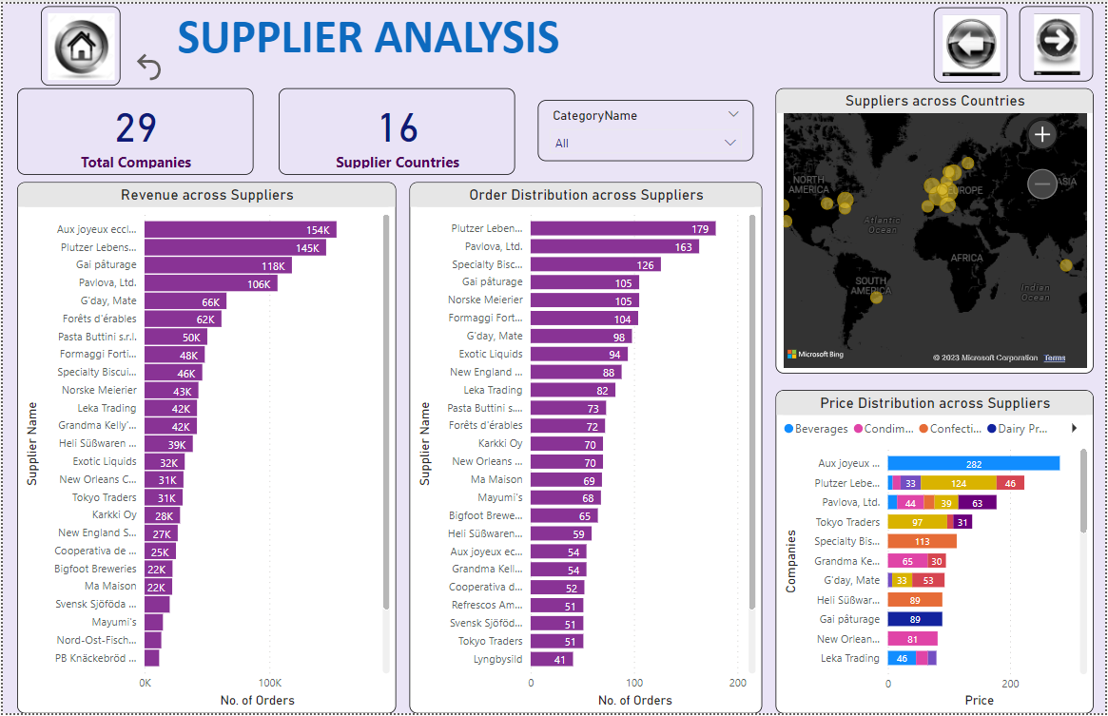

Supplier analysis, tells the story of the supplier’s role in the showcasing the range of pricing of products to the customer in different categories. This analysis shows the suppliers availability in the total countries, revenue shared by the suppliers and their order distribution. Supplier analysis will take care of every detail available to visualise and tells the insights to the management team to take the strategic actions.

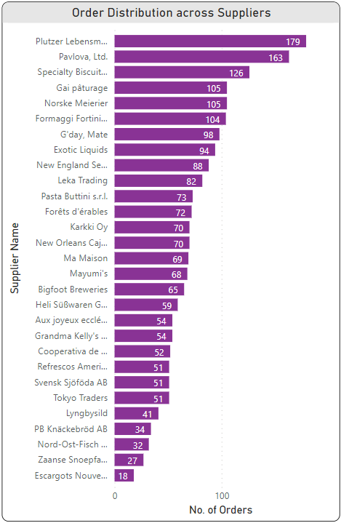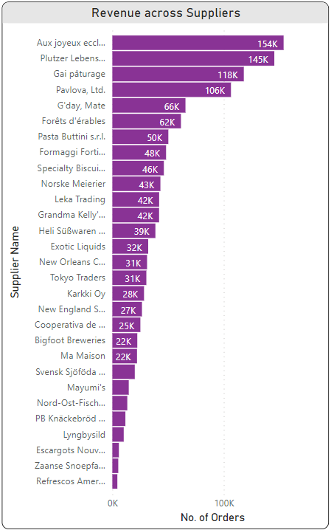**Q13:** What is the distribution of supplier ratings or performance metrics? Can we create a bar chart or radar chart to visualize it?

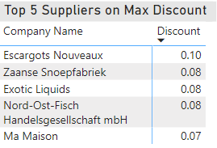

Gleaning from the Supplier Analysis, we can visualize the distribution of sales and orders among the different suppliers. The more sales, orders done by a supplier will be categorized as a good supplier. On the basis of sales Aux Joyeux is the top most supplier and on order basis Plutzer Lebensm is the top most supplier. We have inculcated the tabular data of top most supplier giving the highest discount.

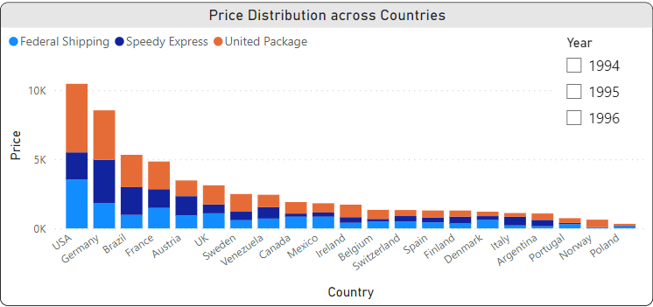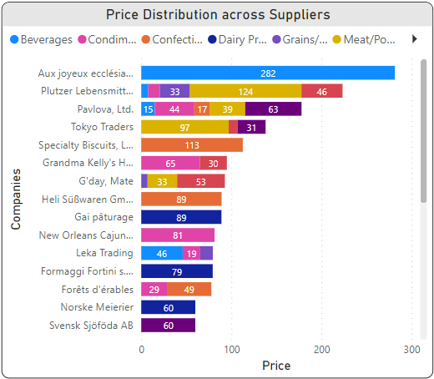**Q14:** How does the cost or pricing structure vary across different suppliers? Can we create a box plot or stacked bar chart to display it?

Gleaning from the Supplier Analysis, we have plotted a stacked bar chart between the suppliers and unit pricing of product across different categories. We have found that we have suppliers which have a unit cost up to 282 and the one which cost around 4.5 for the unit pricing. Which leading us to give a range of product pricing. We have total 16 suppliers and 3 modes of which a supply made. We have also analyzed the price distribution among the various countries and found that USA, Germany and Brazil have a highest unit price of products, and Poland has least.

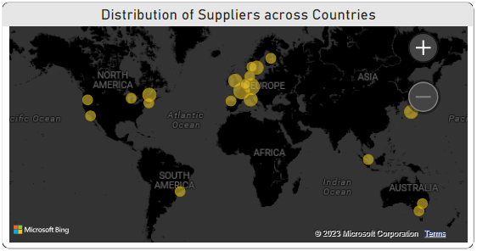**Q15:** Can we visualize the geographical distribution of suppliers using a map or bubble chart?

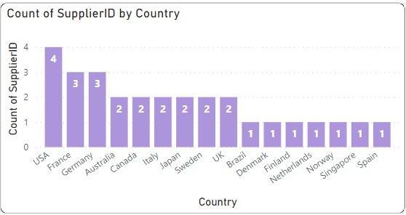

Gleaning from the Supplier Analysis, we have visualized a supplier geometrical distribution. We found that the Europe continent have a highest number of suppliers followed by the America. We have also visualized the distribution across countries and have found that USA have a highest number of suppliers, followed by France and Germany. Least number of suppliers for the Spain, Norway and Singapore. The geographical analysis helping us to understand the distribution of suppliers and provide a room to enhance our services in a better way.



EDA problem statements

**Q:** What are the key factors influencing customer retention or loyalty based on the dataset?

|  |  |
| --- | --- |
| **Factors** | **Details** |
| Quality of Product | Product details are mentioned in the product table providing a brief overview of the product. Product table also includes the product continued or discontinued, which provide the review of the product. |
| Value of the Product | As per the data provided there are varieties of product coming under the different categories and have the unit price values gives the insights about the product value. |
| Convenience and accessibility | There are multiple of suppliers for the product which can fulfil the demand, covering the different cities, regions and countries. Which help the customers to access the product from different demographics. |
| Communication | The data includes the details of the employees, phone number, their countries and regions which helps in understanding the communication between customer and employees. |
| Product Reviews | There was no such direct data for it but from the product table we can understand that the product which are continued will have a +ve reviews and discontinued will have the -ve reviews which will help us in understand the in-demand products. |

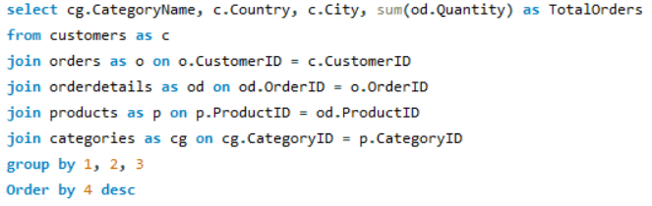**Q:** How do customer preferences vary based on their location or demographics? Can we explore this through interactive visualizations?

Total orders vs Country wise stacked bar chart represents the orders for the different countries including the Categories. We can interpret from the graph that the USA, and Germany have the highest orders or product demand. Among the different product categories, the dairy products are the one which have highest number of orders. The Norway, Poland, and Argentina have the least product orders.

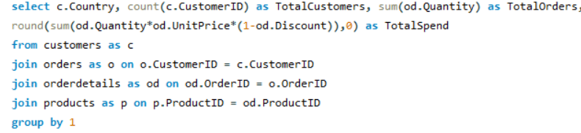**Q:** Are there any interesting patterns or clusters in customer behavior that can be visualized to identify potential market segments?

We have analysed the no. of customers, no. of orders, and their total spend for different countries. We found that the USA and Germany are two markets which have more customers, more orders and leads to get more sales, followed by Brazil, France, and Austria. The Norway, Poland, and Argentina are the market with least no. of orders, customers and sales.

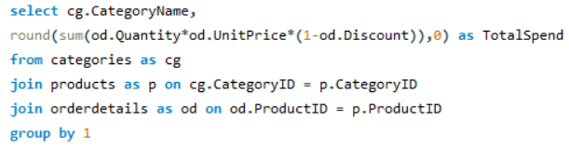**Q:** Are there any specific product categories or SKUs that contribute significantly to order revenue? Can we identify them through visualizations?

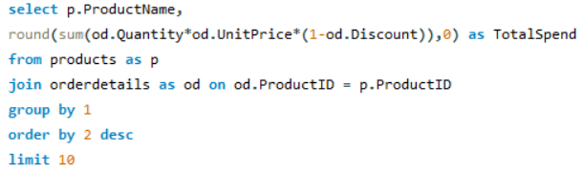

The % of share of total revenue by categories. We found that category beverage, and dairy product have highest contribution to total revenue by 21%, and 19% respectively. Followed by confections 13% and seafood 13%.

Top 10 product revenue for the different categories. The highest contribution of product CA te de Blaye i.e., $141.4K.

**Q:** Are there any correlations between order size and customer demographics or product categories? Can we explore this visually using scatter plots or heatmaps?



**Correlation coefficient: -0.172**

A scatter plot between Total orders vs category shows the correlation between them. We have found that there was a least negative correlation between the two because have a -ve value close to zero. -ve sign indicates that if one value increases other will decreases but they will not follow a relationship.

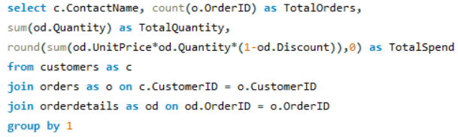**Q:** How does order frequency vary across different customer segments? Can we visualize this using bar charts or tree maps?

The customer segmentation can be done in multiple ways, the customer who place more orders are considered to be the prime customers, the customer who spend more will be considered as a prime customer, and also the order quantity is high considered to be a priority customer.

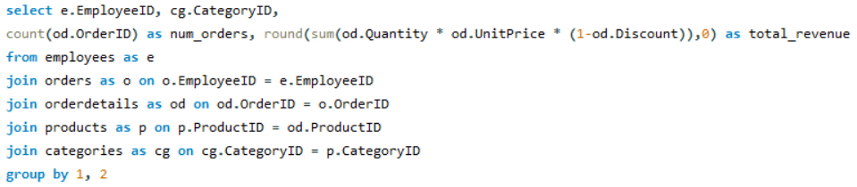**Q:** Are there any correlations between employee satisfaction levels and key performance indicators? Can we explore this visually through scatter plots or line charts?

Distribution of Employees vs Categories/Orders/Revenue shows the relation between them using the scatter plot. The 1st plot indicates that there was no correlation between them (correlation is zero). The 2nd plot indicates that there was a negative relation between the employees and orders with a small relation between them. The 3rd plot indicates that there was no correlation between the employees and revenue and have a negative least correlation between them.

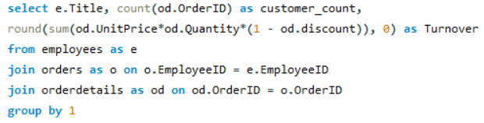**Q:** How does employee turnover vary across different departments or job roles? Can we visualize this using bar charts or heatmaps?

The plots represent the contribution of different employees title to total customers and turnover. The Sales representative is the one responsible for getting maximum tenure and customers because they are dealing with people and going to report to either vice president sales or sales manager. Inside sales contributor have a low scale of market so their sales are less and handling the lesser the customers.

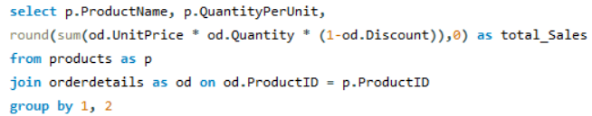**Q:** Are there any correlations between product attributes (e.g., size, color, features) and sales performance? Can we explore this visually using scatter plots or heatmaps?

**Correlation coefficient: -0.05**

We tried to find the correlation between order size and their sales. We found that there was no correlation between them and value is close to zero. Because there are certain products have different scale of sizing like kgs, litres, gms, boxes, and canes. Product cost is nothing to do with its sizing so correlation analysis of size with sales nothing to relate.

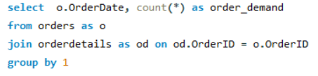**Q:** How does product demand fluctuate over different seasons or months? Can we visualize this through line charts or area charts?

|  |  |
| --- | --- |
| Row Labels | Sum of Orders |
| 1994 | 324 |
| Qtr3 | 128 |
| Qtr4 | 196 |
| 1995 | 1026 |
| Qtr1 | 245 |
| Qtr2 | 254 |
| Qtr3 | 237 |
| Qtr4 | 290 |
| 1996 | 805 |
| Qtr1 | 388 |
| Qtr2 | 417 |

The graph shows the trend for the demand over the years. The demand increases over the years and shows the positive trend for the different seasons. In year 1995 the demand was bit high in first half of year, then decreases for the next quarter and increase in the last quarter of the year. In year 1996 we have the data for the half of the year and it shows a increment in demand.

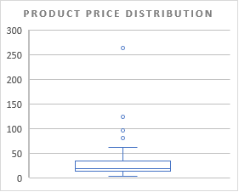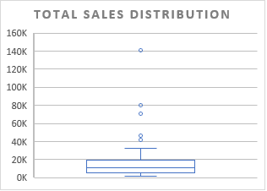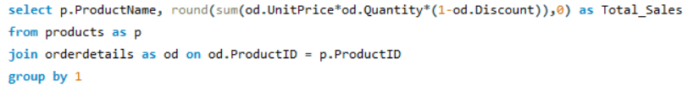**Q:** Can we identify any outliers or anomalies in product performance or sales using visualizations? How can this information be used for product optimization?

The above figure represents the distribution of price of different products. Mostly, the product price lies are in the range of 2nd and 3rd quartile. Only four products whose value is bit larger from the mean value from products price lie outside and called outliers.

The figure represents the distribution of sales of different products. Mostly the product sales lie in the region of 2nd and 3rd quartile region of box. Few products whose sales are high depicts that the product whose unit price high have high value of sales and therefore they are lying outside and called as outliers.

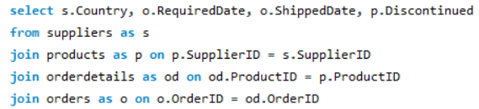**Q:** Are there any correlations between supplier attributes (e.g., location, size, industry) and performance metrics (e.g., on-time delivery, product quality)? Can we explore this visually through scatter plots or heatmaps?

The plots represent the correlation between the shipper’s country and delivery of product on time/product quality. There was no correlation between them because the correlation coefficient value is close to zero. The measures we considered for the cause of not timely delivery and quality is not responsible for it. May be their will be some other factors which can justify the correlation.

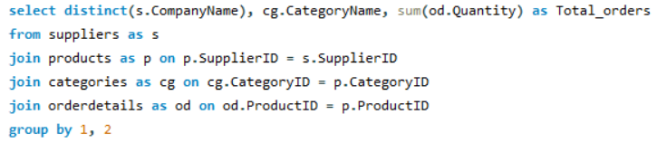**Q:** How does supplier performance vary across different product categories or departments? Can we visualize this using stacked bar charts or grouped column charts?

The above plot represents the performance of different suppliers for the products considering the different categories. Mostly suppliers are supplying the only one category of product. Among 29 suppliers only 2 suppliers are there which are supplying the product with 5 categories. The category of product are more leads to a greater number of orders for the two suppliers.

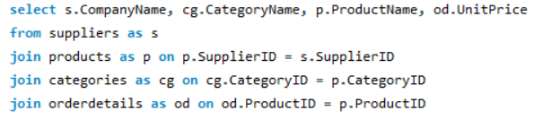**Q:** Can we identify any trends or patterns in supplier costs or pricing structures through visualizations? How can this information be used for procurement optimization?

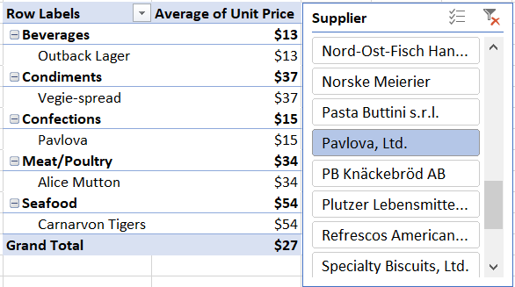

The above chart is a dynamic chart showcase the different categories available and product type along with its price tag. This chart helps us in planning of different product purchasing so we can minimise our order price and also provide the product with different varieties.

CONCLUSIONS:

**Product Analysis:** There are 77 types or products categorised in 8 categories. Mostly orders includes Beverages (19%), Dairy products (18%), Confections (15%), and Seafood (15%). Most likable products belongs to Dairy products, Confections and Seafood.

**Customer Analysis:** The European continent have highest number of customers. SP region in UK have highest number of customers. Customer acquisition is increases throughout the timeline and have a sudden fall after end or 2nd quarter on 1996 because month June be considered as a financial end year.

**Order Analysis:** Total 2155 orders has been delivered till the year 1996 & have 28 days of processing time, and 21 days of shipment. The orders are increasing throughout the time line & have a sudden fall after the end of 2nd quarter of 1996.

**Sales Analysis:** Total sales of 1.3M have been completed. Highest sales registered for the category Beverages followed by Dairy products, Confections, and Meat/Poultry. June is considered as the year end and sales increases throughout the timeline. The sales representative have 71% contribution in total sales.

**Employee Analysis:** There are total 9 employees in 4 department handling the total orders worth of 1.3M. Most of the orders are completed by the sales representatives & have a 30 years of average tenure.

**Supplier Analysis:** There are total 29 suppliers distributing the product to 16 countries. The highest revenue registered by Aux Joyen followed by Plutzer gai Paturage and Pavlora Ltd. Maximum discount offered by Escargo Nouveax.

**Freight Analysis:** The company have 3 shipping modes or suppliers and 16 shipping countries. The highest cost paid by Austria for the shipments. There is a strong +ve correlation between the number of orders and freight charges.

THE END