BUSINESS REQUIREMENTS DOCUMENT

Referral & Loyalty Management System
Customer Acquisition, Engagement & Retention Platform
v5.0

Document Version | 5.0
Status | For Business Review & Approval
Document Type | Business Requirements Document (BRD)
Prepared By | Business Analysis Team

TABLE OF CONTENTS
1. Executive Summary
1.1 Purpose of This Document
1.2 The Business Opportunity
1.3 What This Platform Will Deliver
2. Business Context & Objectives
2.1 Business Problem Statement
2.2 Strategic Business Objectives
2.3 Who Will Use This Platform
2.4 Platform Design Principles
3. Scope of the Platform
3.1 What Is In Scope
3.2 What Is Out of Scope
3.3 Platform Component Overview
4. Functional Requirements
4.1 Customer Profile Management
4.1.1 Why This Module Exists
4.1.2 What the Business Needs
4.1.3 Profile Data Elements
4.1.4 Business Rules
4.2 Customer Enrolment & Membership
4.2.1 What the Business Needs
4.2.2 Business Requirements
4.2.3 Enrolment User Flow
4.3 Tier Management
4.3.1 What the Business Needs
4.3.2 Tier Structure
4.3.3 Tier Benefit Configuration
4.3.4 Upgrade & Downgrade Rules
4.3.5 Tier Upgrade User Flow
4.4 Loyalty Wallet
4.4.1 What the Business Needs
4.4.2 Wallet Requirements
4.5 Points Earning (Accrual)
4.5.1 What the Business Needs
4.5.2 Business Requirements
4.5.3 Earning User Flow
4.6 Points Redemption
4.6.1 What the Business Needs
4.6.2 Business Requirements
4.6.3 Redemption User Flow
4.7 Points Expiry Management
4.7.1 Why This Matters
4.7.2 Expiry Rule Configuration
4.7.3 Expiry Notification Schedule
4.7.4 Breakage Accounting
4.8 Rules Engine
4.8.1 What the Business Needs
4.8.2 Rule Types
4.8.3 Rule Lifecycle Requirements
4.8.4 Conflict Resolution
4.9 Offers, Promotions & Campaign Management
4.9.1 What the Business Needs
4.9.2 Types of Offers
4.9.3 Campaign Management Requirements
4.9.4 Campaign Creation User Flow
4.10 Coupon Management
4.10.1 What the Business Needs
4.10.2 Business Requirements
4.11 Referral Programme
4.11.1 How It Works
4.11.2 Business Requirements
4.11.3 Referral User Flow
4.12 Rewards Catalogue & Inventory Management
4.12.1 Catalogue Requirements
4.12.2 Inventory Management
4.12.3 Partner Rewards Integration
4.13 Merchant Onboarding
4.13.1 What the Business Needs
4.13.2 Merchant Onboarding Stages
4.13.3 Merchant Management Rules
4.13.4 Open Items Requiring Business Decision
4.14 Merchant Self-Service Campaign Portal
4.14.1 Why This Exists
4.14.2 Business Requirements
4.14.3 Merchant Campaign User Flow
4.15 Merchant Settlement
4.15.1 What the Business Needs
4.15.2 Settlement Cycle Requirements
4.15.3 Dispute Handling
4.16 Refunds & Reversals
4.16.1 Why This Matters
4.16.2 Business Requirements
4.17 Loyalty Liability Management
4.17.1 Why This Is Critical
4.17.2 Business Requirements
4.17.3 Liability Forecasting & Provisioning
4.18 Fraud Detection & Prevention
4.18.1 Why a Dedicated Module Is Needed
4.18.2 Fraud Scenarios the System Must Detect
4.18.3 Detection, Alert & Response Requirements
4.19 Administration & Operations
4.19.1 What Business Teams Need to Manage
4.19.2 Programme Configuration
4.19.3 User Roles & Access Control
4.19.4 Maker-Checker Workflow
4.20 Notification Engine
4.20.1 Why Notifications Drive Engagement
4.20.2 Notification Channels
4.20.3 Notification Types & Triggers
4.20.4 Template & Delivery Management
4.21 Event & Webhook Engine
4.21.1 What This Does for the Business
4.21.2 Event Catalogue
4.21.3 Delivery & Retry Rules
4.22 External Integrations Framework
4.22.1 Why a Defined Framework Is Required
4.22.2 Integration Map
4.22.3 Integration Governing Principles
4.23 Reporting & Analytics
4.23.1 What the Business Needs
4.23.2 Business Performance Reports
4.23.3 Finance & Reconciliation Reports
4.23.4 Analytics & Insights
4.23.5 Key Business Metrics
4.23.6 Report Delivery
5. Non-Functional Requirements
5.1 Compliance, Security & Controls
5.1.1 Data Privacy & Security
5.1.2 Audit & Compliance
6. Key Business Rules & Constraints
6.1 Non-Negotiable Business Rules
6.2 Business Constraints
7. Acceptance Criteria (UAT)
7.1 Purpose
7.2 Module Acceptance Criteria
7.3 Overall System Acceptance Criteria
8. Assumptions, Dependencies & Open Items
8.1 Assumptions
8.2 Dependencies
9. Appendix B Platform API Summary

1. Executive Summary

1.1 Purpose of This Document
This Business Requirements Document (BRD) defines what the business needs from a Referral and Loyalty Management System. It is written for business owners, product managers, operations teams, and leadership to understand what the system will do, what value it will deliver, and what decisions need to be made before and during implementation. This document does not describe how the system will be built technically — it describes what it should do, why it matters, and what success looks like.

1.2 The Business Opportunity
Acquiring new customers is expensive, and keeping existing customers loyal is harder as competition increases. Customers expect to be rewarded, and word-of-mouth referrals are among the most cost-effective growth channels available. This platform addresses three core business needs:
- Reward loyal customers so they stay longer and spend more
- Turn happy customers into brand advocates through a structured referral programme
- Runs targeted promotions, offers, and campaigns that drive measurable business outcomes

1.3 What This Platform Will Deliver
At a Glance — Key Business Capabilities
✔ Customers earn points automatically every time they transact
✔ Customers redeem points for discounts, cashback, vouchers, or gifts
✔ Customers refer friends and earn rewards when those friends join and transact
✔ Business teams run time-bound campaigns and offers with full self-service control
✔ Merchants onboard, fund campaigns, and receive settlement reports through a dedicated portal
✔ Finance gets real-time liability tracking, reconciliation, and breakage accounting
✔ Operations and Fraud teams get audit trails, alerts, and case management tools
✔ All connected systems receive real-time event notifications via webhooks

2. Business Context & Objectives

2.1 Business Problem Statement
Currently, the business lacks a unified, automated mechanism to:
- Recognise and reward customers consistently across all channels and touchpoints
- Incentivise existing customers to refer new ones in a trackable, fraud-controlled way
- Run promotional campaigns that can be launched and measured without heavy IT involvement
- Give Finance and Operations teams a single source of truth for loyalty transactions, refunds, and reconciliation
The absence of this platform leads to missed revenue, customer churn, and high manual effort in running promotions.

2.2 Strategic Business Objectives
Business Objective | Expected Outcome
Improve customer retention | Increase repeat transactions by rewarding loyalty behaviour
Grow customer base via referrals | Reduce cost of acquisition through peer-to-peer referral rewards
Drive campaign effectiveness | Launch targeted promotions that are measurable and budget-controlled
Reduce operational effort | Automate coupon issuance, points accrual, and reversal workflows
Improve financial accuracy | Real-time reconciliation of loyalty liabilities and merchant settlements
Enhance customer experience | Transparent, real-time view of rewards and benefits for every customer

2.3 Who Will Use This Platform
Who | What They Do | What They Need
Customer (End User) | Earns and redeems rewards, refers friends, uses coupons | Simple experience; real-time balance; easy redemption
Merchant Partner | Funds offers; accepts loyalty redemptions at point of sale | Clear rules; settlement reports; campaign portal
Business / Product Owner | Designs programmes, sets rules, launches campaigns | Self-service tools; performance dashboards; budget controls
Operations Team | Handles disputes, manual corrections, overrides | Admin interface; audit logs; approval workflows
Finance Team | Reconciles loyalty liabilities and partner settlements | Automated reports; real-time liability data; export tools
External Partner Systems | Banks, payment gateways, CRM tools integrating via APIs | Secure, well-documented API connections; reliable uptime
Compliance Team | Ensures all reward mechanics meet regulatory requirements | Clear compliance rules embedded in platform configuration
Customer Support Team | Resolves user queries; raises manual point adjustments for approval | Fast access to customer loyalty history; adjustment workflow

2.4 Platform Design Principles
Four principles govern every business decision and configuration on this platform:
Principle | What It Means for the Business
Multi-Tenant | One platform can power loyalty programmes for multiple business units or brands — each fully isolated with their own rules, tiers, and data
API-First | Every capability is accessible to connected systems through a secure API — the customer app, merchant POS, CRM, and finance tools all connect through the same interface
Event-Driven | The platform reacts to business events in real time — a payment triggers a points award, a tier threshold triggers an upgrade, a budget limit triggers an automatic campaign stop
Fully Configurable | All earn rates, tier thresholds, campaign rules, and redemption options are set by the business through the admin portal — no IT development required for routine changes

3. Scope of the Platform

3.1 What is in scope
- Customer profile, loyalty membership, and tier management
- Points earning (accrual) based on customer transactions and behaviours
- Points redemption for discounts, cashback, vouchers, merchandise, and services
- Points expiry management with automated notifications and breakage accounting
- Rules engine governing all earning, eligibility, and conflict resolution logic
- Referral programme — tracking, rewarding, and fraud prevention
- Coupon creation, distribution, validation, and redemption tracking
- Promotional offers and campaign management with budget controls
- Rewards catalogue with inventory management and partner reward pools
- Merchant onboarding, self-service campaign portal, and settlement
- Refunds, reversals, manual adjustments, and loyalty liability management
- Fraud detection, admin portal, notification engine, and event/webhook delivery
- Reporting, analytics, compliance controls, and integration framework
- Multi-tenant architecture — multiple business units, brands, or clients supported on a single platform instance

3.2 What is out of scope
- Core banking or payment processing — platform integrates with but does not replace these systems
- Customer KYC verification — handled by existing onboarding systems
- Funding accounts for loyalty liabilities — managed by Finance through existing treasury systems
- Merchant payment settlement execution — the platform provides reports; actual payment is processed externally
- Customer-facing mobile app or website — the platform provides data via APIs; display is handled by existing apps

3.3 Platform Component Overview
The platform is made up of eight components that work together. Each component has a clear business responsibility:
Component | Business Responsibility
Loyalty & Referral Engine | Core engine that manages enrolment, tiers, wallet, points earning, and referral rewards
Campaign & Rules Engine | Controls all promotional logic — who qualifies, what they earn, when offers apply, and how conflicts are resolved
Rewards & Catalogue Service | Manages the full rewards catalogue — what customers can redeem for, stock levels, and partner reward pools
Loyalty Wallet Service | Maintains each customer's real-time points balance, transaction history, and expiry schedule
Coupon & Offer Management | Handles creation, distribution, validation, and usage tracking of all coupons and promotional offers
Reporting & Reconciliation Engine | Generates all operational, financial, and analytics reports for business and finance teams
Admin & Operations Portal | Business-facing interface for configuring programmes, managing users, handling disputes, and monitoring the platform
API Gateway | Secure entry point for all external systems connecting to the platform — handles authentication, rate control, and routing

4. Functional Requirements

4.1 Customer Profile Management

4.1.1 Why This Module Exists
The loyalty platform must know who the customer is, what they prefer, and how they have behaved over time. Every other module depends on the customer profile as its foundation — without it, offers cannot be personalised, campaigns cannot be targeted, and the platform cannot comply with data privacy obligations.

4.1.2 What the Business Needs
- Every customer must have a unified profile consolidating identity, contact details, programme memberships, communication preferences, and behavioural history in one place
- The profile is the single source of truth — a change must reflect immediately across points, offers, campaigns, and notifications
- Customers can view and update their own profile through the customer-facing app or web portal
- Business teams can view a customer's full loyalty profile for support and dispute resolution, with appropriate access controls
- The profile stores communication opt-ins and opt-outs per channel (email, SMS, push notification)
- Customer segmentation tags are manageable at profile level — e.g. 'High Value', 'At Risk of Churn', 'Festive Season Active'
- The profile maintains full behavioural history: all transactions, redemptions, offers accepted or ignored, and referrals
- When a customer is linked to an external system (CRM, banking), the loyalty profile maps to that identity without duplication

4.1.3 Profile Data Elements
Data Category | Fields | Who Can View / Edit
Identity | Name, date of birth, loyalty ID, external system ID | Customer (view own), Admin (full), Operations (view)
Contact Details | Email, mobile, preferred language, time zone | Customer (edit own), Admin (edit), Operations (view)
Programme Memberships | Programmes enrolled, tier, enrolment date, status | Customer (view), Admin (full), Operations (view)
Communication Preferences | Opt-in/out per channel, preferred contact time | Customer (edit), Admin (view), Notification Engine (read)
Segmentation Tags | Business-defined labels for targeting | Admin (full), Campaign Engine (read)
Behavioural History | Transaction history, offers clicked, redemptions, referrals | Admin (full), Analytics (read), Operations (view)

4.1.4 Business Rules
- A customer cannot have more than one active loyalty profile per programme — duplicate detection enforced at enrolment
- A profile inactive for more than 24 months must be flagged before any new points are awarded
- Communication opt-outs must be honoured within 24 hours — no marketing messages after that window
- Profile data must not be shared with merchant partners without explicit customer consent
- Deletion requests must anonymise PII while retaining transaction records for financial compliance

4.2 Customer Enrolment & Membership

4.2.1 What the Business Needs
Customers must be able to join one or more loyalty programmes easily. The business must control who is eligible and how customers are enrolled.

4.2.2 Business Requirements
- Customers can be automatically enrolled at sign-up or first transaction, or choose to opt in manually
- A customer can participate in more than one loyalty programme simultaneously
- The platform supports loyalty tiers (Silver, Gold, Platinum) each with different earning rates and benefits
- Only customers who meet eligibility criteria defined by the business should be enrolled
- Programmes have configurable start and end dates
- The business can suspend or remove a customer from a programme at any time

4.2.3 Enrolment User Flow
📌 USER FLOW — Customer Enrolment
▶ Step 1: Customer downloads the app and completes registration (name, mobile, email)
▶ Step 2: Platform checks eligibility rules — KYC status, account type, geography
▶ Step 3: If eligible: customer is auto-enrolled into the Standard Loyalty Programme
▶ Step 4: A welcome bonus of 100 points is credited to the new loyalty wallet
▶ Step 5: Customer receives a push notification: 'Welcome! You have 100 points to start with'
▶ Step 6: Customer profile is created with Standard tier and all programme rules applied
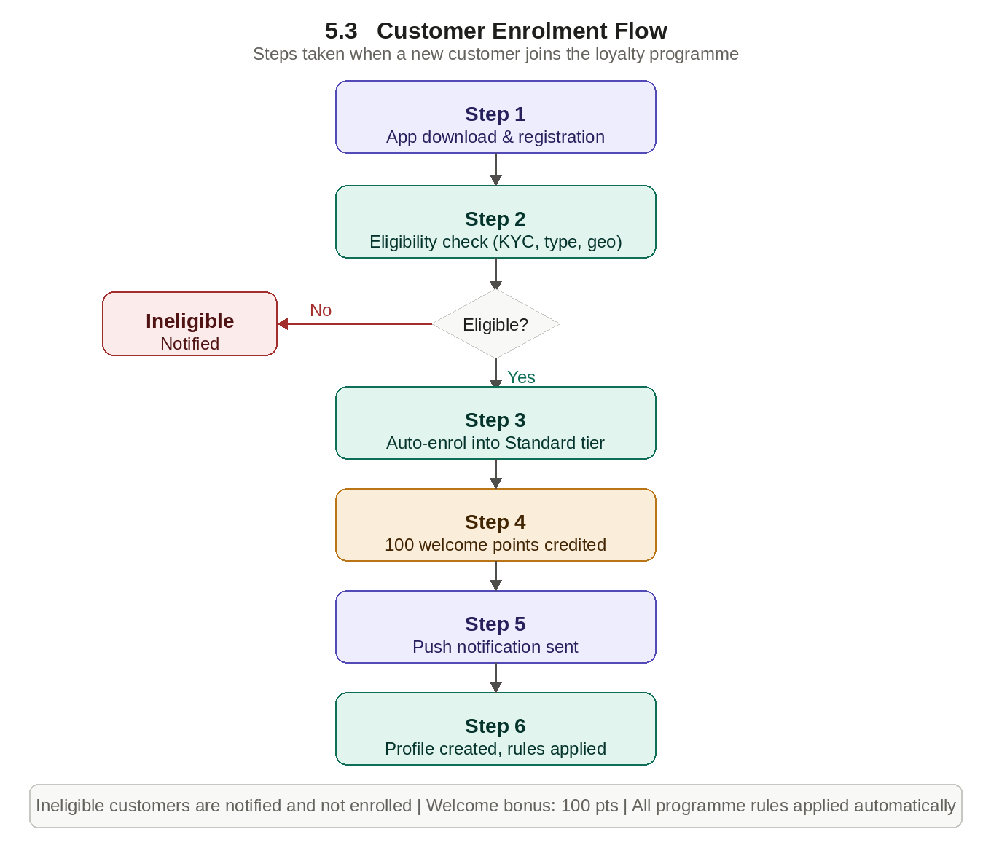

Business Scenario
A premium bank account holder is invited to join the Gold Tier programme. Upon acceptance, they receive a higher earn rate on all transactions. A customer inactive for 12 months is downgraded from Gold to Silver based on configured inactivity rules.

4.3 Tier Management

4.3.1 What the Business Needs
Tiers drive aspiration in a loyalty programme — customers work towards higher tiers for better benefits. Without a dedicated tier module there are no rules for how customers move between tiers, what happens when they miss the threshold, or how edge cases like grace periods are handled.

4.3.2 Tier Structure
- The business can define unlimited tiers (e.g. Standard, Silver, Gold, Platinum, Invite-Only) with a clear hierarchy
- Each tier has configurable qualification criteria: total points in a rolling 12-month period, total spend, or number of transactions
- Each tier carries a defined set of benefits applied automatically: earn multipliers, exclusive rewards, lower redemption thresholds, dedicated support
- Entry threshold and maintenance threshold are set independently — e.g. 5,000 points to enter Gold, 3,000 to stay in Gold

4.3.3 Tier Benefit Configuration
Benefit | Standard | Silver | Gold | Platinum
Points earn multiplier | 1x | 1.5x | 2x | 3x
Welcome bonus (points) | 100 | 200 | 500 | 1,000
Minimum redemption | 500 pts | 70 pts | 200 pts | 100 pts
Exclusive rewards access | No | No | Yes | Yes
Dedicated support line | No | No | No | Yes
Note: Values above are illustrative defaults. Final values must be confirmed by the business before go-live.

4.3.4 Upgrade & Downgrade Rules
- Tier upgrades happen automatically when a customer crosses the qualification threshold — new rate applies on the very next transaction
- Tier downgrades are evaluated at a defined review cycle (annually or quarterly) — not mid-cycle without business authorisation
- Customers receive a 60-day advance warning before a downgrade showing what they need to transact to retain their tier
- A grace period of up to 90 days can be configured for customers who narrowly miss the maintenance threshold
- Manually upgraded customers (relationship management) are flagged and cannot be auto-downgraded without a second approval

4.3.5 Tier Upgrade User Flow
📌 USER FLOW — Tier Upgrade Journey
▶ Step 1: Customer accumulates qualifying transactions throughout the year
▶ Step 2: Platform monitors running total points against tier threshold in real time
▶ Step 3: Customer earns their 5,000th qualifying point — Gold threshold crossed
▶ Step 4: System fires a tier upgraded event — new tier applied immediately
▶ Step 5: Customer receives congratulations push notification within 5 minutes
▶ Step 6: Next transaction automatically receives 2x points (Gold multiplier)
▶ Step 7: At annual review: if below 3,000 maintenance points, 60-day warning issued
▶ Step 8: If still below threshold after grace period, tier is downgraded with notification
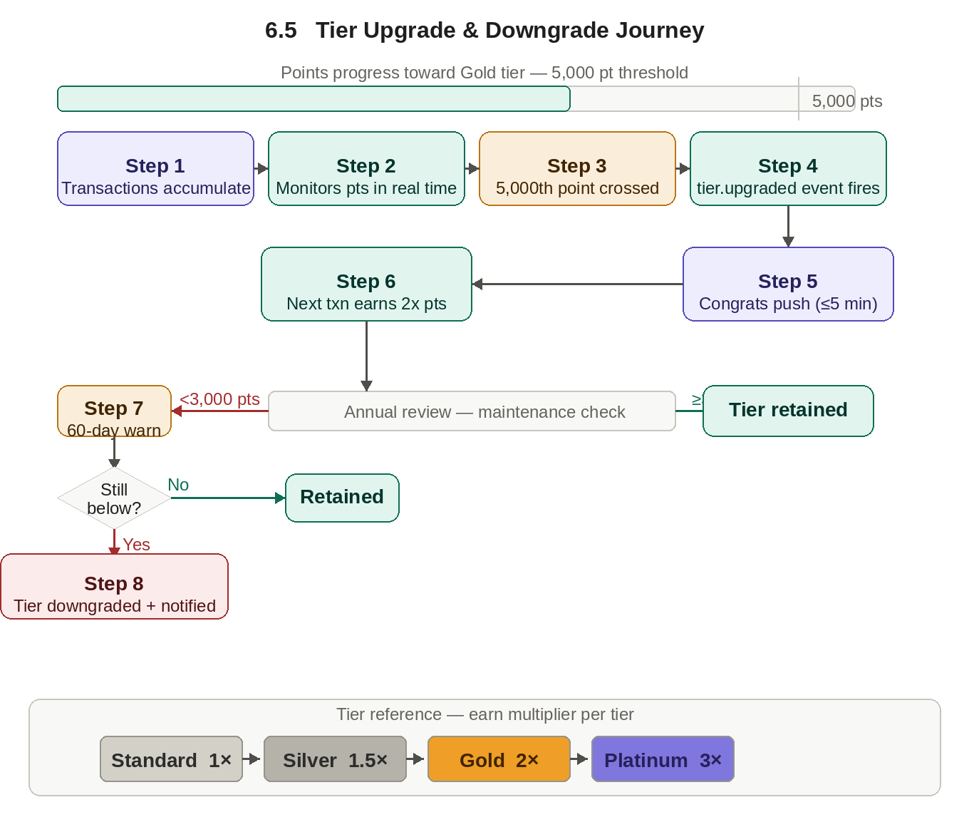

4.4 Loyalty Wallet

4.4.1 What the Business Needs
Each customer has a virtual loyalty wallet that holds their points balance. The wallet is the central ledger for all earn, burn, expiry, and adjustment activity. Every module in the points engine reads from and writes to the wallet.

4.4.2 Wallet Requirements
- The wallet maintains a real-time points balance, a full transaction history (earned, redeemed, expired, adjusted), and upcoming expiry summary
- The wallet supports tier-based multipliers applied automatically at the time of earning
- Negative balances are prevented by default — configurable per programme
- The business can review total outstanding wallet balances across all customers at any time through the liability dashboard
- Every wallet transaction is traceable to its originating event — transaction, campaign, referral, admin adjustment, or expiry

4.5 Points Earning (Accrual)

4.5.1 What the Business Needs
Customers are rewarded with points every time they take a qualifying action. The business has full control over what earns points, how many, and under what conditions.

4.5.2 Business Requirements
- Points are awarded automatically when a customer completes a qualifying transaction — payment, recharge, bill payment, or fund transfer
- The business defines the earning rate — e.g. 1 point per ₹100 spent, or a flat 50 points per bill payment
- Tier-based multipliers apply automatically — Gold members earn 2x, Platinum earn 3x
- Different channels can carry different earning rules — in-app transactions may earn more than branch transactions
- Daily, monthly, or campaign-level earning caps control liability
- An authorised admin can grant manual points with a mandatory reason code and approval trail
- Every point earned is traceable to its originating transaction

4.5.3 Earning User Flow
📌 USER FLOW — Points Earning Journey
▶ Step 1: Customer completes a transaction — e.g. pays electricity bill of ₹2,000 on the app
▶ Step 2: Payment system sends a transaction event to the loyalty platform via API
▶ Step 3: Rules Engine evaluates: Is the transaction eligible? Which earn rule applies? Any multipliers?
▶ Step 4: For a Gold tier customer: base 20 points × 2x multiplier = 40 points calculated
▶ Step 5: Platform checks daily and monthly earn caps — not exceeded
▶ Step 6: 40 points are credited to the loyalty wallet in real time
▶ Step 7: Platform fires a points earned webhook to the customer app
▶ Step 8: Customer receives push notification: 'You earned 40 points on your bill payment!'
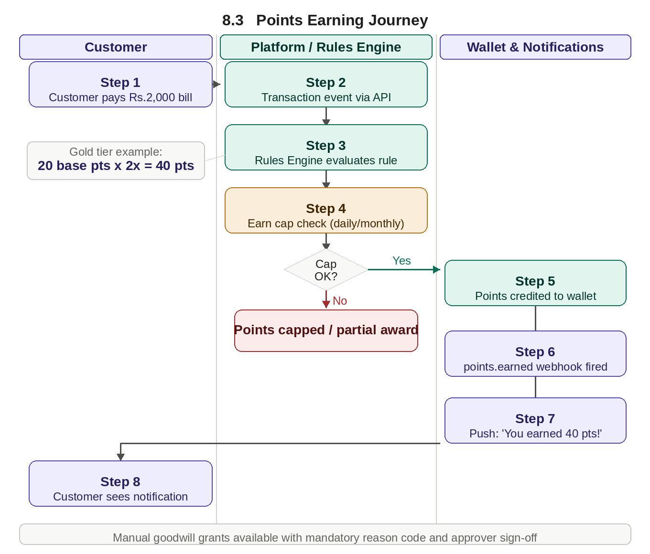

Business Scenarios
Campaign multiplier: A festive campaign offers 5x on grocery purchases. A ₹1,000 grocery spend earns 50 points instead of the base 10.
Goodwill grant: An operations manager awards 200 goodwill points after resolving a complaint. Reason code logged, approver sign-off recorded.

4.6 Points Redemption

4.6.1 What the Business Needs
Customers must be able to use earned points to get real value. The business controls what can be redeemed, at what rate, and through which channels.

4.6.2 Business Requirements
- Customers can redeem points for: discounts on transactions, cashback to their account, vouchers and coupons, physical or digital merchandise, and service benefits such as fee waivers
- Partial redemption is supported — a customer can use 500 of their 1,200 points
- The platform validates sufficient balance before processing any redemption
- Every redemption is confirmed to the customer and the originating system in real time
- The business defines the minimum points required for a redemption
- Redemption is available across channels — app, website, and merchant PO

4.6.3 Redemption User Flow
📌 USER FLOW — Points Redemption Journey
▶ Step 1: Customer opens the app and browses the rewards catalogue
▶ Step 2: Customer selects a reward — e.g. ₹50 cashback for 500 points
▶ Step 3: Platform validates: Does the customer have at least 500 points? Is the reward in stock?
▶ Step 4: If valid: 500 points are reserved immediately — not available to other redemptions
▶ Step 5: Redemption is processed — ₹50 cashback credited to the customer's account
▶ Step 6: Points are deducted from the wallet; transaction recorded in wallet history
▶ Step 7: Platform fires a points.redeemed webhook to the customer app and finance system
▶ Step 8: Customer receives confirmation notification: 'Redeemed! ₹50 cashback is on its way'

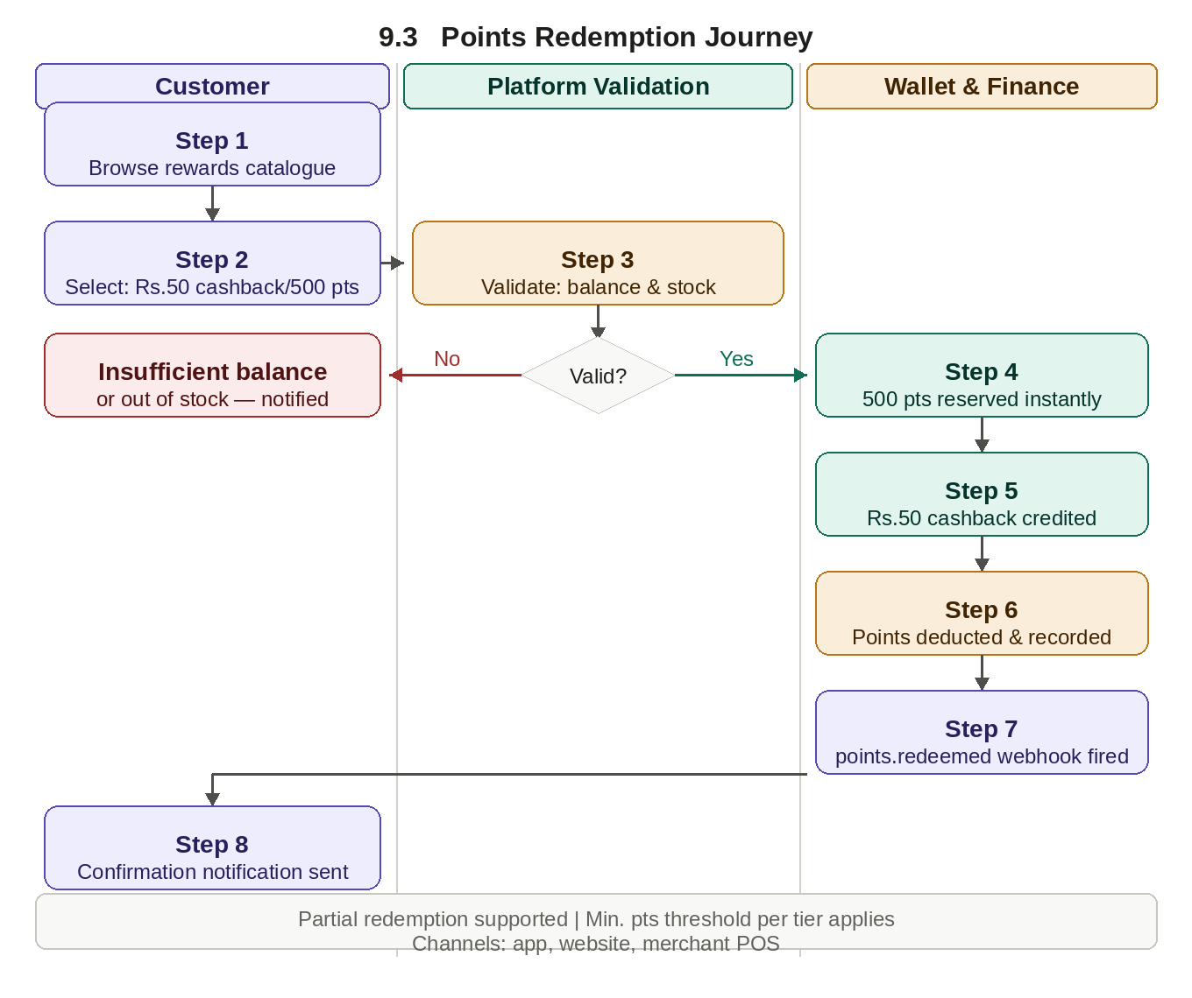

4.7 Points Expiry Management

4.7.1 Why This Matters
Points expiry manages the financial liability of outstanding unredeemed points and creates urgency that drives customer engagement. Poorly managed expiry — without proper notifications — is one of the most common causes of loyalty programme abandonment and customer complaints.

4.7.2 Expiry Rule Configuration
- Different expiry rules per programme — a general programme may use 24-month rolling expiry; a campaign-specific pool may expire after 90 days
- Two models supported: rolling expiry (points expire a fixed period after they were earned) and fixed-date expiry (all points expire on a specific calendar date)
- Tier-based extension: Gold and Platinum members can have points validity extended by 6 months compared to Standard
- Campaign or referral points may carry their own independent expiry rules
- Expiry is processed overnight in batch — never during peak transaction hours

4.7.3 Expiry Notification Schedule
When | What Customer Receives | Channel
60 days before expiry | First warning: exact points expiring, date, and 'Redeem Now' link | Email + Push
7 days before expiry | Second reminder with updated balance and expiry date | Email + Push + SMS
7 days before expiry | Urgent final warning with countdown and redemption prompt | Push + SMS
Day of expiry | Expiry confirmation: points removed, breakage recorded in Finance | Email
Note: Customers who have opted out of marketing must still receive expiry notifications — these are transactional account messages, not marketing.

4.7.4 Breakage Accounting
- Points that expire unredeemed represent 'breakage' — a financial benefit to the business that must be tracked by Finance
- Monthly breakage report: total points expired, monetary equivalent, breakdown by programme and tier, year-to-date trend
- Breakage data automatically reduces the outstanding liability balance in the Liability Management module
- Finance can run 'what-if' breakage forecasts for the next 3, 6, and 12 months based on current wallet balances

4.8 Rules Engine

4.8.1 What the Business Needs
The Rules Engine is the brain of the loyalty platform. It evaluates every customer action against all active rules — from earning multipliers to offer eligibility to campaign targeting — and determines what the customer receives. Without a governed Rules Engine, promotional liability can spiral out of control.

4.8.2 Rule Types
Rule Type | What It Does | Example
Accrual Rule | Defines points earned for a qualifying action | 1 point per ₹100 spent on bill payments
Multiplier Rule | Bonus multiplier on top of base accrual | Gold members earn 2x points on weekends
Eligibility Rule | Determines if customer qualifies for offer | Only customers with 6+ months tenure qualify
Cap Rule | Limits maximum benefit receivable | Maximum 500 bonus points per customer per month
Exclusion Rule | Prevents two rules applying simultaneously | Referral bonus and first-transaction bonus cannot stack
Priority Rule | Defines which rule wins when multiple apply | Campaign rule overrides standard accrual if both apply

4.8.3 Rule Lifecycle Requirements
- Business users create, edit, activate, deactivate, and retire rules from the admin portal — no IT involvement required
- Every rule has a mandatory effective date and an optional end date — activation and deactivation are automatic
- All rules go through a maker-checker approval workflow before activation
- A rule simulation tool allows users to test a new rule against historical data before go-live — estimating liability and customer impact
- All rule changes are versioned — the business can roll back to a previous version within 24 hours
- When multiple rules apply to the same action, the system evaluates them in priority order

4.8.4 Conflict Resolution
- A global conflict resolution policy defaults to either Best-for-Customer (highest reward wins) or Best-for-Business (lowest reward wins) — configured by the business
- All conflict resolution decisions are logged for Finance audit

4.9 Offers, Promotions & Campaign Management

4.9.1 What the Business Needs
Campaign management allows the business to design, launch, and manage promotional programmes with full control over who qualifies, what reward they receive, when the offer is valid, and how much it costs.

4.9.2 Types of Offers
Offer Type | Description | Example
Spend & Earn | Customer earns extra points for spending in a defined category or channel | Earn 3x points on dining this month
Cashback Offer | Percentage of spend returned to customer's account | Get 5% cashback on fuel up to ₹100
Discount Offer | Instant discount at time of transaction | ₹75 off on next recharge above ₹299
Merchant-Funded | Merchant partner funds the offer | 20% off at Brand X stores, funded by Brand X
Time-Bound Promotion | Offer valid only during a specific period | Double points every Saturday in December

4.9.3 Campaign Management Requirements
- Business teams create and configure campaigns from the admin portal without requiring IT support
- Campaigns support targeting rules: customer segment, geography, tier, or transaction history
- Each campaign has a defined budget — the platform stops the campaign automatically when the budget is exhausted
- Campaign priority is configurable when multiple offers apply to the same transaction
- Business users can pause, resume, or terminate a campaign at any time
- Real-time performance tracking shows customers reached, participation count, and budget consumed
- Campaigns above a defined budget threshold require maker-checker approval before going live

4.9.4 Campaign Creation User Flow
📌 USER FLOW — Campaign Creation & Launch
▶ Step 1: Business user logs in to admin portal and selects 'Create New Campaign'
▶ Step 2: User defines: campaign name, offer type, target customer segment, start/end dates, total budget
▶ Step 3: Rules Engine is configured: earn multiplier, eligibility criteria, spending caps
▶ Step 4: Campaign is submitted for approval — routes to authorised approver (maker-checker)
▶ Step 5: Approver reviews terms, confirms budget alignment, and activates the campaign
▶ Step 6: Campaign goes live on the configured start date — eligible customers begin receiving the offer
▶ Step 7: Real-time dashboard updates: customers reached, participations, budget consumed
▶ Step 8: When budget is 80% consumed, an automatic alert is sent to the campaign owner
▶ Step 9: Campaign closes automatically when budget is exhausted or end date is reached
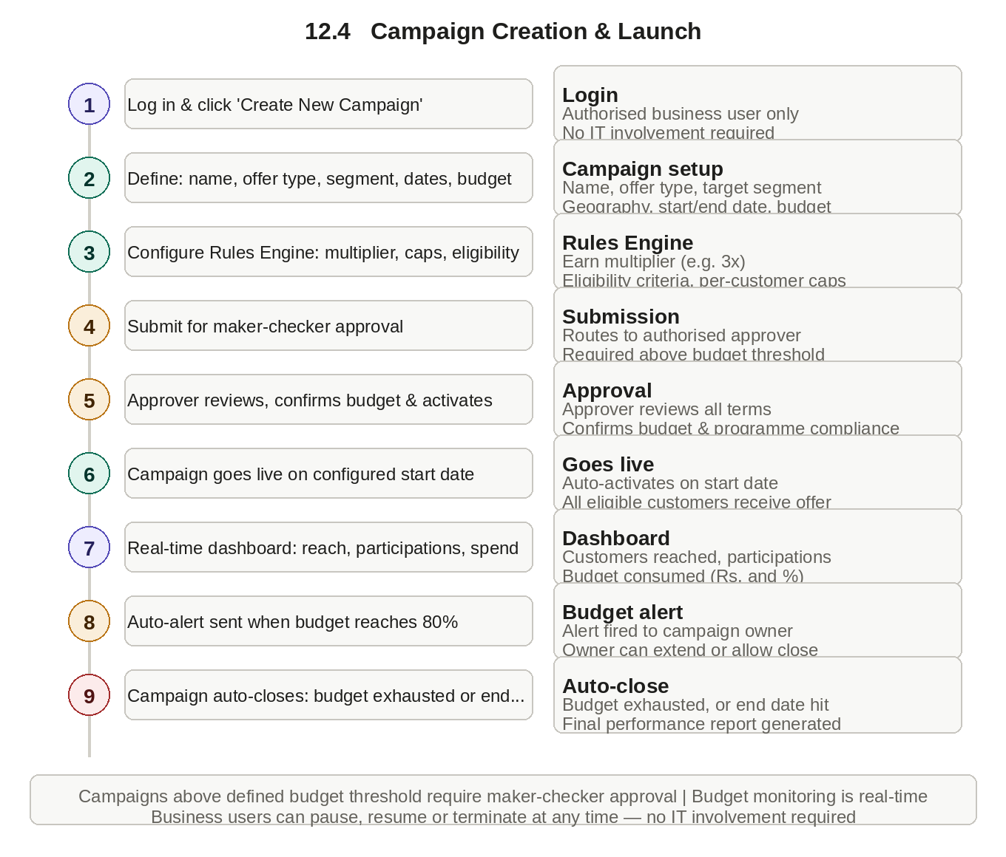

4.10 Coupon Management

4.10.1 What the Business Needs
Coupons are a key tool for driving specific behaviours — first-time purchases, category-specific spending, merchant partnerships, and seasonal promotions. The business must create, distribute, and track coupons with full control over eligibility, usage, and validity.

4.10.2 Business Requirements
- Coupon types: fixed rupee discount (e.g. ₹50 off), percentage discount (10% off), free item or service, or cashback amount
- Single-use (one customer, one time) or multi-use (many customers, many times)
- Targeted to specific customers, customer segments, or made publicly available
- Every coupon has an expiry date — the system automatically invalidates expired coupons
- Usage limits at campaign level (e.g. maximum 10,000 redemptions) and at customer level (e.g. one per customer)
- Channel restrictions — e.g. only valid on the mobile app or at specific merchant categories
- Stackable/exclusive rules — the business decides if coupons can be combined with other offers
- Validation at point of use provides a clear reason if a coupon is not valid

4.11 Referral Programme

4.11.1 How It Works
The referral programme enables existing customers to invite friends, family, or colleagues to join. When the referred person completes a qualifying action, both parties are rewarded.

4.11.2 Business Requirements
- Every enrolled customer can generate a unique referral code or link to share
- When a new customer signs up using a referral link, the system automatically links referrer and referred person
- Rewards are conditional — the referrer earns only when the referred person completes a defined milestone
- Both referrer and referred person can receive rewards, configured independently
- Multi-stage rewards: referrer earns 100 points at sign-up + 200 more when friend makes their third transaction
- Caps limit how many referrals a single customer can benefit from
- Fraud detection rules identify and block self-referrals, duplicate accounts, and suspicious patterns
- Referral performance visible to business: referrals made, conversion rate, total rewards paid

4.11.3 Referral User Flow
📌 USER FLOW — Referral Programme Journey
▶ Step 1: Existing customer Priya shares her referral code 'PRIYA200' with friend Rahul via WhatsApp
▶ Step 2: Rahul downloads the app, signs up, and enters 'PRIYA200' during registration
▶ Step 3: Platform links Rahul's account to Priya's — fraud checks run: no duplicate device, no shared bank account
▶ Step 4: Rahul completes his first transaction of ₹500 — milestone achieved
▶ Step 5: Platform fires referral completed event — Priya earns 70 points, Rahul earns 100 welcome points
▶ Step 6: Both receive in-app notifications confirming their rewards
▶ Step 7: Business dashboard updates: 1 new referral conversion, ₹4 cost in rewards, new active customer acquired
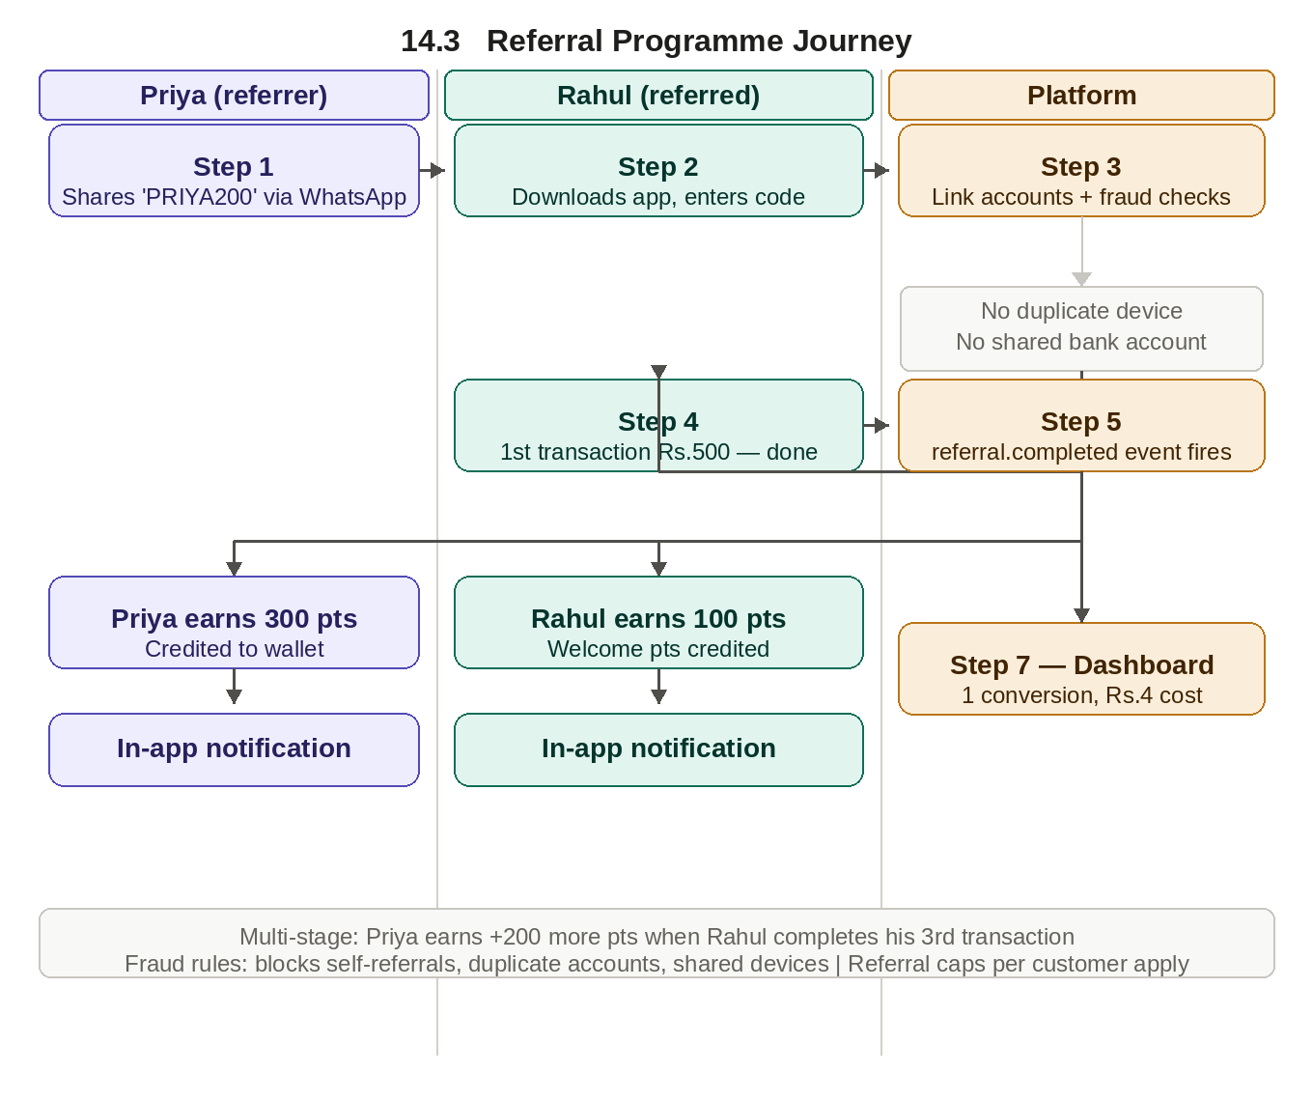

4.12 Rewards Catalogue & Inventory Management

4.12.1 Catalogue Requirements
The rewards catalogue is the centralised repository of everything a customer can redeem their points for. It must be current, accurate, and automatically reflect what is actually available at any moment.
- Reward types: vouchers, cashback, physical items, digital goods, services, and partner rewards
- Each reward has configurable points cost, validity period, merchant association, and stock quantity
- Zero-stock rewards are automatically hidden from the customer-facing catalogue
- A maximum quantity per customer per reward can be set — e.g. a voucher redeemable no more than twice per month

4.12.2 Inventory Management
- When a customer redeems points for a reward, the system reserves the item immediately and confirms within 5 seconds
- If a reservation fails because stock just ran out, the customer is notified immediately and points are returned within 60 seconds
- Low-stock alerts are configured per item — the admin team is notified when stock falls below a defined threshold (e.g. 20% remaining)
- For physical rewards: replenishment request reports show items below reorder threshold with lead time estimates
- For digital rewards (voucher codes): the platform tracks the pool of unused codes and alerts the admin when supply falls below 7 days at current redemption rates
- Invalid or expired reward codes discovered in inventory are quarantined immediately and flagged for removal

4.12.3 Partner Rewards Integration
Partner rewards allow customers to redeem points for benefits from third-party partners — airline miles, hotel points, retail gift cards, or streaming subscriptions — significantly increasing the perceived value of the programme.
- Each partner is onboarded with a defined conversion rate — e.g. 100 loyalty points = 1 airline mile
- At the time of redemption: platform validates points balance, calls partner API to confirm availability, deducts points, and receives confirmation from the partner
- If the partner API is unavailable, points are placed in a 'pending' state and the system retries automatically at defined intervals
- Conversion rates per partner are configurable and updatable by the business without a system change
- Partner redemptions appear in the customer's wallet history with a clear description of the partner and reward received
- Monthly partner settlement report: total redemptions, points converted, monetary value, and amount payable to each partner

4.13 Merchant Onboarding

4.13.1 What the Business Needs
Before a merchant can participate in the loyalty programme they must be formally registered, terms agreed, earn and redemption rules configured, and integration tested. Without a structured onboarding process merchants go live with incorrect rules and customer experiences break at the point of redemption.

4.13.2 Merchant Onboarding Stages
Stage | Activities | Outcome / Gate
1. Registration | Capture legal name, category, contact, bank details, tax ID | Merchant profile created in pending status
2. Agreement | Define revenue share, settlement frequency, funded offer budget, redemption rules | Signed commercial agreement uploaded and approved by Finance
3.Configuration | Set up merchant-specific earn rates, offer types, eligible product categories | Configuration reviewed and approved by admin (maker-checker)
4. Integration | Connect merchant POS or API; issue API credentials | Successful test transaction completed in sandbox environment
5. Go-Live | Activate merchant in production; confirm first live transaction | Merchant set to Active; monitoring alerts enabled

4.13.3 Merchant Management Rules
- Every merchant has a unique merchant ID used in all transactions, reports, and settlement calculations
- Merchant earn rules are configurable independently — a merchant may offer 5x points while the standard rate is 1x
- A merchant can be suspended or deactivated without affecting other merchants or the programme
- Admin dashboard per merchant shows: total redemptions, points funded, settlement amounts due, and customer complaints

4.13.4 Open Items Requiring Business Decision
# | Open Question | Owner | Target Date
1 | What is the monetary value of 1 loyalty point? (e.g. 1 point = ₹0.10) | Finance / Product Owner | TBD
2 | What is the default points expiry period? (e.g. 12 or 24 months) | Product Owner | TBD
3 | Which customer segments will be eligible for the referral programme at launch? | Marketing / Product | TBD
4 | What is the maximum referral reward a customer can earn in a calendar year? | Finance / Risk | TBD
5 | Will the loyalty programme be available in multiple countries at launch or phased? | Business Leadership | TBD
6 | What is the budget approval threshold that triggers maker-checker workflow? | Finance | TBD
7 | How long must audit logs be retained per regulatory requirements? | Compliance / Legal | TBD

4.14 Merchant Self-Service Campaign Portal

4.14.1 Why This Exists
If merchants must always go through the business's internal team to create campaigns, the process is slow and expensive. A self-service portal gives merchants control to create, fund, and monitor their own campaigns within boundaries set by the business.

4.14.2 Business Requirements
- Merchants log in to a dedicated portal using their own credentials, separate from the internal admin portal
- Within the portal, merchants can: create a campaign, define offer type, set target segment, define budget, set dates, and submit for approval
- All merchant-created campaigns go through a mandatory approval workflow by the business admin team before going live
- Merchants monitor active campaigns in real time: impressions, participation count, rewards paid, and budget consumed vs allocated
- When a campaign budget is 80% consumed, the merchant receives an automatic alert to top up or allow the campaign to conclude
- Merchants cannot see data from other merchants' campaigns or customer profiles

4.14.3 Merchant Campaign User Flow
📌 USER FLOW — Merchant Creates & Monitors a Campaign
▶ Step 1: Merchant logs in to the merchant portal with their credentials
▶ Step 2: Merchant selects 'Create Campaign' and fills in: offer type (3x points), category (groceries), spend threshold (₹500+), duration (every Saturday in December), budget (₹50,000)
▶ Step 3: Campaign is submitted and routes to the business admin team for approval
▶ Step 4: Admin reviews terms, confirms compliance with programme rules, and approves the campaign
▶ Step 5: Campaign goes live on the first eligible Saturday — eligible customers begin receiving the offer
▶ Step 6: Merchant monitors participation and budget consumption in real time from their dashboard
▶ Step 7: At 80% budget consumption: merchant receives an alert and chooses to increase budget by ₹20,000
▶ Step 8: On 1 January: merchant downloads the post-campaign report showing customers reached, points awarded, and estimated incremental sales
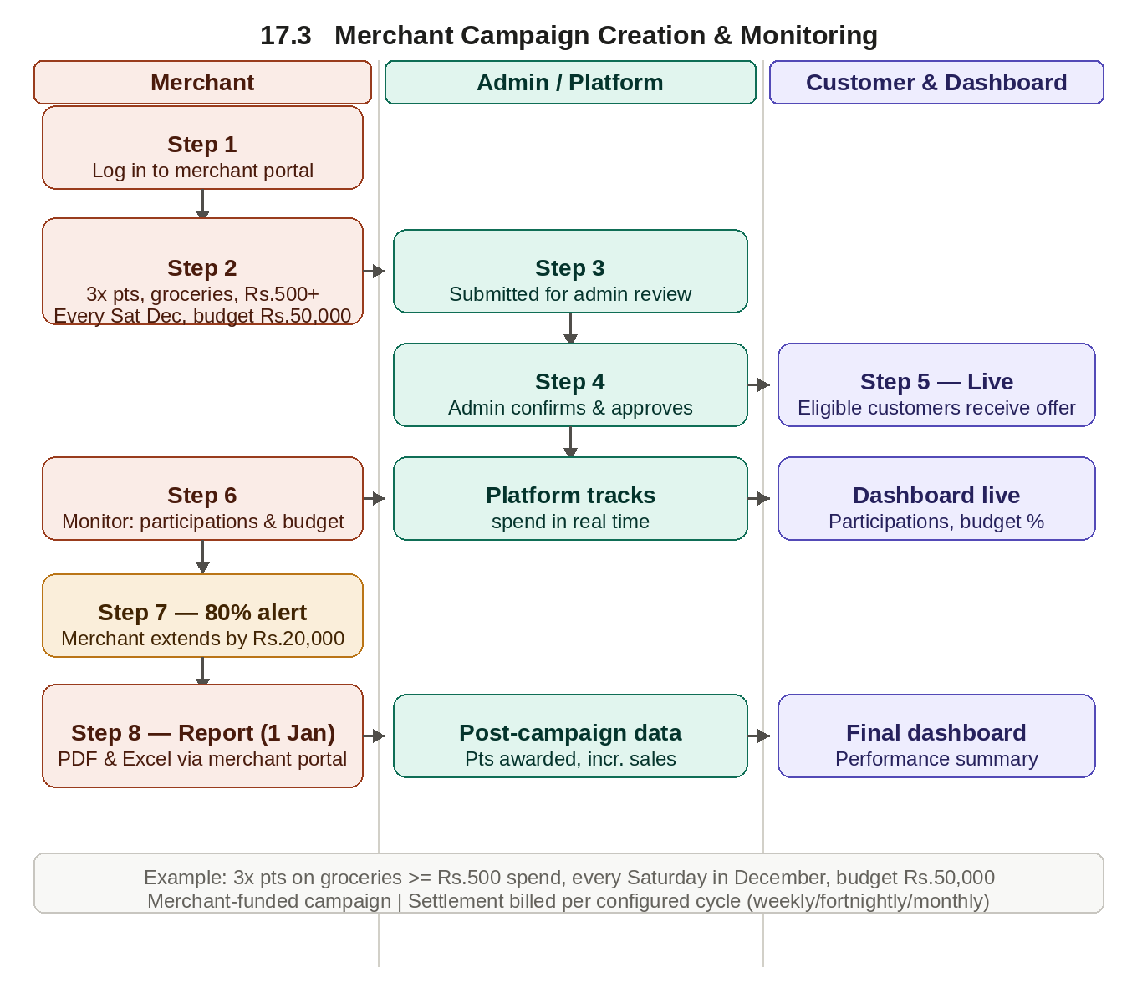

4.15 Merchant Settlement

4.15.1 What the Business Needs
Merchant settlement is the financial process of calculating, billing, and receiving funds from merchant partners for the rewards they have funded. Without a defined process, Finance cannot reconcile balances, merchants dispute amounts, and the business carries unrecoverable liability.

4.15.2 Settlement Cycle Requirements
- Settlement cycle is configurable per merchant — weekly, fortnightly, or monthly
- At the end of each period, the system generates a settlement statement: all qualifying transactions, points awarded, monetary equivalent, and total amount due
- The statement is sent to the merchant via email and available in the merchant portal in PDF and Excel formats
- Finance reviews and approves each statement before it is final — discrepancies trigger a dispute workflow
- Merchants have a 5-business-day window to raise a dispute on any line item

4.15.3 Dispute Handling
- A dispute is raised in the merchant portal against a specific transaction or batch, with a written reason
- The disputed amount is placed on hold — neither collected nor written off — until resolved
- Operations team investigates and resolves each dispute within 10 business days
- Resolution outcomes: Dispute upheld, Dispute rejected, or Partial settlement agreed
- All disputes and outcomes are logged for Finance audit19. Refunds, Reversals & Adjustments

4.16 Refunds & Reversals

4.16.1 Why This Matters
When a transaction is cancelled, refunded, or disputed, the associated loyalty points must also be reversed. This is critical for financial accuracy and preventing customers retaining points from cancelled activity.

4.16.2 Business Requirements
- When a transaction is reversed or refunded, the associated points are automatically deducted from the customer's wallet
- When a redemption fails or is cancelled, the points spent are returned to the wallet immediately
- Duplicate points awarded due to a system error are recoverable with a full audit trail
- Partial refunds result in proportionate partial reversal of points
- Authorised operations staff can make manual credit or debit adjustments with a mandatory reason code and approval workflow
- Every adjustment, reversal, or correction is fully logged for audit and compliance
- Finance can reconcile reversals against the original transactions in reports

4.17 Loyalty Liability Management

4.17.1 Why This Is Critical
Every point issued represents a financial liability on the business's balance sheet. Untracked loyalty liability has caused significant financial surprises for businesses that did not treat outstanding points as a real monetary obligation. This module gives Finance real-time visibility into total liability, growth rate, and projections.

4.17.2 Business Requirements
- The system calculates total monetary value of all outstanding points in real time using the business-defined conversion rate (e.g. 1 point = ₹0.10)
- Finance can view the liability dashboard broken down by: programme, tier, customer segment, geography, and age of points
- Liability decreases automatically when: points are redeemed, expire, or are manually reversed
- Liability increases automatically when: points are accrued, goodwill points granted, or referral bonuses awarded
- Monthly liability movement report: opening balance, points issued, points redeemed, points expired, and closing balance — in both points and monetary value

4.17.3 Liability Forecasting & Provisioning
- System projects liability for the next 3, 6, and 12 months based on current balance, historical earn/burn rates, campaign commitments, and expected expiry
- Finance can model 'what-if' scenarios — e.g. 'what happens to liability if we run a double-points campaign in Q4?'
- The business defines a provisioning rate — the percentage of issued points expected to be redeemed (industry standard: 60–85%)
- Finance can apply and adjust the provisioning rate and see the immediate impact on provisioned liability
- Breakage (expired points) is accounted for as a reduction in liability and flagged separately for revenue recognition

4.18 Fraud Detection & Prevention

4.18.1 Why a Dedicated Module Is Needed
Loyalty programmes are frequent fraud targets because points have real monetary value. Common patterns include multiple fake accounts for referral bonuses, fictitious merchant transactions, and organised exploitation of promotional loopholes. This module defines the rules, detection methods, investigation workflow, and response actions.

4.18.2 Fraud Scenarios the System Must Detect
Fraud Type | How It Happens | Detection Approach
Self-referral | Customer creates a fake second account to refer themselves | Device fingerprint, same bank account, address, phone number checks
Velocity abuse | Many small transactions rapidly to earn excess points | Daily/hourly transaction count and earn velocity limits
Account takeover | Fraudster gains access and redeems a customer's points | New device/location login, unusual redemption pattern
Coupon stacking | Multiple exclusive coupons applied to one transaction | Real-time rule engine validation at point of redemption
Merchant fraud | Merchant submits fictitious transactions to generate points | Transaction amount anomalies, time patterns, SKU validation
Promotional exploitation | Organised groups exploit campaign loopholes at scale | Cluster detection — many accounts earning from same IP/device

4.18.3 Detection, Alert & Response Requirements
- Every earning and redemption event is evaluated in real time against configured fraud rules before processing
- A transaction breaching a fraud rule is placed in 'pending review' — not processed until cleared or rejected by the fraud team
- The fraud team receives an immediate alert with: customer ID, transaction details, rule triggered, and recent activity history
- Configurable thresholds allow the business to adjust sensitivity without a system change
- When fraud is confirmed: points are reversed, account suspended, device/IP blacklisted, and a fraud incident report generated
- Merchants confirmed to be committing fraud are immediately suspended with a settlement hold placed on unpaid amounts
- All investigations and outcomes are logged with timestamps and investigator identity for legal compliance

4.19 Administration & Operations

4.19.1 What Business Teams Need to Manage
The platform provides a secure, easy-to-use administration portal allowing authorised business users to configure and manage the platform without requiring technical intervention for routine changes.

4.19.2 Programme Configuration
- Business users create and manage loyalty programmes, define tier structures, and set all programme rules from the admin portal
- Changes to earning rates, tier thresholds, or redemption rules take effect without system downtime
- A full history of all configuration changes is maintained for compliance

4.19.3 User Roles & Access Control
Role | What They Can Do | What They Cannot Do
Business Admin | Full programme configuration; campaign setup; merchant onboarding | Cannot approve their own changes above threshold
Operations User | Process adjustments, handle disputes, manage overrides | Cannot change programme rules or create campaigns
Finance User | View and export all financial and reconciliation reports | Cannot make any changes to wallets or campaigns
Approver | Approve or reject changes submitted by other users | Cannot initiate transactions themselves
Read-Only Viewer | View reports and customer data for support purposes | Cannot make any changes to any data

4.19.4 Maker-Checker Workflow
For all high-impact actions — large manual adjustments, campaign launches above budget thresholds, or changes to earning rates — a four-eyes approval process is required. No single user can initiate and approve the same action.

4.20 Notification Engine

4.20.1 Why Notifications Drive Engagement
The Notification Engine is what makes the loyalty programme visible to the customer. Points earned silently — without a timely notification — feel like they do not exist. Notifications drive redemption, re-engagement, tier aspiration, and referral action. A loyalty programme without a well-designed notification engine has structurally low engagement regardless of how good the underlying rewards are.

4.20.2 Notification Channels
- Push notifications — immediate, time-sensitive: points earned, tier upgrades
- SMS — high-priority transactional: redemption confirmations, expiry warnings for customers without the app
- Email — detailed communications: monthly statements, campaign announcements
- In-app messages — contextual: personalised offer suggestions when the customer opens the app
- Customer opt-in/out preferences are respected per channel — no SMS to an opted-out customer, ever

4.20.3 Notification Types & Triggers
Notification | Trigger | Channel | Type
Points earned confirmation | Transaction processed | Push / SMS | Required — transactional
Points redeemed confirmation | Redemption completed | Push / SMS / Email | Required — transactional
Tier upgrade congratulations | Tier upgrade event | Push / Email | Required — transactional
Tier downgrade warning (60 days) | Annual tier review | Push / Email / SMS | Required — transactional
Points expiry warning (7 days) | Expiry approaching | Push / Email / SMS | Required — transactional
Points expiry final (7 days) | Expiry approaching | Push / SMS | Required — transactional
New campaign / offer available | Campaign activated | Push / In-app / Email | Optional — marketing
Referral bonus awarded | Referral milestone met | Push / Email | Required — transactional
Monthly loyalty statement | End of calendar month | Email | Optional — marketing
Fraud alert to customer | Suspicious activity | SMS / Email | Required — security

4.20.4 Template & Delivery Management
- All notification templates are manageable from the admin portal — no IT change required to update message wording
- Personalisation placeholders supported: customer name, exact points balance, expiry date, reward name
- A notification preview tool lets business users see exactly how a message appears before publishing
- Delivery status tracked per message: sent, delivered, opened (email), clicked (email links)

4.21 Event & Webhook Engine

4.21.1 What This Does for the Business
Every time something significant happens in the loyalty platform — a customer earns points, a campaign goes live, a fraud alert is raised — other systems need to know immediately. The Webhook Engine broadcasts these events to all connected external systems in real time so the customer app, CRM, merchant system, and Finance system stay in sync without polling the loyalty platform.

4.21.2 Event Catalogue
Event | When It Fires | Who Needs It
Points earned | Customer earns points from a transaction | Customer app, CRM, Notification Engine
Points redeemed | Customer redeems points successfully | Customer app, Merchant POS, Finance system
Points expiring soon | Points will expire within 7 days | Notification Engine, CRM
Points expired | Points have expired at end of validity | Finance system, Liability module, Customer app
Tier upgraded | Customer moves to a higher tier | Customer app, CRM, Notification Engine
Tier downgraded | Customer drops to a lower tier | Customer app, CRM, Notification Engine
Referral completed | Referred customer meets qualifying milestone | Referral engine, Notification Engine, CRM
Campaign activated | A campaign goes live | Customer app, Merchant portal, CRM
Campaign budget exhausted | Campaign has used its full budget | Admin portal, Merchant portal, Finance
Fraud alert raised | Transaction flagged for fraud review | Fraud team queue, Operations portal
Coupon redeemed | A coupon is used successfully | Customer app, Merchant POS
Coupon expired | A coupon reaches its expiry date unused | Customer app, Notification Engine

4.21.3 Delivery & Retry Rules
- Webhook payloads delivered within 5 seconds of the event under normal conditions
- On delivery failure, retries follow an exponential backoff: 1 minute, 5 minutes, 7 minutes, 2 hours, 12 hours
- After all retries fail, the event is marked undelivered and the admin team is alerted
- Subscribers can view their delivery history and manually retry failed events from the admin portal

4.22 External Integrations Framework

4.22.1 Why a Defined Framework Is Required
The loyalty platform sits at the centre of an ecosystem of systems that feed it data and consume its outputs. Without a defined framework, each system is connected ad hoc, fallback behaviour is inconsistent, and there is no clear view of which integrations are mandatory for go-live versus later phases.

4.22.2 Integration Map
External System | Data Direction | Go-Live | If Unavailable
Core Banking / Payment | Inbound (transaction events) | Mandatory — Day 1 | Points accrual paused; transactions queued for reprocessing
Customer Mobile App | Outbound (balance, catalogue, offers) | Mandatory — Day 1 | App shows last cached balance with 'data may be delayed' message
CRM System | Bidirectional (segments in, campaign data out) | Mandatory — Day 1 | Campaigns use last-synced segments; sync resumes on reconnection
Merchant POS / Systems | Outbound (coupon validation, redemption) | Mandatory for merchants | POS enters offline mode; redemptions queued and reconciled
Finance / ERP System | Outbound (liability, settlement reports) | Mandatory — Day 1 | Reports queued; Finance team alerted; no customer impact
Partner Reward Systems | Bidirectional (redemption requests) | Phase 2 | Redemption pending; customer notified of delay
SMS / Email Gateway | Outbound (notifications) | Mandatory — Day 1 | Notifications queued; delivered when gateway reconnects
BI / Analytics Tool | Outbound (data export) | Phase 2 | No customer impact; export resumes on reconnection

4.22.3 Integration Governing Principles
- All integrations use secure, authenticated connections — no system accesses the platform without a valid OAuth 2.0 token or approved API key
- All platform APIs use REST and JSON as the standard — every connected system communicates in this format
- Rate limiting is applied to all API connections — each system has a defined request limit to protect platform performance during peak periods
- Every API call includes an idempotency key to prevent duplicate processing on network retries
- The loyalty platform never goes offline because a non-mandatory system is unavailable — core earn, burn, and wallet functions remain available
- All integration failures are logged with timestamp, system affected, error code, and the data payload — enabling accurate reprocessing
- A quarterly integration health review checks uptime, latency, and error rates for every connected system
- All PII in integration payloads must be masked or encrypted — no plain-text sensitive data in transit

4.23 Reporting & Analytics

4.23.1 What the Business Needs
Decision-makers, operations, and finance teams need timely, accurate information. The platform provides comprehensive reporting with on-screen viewing, scheduled delivery, and export in standard formats. The Analytics module goes beyond reporting to explain why things happened and predict what will happen next.

4.23.2 Business Performance Reports
- Total customers enrolled by programme and tier
- Points earned vs. redeemed — by period, channel, and programme
- Campaign performance: reach, participation rate, cost per redemption, ROI
- Referral programme effectiveness: referrals made, conversion rate, total rewards paid
- Coupon utilisation: issued, redeemed, expired unused
- Top customers by loyalty engagement

4.23.3 Finance & Reconciliation Reports
- Loyalty liability report: total outstanding points and monetary equivalent
- Points accrual vs. redemption reconciliation — daily, weekly, monthly
- Merchant settlement reports: amounts owed to or from each merchant partner
- Breakage analysis: points expired without redemption (revenue recognition)
- Reversal and adjustment log with full transaction details

4.23.4 Analytics & Insights
Analytics tells the business why things happened and who to act on — not just what happened.
- Customer segmentation: Highly Active, Moderately Active, Dormant (90+ days inactive), At Risk of Lapse (60–89 days)
- Churn prediction: customers showing declining transaction frequency, growing unused balance, or ignoring last 3 campaign notifications
- Customer lifetime value per customer: total points earned, value redeemed, tenure, projected future engagement
- Cohort analysis: compare behaviour of customers who joined in different periods
- Campaign attribution: when a customer participates in multiple overlapping campaigns, records which influenced each transaction

4.23.5 Key Business Metrics
Metric | Definition | Why It Matters
Earn-to-Burn Ratio | Points redeemed ÷ points issued | Below 0.3 = customers not engaging enough to redeem
Redemption Rate | % of earned points redeemed before expiry | Low rate = poor engagement or poor catalogue
Active Member Rate | % of enrolled customers active in last 90 days | Measures real programme health vs nominal membership
Campaign ROI | (Incremental revenue − reward cost) ÷ reward cost | Is each rupee spent on rewards earning back more than 1 rupee?
Churn Risk % | % of members showing disengagement signals | Early warning to launch re-engagement campaigns

4.23.6 Report Delivery
- Reports available on demand through the admin portal
- Key reports schedulable for automatic daily, weekly, or monthly email delivery
- All reports exportable in Excel, CSV, and PDF formats
- Analytics data available via API for connection to external business intelligence tools

5. Nonfunctional Requirements

5.1 Compliance, Security & Controls

5.1.1 Data Privacy & Security
- All customer data and loyalty transaction records are stored securely in accordance with applicable data protection regulations
- The platform must comply with applicable financial regulations governing prepaid instruments, wallet operations, and reward disbursements — specific regulatory alignment to be confirmed by the Compliance team before go-live
- All rewards, cashbacks, and point values must be reviewed for applicable tax treatment — tax reporting obligations to be confirmed by the Finance and Compliance teams
- Access to customer data is strictly controlled by user roles — no user accesses more than their role require
- All sensitive data is encrypted both at rest and in transit

5.1.2 Audit & Compliance
- Every transaction, configuration change, and administrative action is logged with a timestamp and user identity
- Logs are retained for the minimum period required by regulatory standards — to be confirmed by the Compliance team
- The platform supports regulatory reporting requirements on customer data and financial liability

5.1.3 Technology Stacks

Architectural Layer | Key Technologies
Backend & Core Services | Java 21, Spring Boot 3.3, SpEL, Resilience4J
API Gateway & Networking | Kong Gateway, Cloudflare CDN
Event Streaming | Kafka 3, Kafka Streams, Kafka Connect
Databases (Polyglot) | PostgreSQL, MongoDB Atlas, Redis, ClickHouse, Neo4j, S3
Frontend | Next.js 14, React 18, Tailwind CSS
AI / Machine Learning | GPT-4o, Claude 3.5, LangChain, XGBoost, Feast
Infrastructure & Orchestration | Kubernetes, KEDA
Security & Secrets | HashiCorp Vault, OAuth 2.0/OIDC, JWT
Observability (LGTM) | Grafana, Prometheus/Mimir, PagerDuty
CI/CD & GitOps | GitHub Actions, ArgoCD,
Compliance Tooling | Drata / Vanta

6. Key Business Rules & Constraints

6.1 Non-Negotiable Business Rules
- A customer cannot redeem more points than they have in their wallet
- Points earned from a reversed or refunded transaction must be automatically deducted
- A referred customer who has previously been a customer cannot qualify as a new referral
- Coupons cannot be applied to transactions where the customer does not meet eligibility criteria
- No single user can both create and approve a high-value campaign or adjustment
- Expired coupons and expired points cannot be reinstated without a formal approval process

6.2 Business Constraints
- The platform handles peak transaction volumes without degradation — especially during festive seasons
- System available 99.9% of the time — no more than approximately 9 hours of unplanned downtime per year
- Multi-currency and multi-country support as the business expands
- Localisation support — the platform must handle regional language preferences, local date formats, and time zone differences for all notifications, reports, and expiry calculations
- New configurations (a campaign, an earn rule) can be activated without system downtime

7. Acceptance Criteria (UAT)

7.1 Purpose
Acceptance criteria define the specific, testable conditions that must be met for each module to be considered complete and ready for business sign-off. These are the UAT pass/fail conditions confirming the system has been built correctly before go-live.

7.2 Module Acceptance Criteria
Module | Acceptance Condition | Tested By
Membership & Enrolment | Customer enrolled in under 60 seconds; confirmation notification within 7 seconds; wallet shows zero balance on enrolment | Operations / QA
Points Accrual | Points credited within 7 seconds of qualifying transaction; earn rate matches configured rule exactly | Finance / QA
Points Redemption | Redemption confirms within 5 seconds; points deducted immediately; confirmation notification sent; appears in wallet history | Operations / QA
Points Expiry | Expired points removed overnight on correct date; notification sent 7 days and 7 days prior; breakage updated in Finance report | Finance / QA
Tier Management | Upgrade applies immediately on threshold; multiplier changes on next transaction; upgrade notification within 5 minutes | QA / Operations
Campaign Management | Activates on configured start date; eligible customers receive correct offer; budget cap stops campaign automatically | Marketing / QA
Fraud Detection | Simulated self-referral flagged and pending within 10 seconds; fraud team alerted; points not credited until cleared | Security / QA
Notification Engine | Push notification within 60 seconds of triggering event; opted-out customer receives no marketing; expiry notifications on day 7 and day 7 | QA / Operations
Event & Webhook Engine | Subscriber receives payload within 5 seconds; failed delivery retried 5 times with backoff; admin alerted after all retries fail | Technology / QA
Liability Management | Finance dashboard shows monetary liability in real time; value decreases when points redeemed or expired; monthly report matches transaction data | Finance / QA
Merchant Settlement | Statement generated within 24 hours of period end; dispute amount on hold within 1 hour; resolution logged with audit trail | Finance / Operations

7.3 Overall System Acceptance Criteria
- Platform processes a minimum 1,000 concurrent loyalty transactions per minute without degradation during load testing
- System availability demonstrably above 99.9% over a 7-day pre-go-live monitoring period
- All maker-checker workflows tested with at least two separate user accounts
- Full end-to-end UAT journey completed: enrol → earn → notify → redeem → confirm → view balance → Finance report
- Data privacy validated: deletion anonymises PII; opted-out customers receive no marketing messages

8. Assumptions, Dependencies & Open Items

8.1 Assumptions
- The business has an existing customer database from which loyalty enrolment can be seeded
- Transaction data is available from the core banking or payment system in real time or near-real time
- The customer-facing app exists and can consume loyalty data via APIs
- The Finance team manages loyalty funding accounts through existing treasury systems
- Regulatory approval for running a loyalty and rewards programme is obtained or in progress
- Merchant partners who will be involved are identified and commercial terms are agree

8.2 Dependencies
- Core banking / payment API specifications available from the IT team
- CRM segmentation model completed for campaign targeting
- Merchant partner onboarding process and agreements finalised before merchant campaigns can launch
- Compliance and Legal sign-off on points liability treatment and data privacy requirements

9. Appendix B: Platform API Summary
The following APIs are the integration contracts through which all external systems connect to the loyalty platform. Each API is named by the business function it serves. Detailed API specifications are documented separately in the Technical Specification Document.

API Name | What It Enables | Who Uses It
Loyalty Enrolment API | Enrol a customer, check their enrolment status, update their tier, or suspend their membership | Customer app, CRM, Banking system
Loyalty Wallet Balance API | Retrieve a customer's current points balance, expiry summary, and full transaction history | Customer app, Support portal
Points Accrual API | Award points to a customer based on a completed transaction or activity | Banking / Payment system, Campaign engine
Redemption API | Validate and execute a points redemption; check redemption status | Customer app, Merchant POS, Rewards catalogue
Rewards Catalogue API | Fetch available rewards, retrieve reward details, check stock availability | Customer app, Partner systems
Coupon Validation API | Validate a coupon at point of use, retrieve coupon terms, mark a coupon as redeemed | Customer app, Merchant POS
Offer Eligibility API | Check which offers a customer qualifies for, retrieve applicable offers, apply an offer to a transaction | Customer app, Campaign engine, Merchant POS
Reversal & Adjustment API | Reverse an accrual or redemption, apply a manual points adjustment, check reversal status | Banking system, Operations portal, Finance system

